TEST 04

Listening
There are 25 questions
You will need coloured pens and pencils.

My name is…………………………….

PART 1
5 questions

This is an example. Now you listen and draw lines.
Mary | Mr James |  | Mrs Lily |  | Sue
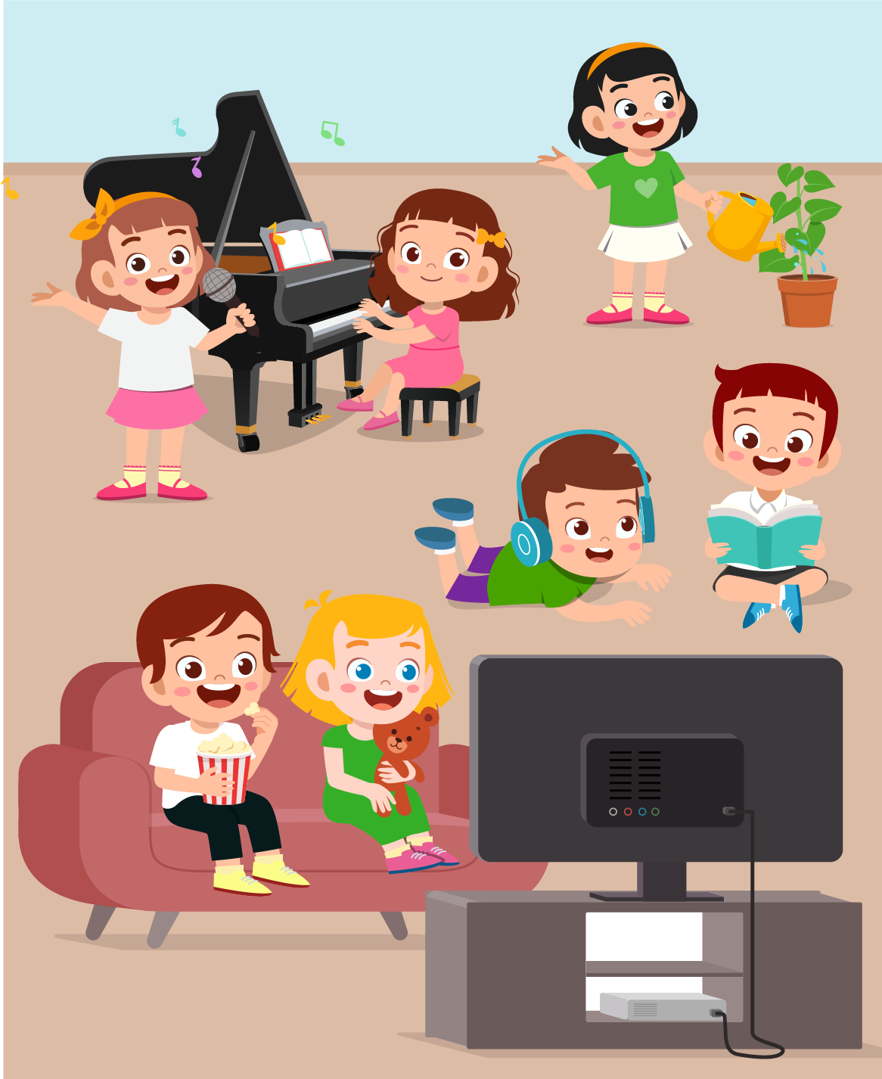
Tom |  | Peter |  | Hoa

PART 2
5 questions

Listen and write. There is one example.
 | 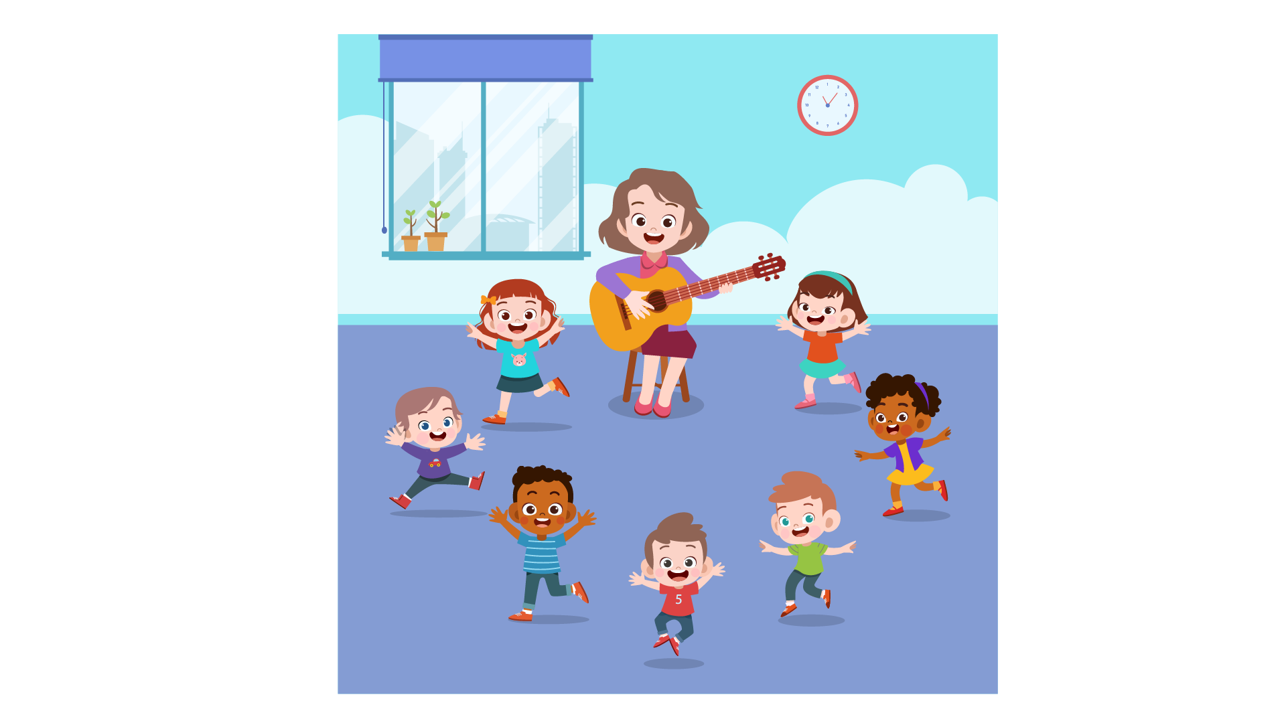
 | DANCE CLASS
0 | When: | …Saturday…
1 | Where: | on the……floor
2 | How often: | …….a week
3 | Number of students: | ……
4 | Teacher’s name: | ……
5 | First lesson on: | ……

PART 3
5 questions

What did Jane do at home yesterday?
Listen and draw a line from the floor to the correct picture.
There is one example

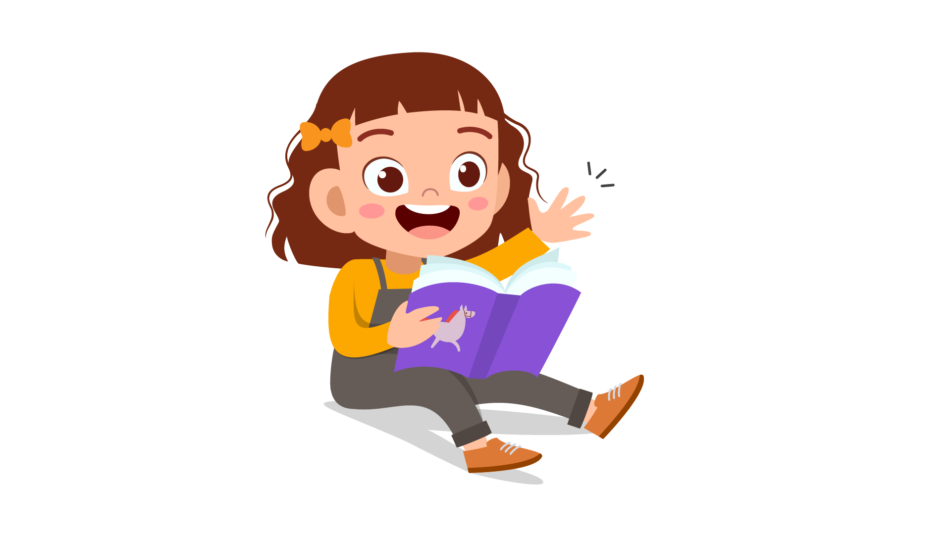 | living room  bedroom  kitchen  dining room  garden  garage  bathroom | 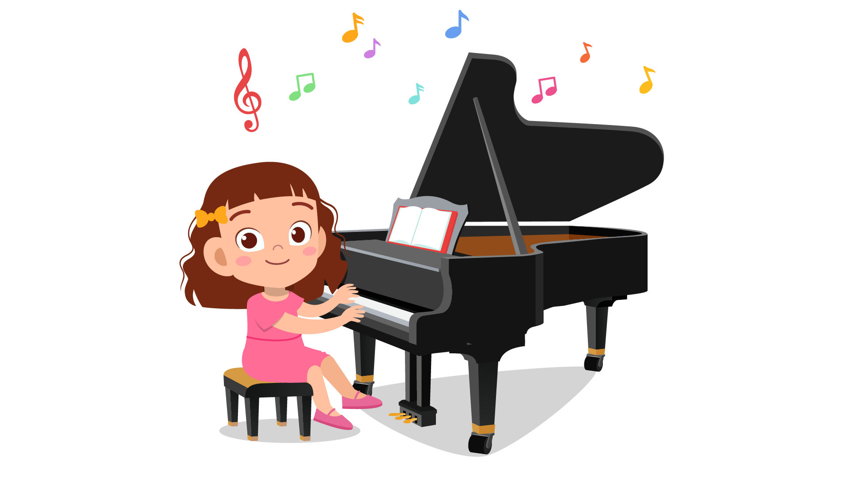
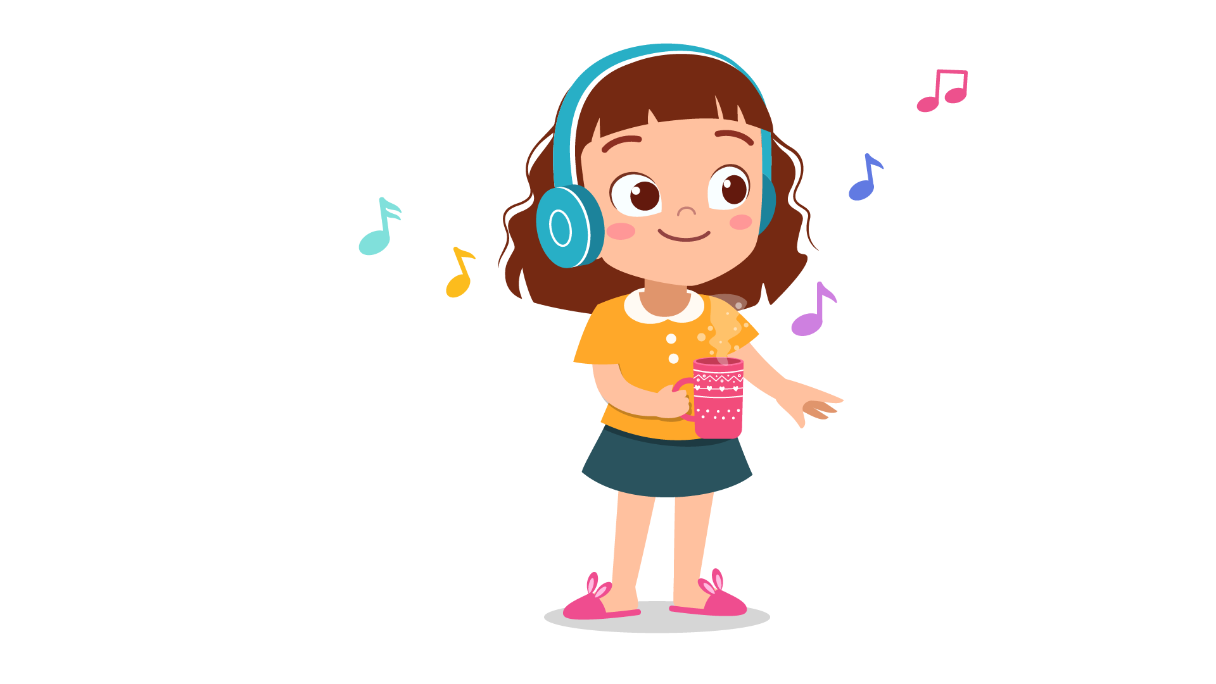 |  | 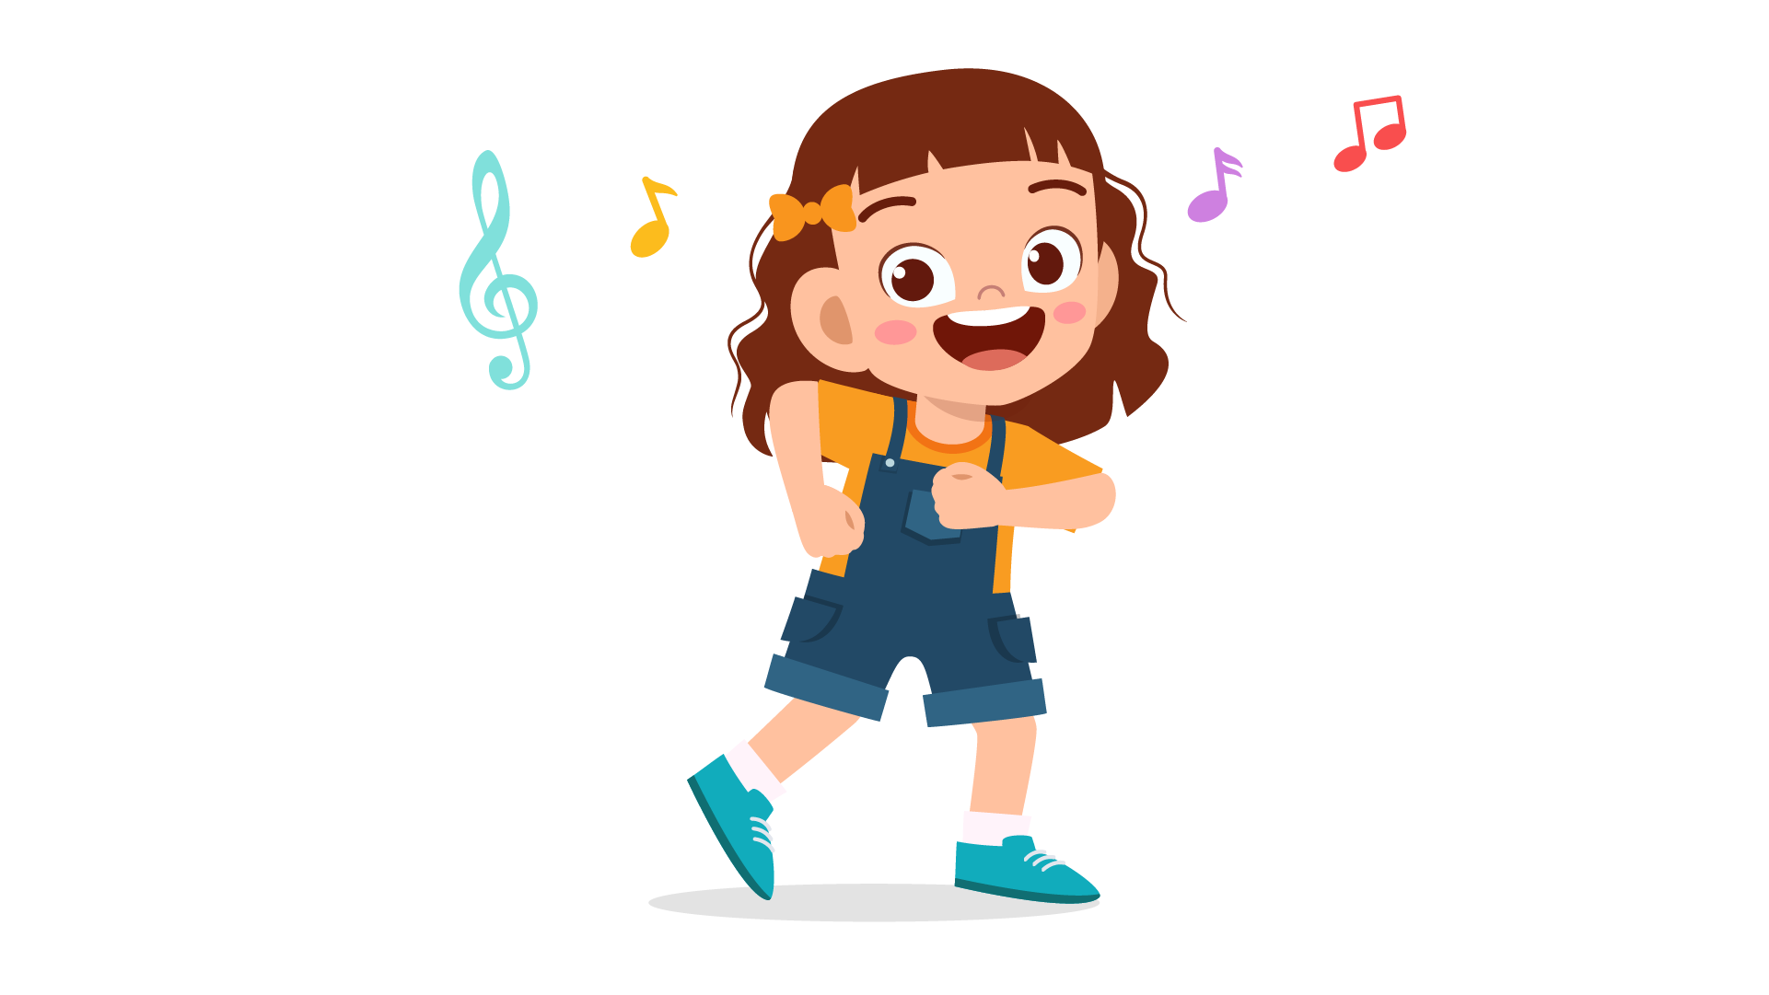
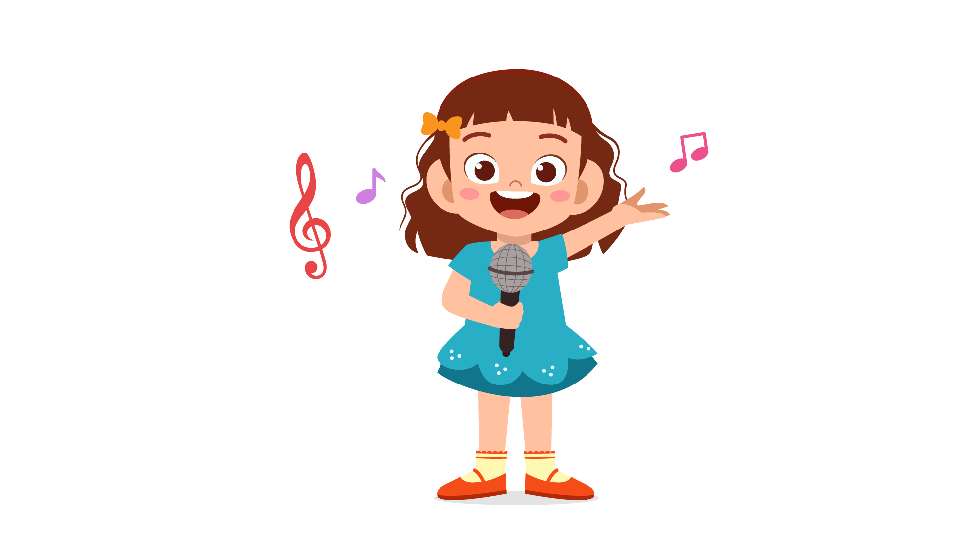 |  | 

PART 4
5 questions

Listen and tick (✓) the box. There is one example.
Example : What time did Laura go to school?
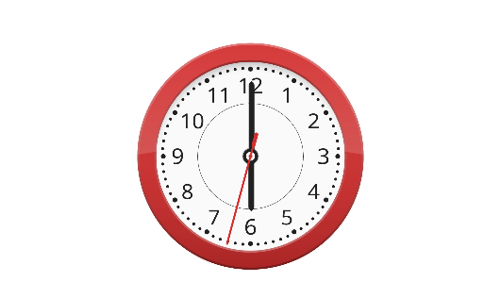 | 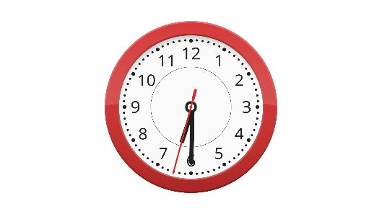 | 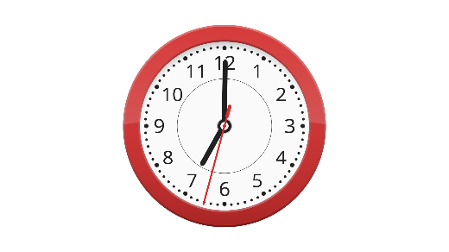
A ⬜ | B ⬜ | C ⬜
- Which child is Ben?
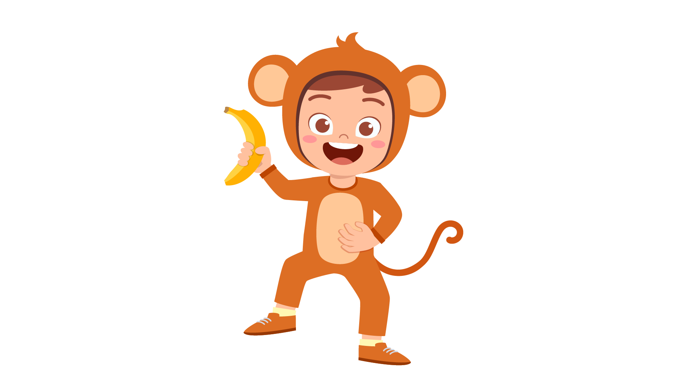 | 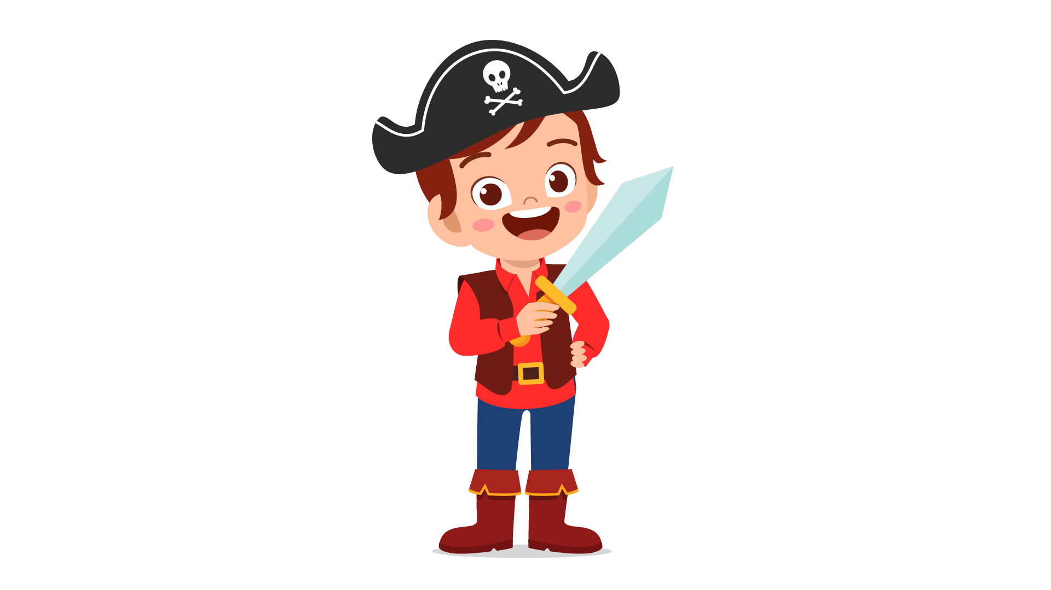 | 
A ⬜ | B ⬜ | C ⬜
- What did Rose have for lunch?
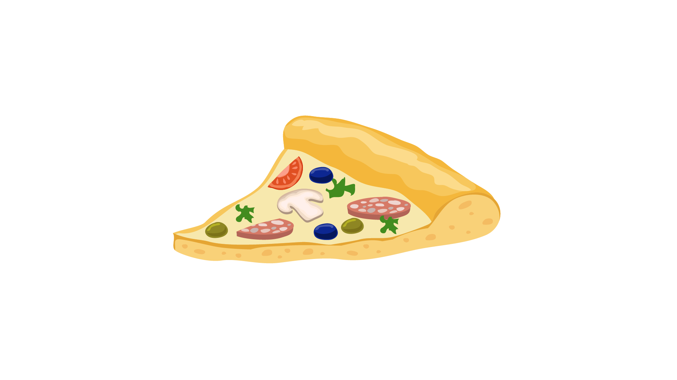 |  | 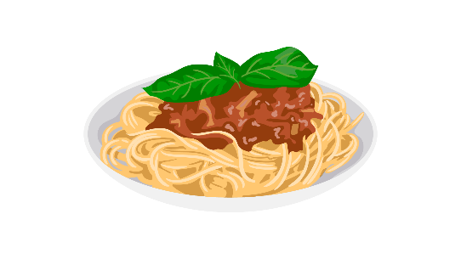
A ⬜ | B ⬜ | C ⬜
- What can Long do?
 |  | 
A ⬜ | B ⬜ | C ⬜
- What did Jack do at the weekend?
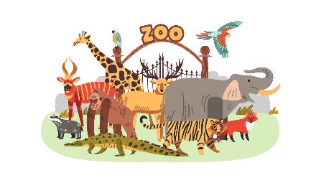 |  | 
A ⬜ | B ⬜ | C ⬜
- What time does the plane leave?
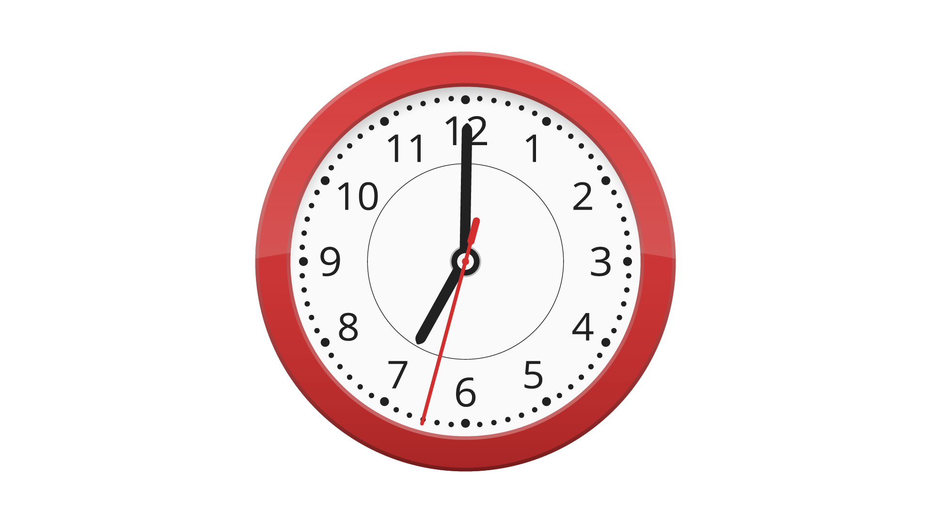 | 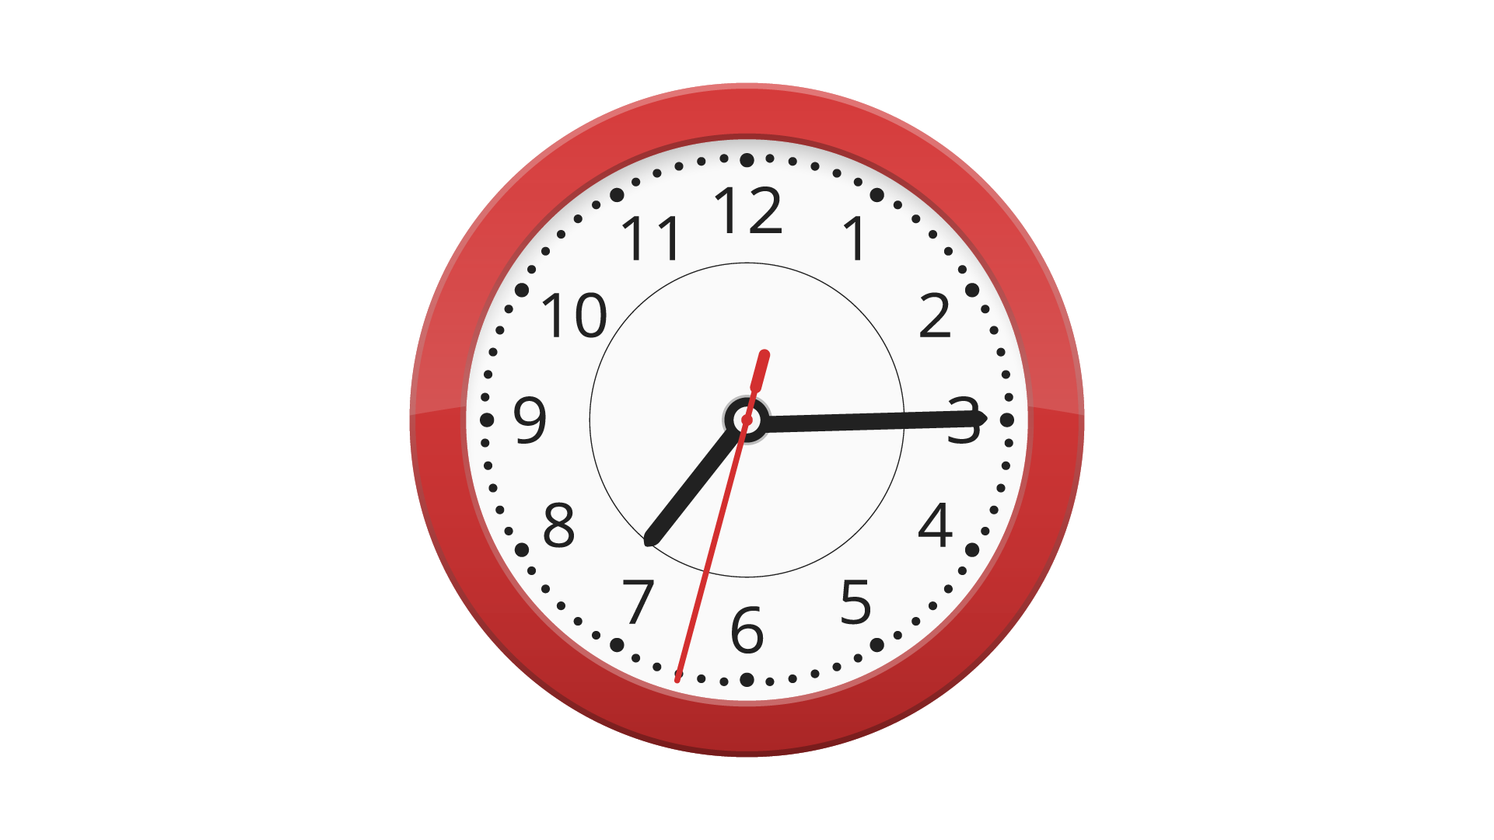 | 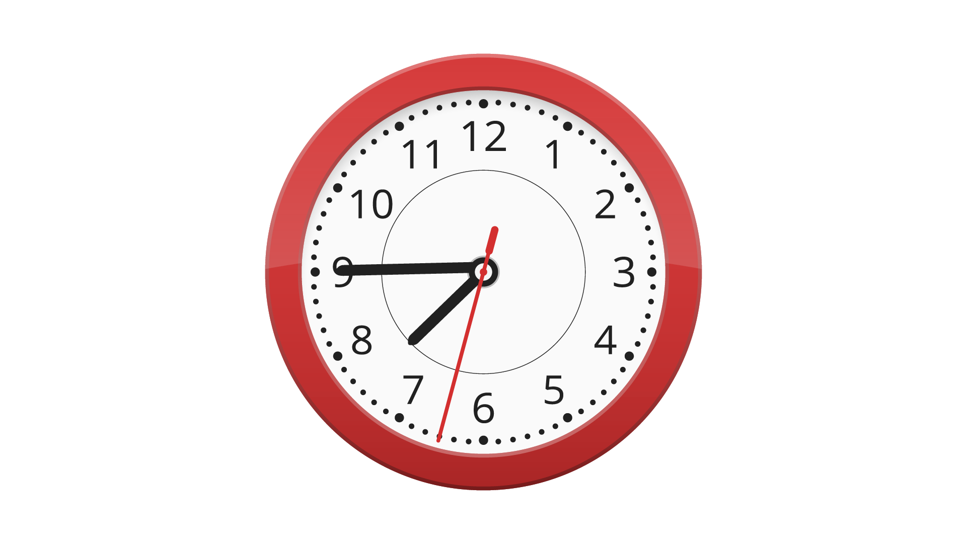
A ⬜ | B ⬜ | C ⬜

PART 5
5 questions

Listen and colour and draw.
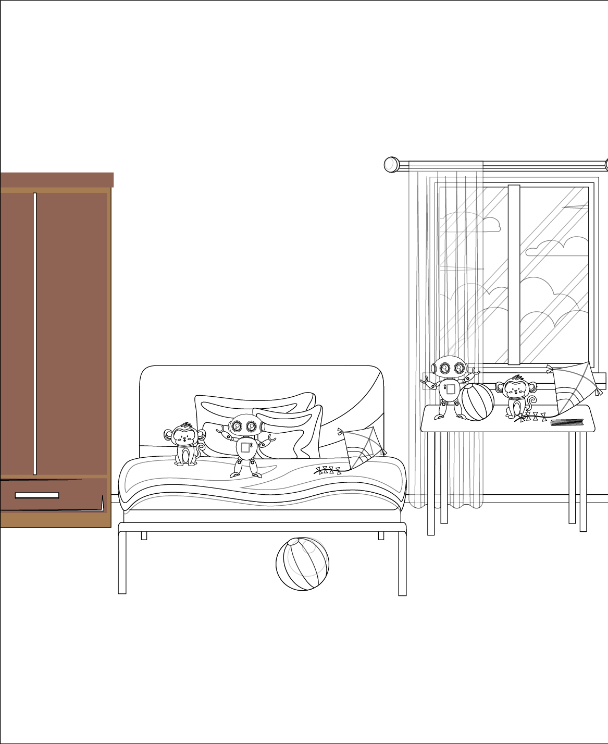

Reading and Writing
There are 35 questions
You have 30 minutes.
You will need a pen or pencil.
My name is…………………………….

PART 1
5 questions

Look and read. Choose the correct word and write them on the lines.

 | 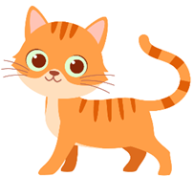
A hospital | A kitten
 | 
A glass | A cloud
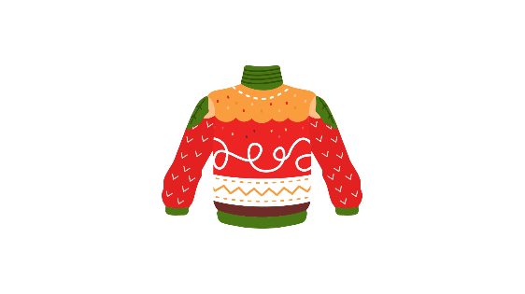 | 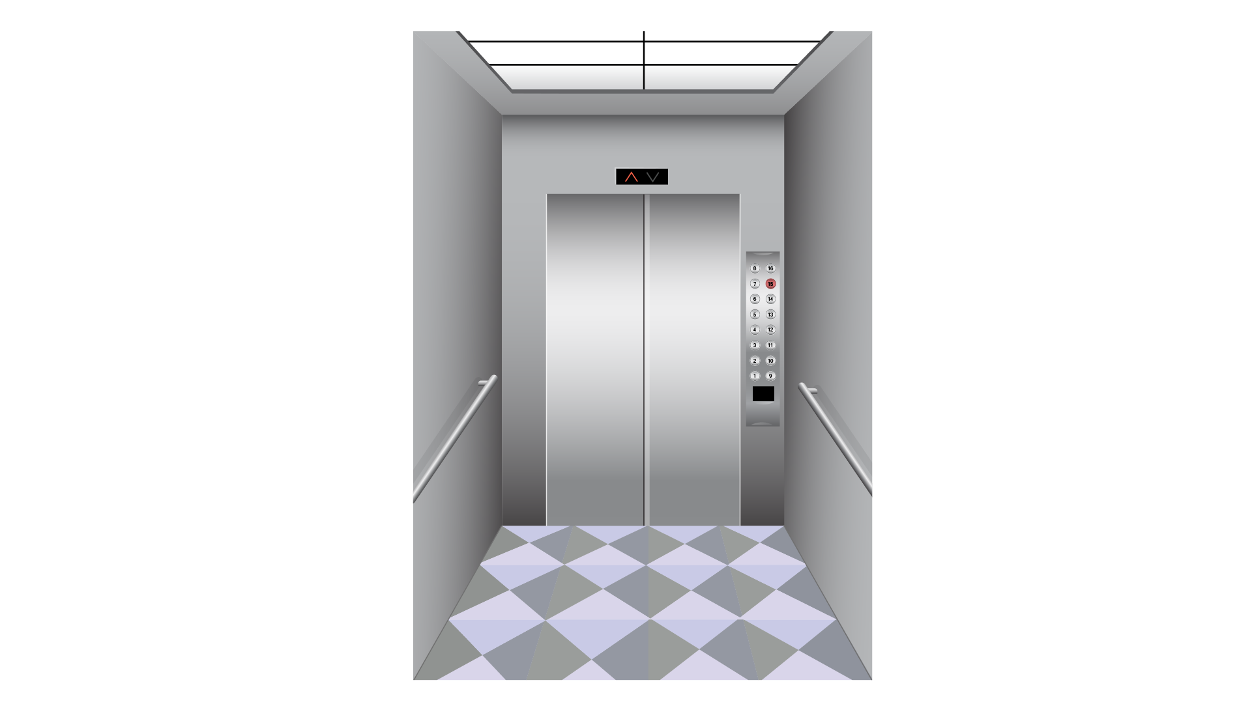
A sweater | An elevator
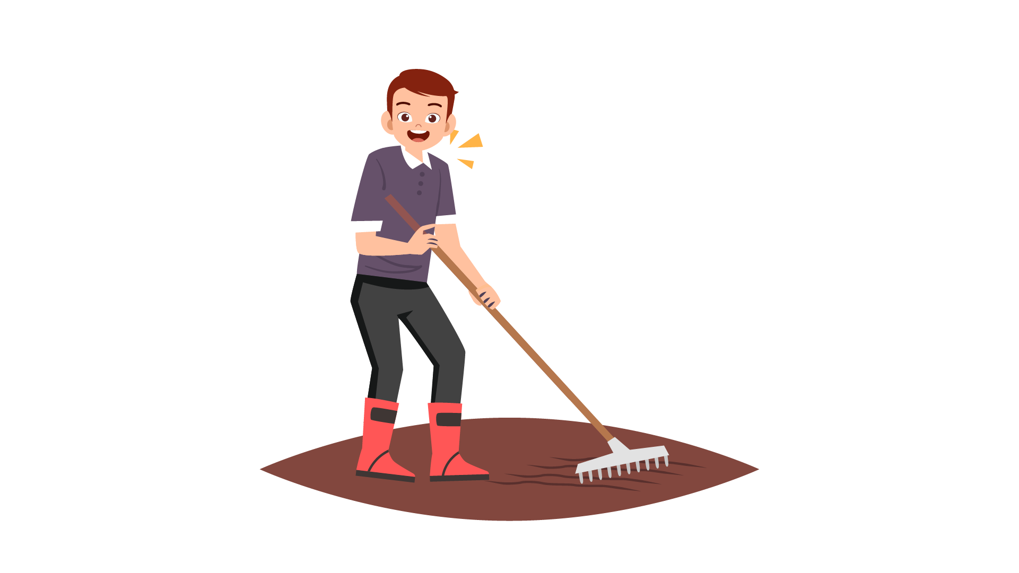 | 
A farmer | A website

Example
(0) | It is a place. A doctor works there. | A hospital
Questions
1 | It's a small cat. | ___________
2 | It’s inside a house. It moves people upstairs. | ___________
3 | It’s a kind of clothes. You wear this when it’s cold. | ___________
4 | You can pour water into it to drink. | ___________
5 | It’s white. It can move in the sky.

PART 2
6 questions

Read the text and choose the best answer.
Jane is talking to her friend, Peter, about the football team.
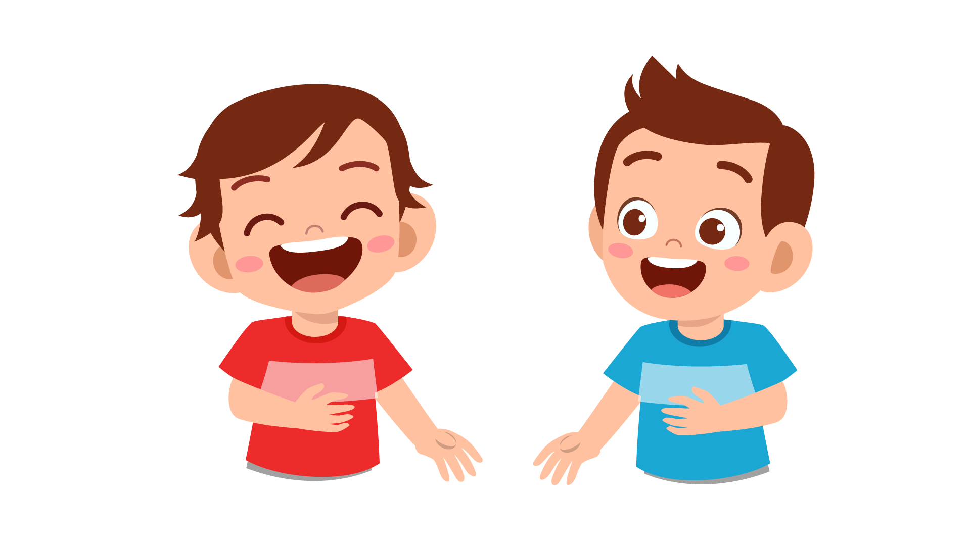

Example:
 | Jane: | I heard you joined the school football team. Congratulations!
 | Peter: | A. Yes, I did.
 |  | B. It’s okay.
 |  | C. Thank you!
Questions:
1 | Jane: | Which class are you in?
 | Peter: | A. When I was 5 years old.
 |  | B. For 5 years.
 |  | C. In the next 5 years.

2 | Jane: | How many members are there in the team?
 | Peter: | A. There are five lessons per week.
 |  | B. We practice twice a week.
 |  | C. Our team has 24 members.

3 | Jane: | When do you practice playing football?
 | Peter: | A. Every day. From 6 p.m. to 8 p.m.
 |  | B. I practice with my best friends.
 |  | C. We practice in the school stadium.

4 | Jane: | Are you going to have a match?
 | Peter: | A. Last week. At the national stadium.
 |  | B. Yes. This weekend.
 |  | C. No. We never practice at the weekend.

5 | Jane: | What do you need to have when practicing?
 | Peter: | A. Shoes, ball and gloves.
 |  | B. My best friend.
 |  | C. I need some books and pens.

6 | Jane: | Do you want to become a footballer in the future?
 | Peter: | A. I would like to practice football with my friends.
 |  | B. I can play football every day.
 |  | C. Of course. It’s my dream.

PART 3
6 questions

Read the story. Choose a word from the box. Write the correct word next to the numbers 1-5. There is one example.
One day, Emily found a book in the school (0) …library…. It was about a princess. She loved the (1) … and she wanted to become a princess. She came home and she told her mother. “Mom, I want to be a princess.” Her mom (2) … and said “Well, come and look at this.”
Her mom opened a big, old box. Inside the box, there were lots of (3) …. Emily took them out. There was a beautiful dress with a shining crown. She put on the dress and wore the crown on her (4) …. “You are a princess now, Emily!”. Emily felt very happy. “I want to look at myself in the (5) ….” Emily’s mom gave her some white shoes. She looked at her face and clothes. Emily laughed and said, “Yes, mom. I am a princess now!”

Example
smiled | chair | clothes
stairs | story | bedroom
head | mirror | opened

(6) Choose the best name for the story.
Tick one box.
Mom’s book about princess | ⬜
Mary and the princess clothes | ⬜
Mary meets a princess | ⬜

PART 4
5 questions

Choose the right words and write them on the line.
 | Tea
 | 
Example  1  2  3  4  5 | We drink tea every day. But where do we get tea from ? Why do people like drinking tea?  People can only grow tea plant … hot and sunny places. People collect tea in the morning … they can get the best tea.  To … tea, you need to put some tea leaves in hot water. You can add milk to make milktea or you can add some lemons.  … people shouldn’t drink tea in the afternoon or evening because they can’t sleep at night.  Some people like coffee more … tea. But in Vietnam, most people like drinking tea in the morning.

Example: | from | in | at
1. | at | on | in
2. | but | and | so
3. | do | make | have
4. | Old | Older | Oldest
5. | then | than | that

PART 5
7 questions

Look at the picture and read the story. Write some words to complete the sentences about the story. You can use 1, 2 or 3 words.
Holiday at the farm
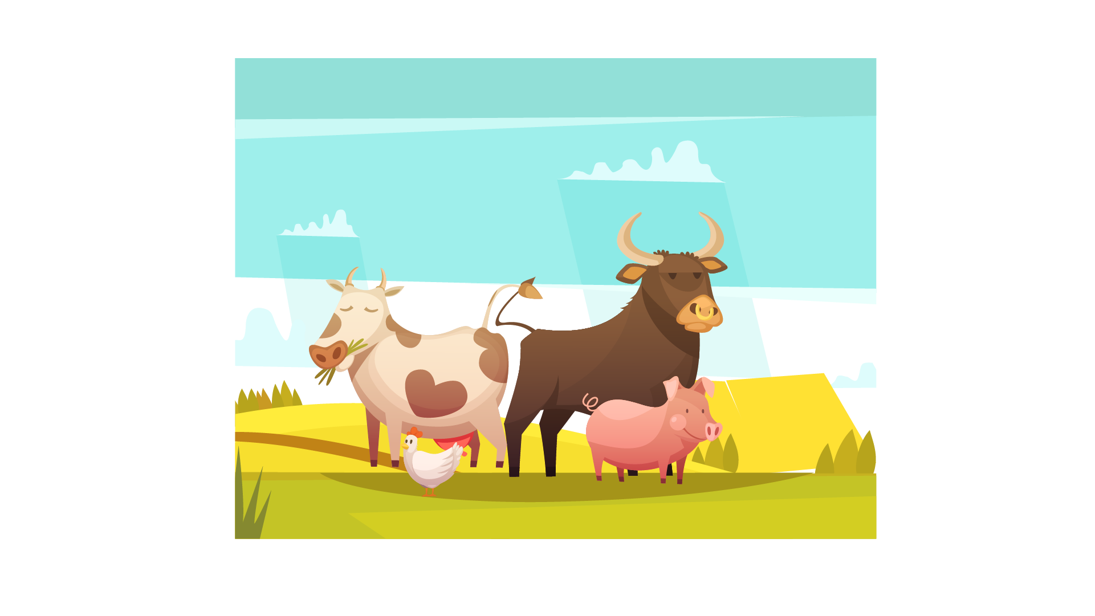
Ben lives in a big city with his parents and his brother , Peter. Every weekend, Dad takes Ben and Peter to Grandparents’ farm in his car. Ben and Peter’s grandparents live on a farm near the sea. They love going there.
Examples:
Ben and Peter live in a ….big city…..
Their grandparents live on the ….farm…..

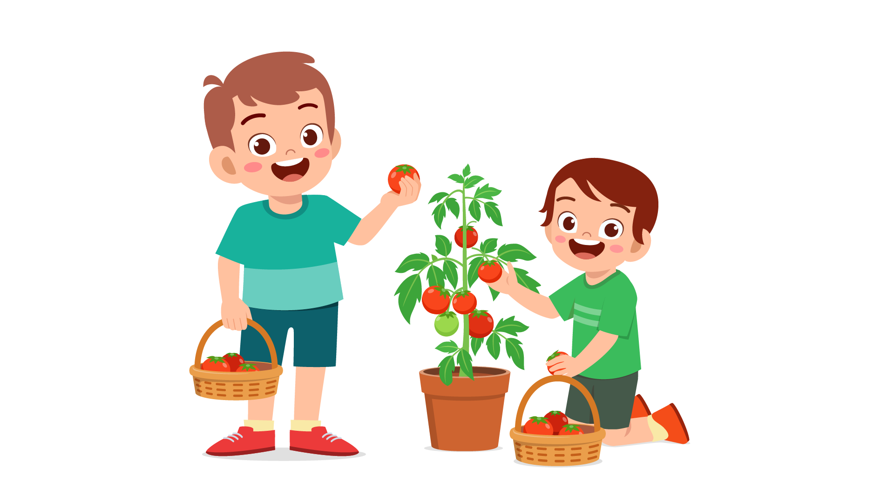
There are many things for Ben and Peter to do on the farm. They can collect tomatoes from the trees, give food to animals or water the plants. Last Sunday, Ben asked Grandpa “Can we play with the horses, Grandpa?” “Why not?” Grandpa said. “And I will show you our two new baby horses! I’d like you to choose names for them.”
Questions:
1 | On the farm, they often pick … from the trees, feed animals and water plants.
2 | Last Sunday, … wanted to play with the horses.
3 | The two baby horses didn’t have …

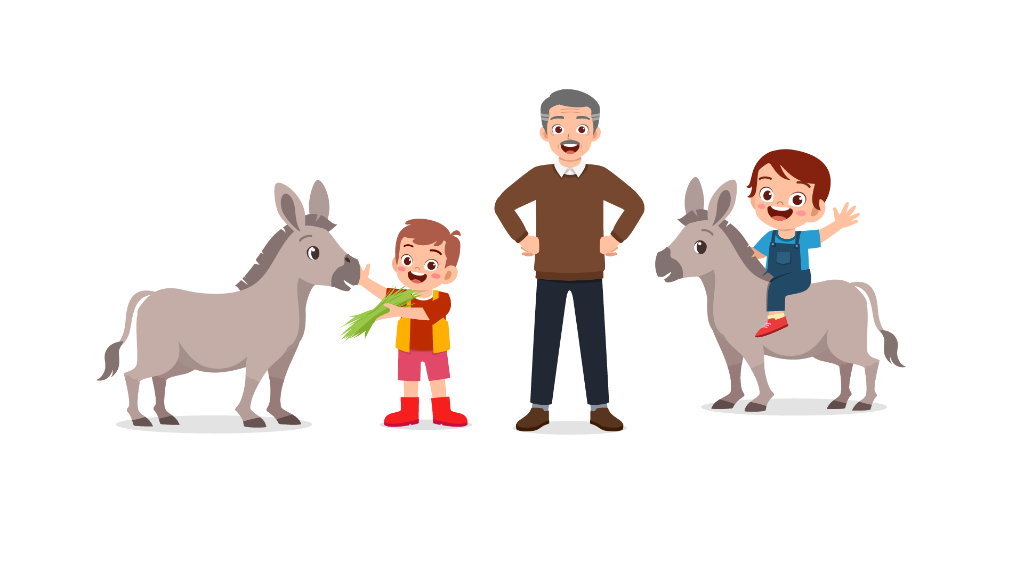
Peter and Ben were surprised when they saw the baby horses. The baby horses made funny noise. Peter and Ben laughed a lot. They were not really small. They had pretty brown eyes and long black tails.
Questions:
4 | Peter and Ben laughed because the baby horses made …
5 | The eyes of the baby horses were …

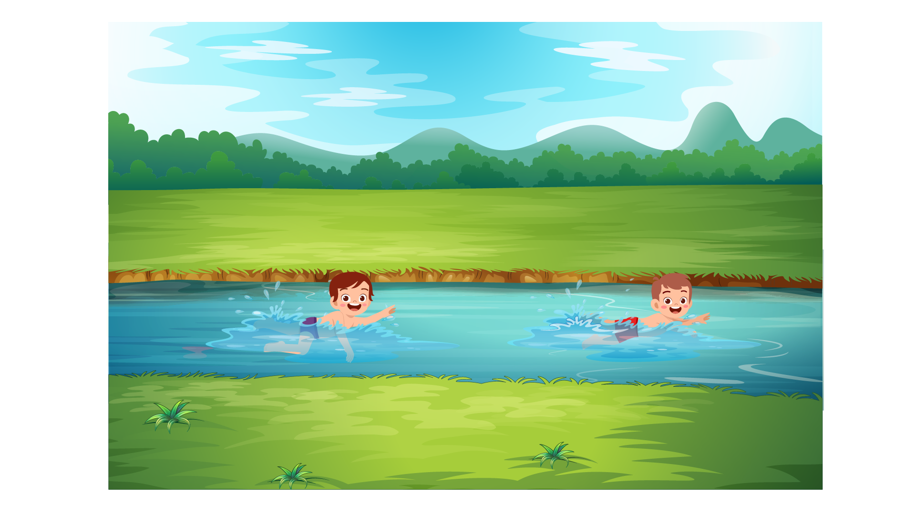
They gave new names to the baby horses. “Your names are Brown and Black!” Peter said to the horses. Then they rode Grandpa’s horse, Mr. Bill, to the river. Peter and Ben swam in the river. The water in the river was very clean and pure. They really loved swimming there. “What a wonderful day!” said Ben.

Questions:
6 | The name of Grandpa’s horse is …
7 | Peter and Ben loved swimming in the ... and pure river.

PART 6
6 questions

Look, read and write.
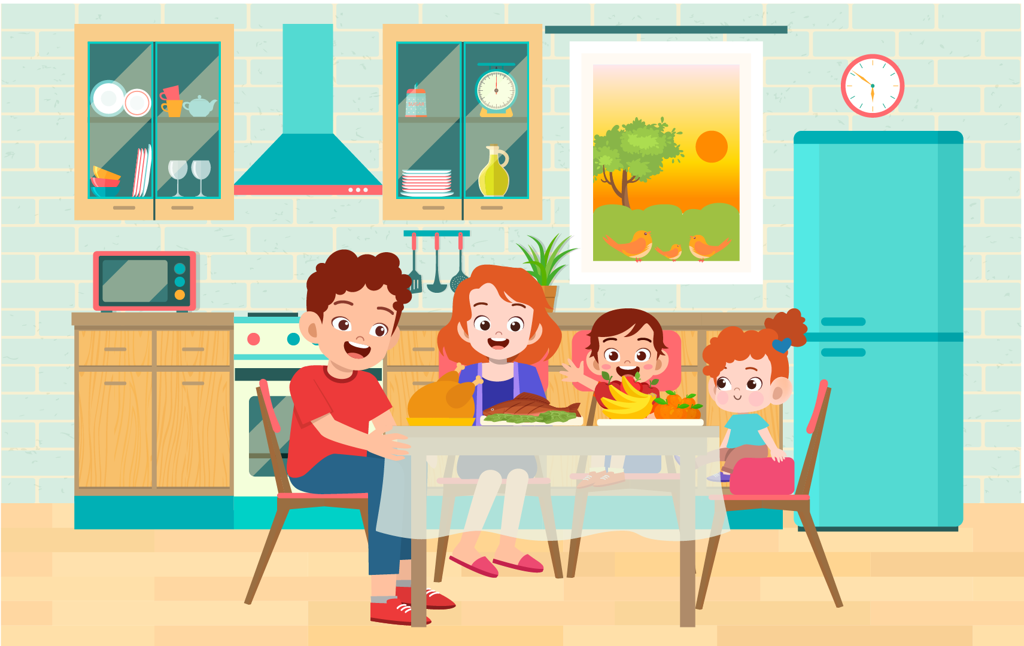

Examples:
There are …four… people in this family.
What is the weather? …sunny…

Complete the sentences.
1. The family is having dinner in the ….
2. The son is sitting between … and her sister.

Answer the questions.
3. What do they have for dinner?
4. What are the birds doing on the window?

Now write two sentences about the picture.
5. …………………………………….
6. …………………………………….
Speaking
My name is…………………………….

Summary of Procedures
The usher introduces the child to the examiner. The examiner asks how old the child is.

- The examiner asks the child to describe several differences between the two Find the Differences pictures, e.g. ‘In picture 1, the blanket is red but in picture 2, the blanket is blue’.
- The examiner tells the child the name of the story and describe the first picture, e.g. “The family is at the zoo. The children are very happy.”. The examiner then asks the child to continue to tell the story.
- The examiner shows how to do the task with the first odd-one-out set of pictures. For example: ‘These are all places. But this is a room in a house’. Then the examiner asks the child to choose one picture in the other three sets and say which is different and why.
- The examiner asks questions about the child, e.g. ‘What does your family often do at the weekend?’

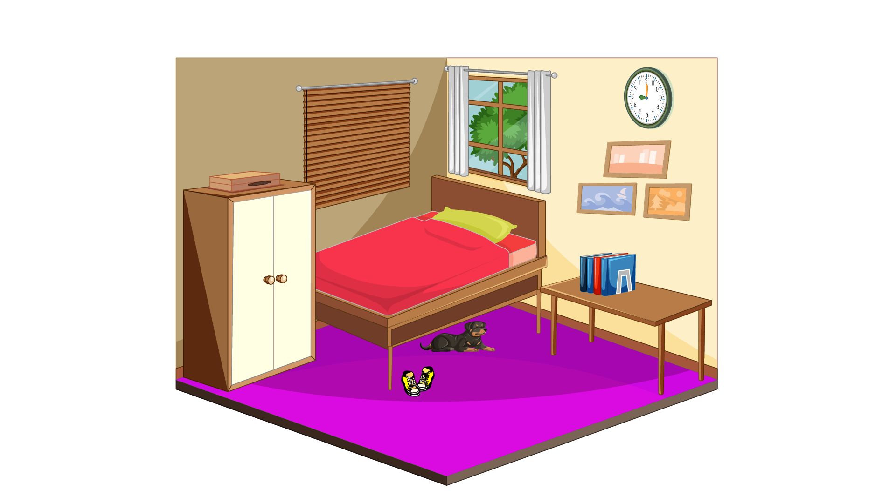 |  | 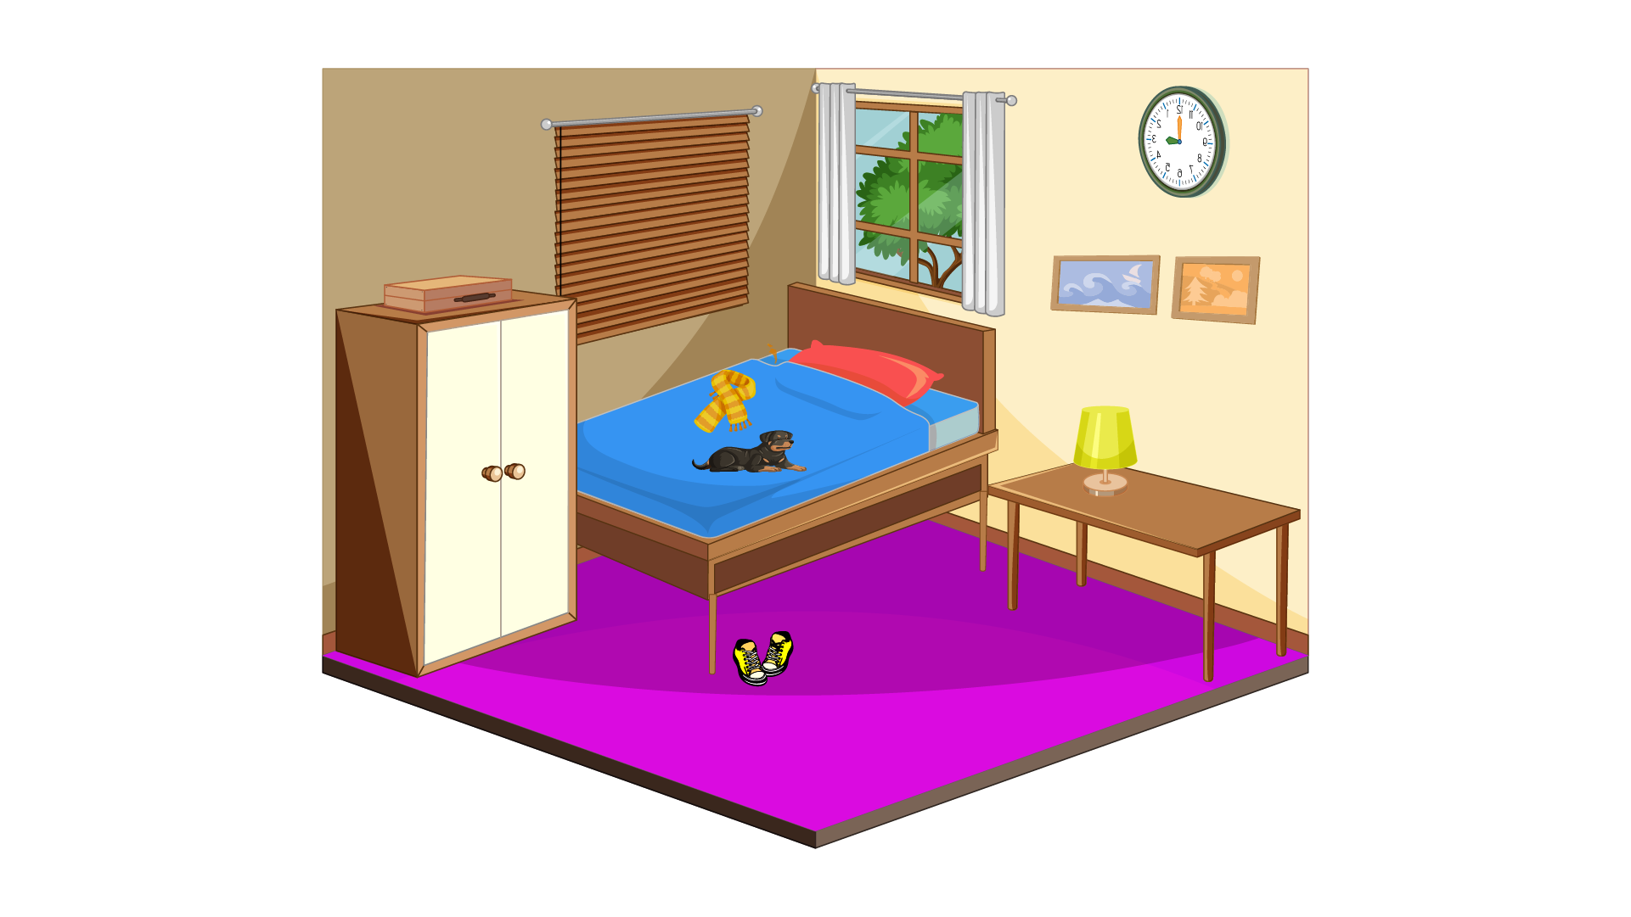

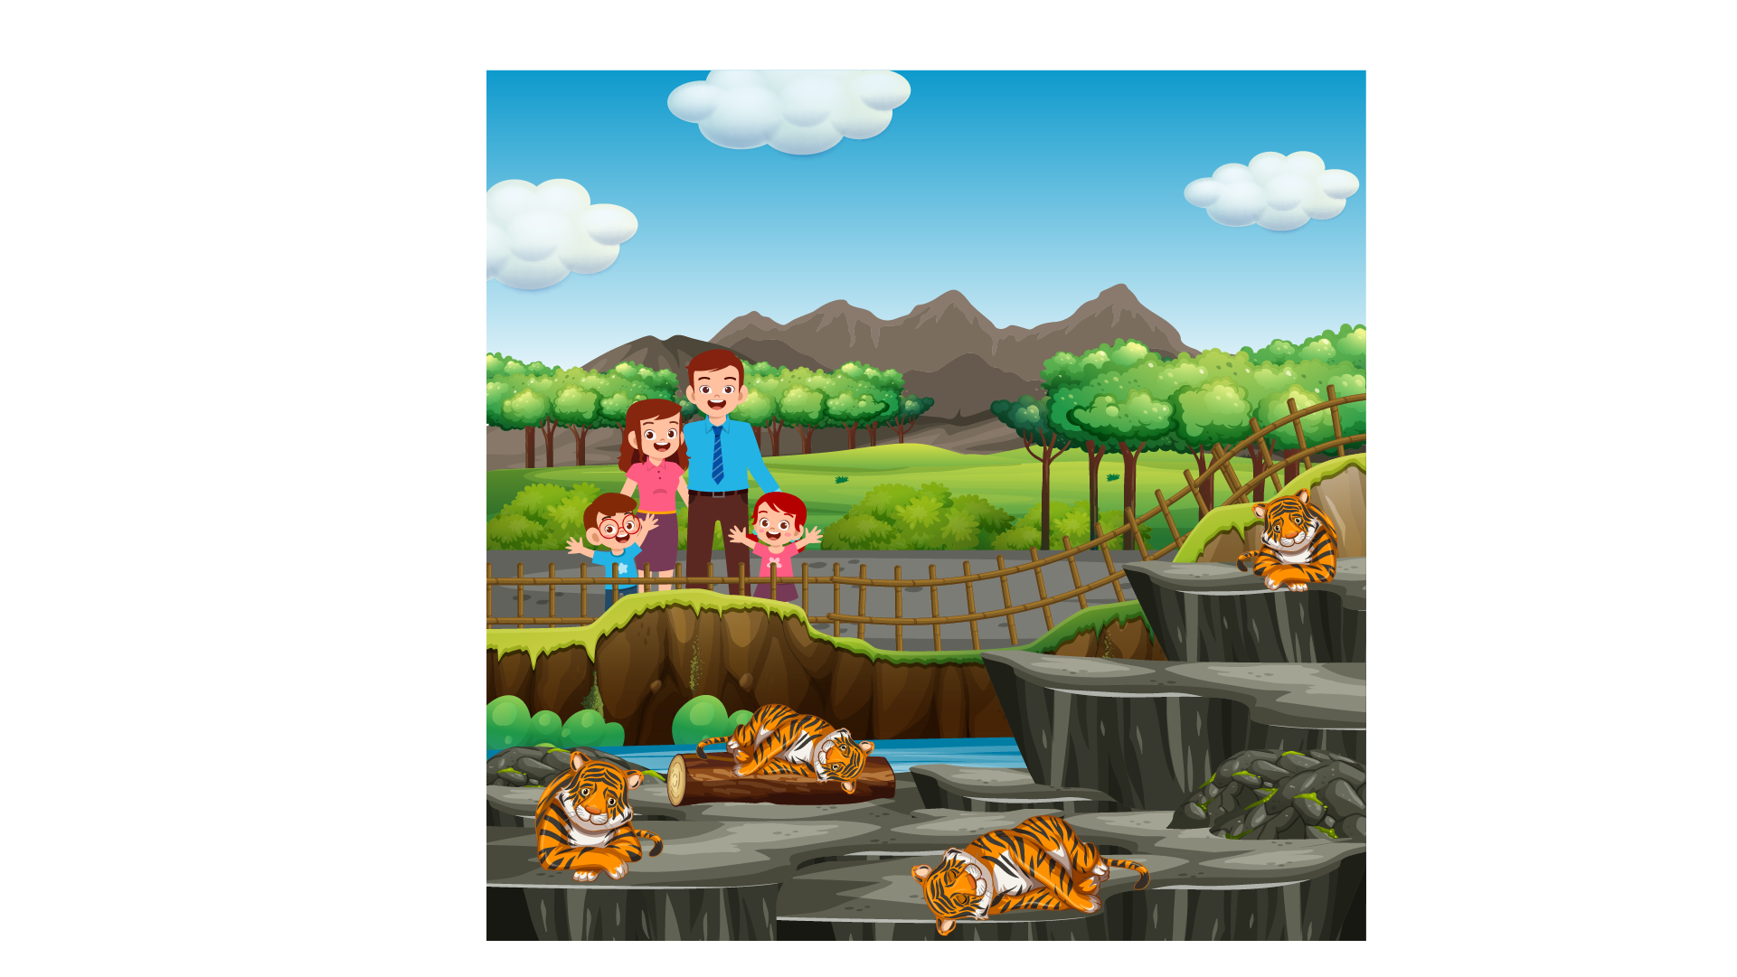
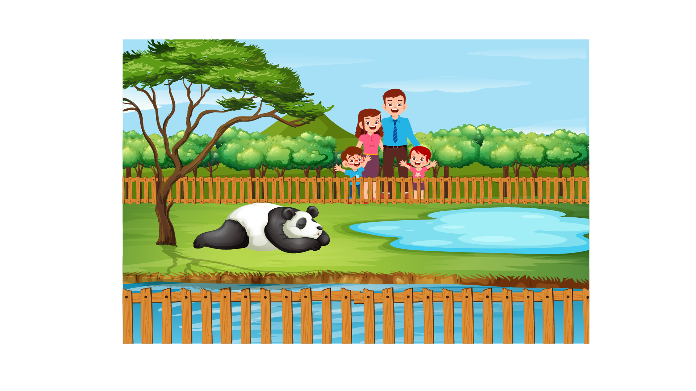 | 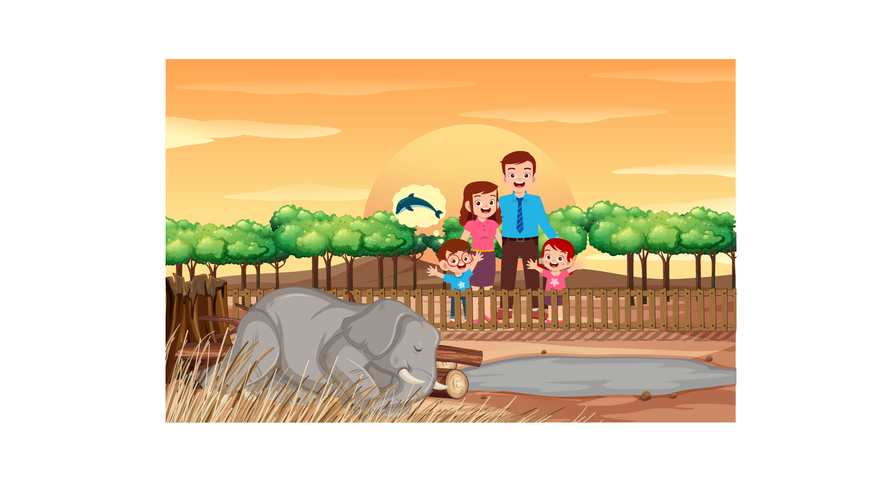 | 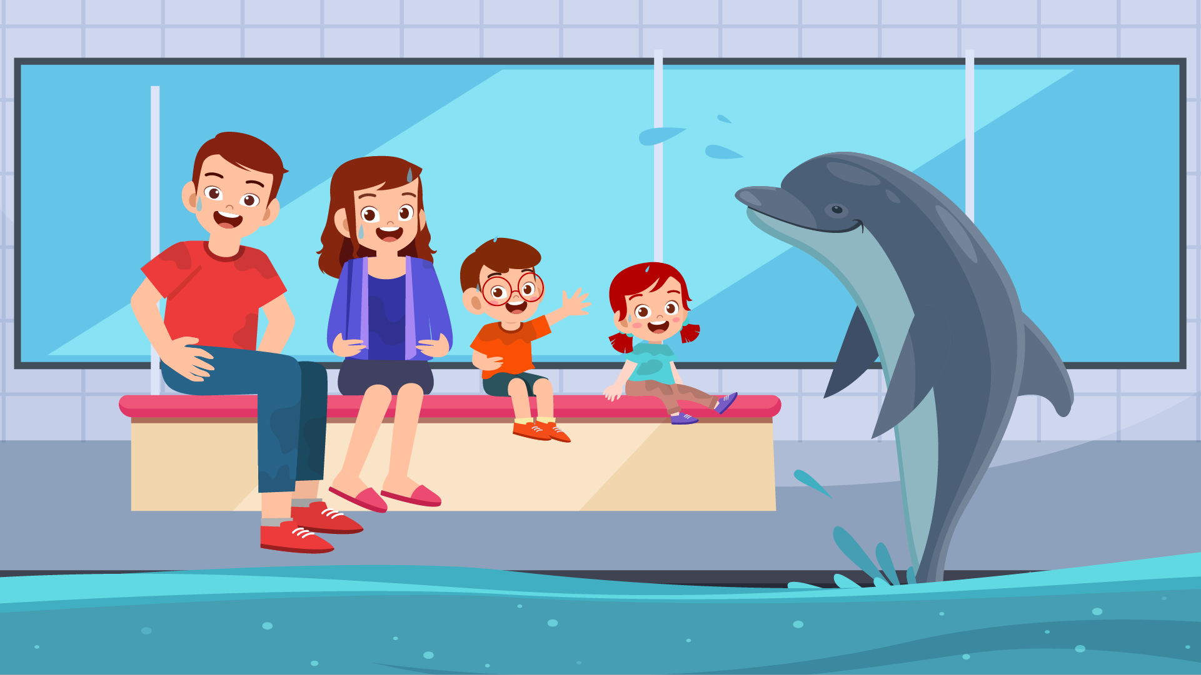

 |  | 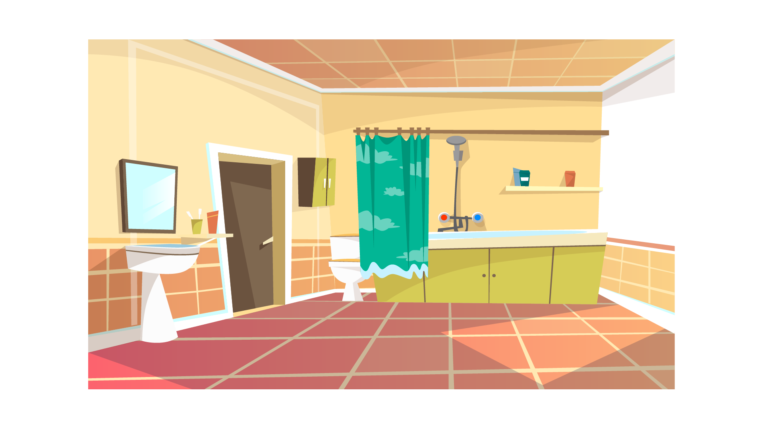 | 
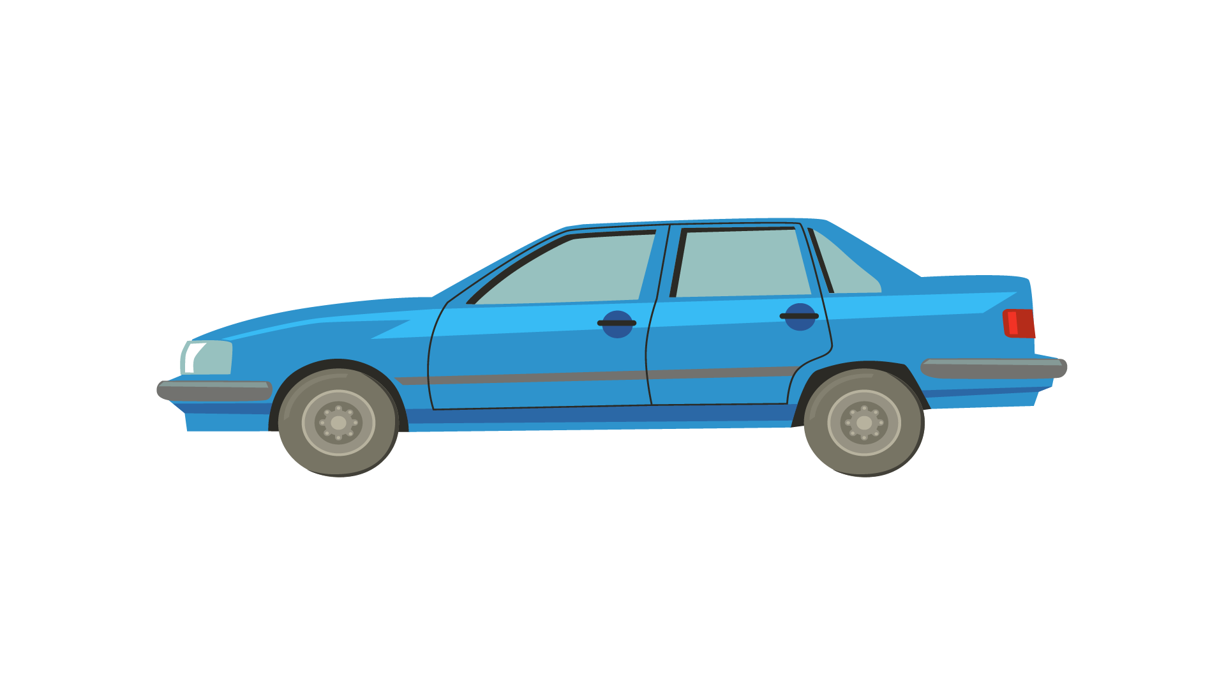 | 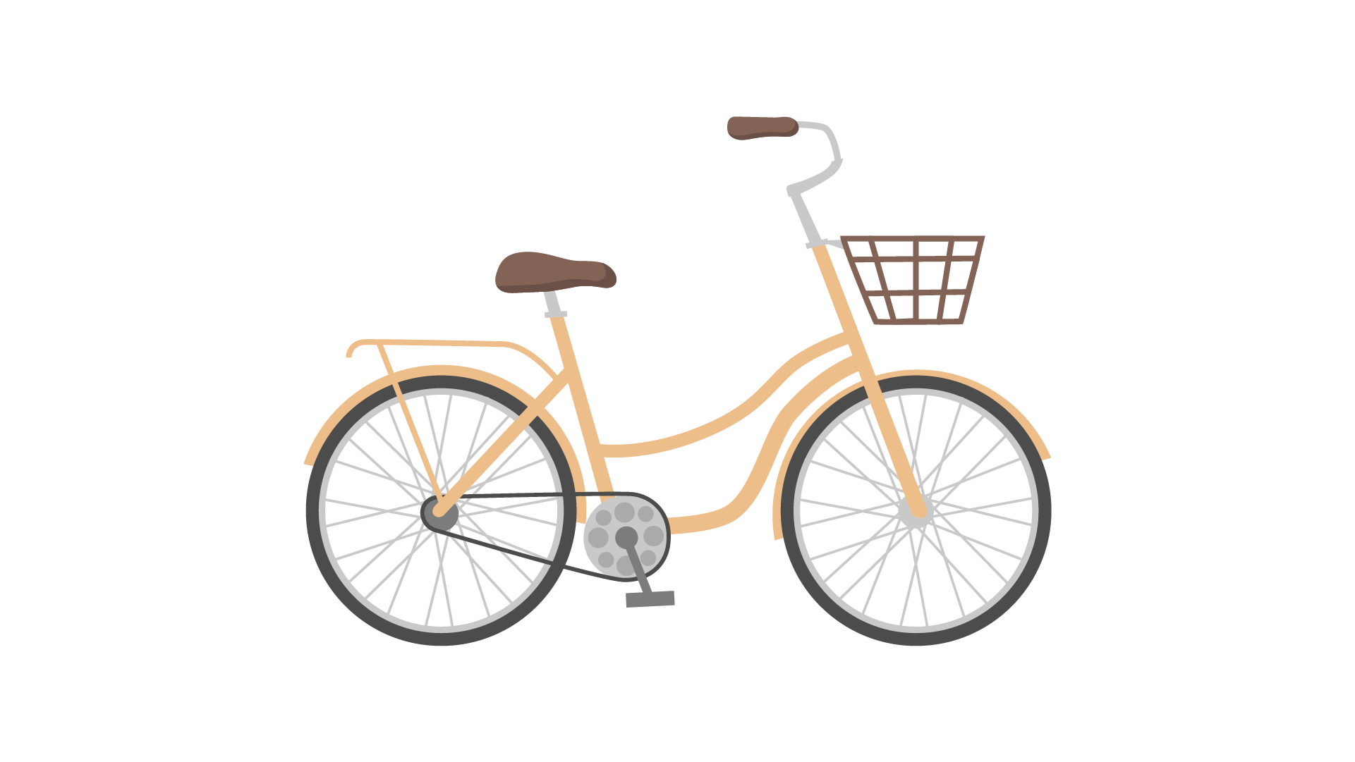 | 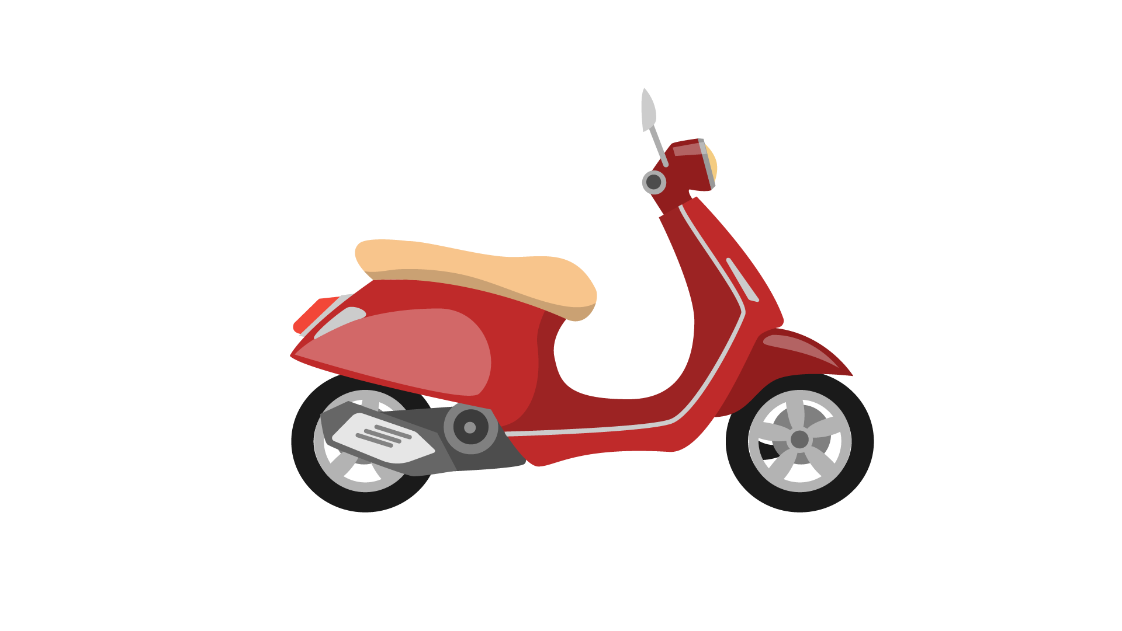 | 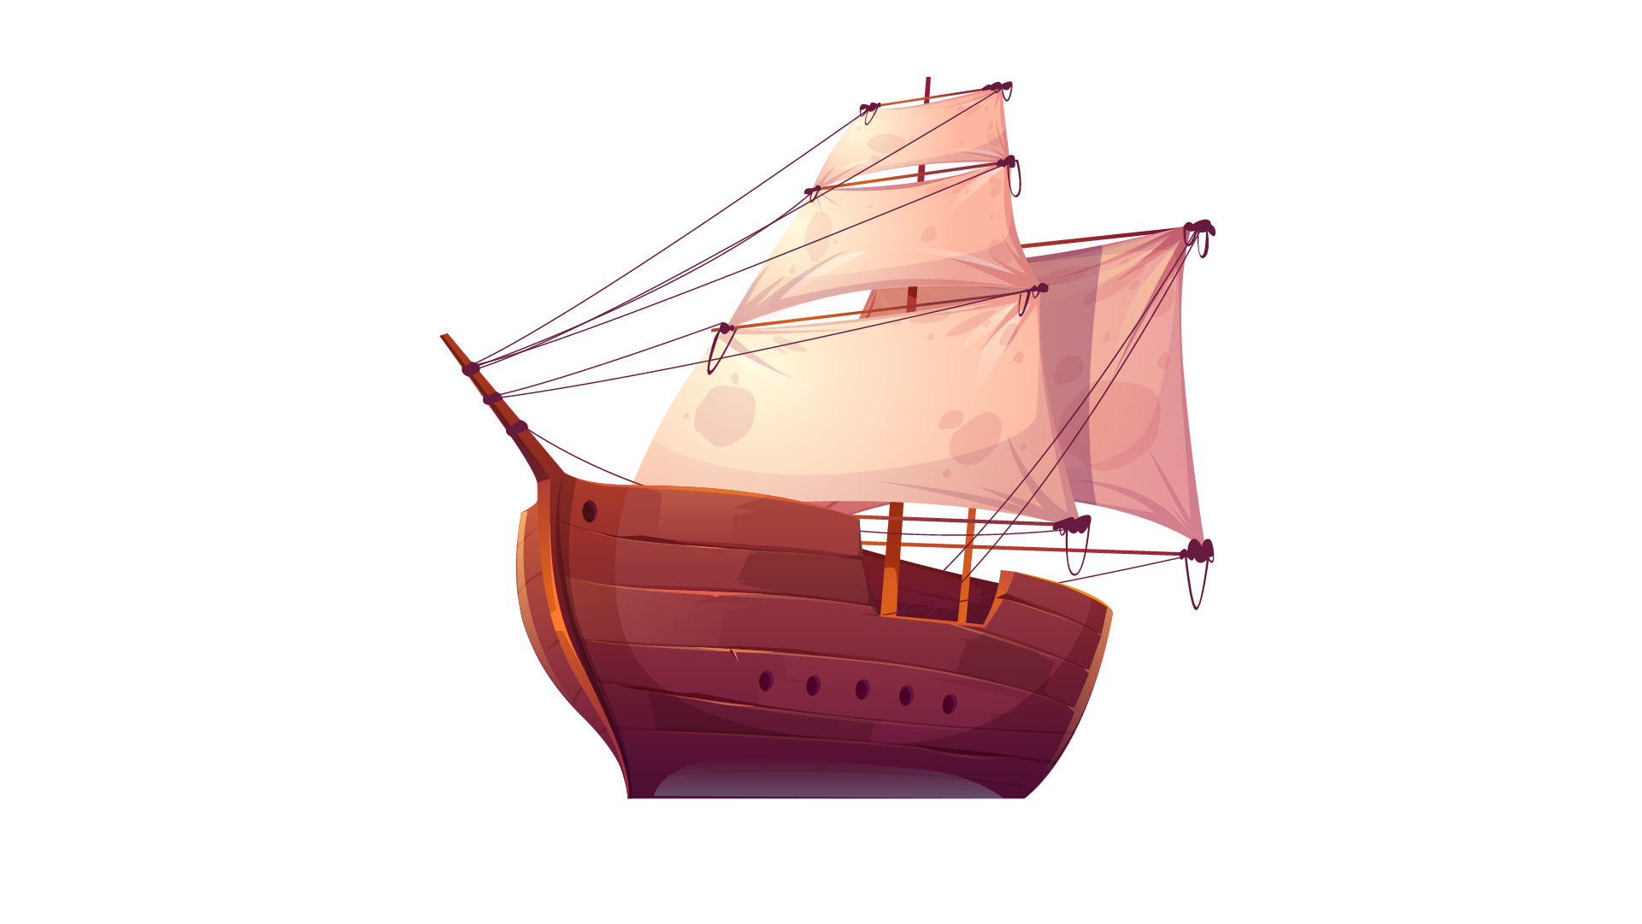

 |  | 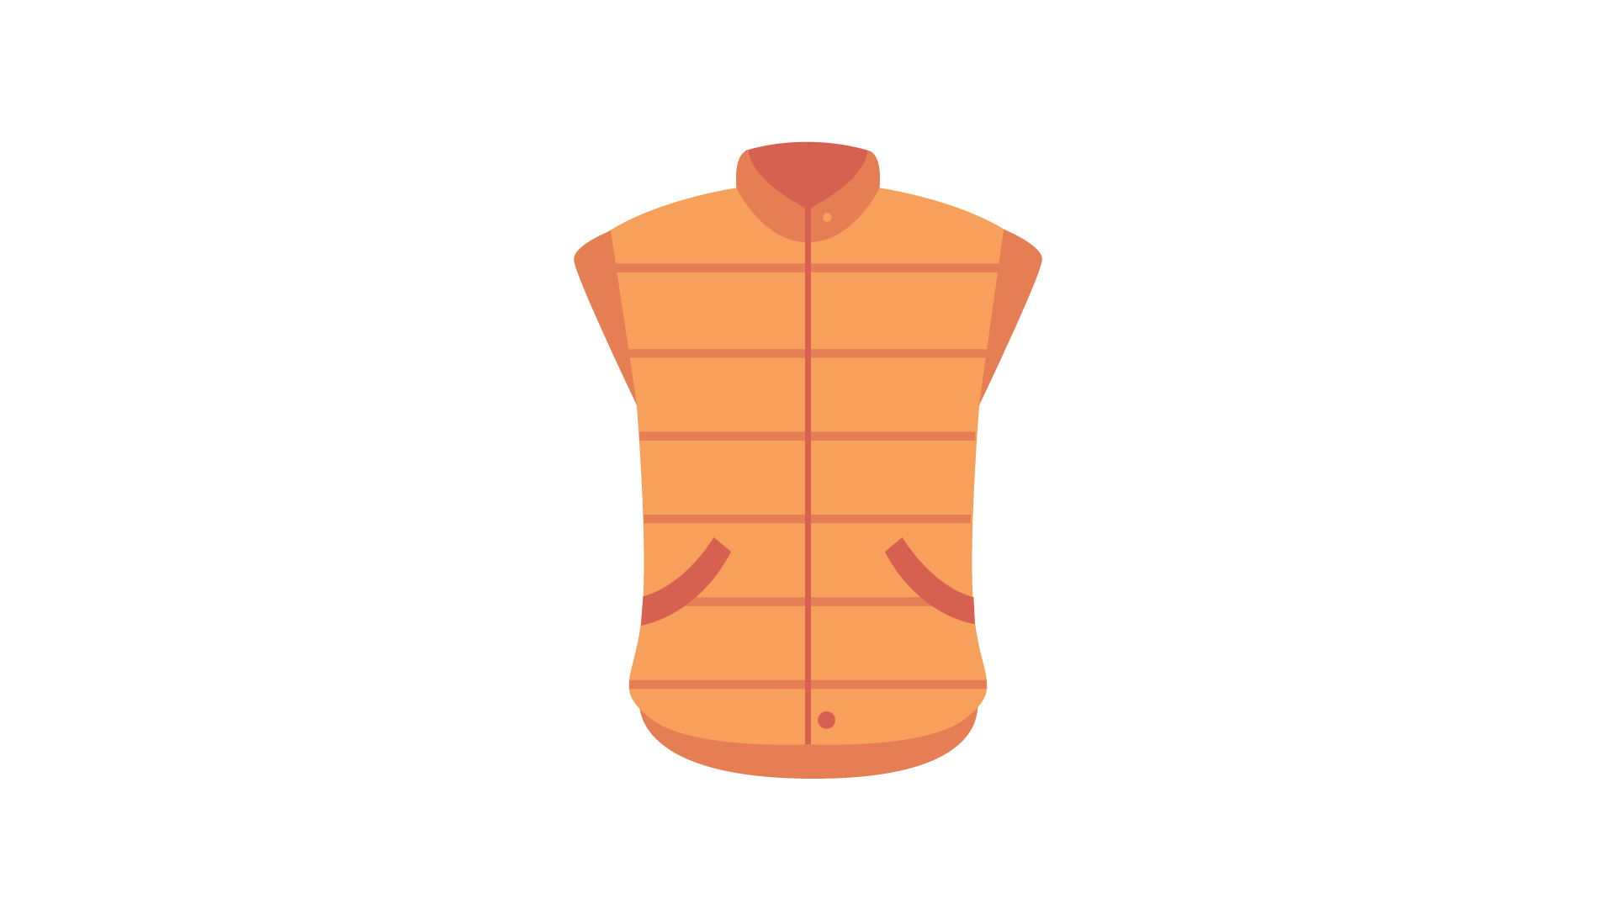 | 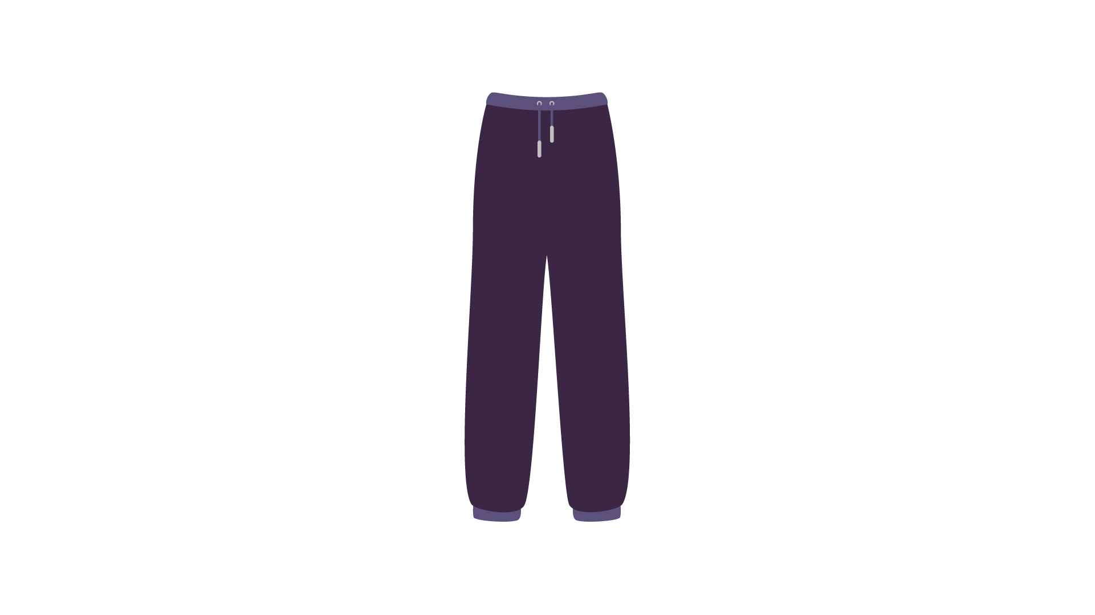
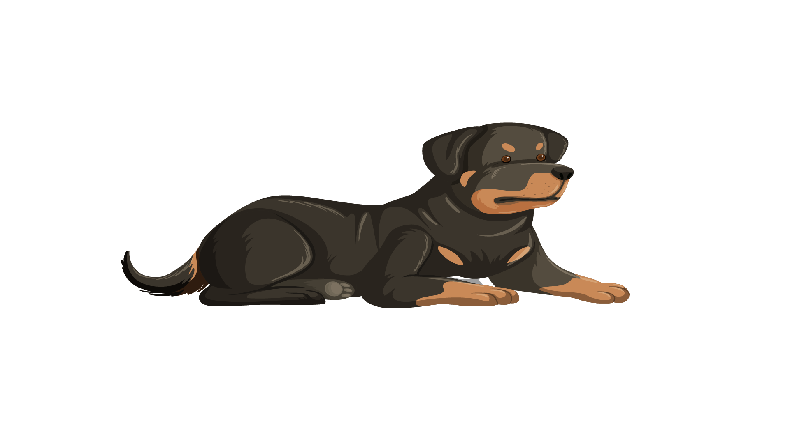 | 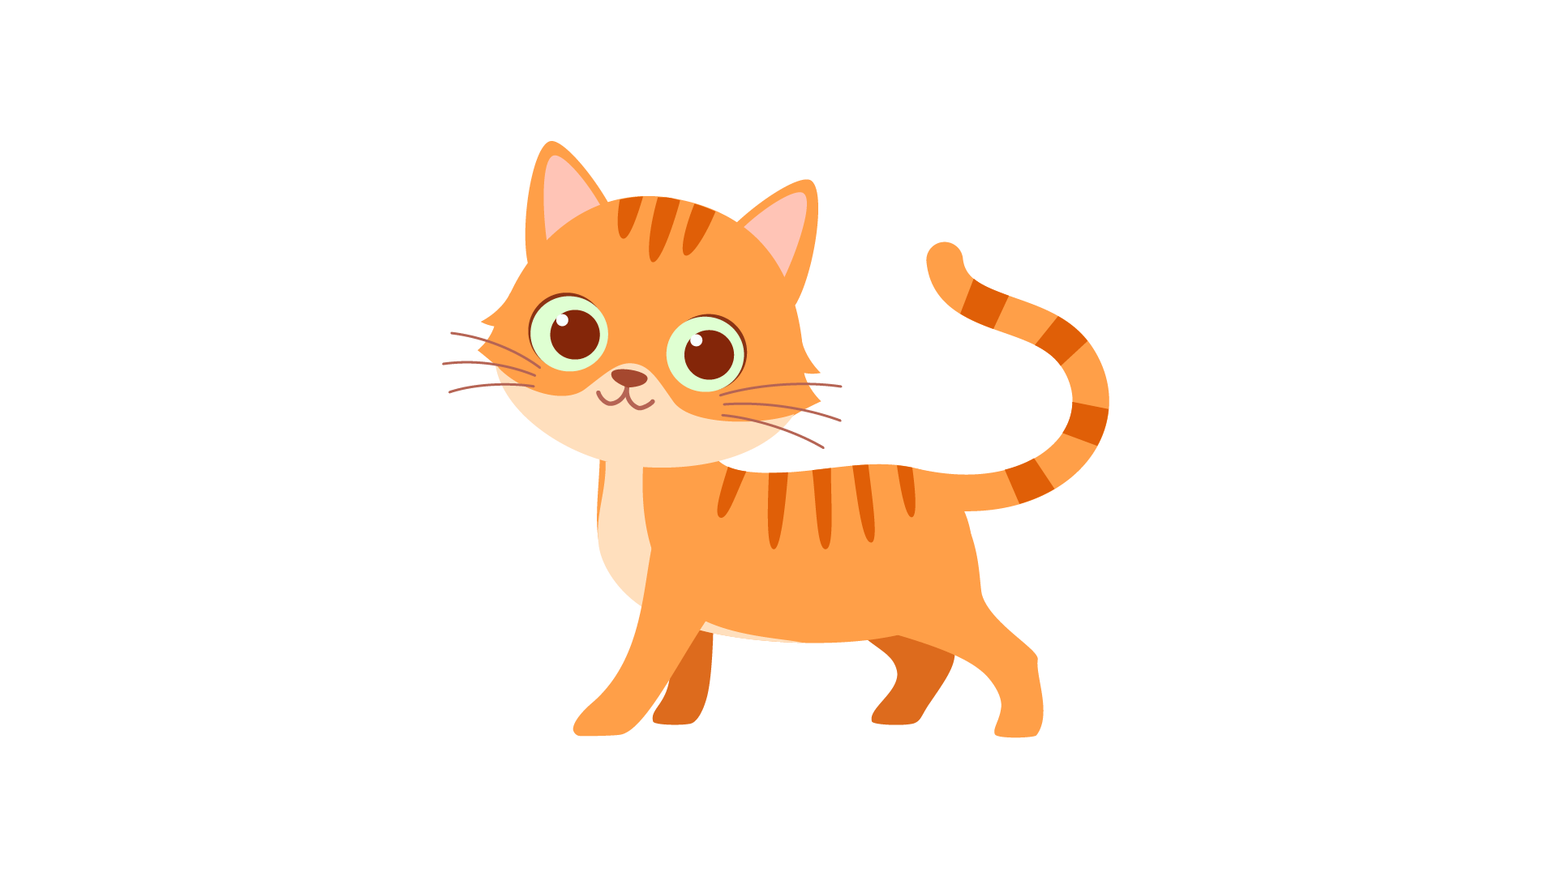 | 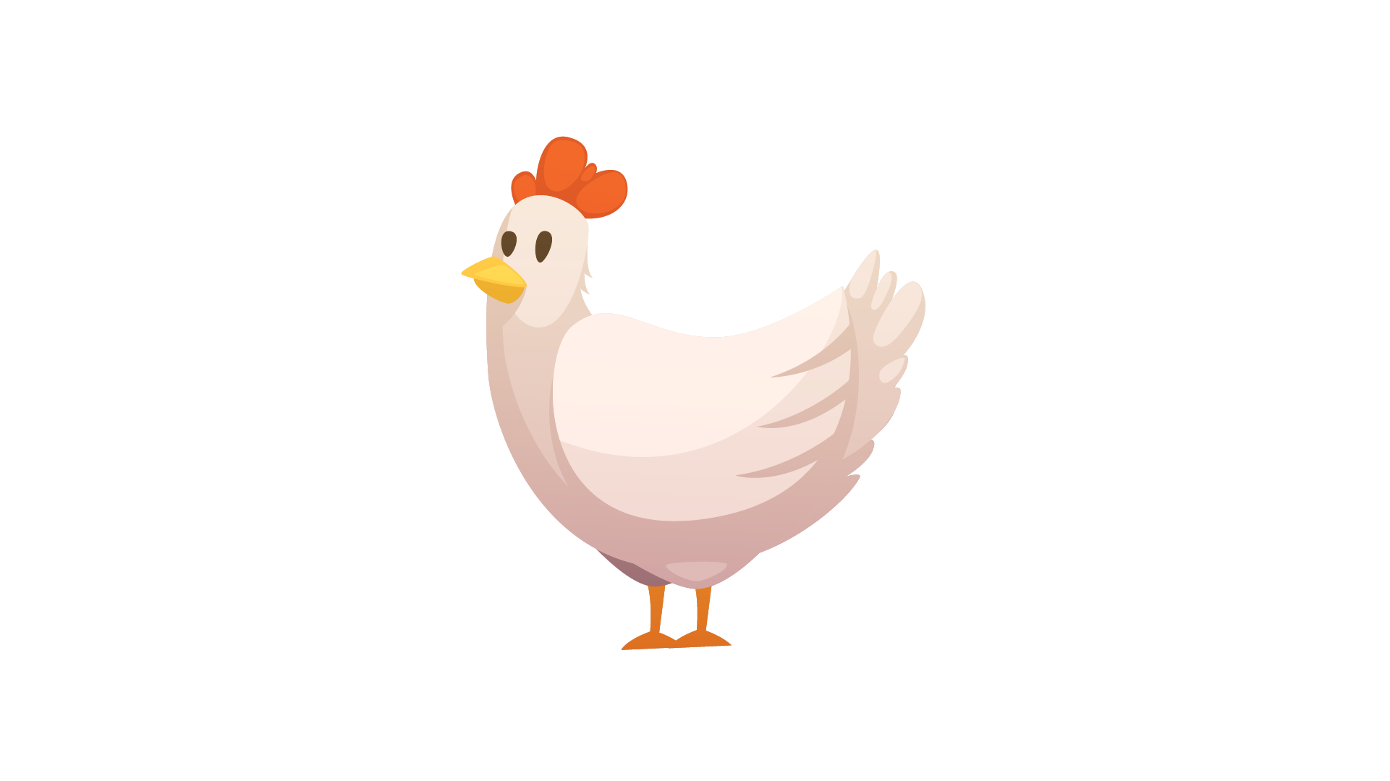 | 

