School: ……………………………………….. | Date:……………………………………..
Class: ……………………………..................... | Period: 41

UNIT 3: ARTS AND MUSIC
Grammar 3b (Page 49)

1. Objectives
By the end of this lesson, students will be able to…
1.1. Language knowledge/ skills
- review: the affirmative or negative form of be going to, the Present Simple or the Present
Continuous (future meaning).
- practise doing grammar exercises.
- use the tenses reviewed to ask and answer about what they are/aren’t doing this weekend/ month.
- think about what 2060 will be like.
1.2. Competences
- improve Ss’ analytical, critical thinking skills.
1.3. Attributes
- build their motivation for study.
- develop their patriotism, kindness, honesty.
2. Teaching aids and materials
- Teacher’s aids: Student’s book and Teacher’s book, class CDs, IWB – Phần mềm tương tác trực quan, projector/interactive whiteboard /TV (if any), PowerPoint slides.
- Students’ aids: Student’s book, Workbook, Notebook.
3. Assessment Evidence
Performance Tasks | Performance Products | Assessment Tools
- Complete the sentences and use the affirmative or negative form of be going to and the verbs in the list.  - Ask and answer using be going to and the prompts below.  - Put the verbs in brackets into the Present Simple or the Present Continuous.  - Choose the correct option.  - Tell their partner two things they are/aren’t doing this weekend, they are/aren’t going to do this month.  - Think and talk about transportation, housing, jobs, food, entertainment and education in 2060. | - Ss’ answers.  - Ss’ answers.  - Ss’ answers.  - Ss’ answers.  - Ss’ own ideas/ presentation.  - Ss’ own ideas/ presentation. | - Observation.  - Observation.  - Observation.  - Observation.  - Observation.  - Observation.

4. Procedures
A. Warm up: 5 minutes
a. Objectives: to review be going to (positive and negative).
b. Content: task 3.
c. Expected outcomes: Ss can recall be going to (positive and negative).
d. Organization
Teacher’s activities | Students’ activities
Task 3. Complete the sentences. Use the affirmative or negative form of be going to and the verbs in the list.  • be • watch • travel • buy • ride • rain  1 Tom isn’t going to ride his bike. (✗)  2 Lisa ___________a new film. (✓)  3 It ___________. Look at the dark clouds. (✓)  4 Mike ___________ to Scotland by train. (✗)  5 Tomorrow, Brian and Edith ___________ their tickets for the festival. (✓)  - Explain the task and read out the example.  - Give Ss time to complete the sentences with the correct form of the verbs in the list.  - Check Ss’ answers (using the IWB). | - Complete the sentences.  - Use the affirmative or negative form of be going to and the verbs in the list.  Answer keys:  2 Lisa is going to watch a new film.  3 It is going to rain. Look at the dark clouds.  4 Mike isn’t going to travel to Scotland by train.  5 Tomorrow, Brian and Edith are going to buy their tickets for the festival.

B. Presentation: 10 minutes
a. Objectives: to help Ss study the affirmative or negative form of be going to, the Present Simple or the Present Continuous (future meaning).
b. Content: Language Box.
c. Expected outcomes: Ss can recall the theory of the affirmative or negative form of be going to, the Present Simple or the Present Continuous (future meaning).
d. Organization
Teacher’s activities | Students’ activities
Note: will – be going to – Present Continuous – Present Simple (future meaning)  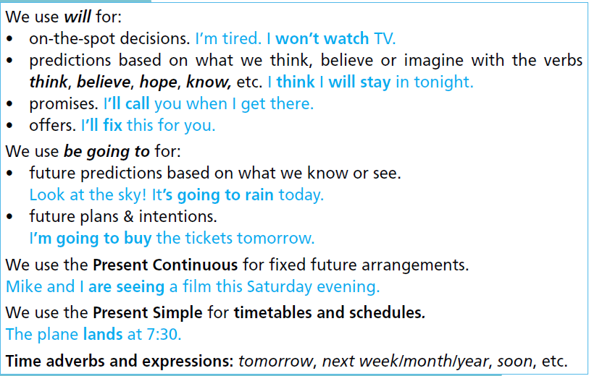  - Ask the Ss to study the theory box and read the examples.  - Elicit further examples from Ss around the class. | - Study the theory box and read the examples.  - Listen to the teacher and take notes.

C. Practice: 15 minutes
a. Objectives: to help Ss practise be going to, the Present Simple or the Present Continuous (future meaning).
b. Content: tasks 4, 5, 6.
c. Expected outcomes: Ss can remember and practise be going to, the Present Simple or the Present Continuous (future meaning).
d. Organization:
Teacher’s activities | Students’ activities
Task 4. Ask and answer using be going to and the prompts below.  1 you / watch the fashion show this Saturday?  A: Are you going to watch the fashion show this Saturday?  B: No, I’m not. / Yes, I am.  2 your dad / take part in the sports match / tomorrow?  3 you mum / go jogging / this weekend?  4 you and your sister (brother) / watch TV / tonight?  5 your friends / play football / next weekend?  - Explain the task and read out the example.  - Give Ss time to complete the task in pairs.  - Check Ss’ answers. | - Work in pairs to complete the task.  - Ask and answer using be going to and the prompts below.  Suggested Answer:  2 A: Is you dad going to take part in the  sports match tomorrow?  B: Yes, he is. / No, he isn’t.  3 A: Is your mum going to go jogging this  weekend?  B: Yes, she is. / No, she isn’t.  4 A: Are you and your sister (brother) going to watch TV tonight?  B: Yes, we are. / No, we aren’t.  5 A: Are your friends going to play football  next weekend?  B: Yes, they are. / No, they aren’t.
Task 5. Put the verbs in brackets into the Present Simple or the Present Continuous.  1 Ella is meeting (meet) Colin this afternoon.  2 Tony _______(come) over this evening to go to the concert.  3 The bus _______ (leave) from Town Square at 8:15.  4 The train _______ (not/stop) at that station on Sundays.  5 I _______ (go) to the opera with my best friend tomorrow.  - Explain the task and read out the example.  - Give Ss time to complete the sentences with the correct form of the verbs.  - Check Ss’ answers (using the IWB). | - Put the verbs in brackets into the Present Simple or the Present Continuous.  - Put the verbs in brackets into the Present Simple or the Present Continuous.  Answer keys:  2. is coming  3. leaves  4. doesn’t stop  5. am going to go
Task 6. Choose the correct option.  1 My parents are buying/are going to buy a new piano next month.  2 The performance starts/will start at 9:30.  3 Ben won’t/isn’t going to study Drama. He doesn’t want to work as an actor.  4 Some people believe we will/are going to have flying cars in the future.  5 Ann and Jane aren’t going/don’t go to the fashion show tonight.  - Explain the task and give Ss time to complete it.  - Check Ss’ answers (using the IWB). | - Choose the correct option.  - Do the task individually and share with their friend.  Answer keys:  2. starts  3. isn’t going to  4. will  5. aren’t going

D. Production: 10 minutes
a. Objectives: to help Ss practise the Present Simple, Wh- questions, adverbs of frequency and prepositions of time.
b. Content: Tasks 7, 8.
c. Expected outcomes: Ss can ask and answer about their daily life.
d. Organization

Teacher’s activities | Students’ activities
Task 7. Tell your partner two things you are/aren’t doing this weekend, you are/aren’t going to do this month.  - Explain the task and give Ss time to complete it in pairs.  - Check Ss’ answers around the class. | - Work in pairs to complete the task.  Suggested Answer:  This weekend, I’m going to the theatre. I’m not going to the cinema. This month, I’m going to go to the stadium with my brother. I’m not going to go to a fashion show.
Task 8. What will 2060 be like? Think about transportation, housing, jobs, food, entertainment and education. Tell the class.  - Explain the task and give Ss time to complete it.  - Check Ss’ answers around the class. | - Think about transportation, housing, jobs, food, entertainment and education in 2060.  - Tell the class.  Suggested Answer:  I think that in 2060 we will have flying cars and buses. Houses will have computers to control any functions of the house, such as lighting, heating, etc. Everyone will work from home. Many people will grow their own food. Everyone will be able to watch a play or listen to a concert from the comfort of their house. Children won’t have to go to school because they will have their classes online.
E. Consolidation and homework assignments: 5 minutes
- Grammar point: the affirmative or negative form of be going to, the Present Simple or the Present Continuous (future meaning).
- Do the exercises in workbook on page 27.
- Complete the grammar note in TA7 Right On! Notebook page 22.
- Prepare the next lesson: Vocabulary 3c (page 49).
5. Reflection
a. What I liked most about this lesson today:
…………………………………………………………………………………………
b. What I learned from this lesson today:
…………………………………………………………………………………………
c. What I should improve for this lesson next time:
…………………………………………………………………………………………

