School: ……………………………………….. | Date:……………………………………..
Class: ……………………………..................... | Period: 44

UNIT 4: NATURAL DISASTERS
Lesson 3.1 – Reading & Writing, pages 42 & 43
1. Objectives
By the end of this lesson, students will be able to…
1.1. Language knowledge/ skills
- practice reading for main ideas and specific information
- learn how to write emergency announcements
1.2. Competences
- improve Ss’ communication, collaboration, analytical, critical thinking skills.
1.3. Attributes
- know what to do before and during a natural disaster.
2. Teaching aids and materials
- Teacher’s aids: Teacher’s aids: Student’s book and Teacher’s book, class CDs, DCR– Phần mềm tương tác trực quan, DHA – Ứng dụng trò chơi tương tác, projector / interactive whiteboard /TV (if any), PowerPoint slides.
- Students’ aids: Student’s book, Workbook, Notebook.
3. Assessment Evidence
Performance Tasks | Performance Products | Assessment Tools
- In pairs: talk about ways that governments can inform people about future disasters and what kind of information disaster announcements give.  - Read the emergency announcement and choose the best heading.  - Read and write short answers.  - In pairs: talk about tips you didn’t know before reading the emergency announcement and what people should or shouldn't do.  - Read about writing emergency announcements, then read the flood warning again. Circle and number the four parts of the announcement noted in the Writing Skill box.  - Number the sentences to match them with the parts of an emergency announcement. | - Ss’ answers.  - Ss’ answers.  - Ss’ answers.  - Ss’ answers.  - Ss’ answers.  - Ss’ answers. | - Observation.  - Observation.  - Observation.  - Observation.  - Observation.  - Observation.
4. Procedures
A. Warm up: 5’
a. Objective: to introduce the topic.
b. Content: Let’s talk.
c. Expected outcomes: Ss can talk about ways that governments can inform people about future disasters and what kind of information disaster announcements give.
Teacher’s activities | Students’ activities
Let’s talk! In pairs: Look at the picture. What are some ways that governments can inform people about future disasters? What kind of information do disaster announcements give?    - Ask Ss to work in pairs, look at the picture and answer the questions:  1.What are some ways that governments can inform people about future disasters?  2.What kind of information do disaster announcements give?  - Call some pairs to give their answers.  - Give feedback. | - Work in pairs, look at the picture and answer the questions.  -Share their ideas.  Answer Keys  1.on TV, radio, social network.  2.when, where, how to stay safe, how to contact for help.
B. New lesson (35’)
1. Reading: 20’
a. Objectives: to help Ss improve their reading skills.
b. Content: tasks a, b, c and d.
c. Expected outcomes: Ss can read for specific details and have general idea about the text.
d. Organization
Teacher’s activities | Students’ activities
Pre-reading:  - Ask Ss to read the instruction and guess the heading.  - Pick some Ss to give their answers.  - Write their guesses on the board.  Task a: Read the emergency announcement and choose the best heading.  1. Flood warning from the National Weather Service  2. Hello everyone from the city of Flagstaff. This is an emergency announcement to tell you some information about the floods and heavy rain.  - Remind the Ss of the function of the heading: state the main idea of the announcement.  - Ask Ss to read the announcement and choose the best heading.  - Let Ss check the answer with their partners.  - Pick some Ss to give their answers.  - Check the answer.  Vocabulary:  - warning (n) /ˈwɔːnɪŋ/ sự cảnh báo  - expect (v) /ɪkˈspekt/ cho rằng  - damage (n) /dæmɪdʒ/ sự hư hại  - instruction (n) /ɪnˈstrʌk.ʃən/ hướng dẫn  - Ask Ss to read the text and underline the words above.  - Get Ss to try to guess their meanings in the context first.  - Explain the meanings of the words.  - Ask Ss to listen and repeat chorally and individually.  - Check Ss’ remembering.  While-reading  Task b: Read and write short answers.  - Use DCR to show the task. Ask Ss to read the questions carefully and underline the key words in each question.  - Get Ss to scan the text to find the key words.  1. Where is the warning for?  2. When will the warning end?  3. What should people have ready to go?  4. Where should people stay?  5. Where can people learn more information?  - Ask Ss to read the parts containing the key words carefully to find the answers to the questions.  - Set the time and monitor the class.  - Check Ss’ answers (using the DCR).  Task c: Listen and read.  - Play the CD and ask Ss to listen and read.  - Pick some Ss to read the passage and correct their pronunciation if necessary. | - Read the announcement and choose the best heading.  - Check the answer with their partners.  - Give their answers  Answer Keys:  1. Flood warning from the National Weather Service  - Read the text and underline the words.  - Try to guess their meanings in the context.  - Listen to the teacher and take notes the meanings of those words.  - Listen and repeat chorally and individually.  - Answer the teacher.  - Read the questions carefully and underline the key words in each question.  Answer keys:  1. Where is the warning for?  2. When will the warning end?  3. What should people have ready to go?  4. Where should people stay?  5. Where can people learn more information?  - Read and answer the questions.  Answer Keys:  1. Flagstaff City  2. on July 12th at 8:00 a.m.  3. emergency items  4. in the highest part of their homes  5. from local TV or the radio  -Listen and read.
Post – reading  Task d: In pairs: What tips didn't you know before reading the emergency announcement?  What else should or shouldn't people do?  - Ask Ss to work in pairs, answering the questions.  - Monitor the class and help them if necessary.  - Pick some Ss to share their ideas. | - Work in pairs to answer the questions.  - Share their ideas.  Sample answer:  I didn't know that you should board up your lower windows.  I think you should also make sure your phone is fully charged.
2. Writing: 15’
a. Objective: to help Ss know the structure of an emergency announcement and what to write in each part.
b. Content: tasks a and b.
c. Expected outcomes: Ss can order sentences to make a complete emergency announcement.
d. Organization
Teacher’s activities | Students’ activities
Task a: Read about writing emergency announcements, then read the flood warning again. Circle and number (1–4) the four parts of the announcement noted in the Writing Skill box.  - Ask Ss to read about writing emergency announcements and answer the questions below in pairs:  a) How many parts are there in an emergency announcement?  b) What is the function of each part?  - Pick some Ss to give their answers.  Writing skill  Writing emergency announcements  A good emergency announcement should include four main parts:  1. Heading – Note the emergency type, who is sending the announcement, and when.  2. What/Where/When notes – Keep these short and simple.  3. Summary – Briefly note the cause and main dangers.  4. Instructions – Note what people should do as point form notes.  - Check the answer.  - Ask Ss to read the flood warning again.  Circle and number (1–4) the four parts of the announcement noted in the Writing Skill box.  - Let Ss check with their partners.  - Pick some Ss to give their answers.  - Check the answer.  Task b: Number the sentences (1–4) to match them with the parts of an emergency announcement. Use the Reading and Writing Skill box to help you.  A. We expect damage to buildings and houses along West Beach.  B. What: Tsunami, Where: Baytown City, When: 07:37 May 3 to 09:30 May 3  C. The wave could be as high as four meters when it hits West Beach.  D. Tsunami warning from the Pacific Ocean Service, Sent: 06:31 May 3  E. Move to higher ground far from the sea immediately.  F. A large undersea earthquake started a tsunami.  - Ask Ss to number the sentences (1–4).  - Set the time and go around to help.  - Let Ss check with their partners.  - Pick some Ss to write their answers on the board.  - Check the answers. | - Read about writing emergency announcements and answer the questions in pairs.  - Give their answers  Answer Keys:  a)Heading, What/Where/When notes, Summary, Instructions.  b)  1. Heading – Note the emergency type, who is sending the announcement, and when.  2. What/Where/When notes – Keep these short and simple.  3. Summary – Briefly note the cause and main dangers.  4. Instructions – Note what people should do as point form notes.  - Read the flood warning again. Circle and number (1–4) the four parts of the announcement noted in the Writing Skill box. - - Check with their partners.  - Give their answers.  Answer keys:  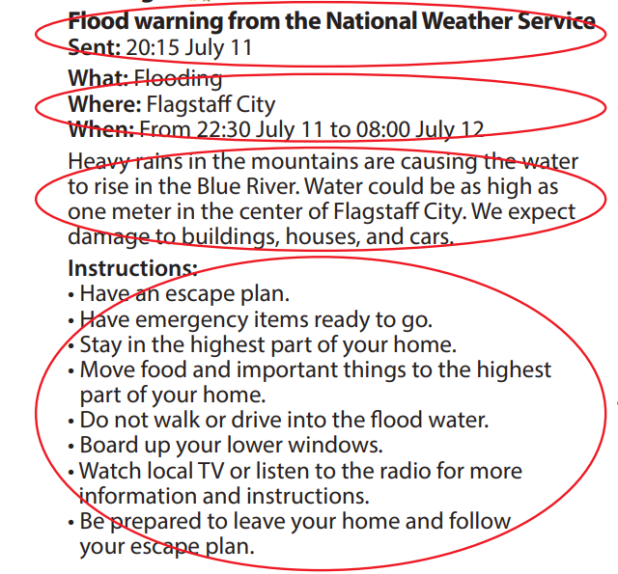  - Unscramble the sentences and then number them (1–5).  - Check with their partners.  - Write their answers on the board.  Answer keys:  A. We expect damage to buildings and houses  along West Beach. 3  B. What: Tsunami, Where: Baytown City, 2  When: 07:37 May 3 to 09:30 May 3  C. The wave could be as high as four meters  when it hits West Beach. 3  D. Tsunami warning from the Pacific Ocean 1  Service, Sent: 06:31 May 3  E. Move to high ground far from the sea immediately. 4  F. A large undersea earthquake started a tsunami. 3
C. Consolidation and homework assignments: 5 minutes
- Vocabulary: warning, expect, damage, instruction
- Do exercises in workbook on page 24.
- Prepare the next lesson: Lesson 3.2 – Speaking & Writing, page 43.
- Do the exercises in Tiếng Anh 8 i-Learn Smart World notebook (page 34).

V. REFLECTION
a. What I liked most about this lesson today:
…………………………………………………………………………………………
b. What I learned from this lesson today:
…………………………………………………………………………………………
c. What I should improve for this lesson next time:
…………………………………………………………………………………………

