Date of preparing: ………………………………….
Date of teaching: ………………………………….

Period …
UNIT 5: AROUND TOWN
Lesson 2 - Part 2 (Page 42) - Grammar

I. OBJECTIVES
By the end of the lesson, Ss will be able to…
1. Knowledge
- use Countable and Uncountable nouns
- use quantifiers
2. Ability
- improve speaking skill
- improve the use of English.
3. Quality
- have positive attitude in English language learning so that they actively participate in all classroom activities
- order food and drinks in a restaurant politely

II. TEACHING AIDS AND LEARNING MATERIALS
Lesson plan, PPT slides, student’s book, workbook, notebook, personal computer (if any), projector/TV, speakers, DCR & DHA on Eduhome, handouts…

III. PROCEDURES
A. Warm up: (5’)
a) Objective: Introduce the new lesson and set the scene for Ss to acquire new language; get students' attention at the beginning of the class by means of enjoyable and short activities as well as to engage them in the steps that follow.
b) Content: Revision of vocabulary about food and drinks
c) Product: Ss review vocabulary and ready for the new lesson
d) Competence: collaboration, communication, critical thinking
e) Organization of the activity:
Teacher’s Activities | Students’ Activities
- Give greetings  - Check attendance  - Option 1: ODD ONE OUT  - Give some set of words (4 words for each set)  - Have Ss do the task: odd one out (find a word which is different from the other three)  - Call Ss to give answers and explain for their answers  - Give feedback  →Lead to the new lesson.  Odd one out  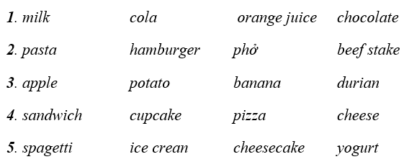  - Option 2: Food around the world  - Have Ss observe a food map (show on the screen or give handouts)  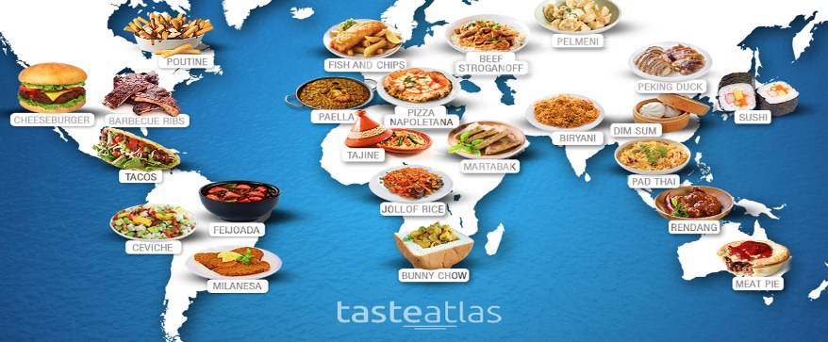  - Have Ss look at the food map and match food with countries  Food: Dim sum, tacos, sushi, cheese burger, pad thai  Countries: Thailand, Japan, Mexico, China, The USA  - Have Ss give answers  - Check answers as a whole class  - Lead to the new lesson | - Greet T  - Work in pairs  - Give answers and explain  Answer keys  1. chocolate (not a drink)  2. phở (a Vietnamese food – not a foreign food)  3. potato (not a fruit)  4. cheese (not made from flour)  5. spaghetti (not a dessert)  - Work in pairs  Answer keys  Dim sum – China  Tacos – Mexico  Sushi – Japan  Cheeseburger – The USA  Pad thai – Thailand

B. New lesson (35’)
- Activities 1: Grammar: Countable and Uncountable nouns; quantifiers (15’)
a) Objective: Ss know how to use Countable and Uncountable nouns; quantifiers.
b) Content:
- Listening and repeating
- Grammar explanation
c) Products: Ss can use Countable and Uncountable nouns; quantifiers to talk about food and drinks
d) Competence: communication, collaboration
e) Organization of the activity:
Teacher’s Activities | Students’ Activities
a. Listen and repeat  - Have Ss look at the picture  - Play the audio (CD1 – Track 61), ask Ss to listen and read the speech bubbles  - Play the audio again and have Ss listen and repeat  *Grammar explanation:  - Have Ss read the Grammar box  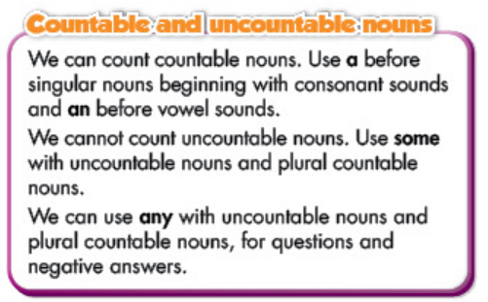  - Ask Ss to make comments on the black bold quantifiers in the examples  - Make explicit: Countable and Uncountable nouns; quantifiers  Countable nouns refer to items that can be counted, even if the number might be extraordinarily high (like counting all the people in the world, for example). Countable nouns can be used with articles such as a/an and the or quantifiers such as a few and many  Uncountable nouns are nouns that come in a state or quantity that is impossible to count; liquids are uncountable, as are things that act like liquids (sand, air). Abstract ideas like creativity or courage are also uncountable. Uncountable nouns are always considered to be singular, and can stand alone or be used with some, any, a little, and much.  - Have some Ss read the sentences aloud  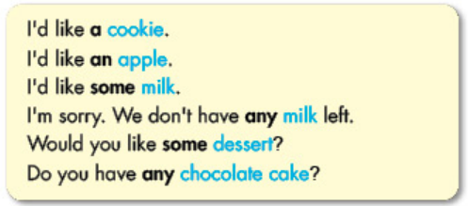  - Have Ss give some examples suing a / an / some or any  - Get feedback | - Look  - Listen and read  - Listen and repeat  - Read  - Comment  - Listen  - Listen and take notes  - Read  - Give examples
- Activity 2: Practice (20’)
a) Objective: Ss can distinguish countable and uncountable nouns and use quantifiers correctly
b) Content:
- Filling in the blanks, using a, an, some or any
- Completing a dialogue
c) Products: Ss can use correct grammar presented in communication
d) Competence: collaboration, creativity, communication, presentation
e) Organization of the activity:
Teacher’s Activities | Students’ Activities
b. Fill in the blanks, using a, an, some, any  - Use the example to demonstrate this activity  - Have Ss use a, an, some, any to fill in the blanks, draw attention to the countable and uncountable nouns  - Have pairs check each other’s work  - Have Ss read their answers with the class  - Check answers as a whole class  c. Look at Alice and Nick and complete the dialogue  - Demonstrate the activity, using the example  - Have Ss look at the picture of Alice and Nick, read the bubbles  - Have Ss complete the dialogue-using the information from the picture  - Go round and give help if necessary  - Call Ss to write answers on the board  - Check and correct Ss’ answers  d. Practice the conversation with your partner  - Option 1:  - Have Ss practice the conversation in pairs.  - Have some Ss demonstrate the activity in front of the class  - Give feedback and evaluation  - Option 2:  - Follow the same steps as option 1  - Give an extra activity: Have Ss practice the conversation-using their own ideas  - Remind Ss to use the food and drinks they know in the warm up activity.  - Have some Ss demonstrate the activity in front of the class  - Give feedback and evaluation | - Look and listen  - Work in pairs  - Read answers  Answer keys  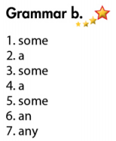  - Look and listen  - Work in pairs  - Give answers  Answer keys  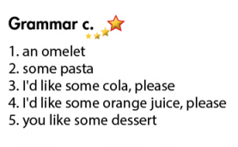  - Work in pairs  - Present  - Work in pairs  - Present

C. Consolidation (3’)
* Countable and uncountable nouns, quantifiers
1. A is used with singular countable nouns that begin with a consonant.
2. An is used with singular countable nouns that begin with a vowel.
3. Some can be used with plural countable nouns and uncountable nouns. Some is usually used in positive statements.
4. Any is usually used for plural countable nouns and uncountable nouns in questions and negative statements.

D. Homework (2’)
- Practice ordering food in a restaurant with a friend.
- Do exercises in WB: Lesson 2 - Writing (page 29).
- Prepare: Lesson 2 – Pronunciation and Speaking (page 43 – SB).

