LỚP HỌC THẦY (CÔ) ___________________________ ĐỀ ÔN TẬP: READING SIGNS/ NOTICES – A2
Test 5
Thời gian làm bài: [Time]
Họ và tên: ________________________________________________ Lớp: 9/___
Nội dung:
Question 1: What does the sign say?

A. Smoking is allowed inside the building whenever you want.
B. Do not smoke inside the building at any time.
C. Smoking is only allowed in some places inside the building.
D. Smoking is encouraged inside the building.

Question 2: What does the notice say?
"The cafe will have live music on Friday nights starting at 7 PM. Enjoy music while you dine."

A. Live music will be played on Saturday nights.
B. The cafe will have live music on Friday nights starting at 7 PM.
C. Music will be played only in the morning.
D. The cafe will not have live music this month.
Question 3: What does the sign say?
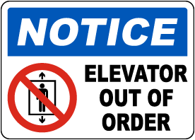
A. The elevator is working well and you can use it.
B. The elevator is not working and you cannot use it.
C. The elevator is being repaired and will work again soon.
D. The elevator is for special use only and not for everyone.

Question 4: What does the notice say?
"The restaurant will have a new menu starting next week. Check online for updates and new dishes."

A. The restaurant has a new menu next week.
B. Check online for the new menu next week.
C. The new menu starts this month, check online for updated new dishes.
D. The restaurant will stay the same.
Question 5: What does the sign say?
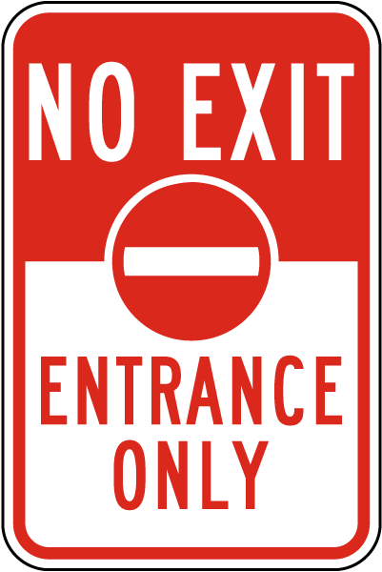
A. You are allowed to enter and exit through this door.
B. This door is meant only for entering and not for exiting.
C. This door is used for both entering and exiting purposes.
D. This door is locked and cannot be used.

Question 6: What does the notice say?
"The local swimming pool is having a water safety course for children on Saturday morning. Sign up now!"

A. The water safety course for children will be held on Saturday mornings.
B. Sign up now for the children's course.
C. The course is held in the afternoon for teenagers.
D. Registration begins next month for the children's course.
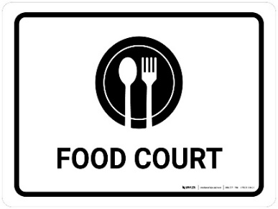
Question 7: What does the sign say?
A. This area is designated as a place to eat food.
B. This location is meant for storing food items only.
C. There is no food available in this area.
D. This area is used for legal proceedings and courts.

Question 8: What does the notice say?

BOOKSHOP - CLOSED AFTERNOONS

A. The bookshop is closed all day. B. The bookshop is open in the morning.
C. The bookshop is open in the afternoon. D. The bookshop is closed in the morning.
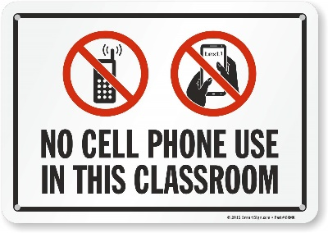
Question 9: What does the sign say?
A. You are allowed to use cell phones everywhere in this area.
B. Using cell phones is not permitted in this area.
C. You may use cell phones here only for emergencies.
D. Using cell phones is encouraged and allowed here.

Question 10: Talk to Ms. Thompson if __________.
A. you have a spare key. B. you have lost something.
C. you know where the bag is. D. a key and a phone
[HẾT]

