UNIT 9. FESTIVALS AROUND THE WORLD
PART 1. THEORY
I. VOCABULARY
No. | English | Type | Pronunciation | Vietnamese
1 | April Fool’s Day | n | /'eɪprəl fu:lz deɪ/ | ngày Nói dối, ngày Cá tháng tư
2 | balloon | n | /bə'lu:n/ | bóng bay
3 | candle | n | /'kændl/ | nến
4 | Cannes Film Festival | n | /kæn fɪlm 'festɪvl/ | Liên hoan phim Cannes
5 | carnival | n | /'kɑ:nɪvl/ | ngày hội, lễ hội
6 | celebration | n | /.selɪ'breɪʃn/ | lễ kỷ niệm
7 | celebratory | n | /.selə'breɪtərɪ/ | sự kỷ niệm, tổ chức lễ để kỷ niệm
8 | Christmas | n | /'krɪsməs/ | Giáng sinh
9 | common | adj | /'kɒrmən/ | thông thường
10 | costume | n | /'kɒstju:m/ | trang phục
11 | dance | V | /dɑ:ns/ | khiêu vũ, múa
12 | dancer | n | /'dɑ:nsə(r)/ | VŨ công
13 | decorate | V | /'dekəreit/ | trang trí
14 | Diwali | n | /di:'wɑ:lɪ/ | lễ hội Diwali
15 | Dutch | n | /dʌtʃ/ | người Hà Lan
16 | Easter | n | /'i:stə(r)/ | lễ Phục sinh
17 | feast | n | /fi:st/ | bữa tiệc lớn
18 | festival | n | /'festivl/ | lễ hội
19 | firework | n | /'faɪəwɜ:k/ | pháo hoa
20 | Flower Festival | n | /'flaʊə(r) 'festɪvl/ | lễ hội Hoa
21 | folk dance | n | /fəʊk dæns/ | điệu múa dân gian
22 | Halloween | n | /,hæləʊ'i:n/ | lễ hội hóa trang
23 | hold | V | /həʊld/ | tổ chức
24 | joyful | adj | /'dʒɔɪfl/ | vui vẻ
25 | lantern | n | /'læntən/ | đèn lồng
26 | Moon cake | n | /mu:n keɪk/ | bánh Trung thu
27 | Netherlands | n | /'neðələndz/ | nước Hà Lan
28 | New Year | n | /nju: jɪə(r)/ | năm mới
29 | parade | n | /pə'reɪd/ | cuộc diễu hành
30 | performer | n | /pə'fɔ:mə(r)/ | người trình diễn, người thể hiện
31 | photo | n | /fəʊtəʊ/ | ảnh
32 | pumpkin | n | /'pʌmpkɪn/ | bí ngô
33 | relax | V | /rɪ'læks/ | thư giãn
34 | religious | adj | /rɪ'hdʒəs/ | mang tính tôn giáo
35 | romantic | adj | /rəʊ'mæntɪk/ | lãng mạn
36 | seasonal | adj | /'si:zənl/ | mang tính theo mùa
37 | Thanksgiving | n | /.θæηks'gɪvɪη/ | lễ Tạ ơn
38 | Tulip festival | n | 'tuləp 'festɪvəl/ | lễ hội hoa Tulip
39 | turkey | n | /'tɜ:kɪ/ | gà tây

II. GRAMMAR
1. YES/ NO QUESTION (Dạng câu hỏi Yes/ No)
a. Định nghĩa
- Câu hỏi yes - no là loại câu hỏi chỉ đưa ra cho người được hỏi hai sự lựa chọn để trả lời là “có” hoặc “không”, “đúng” hoặc “sai” thay vì được đa dạng câu trả lời như các loại câu hỏi khác. Nó là một dạng câu hỏi đóng.
Ex 1:
Do you like this car? (Bạn có thích chiếc xe này không?)
Yes, I do. / No, I don’t. (Có, tôi thích./ Không, tôi không thích.)
Ex 2:
Did you go to the zoo last week? (Bạn đã đi sở thú tuẫn trước phải không?)
Yes, I did. / No, I didn't. (Ừ, đúng vậy/ Không, không phải.)
b. Cách thành lập câu hỏi Yes/ No
Câu hỏi Yes/ No được thành lập bằng cách đưa trợ động từ (is, am, are, do, does, did ...), hoặc động từ khuyết thiêu lên trước chủ ngữ.
b.1. Với động từ to be
Be + S + ...?
- Yes, S + be.
- No, S + be not.
Ex 1:
Is he a doctor? (Anh ấy là bác sĩ phải không?)
Yes, he is. (Vâng, đúng vậy.)
Ex 2:
Are you playing chess? (Bạn đang chơi cờ à?)
No, I am not. (Không, không phải.)
b.2. Động từ thường (ordinary verbs)
Auxiliary verbs + S + V...?
- Yes, S + Auxiliary Verb.
- No, S + Auxiliary Verb + not.
Auxiliary verbs có thể là một trong các trợ động từ: do, does, did, have, has ...
Ex 1:
Does she play the piano well? (Cô ấy chơi đàn piano giỏi phải không?)
Yes, she does./ No, she doesn’t. (Vâng, đúng vậy./ Không phải.)
Ex 2:
Did he go to the museum yesterday? (Anh ấy đến viện bảo tàng ngày hôm qua à?)
Yes, he did./ No, he didn’t. (Đúng vậy. / Không, anh ấy không.)
Ex 3:
Have you finished your homework? (Bạn đã làm xong bài tập về nhà rồi à?)
Yes, I have./ No, I haven’t. (Vâng, đúng vậy. / Không.)
b.3. Với động từ khuyết thiếu (modal verbs)
Modal verb + s + V?
- Yes, s + Modal verb.
- No, s + Modal verb + not.
Modal verbs có thể là một trong các trợ động từ: will, can, may, should, would, could...
Ex 1:
May I open the book? (Tớ có nên mở sách ra không nhỉ?)
Yes, you may. No, you may not. (Không, cậu không nên.)
Ex 2:
Can you play the guitar? (Cậu có thể chơi đàn ghita không?)
Yes, I can./ No, I can’t. (Có, tớ có thể.)
Ex 3:
Could you swim when you were a child? (Khi còn nhỏ, bạn có biết bơi không?)
Yes, I could./ No, I couldn’t. (Có, tôi có thể. / Không, tôi không thể.)

iii. PHONETICS

Stress in two-syllable words (Trọng âm của từ có 2 âm tiết)
1. Với danh từ và tính từ có 2 âm tiết
Với hầu hết các danh từ hoặc tính từ có 2 âm tiết, trọng âm thường nhấn vào ầm tiết đầu.
Ex:
Words | Pronunciation | Type | Meaning
chapter | /'tʃæptər/ | n | chương (sách)
summer | /'sʌmər/ | n | mùa hè
music | /'mju'zɪk/ | n | âm nhạc
better | /'betər/ | adj | tốt hơn
active | /'æktɪv/ | adj | năng động
easy | /'i:zɪ/ | adj | dễ dàng
Ngoại lệ: Nếu danh từ có 2 âm tiết mà âm thứ 2 có chứa nguyên âm đôi hoặc nguyên âm dài thì trọng âm sẽ rơi vào âm số 2.
Ex:
Words | Pronunciation | Type | Meaning
design | /dɪ'zaɪn/ | n | bản phác hoạ
balloon | /bə'lu:n/ | n | bóng bay
advice | /əd'vaɪs/ | n | lời khuyên
estate | /ɪ'steɪt/ | n | tài sản, ruộng đất
alone | /ə'ləʊn/ | adj | một mình
2. Với động từ có 2 âm tiết
Các động từ có 2 âm tiết: trọng âm thường nhấn vào âm tiết thứ hai.
Ex:
Words | Pronunciation | Type | Meaning
invest | /ɪn'vest/ | v | đẩu tư
believe | /bɪ'li:v/ | v | tin tưởng
decide | /dɪ'saɪd/ | v | quyết định
decrease | /dɪ'kri:s/ | v | giảm xuống
Ngoại lệ: Nếu động từ có âm tiết thứ hai là nguyên âm ngắn hoặc kết thúc bởi 1 phụ ầm hoặc không có phụ âm. Hoặc động từ đó chứa âm đuôi nhẹ thì trọng âm thường rơi vào âm tiết thứ nhất. (Nó thường kết thúc ở dạng: er, en, ish, age, ow)
Ex:
Words | Pronunciation | Type | Meaning
enter | /‘entər/ | v | vào
open | /'əʊpən/ | v | mở
manage | /'mænɪdʒ/ | v | điều hành, quản lý
happen | /'hæpən/ | v | xảy ra
visit | /'vɪzɪt/ | v | thăm, tham quan
finish | /fɪnɪʃ/ | v | hoàn thành
offer | /'ɔ:fər/ | v | đề xuất
study | /'stʌdɪ/ | v | học
swallow | /'swɒləʊ/ | v | nuốt
Listen and repeat these words. Track 07
First syllable | answer | question | practise | visit
 | /'ænsər/ | /'kwestʃən/ | /'præktɪs/ | /’vɪzɪt/
Second syllable | account | before | believe | rely
 | /ə'kaʊnt/ | /bɪ'fɔ:r/ | /bɪ'li:v/ | /rɪ’laɪ/

PART 2. LANGUAGE
I. VOCABULARY
Exercise 1. Find the odd one out among A, B, C or D.
1. A. happy | B. funny | C. joyful | D. prefer
2. A. fascinating | B. shopping | C. exciting | D. amazing
3. A. attend | B. celebrate | C. organize | D. festival
4. A. celebration | B. performer | C. artist | D. dancer
5. A. flower | B. cultural | C. traditional | D. local
Exercise 2. Look at the pictures and complete the blanks with available names of festival.
Mother’s Pay | Water Festival | Teacher’s Pay
New Year | Father's Pay | Thanksgiving

 | 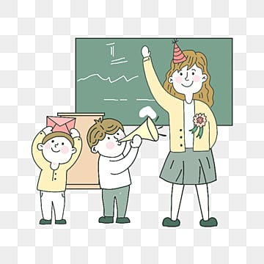 | 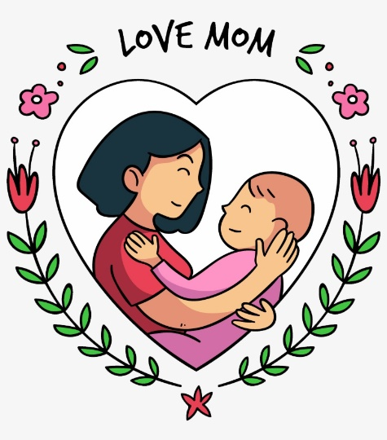
1. | 2. | 3.
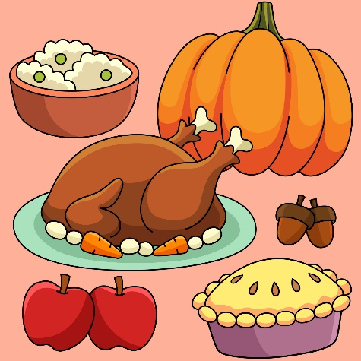 |  | 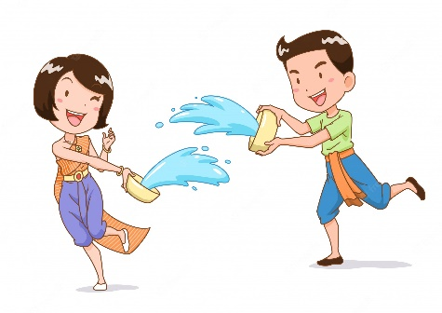
4. | 5. | 6.
Exercise 3. Look at the pictures and complete the blanks with available names of festival.
Christmas | Flower Festival | Easter
Halloween | April Fool’s Pay | Cannes Film Festival

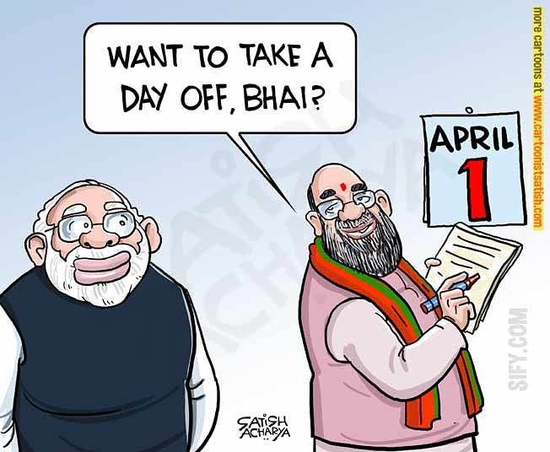 |  | 
1. | 2. | 3.
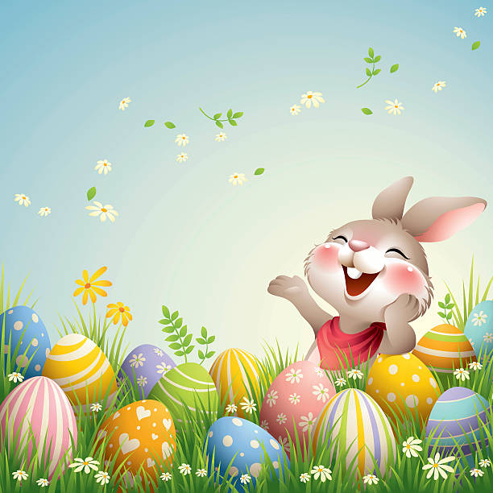 | 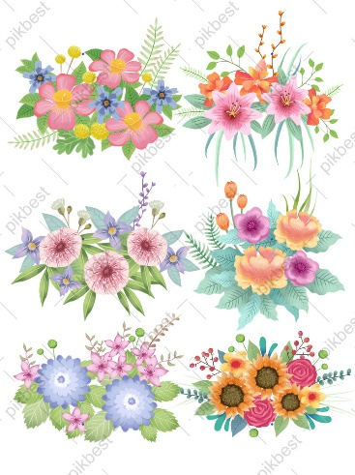 | 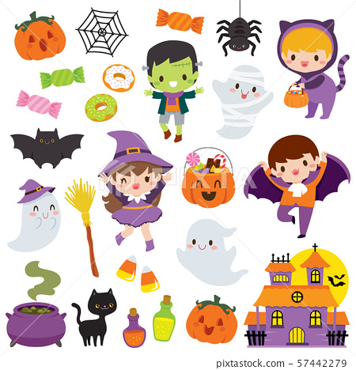
4. | 5. | 6.
Exercise 4. Choose the best option to complete the sentence.
1. Carnival is a popular ____________ in many countries in South America.
A. festival B. music C. harvest D. festive
2. South American people ____________ carnival in different ways.
A. celebration B. celebrate C. celebratory D. decorate
3. At carnival, people wear costumes and ____________ through the streets, playing samba music and dancing.
A. parading B. parade C. attend D. went
4. She is going to Rio Carnival to watch ____________ dance.
A. perform B. performance C. performers D. performed
5. A lot of dancers go to Rio de Janeiro to ____________ the Rio Carnival.
A. attend B. attendance C. harvest D. perform
6. Cooking is a hugely important part of French ____________.
A. celebration B. performance C. culture D. music
7. We ____________ to the Flower Festival in Da Lat last year.
A. went B. arrived C. described D. watched
8. We often ____________ lucky money at Tet.
A. receives B. receive C. received D. receiving
9. I think it is a good ____________ in this circumstance.
A. choose B. chose C. choice D. chooses
10. There are a lot of cultural and ____________ activities held as part of this festival.
A. art B. artists C. arts D. artistic
Exercise 5. Give the correct form of the words given to complete the sentences.
1. I saw so many ____________ flowers when I attended the festival last year. (beauty)
2. The Christmas season is also called the ____________ season. (festival)
3. I loved the ____________ this night. (perform)
4. There is a great ____________ for girls on March 3rd every year. (celebrate)
5. What I like about festivals is that they show the ____________ values of different Communities. (culture)
6. Hoi An is an old city with many places of ____________. (interesting)
7. The ____________ for Hue festival is taken by my group. (prepare)
8. All the streets in the city center are decorated with ____________ lights and red banners. (color)
9. There has been various ____________ shows on TV recently. (entertain)
10. The New Year marks the ____________ of spring and the start of the Lunar New Year. (begin)
II. GRAMMAR
Exercise 1. Put the verbs in brackets into the correct forms of present simple.
1. Robin (play) ______________ football every Sunday.
2. We (have) ______________ a holiday in December every year.
3. He often (go) ______________ to work late.
4. The Moon (circle) ______________ around the Earth.
5. The flight (start) ______________ at 6 a.m every Thursday.
6. Peter (not/ study) ______________ very hard. He never gets high scores.
7. My mother often (teach) ______________ me English on Saturday evenings.
8. She (like) ______________ Literature.
9. My sister (wash) ______________ dishes every day.
10. They (have) ______________ breakfast every morning.
Exercise 2. Turn the sentences in exercise 1 into the interrogative form.
1. _______________________________________________________________________________
2. _______________________________________________________________________________
3. _______________________________________________________________________________
4. _______________________________________________________________________________
5. _______________________________________________________________________________
6. _______________________________________________________________________________
7. _______________________________________________________________________________
8. _______________________________________________________________________________
9. _______________________________________________________________________________
10. ______________________________________________________________________________
Exercise 3. Put the verbs in brackets into the correct forms of past simple.
1. Nam (write) ______________ an essay in Literature class this morning.
2. I (watch) ______________ TV yesterday morning.
3. Nam and you (be) ______________ in the English club last Tuesday.
4. They (eat) ______________ noodles two hours ago.
5. We always (have) ______________ a nice time on Christmas holiday in the past.
6. My father (decorate) ______________ the Christmas tree.
7. She (buy) ______________ a new dress yesterday.
8. They (be) ______________ late for school.
9. Mr. Tam (take) ______________ his children to the museum last Sunday.
10. Hoa (make) ______________ a cushion for her armchair.
Exercise 4. Turn the sentences in exercise 3 into the interrogative form.
1. _______________________________________________________________________________
2. _______________________________________________________________________________
3. _______________________________________________________________________________
4. _______________________________________________________________________________
5. _______________________________________________________________________________
6. _______________________________________________________________________________
7. _______________________________________________________________________________
8. _______________________________________________________________________________
9. _______________________________________________________________________________
10. ______________________________________________________________________________
Exercise 5a. Turn the sentences into the interrogative form and answer it.
1. The dog is small
_______________________________________________________________________________
2. She is a student.
_______________________________________________________________________________
3. We are ready to get a pet.
_______________________________________________________________________________
4. This book is so boring.
_______________________________________________________________________________
5. I am a worker
_______________________________________________________________________________
Exercise 5b. Turn the sentences into the interrogative form and answer it.
1. Mary and Linda were late.
_______________________________________________________________________________
2. Emma and Betty were good friends.
_______________________________________________________________________________
3. They were in the park yesterday
_______________________________________________________________________________
4. His sister was seven years old.
_______________________________________________________________________________
5. It was hot yesterday.
_______________________________________________________________________________
Exercise 6: Write short answers for the following questions. (Answers may vary)
1. Can you play the piano?  _______________________________________ | 6. Can you do this puzzle?  _______________________________________
2. Can you play the guitar?  _______________________________________ | 7. Should you do morning exercise?  _______________________________________
3. Can you sing and dance?  _______________________________________ | 8. Should you smoke?  _______________________________________
4. Can you swim?  _______________________________________ | 9. Will you go to the zoo with me?  _______________________________________
5. Can you speak English?  _______________________________________ | 10. Will you live in the USA in the future?  _______________________________________

III. PHONETICS
Divide these words into two columns as below: stress on first syllable or stress on second syllable. Track 08
banquet | apply | agree | country | mother
disease | cowboy | cancer | reply | borrow
schedule | pleasure | tonight | provide | suggest
persuade | machine | treatment | cover | desire
reduce | humour | farmer | decide | lecture
birthday | prepare | enjoy | money | suppose

Stress on first syllable | Stress on second syllable

PART 3. COMMUNICATION SKILLS
I. LISTENING
Listen and do the tasks followed. Track 09
Exercise 1. Listen and decide if each statement is True (T), or False (F), or Not Given (NG).
1. Christmas is the most important holiday in Britain. ___________
2. People decorated their houses with balloon, paper chains, holly,... ___________
3. The Christmas dinner is a feast with the main dish is Christmas pudding. ___________
4. The Queen gives Christmas speech at 3 a.m on December 25th. ___________
5. The Christmas speech of the Queen is broadcast on radio and television. ___________
Exercise 2. Listen again and answer the questions.
1. When does Christmas Eve occur?
_____________________________________________________________________________
2. What do people decorate the top of the trees with?
_____________________________________________________________________________
3. Where do children hang up their stocking?
_____________________________________________________________________________
4. What do children get on the morning of the 25th?
_____________________________________________________________________________
5. When does Christmas dinner take place?
_____________________________________________________________________________
II. SPEAKING
Read the conversation and answer the questions. Then practise speaking the conversation.
Mary: Hi, Hoa.
Hoa: Hi, Mary.
Mary: What did you do last weekend?
Hoa: I went to Hoi Mua Festival with my parents.
Mary: Where is it?
Hoa: It's in Phu Yen.
Mary: What is it about?
Hoa: Ah. It's held to thank the Rice God for the crop, and to pray for better crops in the future.
Mary: Really? What do people usually do at the festival?
Hoa: People play drums, sing songs and dance. They also drink rice wine through a long thin bamboo tube. My father likes it.
Mary: Are there any other activities?
Hoa: Yes. There are cultural shows, buffalo races, and traditional games.
Mary: Oh, that sounds really interesting. How often does it take?
Hoa: Every March.
Mary: I would like to go there next year.
Questions:
1. What did Hoa do last weekend?
_______________________________________________________________________________
2. Who did she go with?
_______________________________________________________________________________
3. What is Hoi Mua held for?
_______________________________________________________________________________
4. What do people usually do at the festival?
_______________________________________________________________________________
5. Would Mary like to go there?
_______________________________________________________________________________
III. READING
Exercise 1. Read the text and then choose the best answer A, B, C, or D.
Visit the Edinburgh Festival
Every year, thousands of people come to Edinburgh, the capital city of Scotland, to be part of the Edinburgh Festival. For three weeks every August and September the city is filled with actors and artists from all over the world. They come to Edinburgh for the biggest arts festival in Britain. During this time, the streets of the city are alive with music and dance from early in the morning untill late at night. You can even see artists painting pictures on the streets.
Tens of thousands of tourists come to the festival to see new films and plays and to hear music played by famous musicians. This year, you can see over five hundred performances with actors from more than forty countries.
The tickets for these performances are quite cheap, and it is usually easier to see your favourite star in Edinburgh than it is in London. So come to Edinburgh next summer!
1. How many people come to attend the Edinburgh Festival every year?
A. Thousand people
B. Thousands of people
C. Some people
D. Few people
2. How long does the Edinburgh Festival last?
A. Two months
B. Three months
C. Three weeks
D. For 3 weeks every August and September
3. What can you even see artists doing on the streets?
A. Playing the guitar on the streets
B. Singing songs on the streets
C. Painting pictures on the streets
D. Dancing on the streets
4. How many performances can people see this year?
A. Tens of thousands
B. Thousands
C. Some people
D. Over five hundred
5. How much are the tickets for these performances?
A. Very cheap
B. Very expensive

C. Not cheap

D. Not quite expensive
Exercise 2. Choose the word from the box that best fits the blank space in the following passage.
their | recent | a lot of | fewer | consisted
way | explain | which | been | would
The worlds first film was shown in 1895 by two French brothers, Louis and Auguste Lumiere. Although it only (1) ___________ of short, simple scenes, people loved it and films have (2) ___________ popular ever since. The first films were silent, with titles on the screen to (3) ___________ the story.
Soon the public had (4) ___________ favorite actors and actresses and, in this (5) ___________, the first film stars appeared. In the 1927, the first “talkie”, a film with sound, was shown and from then on, the public (6) ___________ only accept this kind of film.
Further improvements continued, particularly in America, (7) ___________ produced 95% of all films. With the arrival of television in 1950s, (8) ___________ people went to see films, but in (9) ___________ years audiences have grown again. More countries have started to produce films that influences film-making and there are currently (10) ___________ national film industries.
Exercise 3. Read the passage. Decide whether the statements are True (T) or False (F) then answer the questions.
My favorite movie is cartoon “Tom and Jerry”. Tom is a cat with blue and white color. He keeps the house for a normal family and has a very free life. His job is chasing Jerry day by day. Jerry is a rown house mouse. He usually lives in the deep cave behind the wall. Although they hate each other so much and always find ways to hurt the opponent but when Tom or Jerry falls into really dangerous situations, then both become another savior. The film is an endless confrontation between Tom and Jerry, bring plenty of laughter for the audiences. I love this film because when I watch it I feel very glad, feeling like returned to my childhood.
1. What’s Tom’s color?
_________________________________________________________________________________
2. Does Tom usually live in a cage?
_________________________________________________________________________________
3. When will they help each other?
_________________________________________________________________________________
4. How do the audiences feel when they watch “Tom and Jerry”?
_________________________________________________________________________________
5. Why does the writer love “Tom and Jerry”?
_________________________________________________________________________________
IV. WRITING
Exercise 1a. Rewrite the sentences without changing the meaning of the original sentences.
1. It’s a good idea to eat a lot of fruit and vegetables every day.
We should
2. We couldn’t keep on cleaning the streets because of the heavy rain.
Because it
3. The garden party wont take place if the weather doesn’t improve.
Unless
4. Both students and teachers can borrow books from the library.
The library lends
5. Nobody plays this piece of music as beautifully as he does.
He plays this
Exercise 1b: Use the words in brackets and rewrite the sentences without changing the meaning of the original sentences.
1. I would like six apples. (DOZEN)
_________________________________________________________________________________
2. What is the price of a bowl of beef noodle soup? (MUCH)
_________________________________________________________________________________
3. There is sugar in many kinds of food. (HAVE)
_________________________________________________________________________________
4. We haven’t got any tomatoes. (THERE)
_________________________________________________________________________________
5. My sister likes chicken very much. (FAVOURITE)
_________________________________________________________________________________
Exercise 2. Use the words in brackets and rewrite the sentences without changing the meaning of the original sentences.
1. How much are these shoes? (How much...)
_________________________________________________________________________________
2. It takes me about five minutes to go to school by bike. (spend)
_________________________________________________________________________________
3. It often takes him two hours to do his homework. (He)
_________________________________________________________________________________
4. She spends one hour with her housework. (It...)
_________________________________________________________________________________
5. Where will she mail her letter? (send)
_________________________________________________________________________________
6. They usually walk to school. (foot)
_________________________________________________________________________________
7. He usually rides to school. (bike)
_________________________________________________________________________________
8. Mr. Hung sometimes travels to work by plane. (fly)
_________________________________________________________________________________
9. They never go to school late. (They are...)
_________________________________________________________________________________
10. Do you have a better refrigerator than this? (Is this...?)
_________________________________________________________________________________
Exercise 3. Imagine Christmas is coming, write a letter to Santa Claus. The answer may vary.
___________________________________________________________________________________
___________________________________________________________________________________
___________________________________________________________________________________
___________________________________________________________________________________
___________________________________________________________________________________
___________________________________________________________________________________
___________________________________________________________________________________
___________________________________________________________________________________
___________________________________________________________________________________

