Week:……………..  Period:……………. | Date of planning : …/… / 2023  Date of teaching : …/… / 2023

UNIT 4: ETHNIC GROUPS OF VIET NAM
Lesson 4: Communication

I. OBJECTIVES
By the end of this lesson, students will be able to gain:
1. Knowledge:
- Use the lexical items related to the life of the ethnic people.
- Give opinions about the lifestyle of ethnic minority groups.
- Ask and answer about the Jrai people.
2. Competences:
- Develop communication skills and creativity
- Be collaborative and supportive in pair work and teamwork
- Actively join in class activities
3. Personal qualities
- Love talking about ethnic groups of Viet Nam.
- Develop self-study skills
II. MATERIALS
- Grade 8 textbook, Unit 4: Communication
- Computer connected to the Internet
- Projector / TV
- hoclieu.vn
III. PROCEDURES
1. WARM-UP (5 mins)
a. Objectives:
- To create an active atmosphere in the class before the lesson.
- To lead into the new lesson.
b. Content:
- Kim’s game.
c. Expected outcomes:
- Ss review words related to ethnic groups in Viet Nam.
d. Organisation

TEACHER AND STUDENTS’ ACTIVITIES | CONTENTS
- Teacher divides Ss into 4 groups.  - Teacher gives each group a piece of paper.  - Teacher shows 8 pictures about ethnic groups of Viet Nam in 2 minutes.  - Ss look at the pictures, guess the names of ethnic groups (without writing).  - Ss work in their group and write the names of ethnic groups in 2 minutes.  - Teacher asks 4 groups to exchange the posters.  - Teacher shows the answers and asks them to check in 1 minute  - The group with the most correct words is the winner. | Kim’s game  Answer key:  Hmong, Hoa, Brau, Nung, Khmer, Cham, Tay, Ede.
2. ACTIVITY 1: PRESENTATION (18 mins)
a. Objectives:
- To introduce new words related to the life of the ethnic people.
- To introduce some ways to give opinions and allow Ss some practice.
b. Content:
- Vocabulary
- Task 1: Listen and read the conversation. Pay attention to the highlighted parts.
- Task 2: Work in pairs. Make a similar conversation to ask and give opinions about these topics.
c. Expected outcomes:
- Ss know how to give opinions in English.
d. Organisation
TEACHER AND STUDENTS’ ACTIVITIES | CONTENTS
Vocabulary (5 mins)
- Teacher introduces the vocabulary.  - Teacher explains the meaning of the new vocabulary, using pictures and translation.  - Teacher checks students’ understanding with the “What and where?” technique. | New words:  1. weave (v)  2. hunt (v)  3. role (n)  4. statue (n)
Task 1: Listen and read the conversation. Pay attention to the highlighted parts. (6 mins)
- Teacher asks Ss to listen and read along with the conversation. Teacher asks Ss to pay attention to the highlighted parts.  - Ss work individually, listen to the audio file and read along with the conversation.  - Teacher elicits the structures giving opinions.  - Teacher asks Ss to practise the conversation in pairs. | Structures to give opinions:  - I think …  - To my way of thinking …
Task 2. Work in pairs. Make a similar conversation to ask and give opinions about these topics. (7 mins)
- Teacher asks Ss to work in pairs to make conversations, using structures for giving opinions.  - Ss use the structures given and make similar conversations about the following topics:  + Playing traditional games.  + Living close to nature.  - Teacher asks some pairs to perform their conversations.  - Teacher comments on their performance. | Suggested conversation:  A: What do you think about playing traditional games?  B: I think/ To my way of thinking it’s …
3. ACTIVITY 3: PRACTICE (18 mins)
a. Objectives:
- To provide students with more knowledge about the lifestyle of ethnic minority groups through a quiz.
- To give students some practice asking and answering about some information in the notes of Jrai people.
b. Content:
- Task 3: GAME: How much do you know about ethnic groups in Viet Nam?
- Task 4: Work in pairs. Read the notes below about the Jrai. Take turns to ask and answer about the information.
- Task 5: Work in groups. Share with your group the information about the Jrai people you find interesting.
c. Expected outcomes:
- Ss know more about the lifestyle of ethnic minority groups.
- Ss can practise asking and answering about some information in the notes of Jrai people.
- Share with the group the information about the Jrai people they find interesting.
d. Organisation

TEACHER AND STUDENTS’ ACTIVITIES | CONTENTS
Task 3: How much do you know about ethnic groups in Viet Nam? (6 mins)
- Teacher asks Ss to work individually, read the sentences carefully and choose the correct answers.  - Ss do the exercise in 3 minutes.  The game “Who’s the millionaire?  - Teacher divides the class into 2 teams, explains the rules and lets them play the game.  - Each team has to answer the questions by choosing the best answer. The team with more points is the winner. | 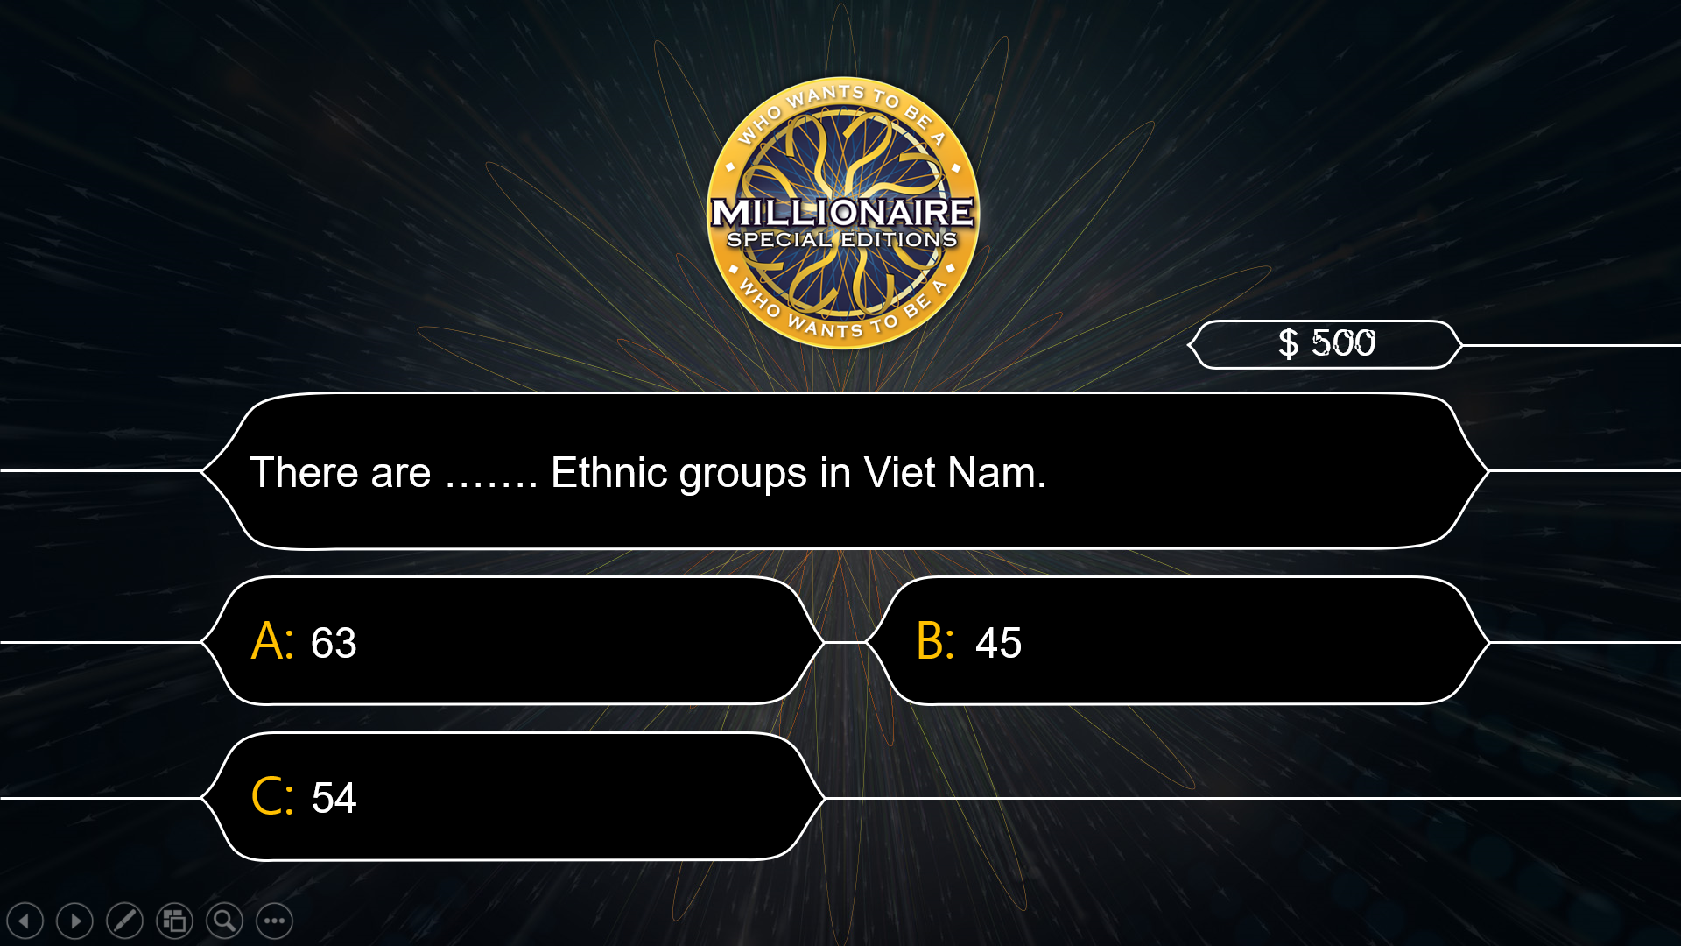  Answer key:  1. C  2. B  3. B  4. A  5. C  6. C
Task 4: Work in pairs. Read the notes below about the Jrai. Take turns to ask and answer about the information. (7 mins)
- Teacher asks Ss to work in pairs.  - Ss read each piece of information carefully and decide on the question they want to ask and the answer they would give.  - Teacher asks Ss to swap their roles of asking and answering.  - Teacher calls on 2-3 pairs to share their questions and answers.  - Teacher corrects them if needed. | Suggested questions and answers:  1. What is the population of the Jrai?  => It is about 513,930.  2. Where do they live?  => They live mainly in Gia Lai.  3. What type of house do they live in?  => They live in stilt houses.  4. What do they do for their living?  => They grow crops, weave, …
Task 5. Work in groups. Share with your group the information about the Jrai people you find interesting. (5 mins)
- Teacher asks Ss to work in groups.  - Teacher allows Ss some time to refer to the notes in 4 and choose the features they are interested in.  - Ss give their opinions on certain features of the Jrai people, using the suggested structures.  - Teacher calls on some groups to share their opinions with the class. | Students may start sharing their opinions with:  - I like … because …  - I think that …
4. CONSOLIDATION (4 mins)
a. Wrap-up
- Teacher asks Ss to summarise the main points of the lesson.
b. Homework
- Learn by heart all the words that they have just learnt.
- Do exercises in the workbook.
- Prepare for Lesson 5 – Skills 1.

