Date of preparing: ………………………………….
Date of teaching: ………………………………….

Period …
UNIT 4: FESTIVALS and FREE TIME
Lesson 3 - Part 2 (Page 37) – Reading, Speaking and Writing

I. OBJECTIVES
By the end of the lesson, Ss will be able to…
1. Knowledge
- read an article about a famous festival in Vietnam.
- talk about the Mid-Autumn Festival.
- write messages about a festival.
2. Ability
- improve the reading, speaking and writing skills.
3. Quality
- have positive attitude in English language learning so that they actively participate in all classroom activities.
- respect traditional Vietnam culture.

II. TEACHING AIDS AND LEARNING MATERIALS
Lesson plan, PPT slides, student’s book, workbook, notebook, personal computer (if any), projector/TV, speakers, DCR & DHA on Eduhome, handouts…
III. PROCEDURES
A. Warm up: (5’)
a) Objective: to introduce the new lesson and set the scene for Ss to acquire new language; to get students' attention at the beginning of the class by means of enjoyable and short activities as well as to engage them in the steps that follow
b) Content: introducing “Tết” or the Mid-Autumn Festival.
c) Product: Ss have a general idea about the festivals that are mentioned in the lesson.
d) Competence: collaboration, communication, critical thinking.
e) Organization of the activity:
Teacher’s Activities | Students’ Activities
- Give greetings  - Check attendance  - Option 1:  - Prepare things about Tet such as peach blossom, bánh chưng, red envelope, watermelon seed, fruits, … and put them in a box or bag  - Have 1 S touch these things without looking inside the box, describe things  - Have the rest of the class guess what thing is being described  - Ask Ss to tell the name of the festival through things in the box.  → Lead to the new lesson.  - Option 2: Game: JIGSAW PUZZLE  - Prepare a picture which is cut into many pieces  - Have Ss work in groups to arrange the pieces to make a right picture, then hang it on the board  - Have Ss give name of the festival in the picture  - The quickest group to have the right picture and name of the festival will be the winner.  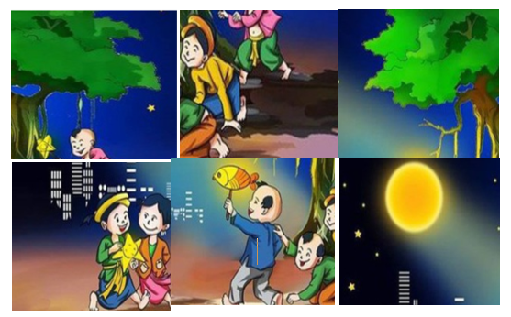  → Lead to the new lesson | - Greet T  - Do as the teacher requests  - Guess  - Give name of the festival  Answer keys  Luna New Year Festival or Tết  - Work in groups  - Give names  Answer keys  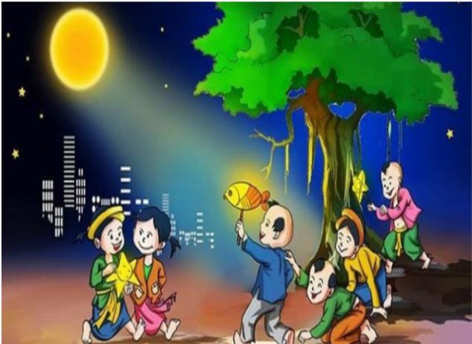  Name: The Mid-Autumn Festival

B. New lesson (35’)
- Activities 1: Reading (10’)
a) Objective: Ss improve their reading skill (scanning, skimming)
b) Content: Reading an article and recognizing the correct and incorrect information.
c) Products: Ss know about Tết – a traditional festival in Vietnam.
d) Competence: Collaboration, communication, analytical and synthesizing skills.
e) Organization of the activity:
Teacher’s Activities | Students’ Activities
a. Read the article and underline all the festival activities  - Have Ss read the article individually  - Have some Ss read the article aloud  - Demonstrate the activity using the example  - Have Ss underline all the festival activities  - Check answers as a whole class.  b. Read and write “Yes” or “No”  - Option 1:  - Have Ss read the article again  - Have Ss read the sentences and write “Yes” or “No”  - Call Ss to give answers  - Check answers as a whole class.  - Option 2:  - Have Ss read the sentences to guess the key word (the word that helps they find the answers quickly and correctly)  - Have Ss read the article again and write “Yes / “No”  - Haves Ss underline the sentences that help them find the answers  - Call Ss to give answers, explain  - Check answers as a whole class.  - Have Ss make the “No” sentences into “Yes” | - Read in silence  - Read in front of the class  - Do the task  - Check  Answer keys  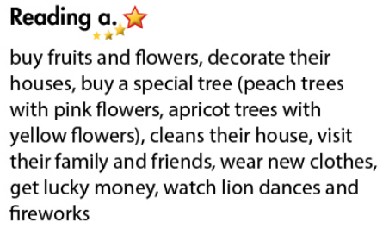  - Read  - Do the task  - Give answers, explain  Answer keys  1. No 2. No 3. No 4. Yes  - Read, find key words  - Do the task  - Give answers, explain  Answer keys  Keywords:  1. during 2. Every, same  3. during 4. during  No → Yes  1. People buy fruits and flowers before Tết.  2. People in the north and the south have different types of trees.  3. People clean their houses before Tết.
- Activity 2: Speaking: Festival Fun (10’)
a) Objective: Ss can talk about a festival.
b) Content: Talking about what people do before and during the Mid – Autumn Festival.
c) Products: Ss can talk about the festivals they like.
d) Competence: Collaboration, communication, creativity.
e) Organization of the activity:

Teacher’s Activities | Students’ Activities
a. You’re telling a friend from overseas about the Mid-Autumn Festival. Take turns to talk about what people do before and during the Mid-Autumn Festival  - Demonstrate the activity by asking and answering with a student  - Have Ss practice the conversation in pairs  - Have Ss take turns to talk about what people do before and during the Mid-Autumn Festival  - Remind Ss to use the words / sounds to get time to think (hesitate)  - Have some pairs act out the conversation in front of the class  - Give feedback and evaluation.  b. Talk about other festivals you know  - Option 1:  - Have Ss work in pairs to talk about other festivals they know  - Go round and give help if necessary  - Call some pairs to demonstrate the activity  - Give feedback and evaluation  - Option 2:  - Give Ss some suggestions about other festivals (like pictures and phrases in part a.)  Example: The Christmas Festival  - Have Ss practice the conversation in pairs and present their conversation in front of the class  - Give feedback and evaluation  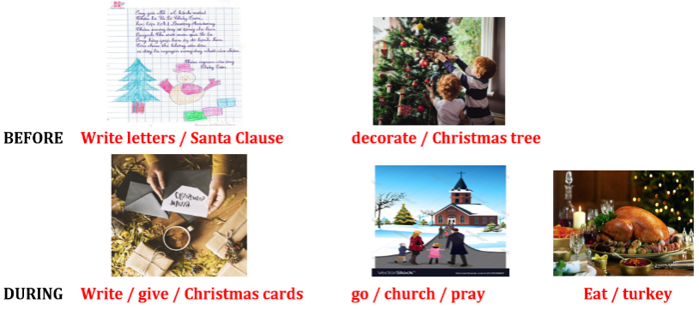 | - Observe and listen  - Work in pairs  - Present  - Work in pairs  - Present  - Look  - Work in pairs  - Present
- Activity 3: Writing (15’)
a) Objective: Ss can write messages with emojis.
b) Content: Writing messages about the Mid-Autumn Festival.
c) Products: Ss can produce a message using emojis.
d) Competence: collaboration, communication, creativity.
e) Organization of the activity:
Teacher’s Activities | Students’ Activities
a. Read Nhiên and Sarah’s messages. Guess what the emojis (pictures) mean and match the emojis to their meanings.  - Have Ss work in pairs to read the messages together  - Have Ss guess what the emojis mean and match them to their meanings  - Call Ss to give answers  - Check answers as a whole class  b. Write similar messages about the Mid-Autumn Festival  - Have Ss work in pairs, sitting back-to-back  - Explain they will have a written conversation using messages in English and emojis  - Have S A write a greeting to S B on a piece of paper and then hand it to them  - Have S B reply the Mid-Autumn Festival and hand the paper back. Continue this manner with the pair passing the paper between them.  - Have some Ss read / write their messages in front of the class  - Give feedback and evaluation  - Option 2:  - Follow the same steps as option 1. However, let Ss use the cell phone or laptop with some messing app like Facebook messenger or Zalo, Viber to write and send messages.  - Comment on Ss’ writings, correct their spelling and grammar | - Look and guess  - Give answers  Answer keys  a. karaoke b. happy c. party  d. Vietnam e. money f. fireworks  - Work in pairs  - Write / read  Suggested writing  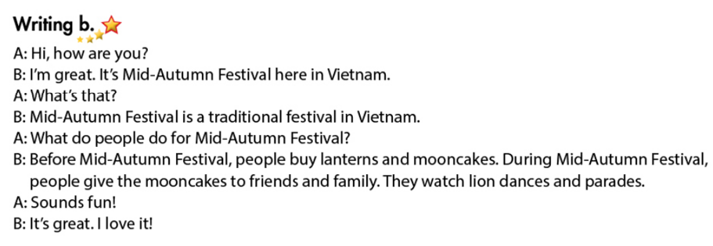

C. Consolidation (3’)
* Festival activities:
Tết: buy fruits and flowers, decorate houses, clean houses, wear new clothes, get lucky money, watch lion dances, …
Mid – Autumn Festival: buy lanterns and mooncakes, give presents to friends and family, watch lion and dragon dancing, watch lantern parades, …
* Asking about festival activities: What do people do before / during the festival?
What do people do for + holiday?

D. Homework (2’)
- Finish the writing part.
- Find more information about some traditional holidays in Vietnam.
- Do exercises in Workbook: Reading and Writing (page 25).
- Prepare: Unit 4 - Review (page 92 – SB).

