Đề tài :

USING AI APPS TO ASSIST TEACHERS IN DESIGNING LISTENING TASKS FOR GIFTED STUDENTS

Table of contents
Chapter 1: Introduction 2
Chapter 2: Literature Review 3
Definitions of AI 3
The impact of AI on language learning outcomes 3
Some useful applications and AI- driven platforms 3
Drawbacks of AI 5
Research questions 6
Chapter 3: Methodology 7
Participants 7
Data collection instruments and procedure 7
Chapter 4: Data Analysis and Interpretation. 10
Chapter 5: Conclusion and Recommendation 18
References 19
Appendices 21

CHAPTER I – INTRODUCTION

Recent advances in technology have brought significant changes in every aspect of our lives, and education is no exception. Various devices at the cutting-edge of technology have been developed to make learning better in general and improve English teaching and learning in particular. The utilization of artificial intelligence (AI) technology in teaching and learning in high schools is inevitable in the Industry 4.0 era.
In fact, AI is becoming common in English teaching. AI-powered platforms have had positive effects on various aspects of language learning and teaching. One of the advantages is that AI will make English learning an exciting and active experience, because each student will have a "native teacher" who always accompanies and facilitates in correcting listening and speaking practice, grading, correcting errors and giving personalized exercises (Woolf, et al.(2013) and Kurshan (2016)). These AI-driven platforms offer personalized learning experiences, tailoring content to meet the individual needs of each student. In addition, AI helps control the quality of students' learning and training through big data systems, helping students look up and track their progress every day. Liu also indicated that providing instant feedback, correcting errors, and offering suggestions can help learners improve their language production skills. (Liu et al., 2019)
With numerous benefits that AI brings to education, English teachers, therefore, are necessary to get updated with technologies to equip their students with the digital skills and competence in order to meet the requirements of a technology-driven society. In Vietnam, there have been different studies regarding students’ attitudes towards the integration of technology in education, but the use of AI technology in assessment and AI as a teaching assistant, particularly the use of AI in teaching English in high schools is a relatively new concept. Therefore, this study was conducted with a view to helping English teachers to explore the effectiveness of some AI tools in teaching the language and helping students to improve their listening skill through different activities for learning and assessment designed by AI. The researchers focused on some AI tools for teachers such as Twee, Magic School and Brisk Teaching. The research was conducted with the participation of 20 English majored students who are in grade 10 and five surveyed teachers. Data from the research was mainly collected through tests, questionnaires and interviews.

CHAPTER II- LITERATURE REVIEW

Definitions of Artificial Intelligence
The term artificial intelligence (AI) was coined in 1956, but AI has have gained in popularity over recent years thanks to increased data volumes, advanced algorithms, and enhancements in computing power and storage. There are a lot of ways in which Artificial Intelligence (AI) has been defined. According to Wikipedia, Artificial Intelligence in its broadest sense is “intelligence exhibited by machines, particularly computer systems. It is a field of research in computer science that develops and studies methods and software that enable machines to perceive their environment and use learning and intelligence to take actions that maximize their chances of achieving defined goals. Such machines may be called AIs.” Cambridge Dictionary provides a clear definition of the term “artificial intelligence” which means “the use or study of computer systems or machines that have some of the qualities that the human brain has, such as the ability to interpret and produce language in a way that seems human, recognize or create images, solve problems, and learn from data supplied to them”.
The impact of AI on language learning outcomes
The rapid advancement of Artificial Intelligence (AI) has created a promising foundation for its application in education. This is because AI not only enhances traditional classroom interactions between teachers and students but also expands the possibilities of online learning by offering increased flexibility and support (Son et al., 2023). This is especially relevant in language learning, where AI helps address critical challenges such as limited access to native speakers, the lack of immediate feedback, and the need for individualized attention (Rusmiyanto et al., 2023).
AI’s unique capabilities further highlight its importance in language education. Simply put, As Ghafar et al. (2023) explained, AI can analyze language down to the phoneme level, providing near-instant feedback on learners’ progress. Its accessibility – often without requiring internet – makes AI a flexible and scalable solution, capable of supporting a vast number of learners. Moreover, Instructional material designers are also benefiting from AI-driven applications, especially in developing content for language learning.
The positive impact of AI on language learning outcomes has been further demonstrated through AI tutoring models. Yan (2024) found that students who used AI-based instruction saw a performance improvement of 12.02 points, which was 10.19 points higher than those in the control group. Yan also proposed strategies to optimize AI’s role in foreign language education, such as enriching the content, enhancing technological integration, and adopting flexible assessment methods. What matters more is that AI enables learners to practice English in a risk-free environment, encouraging greater willingness to communicate. AI-driven chatbots, equipped with communication strategies, can significantly boost students’ confidence and performance (Son et al., 2023). Through these innovations, AI is not only transforming how students learn but also providing a more inclusive and effective approach to language education.
Some useful applications and AI- driven platforms
ChatGPT
As a chatbot, ChatGPT offers distinct advantages in supporting the process of learning English. Within this framework, it serves as a virtual assistant that helps with understanding grammar, building vocabulary, and practicing speaking skills (Arbi, 2024). He also notes that English teachers can leverage ChatGPT as a resource to offer further clarification, respond to student inquiries, or deliver language exercises suited to their comprehension level. The quick response time and constant availability of this AI make it an excellent tool for boosting interactivity in the English classroom. Son et al. (2023) emphasizes creativity and critical thinking gained while using chatbot ChatGPT.
MagicSchool
The app offers a wide range of options for automation of administrative tasks, and it can assist in lesson planning, and help teachers create the resources for assessing students and meeting the students’ needs.
When it comes to benefits of MagicSchool, Dr. La Tricia Clark, an educator states: “the platform offers an array of tools that are every teacher's dream, covering all the bases when it comes to designing a personalized learning experience for students of different levels. The text rewriter and proofreading tools were already favorites, but the scaffolding tool took my breath away.” She emphasizes that MagicSchool is an excellent supplement to outdated curricula, enabling teachers to make lessons more relevant and explicit while supporting differentiated instruction in a matter of seconds.
Dr. Jamie Burton, the principal of New Hope Elementary, says that teachers who are familiar with AI are already using chatbots to do some of the same work as MagicSchool. MagicSchool is making this work even easier for busy educators by providing categories with easy prompt input enabling teachers to be more efficient with their time. MagicSchool is bridging the latest advancements with AI to teacher classrooms.
Eric Santos, a Regional Educational Technology Coordinator prefers The Text Leveler and MC quiz generator when mentioning the tools that Magicschool offers. As a science teacher, he points out that these would have saved him a ton of time. He insists that differentiating text without losing content and vocabulary use is an extremely time - consuming task, but these tools allow him to automate tasks that are repetitive yet required attention to detail, which gives him a lot more time for other tasks like designing summative assessments and responding to student needs.
Twee
With the increasing demand for personalized and interactive education, English teachers are constantly looking for innovative tools in an attempt to improve their teaching methods and encourage students’ involvement. This leads to the development of a revolutionary AI-powered tool, Twee, specifically for English teachers.
This tool utilizes advanced artificial intelligence algorithms to generate a wide range of questions, activities, lessons, and readings, tailored to the specific needs and proficiency levels of students. By harnessing the power of AI, Twee aims to revolutionize the way English is taught, making it more dynamic, engaging, and efficient for both teachers and students.
There are various opinions on the benefits of Twee. Many people have stated innumerable reasons why educators are keen on using Twee in their teaching. Advantages of Twee such as time saving, quality enhancement, versatility, customization and pedagogical integrity are worth mentioning. With Twee, educators can save time, enhance the quality of their instructional materials, and create engaging learning experiences that inspire and empower students to be successful.
Brisk Teaching
Brisk Teaching is a web-based, AI-powered tool for automating some key classroom tasks. With a simple download of free version, the users can utilize over 20 built-in AI prompts to automate key tasks like creating lesson plans, quiz questions, and presentations. Moreover, it offers teachers tools for differentiation, like translating text into more than languages and adjusting the reading level of digital texts.
Among many AI-powered tools for teachers, Brisk stands out for its focus on helping teachers learn how to use AI to complement and improve their work, not replace it. The teacher-created videos are especially good: They show how using AI tools is an ongoing process where teachers refine what they put into a template prompt and then refine and add to the materials that the AI tool generates as a result. Brisk is an especially powerful tool for helping teachers purposefully experiment with an AI tool: There's a lot of scaffolding available to inform new users getting started and inspire seasoned AI users to find more powerful ways to leverage AI-powered prompts.
Microsoft Teams
Microsoft Teams is a comprehensive collaboration platform that combines chat, video meetings, file sharing, and app integration to support teamwork in any environment. It enables real-time communication and document co-editing, making it ideal for both remote and in-class teams.
One valuable tool within Teams is Microsoft Forms, which allows users to create surveys, quizzes, and feedback forms. Educators and trainers can also design listening tasks by embedding audio clips into Forms, enabling students to listen and respond to questions directly—perfect for language learning or auditory assessments.
Ms Teams integrates with productivity apps like Copilot, an AI assistant that helps teachers save time by generating lesson plans, quizzes, feedback, and more. It supports creativity, streamlines tasks, and enhances teaching with smart suggestions.
Backed by Microsoft 365’s security and compliance, Teams ensures safe, flexible, and efficient collaboration among users.
Google Forms
Google Forms is a free tool that allows teachers to create quizzes, surveys, and assessments easily. It supports automatic grading, data collection, and collaboration, making classroom management and student feedback more efficient and interactive.
Drawbacks of AI
AI has great potential in improving language learning, but it faces limitations. Human languages are complex, involving paralinguistic cues like body language, gestures, facial expressions, and emotions, which AI has yet to master (Sharadgah & Sa’di, 2022). AI’s passive and mechanical behavior further diminishes its effectiveness in language learning (Crompton et al., 2023). Moreover, AI tools often lack customization for different learning styles and skill levels, while cultural and linguistic biases in algorithms persist. Accessibility issues, particularly unequal access to AI tools, also hinder its broader application (Macías et al., 2024). Ethical concerns, including privacy, fairness, bias, and transparency, are additional challenges that must be addressed (Nguyen, 2024). Teachers’ confidence in using technology, along with facility shortages and technical issues, adds to the difficulties of integrating AI into classrooms (Dong & Le, 2024). Additionally, the rise of chatbots disrupts traditional teaching roles and contributes to “search-as-learning” methods (Du & Daniel, 2024). Finally, learners’ technological limitations and study habits may overshadow the benefits of AI tools in exam preparation (Shazly, 2021).
It is also essential to mention the drawbacks of virtual assessment. Some researchers insisted that if the Internet connection is poor, the exam can be a failure (Yulianto & Mujtahin, 2021). Thus, there exists a dependence on technology that sometimes goes beyond human control. Cheating in virtual exams is worth considering, even though many measures have been provided to prevent this issue. Furthermore, teachers and students also recounted their negative feelings towards the test validity, practicality, and reliability of e-assessment (Dermo, 2009; Yulianto & Mujtahin, 2021).

Research Questions
The study was designed to answer the following research questions:
- How effective are several AI-powered tools to assist teachers in designing listening tasks for gifted students?
- How do students’ learning outcomes improve with the assistance of some AI- powered tools?

CHAPTER III– METHODOLOGY
Participants
This study was conducted at Bao Loc High School for the Gifted. Students from 2 groups were selected to participate in this study:
- Group 1: 10 students (5 females and 5 males) in the same class of 10 English majors.
- Group 2: 10 students (6 females and 4 males) in the same class of 10 English majors.
- 5 English teachers from the school (1 male and 4 females)
Participation in the study was voluntary and anonymous. They were guaranteed that the information collected was totally confidential. The two groups have English lessons on a regular basis of six periods per week.
The data were collected from two groups of 10 English majors of Bao Loc High School for the Gifted. Group 1 was chosen as the Control group in which the conventional teaching methods with no use of AI tools were applied while Group 2 as the Experimental group was taught with the application of AI-powered tools. Detailed information of these two kinds of participants is shown in the table below:
The description of the two groups
GROUP | Male |  | Female |  | Total
GROUP | Number | % | Number | % | Total
Control Group | 5 | 50% | 5 | 50% | 10
Experimental Group | 4 | 40 % | 6 | 60 % | 10
The description of the teachers
Age | Experience in teaching English |  | Male |  | Female |  | Total
From 30 to 52 | Under 5 years | 0 | Number | % | Number | % | Total
From 30 to 52 | 5-10 years | 1 | 2 | 40% | 3 | 60% | 5
From 30 to 52 | Over 10 years | 4
Data collection instruments and procedure
The research has been mainly conducted in the light of qualitative and quantitative methods. Data from the pre-test, the post-test, questionnaires and interviews were collected and analyzed to find out answers to the research questions.
In this study, a pre-test of English Listening skill was delivered to students to find out their proficiency before the treatment. The test consists of 30 questions with the total scores of 30 and has 4 listening sections. After an eight-week intervention with AI tools, a post-test, which was similar to the pre-test, was conducted to examine if there is an improvement in the students' English competence. The overall test score would be used to measure the students’ improvement and changes exactly. In other words, the value of AI tools was evaluated by the cores of the students’ tests which were obtained before and after the treatment. The pre-test was carried out to know the students’ English listening level, while the post-test was conducted to know the effect of exercises generated by AI-powered tools on their learning outcomes.
The comparison was made two-tailed because there was no justification for expecting any particular direction in means comparison (Brown, 2001, p.151). The employed formula was (Brown, 2001, p. 152).
In the above formula, t_{obs} stands for t-test observed for the difference in means, M for means, SD for standard deviation, E for experimental group, and C for control group. Then the observed t value was compared with the critical value got from the t-distribution table (see Appendix D) (Brown, 2001, p. 153). This helped the researchers find out whether the two groups were at the same level of language proficiency. The result was run on a computer using SPSS (the statistical package for the social sciences).
By comparing the result of the pre-test and the post-test, the researcher
measured the gains that the subjects had made and determined the effectiveness of the treatment (Hatch & Farhady, 1982, p. 20).
In regard to the survey, two questionnaires were designed to collect data from students. The pre-treatment questionnaire sought to find out the students’ weaknesses in terms of level of English, particularly Listening skill. The post-treatment questionnaire investigated the benefits of using AI tools in designing English listening tasks and assessment to see if the weaknesses identified in the pre-treatment questionnaire had been surmounted. The questionnaires used a Likert scale ranging from one to five, moving from strongly disagree to strongly agree respectively, and ended with open-ended questions at which the participants can add more information about their weaknesses and limitations of the AI- powered tools. The questionnaires were conducted via Google Forms.
Interviews were conducted to get information from the English teachers so that details of some findings were clearly presented and explained. The results found are believed to support data collected from the tests and the questionnaires.
Although the research was designed to last 10 weeks, the intervention phase was 8 weeks because the first and the last weeks were left for preparing, collecting, and analyzing data.

The procedure of the study

Time | Tasks
Week 1 | - Identify the problems  - Working with the students  - Design the tests, questionnaires for the students  - Deliver the pre-tests and the pre-treatment questionnaires  - Analyze the data collected from the pre-tests and the pre-treatment questionnaires
Week 2- 9 | - Review AI tools for designing listening tasks and choose the most suitable ones  - Introduce and train AI tools to the participants  - Apply AI tools in English teaching and assessment  - Observe the groups and support the participants in applying AI tools in their learning
Week 10 | - Deliver the post-tests and the post-treatment questionnaires to the students and conduct interviews  - Analyze the data collected from the post-tests, the post-treatment questionnaires, and the interviews  - Draw conclusions
During the ten weeks of conducting this project, free versions of Twee, Magic School and Brisk were introduced to the teachers and the students as main intervention instruments. During and after each lesson, the students in the experimental group were asked to do more exercises and tests which were designed by these AI- driven tools to review the lesson and improve their English. The students then checked the results and also saw the suggestions, and decided how they should improve their work. The teachers reviewed the answers and asked students to notice systematic errors for the whole class. The teachers were also encouraged to use the AI tools to check their students’ answers and make proper suggestions. Students in the control group, however, were given the same amount of work without the use of AI apps. The teacher and students in this group used the conventional teaching and learning methods.
Experimental teaching
The experimental teaching took place over eight weeks from October 16th, 2024 to December 10th 2024. During this period, the students in the experimental group from 10 English major were taught different listening lessons incorporated with a variety of activities designed by AI- powered tools. These activities aimed to help students have more practice for each lesson, develop their listening competencies and do some revision on what they had learned. Some typical activities for the experimental group can be found in Appendix E.

CHAPTER IV– DATA ANALYSIS AND INTERPRETATION
Pre-treatment questionnaire
As mentioned previously, the pre-treatment questionnaire has been completed to find out students’ level of English and weaknesses. Based on the data, we can see that all students have been learning English for 8 years or more (100 %).
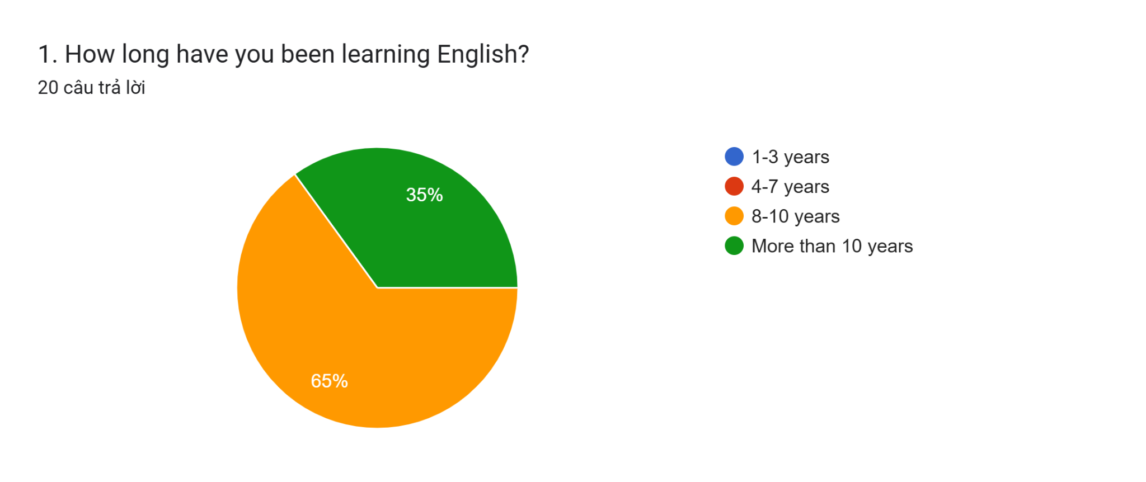
When it comes to difficulties in learning English, a large number of students have voiced their concern about the difficulties that they have over some English receptive and productive skills. More specifically, over 60 % of the students said they had trouble with Listening skills and half of the students found writing challenging. Regarding language areas, over a third of the surveyed subjects said that they had trouble learning vocabulary and grammar. Moreover, 30 percent of students have had problems with reading and pronunciation. These findings had shown that there was a need for the researcher to help the learners with their problems.
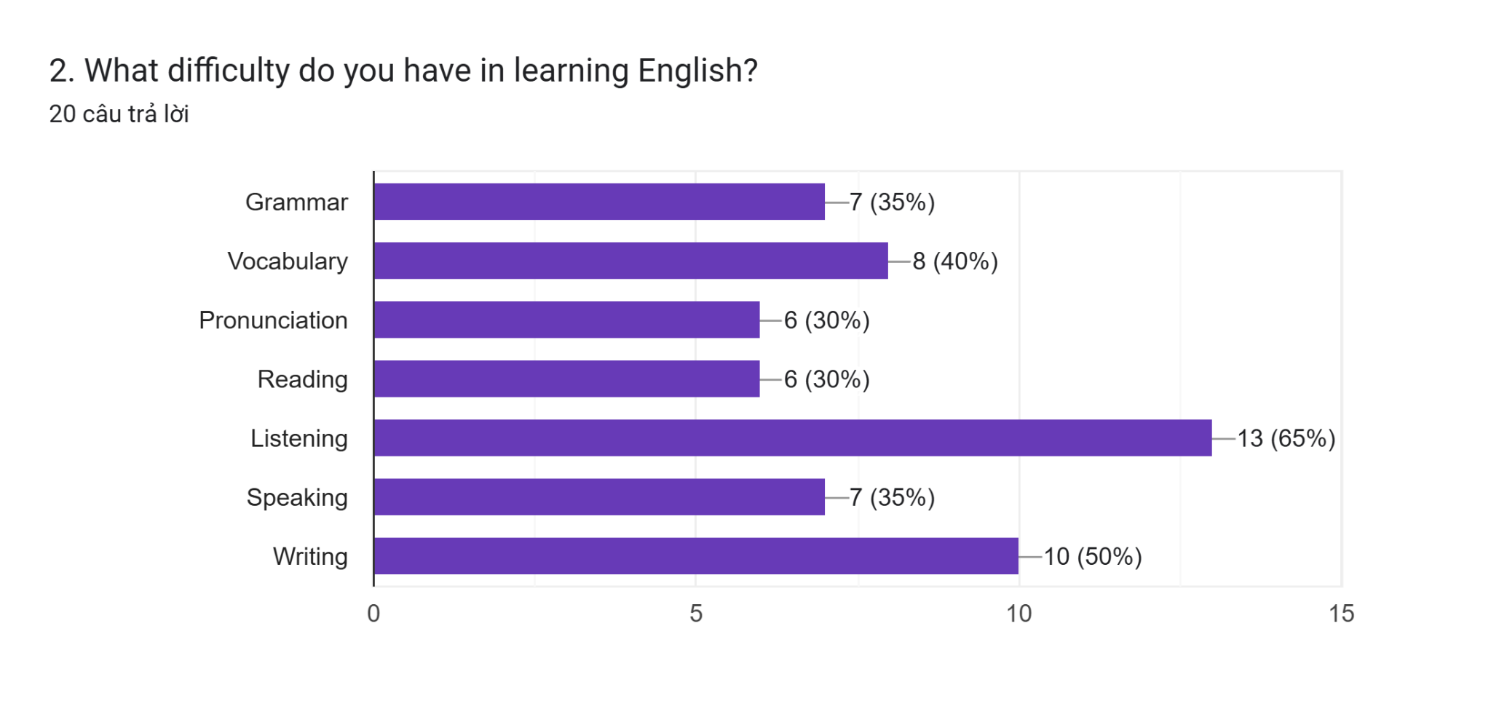
A minority of students said they had no experience of learning with apps while over 60 % of the students stated they had experienced these in their learning.
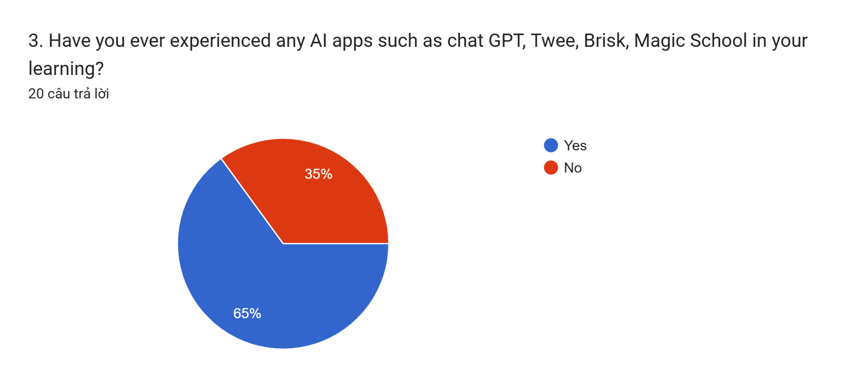
The subjects of the study also valued the roles of Artificial Intelligence in language learning. 95 % of them expressed a wish to study with AI apps in the future.
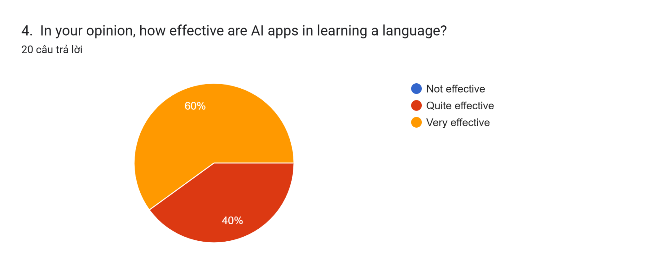
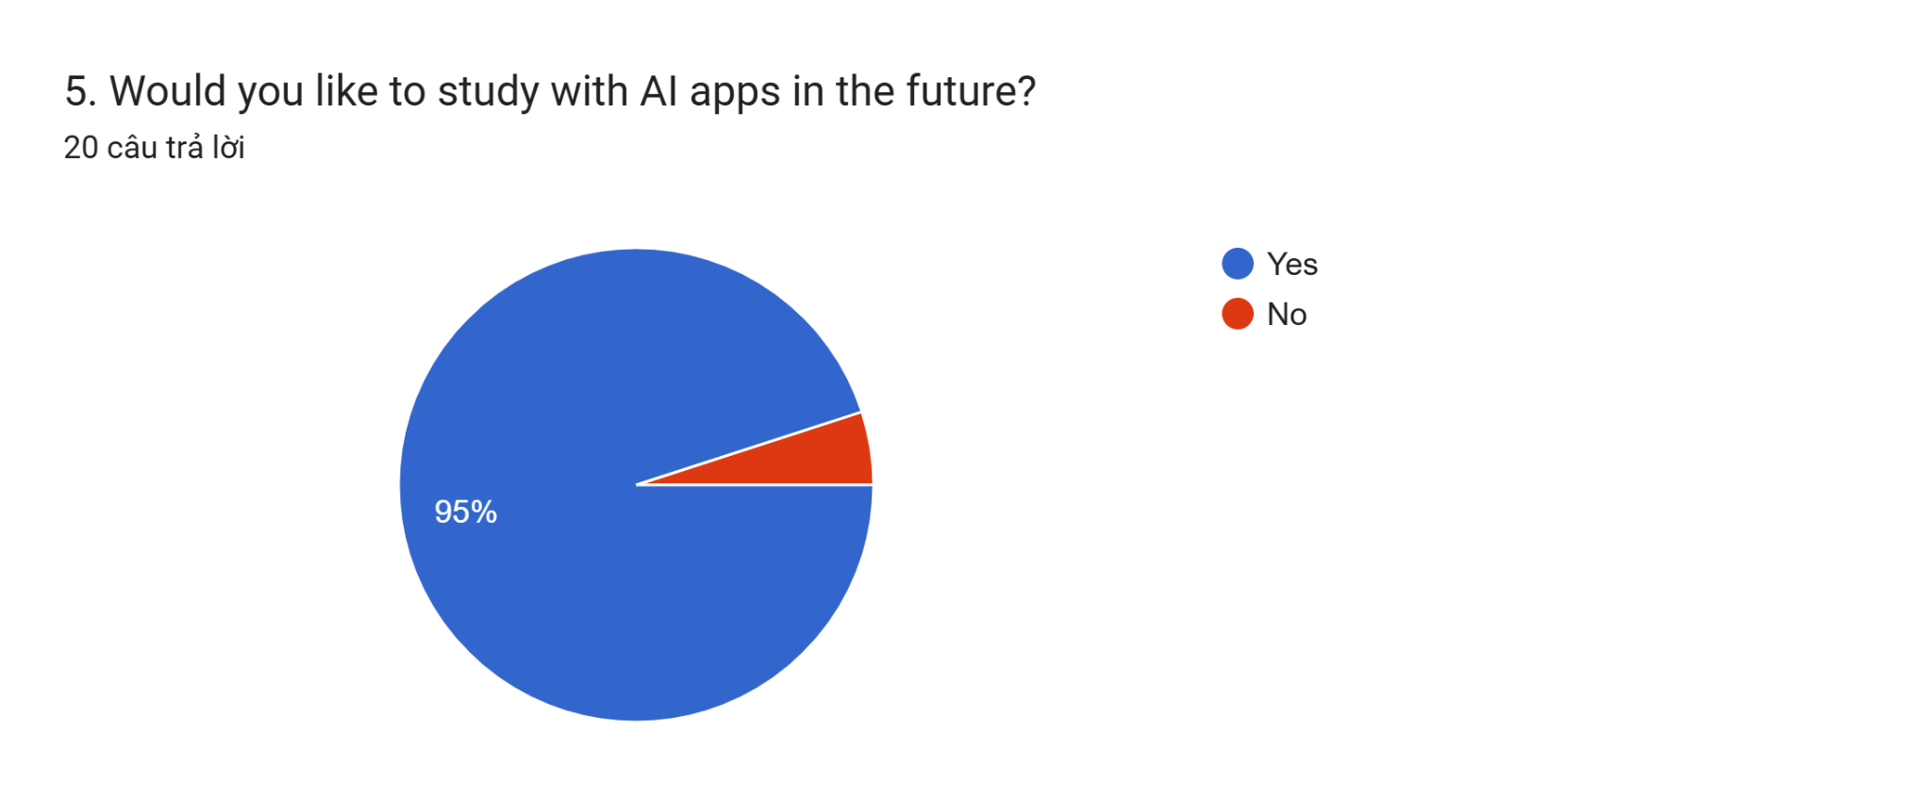
In conclusion, the background information of the participants that the researchers collected from the questionnaire before the treatment supports the idea that the AI apps are necessary to assist teachers in addressing learners’ problems.
The results of students’ English tests before the application of AI tools
As mentioned previously, the pre-treatment test has been carried out to find out students’ level of listening skill and weaknesses. Based on the collected data, the researcher could evaluate the students’ weaknesses and choose appropriate AI-driven tools to facilitate their learning process.
Regarding tests, students’ scores were grouped into 3 categories of fail (under 15 point ), pass and credit (15 to 21 points) and distinction (above 21 points) ( Maximum scores: 30 points)
By comparing the result of the pre-test and the post-test, the researchers measured the gains that the subjects had made and determined the effectiveness of the treatment (Hatch & Farhady, 1982, p. 20).
According to the table and the chart, there were only slight differences in each score group between two groups. To be specific, bad scores (under 15) accounted for 40 % in both the experimental and control group. About 40 % of the students belonging to the experimental group scored from 15 to 21 while that figure in the control group was lower at 30 %.
Pretest results of two groups
Score | Under 15 |  | From 15 to 21 |  | Above 21
Experimental | 4 | 40 % | 4 | 40 % | 2 | 20 %
Control | 4 | 40 % | 3 | 30 % | 3 | 30 %

It is obvious from the data presentation above that there was some disparity, albeit very slight, among the three specific categories under scrutiny – fail, pass and credit, and distinction. Therefore, it was necessary to examine the scores taken as a whole or mean value which is summarized in the following tables.

Mean and standard deviation of pretest
Experimental Group

Statistics
VAR00001
N | Valid | 10
N | Missing | 0
Mean |  | 18.0000
Std. Deviation |  | 4.42217

Control Group

Statistics
VAR00001
N | Valid | 10
N | Missing | 0
Mean |  | 17.0000
Std. Deviation |  | 4.16333

Mean and standard deviation of two groups’ results in pretest
 | Mean | Standard Deviation
Experimental | 18.0000 | 4.42217
Control | 17.0000 | 4.16333
The means for the experimental and control groups were 5.8429 and 5.5857 respectively. As such, their difference was 0.2572. The standard deviation of nearly the same showed that the dispersion of scores around the central tendency was similar. To examine whether the difference in the means was statistically significant, an independent sample t-test was carried out by hand first:
$$obsEC=\frac{ME-MC}{\sqrt{(SDE^{2}/NE)+(SDC^{2}/NC)}}$$

$obsEC=\frac{18-17 }{\sqrt{(4.42217{}^{2}/10)+(4.16333{}^{2}/10)}}$= 1.7559
The result obtained from manual calculation was 1.7559. Since the absolute value of t did not exceed the critical value of 1.98 (with df=95, p ≤ .05, and a two-tailed test), the difference between two means was not statistically significant. It can be concluded inferentially that students in two groups were equal in terms of listening competencies at the beginning of the research.
Mean and standard deviation of two groups’ results in posttest

Experimental Group
Statistics
VAR00001
N | Valid | 10
N | Missing | 0
Mean |  | 22.7000
Std. Deviation |  | 4.00139

Control Group

Statistics
VAR00001
N | Valid | 10
N | Missing | 0
Mean |  | 18.9000
Std. Deviation |  | 3.90014

The following table shows statistics of two groups’ results in posttest.
 | Mean | Standard Deviation
Experimental | 22.7000 | 4.00139
Control | 18.9000 | 3.90014
It is obvious from the table that the experimental group had a mean of 22.7000 which surpassed that of the control group at 18.9000. Whether the difference carried a statistical significance was proved through the independent sample t-test calculated by hand.
$$tobsEC=\frac{ME-MC}{\sqrt{(SDE^{2}/NE)+(SDC^{2}/NC)}}$$
$tobsEC=\frac{22.7000-18.9000}{\sqrt{(4.00139{}^{2}/10)+(3.90014{}^{2}/10)}}$ = 2.1506
The t value obtained of 2.1506 exceeded the critical value of 1.98 (a two-tailed test, df=95, p≤.05). Therefore, there was a statistically significant difference in performance between the two groups in the posttest. This gives grounds for the conclusion that the experimental group surpassed the control group in the test thanks to the treatment.
Results of pretest and posttest of experimental group

In conclusion, the analysis of the two tests proves that teaching with the help of AI tools is obviously an element of students’ progress in enriching lexical items and listening comprehension. After eight weeks of experimental teaching, the experimental group’s English listening proficiency has improved a lot.
Post- treatment questionnaire
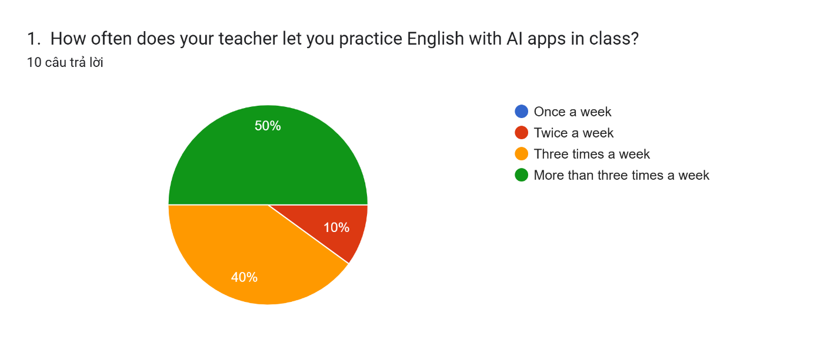
The pie chart shows the frequency of experiencing AI-powered tools of students. 100 % of them said they could practice English with AI apps twice a week or more.
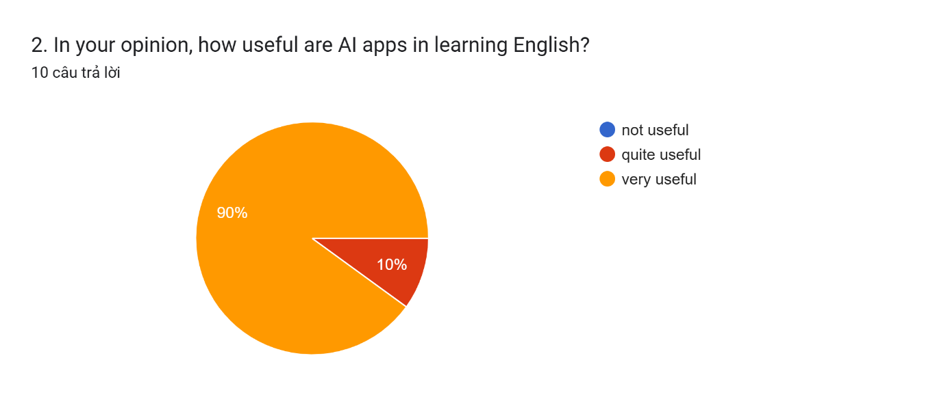
Regarding the evaluation of AI-driven tools, all participants appreciated the usefulness of these tools.
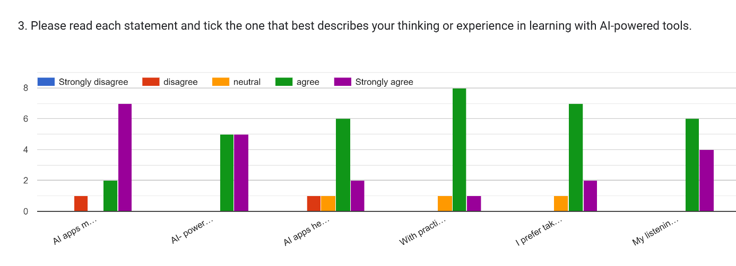
When it came to the benefits of AI-driven tools, most of students were in agreement with the ideas that AI- powered tools contributed to the exciting atmosphere of the classroom and the improvement of their language, listening ability and learning outcomes as a whole. Only a small number of students remained neutral or disagreed with those statements. Furthermore, many participating students (9 out of 10 students) also expressed their preference for the online tests.
When being asked about the difficulties in experiencing AI-driven platforms in learning English, most students stated they didn’t have any problems. However, it is significant to emphasize some problems raised by several students such as the requirement of electronic devices and Internet connection for their lessons with the AI- based flatforms.
Interview
In response to the questions, all teachers interviewed said that they had taken advantage of AI-powered tools in their teaching and they also expressed their willingness to utilize AI apps to generate quizzes and extra materials for their classes.
When it came to the effectiveness of AI – driven applications such as Twee, Brisk Teaching or Magic School, five teachers rated those apps quite effective and very effective in designing activities or quizzes. They also concluded that the tools were beneficial for students.
Teacher A said that:
“I think creating quizzes with AI – driven platforms such as Briskteaching is time-saving and they provide a variety of questions generated for listening comprehension quizzes.”
Teacher C added:
“I am willing to use AI apps to generate quizzes and extra materials for my students. They are convenient, and help reduce workload for teachers. Moreover, we can see the grades of studies instantly and check their completion or progress.”
However, the participating teachers agreed that the reliability of some tasks was not high and it was essential for the teachers to check the accuracy of the answers. It also demanded a lot of the teachers since they needed to be competent at technology and manage the testing well.
Discussion
The findings of the research illustrate that AI-driven platforms have had a positive influence on students’ learning. AI-powered utilization has assisted teachers a lot in their work and helped students practice English in a creative and confident way. Despite the acknowledgement of their advantages, careful consideration of the other side of AI should be taken. Some teachers and researchers have warned that people will rely too much on AI, which makes them become technology-dependent. Moreover, since AI can think and generate ideas as humans do, we, the real humans, will turn into a lazier version that may lose the ability to think creatively, logically, and thoughtfully (Kornfeld & Roy, 2021).
While the integration of AI-assisted tools into language instruction offers notable advantages, their application in the design of listening tasks presents several limitations that warrant consideration. Firstly, the authenticity of AI-generated listening materials is often questionable, as synthesized audio may lack essential features of natural speech such as intonation, pausing, variation in accent, and spontaneous language use. These elements are crucial in fostering learners’ ability to comprehend real-world spoken discourse. Furthermore, the content produced by AI tools may contain linguistic inaccuracies, illogical question sequencing, or inconsistencies in difficulty levels, thus necessitating thorough review and manual adjustments by teachers. This, in turn, may increase the preparation time required and place an additional burden on instructors, particularly those who lack advanced technological proficiency. Sometimes, video posted on Youtube are authorized, which hinder the process of producing the tasks, such as what can be done in Magic school. Moreover, AI systems are inherently limited in their ability to make pedagogically sound decisions and to adapt materials to the nuanced needs, interests, and backgrounds of individual learners. The use of such tools also presupposes consistent access to electronic devices and stable internet connectivity, conditions which may not be met in all educational settings. Finally, excessive dependence on AI in instructional design may inadvertently diminish teachers’ agency and creativity in developing contextually appropriate and pedagogically rich listening activities. These considerations suggest that while AI tools can serve as valuable support mechanisms, their effectiveness is maximized only when complemented by informed and critical human oversight.
CHAPTER V– CONCLUSION AND RECOMMENDATION

The study was carried out to investigate the effects of adopting AI-powered tools in helping teachers to design listening tasks for gifted students and aimed at improving their listening skills. The research findings help to answer the research questions posed in this study. Students show positive attitudes towards learning English with AI-driven platforms. The surveyed teachers acknowledge the effectiveness and assistance of Artificial Intelligence in their teaching.
This paper, however, looks more at the positive side of AI. It is expected that a more elaborate study on the other side of AI should be conducted in the near future. Moreover, due to the limitation of free versions of some AI- powered tools, the researcher couldn’t take full advantage of them during the experiential teaching. It is anticipated that the researcher will be able to afford and exploit some more apps soon.

REFERENCES
Arbi, A. P. (2024). Optimizing the use of artificial intelligence in English language learning: A literature review. Gudang Jurnal Multidisiplin Ilmu, 2(2), 25-30. https://doi.org/10.59435/gjmi.v2i2.278
Brown, J.D. (2001). Using surveys in language programs. Cambridge: Cambridge University Press.
Cambridge Dictionary. Artificial Intelligence. Retrieved December 2, 2024, from https://dictionary.cambridge.org/dictionary/english/artificial-intelligence
Crompton, H., Burke, D., Edmett, A., & Ichaporia, N. (2024). AI and English language teaching: Affordances and challenges. British Journal of Educational Technology, 00, 1-27. https://doi.org/10.1111/bjet.13460
Dermo, J. (2009). e‐Assessment and the student learning experience: A survey of student perceptions of e‐assessment. British Journal of Educational Technology, 40(2), 203-214.
https://doi.org/10.1111/j.14678535.2008.00915
Du, J., & Daniel, B. K. (2024). Transforming language education: A systematic review of AI-powered chatbots for English as a foreign language speaking practice. Computers and Education: Artificial Intelligence, 6, 1-12. https://doi.org/10.1016/j.caeai.2024.100230
Ghafar, Z. N., Salh, H. F., Abdulrahim, M. A., Farxha, S. S., Arf, S. F., & Rahim, R. I. (2023). The role of artificial intelligence technology on English language learning: A literature review. Canadian Journal of Language and Literature Studies, 3(2), 17-31. https://doi.org/10.53103/cjlls.v3i2.87
Hatch, E., & Farhady, H. (1982). Research design and statistics for applied linguistics. Massachusetts: Newbury House Publishers, Inc.
Kornfeld, L., & Roy, D. (2021). Educational implications of AI writing tools for academic writing. British Journal of Educational Technology, 52 (1), 248–262. https://doi.org/10.1111/bjet.12973.
Jiang, R. (2022). How does artificial intelligence empower EFL teaching and learning nowadays? A review on artificial intelligence in the EFL context. Frontiers in Psychology, 13, 1-8. 13:1049401.
DOI: 10.3389/fpsyg.2022.1049401
Liu, C.-C., Liao, M.-G., Chang, C.-H., & Lin, H.-M. (2022). An analysis of children's interaction with an AI chatbot and its impact on their interest in reading. Computers &amp; Education, 189, 104576. https://doi.org/10.1016/j.compedu.2022.104576
Macías, A. M., Solano, D. O., Perero, L. M., Panimboza, J. A., & Soledispa, C. J. (2024). The potential of artificial intelligence to improve speaking skills in a second language (English) fluently. Ciencia Latina Internacional, 8(3), 3826-3834. https://doi.org/10.37811/cl_rcm.v8i3.11592
Nguyen, T. X. (2024). English majors’ perceptions of ai tool application in English language learning at tertiary level in Vietnam. Journal of Knowledge Learning and Science Technology, 3(1), 179-190. https://doi.org/10.60087/jklst.vol3.n1.p193
Obari, H., Lambacher, S., & Kikuchi, H. (2020). The impact of using AI and VR with blended learning on English as a foreign language teaching. In K.-M. Frederiksen, S. Larsen, L. Bradley & S. Thouësny (Eds), CALL for widening participation: short papers from EUROCALL 2020 (pp. 253-258).Research-publishing.net. https://doi.org/10.14705/rpnet.2020.48.1197
Phan, T. N. (2022). Using artificial intelligence applications for teaching and learning foreign language: Facts and solutions. International Journal of English Language, Education and Literature Studies, 1(4), 12-15. DOI:10.22161/ijeel.1.4.2
Rusmiyanto, Huriati, N., Fitriani, N., Tyas, N. K., Rofi’i, A., & Sari, M. N. (2023). The role of artificial intelligence (AI) in developing English language learner's communication skills. Journal on Education, 6(1), 750-757. https://doi.org/10.31004/joe.v6i1.2990
Sharadgah, T. A., & Sa’di, R. A. (2022). A systematic review of research on the use of artificial intelligence in English language teaching and learning (2015-2021): What are the current effects? Journal of Information Technology Education: Research, 21, 337-377. https://doi.org/10.28945/4999
Shazly, R. E. (2021). Effects of artificial intelligence on English speaking anxiety and speaking performance: A case study. Wiley. https://doi.org/10.1111/exsy.12667
Son, J.-B., Ružić, N. K., & Philpott, A. (2023). Artificial intelligence technologies and applications for language learning and teaching. Journal of China Computer-Assiste d Language Learning. 10.1515/jccall-2023-0015. https://doi.org/10.1515/jccall-2023-0015
Wikipedia. Artificial Intelligence. Retrieved December 2, 2024, from https://en.wikipedia.org/wiki/Artificial_intelligence
Yan, J. (2024). Effectiveness analysis and optimization path of AI tutoring models in foreign language learning applications. Applied Mathematics and Nonlinear Sciences, 9(1), 1-14. DOI:10.2478/amns-2024-1341
Yulianto, D., & Mujtahin, N. M. (2021). Online assessment during COVID-19 pandemic: EFL teachers’ perspectives and their practices. Journal of English Teaching, 7(2), 229–242. http://ejournal.uki.ac.id/index.php/jet/article/view/2770

APPENDIX A
Student’s questionnaire
PRE- TREATMENT QUESTIONNAIRE

Section 1: Respondent’s background
1. Fullname:_____________________________________
2. Gender: ◻ Male ◻ Female
3. Age:__________
Section 2: Questions
- How long have you been learning English?
◻ 1-3 years ◻ 4 -7 years ◻ 8-10 years ◻ more than 10 years
- What difficulty do you have in learning English? (You can choose more than one option)

◻ Grammar ◻ Pronunciation
◻ Vocabulary ◻ Speaking
◻ Reading ◻ Listening
◻ Writing
- Have you ever experienced any AI apps (e.g. chat GPT, Twee, Brisk) in your learning?
◻ Yes ◻ No
- Do you like studying with AI apps?
◻ Yes ◻ No

THIS IS THE END OF THE QUESTIONNAIRE. THANK YOU FOR YOUR COOPERATION.

APPENDIX B
Student’s questionnaire
POST- TREATMENT QUESTIONNAIRE
Section 1: Respondent’s background
1. Fullname:_____________________________________
2. Gender: ◻ Male ◻ Female
3. Age:__________

Section 2: Questions
- How often does your teacher let you practice English with AI apps in class?
◻ Once a week ◻ Twice a week
◻ Three times a week ◻ More than three times a week
- In your opinion, how useful are AI apps in learning English Listening?
◻ not useful ◻ quite useful ◻ very useful
3. Please read each statement and tick the one that best describes your thinking or experience in learning with AI-powered tools.
1. Strongly disagree 2. disagree 3. neutral 4. agree 5. Strongly agree
 | Statements | 1 | 2 | 3 | 4 | 5
1 | AI apps make the lessons more interesting.
2 | Twee and Brisk help me enhance listening ability.
3 | AI apps help me to improve my language knowledge.
4 | With practices that the teacher gave me on AI apps, I find it easy to remember the lesson.
5 | I prefer taking tests online to traditional ones.
6 | My listening skill has improved thanks to materials from AI apps that my teacher used.
4. Have you had any difficulties in experiencing AI-driven platforms for your learning? If yes, please specify.
_________________________________________________________
THANK YOU SO MUCH FOR YOUR KIND HELP!
APPENDIX C
INTERVIEW SHEET
(for teachers)
Background information
Name: ______________________ ◻ Male ◻ Female
Age: ________ School: ______________________________
Teaching major: ______________ Teaching experience: ________
Questions for interviewing:
- Have you ever utilized AI-powered tools in your teaching?
- Are you willing to use AI apps to generate Listening tasks for your students?
- How effective are AI-powered tools such as Twee and BriskTeaching in designing Listening tasks for your class?
- What benefits have AI-driven platforms brought to you in your teaching?
- Are there any problems and limitations of these tools?

THANK YOU FOR YOUR COOPERATION.

APPENDIX D
t-distribution table
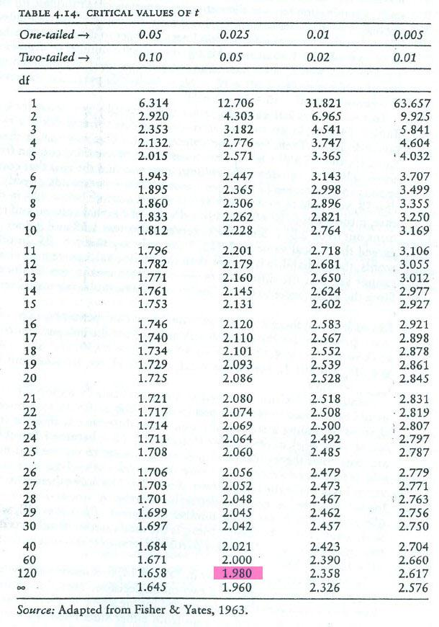

APPENDIX E
Some examples of the assignments designed by AI-powered tools
Brisk teaching
https://docs.google.com/forms/d/1Qyk5nlcLkaHoGQ0hgfUh3AAko8V3ljxGt9zeN6Nnp1w/edit
https://docs.google.com/forms/d/e/1FAIpQLSe7fwGJQWHLw4SBDoDB5YYUXu8y4Lx7F1WCggb4dgibIYH2-w/viewform
https://docs.google.com/forms/d/1vGlKLyQ8p5F3nt5cXynnfcYSbcuXy3MeSrvznnadfDU/edit
https://docs.google.com/forms/d/e/1FAIpQLScvAoFXkZWjnO0AdoF9d4W5AArWpYu54zhMo_hS1C1neuiGZQ/viewform
https://docs.google.com/forms/d/1cT0u6rVwbeC5Oc0T5Cnj_HrQyOfh8vQrLnumbzd9YkY/edit
https://docs.google.com/forms/d/1GGbhezOnCBKAsZZlFKCQ1KsZnXq-wpYvzkKjq26O2io/edit
https://docs.google.com/forms/d/1efKLoZbEx9pVB-bqouCurIc2xUDssLBTLGCpUNih6Es/edit
https://docs.google.com/forms/d/1AWcynkPEiYUQsoG-f4tBBX29xS6dzd5-GElDjJC4gAg/edit#responses
ChatGPT and Copilot
Exercise 1:
Script edited from youtube link: https://www.youtube.com/watch?v=XQuwFb0JMqg&t=72s
Southeast Asia has a lot of incredible countries to offer and it can be hard to know which to visit. This is Katie from Creative Travel Guide and today we share the five best destinations to visit in Southeast Asia. Looking for more travel tips? Make sure to hit subscribe and ring that notification bell.
So firstly we have Cambodia. Now there are some pros for visiting Cambodia which include everything being cheap. So hotels, transport, food, drink and attractions are all relatively cheap.
Perfect for those traveling Asia on a budget. The people in Cambodia are warm and friendly who are always welcoming to tourists. Visit the capital city of Phnom Penh which holds some destructive history but is worth learning about and exploring.
Whilst you're in Cambodia also make sure to head to Siem Reap home to the stunning and expansive Angkor Wat, an ancient complex that was hidden from civilization for thousands of years. Next we have Singapore. So at the height of sophistication, the contemporary city of Singapore is a perfect choice for those looking for some luxury in their travels.
Visit the temples and hawker markets before exploring the shopping malls, casinos and marina bay sands. Just be aware that although Southeast Asia is a pretty affordable place to explore, Singapore does have expensive accommodation options. So this is one of the more pricier places to visit in the region.
Next we have the Philippines. So the Philippines offers a mixture of busy city centers, luscious landscapes and picturesque beaches. There is so much to enjoy across the country of the Philippines that makes the place well worth a visit.
Again this is a very affordable place to explore and there are so many stunning sights to be found here. Just bear in mind that you will need a little bit more time to really explore the Philippines properly. The country is a developing place with less tourists than the rest of Southeast Asia, meaning that transport between the cities and different islands can be slightly trickier and longer than the rest of Asia.
The next place you have to visit in Southeast Asia is Vietnam. There are so many different cities, towns and attractions to explore in Vietnam from the war museums and Chu Chi tunnels to one of the natural seven wonders of the world, Halong Bay. You could spend months in Vietnam exploring and learning about this rich culture.
Vietnam is actually one of the cheapest places to visit in Southeast Asia with private rooms still costing only around eight dollars a night. Plus everything is accessible. There are plenty of flights and transport options for all budgets.
And lastly we have Thailand. With warm weather all year round, glorious beaches, breathtaking nature, bustling cities and incredible temples, there is something for everyone in Thailand. Head to Bangkok to see the sights and visit the markets.
Journey up north to see the historic city of Chiang Mai and make sure to spend some time island hopping in the south. Whilst you're in Thailand, you will also want to check out the amazing food from pad thai and curries to durian and mango sticky rice. Watch this video to learn about the best cheap destinations in Asia.
Then for some tips for backpacking Asia, watch this video. We hope you have an incredible time in Southeast Asia. Let us know in the comments below where you are heading to.
Happy travels and stay creative.
Listening task:
For questions 6-10, you will hear about five countries in Southeast Asia. Match each number (6-10) in Column I with the correct description (A–J) to make a correct statement according to what is stated or implied by the speakers. Write your answers in the corresponding numbered provided.
Column I | Column II
6. Cambodia  7. Singapore  8. The Philippines  9. Vietnam  10. Thailand | A. experiences four seasons with colorful autumn foliage.  B. offers affordable hotels, transport, and friendly locals.  C. showcases quiet rural areas with low tourist visits.  D. presents modern luxury shopping, casinos, and expensive hotels.  E. includes large rainforests and extensive river systems.  F. provides budget-friendly travel, rich culture, and historical sites.  G. features warm climate, bustling markets, and many beautiful islands.  H. contains vast deserts and ancient pyramids.  I. attracts skiers and hikers to mountain resorts.  J. has busy cities, diverse landscapes, and slow transport connections.
Suggested answers:
6. B 7. D 8. J 9. F 10. G
Exercise 2:
Script edited from youtube link
(Source: https://www.youtube.com/watch?v=UVf2Yw7uFoE)
As the effects of climate change become more visible around the world, governments are under increasing pressure to speed up the transition to clean energy. But while some countries are taking bold steps, others are falling behind. Our report tonight looks at how progress toward renewable energy is unfolding — and why the global race remains uneven.
Over the past decade, Germany has emerged as one of the most ambitious nations when it comes to energy reform. In a landmark commitment, the country has pledged to become carbon-neutral by 2045. This goal is part of Germany’s broader “Energiewende,” or energy transition — a national strategy that involves shutting down coal-fired power plants, phasing out nuclear energy, and ramping up investments in wind, solar, and hydrogen technologies.
Meanwhile, China has taken a different but equally influential path. It has become the world’s largest producer of solar panels, manufacturing over 80 percent of the global supply. At the same time, it is investing billions in large-scale wind farms and hydroelectric projects. Analysts say this gives China a central role in shaping the future of renewable energy worldwide.
But while countries like Germany and China push forward, others continue to face major obstacles. In Sub-Saharan Africa, for instance, the potential for solar energy is enormous — yet access remains limited. Many regions lack basic infrastructure, such as power grids, to support wide-scale electricity distribution. Financing is another barrier. Without reliable investment and government support, large-scale renewable projects often stall before they begin.
The International Energy Agency has raised the alarm. In its latest assessment, the agency warned that if current investment trends continue, the world will miss key climate targets set under the Paris Agreement. It says much more funding is needed, especially in developing regions, to close the gap between energy demand and clean energy supply.
At the same time, demand for energy is growing — and fast. In countries like India, Indonesia, and Nigeria, population growth, urbanization, and industrial expansion are driving electricity use to record levels. However, renewable energy systems are not being built quickly enough to keep up. As a result, many nations are turning back to coal or gas to meet short-term needs, raising concerns about long-term emissions.
This has led to fresh calls for what experts describe as a “just energy transition.” The idea is simple: clean energy must not only be environmentally sustainable but also socially and economically fair. That means ensuring that low- and middle-income countries have access to technology, funding, and infrastructure — and that no region is left behind in the global energy shift.
The transition to renewable energy is no longer a question of if, but how fast and how fairly it can be achieved. With climate risks intensifying and deadlines approaching, many believe that stronger global cooperation is not just necessary — it’s urgent.
Listening task:
For questions 6 - 10, you will hear a news report discussing how different countries and regions are progressing in the transition to renewable energy. Listen carefully to the recording and match each location or organization with the correct description. Write your answers in the corresponding numbered boxes provided.
Column I | Column II
6. Germany  7. China  8. Sub-Saharan Africa  9. International Energy Agency (IEA)  10. The World | A. is experiencing setbacks in phasing out coal due to energy shortages.  B. is pioneering large-scale offshore wind energy development.  C. faces critical infrastructure gaps despite having high solar potential.  D. warns that the current pace of transition is insufficient to meet climate goals.  E. is shifting its economic strategy to focus more on electric vehicle production.  F. has committed to becoming carbon-neutral by 2045.  G. has surpassed all other countries in solar panel manufacturing.  H. is facing delays in its nuclear energy expansion projects.  I. is heavily investing in energy storage technologies for grid stability.  J. sees increasing energy demand outpacing the growth of renewables.
Suggested answers:
1F | 2G | 3C | 4D | 5J

Exercise 3:
Source: Adapted from CAE Reading & Use of English, Test 2
The Beach by Alex Garland
Alex Garland's tale of a group of work-shy travellers who independently discover an island paradise in Thailand inspired a generation of gap year students to head to the Far East. Garland acidly investigates what such people would do if found their idea of Paradise – keep it to themselves, whatever the cost. What purports to be a likeable, broad-minded community turns out to be cliquish, mistrustful and selfish. Garland displays nerve in slaughtering the characters that are likely to closely resemble his main readership.
Notes From a Small Island by Bill Bryson
An unabashed Anglophile, Bryson spent 20 years in Britain before deciding to repatriate to his native Iowa. Notes from a Small Island depicts his farewell journey across "the green and kindly island" with humour and nostalgia. Although readers from all nations will enjoy it, only the British themselves will experience the full gamut of emotions that this book has to offer; at times, cringing as Bryson deftly points out their most ridiculous foibles, while at others feeling immense pride at its rich and varied culture.
Arabian Sands by Wilfred Thesiger
Thesiger's account of a precarious journey through the Arabian deserts met with considerable acclaim ever since its publication in 1956. The book covers five years that the author spent in and around the Empty Quarter, half a million square miles of cruel desert. Before Thesiger, no other traveller had dared to cross this empty wasteland, except for the Bedu who inhabit it. Thesiger lived as one of the tribe, describing their unimaginable hardships as if they were mere inconveniences. His experiences are unique, and will remain so now that the world he described, which had been unchanged for millennia, has been invaded by oil companies.
Naples '44 by Norman Lewis
Norman Lewis arrived in war-torn Naples as an intelligence officer in 1944, ostensibly employed by the army to liaise with the locals. His year-long journal that he kept at the time is a heart-warming portrait of a city that had descended into chaos, and its starving population. Lewis had a keen sense of observation and depicts the idiosyncrasies of Italian culture with humour, warmth and accuracy. The reader will encounter respectable women driven to prostitution and a gynaecologist who "specializes in the restoration of lost virginity". The book leaves the reader with both a profound sadness at the futility of war and a strange reassurance that people are inherently good, despite their incredibly bleak and desperate circumstances.
A Short Walk in the Hindu Kush by Eric Newby
Newby humorously describes the trials and tribulations encountered that Eric Newby and his climbing partner Hugh Carless as they attempt, and fail, to scale one of Afghanistan's most challenging peaks. However, neither Newby nor his friend have any experience in climbing; moreover the area they are visiting is basically unchartered and potentially violent territory. Their expedition is so ill-thought-out that at times it reads like a farce. At one point they encounter the explorer Wilfred Thesiger as they are blowing up their air-beds. 'You must be a couple of pansies,' comments the experienced adventurer. Although Newby provides enough description of the landscape to give the reader a sense of being there, it does not overshadow the exploration of human character which is the overriding theme of the book.
For questions 6 – 10, listen to a book review and match each number (6 - 10) in Column I with one letter (A - J) in Column II to make a correct statement according to what is stated or implied by the speaker. Write your answers in the corresponding numbered boxes provided.
Column I | Column II
6. The Beach by Alex Garland  7. Notes From a Small Island by Bill Bryson  8. Arabian Sands by Wilfred Thesiger  9. Naples '44 by Norman Lewis  10. A Short Walk in the Hindu Kush by Eric Newby | A. played down the challenging lifestyle he encountered  B. may make a majority of readers feel embarrassed  C. portrayed the people who would read his book in a bad light  D. is written in a diary form  E. shows how well-prepared the writer was for his travels  F. describes a relationship, rather than an environment  G. described a lifestyle which has reversibly altered  H. focuses on the positive attributes of travellers who seek to discover new places  I. is best read by people from the nation depicted in the book  J. will best suit readers of a specific nationality and age-group
Suggested answers:
6 C | 7 I | 8 A | 9 D | 10 F

Magicschool

Comprehension Questions for Video
- True or False: Tamara is interviewing for a position in human resources.
- True or False: Tamara has worked in human resources for over 10 years.
- True or False: The interviewer mentions that being late to work is acceptable up to five times in six months.
- True or False: Tamara believes that teamwork is an important quality to look for when hiring someone.
- True or False: Tamara was in the United States Navy before applying for this position.
- True or False: The current human resource assistant has been in the position for four years.
- True or False: Tamara has no questions for the interviewer at the end of the interview.

Answer Key:
- True (0:05)
- True (0:10)
- False (0:30)
- True (0:35)
- False (0:10)
- True (1:05)
- True (1:20)
Script:
I: interviewer ; T: Tamara
T: Good morning. I'm Tamara Hamilton, and I'm here for my interview.
I: Hi, Tamara. Nice to meet you. I'm Stephanie.
T: Thank you.
I: Well, Tamara, what position are you interviewing for today?
T: I'm actually interviewing for your human resource assistance position.
I: Very good. And where did you see this job posted?
T: I actually saw it in the Work in Texas database. I matched up to it in my profile.
I: Great. That's very exciting. Well, thank you for being here today. Tell me if you would a little bit about your human resource background.
T: Well, I spent the last 21 years in the United States Air Force as a human resource assistant,
and I actually recruited and interviewed individuals to come into the United States Air Force.
I: Very good. Well, let me ask you a question. When you're interviewing someone for a job, what qualities are you looking for?
T: I'm actually looking for qualities more so that deal with teamwork, ability to attention to detail,
and see if they can work by themselves at times. We know that all times they won't be able to, but the ability to take self-initiative and to work alone.
I: Okay. If you would, tell me how many times you think in, say, a six-month period, it's okay to be late to work.
T: Six-month period. Now, coming from the United States Air Force, we know there are times. Being late, we give you three strikes.
I: Three times in a six-month period?
T: Three times in a six-month period.
I: Okay.
T: And normally, you have processes and procedures that you would follow up with those lateness.
For instance, if you're going to be late, we've already told you ahead of time what you need to do
to ensure that your supervisor or whoever's in charge knows why you're being late.
I: Good. Okay. What would your previous co-worker say about you? If we went to talk to your last job and said, tell us about Tamara, what would they say is your greatest quality?
T: Easy to get along, bubbly attitude, means business, wants to get the job done.
I: Okay. What would they say is the thing that Tamara needs to do a little better? We all have those things we can improve upon. What's the thing that you're working on?
T: Coming off, or not coming off so harsh with an individual, the things like if you make a mistake,
you know, why did you make the mistake and try to find out the root problem of it and then teach them better on so it doesn't happen again.
I: Okay. What do you think it takes to be a good employee?
T: A good employee, showing up to work on time, being there as a team member, knowing your job.
I: Knowing your job.
T: Knowing your job. If you don't know the job, ask questions.
Don't sit there like I'm not on the log and not ask the question.
And I truly believe in taking self-initiative, you know, to bring something to the table.
I: Okay. Well, Tamara, do you have any questions of me?
T: Well, one question I do have of you, and I was just reading some information last week,
is how many people, or how often have you had to fill this position as a human resource assistant?
I: We've, this position has had one person in it for the last four years, and she actually has a husband who's relocating out of the area, and so she wants to follow him, and that's what's created this position that we're interviewing you for today.
T: Thank you very much.
I: Any other questions?
T: No, ma'am. Sure don't.
I: Well, Tamara, thank you for coming in today. I really appreciate it. What I'm going to do is give you my card, okay? And if you have any questions that come up, please call me, and I expect that you're going to be hearing from us within the next day or two.
T: Thank you very much, and I appreciate your time, ma'am.
I: Thank you so much. All right.
T: Bye-bye.
I: Bye-bye.
Source: https://youtu.be/SieNfciN274?si=0gi5gEAQzH1ZQgWi
Exercise 2:

Video Comprehension Questions on Dugongs in the UAE
1. What is the nickname of the dugong?
a. Sea cow
b. Water horse
c. Ocean pig
d. Marine elephant

2. How long can an adult dugong grow?
a. 5 feet
b. 10 feet
c. 15 feet
d. 20 feet

3. What major threat to dugongs is caused by human activity?
a. Overfishing
b. Pollution
c. Climate change
d. Habitat loss

4. How much seagrass can a dugong consume in a single day?
a. 30 pounds
b. 50 pounds
c. 70 pounds
d. 90 pounds

5. What is one of the measures taken to protect the dugong population?
a. Increasing boat speed
b. Banning fishing
c. Establishing marine protected areas
d. Allowing dredging

6. How many dugongs spend their summers near Abu Dhabi?
a. 1,000
b. 2,000
c. 3,000
d. 4,000

7. What organization is working to protect the dugongs?
a. Save Our Seas Foundation
b. Environment Agency Abu Dhabi
c. Marine Conservation Society
d. World Wildlife Fund

8. Why are the seagrass beds dying?
a. Natural disasters
b. Climate change
c. Dredging and construction
d. Overpopulation of dugongs

9. What is the dugong population status in the UAE?
a. Thriving
b. Vulnerable to extinction
c. Endangered
d. Critically endangered

10. What type of educational programs are mentioned in the video?
a. Marine biology courses
b. Local children learning about marine ecosystems
c. Wildlife conservation seminars
d. Fishing techniques training

Answer Key:
- a (0:15)
- b (0:20)
- d (0:25)
- c (0:35)
- c (1:00)
- b (1:15)
- b (1:30)
- c (2:00)
- b (2:15)
- b (2:45)

Vocabulary for revision after listening edited using Twee
Fill in the gaps with the words or phrases in the table:
burgeoning population | the remains | bulky | comes at a cost | beleaguered species
leach | swells | vulnerable | so-called | priority

In the seagrass beds, they seem _______________(1), placid, and content. But conservationists are worried. Some of these creatures share the coastline with the largest of the emirates, Abu Dhabi. Over a million people live here, and that number is swelling by over 50,000 each year. New buildings sprout from the sands, and engineers drive back the sea to house the _______________(2). All this prime real estate _______________(3), not just to the buyers, but to the marine environment as well. Dredging and construction _______________(4) silt into the gulf, which chokes corals. Worse for the dugongs, the silt smothers the seagrass. Covering their food supply with a blanket of debris and pollution, the seagrass beds are dying. It's a potential threat because these _______________(5)sea cows need to consume huge amounts of seagrass in order to survive. The underwater vegetation has a very low nutritional value. What dugongs lack in quality, they make up for in vast quantities. An adult can eat almost 70 pounds of grass in a single day. It's not only dugongs that suffer. The seagrasses also provide food and shelter for the endangered green turtle. And the sea turtle, in turn, provides transportation for fish called remoras. So with the seagrass beds buried, entire ecosystems of marine creatures feel the impact. But in the Emirate of Abu Dhabi, it's the dugong population that is most in the spotlight. The species has already been listed as _______________(6) to extinction. And this is part of the second largest population remaining in the world. To lose these dugongs would be a further blow to an already _______________(7). To find out what it will take to protect the dugongs, a government organization called the Environment Agency Abu Dhabi, or EAD, has been asked to investigate. The first _______________(8) is head count. More than 2,000 dugongs spend their summers near Abu Dhabi. In the winter, the number _______________(9) to almost 3,000. When a dead dugong washes up on shore, a team of scientists moves in to examine _______________(10).
Suggested answers:
1 bulky
2 burgeoning population
3 comes at a cost
4 leach
5 so-called
6 vulnerable
7 beleaguered species
8 priority
9 swells
10 the remains
Script:
From the sculpted beauty of desert dunes to the undersea realms of the Persian Gulf, the United Arab Emirates is a study in contrast. And while most people associate Arabia with desert life, the region is in fact teeming with marine animals as well, and perhaps none more intriguing than the dugong. Its nickname is the sea cow, and like its namesake, it spends hours each day grazing. Dugongs ply the warm, shallow waters off the coast, feeding along seemingly endless beds of waving seagrass. Their cylinder-shaped bodies measure more than 10 feet in length, and fully grown, they can weigh in at over 800 pounds.
In the seagrass beds, they seem bulky, placid, and content. But conservationists are worried. Some of these creatures share the coastline with the largest of the emirates, Abu Dhabi. Over a million people live here, and that number is swelling by over 50,000 each year. New buildings sprout from the sands, and engineers drive back the sea to house the burgeoning population. All this prime real estate comes at a cost, not just to the buyers, but to the marine environment as well. Dredging and construction leach silt into the gulf, which chokes corals. Worse for the dugongs, the silt smothers the seagrass. Covering their food supply with a blanket of debris and pollution, the seagrass beds are dying. It's a potential threat because these so-called sea cows need to consume huge amounts of seagrass in order to survive. The underwater vegetation has a very low nutritional value. What dugongs lack in quality, they make up for in vast quantities. An adult can eat almost 70 pounds of grass in a single day. It's not only dugongs that suffer. The seagrasses also provide food and shelter for the endangered green turtle. And the sea turtle, in turn, provides transportation for fish called remoras. So with the seagrass beds buried, entire ecosystems of marine creatures feel the impact. But in the Emirate of Abu Dhabi, it's the dugong population that is most in the spotlight. The species has already been listed as vulnerable to extinction. And this is part of the second largest population remaining in the world. To lose these dugongs would be a further blow to an already beleaguered species. To find out what it will take to protect the dugongs, a government organization called the Environment Agency Abu Dhabi, or EAD, has been asked to investigate. The first priority is head count. More than 2,000 dugongs spend their summers near Abu Dhabi. In the winter, the number swells to almost 3,000. When a dead dugong washes up on shore, a team of scientists moves in to examine the remains. First, they measure the body. And then take photographs. With the data collected, scientists try to determine the cause of death. Many of the animals are killed by boats. Others drown when they become entangled in fishing nets. Now that the authorities know where the dugongs are and how they're being impacted, they can continue to make plans to keep them safe.
When a lot of pressure came into the marine environment, the population declined. So today we have a well-established strategy for conservation of the dugong.
A major part of the conservation area is a marine protected area in the region with the densest population of dugongs. It's one of the largest sanctuaries of its kind in the Middle East. government has also enacted laws that reduce the boat speed in some areas. It's also banned certain types of fishing nets that cause the most damage to dugongs. And education awareness programs sponsored by the Save Our Seas Foundation give local children the chance to learn about the dugongs and the entire Gulf ecosystem.
Abu Dhabi is working to make sure the dugong has a future and that what happens in the sands of Arabia doesn't completely spill into its undersea realm.
https://www.youtube.com/watch?v=YProaycNpHE&t=95s

APPENDIX F
PRE- TEST
30 questions (1 point / each question) Total: 30 points
(Link for audio: https://drive.google.com/drive/folders/1TffFlZ0IJYQet-1OdTZRItXB0YHR35XE)
PART 1: You will hear people talking in eight different situations. For questions 1-8, choose the best answer (A, B or C).
- You hear a man talking about a book. What does he particularly like about it?
- It’s amusing. B. It’s well written. C. It’s informative.
- You hear a caller on a radio phone-in programme. Why has she called?
- to criticise the appearance of a new building
- to question the purpose of a new building
- to explain the location of a new building
- You overhear a conversation about families. What language does the man usually speak at home?
- Dutch B. English C. Spanish
- You hear a woman talking about learning how to make jewellery. What does she say about it?
- It’s made her realise that she lacks practical skills.
- It’s easier to do than she had expected.
- It’s created new opportunities for her.
- You hear a man talking about a new car he’s just bought. The man was most attracted to this model by
- its economy. B. its reliability. C. its size.
- You overhear two sales assistants talking about their new manager. What does the woman say about him?
- He’s well qualified for the job. B. He’s been very polite so far. C. He seems very efficient.
- You hear a man talking about a tennis competition. What does he say about it?
- It was less successful than a newspaper suggested.
- More people should have taken part in it.
- The players enjoyed it.
- You hear a cycle mechanic talking to a customer. What does he say about the customer’s bike?
- It’s not worth repairing.
- It would be impossible to repair.
- It’s difficult to get the parts needed for the repair.
Part 2: You will hear a woman called Britt Foxton talking about women’s basketball. For questions 9-18, complete the sentences with a word or short phrase.
Women’s basketball
Britt first designed her website when she was at (9) __________________.
Britt’s website is now called (10) ___________________.
Britt says that (11) ___________________is the main topic now covered by her website.
Britt began writing her book in the month of (12) ___________________.
Britt says that women’s basketball has been an Olympic sport since the year (13) _________.
The first women basketball players suffered (14) ___________________ as well as discomfort as a result of their clothing.
Britt says that both handkerchiefs and (15) ___________________ were often found on court after early women's games.
Britt mentions (16) ___________________ as something that women basketball players were not allowed to use on court.
Britt tells us about a women's team with the name (17) ___________________.
When talking about her book, Britt describes herself as a (18) ___________________.
Part 3. You will hear five short extracts in which people are talking about holiday jobs they have done. For questions 19-23, choose from the list (A-H) what each speaker says about the job they did. Use the letters only once. There are three extra letters which you do not need to use.
- I was disappointed not to earn more.
- The routine made it very boring.
- I didn’t like the way some people were rude to me.
- I didn’t have to work very hard.
- My boss was very demanding.
- I needed to be very sociable.
- Some of my colleagues were very friendly.
- I had to be prepared for unexpected events.

Speaker 1  19. _________ | Speaker 2  20. _________ | Speaker 3  21. _________ | Speaker 4  22. _________ | Speaker 5  23. _________

Part 4: You will hear an interview with a novelist called Grog Mold I or questions 24-30, choose the best answer (A, B or C).
24. What led Greg to start reading as a child?
A. the encouragement of his parents
B. spending time exploring a local library
C. some books he was allowed to look through
25. What does Greg say about his schooldays?
A. He found books more interesting than websites.
B. He liked reading books that had been made into films.
C. He was inspired by the way one teacher used books in class.
26. How did Greg feel when his first novel was published?
A. calm B. relieved C. disappointed
27. What does Greg say about the place where he writes?
A. He likes to keep distractions to a minimum.
B. He has a favourite pen that he always uses.
C. He enjoys varying the room where he works.
28. What is different about Greg’s next book?
A. the period in which it is set
B. the readers it is intended for
C. the seriousness of the message
29. Greg says that writing novels based on your own experiences can
A. be very difficult to do well.
B. limit what you can describe.
C. quickly become boring for readers.
30. Greg advises new writers to avoid
A. explaining the meaning of symbols they use.
B. mentioning people’s clothes too much.
C. involving too many different places.

END OF THE TEST

APPENDIX G
POST TEST
30 questions (1 point / each question) Total: 30 points
(Link for audio: https://drive.google.com/drive/folders/1Q7Ns7_1qh1O3rua-MYe83L0VHprDwnGU)
Part 1: You will hear people talking in eight different situations. For questions 1-8, choose the best answer (A, B or C).
1 You hear a woman talking about the gym she goes to. What made her decide to join it?
- the chance to do a group activity
- a friend’s recommendation
- its high-quality facilities
2. You hear some information on a travel programme. Which holiday destinations have become more popular this year?
- city breaks B. traditional beach resorts C. skiing and other activity centres
- You hear part of an interview with a man who teaches people to ride a bicycle. He says that the adults he teaches
- take the lessons more seriously than kids do.
- are more likely to feel embarrassed than kids.
- worry less about making mistakes than kids do.
- You hear a businesswoman leaving a phone message. What is she doing?
- apologising for a delay in something
- explaining why she can’t do something
- requesting further information about something
- You hear a man talking about how he gets ideas for his work. What does he do?
- He’s a film director. B. He’s an artist. C. He’s a writer.
- You overhear a woman talking to a sales assistant in a shop. What does she want him to do about her computer?
- refund the money she paid for it
- provide her with a different model
- show her how to set it up correctly
- You hear two friends talking about a rock concert they went to. What do they agree about?
- Some of the acts were a bit disappointing.
- The tickets were good value for money.
- The venue was not really suitable.
- You hear part of a programme about websites. What is the woman’s opinion of the sites she visited?
- There’s little difference between them.
- Most of them aren’t very well designed.
- They aren’t as interesting as she’d expected.

Part 2: You will hear a student called Erica talking about learning how to do make-up for the entertainment industry. For questions 9-18, complete the sentences with a word or short phrase.
Learning about make-up
Erica got a diploma in a subject called (9) ________________.
Erica’s usual school uniform is (10) ________________ in colour.
In her first lesson, Erica is learning about how to use (11) ________________. •
Erica was particularly interested in a lesson given by a (12) _______________ teacher.
Erica is hoping to have a career in the (13) ________________ department of a cosmetics firm.
Erica’s brother did a course in (14) ________________ which he didn’t enjoy.
Erica remembers using the (15) ________________ from their mum’s make-up bag as children.
They learnt a lot from a recent lesson on the subject of (16) ________________.
Erica’s brother hopes to follow a career as a make-up artist in the (17)
______________industry.
They have already been offered a work-experience placement at a local (18) ________________.
Part 3. You will hear five short extracts in which people are talking about being given advice. For questions 19-23, choose from the list (A-H) what each speaker was advised to do. Use the letters only once. There are three extra letters which you do not need to use.
- make an apology
- accept an offer
- issue an invitation
- change a plan
- consult an expert
- admit to a mistake
- make an excuse
- cancel an arrangement

Speaker 1  19. _________ | Speaker 2  20. _________ | Speaker 3  21. _________ | Speaker 4  22. _________ | Speaker 5  23. _________

Part 4. You will hear an interview with a girl called Steffi Smeeton, who is talking about a group cycling trip she went on. For questions 24-30, choose the best answer (A, B or C).
24. How did Steffi feel when she first heard about the trip?
A. unsure whether she’d be fit enough
B. surprised that such things existed
C. certain that she’d enjoy it
25. The main thing that Steffi hoped to get out of the trip was
A. a greater commitment to cycling.
B. a new way of dealing with life’s challenges.
C. a chance to meet many different sorts of people.
26. How did Steffi’s family react to news of the trip?
A. Everyone wanted to help her get ready.
B. Her brother wished that he could go too.
C. Her sister-in-law thought it was a bad idea.
27. Steffi says that some of the group members
A. lost patience with those who couldn’t keep up.
B. were too tired to socialise in the evenings.
C. already had experience of that sort of trip.
28. Steffi says that some group members agreed to
A. go out cycling together at weekends.
B. keep in electronic contact with each other.
C. go on another trip together in the future.
29. Steffi says that the trip has taught her to
A. see the importance of being part of a team.
B. work more efficiently in her college studies.
C. have a more relaxed attitude in general.
30. What activity does Steffi plan to try next?
A. running B. sailing C. flying

END OF THE TEST

APPENDIX H
Pre- test scores for both groups

Experimental group | Score | Control group | Score
1 | 14 | 1 | 25
2 | 20 | 2 | 14
3 | 13 | 3 | 14
4 | 20 | 4 | 21
5 | 13 | 5 | 16
6 | 19 | 6 | 17
7 | 14 | 7 | 17
8 | 25 | 8 | 12
9 | 18 | 9 | 13
10 | 24 | 10 | 21

APPENDIX I
Post-test scores for both groups

Experimental Group | Score | Control Group | Score
1 | 16 | 1 | 25
2 | 24 | 2 | 17
3 | 19 | 3 | 18
4 | 25 | 4 | 25
5 | 20 | 5 | 17
6 | 25 | 6 | 18
7 | 20 | 7 | 20
8 | 27 | 8 | 14
9 | 22 | 9 | 14
10 | 29 | 10 | 21

