School: ……………………………………….. | Date:………………………………..
Class: ……………………………..................... | Period: ……………………….........

UNIT 8: TRADITIONS OF ETHNIC GROUPS IN VIETNAM
Lesson 2.2 – Grammar (Pages 79 & 80)
I. OBJECTIVES
By the end of the lesson, Ss will be able to:
1.1. Language knowledge and skills
- listen and report the questions.
- use “reported speech for questions” to report someone’s question.
1.2. Competences
- improve speaking, listening and writing skills.
- improve the use of English.
1.3. Attributes
- nuture national pride, culture respect for different ethinic groups.
II. TEACHING AIDS AND LEARNING MATERIALS
1. Teacher’s aids: Student book and Teacher’s book, class CDs, Digital Book (DCR phần mềm tương tác SB, DHA (từ vựng/ cấu trúc) phần mềm trò chơi tương tác), projector/interactive whiteboard / TV (if any), PowerPoint slides, handouts.
2. Students’ aids: Student’s book, workbook, notebook.
III. ASSESSMENT EVIDENCE
Performance Tasks | Performance Products | Assessment Tools
- Listen and repeat.  - Study the grammar box.  - Circle the correct words in reported speech.  - Complete the sentences using reported speech for questions.  - Ask and answer in pair to report someone’s question. | - Ss’ performance.  - Ss’ answers /performance.  - Ss’ answers.  - Ss’ answers/ presentation. | - T’s feedback.  - T’s feedback/Peers’ feedback.  - T’s feedback/Peers’ feedback.  - T’s observation, T’s feedback/Peers’ feedback.
IV. PROCEDURES
A. Warm up: (5’)
a) Objective: Introduce the new lesson and set the scene for Ss to acquire new language; get students' attention at the beginning of the class by enjoyable and short activities as well as to engage them in the follow-up steps.
b) Content: Review vocabulary about crafts, food, and culture of ethnic groups.
c) Expected outcomes: Ss review words about the craft, food, and culture and Ss have general ideas about the grammar point they are going to study in the new lesson.
d) Organization of the activity:
TEACHER’S ACTIVITIES | STUDENTS’ ACTIVITIES
- Option 1: Unscramble the letters  - Scramble the letters in the words:  - Have Ss raise hand to spell the word out in the correct order.  - Have Ss say the word aloud with correct pronunciation.  - Have Ss make sentences using the words they have just unscrambled.  Wordlist: blouse, apron, sticky rice, steamed, utensils, corn  → Lead to the new lesson.  - Option 2: Game: Letter Lingo  - Have Ss close all books and notebooks.  - Give the first letter of the word and explain the rule that Ss try to guess the word in as few tries as possible. Ss have 5 attempts at guessing the correct word. The first student to give the correct key word in the shortest time will be the winner.  - Start a timer for each guess until SS submit a word.  - Tell Ss about the grammar point they are going to study in the new lesson: “reported speech for questions”  →Lead to the new lesson. | - Look and listen to T’s instruction.  - Raise hand to answer.  - Say the words aloud  - Make sentences  - Read sentences.  - Close books and notebooks.  - Listen to the rule.  - Try to guess the correct word.  - Listen and get ready for the lesson.

B. New lesson (35’)
- Activity 1: Presentation (10’)
a) Objective: To provide Ss the point that they can use reported speech to say or repeat questions that someone asked before the time of speaking.
b) Content: Introduce “reported speech for questions” including the structure and the rules.
c) Expected outcomes: Ss know how to use “reported speech for questions” to do some following exercises.
d) Organization of the activity:
TEACHER’S ACTIVITIES | STUDENTS’ ACTIVITIES
- Tell Ss to read the first grammar box.  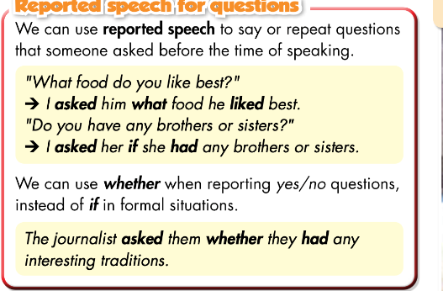  - Explain the rules and usage of “reported speech for questions”.  - Go through the grammar point with the class to make sure everybody understands.  Task a  - Ask Ss to look at the pictures box on page 79 and do a small practice.  - Ask Ss to give examples using the grammar point.(if time allows).  Task b  - Play the audio (CD2-track 34). Have Ss listen and check the answers.  - Have Ss listen and repeat the sentences.  - Walk Ss through the second reported speech form and make sure everyone understands the form of reported speech for questions.  - Have Ss look at the example sentences and tell them to underline the parts that adequately match with the structures.  - Reiterate the difference between reporting a Wh-question and Yes/No question and make sure Ss grasp the knowledge to get ready for the practiced exercise. | - Read the grammar box.  - Listen and take notes.  - Listen and highlight the important knowledge in the grammar box.  - Look and complete the sentence.  Answer Key  I asked her what crops she grew.  - Volunter to make example sentences.  - Listen and chek the answer.  - Listen and say the sentences.  - Look, listen and take notes.  - Mirror the structure and the example sentences then do the task properly.  - Listen and encapsulate the target learning points.
- Activity 2: Practice (19’)
a) Objective: Ss understnd the usage of the reported speech for questions confidently.
b) Content:
- Do exercise task a to identify the correct form of a statement.
- Do exercise task b to complete the sentences to report what someone asked.
c) Expected outcomes: Students can apply the learned structures to actual written exercise and get ready for the speaking exercise.
d) Organization of the activity:

TEACHER’S ACTIVITIES | STUDENTS’ ACTIVITIES
Task a. Read the notes and examples above, then circle the corret words.  - Have the Ss read the instruction and make sure they understand what to do.  - Have Ss look at the examples and recall their memory about the structure of reported speech for questions.  - Have Ss do the exercise individually.  - Call out some volunteers to answer.  - Give correction and explain.  Task b. Complete the sentences to report what these people said.  - Demonstrate the activity, using the example (using DCR).  - Have the Ss read the instruction and make sure they understand what to do.  - Have Ss look at the examples and recall their memory about the structure of reported speech for questions.  - Call Ss to read the example.  - Have Ss work in pairs. After each student are finished writing. They can practice reading to each other the questions, saying the answers and vice versa.  - Call out some volunteers to answer.  - Give correction and explain. | - Listen and read the instruction as requested.  - Look and write down the structures of reported speech for questionss.  - Do the task carefully by themselves.  - Raise hands to give the answer.  - Look, listen and correct the mistakes.  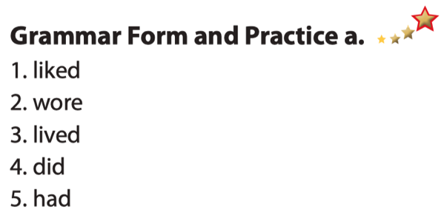  Answer keys  - Listen and read the instruction as requested.  - Look and read the example sentence.  - Work in pairs and do the exercise then practice speaking to each other.  - Raise hands to give answer.  - Look and correct the mistakes.  Answer keys  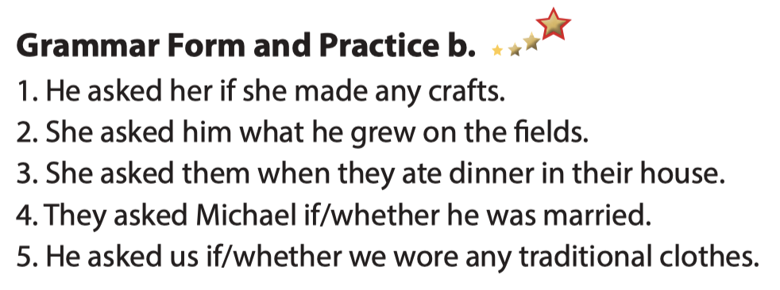

- Activity 3: Production (6’)
a) Objective: Students master the grammar point they study in the lesson.
b) Content: Speaking - asking and aswering questions using reported speech for questions.
c) Expected outcomes: Ss produce the new language successfully, and they can apply the reported speech for questions iin daily life.
d) Organization of the activity:
TEACHER’S ACTIVITIES | STUDENTS’ ACTIVITIES
Task c. In fours: Take turn asking and answering questions in pairs from this page or using your own ideas. then, report to one of the group members.  - Use DCR to show the task.  - Divide class into group of four.  - Have each pair in a group pratice asking & answering. questions using reported speech for questions.  - Encourage Ss to think of their ow ideas using Wh-question type and Yes/No question type.  - Have some pairs demonstrate the activity in front of the class.  - Give feedback and evaluation. | - Practice speaking to each other.  - Think new questions then practice with partner.  - Speak in front of the class.  - Listen.

C. Consolidation and homework assignments (5’)
*Consolidation
- Unserdtand the usage and form of reported speech for questions.
- Apply the grammar point in speaking and reporting a question.
.
* Homework:
- Do the exercises a and b in WB: Grammar (page 47)
- Complete the grammar notes in Tiếng Anh earn Smart World Notebook (page 67).
- Play the consolidation games in Tiếng Anh 7 i-Learn Smart World DHA App on www.eduhome.com.vn
- Prepare: Lesson 2.3 – Pronunciation and Speaking (pages 80 & 81 – SB).

V. Reflection
a. What I liked most about this lesson today:
…………………………………………………………………………………………
- What I learned from this lesson today:
…………………………………………………………………………………………
c. What I should improve for this lesson next time:
…………………………………………………………………………………………

