School: ……………………………………….. | Date:……………………………………..
Class: ……………………………..................... | Period: 26

UNIT 2: FIT FOR LIFE
Grammar 2e (Page 36)

1. Objectives
By the end of this lesson, students will be able to…
1.1. Language knowledge/ skills
- learn and use new grammar point: used to.
- practise doing grammar exercises.
- talk about their activities they used to do when they were 6.
1.2. Competences
- improve Ss’ analytical, collaboration and critical thinking skills.
1.3. Attributes
- develop their patriotism, kindness, honesty and accountability.
2. Teaching aids and materials
- Teacher’s aids: Student’s book and Teacher’s book, class CDs, IWB – Phần mềm tương tác trực quan, projector/interactive whiteboard /TV (if any), PowerPoint slides.
- Students’ aids: Student’s book, Workbook, Notebook.
3. Assessment Evidence
Performance Tasks | Performance Products | Assessment Tools
- Look at the cartoon and answer the questions.  - Choose the correct option.  - Write what James used to/didn’t use to do when he was six.  - Ask their friend about what their partner used to do when he/she was six? | - Ss’ answers.  - Ss’ answers.  - Ss’ answers.  - Ss’ own sentences/ presentation. | - Observation.  - Observation.  - Observation.  - Observation.

4. Procedures
A. Warm up: 5 minutes
a. Objectives: to help Ss brainstorm the topic and introduce “used to”.
b. Content: Cartoon.
c. Expected outcomes: Ss can think about the topic and have some general ideas about “used to”
d. Organization
Teacher’s activities | Students’ activities
Look at the cartoon and answer the questions.  1. When do we use “used to”?  2. What is the form of the verb after “used to”?  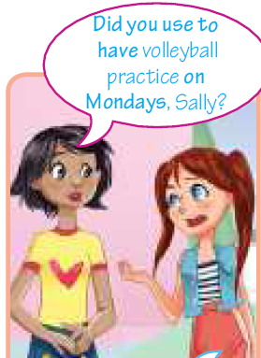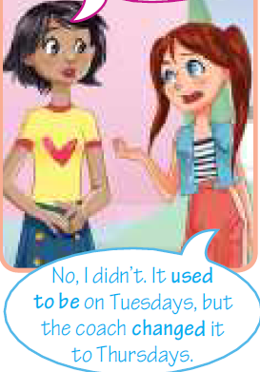  - Ask Ss to look at the cartoon and answer the questions.  - Ask Ss to work in pair to complete the task.  - Check Ss’ answers. | - Look at the cartoon and answer the questions.  - Work in pair to complete the task.  Answer keys:  1. We use used to to talk about things that happened regularly in the past, but they don’t happen anymore.  2. bare infinitive.
B. Presentation: 10 minutes
a. Objectives: to present USED TO (possitive and negative).
b. Content: Language box and Note! box.
c. Expected outcomes: Ss can remember and understand USED TO (possitive and negative).
d. Organization

Teacher’s activities | Students’ activities
USED TO:  We use used to to talk about things that happened regularly in the past, but they don’t happen anymore.  We can use the Past Simple instead of used to with no difference in meaning to talk about past habits.  She used to eat meat more often when she was younger.  She ate meat more often when she was younger.  - Explain that we use used to to talk about past habits or things that don’t happen anymore. We can also use used to to talk about past states.  - Ask Ss to read the table/theory box and the cartoon. Draw their attention to the words in bold. (Did you use to have – on Mondays, used to be - changed)  Note!  We don’t use used to for actions that happened at a stated time in the past.  e.g. I went to football practice yesterday.  (NOT: I used to go to football practice yesterday.)  - Draw Ss’ attention to the Note! box. | - Read the theory in the language boxes and listen to teacher’s explanation.  - Take notes.  - Listen to the teacher and take notes.
C. Practice: 15 minutes
a. Objectives: to help Ss practise USED TO (possitive and negative).
b. Content: tasks 1, 2.
c. Expected outcomes: Ss can remember and understand USED TO (possitive and negative).
d. Organization:
Teacher’s activities | Students’ activities
Task 1: Choose the correct option. Sometimes, both options are correct.  1 Marko used to go/went snorkelling every summer but now he’s too busy.  2 Mary didn’t use/used to play tennis when she was at college.  3 Jane left/used to leave for the gym an hour ago.  4 Every summer, we used to go/went swimming.  5 Did Jenny use/used to play basketball when she was a kid?  6 The sports centre used to move/moved to a new location.  7 I didn’t use/used to go jogging when I was a kid.  8 My parents used to buy/bought me a new racquet last week.  - Explain the task and give Ss time to complete it.  - Check Ss’ answers (using the IWB). | - Choose the correct option.  - Do the task individually and share with their friend.  Answer keys:  2. use 3. left  4. used to go/ went 5. use  6. moved 7. use  8. bought
Task 2: Write what James used to/didn’t use to do when he was six.  1 live in a village (✓) James used to live in a village.  2 wear glasses (✗)  3 read comic books (✓)  4. summers at the seaside (✓)  5 go sailing (✗)  6 play video games (✗)  7 ride a bike (✓)  8 study French (✗)  - Explain the task and read out the example and then give Ss time to complete it.  - Check Ss’ answers around the class (using the IWB). | - Work in pairs to complete the task.  Answer keys:  2. James didn’t use to wear glasses.  3. James used to read comic books.  4. James used to spend summers at the seaside.  5. James didn’t use to go sailing.  6. James didn’t use to play video games.  7. James used to ride a bike.  8. James didn’t use to study French.
D. Production: 10 minutes
a. Objectives: to help Ss to use the target language and information in the real situation.
b. Content: task 3
c. Expected outcomes: Ss can talk about their activities they used to do when they were six.
d. Organization
Teacher’s activities | Students’ activities
Task 3. What did your partner use to do when he/she was six? Ask to find out, then tell the class.  A: Did you use to go to the cinema?  B: No, I didn’t. I used to watch cartoons on TV.  - Ask Ss to ask and answer in pairs about what they used to do when they were six.  - Monitor the activity around the class and then ask various Ss to tell the class what their partner did. | - Ask and answer in pairs about what they used to do when they were six.  Suggested Answers:  A: Did you use to play with toy cars?  B: No, I didn’t. I used to watch TV.  A: Did you use to go to ballet lessons?  B: No, I didn’t. I used to play sports.

E. Consolidation and homework assignments: 5 minutes
- Grammar points: USED TO (possitive and negative).
- Do the exercises in workbook on page 20.
- Complete the grammar note in TA7 Right On! Notebook page 16.
- Prepare the next lesson: Grammar 2e (page 37).

5. Reflection

a. What I liked most about this lesson today:
…………………………………………………………………………………………
b. What I learned from this lesson today:
…………………………………………………………………………………………
c. What I should improve for this lesson next time:
…………………………………………………………………………………………

