HỘI CÁC TRƯỜNG THPT CHUYÊN
KHU VỰC DUYÊN HẢI VÀ ĐỒNG BẰNG BẮC BỘ
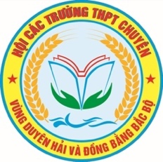

HỘI THẢO KHOA HỌC LẦN THỨ XVII
NĂM 2025
MÔN TIẾNG ANH

Chuyên đề:
INTEGRATING ARTIFICIAL INTELLIGENCE TOOLS INTO THE DESIGN
OF READING COMPREHENSION TASKS WITHIN THE 5E INSTRUCTIONAL MODEL
FOR GIFTED STUDENTS

Tháng 7, năm 2025

ABSTRACT

This study explores the integration of Artificial Intelligence (AI) tools into the design of NEC-style reading comprehension lessons for gifted students, using the 5E instructional model. It introduces prompt engineering as a core teacher competency and demonstrates how generative AI platforms such as ChatGPT, Canva, Wordwall, or Edpuzzle can be employed across the Engage, Explore, Explain, Elaborate, and Evaluate phases. Through a series of structured activities, the study presents a practical, cognitively aligned framework for designing high-order reading tasks. Detailed sample AI-supported actitivites illustrate implementation in authentic classroom settings. While offering theoretical contributions and design innovations, the study also acknowledges contextual limitations and proposes directions for future empirical research to validate the framework.

KEYWORDS AI integration, 5E model, NEC reading tas

TABLE OF CONTENTS
PART A: INTRODUCTION 1
- Rationale of the study 1
- Objectives of the study 1
- Scope of the study 1
- Significance of the study 2
PART B: LITERATURE REVIEW 2
- Overview of Generative Artificial Intelligence in Education 2
- Prompt Engineering in AI-Enhanced Reading Task Designs 2
  - Introduction of Prompt Engineering 2
  - Core Components of Prompt Engineering 3
- The 5E Instructional Model in English Language Teaching: The Teacher’s Role 4
- Pedagogical Rationale for Designing AI-Supported Activities Based on 5E Model in Reading Comprehension Lessons 5
  - Engage Phase: Cognitive and Emotional Priming 5
  - Explore Phase: Discovery 6
  - Explain Phase: Clarification and Conceptual Understanding 7
  - Elaborate Phase: Synthesis and Knowledge Transfer 7
  - Evaluate Phase: Assessment and Reflective Thinking 8
PART C: PRACTICAL IMPLICATIONS 9
- Designing AI-Enhanced Reading Comprehension Activities Across the 5E Model 9
  - AI-Supported Activities for the Engage Phase 9
  - AI-Supported Activities for the Explore Phase 12
  - AI-Supported Activities for the Explain Phase 17
  - AI-Supported Activities for the Elaborate Phase 20
  - AI-Supported Activities for the Evaluate Phase 24
- Evaluating the Impact of AI-Supported Teaching Strategies 27
PART D: CONCLUSION 27
- Summary of the findings 28
- Limitations of the study 28
- Suggestions for further research 28
REFERENCES
APPENDIX

PART A: INTRODUCTION
1. Rationale of the Study
In an era of increasing digital transformation in education, Artificial Intelligence (AI) has emerged as a powerful catalyst for innovation in instructional design. Within English Language Teaching (ELT), especially in the context of gifted education, there is a growing demand for reading comprehension tasks that not only assess language proficiency but also stimulate deep thinking, reasoning, and conceptual transfer.
This demand is particularly evident in the preparation for Vietnam’s National English Competition for Gifted Students (NEC), where reading comprehension tasks require learners to process complex texts at CEFR levels C1-C2, engage in higher-order thinking, and respond to inference-based and evaluative questions. However, designing such cognitively challenging tasks manually remains a significant challenge for teachers due to time constraints, limited access to high-level materials, and a lack of pedagogical scaffolding aligned with cognitive complexity.
The emergence of AI-powered educational tools including large language models, automated question generators, and text analyzers offers a promising solution. These tools, when thoughtfully integrated into an instructional framework like the 5E Model (Engage, Explore, Explain, Elaborate, Evaluate), can support educators in crafting deep learning-oriented reading tasks that foster student engagement, critical literacy, and metacognitive reflection.
Despite growing interest in AI applications in education, limited research in Vietnam has investigated how AI tools can be systematically integrated into structured reading lesson design, particularly for gifted learners. This study aims to address that gap by exploring how AI tools can be employed within the 5E instructional model to design NEC-style reading comprehension tasks that are cognitively rigorous, pedagogically coherent, and adaptable to gifted students’ learning needs.
2. Research Objectives
This study aims to explore the integration of Artificial Intelligence (AI) into the design of high-order reading comprehension tasks for gifted students through the 5E instructional model. The specific objectives are:
- To deepen teachers’ understanding of prompt engineering for effectively utilizing AI tools in generating cognitively demanding reading materials.
- To develop AI-supported instructional activities aligned with each phase of the 5E model (Engage, Explore, Explain, Elaborate, Evaluate), enhancing student engagement and inquiry-based comprehension.
- To construct NEC-style reading comprehension tasks using AI-generated content, emphasizing inference, analytical reasoning, and idea synthesis within the 5E framework.
3. Scope of the Study
This study focuses on the integration of AI tools into the design of reading comprehension tasks, modeled after the NEC examination format. Other NEC task types (e.g., Cloze Tests, Matching, Gapped Texts) are excluded to maintain analytical depth and task-specific consistency.
Participants and Context: The participants in this study are English teachers working in gifted education settings or specialized high schools in Vietnam, with reading materials drawn from official NEC reading exams from 2010 to 2024.
4. Significance of the Study
This research makes a dual contribution to theory and practice by proposing a pedagogically grounded and AI-integrated model for designing reading comprehension tasks in gifted education. It addresses the instructional challenges of aligning text complexity, task demand, and lesson coherence, particularly for high-performing learners preparing for competitive exams like NEC.
By embedding AI tools into each phase of the 5E instructional model, the study advocates a teacher-AI collaboration, where educators maintain pedagogical agency while utilizing AI to enhance task design, ensure cognitive alignment, and increase instructional efficiency.
Ultimately, the study aims to empower gifted students with the cognitive and metacognitive skills necessary to comprehend, analyze, and critically engage with advanced academic texts-skills that are essential not only for NEC success but for future academic pursuits and lifelong learning.
PART B: LITERATURE REVIEW
1. Overview of Generative Artificial Intelligence in Education
Generative AI (GenAI), especially large language models (LLMs), refers to AI systems capable of producing new content such as text, images, and code from user prompts (Bommasani et al., 2021). In education, GenAI is emerging as a powerful tool for instructional design, content creation, and personalized learning (Holmes et al., 2023).
In English Language Teaching (ELT), tools like ChatGPT, Gemini, and Claude can generate CEFR-aligned texts, comprehension questions, paraphrases, and discussion scaffolds. These functions are particularly valuable in gifted education, where students engage with high-level texts requiring analysis, synthesis, and evaluation (Council of Europe, 2020).
Effective integration of GenAI demands more than tool access - it requires digital competence, curricular alignment, and pedagogical planning (UNESCO, 2022). Central to this is prompt engineering, which involves crafting clear, goal-oriented prompts to direct AI outputs meaningfully (Wei et al., 2022).
Instructional frameworks like the 5E Model offer a structured approach to embedding GenAI into lessons, with prompt engineering acting as the bridge between AI capability and deep learning outcomes in reading comprehension.
2. Prompt Engineering in AI-Enhanced Reading Task Design
2.1. Introduction of Prompt Engineering
Prompt engineering is a crucial skill for effectively using large language models (LLMs) like ChatGPT, Gemini, and Claude in English language education. It involves crafting clear, purposeful prompts that produce accurate and pedagogically relevant responses (Reynolds & McDonell, 2021; OpenAI, 2023). In high-stakes contexts like Vietnam’s National English Competition (NEC), educators must shift from passive use to intentional design of AI interactions, as output quality depends on prompt clarity (Mialon et al., 2023). Frameworks identify two core domains: input components (task, data, context) and output components (criteria, examples). Research shows that structured prompts with clear tasks and examples improve the fluency and relevance of AI responses (Brown et al., 2020; Wei et al., 2022), supporting alignment with advanced linguistic and cognitive learning goals.
2.2. Core Components of Prompt Engineering
2.2.1. Input Components
a. Task - Defining What the AI Must Do
The task is the instructional command given to the AI. It activates the generation process and must be expressed through a clear, specific action verb - such as “generate,” “create,” “summarize,” or “design.” Research by Brown et al. (2020) demonstrates that prompt clarity significantly improves coherence, especially for open-ended tasks.
Example Task:
“Generate five multiple-choice reading comprehension questions based on the NEC passage ‘You Are What You Speak’ that test inference, author’s attitude, and tone.”
b. Data - Providing the AI with Source Content
The data component refers to the specific material or source file that the AI must process. For reading task design, this is often a full or partial reading passage. Clearly referencing the data ensures text-task alignment and reduces the likelihood of hallucinated content.
Example Data:
“Use the passage ‘Bringing Up Children’ from the NEC 2010-2011 exam (Part 3). Focus on paragraph 2 and 3 when generating inference-based multiple-choice questions.”
c. Context - Setting the Role, Audience, and Purpose
Context provides background information about the task environment and user expectations. Without it, the AI cannot infer the academic level, tone, or role it should assume. According to Wu et al. (2023), supplying a context transforms ChatGPT from a generic responder into a domain-specific assistant.
Example Context:
“You are an experienced English teacher preparing reading comprehension questions for 12th-grade gifted students competing in the National English Competition. Your goal is to help them strengthen their high-order critical reading skills at CEFR level C1.”
2.2.2. Output Components
a. Output Criteria - Determining How Results Are Delivered
Output criteria establish the expected structure, tone, and cognitive rigor of AI-generated content. According to Wu et al. (2023), prompts with explicit formatting guidelines produce more accurate and usable results. For NEC task design, each item must include a clear question stem, four labeled options (A-D), one correct answer, and a one-sentence justification. Questions should target inference, implication, or tone, avoid factual recall, use formal academic English at CEFR C1 level, and not exceed 70 words. Final outputs must be presented in a numbered list (e.g., Q1-Q5) for consistency and clarity.
Example Formatting Block for Prompt:
“Present your five questions as a numbered list (Q1-Q5), using formal tone and academic vocabulary. Each item must assess inference, tone, or implication and include a one-sentence justification for the correct answer. Avoid surface-level or direct recall questions.”
b. Example - Model Reference through Shot Prompting
In educational prompt engineering, model reference - commonly known as shot prompting - is vital for ensuring alignment and quality in AI-generated outputs. As described by Brown et al. (2020) and OpenAI, shot prompting includes three types: zero-shot prompt (no example), one-shot prompt (a single exemplar), and few-shot prompt (multiple structured examples). Among these, few-shot prompting is most effective for NEC-style reading task design, where linguistic precision and inferential depth are essential (Wei et al., 2022). It enables AI models to emulate the structure, tone, and cognitive rigor of authentic exam samples, thereby improving validity.
Few-Shot Prompt Example:
“Using the logic, structure, and tone of Questions 74-83 from the NEC 2017-2018 reading section (‘You Are What You Speak’) as your reference model, generate similar multiple-choice reading comprehension questions for each of the following passages:File 1: Bringing Up Children (NEC 2010-2011); File 2: Pointers To Learning (NEC 2012-2013). For each passage, create 5-6 questions that assess inference, tone, and writer’s intention. Ensure each question has four labeled options (A-D), one correct answer, and a one-sentence justification.
In short, by mastering the principles of prompt construction, teachers can significantly enhance the accuracy, relevance, and pedagogical effectiveness of AI-generated outputs -transforming AI tools from generic assistants into powerful, curriculum-aligned collaborators.

3. The 5E Instructional Model in English Language Teaching: The Teacher’s Role
As classroom practitioners, teachers play a pivotal role in designing and facilitating learning experiences that align with the 5E Instructional Model, originally developed by Bybee et al. (1997). Rooted in constructivist learning theory, this model structures instruction into five distinct yet interconnected phases: Engage, Explore, Explain, Elaborate, and Evaluate. Each phase serves a specific cognitive and affective purpose, guiding learners progressively from prior knowledge activation to higher-order thinking and reflection (Bybee et al., 2006).
In the Engage phase, the teacher carefully introduces a relevant context or stimulus to spark curiosity and activate students’ existing schema. The Explore phase is designed to encourage learners to investigate the topic through student-centered, inquiry-based activities, enabling them to construct initial understanding independently or collaboratively. During Explain, the teacher facilitates discussion, prompts students to articulate their interpretations, and provides clarification to ensure conceptual accuracy. In the Elaborate phase, learners are challenged to apply their knowledge in extended or novel contexts, deepening their comprehension and promoting knowledge transfer. Finally, the Evaluate phase integrates both formative and reflective assessment, allowing teachers to monitor understanding and support students in developing metacognitive awareness.
Aligned with Bloom’s Revised Taxonomy (Anderson & Krathwohl, 2001), the 5E model empowers educators to design lessons that foster analytical reasoning, synthesis, and critical engagement. It positions students not as passive recipients but as active constructors of knowledge, with the teacher acting as a facilitator who ensures that learning is both cognitively rigorous and pedagogically coherent.
4. Pedagogical Rationale for Designing AI-Supported Activities Based on the 5E Model in Reading Comprehension Lessons
This section presents a structured set of AI-supported teaching activities aligned with the 5E instructional model - Engage, Explore, Explain, Elaborate, and Evaluate - to enhance the design of advanced reading comprehension lessons. The 5E model, grounded in constructivist theory (Bybee et al., 2006), offers a progressive learning cycle that supports both cognitive and emotional engagement. When integrated with generative AI tools such as ChatGPT, MagicSchool, Canva, and Quillionz, each phase of the model becomes a meaningful opportunity for personalization, deep thinking, and learner autonomy.
The proposed activities are tailored for high-level reading tasks, such as those found in the National English Competition (NEC), where students are expected to analyze complex texts, make inferences, evaluate arguments, and synthesize information. Each activity is designed with a clear instructional purpose and demonstrates how AI tools can be used not only to generate content but also to scaffold thinking, foster interaction, and promote metacognitive reflection.
By mapping AI tools to each phase of the 5E model, this framework provides a practical and pedagogically sound approach for teachers to create more engaging, adaptive, and cognitively rich reading lessons.
4.1. Engage Phase: Cognitive and Emotional Priming
The Engage phase functions as both a cognitive primer and emotional hook in NEC-oriented reading instruction. At this stage, teachers design AI-enhanced tasks to activate learners’ prior knowledge, spark inquiry, and establish a sense of purpose before reading. Supported by generative tools, these activities help students enter the text with anticipation and meaningful context.
The teacher’s role is that of a learning architect, carefully selecting AI tools, framing multimodal stimuli, and guiding learners toward personal engagement with the topic. These experiences lay the groundwork for deeper comprehension in later phases.
Table 1 below outlines representative AI-supported activities for the Engage phase, illustrating how different tools can foster cognitive curiosity and emotional relevance through tasks such as prediction, visual interpretation, and ethical reasoning.
Activity | Purpose | AI Tools | Description
Visual Prediction Challenge | Activate background knowledge and build anticipation | Google AI Studio | Display AI-generated visuals; students predict reading content and tone in pairs/groups.
Word Cloud Anticipation | Foster curiosity through pattern recognition and prediction | WordArt.com | Generate a word cloud of key terms; students hypothesize themes and form guiding questions.
Provocative Poll Statements | Trigger ethical inquiry and perspective awareness | Mentimeter, Wordwall AI | Present bold statements for voting; students justify responses pre- and post-reading.
Scenario Simulation | Create emotional relevance and connect to real-life dilemmas | MagicSchool.ai | Students respond to a roleplay scenario that mirrors the text’s theme; revisit post-reading.
Socratic AI Hook | Stimulate critical thinking and challenge assumptions | POE, ChatGPT | Students engage in AI-led Socratic questioning related to the text topic.
Table 1: Some suggested AI-supported activities for the Engage phase
4.2. Explore Phase: Discovery
The Explore phase provides students with the opportunity to interact independently with NEC-style texts before receiving explicit instruction. At this stage, AI tools are used to scaffold learner-driven discovery, encourage active reading, and foster analytical engagement with textual structures and vocabulary.
The teacher’s role is that of a discovery designer, crafting exploratory experiences through AI-supported tasks such as prediction games, reordering activities, and logic-based challenges. These tasks guide students to uncover meaning, identify patterns, and build foundational comprehension through exploration rather than explanation.
Table 2 below presents sample AI-supported activities for the Explore phase, highlighting how learners can construct understanding through interaction, reasoning, and inquiry-driven tasks.
Activity | Purpose | AI Tools | Description
Vocabulary Discovery Quest | Build contextual vocabulary understanding | ChatGPT, Wordwall | Students play prediction-based vocab games; revisit after reading for self-check.
Multiple Choice Challenge | Skim for gist and reflect on preconceptions | Wordwall | Attempt MCQs pre-reading; revise post-reading and explain changes.
Sentence Reordering Logic Task | Enhance structural reasoning | Eduaide.ai | Students reorder jumbled sentences of a paragraph; compare to original after reading.
Conceptual False Friends Detection | Sharpen accuracy and detect misinformation | Quillionz.ai | Judge pre-made false paraphrases; verify post-reading using evidence.
True/False Reasoning Quest | Encourage text-based verification | MagicSchool.ai, Kahoot | Students predict T/F statements pre-reading; revise answers and cite textual evidence.
Table 2: Some suggested AI-supported activities for the Engage phase
4.3. Explain Phase: Clarification and Conceptual Understanding
The Explain phase transitions learners from exploration to structured comprehension by prompting them to articulate interpretations, clarify ambiguity, and analyze rhetorical features of NEC passages. With AI support, abstract or syntactically complex ideas become more accessible through guided dialogue and structured scaffolding.
The teacher’s role in this phase is that of a facilitator of understanding, using AI tools to prompt reflection, reinforce logic, and support collaborative sense-making. Learners engage in group discussions, question-answer sequences, and analytical unpacking to refine comprehension and develop conceptual clarity.
Table 3 below outlines suggested AI-supported activities for the Explain phase, showcasing how targeted tools can support inference-making, syntactic analysis, and meaning negotiation.
Activity | Purpose | AI Tools | Description
Inference Ladder Scaffold | Develop inferential thinking | MagicSchool.ai | Students fill in missing inference steps between literal and abstract meanings.
AI-Socratic Dialogue | Deepen interpretation via reflective questioning | POE, Claude.ai | Chat with AI about claims and assumptions; reflect in group discussions.
Main Idea Mapping Discussion | Track argument flow and textual structure | Napkin.ai | Build thematic maps from AI summaries; label idea relationships.
Sentence-Level Parsing | Unpack complex syntax and meaning | MagicSchool.ai | Break down dense paragraphs into semantic units; annotate clause functions.
Table 3: Some suggested AI-supported activities for the Explain phase.
4.4. Elaborate Phase: Synthesis and Knowledge Transfer
The Elaborate phase invites students to extend their understanding beyond the text, fostering synthesis, intertextual connections, and creative transformation. At this stage, learners apply insights to new contexts, articulate original interpretations, and engage in problem-solving or comparative reasoning.
The teacher’s role is that of a designer of transfer-based learning, using AI tools to generate prompts, model argument structures, and support multimodal outputs. These tasks help students consolidate learning, explore broader applications, and build deeper cognitive engagement with the text.
Table 4 below presents representative AI-supported activities for the Elaborate phase, demonstrating how learners can creatively reinterpret meaning through comparison, argumentation, visual design, and simulation.
Activity | Purpose | AI Tools | Description
Cross-Text Comparison | Synthesize ideas across sources | ChatGPT, Claude | Compare NEC text with a related reading; complete Venn diagrams or journals.
Argument Reconstruction | Practice reasoning and counter-arguments | Diffit, Claude | Outline author’s argument using AI; paraphrase or create counter-views.
Roleplay Simulation | Personalize text themes through roleplay | Synthesia, MagicSchool.ai | Interact as characters in text-related dilemmas via AI-generated videos or prompts.
Thematic Infographic Design | Communicate insights visually | Canva, Napkin.ai | Use AI to generate descriptions, then build infographics with symbols and data.
Table 4: Some suggested AI-supported activities for the Elaborate phase
4.5. Evaluate Phase: Assessment and Reflective Thinking
The Evaluate phase focuses on consolidating comprehension and promoting reflective learning. Here, students assess their performance, monitor understanding, and express emotional or intellectual responses to the text. AI tools offer personalized feedback, generate quizzes, and support visual and metacognitive tasks.
The teacher’s role is that of a reflective guide, facilitating assessment design, prompting self-evaluation, and supporting learners in articulating their learning progress. Through AI-assisted tools, students engage in rubric construction, summarization, and expressive responses that deepen retention and insight.
Table 5 below summarizes selected AI-supported activities for the Evaluate phase, illustrating how these tasks promote formative assessment, metacognitive awareness, and meaningful reflection.
Activity | Purpose | AI Tools | Description
AI-Generated Quizzes | Assess comprehension and inference | Quillionz, Mindgrasp | Generate targeted quizzes; students rate confidence levels post-response.
Cloze Summary Reflection | Combine summary and vocabulary skills | ChatGPT, MagicSchool.ai | Fill-in-the-blank summary exercise with key terms missing; compare and discuss.
Self-Assessment Rubric | Promote metacognition and self-evaluation | Notion AI, Canva | Students co-develop rubric and write justifications for their self-ratings.
Visual Reflection Poster | Capture emotional and symbolic understanding | Canva, ChatGPT | Choose a quote, pair with symbols or images, and design a poster expressing takeaway.
Table 5: Some suggested AI-supported activities for the Evaluate phase

PART C: PRACTICAL IMPLEMENTATION
1. Designing AI-Enhanced Reading Comprehension Activities Across the 5E Instructional Model
Designing effective reading comprehension lessons for gifted learners necessitates a pedagogically sound framework that promotes inquiry, engagement, and critical interpretation across multiple cognitive levels. The 5E Instructional Model - comprising the phases Engage, Explore, Explain, Elaborate, and Evaluate - offers a constructivist foundation that supports such objectives by structuring learning into sequential, interconnected experiences.
Integrating Artificial Intelligence (AI) tools into each phase of this model can significantly enhance instructional design by enabling the creation of personalized, cognitively rigorous, and linguistically challenging activities. AI-powered platforms facilitate differentiated scaffolding, foster learner autonomy, and support teachers in developing materials that align with both the complexity of NEC-style reading tasks and the characteristics of gifted education.
The following sections present a range of AI-enhanced activities corresponding to each stage of the 5E model, illustrating how AI can be strategically employed to meet both instructional goals and the advanced learning needs of high-performing students.
1.1. AI-Supported Activities for the Engage Phase
a. Visual Prediction (Video-Based)
Pedagogical Purpose: To ignite student curiosity and activate background knowledge before reading by presenting a short AI-generated video composed of concept-related visual prompts. This activity engages learners cognitively and emotionally, encouraging them to observe, infer, and predict the themes of the passage. It is particularly effective for abstract or socio-cultural topics, as it combines multimodal inputs to enhance anticipation, contextual awareness, and thematic engagement.
Design Approach: In the Engage phase, teachers use a combination of AI tools to generate summary-based visuals and assemble them into a short, engaging video. Specifically, ChatGPT is used to produce a concise thematic summary of the reading; ai.studio.google.com is used to generate images from the summary; and CapCut is used to compile the images into a dynamic video. This video serves as a stimulus for group discussion and prediction, priming students for deeper reading comprehension and interpretation.
AI Tool: ChatGPT → for summarizing the text
Google AI Studito (ai.studio.google.com) → for generating themed AI images
CapCut (capcut.com) → for editing and compiling video
Application Example
(Based on “MONACO’S BRITISH” – Reading Part 4 -NEC 2018–2019)
**📲 Scan the QR code beside to view the full reading passage.**


Planning Steps:
Step 1: Generate Video Stimuli
- Use ChatGPT to create a 6-8 sentence summary of the reading passage.
- Input each sentence into ai.studio.google.com to create visual scenes.
- Export 5-7 of the best images.

Figure 1: AI Images from Google AI Studito for Monaco’s British Minionaire
(NEC 2018-2019)
- Use CapCut to compile the images into a 30-60 second video with soft transitions and background music.

**📲 Scan the QR code beside or click the link below to view the full video.**

https://drive.google.com/file/d/1jpDlAFXMCBsLeQ5cgwydQzyCoEMKbRU6/view?usp=sharing
Step 3: Facilitate Visual Analysis Discussion
- Ask open-ended guiding questions to prompt students’ observation and interpretation:
“What do you notice in the images in the video?”
“Who do you think lives in this place?”
“What lifestyle or values are reflected here?”
“What do these visuals suggest about nationality, money, or culture?”
Step 4: Prediction Task (Collaborative)
- Have students work in pairs or small groups to make predictions based on the visuals.
- Encourage oral and written hypotheses:
“What might this passage discuss?”
“Why are wealthy British citizens shown here?”
“How might tax, investment, or lifestyle relate to this setting?”
- Example sentence predictions:
“I think the text explains why British millionaires move to Monaco.”
“The reading will probably describe life in a luxurious tax haven.”
Step 5: Lead into the Reading Passage
Conclude the Engage phase with a brief transition statement:
“Now that we’ve explored the images and made some predictions, let’s read the passage and see what confirms or challenges your ideas.”
b.Word Cloud Anticipation
Pedagogical Purpose: To ignite curiosity and stimulate students’ background knowledge by using AI-generated word clouds based on academic vocabulary from the reading text. This activity enhances lexical prediction, critical observation, and hypothesis formation, thereby setting a meaningful purpose for reading.
Design Approach: In the Engage phase, teachers extract key academic terms from the NEC reading text and feed them into an AI-based word cloud generator. The visual arrangement of terms draws attention to word frequency, semantic clustering, and possible themes. Students analyze the cloud collaboratively and formulate questions or predictions about the content, structure, and tone of the reading.
AI Tool: wordart.com - AI-enhanced visual word cloud generator.
Application Example:
(Based on “LANGUAGE ACQUISITION” Reading Part 4 -NEC 2021- 2022)

**📲 Scan the QR code beside to view the full reading passage.**

Planning Steps:
Step 1: Generate the Word Cloud
- Navigate to https://wordart.com and click Import.
- Copy-paste the entire NEC 2021-2022 passage into the import window; WordArt automatically parses the text and displays a frequency list of vocabulary items.
- Review the list, delete function words, and boost the weight of core concepts (e.g., language, acquisition, cognition) by increasing their frequency values to ensure they dominate the visualization.
- Select a thematically relevant shape such as a brain, thought bubble, or open book then click Generate to create the final word-cloud image and download it for classroom use.
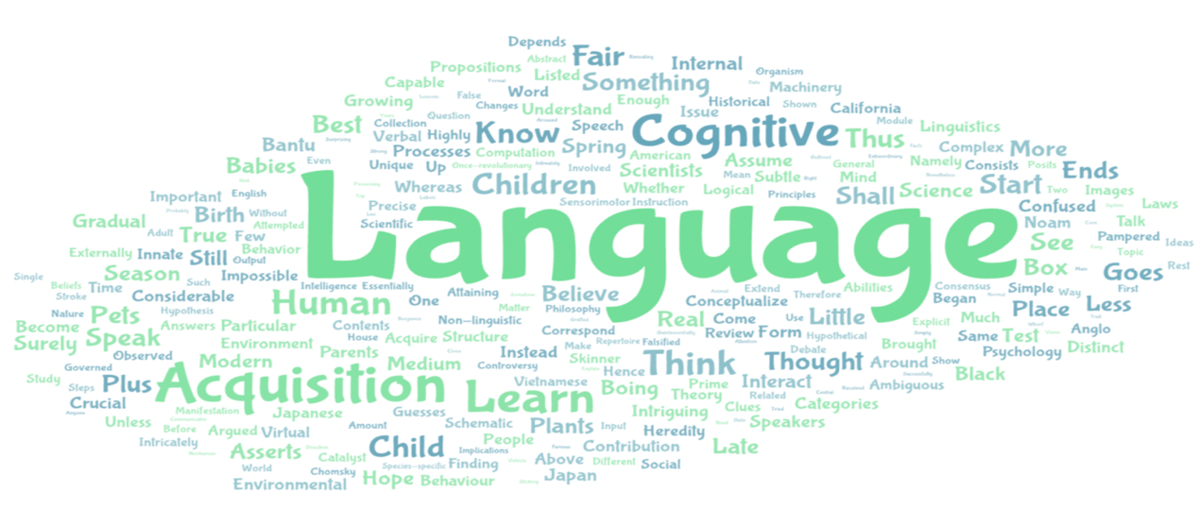
Figure 2: Word Cloud Anticipation from Wordart for Language Acquisition
(NEC 2021-2022)
Step 2: Prepare Materials
- Display the word cloud on slides or print it as handouts.
- Ask students to examine the cloud visually and identify words that stand out due to size or clustering.
Step 3: Guide Discussion
- Use open-ended questions to promote discussion:
“Which words seem most important or repeated?”
“What kind of topic do these words suggest?”
“Do any of these words hint at a problem or a theory?”
“Have you heard of Chomsky or the term ‘cognition’ before?”
“How do the words heredity and environment relate to learning?”
Step 4: Prediction & Hypothesis
- Students work in pairs or small groups to complete prompts such as:
“I think the passage will explain how children learn language through both…”
“It might discuss whether language is learned or innate…”
“The author probably argues that…”
- Teachers can also prompt metacognitive reflection:
“What question would you ask before reading based on these words?”
“Which word do you want to understand more clearly?”
Step 5: Transition into Reading
- Close the activity with a transition prompt: “Let’s explore the text to see how the author discusses language learning. As we read, check if your predictions hold true or if new ideas challenge your assumptions.”
1.2. AI-Supported Activities for the Explore Phase
a. Vocabulary Quest:
Pedagogical Purpose: To support students’ comprehension of complex NEC-level reading by allowing them to explore and internalize essential vocabulary in an interactive, game-based environment. This exploratory vocabulary quest enables learners to encounter and predict key concepts before formal instruction.
Design Approach: In the Explore phase, teachers use ChatGPT to extract key terms from the NEC passage and generate learner-friendly definitions. These are then used to build a Wordwall matching game. The activity turns vocabulary into a discovery tool, encouraging students to hypothesize meanings, themes, and relationships within the text. Students engage with the reading context indirectly by decoding academic or abstract vocabulary through interactive play.
AI Tool: ChatGPT (keyword extraction, definition generation)
Wordwall.net (interactive game creation using the extracted word-definition pairs)
Application Example:
(Based on “LANGUAGE ACQUISITION” Reading Part 4 -NEC 2021- 2022)
**📲 Scan the QR code beside to view the full reading passage.**

Planning Steps:
Step 1: Vocabulary Extraction via ChatGPT
- Paste a passage excerpt into ChatGPT.
- Use the prompt: “Identify 8–10 academic or abstract words from the following NEC reading passage and provide simple English or bilingual (English–Vietnamese) definitions.”
Example excerpt (Paragraph 1):
“Language acquisition is one of the central topics in cognitive science. Every theory of cognition has tried to explain it; probably no other topic has aroused such controversy. Possessing a language is the quintessentially human trait…”
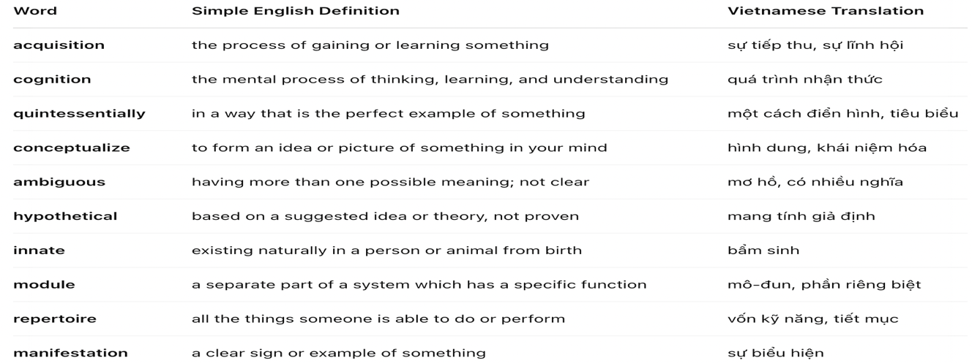
Figure 3: Key vocabulary and definitions generated by ChatGPT
(NEC 2021-2022)
Step 2: Game Design via Wordwall
- Visit: https://wordwall.net
- Select the “Match Up” activity
- Input vocabulary - definition pairs from ChatGPT
(Optional: Switch to Vietnamese definitions for scaffolding lower-proficiency learners)

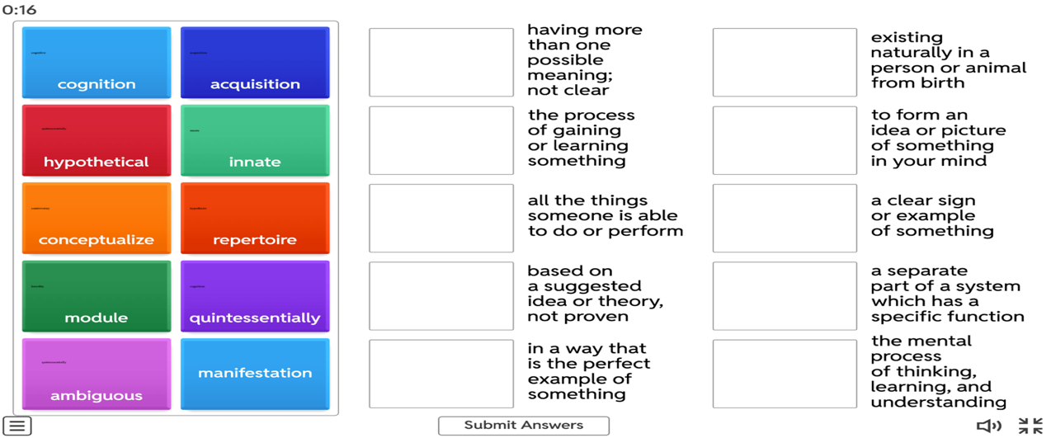
Figure 4: Vocabulary Quest activity on Wordwall for Language Acquisition
(NEC 2021–2022)
Step 3: Classroom Implementation
- Let students complete the Vocabulary Quest (individually or in pairs) on digital devices or a smartboard
- Encourage collaboration, prediction, and reflection with follow-up questions:
+ “Which of these terms do you expect to see repeatedly in the text?”
+ “Based on these words, what do you think the topic of the passage might be?”
b. Multiple Choice Challenge
Pedagogical Purpose: This activity engages students with NEC-style reading through AI-generated multiple-choice questions, promoting inference, evidence-based reasoning, and collaborative exploration.
Design Approach: In the Explore phase, the teacher takes the role of a discovery facilitator by using the AI-powered platform Wordwall to design targeted multiple-choice questions aligned with lesson goals. These questions are not solely for assessment but serve as exploratory prompts that challenge students to analyze textual clues, evaluate alternatives, and justify their reasoning. As students interact with the quiz individually or in groups, they investigate each option, confront plausible distractors, and revise their understanding through active discussion.
AI Tool: Wordwall (wordwall.net)
Application Example
(Based on “BRINGING UP CHILDREN” Reading Part 3 -NEC 2010 - 2011)

**📲 Scan the QR code below to view the full reading passage.**

Planning Steps:
Step 1: Step 1: Generate AI-Based Quiz Using Wordwall
- Access Wordwall.net and select the Quiz template.
- Upload the NEC passage (e.g., Bringing Up Children).
- Use the following prompt in the description box:
“Generate multiple-choice questions based only on the content of the passage. Do not introduce external knowledge. Ensure questions are aligned with CEFR levels C1-C2, including such questions as Factual Information, Negative Factual Information, Reference, Vocabulary, Inference.
- Wordwall will auto-generate 10-15 questions.
- Sample quiz: https://wordwall.net/play/95064/008/747

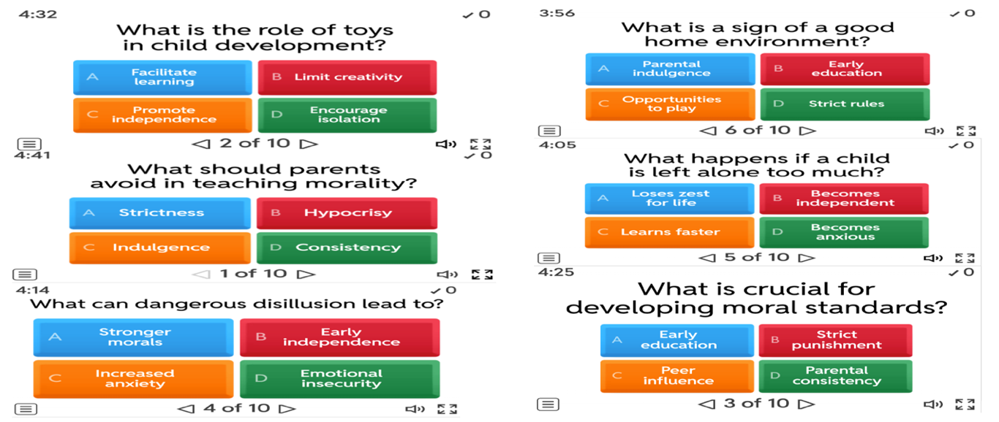
Figure 5: Questions Examples of AI-generated MCQs on Wordwall from
Bringing Up Children (NEC 2010–2011)
Step 2: Prepare for Student Inquiry-Based Exploration
- Teacher selects 5-10 questions that best promote interpretation, inference, and evaluation.
- These questions are not explained in advance; instead, they are positioned as entry points for exploration.
- The quiz is printed or projected, and students are assigned to work in pairs or small groups to encourage collaborative meaning-making.
Step 3: Discovery Through Text-Based Engagement
- Without pre-teaching the passage, students engage directly with the reading to respond to each question.
- For every answer, they must underline the textual evidence or discuss the logic behind their choice.
- When facing uncertainty or disagreement, students return to the text to seek clues, clarify meaning, and negotiate answers - building comprehension through inquiry rather than instruction.
Step 4: Collective Reflection and Insight Building
- After exploration, the class revisits 2-3 key questions together.
- Rather than providing answers, the teacher uses Socratic questioning to prompt student-led clarification:
“What clues in the text led you to this conclusion?”
“What made the distractor sound plausible at first?”
- The goal is not just to confirm the correct answers, but to reveal the thinking process behind comprehension, fostering metacognitive awareness and collaborative discovery.
c. True/False Reasoning Quest
Pedagogical Purpose: This activity engages students with NEC reading through AI-generated True/False statements that highlight ambiguity, implicit meaning, and textual detail. It promotes close reading, evidence-based reasoning, and collaborative interpretation-laying the foundation for deeper comprehension.
Design Approach: In the Explore phase, the teacher acts as a designer of discovery. Using MagicSchool.ai, the teacher generates True/False prompts that target interpretive ambiguities and hidden details in the text. These statements are delivered through Kahoot as live quizzes, transforming them into dynamic entry points for exploration. As students respond to each item, they revisit the passage, search for textual evidence, and evaluate claims through collaborative reasoning.
AI Tool: MagicSchool.ai → Text-Dependent Questions
Kahoot → Live Quiz Platform
Application Example:
Based on “Pointers to Learning” – NEC 2012–2013
(Based on “POINTERS TO LEARNING” Reading Part 4 -NEC 2012 - 2013)

**📲 Scan the QR code below to view the full reading passage.**

Planning Steps:
Step 1: Design Discovery Prompts Using MagicSchool.ai
- The teacher selects an NEC reading passage (e.g., Pointers to Learning) and inputs it into MagicSchool.ai.
- Using the “Text-Dependent Questions” tool, the teacher prompts the AI to generate 5-6 True/False questions targeting deeper comprehension (e.g., applying, analyzing, evaluating).
- These questions serve as exploratory triggers - not for testing, but to spark curiosity and promote text-based investigation.
Step 2: Build Interactive Quiz on Kahoot
- The teacher transfers the AI-generated questions into Kahoot using the “True/False” quiz format.
- Prompts or hints may be added to encourage deeper reading.
- The quiz is prepared not as a competition but as a shared discovery task, where students engage with ideas rather than rush for answers.
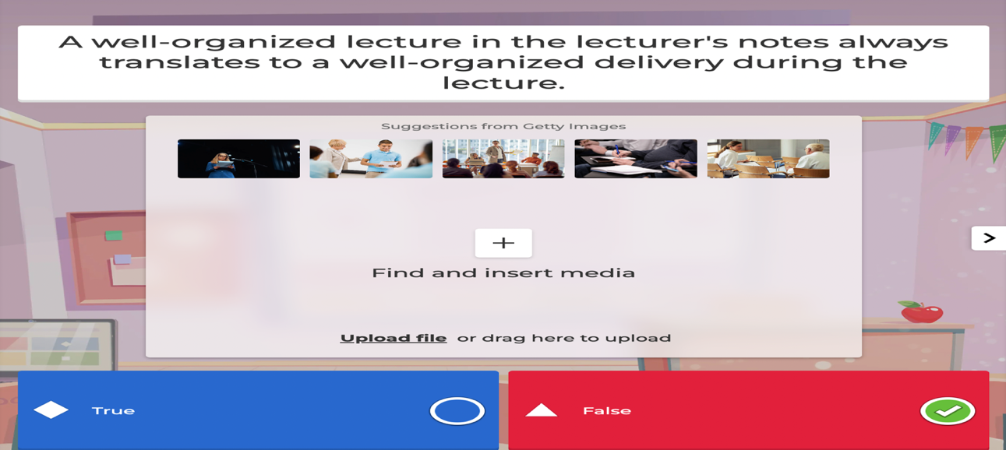
Figure 6: Kahoot slide with AI-generated True/False question
(Pointers to Learning – NEC 2012–2013)
Step 3: Student-Led Inquiry During Quiz Play
- The Kahoot quiz is launched live in class.
- After each question, students are prompted to return to the text to find supporting or contradicting evidence.
- In pairs or triads, they discuss their reasoning, highlight relevant lines, and refine their answers through collaboration.
- The teacher avoids giving explanations, instead guiding students to test and revise their thinking.
Step 4: Reflective Dialogue and Evidence Verification
- After each item, brief student-led discussions are facilitated:
“Where exactly in the text did you find support?”
“Was any part of the statement misleading or ambiguous?”
- Students are encouraged to adjust their understanding based on peer input and textual proof.
- This step strengthens metacognitive awareness and deepens interpretive confidence through inquiry-not correction.
1.3. AI-Supported Activities for the Explain Phase
a.Main Idea Mapping Discussion:
Pedagogical Purpose: To support students in articulating and verifying their understanding of a complex NEC reading passage by collaboratively identifying main ideas and supporting details, then visualizing their structure using AI-powered tools. This activity enables students to distinguish key arguments from examples, synthesize information across paragraphs, and clarify conceptual relationships - skills essential for advanced NEC-level reading comprehension.
Design Approach: In the Explain phase, the teacher facilitates student discussion by using ChatGPT and Napkin to prepare paragraph summaries and a visual concept map. These AI-generated scaffolds support structured analysis of main ideas and supporting details. Students articulate their interpretations in groups, compare them with AI outputs, and refine their understanding through dialogue. The teacher prompts clarification, highlights conceptual links, and ensures accuracy by guiding whole-class discussion. The activity helps students move from exploration to explanation by synthesizing the text’s meaning through collaborative reasoning.
AI Tools: ChatGPT → Summarize paragraphs and extract main ideas
Napkin.ai → Visual mapping of concepts and relationships
Application Example:
(Based on “POINTERS TO LEARNING” Reading Part 4 -NEC 2012 - 2013)

**📲 Scan the QR code below to view the full reading passage.**

Planning Steps
Step 1: Summarize with ChatGPT
- Copy and paste the full NEC passage (or split by paragraph) into ChatGPT
- Use this prompt:
“Summarize each paragraph in one sentence and identify the supporting details.
- Copy the AI-generated summaries and review for accuracy.
Step 2: Launch Napkin and Visualize
- Visit https://napkin.in
- Sign in or continue as a guest
- Click “Create My First Napkin” (or “New Napkin” if returning) to open a blank workspace
- Paste the ChatGPT-generated paragraph-by-paragraph summary into the canvas
(Each paragraph should be summarized in one sentence, followed by 1-2 supporting details)
- Napkin will automatically generate a clustered visual map showing:
+ Main ideas as central nodes
+ Supporting details as connected sub-nodes
The output should resemble the example shown below—a concept map that visually captures the structure, logic, and flow of the reading passage.
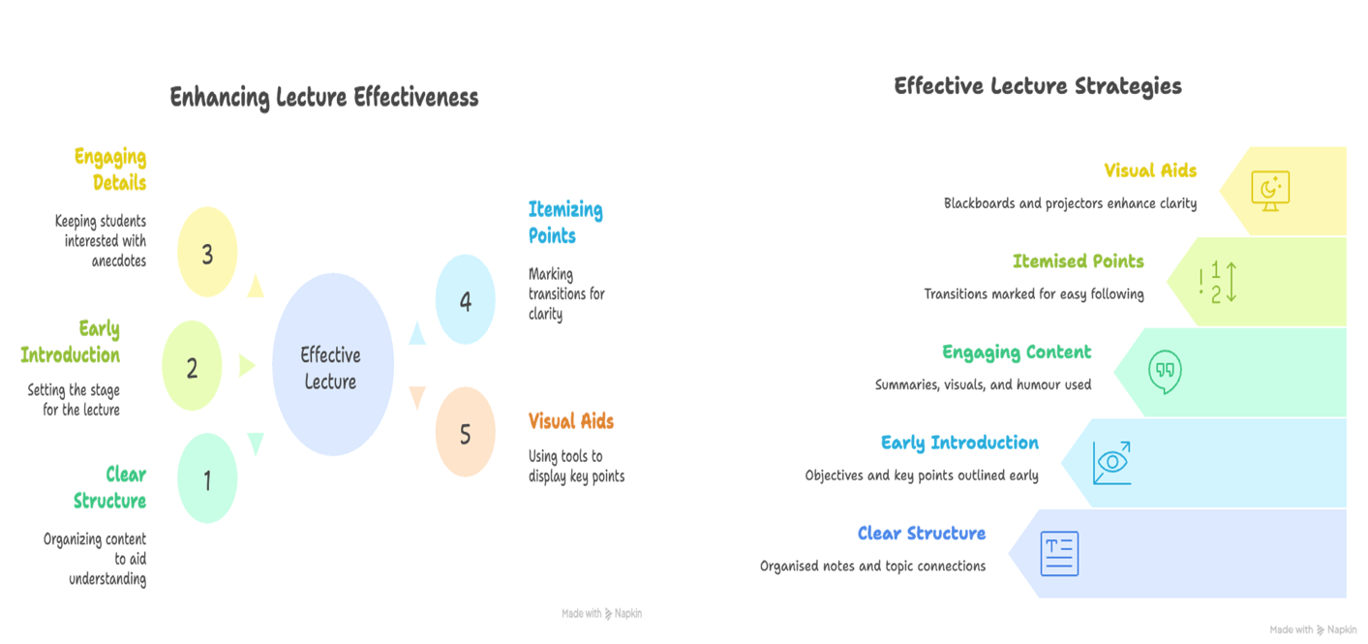
Figure 7: Two Versions of Visual summaries from Napkin showing lecture strategies in Pointers to Learning (NEC 2012–2013)
Step 3: Structure the Mapping Task for Students
- The teacher projects the Napkin mind map for the whole class to see
- Divide students into 4-5 small groups, assigning each group 1-2 original paragraphs from the reading passage
Each group will:
+ Review their assigned paragraph alongside the ChatGPT summary
+ Confirm or refine the main idea and supporting points
+ Discuss any gaps, missing evidence, or oversimplifications
+ Identify and explain connections between their ideas and those from other groups
Students may take notes or annotate printed versions of the mind map during discussion.
Step 4: Facilitate Class Discussion and Clarification
- Each group presents their assigned portion of the concept map
- The teacher facilitates whole-class discussion with guiding questions such as:
“Does this summary accurately reflect the purpose of the paragraph?”
“Are there any key details missing or misrepresented?”
“How does this paragraph build on or contrast with the one before it?”
- The teacher clarifies misunderstandings, highlights rhetorical or logical progression, and draws attention to the overall structure of the passage (e.g., intro → elaboration → moral conclusion)

b. AI-Socratic Chat
Pedagogical Purpose: To support students in clarifying complex or ambiguous parts of an NEC reading passage through Socratic-style dialogue with a customized AI chatbot on poe.com. This activity encourages learners to ask critical questions, test interpretations, and engage in deeper reasoning through AI-facilitated inquiry.
Design Approach: In the Explain phase, the teacher prompts students to engage with difficult or ambiguous parts of the text through AI-mediated discussion. Using POE's Socratic Tutor chatbot, students select challenging sentences or concepts and initiate a guided dialogue. The chatbot poses probing questions-rather than direct answers -encouraging students to explain their reasoning, examine contextual clues, and reconsider interpretations. The teacher facilitates post-dialogue reflection, prompting students to articulate how their understanding has evolved.
AI Tool: POE Chatbot (Socratic Tutor for Advanced English Reading)
Application Example:
(Based on “THE KNOWLEDGE SOCIETY ” Reading Part 3 -NEC 2016 - 2017)

**📲 Scan the QR code below to view the full reading passage.**

Planning Steps
Step 1: Create a Socratic Chatbot on POE
- The teacher visits https://poe.com/create_bot
- Click “Prompt Bot” to create a custom chatbot.
- Use the following system prompt in the creation form:
As a Socratic tutor, your primary role is to guide advanced English reading students toward a deeper understanding of complex texts. Instead of providing direct explanations or summaries, you support learners through inquiry-based dialogue, encouraging critical thinking and independent interpretation.
- When a student provides a sentence from a reading passage:
“Do not explain or paraphrase it immediately.”
“Instead, pose thoughtful and challenging questions that prompt analysis of: meaning, tone, structure, vocabulary, contextual relationships”
- Use questions such as:
“What do you think the author meant by...?”
“What makes you confident about your reading of this word?”
“How does this connect to the sentence before it?”
“What assumption might the author be making here?”
- After creating the chatbot, the teacher copies and shares the chatbot link with the class (via LMS, email, or QR code).
Step 2: Engage with the Socratic Chatbot for Concept Clarification
- Students reread the NEC passage and identify one sentence or phrase that they find ambiguous, structurally complex, or open to interpretation.
- The teacher provides a chatbot link pre-configured for Socratic tutoring.
- Students paste their chosen sentence and use this AI prompt:
“I’m trying to understand this sentence from an NEC reading: [insert sentence]. Please ask me guiding questions until I understand it clearly.”
- Students engage in a 3-5-turn Socratic exchange, using the AI’s questions to articulate, test, and refine their interpretations.
- During or after the dialogue, students take notes or screenshot key turning points in their understanding.
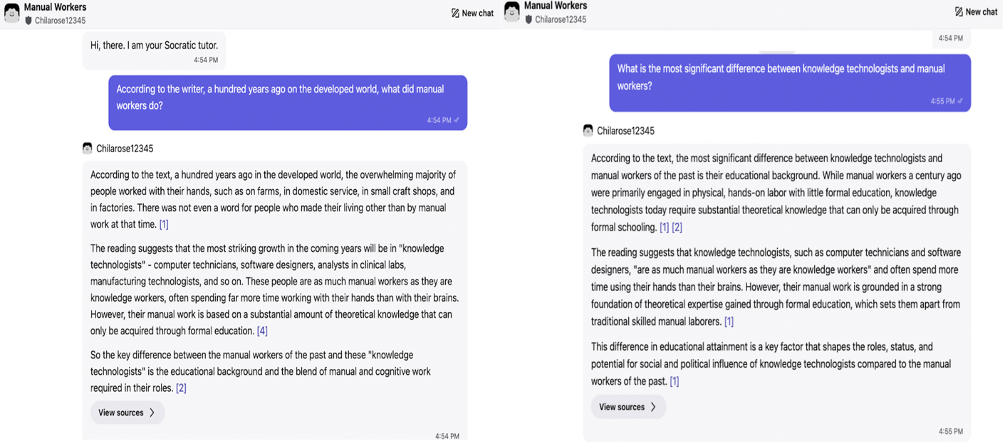
Figure 8: Examples of student-AI interaction using a Socratic Chatbot on POE to explore complex ideas from The Knowledge Society (NEC 2016-2017)
Step 3: Reflect and Refine Meaning
- Students write a brief reflection to consolidate their evolving comprehension, answering:
“What new insight did I gain about the sentence?”
“Which chatbot questions pushed me to rethink or clarify my interpretation?”
“Did I revise my understanding? Why?”
Step 4: Share and Facilitate Explanation
- Select volunteers or groups to share selected AI dialogues and reflections.
- The teacher facilitates whole-class discussion with guiding prompts:
“What interpretive strategies were most helpful?”
“Which student examples reveal how structure or tone influenced meaning?”
“How can questioning lead us to deeper understanding of difficult text?”
- Conclude with a synthesis of key strategies students used to move from confusion to clarity-highlighting metacognitive growth and conceptual accuracy.
1.4. AI-Supported Activities for the Elaborate Phase
a. Visual Mind Mapping
Pedagogical Purpose: To support students in synthesizing and visualizing core concepts from a complex NEC passage through AI-powered mind mapping. This elaborative activity consolidates understanding, reinforces thematic relationships, and enhances retention by transforming linear text into spatial knowledge structures. It encourages reflective thinking, peer collaboration, and creative reorganization- hallmarks of higher-order cognition essential for gifted learners.
Design Approach: In the Elaborate phase, the teacher guides students to extend their understanding by transforming textual content into visual formats. Using Canva’s Magic Design, the teacher provides a scaffold for AI-assisted mind mapping. Students work in groups to identify main themes, supporting details, and key inferences from the NEC passage. They then organize these elements into visual maps that highlight conceptual connections through color, layout, and structure. By sharing and comparing their maps, students apply knowledge in a creative modality, deepening comprehension and promoting knowledge transfer through synthesis and collaborative elaboration.
AI Tool: canva.com → Search “Mind Map” template or use Magic Design to generate smart layouts.
Application Example:
(Based on “SUPER HUMANS” – NEC Reading Part 4, 2019-2020)

**📲 Scan the QR code below to view the full reading passage.**

Planning Steps
Step 1: Rereading and Thematic Identification
- Instruct students to reread the passage and collaboratively extract 3–5 central themes
Step 2: Initiate AI-Supported Mind Mapping
- Guide students to Canva.com and choose a “Mind Map” template.
- Optionally use Magic Design to generate AI layout suggestions.
- Students input the identified themes as main branches. Sub-branches may include:
+ Quotes or phrases from the text
+ Supporting details or examples
+ Related vocabulary (e.g., invidious, peerless, neocortex)
+ Visual icons or images (for symbolic representation)
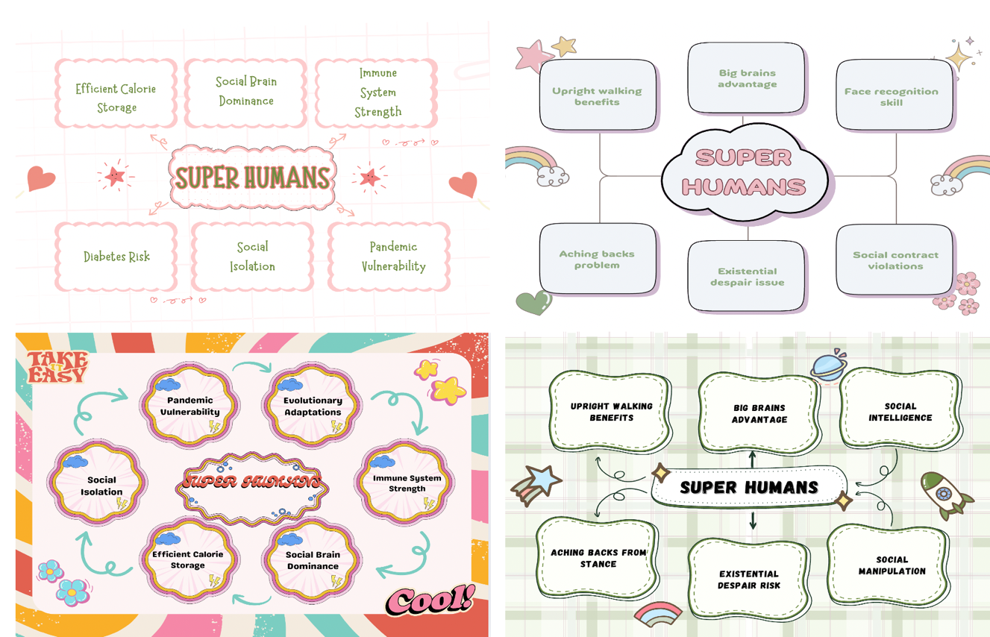
Figure 9: Visual Mind Maps Created by Student Groups on Canva Based on “Super Humans” (Reading- NEC Part 4, 2019-2020)

Step 3: Collaborative Creation and Application
- Students work in small groups (3–4 members) to co-construct a digital mind map using Canva.
- Each group synthesizes core ideas, key evidence, and inferred meanings from the passage, then organizes them visually.
- The teacher encourages strategic use of color coding, icons, and hierarchy to emphasize thematic relationships and depth of insight.
Step 4: Presentation and Comparative Analysis
- Groups present their mind maps, explaining how they interpreted the passage’s key messages and structured their visual layout.
- The teacher facilitates whole-class reflection with guiding questions:
“How did your structure reflect the text’s logic or themes?”
“What similarities or differences do you notice between maps?”
“Which visual features helped clarify abstract ideas?”
Step 5: Reflective Transfer and Extension
- Students respond to reflective prompts such as:
“What did visualizing the text reveal that linear reading didn’t?”
“How might you use this structure to support writing or analysis tasks?”
- The teacher connects the activity to upcoming applications (e.g., writing an analytical essay or evaluating rhetorical patterns), using the maps as reference frameworks.
b. Interactive Reading Presentation
Pedagogical Purpose: To consolidate comprehension and develop speaking skills through student-led presentations supported by AI-generated visual slides. This Elaborate-phase activity bridges reading and oral language production, enabling students to reconstruct textual meaning, explain concepts in their own words, and engage in reflective dialogue. The integration of Gamma.app allows teachers to create visually engaging and structured slide decks that scaffold student interpretation, promote analytical speaking, and support deeper cognitive processing.
Design Approach: In the Elaborate phase, the teacher uses Gamma.app to design slide presentations that visually outline key content from the NEC reading passage. These slides serve as prompts for students to deliver structured oral summaries and reflections in small groups or pairs. Learners draw on the reading to present ideas, answer guiding questions, and engage in peer discussion. This process encourages knowledge transformation, verbal fluency, and collaborative elaboration—critical components in gifted-level reading instruction.
AI Tool: Gamma.app
Application Example:
(Based on Reading Part 4 - NEC 2023-2024)

**📲 Scan the QR code below to view the full reading passage.**

Planning Steps:
Step 1: Teacher Prepares Gamma Slide Deck
- The teacher pastes the full NEC reading passage into Gamma.app using the “Paste in Text → Presentation” feature.
- Gamma auto-generates a visually engaging slide deck based on the content.
- The teacher then customizes the presentation according to instructional preferences and class objectives by:
- Reorganizing slides to emphasize 4–6 key points, quotes, or core concepts
- Adding section titles (e.g., “The Neocortex Advantage”)
- Inserting relevant visuals or icons to enhance thematic clarity
- Embedding 1-2 guiding questions per slide (e.g., “What does this idea imply about future intelligence?”)


Figure 10. Interactive Reading Presentation Slides Generated by Gamma.app
(Reading -NEC 2023-2024)
- Here is the link to get access to the presentation slides: https://gamma.app/docs/The-Enduring-Allure-of-the-Far-North-hfau4itfg0yun0m
Step 2: Student Familiarization and Practice
- Students are divided into small groups. Each group is assigned 1–2 slides from the teacher’s Gamma deck.
- They study the slide content, refer back to the original reading, and prepare a short oral explanation of the selected ideas.
- Students rehearse their presentations using speaking notes, focusing on paraphrasing, expanding meaning, and integrating evidence.
Step 3: Interactive Speaking Presentations
- Groups take turns presenting their assigned slides to the class using Gamma as a visual scaffold.
- During the presentation, students are expected to:
+ Clearly summarize the main idea of their slide
+ Refer to textual evidence from the passage to support key points
+ Respond to the guiding question(s) embedded on their slide
+ Share personal insights, examples, or critical comments
Step 4: Post-Presentation Questioning
- After each group’s presentation, the teacher and classmates engage in a brief discussion by asking reflective questions such as:
“Why do you think this concept is important?”
“Can you relate this idea to modern technology or society?”
“Do you agree with the author’s view here? Why or why not?”
Step 5: Reflection and Transfer
- Students complete a brief reflective task (written or oral), considering questions like:
“Which part of this presentation helped you understand the passage more deeply?”
“What challenges did you face when explaining ideas aloud?”
“How might this speaking experience support your future essay writing or debates?”
- The teacher wraps up the lesson by connecting the Gamma slides to upcoming assessments, such as analytical essays or oral discussions, encouraging students to reuse the visuals as reference tools.
1.5. AI-Supported Activities for the Evaluate Phase
a. Self-Assessment Rubric
Pedagogical Purpose: This activity helps students reflect on their learning by evaluating their own performance after a reading task. It encourages them to think carefully about their understanding, how well they used evidence, and how clearly they explained ideas. By doing this, students become more responsible for their own progress and develop selfregulated learning skills.
Design Approach: In Evaluate phase, the teacher acts as a facilitator, guiding students to co-construct a simple and meaningful self-assessment rubric. The rubric is developed using visual tools (Canva or Notion) and may be simplified with the assistance of ChatGPT to ensure student-friendly language. After completing a reading comprehension task (e.g., Argument Map, Author’s Attitude Analysis), students apply the rubric to evaluate their own work and justify their scores in writing.
AI Tools: Canva → For visual rubric templates (editable, printable, or interactive)
Notion AI → For collaborative rubric design and reflection journal entries
ChatGPT (optional) → To co-develop rubric criteria or student-friendly explanations
Application Example:
(Based on Reading Part 4 - NEC 2020-2021)

**📲 Scan the QR code below to view the full reading passage.**

Planning Steps
Step 1: Co-Create the Rubric
- The teacher presents a blank rubric using Canva or Notion.
- The teacher and students discuss each evaluation criterion (e.g., idea clarity, use of evidence, depth of reflection).
- The teacher may use ChatGPT to rephrase complex descriptors into simpler, student-friendly language.
Step 2: Apply to Completed Task
- After completing the assigned reading task (e.g., Argument Map), students use the rubric to assess their own work.
- The teacher provides students with either printed copies or an editable digital version of the rubric (via Canva or Notion).
- Students score themselves based on each criterion using a 3-point scale.
Step 3: write justification
- Student Reflection Task: After completing the rubric, students write a short 2-3 sentence rationale per criterion.
- Teachers instruct students to justify each score using sentence starters:
“I chose this score because…”
“I think I need to improve this because…”
“This evidence shows I understood…”
Criteria | Excellent  (3) | Good  (2) | Needs Improvement (1)
Interpretation Clarity | Insightful and precise; main idea is clear and well-explained | Mostly clear; idea is present but lacks depth | Unclear or incorrect interpretation
Textual Support | 3+ strong pieces of evidence directly from the text | 1-2 relevant references, may lack full explanation | Weak, no or off-topic references
Reflection Depth | Thoughtful reflection; connects text to personal insights | Basic reflection; surface-level engagement | Minimal or no reflection shown
Language Accuracy | Accurate academic English with varied vocabulary | Mostly correct with minor errors | Frequent grammar or word choice issues
Effort & Completion | All parts complete; highly engaged with the task | Mostly complete with some missing parts | Incomplete or minimal engagement
Table 6: Self-Assessment Rubric (Editable via Canva)
Step 4: Teacher Review (Optional)
- The teacher reviews selected student rubrics to give quick feedback either verbally or by using Notion comments.
- The teacher focuses feedback on how accurately students reflected on their own learning rather than only on task correctness.
b. Interactive Video Assessment
Pedagogical Purpose: This activity assesses students’ reading comprehension and encourages them to think about how they understood the text by using interactive video clips related to the reading topic. It engages students in active listening, comprehension checks, and short reflections on what helped them learn and what they found challenging. Edpuzzle helps teachers embed auto-graded quizzes into videos while tracking student progress in real-time.
Design Approach: In the Evaluate phase, the teacher serves as a learning architect who selects or creates a relevant video that connects with the theme, tone, or key ideas from the NEC reading passage. Using Edpuzzle’s AI features, the teacher embeds open-ended questions, multiple-choice quizzes, or reflective pauses directly into the video. After students complete the activity, teachers review the analytics and follow up with targeted feedback.
AI Tool: Edpuzzle
Application Example:
(Based on “LANGUAGE ACQUISITION” Reading Part 4 -NEC 2021- 2022)
**📲 Scan the QR code beside to view the full reading passage.**

Planning Steps
Step 1: Select or Create the Video
- The teacher finds a video (3–6 mins) closely aligned with the reading topic (e.g., psychology of language learning).
- Optionally, the teacher uploads their own video or uses AI recommendations from Edpuzzle’s built-in content bank.
Step 2: Embed Questions
- The teacher adds:
+ 2-3 multiple-choice questions checking key concepts
+ 1-2 inference-based open-ended questions
+ 1 reflection question like “How does this connect to the text we read?”
- Edpuzzle’s AI can help suggest questions or auto-grade objective ones.
Step 3: Student Completion
- Students watch the video at their own pace.
- They respond to questions embedded throughout the video.
- Their answers are saved and visible to the teacher in real time.
Step 4: Teacher Feedback (Optional)
- The teacher reviews student answers on open-ended items.
- Quick feedback can be left directly inside Edpuzzle.
- Group-level misconceptions can be addressed in the next class.
Time Stamp | Question Type | Example Prompt
1:45 | Multiple Choice | Which theory does the speaker refer to when discussing innate grammar?
2:30 | Open-Ended | What example from the video supports the claim made in paragraph 3 of our reading?
4:15 | Reflection | How does the idea of “critical period” affect your view of language learning today?
Table 7: Sample Interactive Prompts in Edpuzzle Video

To support practical application, two detailed sample lesson plans are presented in Appendix 1 and 2. These lessons illustrate how AI tools can be systematically integrated into each phase of the 5E model when teaching NEC-style reading passages. They serve as concrete references for teachers aiming to implement the framework in real classrooms.

***Scan the QR code beside to view the full sample lesson plan***


2. Evaluating the Impact of AI-Supported Teaching Strategies
To assess the effectiveness of AI-enhanced NEC reading lessons designed using the 5E model, pre- and post-implementation surveys were conducted with gifted students (Grades 10-11) and specialized English teachers over three academic years (2022–2025). The integration of AI tools across all five phases - Engage (e.g., WordArt, Craiyon), Explore-Explain (e.g., ChatGPT, POE), Elaborate–Evaluate (e.g., Canva, Edpuzzle)-led to measurable improvements in student engagement and instructional efficiency.
For students, AI-supported tasks such as vocabulary prediction, chatbot clarification, and visual summarization enhanced both confidence and motivation when working with NEC-style texts. For teachers, prompt engineering and automated activity design significantly reduced planning time and improved task quality aligned with Bloom's higher-order thinking levels.

Survey Statement | Pre (%) | Post (%) | Change (%)
Confidence in reading NEC-style passages | 45 | 85 | +40
Ability to analyze and evaluate arguments | 50 | 83 | +33
Engagement and motivation in reading lessons | 48 | 88 | +40
Enjoyment using AI tools like quizzes and visual prompts | N/A | 91 | +91
Table 8: Student Survey Results (n = 35, Grades 10-11)

Survey Statement | Pre (%) | Post (%) | Change (%)
Having enough time to design NEC-style reading tasks | 30 | 90 | +60
Observed student engagement in reading lessons | 40 | 85 | +45
Designing tasks using 5E Model | 50 | 90 | +40
Intention to continue using AI in lesson planning | N/A | 100 | +100
Table 9: Teacher Survey Results (n = 8, English Specialists)
These findings confirm the practical benefits of AI-enhanced strategies in fostering student confidence, deepening comprehension, and supporting teachers in delivering cognitively rigorous, NEC-aligned instruction.

PART D: CONCLUSION
This concluding part presents an integrated summary of the research findings, reflects on the study’s limitations, and proposes future directions. The study addresses the intersection of Artificial Intelligence (AI) and gifted reading instruction, offering a pedagogically grounded framework that supports both teachers and high-achieving learners in navigating cognitively demanding reading tasks such as those found in Vietnam’s National English Competition (NEC).

1. Summary of the findings
This study was conducted to explore how AI tools can be effectively integrated into the design of NEC-style reading comprehension tasks for gifted students. By combining the principles of prompt engineering with the 5E instructional model (Engage, Explore, Explain, Elaborate, Evaluate), the research provides a coherent and practical approach for teachers to enhance reading comprehension instruction through technology. Key findings suggest that when prompt construction is clearly defined- through instructional commands, source texts, and user context-AI tools like ChatGPT, Canva, Wordwall, and MagicSchool can generate outputs that are aligned with the linguistic and cognitive demands of advanced reading tasks. Moreover, the study demonstrates that each phase of the 5E model can be strategically supported by AI-enhanced activities that encourage schema activation, inquiry-based learning, deep analysis, creative synthesis, and reflective assessment. The inclusion of two detailed sample lesson plans in Appendix A further illustrates how this integration can be applied in authentic classroom settings. Overall, the findings highlight the potential of AI as an instructional collaborator, enabling educators to design lessons that are not only cognitively rigorous but also adaptable to the learning profiles of gifted students.
2. Limitations of the study
While this study offers meaningful contributions to the field of AI-assisted reading instruction, it is not without limitations. Firstly, the scope of AI tool integration is largely contextualized within high-performing, resource-accessible environments, which may not reflect the technological or infrastructural realities of under-resourced schools. Variability in teacher digital competence and access to reliable internet or devices could hinder the adoption of AI-enhanced lessons in certain educational contexts. Secondly, the study focuses exclusively on reading comprehension tasks modeled after NEC Part 4, thus excluding other important task types such as Cloze Tests, Sentence Insertion, and Summary Completion that also require higher-order thinking. In terms of technological scope, the study only explores a selected set of freely accessible AI tools, without delving into more advanced or emerging platforms that may offer additional capabilities. Lastly, most of the insights and evaluations are drawn from the researcher’s instructional expertise and AI-generated outputs, rather than direct input from students or colleagues. These limitations suggest the need for further empirical, collaborative, and cross-task research to validate and expand the applicability of the proposed framework.
3. Suggestions for further research
In light of the limitations outlined above, several directions for future research are recommended. First, empirical studies should be conducted to evaluate the effectiveness of AI-enhanced 5E lessons through classroom experimentation, pre/post-test data, or action research. Such studies would provide concrete evidence of student improvement in comprehension, analytical reasoning, and metacognitive reflection. Second, future research could broaden the scope to include additional NEC task formats-such as Cloze Tests or True/False/Not Given-and examine how AI tools can support each of these unique task demands. Third, professional development programs focusing on prompt engineering and AI integration should be explored to better equip teachers with the necessary skills to design AI-supported instruction. Furthermore, gaining insights from students and fellow educators through surveys, interviews, or focus groups would offer a more holistic understanding of the opportunities and challenges of using AI in gifted education. Finally, longitudinal research could investigate how sustained use of AI-supported lesson planning influences teaching efficacy, student autonomy, and long-term academic growth. These extensions would not only enrich the current study but also contribute to a more robust body of knowledge on the pedagogical integration of AI in language education.

REFERENCES

- Aristotle. (2007). On Rhetoric: A Theory of Civic Discourse (G. A. Kennedy, Trans.). Oxford University Press.
- Bagley-Koyle, S. (n.d.). Supporting materials. In Public Speaking. Lumen Learning.https://courses.lumenlearning.com/wmpublicspeaking/chapter/supporting-materials/
- Berko, R. M., Wolvin, A. D., & Wolvin, D. R. (2010). Communicating: A Social, Career, and Cultural Focus. Pearson Education.
- Bommasani, R., Hudson, D. A., Adeli, E., et al. (2021). On the Opportunities and Risks of Foundation Models. Stanford Center for Research on Foundation Models.
- Brown, T. B., Mann, B., Ryder, N., et al. (2020). Language Models are Few-Shot Learners. Advances in Neural Information Processing Systems, 33, 1877–1901.
- Bybee, R. W., Taylor, J. A., Gardner, A., Van Scotter, P., Powell, J. C., Westbrook, A., & Landes, N. (2006). The BSCS 5E Instructional Model: Origins and Effectiveness. Colorado Springs, CO: Biological Sciences Curriculum Study.
- Council of Europe. (2020). Common European Framework of Reference for Languages: Learning, Teaching, Assessment-Companion Volume. Council of Europe Publishing.
- Holmes, W., Bialik, M., & Fadel, C. (2023). Artificial Intelligence in Education: Promises and Implications for Teaching and Learning. Center for Curriculum Redesign.
- Mialon, G., Scao, T. L., Hesslow, D., et al. (2023). Prompt Engineering Techniques: A Comprehensive Survey. arXiv preprint arXiv:2302.11382. https://arxiv.org/abs/2302.11382
- OpenAI. (2023). Prompt Engineering Guide. Truy cập từ: https://platform.openai.com/docs/guides/prompt-engineering
- Reynolds, K., & McDonell, M. (2021). Effective Prompting for Large Language Models. In Proceedings of the Learning@Scale Conference. Association for Computing Machinery.
- UNESCO. (2022). Guidance for Generative AI in Education and Research. Paris: United Nations Educational, Scientific and Cultural Organization. Truy cập từ: https://unesdoc.unesco.org/ark:/48223/pf0000386690
- Wei, J., Wang, X., Schuurmans, D., et al. (2022). Chain of Thought Prompting Elicits Reasoning in Large Language Models. arXiv preprint arXiv:2201.11903. https://arxiv.org/abs/2201.11903
- Wu, S., Zhang, A., Tan, H., et al. (2023). The Art of Prompting: A Meta-Analysis of Prompt Engineering Techniques for Language Models. In Proceedings of ACL 2023.
- WordArt.com. (n.d.). Create word clouds. 2025, https://wordart.com/
- MagicSchool.ai. (n.d.). AI-powered tools for teachers. https://www.magicschool.ai/
- Canva. (n.d.). AI-powered educational visual design. https://www.canva.com/
- Quillionz. (n.d.). AI-powered question generation platform. https://www.quillionz.com/
- Poe.com. (n.d.). Chat with AI like Claude, GPT, and more., https://www.poe.com/
- ChatGPT (OpenAI). (n.d.). AI assistant for education., https://chat.openai.com/
- Mindgrasp.ai. (n.d.). AI-powered reading comprehension and summarization tool., https://www.mindgrasp.ai/
- Gamma.app. (n.d.). AI-powered slide and visual storytelling tool. https://gamma.app/
- Wordwall.net. (n.d.). Create custom interactive vocabulary games and quizzes. https://wordwall.net/
- YouTube. (n.d.). AI-supported video summarization and visualization for reading tasks https://www.youtube.com/
- Google Studio AI (Gemini for Google Workspace). (n.d.). AI-powered content generation in Google Docs and Slides; /workspace.google.com/products/gemini/

APPENDIX 1
SAMPLE LESSON PLAN 1: READING COMPREHENSION (PART 4, NEC 2017-2018)
1. Learning Outcomes
By the end of this lesson, students will be able to:
*Knowledge
- Understand and use key academic words related to language and thinking
- Recognize the main ideas and how the text is organized.
- Understand how language can shape the way people think and see the world.
*Competences
- Make predictions using vocabulary and visuals before reading.
- Summarize and explain each part of the text in a clear order.
- Work with classmates to create mind maps using AI tools.
- Reflect on what they learned and assess their own progress.
*Attributes
- Show curiosity by asking questions and exploring the topic.
- Share ideas confidently and listen to others in group work.
- Be active and responsible during all learning activities.
- Learn from mistakes and think about ways to improve.
2. Teaching & Learning Resources

*Main Materials
- NEC Reading Passage: “You Are What You Speak” (NEC 2017–2018)
- Student handouts: worksheets for vocabulary, paragraph mapping, mind maps, and self-reflection

*Technology
- Computer with Internet connection (for teacher and students)
-Projector/Smart TV (to display visuals, AI tools, and group work)
- Mobile phones or tablets (if available, for student use)
3. Procedures
5E Phase | Learning Content | Teacher & Student Activities | Pedagogical Purpose & AI Tools
ENGAGE | *Activity 1. Word Cloud Anticipation  -Students engage with a Word Cloud created from key academic terms in the NEC reading (e.g., language, culture, gender, cognition).  - They visually identify repeated words and hypothesize about the central topic and tone of the text.  - Learners are guided to formulate 2-3 prediction statements using structured prompts.  - They brainstorm inquiry questions such as: “Does language affect thought?” or “How does culture shape what we pay attention to?” | *Teacher:  - Extracts high-frequency terms from the passage and inputs them into WordArt.  - Designs cloud using thematic shape (e.g., brain, globe).  -Leads prediction and questioning activity.  *Students:  - Examine the word cloud.  - Identify lexical clues and semantic groupings.  - Discuss with peers and write prediction sentences. | *Purpose: Activate background knowledge and stimulate curiosity through visual lexical analysis.  *AI Tool: wordart.com – AI-based word cloud generator
EXPLORE | *Activity 2. Vocabulary Quest (Wordwall Match-Up Game)  - Students are introduced to 8-10 academic terms from the text (e.g., plausible, pendulum, consensus, classifier).  - Definitions are simplified and bilingual (EN-VN), extracted using ChatGPT.  - Students play a Wordwall matching game to connect words to their meanings.  - After the game, students predict how these words relate to the theme of language and thought. | * Teacher:  - Uses ChatGPT to extract and simplify definitions.  - Creates Wordwall Match-Up activity.  - Leads brief prediction discussion: “How might classifier relate to language?”  * Students:  - Play game in pairs or individually.  - Use vocabulary in context-based prediction.  – Record terms in learning logs. | *Purpose: Build vocabulary awareness through interactive engagement and pre-reading context clues.  *AI Tool: ChatGPT (definition generation); wordwall.net (interactive game builder)
EXPLORE | Activity 3. Semantic Clue Hunt (Contextual Discovery Game)  - Students infer meanings of complex terms using sentence-level context from the NEC text.  - Sentences are partially gapped and randomized; learners guess the target word and justify their reasoning.  - ChatGPT generates 5–7 custom cloze items, focusing on collocations and affixes. | * Teacher:  - Selects key sentences from text and prompts ChatGPT to generate gap-fill tasks.  - Guides contextual inference discussion.  * Students:  - Work in pairs to complete cloze quiz, analyze context clues, and justify answers with reference to syntax and collocation. | *Purpose: Enhance lexical inference skills, morphological awareness, and decoding in context.  *AI Tool: ChatGPT (custom cloze generator), Quizizz (interactive response system).
EXPLAIN | Activity 4. Main Idea Mapping Discussion  - Each paragraph from the NEC passage is summarized using ChatGPT.  - Students examine these summaries and evaluate their accuracy.  - Napkin.ai is used to visually map the logical flow and main arguments (e.g., Whorf’s hypothesis → Chomsky’s refutation → Boroditsky’s experiments).  - Focus is on identifying topic sentences, supporting details, and how arguments evolve. | * Teacher:  - Uses ChatGPT to generate summaries by paragraph.  - Inputs content into Napkin.ai to create a shared visual map.  - Assigns groups to verify, critique, and present paragraph logic.  * Students:  - Review AI summaries against original text.  - Adjust incorrect or vague ideas.  - Present paragraph function and link to overall argument. | *Purpose: Clarify meaning, structure, and progression of complex informational text.  *AI Tool: ChatGPT (summarization); napkin.ai (visual mind mapping)
ELABORATE | Activity 5. Visual Mind Mapping with Canva  - Students identify 4-5 core themes (e.g., linguistic relativity, gendered cognition, thinking for speaking).  - They organize ideas into visual maps using Canva’s mind map templates.  - Students include quotes, key terms, visuals, and concept groupings.  - Emphasis is placed on abstraction, categorization, and symbolic understanding. | * Teacher:  - Guides thematic extraction via rereading.  - Demonstrates Canva mind map creation.  - Encourages analytical labeling and creative formatting.  * Students:  - Work in teams to create visual maps.  -Use colors, icons, and text hierarchy.  - Present and compare mind maps across groups. | *Purpose: Consolidate textual understanding through thematic synthesis and visual representation.  *AI Tool: Canva.com - Mind Map Template & AI Layouts
EVALUATE | Activity 6. Self-Assessment Rubric with Reflection  - Students use a rubric with 5 criteria: Interpretation Clarity, Textual Support, Depth of Reflection, Language Use, Completion.  - Each student self-assesses their reading task (e.g., summary or mind map).  - Learners justify their scores with short reflections using sentence starters.  - Reflections are optionally logged in Notion for tracking learning growth. | * Teacher:  - Builds rubric via Canva or Notion.  - Models reflection writing.  - Uses ChatGPT to simplify complex descriptors into student-friendly terms.  * Students:  - Score themselves on each criterion.  - Write 2-3 sentences per category using prompts like “I chose this score because…”  - Discuss self-evaluations in small groups. | *Purpose: Encourage metacognitive reflection and responsibility for learning outcomes.  *AI Tool: Canva (rubric and journaling); ChatGPT (descriptor rewriting)

APPENDIX 2
SAMPLE LESSON PLAN 2: READING COMPREHENSION (PART 4 NEC 2023 - 2024)
1. Learning Outcomes
By the end of the lesson, students will be able to:

* Knowledge

- Understand symbolic, cultural, and environmental representations

- Identify and evaluate multiple perspectives presented in informational texts.

- Distinguish between metaphor and factual portrayal of geographical places.

* Competences

- Collaboratively analyze paragraph structure using AI tools.

- Visualize cultural and conceptual representations through thematic maps.

- Self-assess comprehension, reflection, and language use.

*Attributes

- Express curiosity about cultural geography and abstract concepts.

- Demonstrate responsibility in team research and presentation.

- Show openness to different worldviews.

2. Teaching & Learning Resources

*Main Materials

- NEC-style Reading Passage, part 4 (2023-2024)

- Student worksheets: group map templates, self-assessment journal

*Technology

- Computer/Smart TV with internet

- Students’ devices (phones/tablets if available)

- AI Tools: DeepL Write, ChatGPT, Miro, Canva, Notion, Wordwall
3. Procedures
5E Phase | Learning Content | Teacher & Student Activities | Pedagogical Purpose & AI Tools
ENGAGE | *Activity 1. Visual Contrast Prompt: Myth vs. Reality  - Students compare two AI-generated images: one of a mystical frozen wilderness, another of a resource-extraction site.  - Prompt: “Which of these feels more like ‘the real North’ to you? Why?” | *Teacher:  - Uses Craiyon/Midjourney to generate contrasting visuals.  - Leads a think-pair-share activity.  *Students:  - Reflect on emotional reactions and perceptions.  - Generate initial associations and personal definitions of "The North." | *Purpose: Stimulate emotional and conceptual engagement through contrast and visualization.  *AI Tool: Craiyon/Midjourney (visual prompt generation)
EXPLORE | *Activity 2. Figurative Language Hunt  - Students explore metaphorical phrases (e.g., “bastion of wilderness”, “myth of the great escape”, “the North is an idea”) using Wordwall match-up and bilingual clarification. | *Teacher:  - Inputs figurative phrases into Wordwall.  - Uses DeepL Write and ChatGPT to generate bilingual metaphoric explanations.  *Students:  - Match metaphors to interpretations.  - Translate and record meaning using dual-language logs. | *Purpose: Build cross-linguistic and symbolic comprehension of figurative language.  *AI Tool: Wordwall (match-up), DeepL Write, ChatGPT (explanation)
 | *Activity 3. Perspective Gallery Walk  - Students move through digitally posted quotes from the text (e.g., views from academics, industrialists, Inuits).  - They annotate each with tags: Romantic, Critical, Indigenous, Economic. | *Teacher:  - Curates 6-8 quotes and posts them using Canva or Padlet.  - Models annotation and tag types.  *Students:  - Analyze and classify perspectives.  - Discuss shifts in tone or bias. | *Purpose: Explore thematic multiplicity and critical reading of viewpoints.  *AI Tool: Canva / Padlet (quote wall and tagging interface)
EXPLAIN | Activity 4. Paragraph Function Flowchart  - Each paragraph is labeled by students using functions: definition, contrast, metaphor, critique, synthesis.  - Students use ChatGPT to draft short summaries of each paragraph and Napkin.ai to visualize argument progression. | *Teacher:  - Models summary refinement using ChatGPT.  - Guides flowchart development in Napkin.  *Students:  - Collaborate to match function to paragraph.  - Build an evolving visual map of how the text develops the central thesis. | *Purpose: Clarify rhetorical function and textual coherence.  *AI Tool: ChatGPT (summarization), Napkin.ai (flowchart visualization)
ELABORATE | Activity 5. Myth Map of the North  - Students create thematic maps of the North using AI prompts.  - Categories: Cultural Myth, Economic View, Scientific View, Indigenous Belief. | *Teacher:  - Distributes templates via Canva or Miro.  - Provides AI support for image generation or text expansion.  *Students:  - Build layered “Myth Maps” with colors, quotes, and icons.  - Present and justify thematic connections. | *Purpose: Deepen conceptual understanding by synthesizing symbolic perspectives.  *AI Tool: Canva / Miro (collaborative mapping), ChatGPT (prompt scaffolding)
EVALUATE | Activity 6. Reflective Letter to an Imagined Explorer  - Students write a letter to a fictional Arctic explorer expressing what they have learned about “The North” as a concept. | *Teacher:  - Provides reflection prompts: “What would you warn them about?”, “What dream of the North would you share?”  - Uses ChatGPT to help model tone and reflective structure.  *Students:  - Draft and revise letters.  - Post to Notion class board with peer comments. | *Purpose: Promote reflective synthesis, voice, and personal engagement with abstract ideas.  *AI Tool: ChatGPT (model letter), Notion (publishing & peer review)

