**LỚP HỌC THẦY (CÔ) ___________________________** **ĐỀ ÔN TẬP: READING SIGNS/ NOTICES – A2**

**Test 14**

*Thời gian làm bài: [Time]*

Họ và tên: ________________________________________________ Lớp: 9/___

**Nội dung:**

**Question 1:** What does this sign mean?

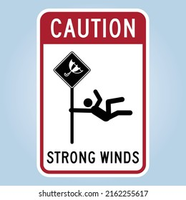**A.** High winds are dangerous; stay away, meaning you should avoid the area due to the high winds.

**B.** High winds are not a risk, meaning they are not harmful or dangerous.

**C.** High winds are decorative, meaning they are merely for show and not a real concern.

**D.** High winds are not dangerous, meaning they do not pose any significant threat.

**Question 2:** Read the sentences in italics. Then choose the correct meaning.

Please take off your shoes before entering.

**A.** Only take off shoes in the living room. **B.** Wear your shoes inside the house.

**C.** Remove your shoes before you enter the house. **D.** You can wear shoes inside but not in the kitchen.

**Question 3:** What does this sign mean?

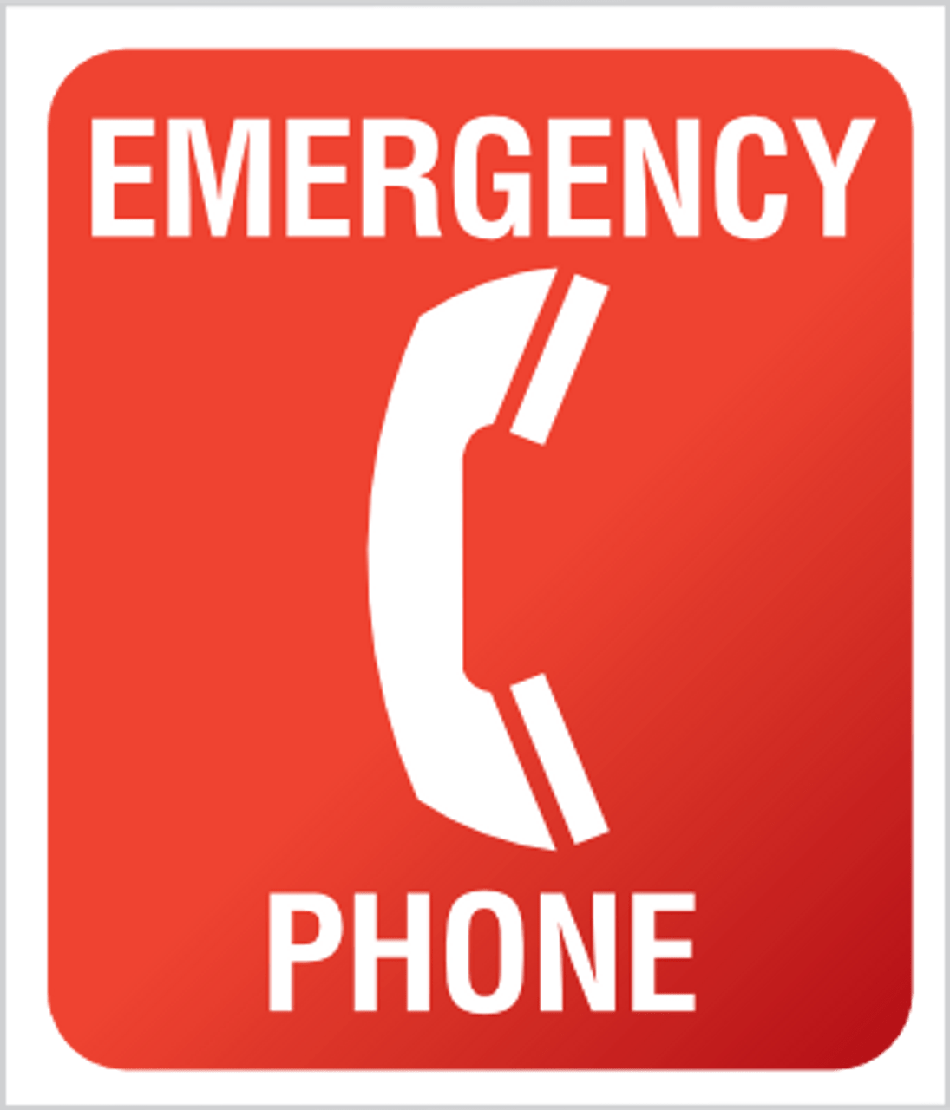

**A.** No phone is available, meaning there is no phone here to use.

**B.** Phone is out of order, meaning the phone is not working and cannot be used**.**

**C.** Phone is for authorized use only, meaning only certain people can use this phone.

**D.** Emergency phone is available, meaning there is a phone for emergencies only.

**Question 4:** Read the text message and choose the correct answer.



Hi Tim,

I’m organising a football match in the park this Saturday at 4pm. Everyone is welcome to join. Let me know if you can join.

Alex

**A.** Tim wants to play football. **B.** Alex invited Tim to the football match.

**C.** Tim wants to join the football match. **D.** Tim and Alex want to play football together.

**Question 5:** 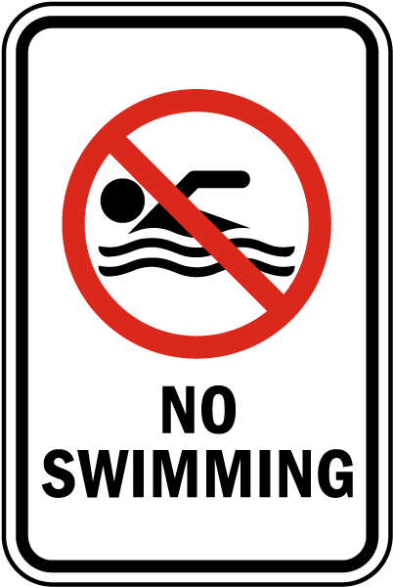What does this sign mean?

**A.** Swimming is allowed in this are**a.**  
**B.** Swimming is not suggested in this are**a.**

**C.** Swimming is not allowed at certain times.  
**D.** Swimming is not allowed in this are**a.**

**Question 6:** What does the message ask for?



Hi Emily,

We are having a knitting workshop this Wednesday at 3pm at the community centre. Would you like to join us?

Nancy

**A.** Attend a knitting workshop **B.** Go to a museum

**C.** Watch a sports match **D.** Visit a friend

**Question 7:** What does this sign mean?

**A.** Don't litter in the morning because the camera will record it.

**B.** You are allowed to throw trash at specific times.

**C.** Throw trash in the right place, don't litter here.

**D.** There is a camera here.

**Question 8:** What is the main idea of ​​the message?



Hi Jim,

We are having a quiz night at the cafe this Tuesday at 7pm. Come and test your knowledge. Will you join us to test your knowledge?

Claire

**A.** Attend a quiz night **B.** Go to a sports match

**C.** Participate to test your knowledge **D.** Go swimming

**Question 9:** What does this sign mean?

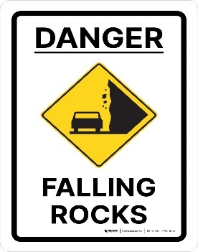

**A.** Be careful; rocks might fall.  
**B.** It is safe to climb the rocks.  
**C.** There are no rocks in this are**a.**  
**D.** The rocks are there for decoration.

**Question 10:** What should you do according to the notice?

The library will be closed for maintenance on Saturday. Please return all books by Friday

**Reminder**

**A.** The library will be open all week. **B.** Books must be returned by Friday.

**C.** You can return books on Saturday. **D.** The library is closed only on Sundays.

**[HẾT]**