UNITS | VOCABULARY | GRAMMAR
Unit 6  EDUCATION | - Vocabulary related to education  - Adjectives to talk about feelings at school | - Present Simple and “have to”  - Intensifiers and “because”  - Conjunctions “However”, “Although”
Unit 7  TRANSPORTATION | - Vocabulary related to personal belongings  - Compare different types of transportation | - Possessive pronouns and adjectives in order  - “(not) as … as …”
Unit 8  FESTIVALS AROUND THE WORLD | - Talks about festivals around the world  - Compare how different countries celebrate festivals | - Future simple  - “like” and “different from”
Unit 9  ENGLISH IN THE WORLD | - Talk about tourist attractions and cultures of English-speaking countries  - Talk about holidays in English-speaking countries  - Pronunciation: /ð/ sound and /ə/ sound | - Articles  - Past simple with irregular verbs
Unit 10  ENERGY SOURCES | - Talk about different types and sources of energy  - Talk about advantages and disadvantages of energy sources | - “more …than…” and “less…than…”  - “and” and “but”
Tiếng Anh 7 – i-LEARN SMART WORLD

FINAL TEST – SEMESTER 2
Note: Each correct answer earns 0.2 points.

I. PRONUNCIATION (0.8 points)
A. Choose the word whose underlined part is pronounced differently.
1. A. midnight B. delighted C. turbine D. visit
2. A. arrived B. affected C. exchanged D. agreed
B. Choose the word that has a different stressed syllable from the rest.
3. A. frequent B. solar C. although D. swimsuit
4. A. performance B. energy C. celebrate D. sightseeing

II. VOCABULARY AND GRAMMAR (2.4 points)
Choose the best option (A, B, C or D) to complete each of the following questions.
5. In the future, we will not have any more fossil fuels, __________ renewable energy will always be available.
A. so B. but C. because D. however
6. They are going to install solar ________ on the roofs to provide power for their house.
A. turbines B. plants C. station D. panels
7. If you turn down the heating at home, you’ll use __________ energy and save a lot of money on electricity.
A. more B. much C. less D. few
8. After my holiday in the UK, I bought a teapot with images of London as a __________ for my grandmother.
A. postcard B. souvenir C. sight D. decoration
9. The teacher says we __________ buy new uniform. We can use the one from last year.
A. must B. don’t need C. mustn’t D. don’t have to
10. In Britain, people celebrate Easter at a different time each year. It __________ on Sunday, April 9th, 2023.
A. is happening B. is going to hold
C. will take place D. takes part
11. On Easter Sunday in Argentina, people __________ eggs with family members and friends.
A. exchange B. give C. have D. celebrate
12. Janet got very __________ the other day because she lost her wallet.
A. delighted B. upset C. comfortable D. pleased
13. I think math is __________ for me than other subjects.
A. the easiest B. so easy C. more easy D. much easier
14. Student A: I think solar power is clean to run.
Student B: _________
A. So do I. B. That’s a good idea.
C. I prefer solar power. D. I am, too.
15. What does the sign mean?
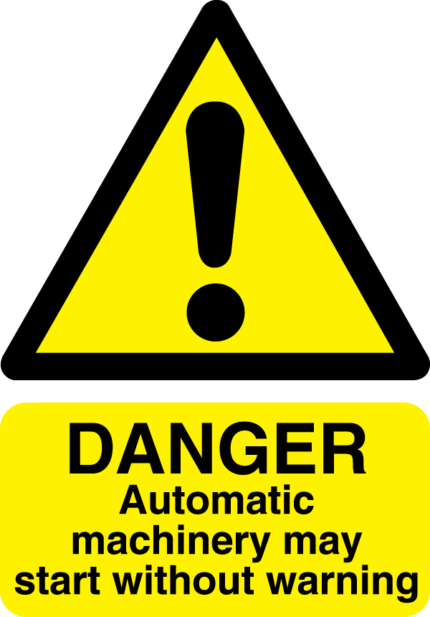 | A. Don’t start the machine without warning people first.  B. When you hear a warning sound, the machine will start.  C. Be careful because the machine can start at any time.  D. People should start the machine automatically.

16. What does this sign mean?
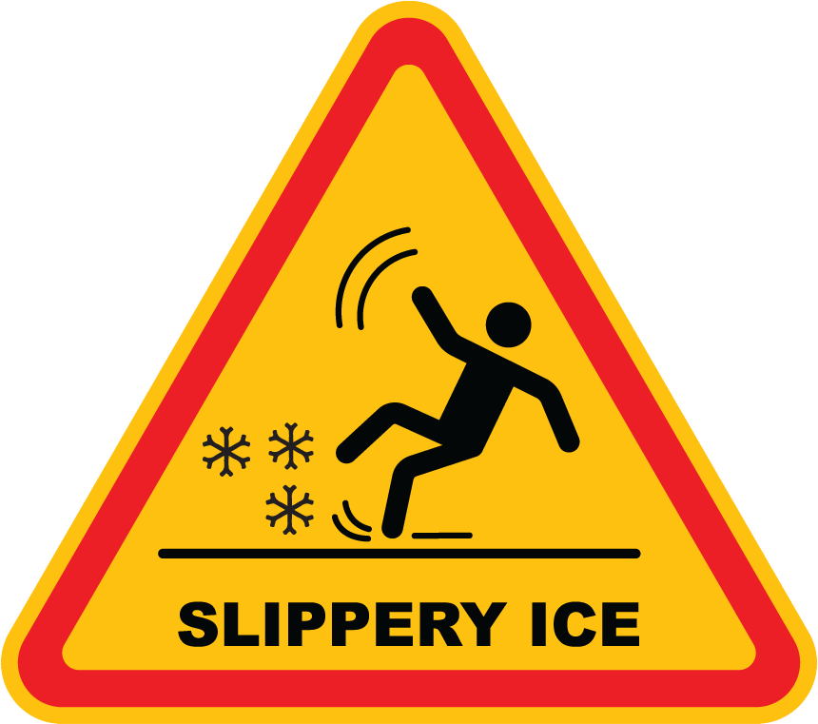 | A. You should walk or drive carefully because there is ice on the road.  B. You shouldn’t slip over on the ice, so be careful.  C. Don’t go out because the roads are slippery like ice.  D. The roads are slippery because it is as cold as ice.

III. WORD FORMATION (1.2 points)
Write the correct form of the words in brackets.
17. In New York City, riding the bus is often cleaner and more ___comfortable_______ than using the subway. (COMFORT)
18. The Louvre Museum is one of the world’s most famous museums and a ___historic________ landmark in Paris. (HISTORY)
19. The hotel shuttle service is _reliable_________. It leaves from here every 30 minutes. (RELY)
20. On Thanksgiving Day, it is ___traditional_______ for the Americans to share a family meal and watch sporting events. (TRADITION)
21. On Easter Sunday, parade _participants_________ often wear colorful costumes and amazing hats. (PARTICIPATE)
22. ‘Songkran’ – Thai New Year is __different________ from Vietnamese Lunar New Year. Thai people celebrate it from 13th April to 15th April. (DIFFER)

IV. LISTENING (2 points)
A. You will listen to the following conversation. For each question, circle the correct option A, B, C, or D.
23. What are the students going to the city to celebrate?
A. Easter B. Christmas C. New Year’s Eve D. Birthday

24. What is Lisa’s family tradition?
A. spend the night at a hotel B. watch the fireworks show
C. go to a concert D. go to the city

25. When does the fireworks show begin?
A. 11 p.m. B. 1 a.m. C. 12 a.m. D. 11.30 p.m.

26. Why does Cindy need money?
A. food and concert ticket B. hotel and food
C. hotel and concert ticket D. food and fireworks show

27. What will Cindy’s mom need to exchange with Lisa’s parents?
A. gifts B. phone numbers C. food D. concert tickets

B. Listen to the following conversation. For each question, write T if the statement is TRUE and F if it is FALSE.

28. Tom thought the ocean was beautiful and clean. __F__
29. Tom bought souvenirs for his friends. __T__
30. Tom forgot his swimsuit at home, so he had to buy a new one. __T__
31. Tom spent the night taking photos after the sun went down. __F__
32. Tom spent his vacation relaxing, buying gifts, and taking photos at the beach. __T__

V. READING (2 points)
A. Read the following passage. For each question, complete the notes with NO MORE THAN ONE WORD.
Dear Mayor,
My name is Henry Little. I am the town's energy expert. I have completed my research on new renewable energy sources and have found a few that I would suggest. Solar panels work great during the day and are very cheap to build. Wind turbines are clean to run and will work great during the windy seasons like fall and spring. Finally, nuclear power is clean and can run all day. Renewable energy has many advantages over non-renewable sources like coal. However, the town should keep a natural gas power plant just in case it's cloudy or the wind stops. A good mix of both energy sources can help keep the lights on and reduce pollution, so I suggest the town increase the total use of renewable energy to 70%, close the coal power plant, and keep the natural gas plant.
Henry, the town’s (33)__energy__ expert, completed his research on renewables. He suggested that the town use (34)__solar panels__ because they work great during the day and wind turbines because they are (35)__clean__ to run. Henry also suggested (36)__nuclear__ because it can run all day, and the town should increase the total use of (37)__renewable__ energy to 70%.

B. Read the following passage. For each question, circle the correct option A, B, C, or D.

Dear Cindy,
I hope all is well. I am sending you this postcard from London, England. I will be staying at the historic Ritz Hotel for the next two weeks on vacation, and I invite you to come and visit. We can check out the British Museum in the Bloomsbury area and see the science and human history exhibit. We could also do some sightseeing around the city. I hear Kensington Park is a great place to go and look around. Or, I can take you to Portobello Road in the Notting Hill district. It’s the largest market in the world, and you can find everything there, from fashion to food. Plus, it is a great place to buy souvenirs. Well, I hope you can visit. I could use a friend to take photos with and share some delicious fish and chips.
Your friend, Tom

38. Tom sent a postcard to Cindy from…
A. Notting Hill B. Bloomsbury C. Portobello Road D. London, England

39. Where is Tom staying for the next two weeks?
A. Portobello Road B. London, England C. Ritz Hotel D. British Museum

40. What is located in the Bloomsbury area and has a science and human history exhibit?
A. a museum B. a stadium C. a hotel D. a park

41. Where can Cindy find great souvenirs to buy?
A. British Museum B. Ritz Carlton C. Portobello Road D. Kensington Park

42. Why did Tom send this postcard to Cindy?
A. He wanted her to come and visit London so they could take a tour of the city together.
B. To tell her about all the places he visited on vacation.
C. He wanted her to know he got some great souvenirs and took photos.
D. To let her know he was staying at the famous Ritz Hotel.

VI. WRITING (1.6 points)
A. Rewrite the following sentences without changing their meaning. Use the given word(s) if any.
43. It’s our duty to keep the classroom clean and tidy.
→ We have to keep the classroom clean and tidy.
→ We must keep the classroom clean and tidy.
44. We’ll go to the theater by taxi, so it’s unnecessary for you to drive.
→ We’ll go to the theater by taxi, so you don’t have to drive.
→ We’ll go to the theater by taxi, so you don’t need to drive.
→ We’ll go to the theater by taxi, so you needn’t drive.
45. There are recycling bins in our apartment block. Some people still don’t bother to separate plastic and paper. (ALTHOUGH)
→ Although there are recycling bins in our apartment block, some people still don’t bother to separate plastic and paper.
→ Some people still don’t bother to separate plastic and paper although there are recycling bins in our apartment block.
46. Canada gets 25% of its energy from hydropower and 3.5% from coal. (MORE)
→ Canada gets more energy from hydropower than from coal.

B. Use the given words or phrases to make complete sentences.
47. I / be / nervous / because / I / receive / exam results / tomorrow.
→ I am nervous because I will receive the exam results tomorrow.
→ I am nervous because I am going to receive the exam results tomorrow.
→ I am nervous because I am receiving the exam results tomorrow.
48. We / look forward / visit / Empire State Building / Saturday.
→ We are looking forward to visiting the Empire State Building on Saturday.
→ We look forward to visiting the Empire State Building on Saturday.
→ We are looking/ look forward to visiting the Empire State Building next Saturday.
49. Yesterday / weather / nice / so / we / go sightseeing / visit / Sydney Opera House.
→ Yesterday, the weather was nice, so we went sightseeing and visited the Sydney Opera House.
50. Like American people / Germans / decorate / Christmas trees / lights / tinsel.
→ Like American people, Germans decorate Christmas trees with lights and tinsel.

***End – Of – Test***
Listening Scripts

Script A

Cindy: Mom, some students are going to the city to celebrate New Year’s Eve. Can I go?
Mom: Are any parents going?
Cindy: Yes. Lisa’s family is going. They booked a hotel room and will drive us to the city.
Mom: Are you spending the night?
Cindy: I would like to. Lisa said it's their family tradition to watch the fireworks show at midnight.
Mom: Will you need any money?
Cindy: Not for the hotel room. I only need money to buy a concert ticket and for food.
Mom: What concert?
Cindy: Lady Gaga. She will be performing this year in Times Square.
Mom: Sounds fun. Just remember that the weather gets cold at night, and sometimes snows. If you go, you will need to wear warm clothes.
Cindy: So I can go?
Mom: I will need to exchange phone numbers with Lisa's parents first.

Script B

Bryan: Hi Tom! How was your vacation?
Tom: It was relaxing, and I had a great time.
Bryan: What did you do?
Tom: I went swimming in the ocean.
Bryan: How was the sand?
Tom: The sand was so beautiful and clean.
Bryan: Did you get to buy anything fun from the stores?
Tom: Yes, I bought some sea shells and a couple of rocks. I plan on painting and giving them away as gifts to some friends.
Bryan: That’s a great idea. Did you buy anything else?
Tom: I had to buy a swimsuit because I forgot to bring mine from home.
Bryan: I’ve done that before. What else did you do?
Tom: I spent a day taking photos. I took a great picture right as the sun was going down.
Bryan: It sounds like you enjoyed your trip.
Tom: I did.

