**ĐỀ VỀ ĐÍCH – THI VÀO 10 |HÀ NỘI**

**ENGLISH 9**

**ĐỀ SỐ 01**

**ENG LISH**

**2025**

**Mark the letter A, B, C, or D on your answer sheet to indicate the word whose underlined part differs from the other three in pronunciation in each of the following questions.**

**Question 1:** A. april B. baker C. ladder D. danger

**Question 2:** A. relatable B. unstated C. amazing D. debatable

**Mark the letter A, B, C, or D on your answer sheet to indicate the word that differs from the other three in the position of primary stress in each of the following questions.**

**Question 3:** A. concept B. advice C. forget D. suggest

**Question 4:** A. effective B. persuasion C. researcher D. sculpture

**Mark the letter A, B, C, or D on your answer sheet to indicate the correct answer to each of the following questions.**

Question 5: Although online learning is convenient, some students find it difficult to _________ without a classroom environment.

A. understand B. communicate C. concentrate D. interact

Question 6: By the time the courier arrived, the customer had already paid for the order, so the package _________ without any delay.

A. delivered B. had delivered C. has been delivered D. was delivered

Question 7: John is the _________ player on the team. He scores the most points in every match.

A. better B. well C. best D. good

Question 8: If you _________ your dog regularly, it _________ new tricks and obey your commands easily.

A. train - will learn B. trained – will learn C. train - learning D. training – would learn

Question 9: Anna is lost in a nature reserve and asks a park ranger for help.

Anna: Excuse me, I think I'm lost. _________?

Park Ranger: Sure! Where are you trying to go?

A. Can you show me the way to the main entrance? B. Do you sell maps of this area?

C. You must take me to the exit now! D. Do you need me to show you the right way?

Question 10: David is a teenager _________ independence helps him take care of himself while his parents are at work.

A. who B. which C. whose D. that

Question 11: Studying online has become increasingly _________, especially since the COVID-19 pandemic, as it offers flexibility and convenience.

A. legendary B. widespread C. popular D. famous

Question 12: There was too _________ traffic on the way, so we arrived late.

A. some B. many C. much D. a lot

**Read the following announcement and mark the letter A, B, C, or D on your answer sheet to indicate the correct option that best fits each of the numbered blanks from 13 to 16.**

**Light and Strong Backpack – Perfect for Everyday Use!**

Are you looking for a backpack that holds up well for school, work, or travel? Our backpack is made (13) _________ strong material that will last for years. It has (14) _________ large space for books, a laptop, and other essentials. The waterproof fabric helps (15) _________ out water, and the soft straps make it easy to carry. With many pockets, you can sort out your items (16) _________.

Right now, we have a special sale. If you pick up your backpack today, you will get 20% off your first order! Visit our store or shop online at [www.bestbags.com](http://www.bestbags.com). Free shipping on all orders!

**Question 13:** A. by B. in C. with D. from

**Question 14:** A. an B. the C. a D. $∅$

**Question 15:** A. hand B. keep C. take D. make

**Question 16:**  A. easily B. easy C. ease D. easing

**Question 17:** **Put the sentences (a-c) in the correct order, then fill in the blank** () **to make a logical text.**

() _________. Not reaching those goals might be discouraging and lead to giving up altogether. To avoid feeling overwhelmed, it is advisable to start small and concentrate on one goal at a time. If you want to lose weight, make small and achievable goals. _________.

**[Adapted from Global Success 9 Workbook]**

a. However, it is important to be realistic with yourself when setting these goals.

b. If you want to quit smoking, lose a significant amount of weight, or run a marathon, it is unlikely to happen overnight, or even in a few months or a year.

c. In the pursuit of a healthy lifestyle, setting realistic goals is the key to success.

A. a-c-b B. b-c-a C. c-a-b D. c-b-a

**Question 18: Choose the sentence that can end the text (in Question 17) most appropriately.**

A. Not drinking too much water during the day and getting enough sleep are also important to maintaining a healthy lifestyle.

B. Sometimes you may feel like comparing your progress with others, but everyone's journey to health is different.

C. For example, you can start by working out at least three times a week or adding more vegetables to your meals when you want seconds.

D. Small goals like skipping meals or going on a strict diet may seem effective, but in the long run, they are not sustainable.

**Read the following passage and mark the letter A, B, C, or D on your answer sheet to indicate the correct word or phrase that best fits each of the numbered blanks from 19 to 24.**

London is a thriving commercial and cultural centre with (19) _________ significant financial organisations such as the Bank of England and the London Stock Exchange. They are located in the area (20) _________ the City. Docklands, the former port in east London, has been redeveloped as a business centre. The West End boasts theatres, cinemas, museums, and stores. (21) _________ the high cost of housing near the city centre, many people (22) _________ in London prefer (23) _________ in the suburbs and commute to work by train or bus. (24) _________ is well-connected, with various modes of transportation available, including the red London buses, black taxi cabs, and the London Underground, commonly known as ‘the Tube’!

**[Adapted from Global Success 9 Workbook]**

Question 19: A. many B. much C. another D. any

Question 20: A. is calling B. called C. calling D. is called

Question 21: A. In spite of B. However C. Due to D. Such as

Question 22: A. to work B. worked C. to working D. working

Question 23: A. to living B. live C. to live D. living

**Question 24:** A. London’s system transportation B. London’s transportation system

C. transportation system of London D. transportation of system London

**Mark the letter A, B, C or D on your answer sheet to indicate the sentence that is closest in meaning to the original sentence in each of the following questions.**

Question 25: "The government should take immediate action to protect the environment," said the expert.

A. The expert said that the government should took immediate action to protect the environment.

B. The expert said the government should have taken immediate action to protect the environment.

C. The expert asked that the government should take immediate action to protect the environment.

D. The expert said that the government should take immediate action to protect the environment.

Question 26: Nick was lucky. He found his lost wallet in the crowded shopping mall.

A. Nick was enough luck to find his lost wallet in the crowded shopping mall.

B. It was lucky enough for Nick to find his wallet in the crowded shopping mall.

C. Nick's wallet was lucky enough for Nick to find it in the crowded shopping mall.

D. Nick was lucky enough to find his lost wallet in the crowded shopping mall.

Mark the letter A, B, C, or D on your answer sheet to indicate the sentence that is made from the given cues in each of the following questions.

Question 27: It / generous / Tommy / pay / all / meals / we / have / yesterday.

A. It was very generous on Tommy to pay for all the meals we had yesterday.

B. It is very generous of Tommy to pay for all the meals we have yesterday.

C. It is very generous of Tommy paying for all the meals we had yesterday.

D. It was very generous of Tommy to pay for all the meals we had yesterday.

Question 28: The woman / live / next door / donate / thousands of dollars / local charities / every year.

A. The woman who lives next door donates thousands of dollars to local charities every year.

B. The woman lives next door donates thousands of dollars to local charities every year.

C. The woman who lives next door donating thousands of dollars to local charities every year.

D. The woman which lives next door donates thousands of dollars to local charities every year.

Read the following sign or notice and mark the letter A, B, C, or D on your answer sheet to indicate the correct answer to each of the following questions.

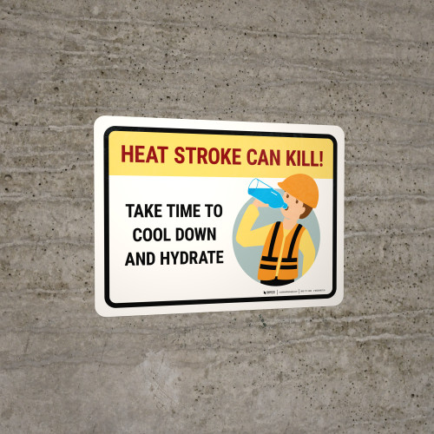Question 29: What does the sign say?

A. Drink less water and cool down to avoid heatstroke.

B. Heatstroke can be fatal so avoid drinking water and cooling down.

C. Take time to hydrate and cool down to avoid heatstroke.

D. Take your time with the heat by reducing the temperature and water.

Question 30: What is the main purpose of the notice?

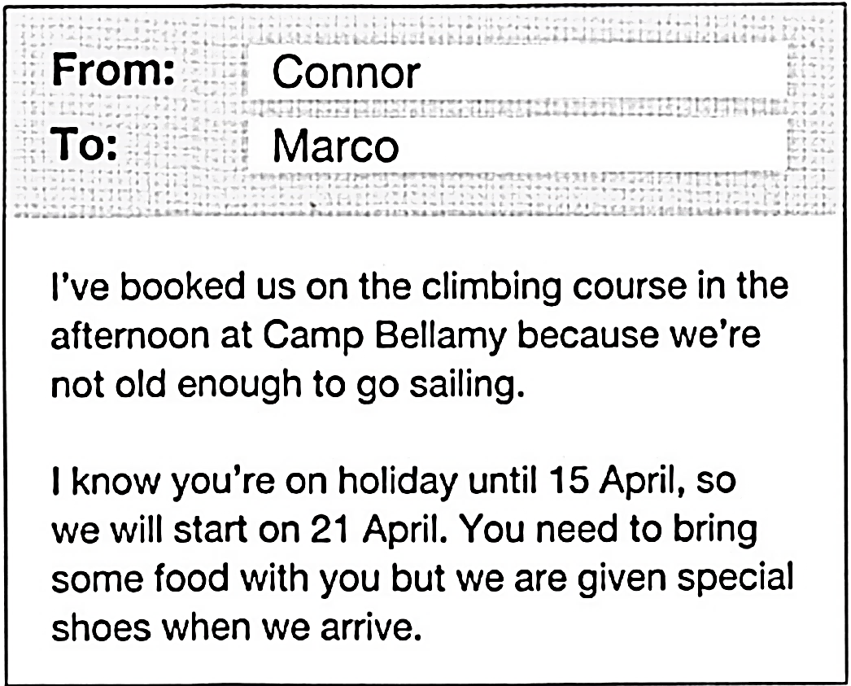

A. To remind Marco about the equipment needed for the climbing course.

B. To explain why a different activity was chosen instead of sailing.

C. To inform Marco about the details of their planned activity.

D. To invite Marco to join a climbing course at Camp Bellamy.

**Read the following passage and mark the letter A, B, C, or D on your answer sheet to indicate the correct answer to each of the following questions from 31 to 36.**

**The Grand Canyon**

The Grand Canyon is one of the most famous natural wonders in the world. Located in the United States, in the state of Arizona, this massive canyon is about 446 kilometers long and up to 1,800 meters deep. It was formed over millions of years by the Colorado River, which slowly carved through layers of rock. Today, it is one of the most **popular** tourist attractions in the world.

One of the most amazing things about the Grand Canyon is its colorful rock formations. The canyon walls display shades of red, orange, brown, and even purple, especially during sunrise and sunset. These colors come from different types of rock layers, some of which are over a billion years old.

Visitors to the Grand Canyon can explore it in many ways. Hiking is a popular activity, with trails leading to different viewpoints. The South Rim is the most visited area because it offers the best views. For those who enjoy adventure, rafting down the Colorado River provides a unique way to experience the canyon. Helicopter tours are also available for those who want to see the canyon from above.

The Grand Canyon is home to many types of plants and animals. Visitors may see mule deer, mountain lions, and even the rare California condor, one of the largest birds in the world. The canyon also has unique desert plants, such as cacti and juniper trees.

This natural wonder is not only beautiful but also important for science. Geologists study the rock layers to understand the Earth's history. However, the Grand Canyon faces environmental challenges, such as pollution and climate change, which can affect its ecosystem.

The Grand Canyon is a true wonder of nature. Its **breathtaking** views, rich history, and diverse wildlife make it a place worth visiting. Protecting this incredible site will ensure that future generations can enjoy its beauty as well.

**Question 31:** What is the main idea of the passage?  
A. The history of the Grand Canyon. B. The wildlife in the Grand Canyon.  
C. The Grand Canyon and its significance. D. The formation of the Grand Canyon.

**Question 32:** The word "**popular**" in paragraph 1 is opposite in meaning to:  
A. unknown B. famous C. crowded D. interesting

**Question 33:** The word "**breathtaking**" in the last paragraph is closest in meaning to:  
A. dangerous B. enormous C. impressive D. strange

**Question 34:** Which of the following statements is true based on the passage?  
A. The Grand Canyon is at risk due to environmental problems.  
B. The South Rim is the least visited area of the canyon.  
C. The Grand Canyon is mainly known for its animal species.  
D. Most of the rock layers in the canyon are less than a million years old.

**Question 35:** Which method did the author not use when talking about the Grand Canyon?

A. Comparison B. Personification C. Statistical data D. Listing

**Question 36:** Which of the following best describes the primary purpose of the passage?

A. To analyze the geological formation of the Grand Canyon in detail.  
B. To highlight the significance of the Grand Canyon from multiple perspectives.  
C. To compare the Grand Canyon to other natural wonders of the world.  
D. To persuade readers to visit the Grand Canyon as a tourist destination.

**Four phrases/ sentences have been removed from the text below. For each question, mark the letter A, B, C, or D on your answer sheet to indicate the correct option that best fits each of the numbered blanks from 37 to 40.**

**HOW TO MANAGE YOUR TIME**

Balance is key for Mary, a busy teenager. She uses an app to stay organized with her assignments and deadlines; the app helps her receive reminders to ensure she doesn’t forget anything. (37) _________. She’s mindful of not spending too much time on online social media, limiting her usage to an hour each day to avoid wasting her time. On weekends, Mary enjoys relaxing and socializing with friends, going to the cinema, shopping, or just hanging out. She also does some volunteer work at a local charity, (38) _________.

James, an adult working a nine-to-five job, is also aware of the importance of time management. He starts his day by making a to-do list, (39) _________. To avoid distractions, James turns off email and social media notifications on his phone and closes his office door, allowing him to concentrate. On the day when he must work overtime, he quickly rearranges his tasks and makes sure everything gets completed on time. When at home, James spends his quality time with his family, (40) _________. James and his wife share the housework, taking turns cooking and cleaning, ensuring a great work-life balance. In his free time, James keeps fit by playing football with friends and going to the gym, which helps him relax and clear his mind.

A. playing games or going to the park with his two young children

B. prioritizing the most urgent or difficult tasks first when he has the most energy

C. which provides valuable academic experience and looks great on her CV

D. Mary also makes a daily to-do list to help her stay focused and motivated

**Question 37: _________ Question 38: _________ Question 39: _________ Question 40: _________**