|  |
| --- |
| **Tiếng Anh 8 i-Learn Smart World - Luyện tập - Unit 6 Time allotted: 45** |

**PART 1 PRONUNCIATION (4 questions)**

**Choose the word whose underlined part differs from the other three in pronunciation in the following question.**

1. A. alien B. space C. strange D. planet

2. A. visit B. tiny C. disk D. thin

**Choose the word that differs from the other three in the position of the main stress in the following question.**

3. A. report B. hover C. Venus D. saucer

4. A. oxygen B. gravity C. disappear D. similar

**PART 2 USE OF ENGLISH (13 questions)**

**Choose the option that best completes the following sentence.**

5. There are eight ______________ in our solar system.

A. stars B. galaxies C. spaces D. planets

6. Venus is often called "Earth's twin" because they're ______________ in size and structure.

A. similar B. same C. like D. common

7. Mercury is very close to the Sun, so the daytime ______________ can reach over 400 degrees Celsius.

A. measurement B. temperature C. quality D. character

8. Without ______________, there would be no force to keep objects on the ground.

A. energy B. resource C. gravity D. strength

9. There is no ______________ in space, so people can hardly breathe.

A. oxygen B. view C. cloud D. heat

10. The boys were ______________ when they saw a flying saucer land in their backyard.

A. scary B. worrying C. terrified D. amazing

11. The woman reported that she had seen a(n) ______________ alien with the size of a building.

A. tiny B. huge C. average D. small

12. I ______________ home from work late one night when a strange light ______________ in the sky.

A. was driving / was appearing B. drove / appeared C. was driving / appeared D. drove / was appearing

13. I think people ______________ on the moon because it is quite close to Earth.

A. will live B. are living C. are going to live D. live

14. In a hundred years, people ______________ in space stations as there ______________ enough space for us on Earth.

A. are living / isn't B. live / isn't C. are living / won't be D. will live / won't be

15. Scientists predict that aliens ______________ contact with Earth in the near future.

A. are going to make B. will make C. are making D. have made

16. While the men were hiking in the mountain, they ______________ a strange creature.

A. met B. were meeting C. have met D. had met

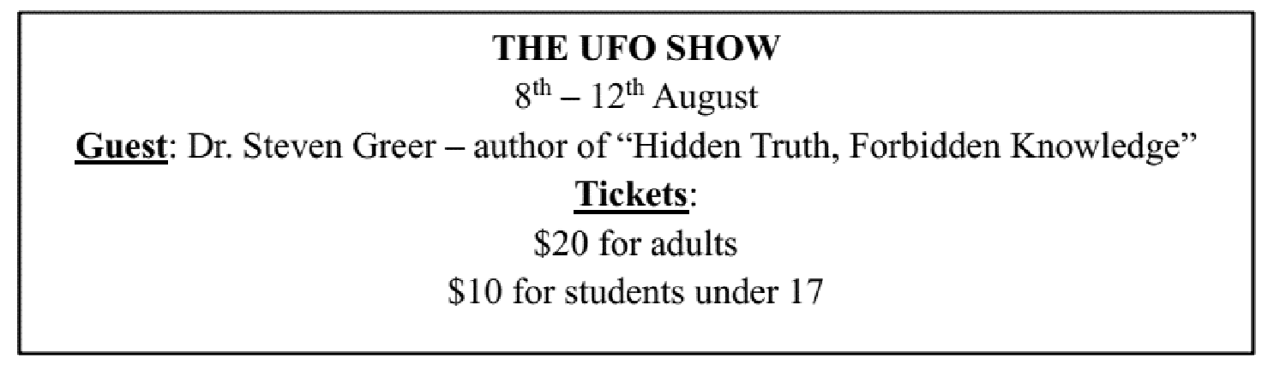

17. What does the poster say?

A. The talk show is about Dr. Steven Greer.

B. Students under 17 years old can buy tickets with half price.

C. The talk show will introduce the book ''Hidden Truth, Forbidden Knowledge''.

D. Dr. Steven Greer will discuss his book in the talk show.

**PART 3 WORD FORMATION (6 questions)**

**Write the correct form of the given word.**

18. The flying saucer ______________ before I could take a photo. ***(APPEAR)***

19. If the Earth becomes too ______________, we may need to look to other planets for a new home. ***(CROWD)***

20. Liam believed he saw a UFO in the sky, and it looked like a ______________ object. ***(CIRCLE)***

21. Several people saw a(n) ______________ object in the sky last night. ***(IDENTIFY)***

22. The gravity of other planets can be ______________ for humans, especially when it is too strong or too weak. ***(HEALTH)***

23. The boy made a(n) ______________ report of a UFO hovering above his house. Nobody believed him. ***(BELIEVE)***

**PART 4 ERROR RECOGNITION**

**Find the underlined part that needs correction in the following question.**

24. In the future, if we live on space stations, we will have a great view on Earth.

A. In the future B. live on C. will have D. view on

**PART 5**  **READING (5 questions)**

**Read the website article. Choose True, False, or NI if the information is not in the text. (5 questions)**

|  |
| --- |
| Many scientists believe that people will live on other planets in the future, but not on one of the planets in our system.  We cannot live on the four outer planets, Jupiter, Saturn, Neptune and Uranus, because they are large balls of gas.  The four inner planets, including the Earth, are made of rock, so it is possible to land spaceships on Mercury, Mars and Venus. At some time in the future, spaceships might be able to travel the huge distances in an astronaut’s lifetime, or perhaps people could go into something like a freezer while the journey happened. However, the average temperature on both Venus and Mercury is much too high for human life.  Mars has a very thin atmosphere, and this is why there is no water on the surface except in the form of ice. A thick atmosphere like the Earth’s keeps water on the surface in rivers and oceans and near the surface of a planet in the form of rain. Venus has the opposite problem with its atmosphere. It is very heavy, so it pushes down on the surface with about 100 times the strength of the Earth’s atmosphere. |

**Answers** **True** **False** **Not given**

25. The writer gives information about all the planets in our system. **◯** **◯** **◯**

26. Mars' temperature is suitable for human life. **◯** **◯** **◯**

27. Mars and Venus have similar atmospheres. **◯** **◯** **◯**

28. There is no water on the surface of Venus. **◯** **◯** **◯**

29. The writer suggests the best planet for people to live on in the future. **◯** **◯** **◯**

**PART 6 LISTENING (5 questions)**

**You will hear five people talking about strange experiences. Match each speaker with one of the actions after the experience. (5 questions)**

30. Speaker 1 a. ran away.

31. Speaker 2 b. hid.

32. Speaker 3 c. woke up.

33. Speaker 4 d. looked at photos.

34. Speaker 5 e. told the police.

f. didn’t tell anyone.

**PART 7**  **WRITING (6 questions)**

**Rewrite the following sentence without changing its meaning. Use the given word(s) if any.**

35. People are likely to travel to other planets in the future.

→ WILL___________

36. It will be impossible for people to live on Mars because there is no air.

→ People ___________

37. Colin saw a strange disk-shaped flying object on his way home.

→ WHEN___________

**Rewrite the following sentence without changing its meaning. Use the given word(s) if any.**

38. While we were asleep, we heard a loud noise outside.

→ SLEEPING___________

**Use the given words or phrases to make a complete sentence.**

39. Mr. Brown / walk / the forest / when / he / see / green alien / tiny head / .

→ ___________

40. Scientists / predict / we / find / more evidence / life / other planets.

→ ___________

**---THE END---**