Date of preparing: ………………………………….
Date of teaching: ………………………………….

Period …
UNIT 8: THE WORLD AROUND US
Lesson 1 – Part 2 (Page 63) - Grammar

I. OBJECTIVES
By the end of the lesson, Ss will be able to…
1. Knowledge
- know how to use the modals "should" and "can";
2. Ability
- improve the use of language and speaking and writing skills;
- develop the ability to communicate and cooperate with their partners, to self-study, to solve problems in conversation situations;
3. Quality
- have a positive attitude in English language learning so that they actively participate in all classroom activities, especially about the topic "The world around us".
II. TEACHING AIDS AND LEARNING MATERIALS
Lesson plan, PPT slides, Student’s book, workbook, notebook, personal computer (if any), projector/ TV, speakers, DCR & DHA on Eduhome, CD player, handouts…
III. PROCEDURES
- Warm up: (5’)
a) Objective: To help Ss relax, review/ remember new words they have learnt.
b) Content: Doing the crossword puzzle
c) Product: Ss can review the vocabulary learned
d) Competence: Critical thinking
e) Organization of the activity:
Teacher’s activities | Students’ activities
* Game: Crossword puzzle  - Ask students to play the game using new words on page 44 in workbook. | - Look at the pictures to do the crossword puzzle individually.  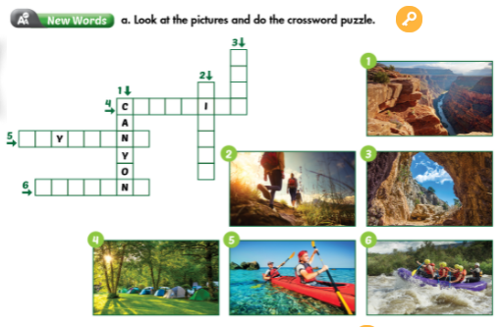

B. New lesson (35’) Grammar
a) Objective: To help Ss know and use the modals "should" and "can".
b) Contents:
- Listening and repeating
- Circling the correct modals
- Completing the dialogue
c) Products: Students know the usage of modals and use them correctly in communication
+ "Should" to ask for and give advice,
+ "Can" to talk about possibility, and "can't" for things that are very unsafe to do.
d) Competence: Communication, collaboration, presentation
e) Organization of the activity:
Teacher’s activities | Students’ activities
* Presentation  a. Listen and repeat.  - Elicit the grammar rules from the students.  - Explain how to use the modals "should" and "can" and give examples.  - Play the audio. (CD2 – 30)  * Practice  b. Circle the correct modals.  - Ask Ss to circle the correct modals.  - Give feedback and correct the answers.  c. Complete the dialogue.  - Have Ss complete the dialogue.  - Give feedback and correct. (Make sure Ss understand the situations of the dialogue.)  d. Now, practice the conversation with your partner.  - Have Ss take turns practicing the dialogue.  - Have some pairs demonstrate the activity.  * Consolidation:  - Use mind map to review/ consolidate the modals: should" and " can" | - Look at the box, read and answer individually.  - Write them down in their notebooks.  * Modals:  + We use should to ask for and give advice.  + We use can to talk about possibility, and can't for things that are very unsafe to do.  Ex1: I/ She should go to Greenwater Cave.  Ex2: They/ we shouldn't go hiking there.  Ex3: They/ we can't swim in that water.  Ex4: Should I travel there?  - Listen and repeat.  - Read the sentences and then circle individually.  - Share the answers with their partners.  - Circle the answers on the board and explain if necessary.  * Answer keys:  1. can't 2. should 3. can  4. shouldn't 5. can't 6. shouldn't  - Read the dialogue and then complete individually.  - Share the answers with their partners.  - Give the answers.  * Answer keys:  2. Can we do there 3. No, we can't  4. Yes, you should 5. No, we shouldn't  - Work in pairs.  - Demonstrate the activity in front of the class.

C. Consolidation (2’)
* Modals
Form:
(+) S + should/ can + …
(-) S + shouldn’t/ can’t + …
(?) Should/ Can+ S + …?
Usage:
“Should” to ask for and give advice.
“Can” to talk about possibility.
“Can’t” for things that are very unsafe to do.

D. Homework (3’)
- Learn the usage of modals "should" and "can"
- Practice asking for and giving advice and talking about possibility with your partners/ classmates.
- Do grammar exercises a, b and writing on page 45 in workbook.
- Prepare for the new lesson: Pronunciation and speaking (page 64)
- Ask them to think of a plan for a class trip. Where are you going to go and what are you going to do/ prepare?

