TEST 09

Listening
There are 25 questions
You will need coloured pens and pencils.

My name is…………………………….

PART 1
5 questions

This is an example. Now you listen and draw lines.
Jim | Fred |  | Jack |  | Paul
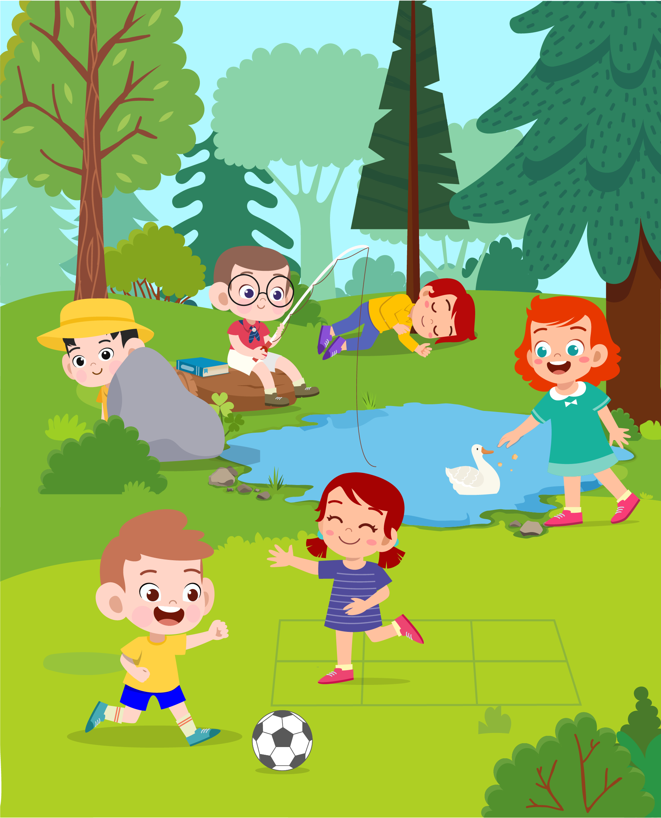
Mary |  | Betty |  | Tom

PART 2
5 questions

Listen and write. There is one example.
 | 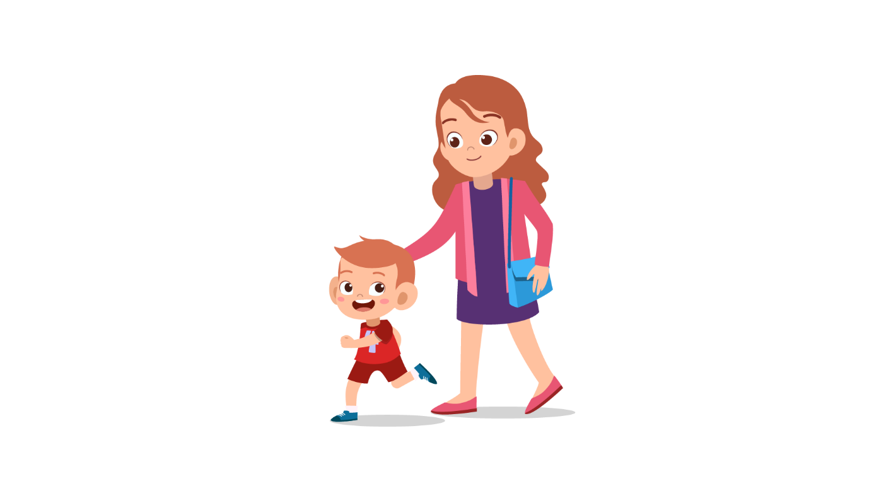
 | SPORTS CLUB
0 | Name: | …Jim Rock…
1 | Age: | ……
2 | Address: | 15 …… Road
3 | Favourite sport: | ……
4 | Open: | Monday - ……
5 | Number of times a week: | ……

PART 3
5 questions

Why was Tony’s week so difficult?
Listen and draw a line from the floor to the correct picture.
There is one example

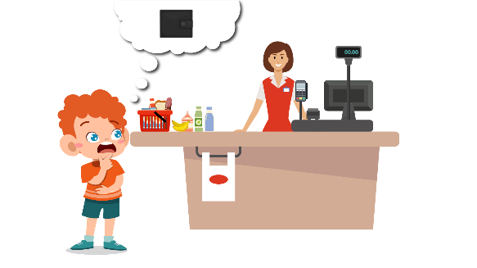 | Monday  Tuesday  Wednesday  Thursday  Friday | 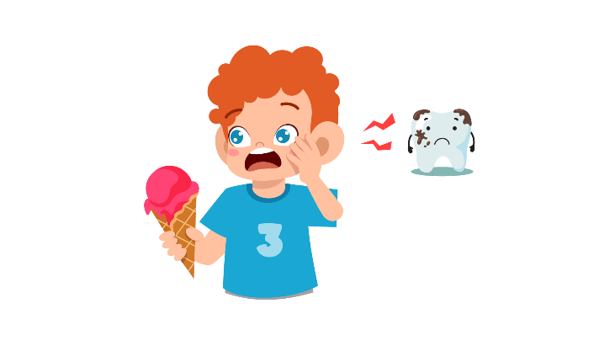
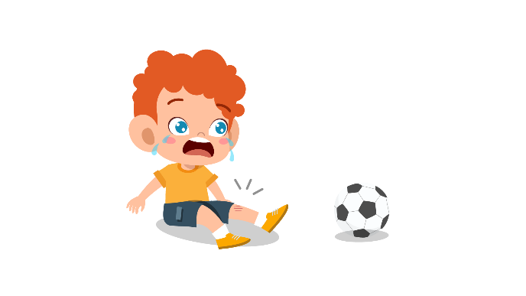 |  | 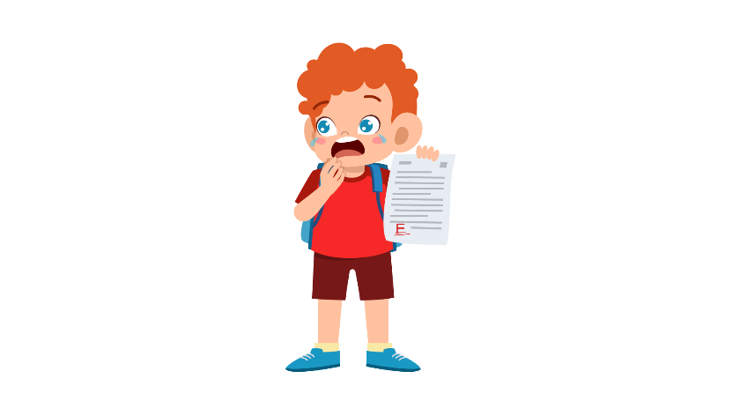
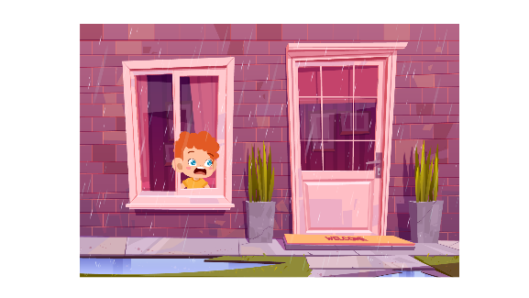 |  | 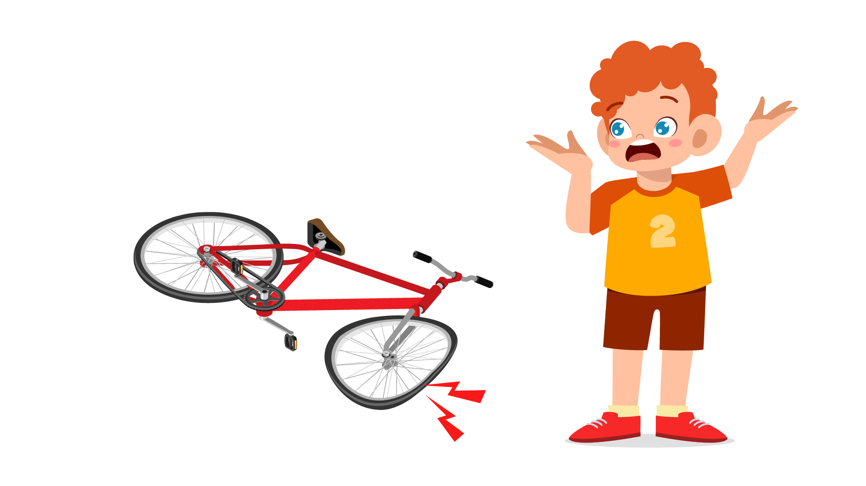

PART 4
5 questions

Listen and tick (✓) the box. There is one example.
What time did Laura go to school?
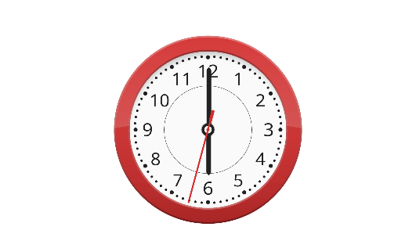 |  | 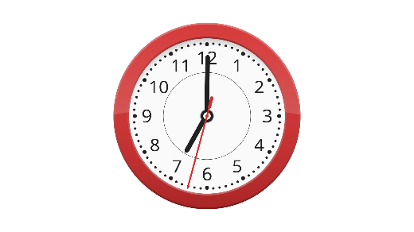
A ⬜ | B ⬜ | C ⬜
- What’s wrong with Daisy?
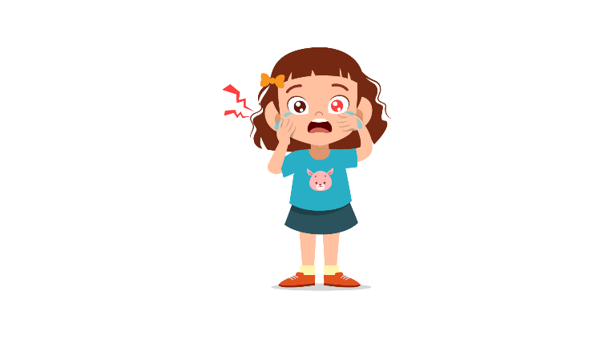 | 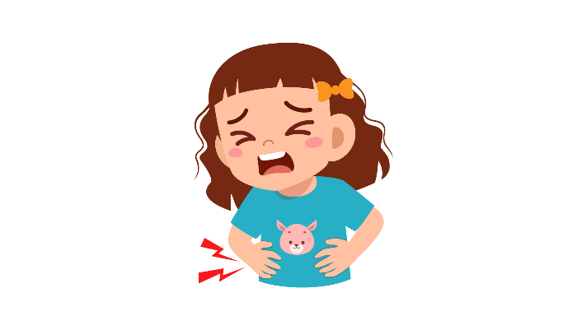 | 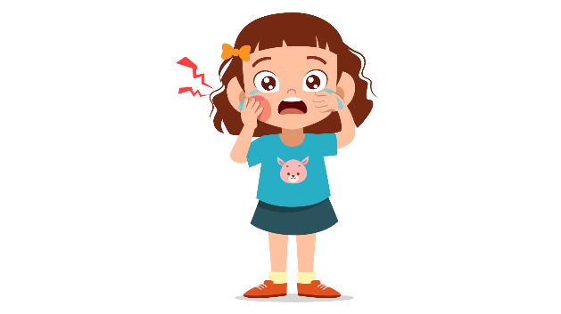
A ⬜ | B ⬜ | C ⬜
- Who’s Tony’s father?
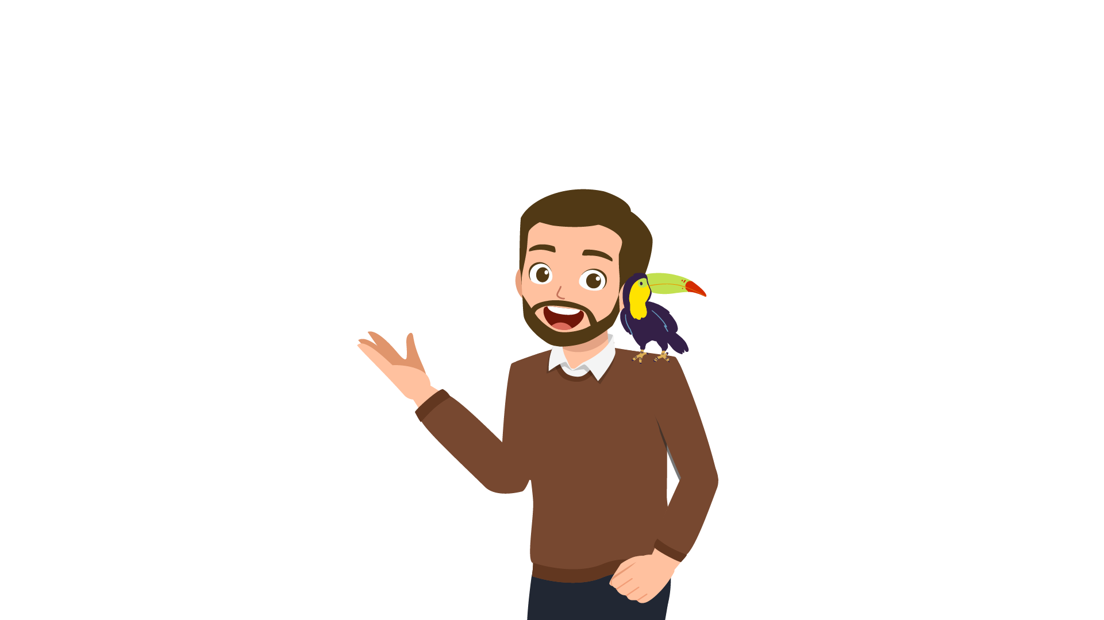 | 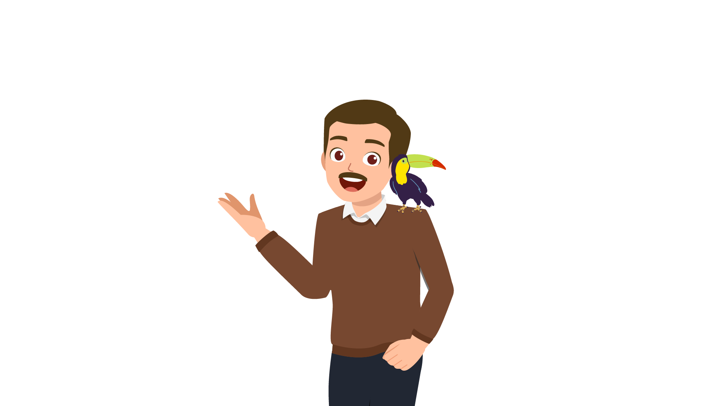 | 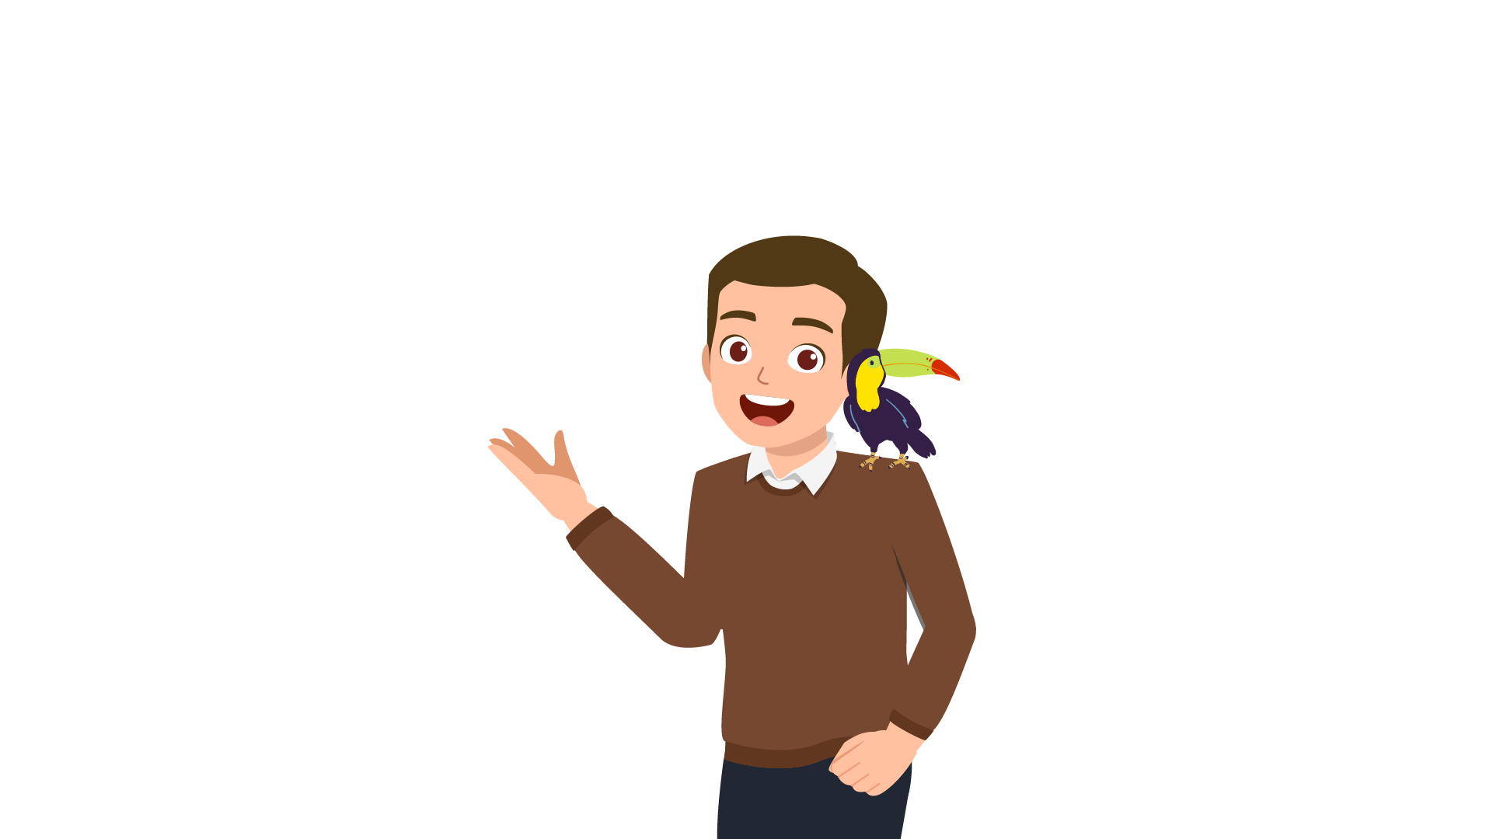
A ⬜ | B ⬜ | C ⬜
- Which food did Hugo have for breakfast?
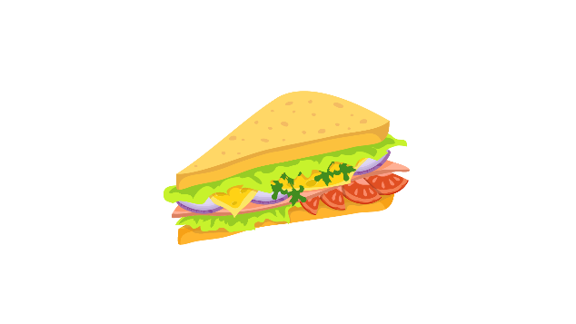 |  | 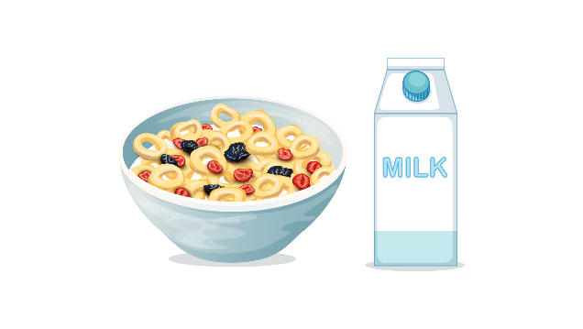
A ⬜ | B ⬜ | C ⬜
- What does Jane have to do?
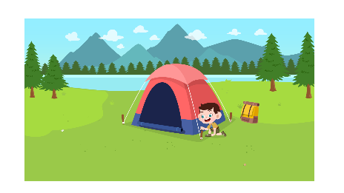 | 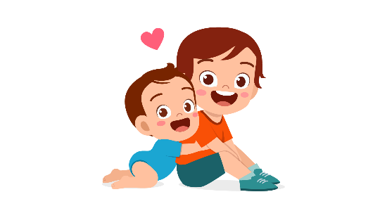 | 
A ⬜ | B ⬜ | C ⬜

- What does Paul want to do?
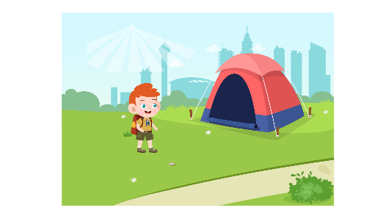 | 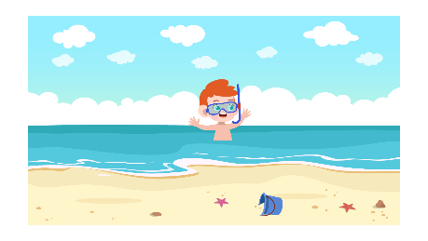 | 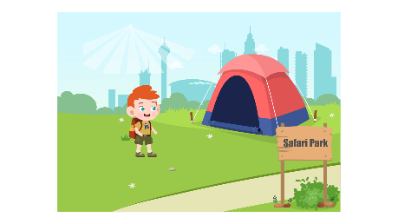
A ⬜ | B ⬜ | C ⬜

PART 5
5 questions

Listen and colour and draw.

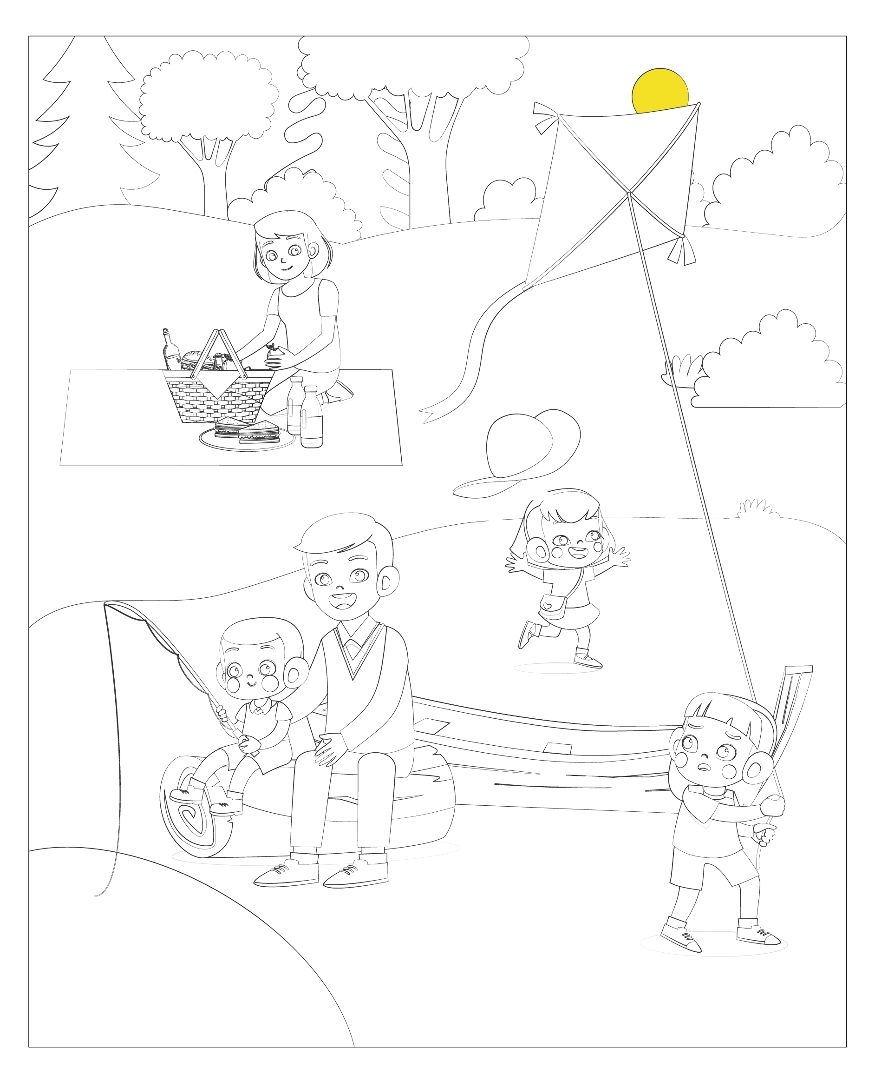

Reading and Writing
There are 35 questions
You have 30 minutes.
You will need a pen or pencil.
My name is…………………………….

PART 1
5 questions

Look and read. Choose the correct word and write them on the lines.

 | 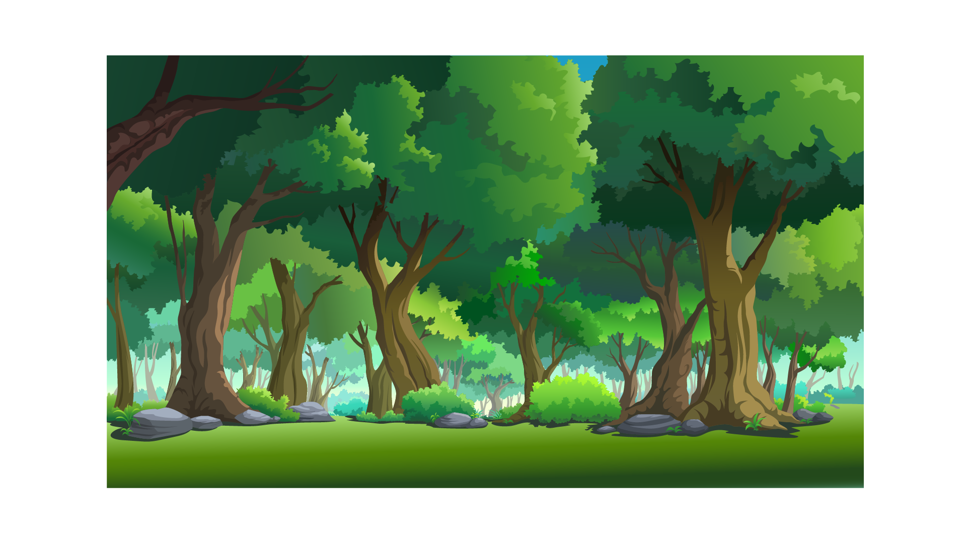
A hospital | Forest
 | 
Soup | Butterfly
 | 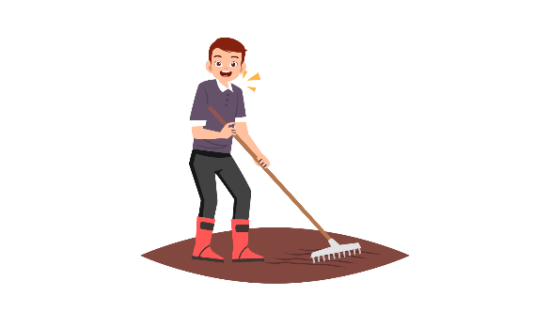
A torch | Farmer
 | 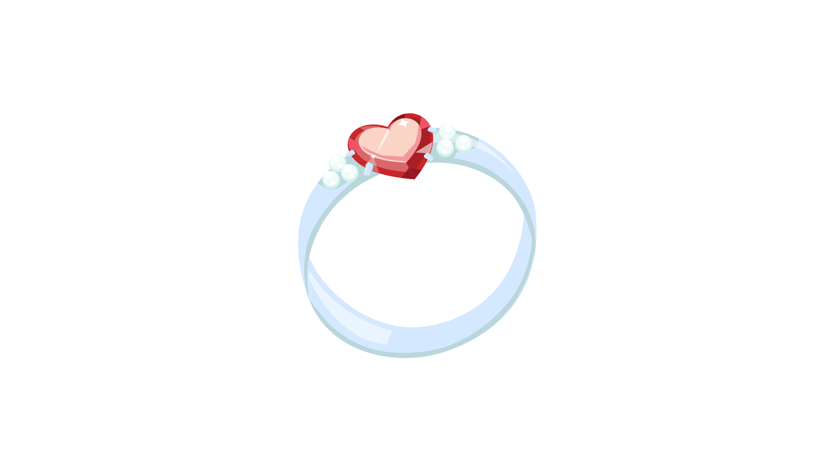
Blanket | A ring

Example
(0) | It is a place. A doctor works there. | A hospital
Questions
1 | People use this on their bed in cold weather. | ___________
2 | This person lives on a farm, works in the field and has got some animals | ___________
3 | A small light that people use when it’s dark. You can carry it anywhere | ___________
4 | It’s usually made of gold or silver. People wear it on their fingers. | ___________
5 | You put it in a bowl and eat it hot. It’s a great food when the weather is cold.

PART 2
6 questions

Read the text and choose the best answer.
Paul is talking to his cousin, Vicky.
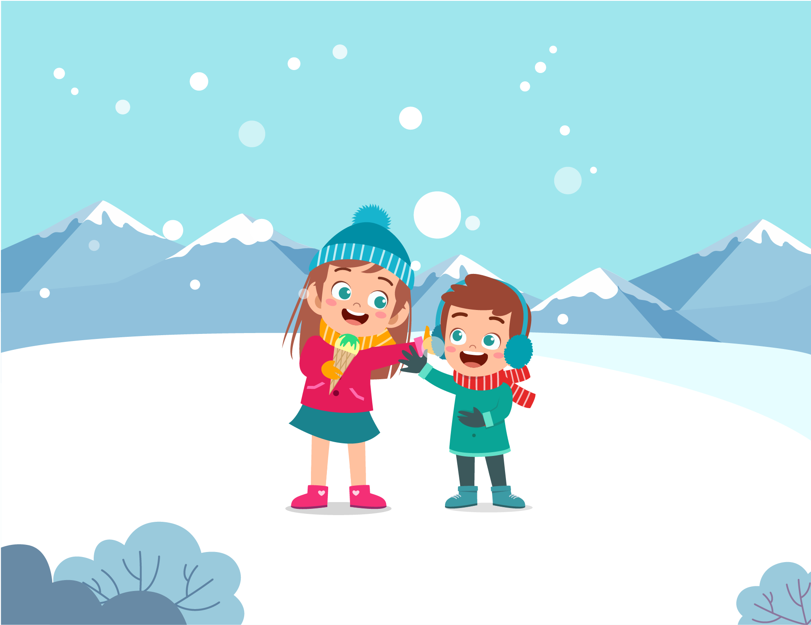

Example:
 | Paul: | Vicky, what are you doing?
 | Vicky: | A. I went to a mountain.
 |  | B. I like skiing.
 |  | C. I am eating an ice cream.
Questions:
1 | Paul: | But it’s really cold today!
 | Vicky: | A. So? I always eat ice cream.
 |  | B. I know. I hate hot weather.
 |  | C. And it’s snowy, too.

2 | Paul: | Can I have some?
 | Vicky: | A. No, I can’t.
 |  | B. Yes, of course I can.
 |  | C. Sure. Here you are.

3 | Paul: | Mmmm. Yummy. Is that your new scarf?
 | Vicky: | A. I don’t know.
 |  | B. Yes. My Mum and Dad gave me on my birthday.
 |  | C. No, I didn’t. It was too difficult.

4 | Paul: | Well, it looks nice. Let’s go for a walk outside.
 | Vicky: | A. That’s a good idea.
 |  | B. I had to be at school at 8 o’clock in the morning.
 |  | C. Can we come, too?

5 | Paul: | How about asking Jack and Jill to go with us?
 | Vicky: | A. I don’t know him.
 |  | B. They didn’t like ice cream.
 |  | C. I called them but they said they were tired.

6 | Vicky: | I’m hungry now. Do you want to eat something?
 | Paul: | A. I would like a cup of tea.
 |  | B. Why don’t we go to a restaurant near here?
 |  | C. Let’s go to the park!

PART 3
6 questions

Read the story. Choose a word from the box. Write the correct word next to the numbers 1-5. There is one example.
One day, my parents and I walked past a pet shop. We stopped to look at the cute ...dogs... I wanted to have one, but Mom said we should get a (1) __________ instead because she likes cats. There were smaller animals such as (2) __________ and hamsters. All the pets lived in (3) __________ and they didn’t look happy. Dad said we shouldn’t buy (4) __________ from a pet store. He suggested adopting one. But before we did that, we needed to discuss how we would take care of it.
Dad knew that I was a bit disappointed, so he cheered me up by buying me a teddy (5) __________. It was very cute.

Example
zoo | dogs | bear
robot | kitten | cages
animals | tree | rabbits

(6) Choose the best name for the story.
Tick one box.
A. My favourite toy | ⬜
B. Buying a pet | ⬜
C. Going to the zoo | ⬜

PART 4
5 questions

Choose the right words and write them on the line.
 | Dolphins
 | 
Example  1  2  3  4  5 | Dolphins are part (0) of the whale family.  They are smaller (1) ________ most whales and they have small teeth.  Dolphins are very clever animals. They learn things very (2) ________ and a dolphin can make noises to ‘talk’ to another dolphin. Dolphins live with their families. They like to play in the water and to jump (3) ________ of the water and back in again. A lot of people (4) ________ sail boats say that dolphins like to be near people. They come very near to boats and sometimes they (5) ________ with the boats for days.

Example: | in | of | with
1. | then | that | than
2. | quick | quickly | quickest
3. | out | from | up
4. | which | what | who
5. | swam | swim | swimming

PART 5
7 questions

Look at the picture and read the story. Write some words to complete the sentences about the story. You can use 1, 2 or 3 words.
My first day at school

I remember my first day at school very well. I knew the school quite well because my older sister, Sandy, went there. Every day, dad and I met her at the school gate after school. She often carried a painting. I felt jealous. I wanted to paint, too!
Examples:
I met my sister, Sandy at the school gate every day after school.
My sister, Sandy often carried a painting to school.

I was five years old when I started school. Most children in my class started school in September, but I started school in January, when I was five years old, because my birthday is in December. I was excited about my first day. I had my new uniform: a black skirt, a white t-shirt and green jumper, and a new red bag.
Questions:
1. I started school in ____________.
2. I felt ____________ about my first day at school.


When we arrived that day, a teacher met the new children at the school gate. Dad hugged me and said goodbye. I stood with the other children. I didn’t talk to them because I was too nervous. Then, Mrs Wilson took us to our classroom. All the other children were already there. They looked at us when we entered the room. When thirty children looked at me, I started to cry!

Questions:
3. My dad ____________ me before we said goodbye at the school gate.
4. I couldn’t talk to the other children because I felt too ____________.
5. Then Mrs Wilson, a teacher took me to the ____________.

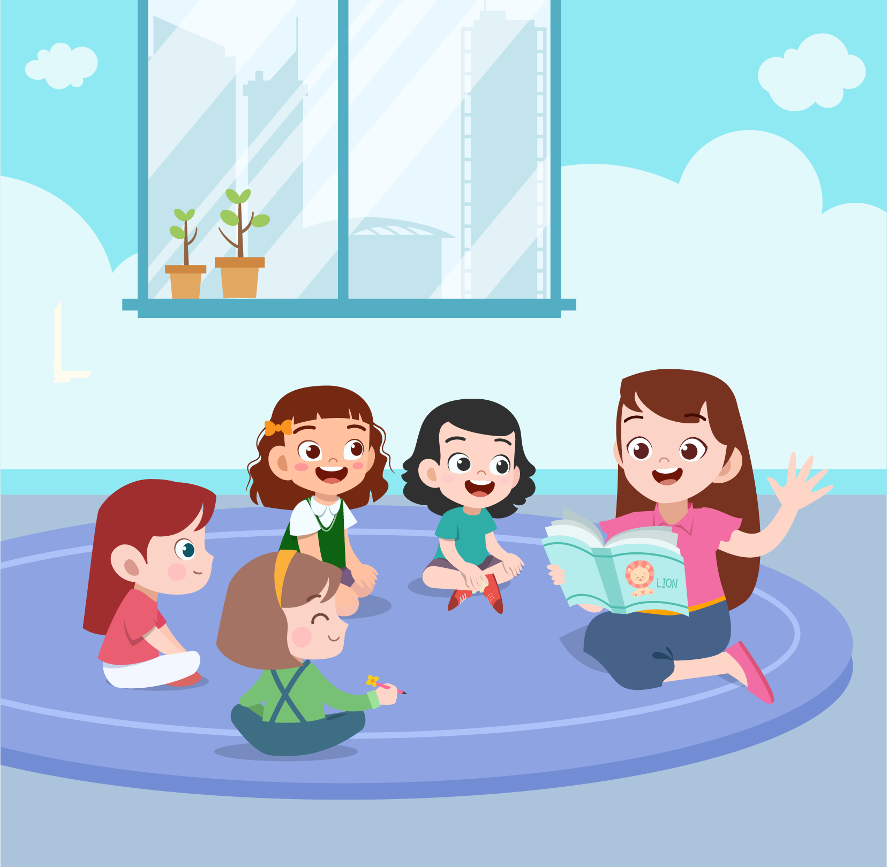
But I wasn’t upset for long. I sat with the other children on the carpet. Our teacher, Miss Holland, read us a story. Later, we drew pictures with pencils and crayons. At break time, I made friends with a girl called Megan. At the end of the day, I ran to the school gate with Megan and my picture, just like Sandy always did.

Questions:
6. I sat on the ____________ with other children and listened to a story.
7. At the end of the day, I ran to the school gate with my ____________.

PART 6
6 questions

Look, read and write.
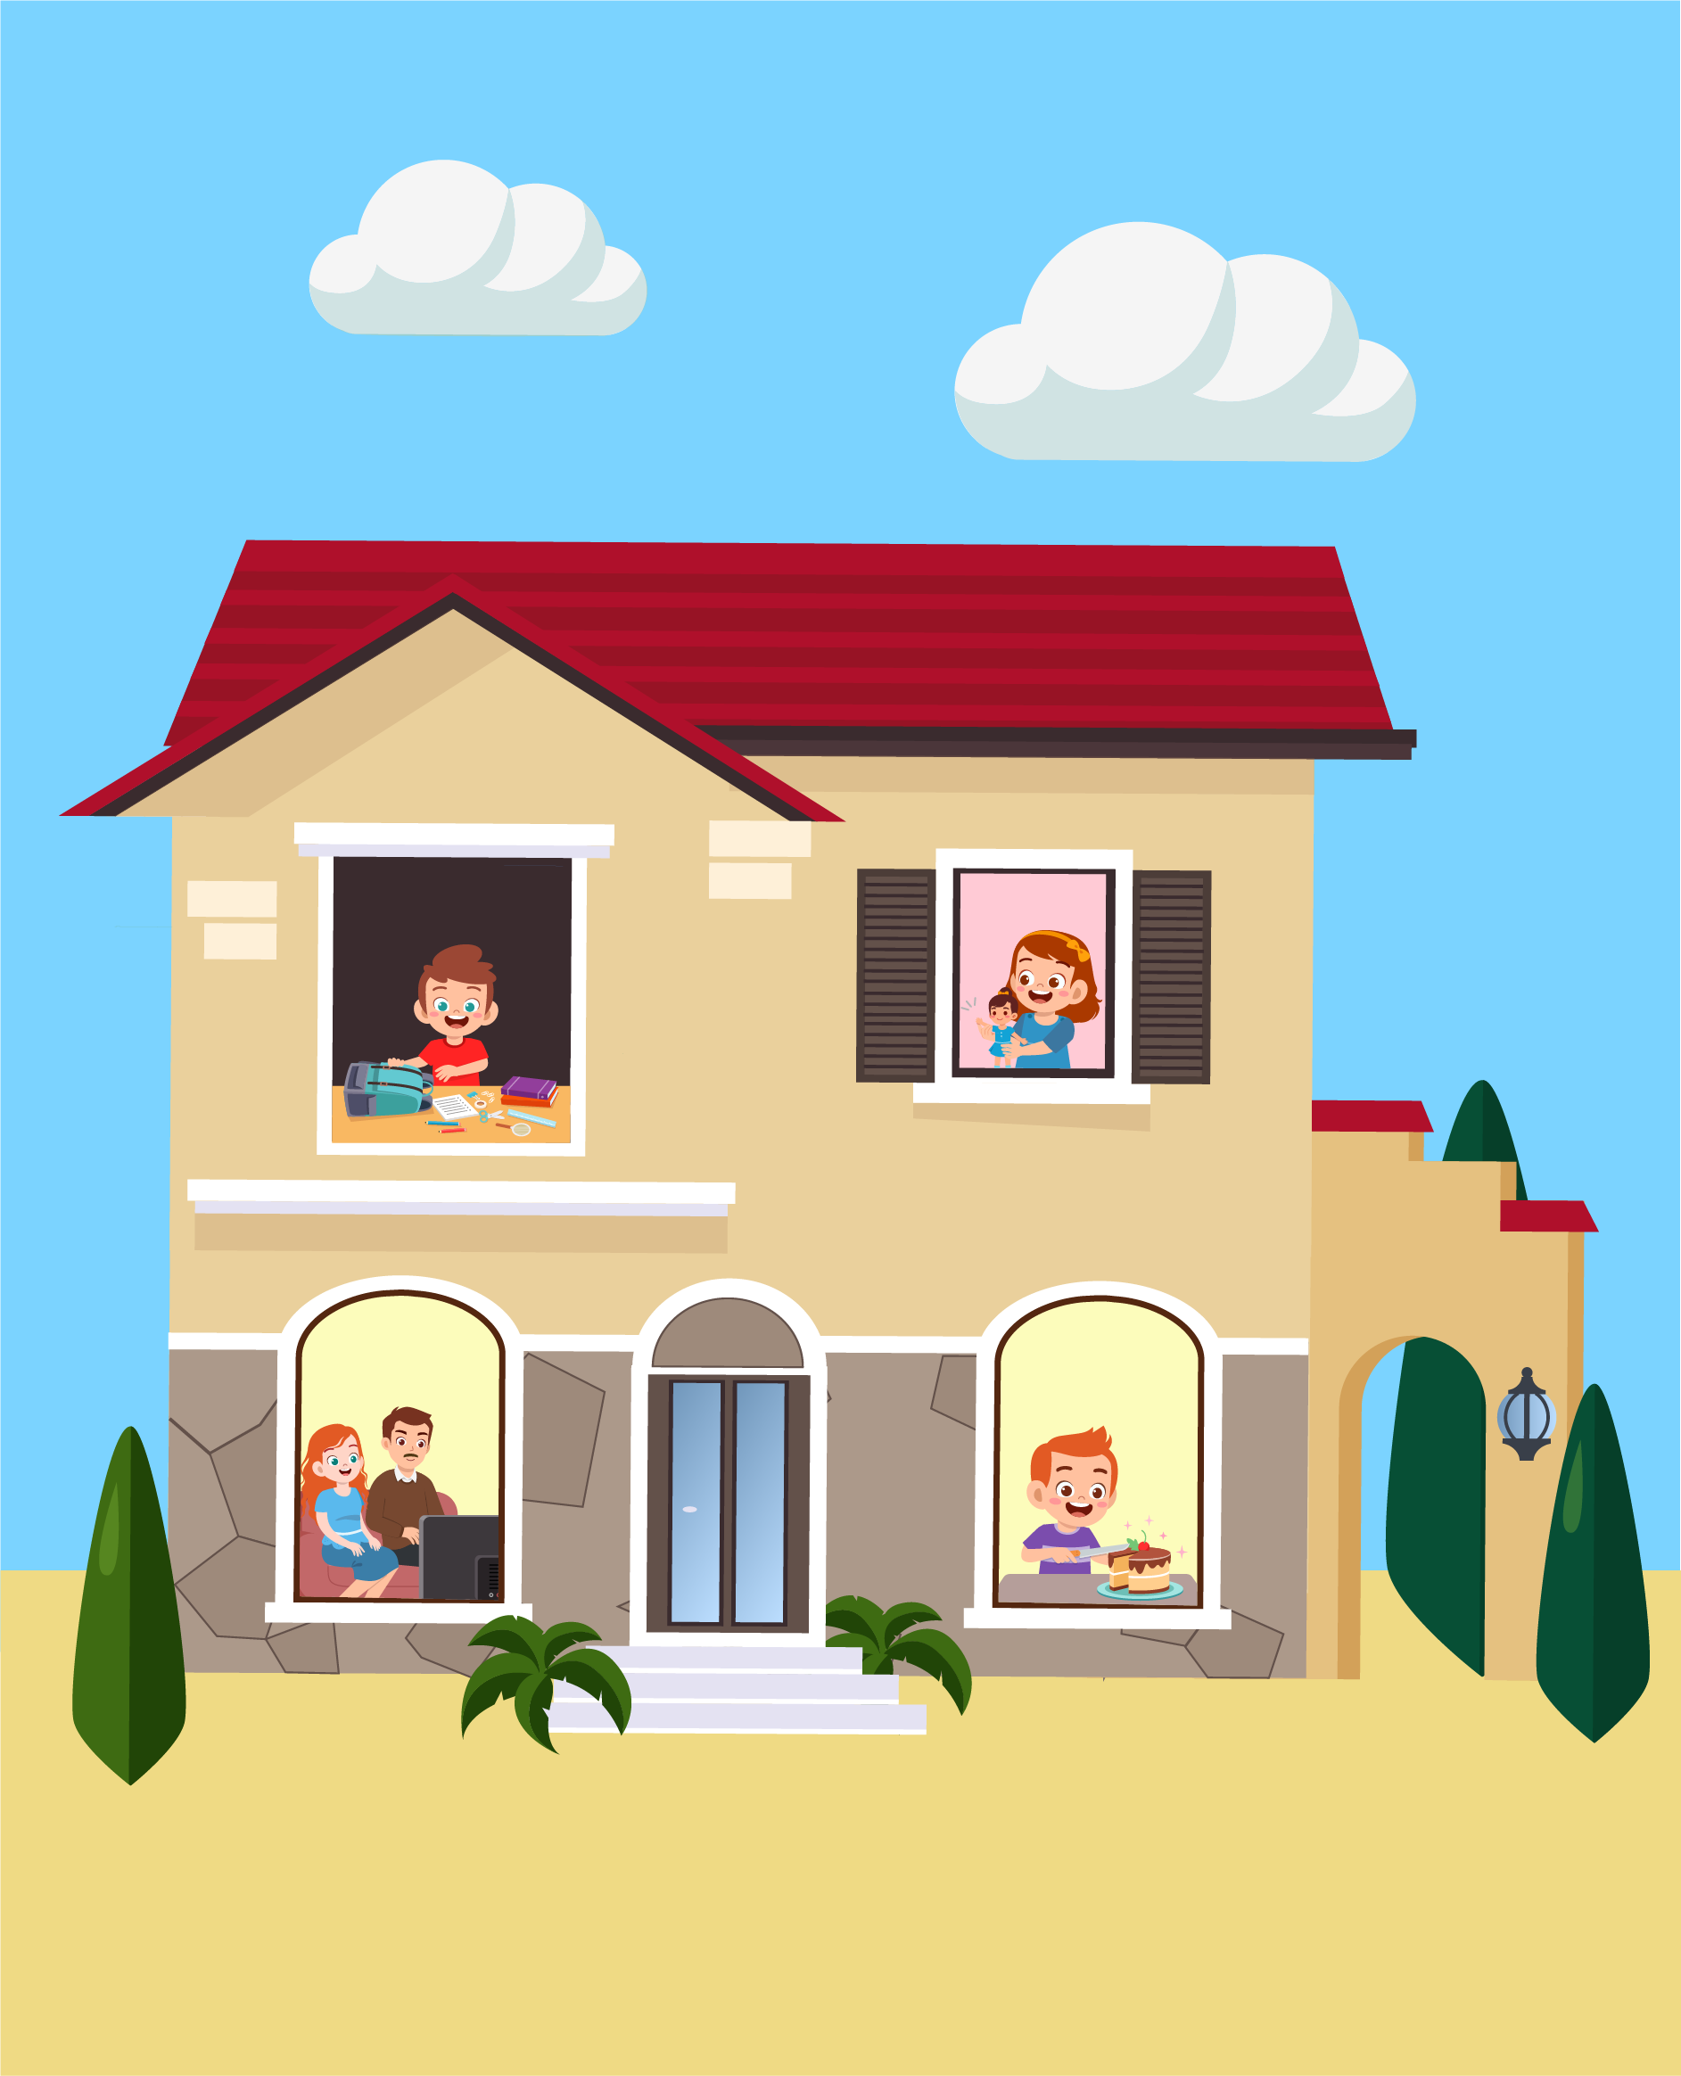

Examples:
The house has got two …floors…
What is the boy on the first floor cutting? …birthday cake…

Complete the sentences.
- The parents are on the _________ floor.
- The boy in the second floor is wearing a _______.

Answer the questions.
- Where is the boy in yellow shirt?
- What is the girl on the second floor holding?

Now write two sentences about the pictures.
- ________________________________________
- ________________________________________
Speaking
My name is…………………………….

Summary of Procedures
The usher introduces the child to the examiner. The examiner asks how old the child is.

- The examiner asks the child to describe several differences between the two Find the Differences pictures, e.g. ‘In picture 1, the girl is wearing a green sweater but in picture 2, the girl is wearing a yellow sweater.’
- The examiner tells the child the name of the story and describes the first picture, e.g. “Jake is walking in the forest.”. The examiner then asks the child to continue to tell the story.
- The examiner shows how to do the task with the first odd-one-out set of pictures. For example: ‘These are all places. But this is a room in a house’. Then the examiner asks the child to choose one picture in the other three sets and say which is different and why.
- The examiner asks questions about the child, e.g. ‘Who’s the youngest in your family?’

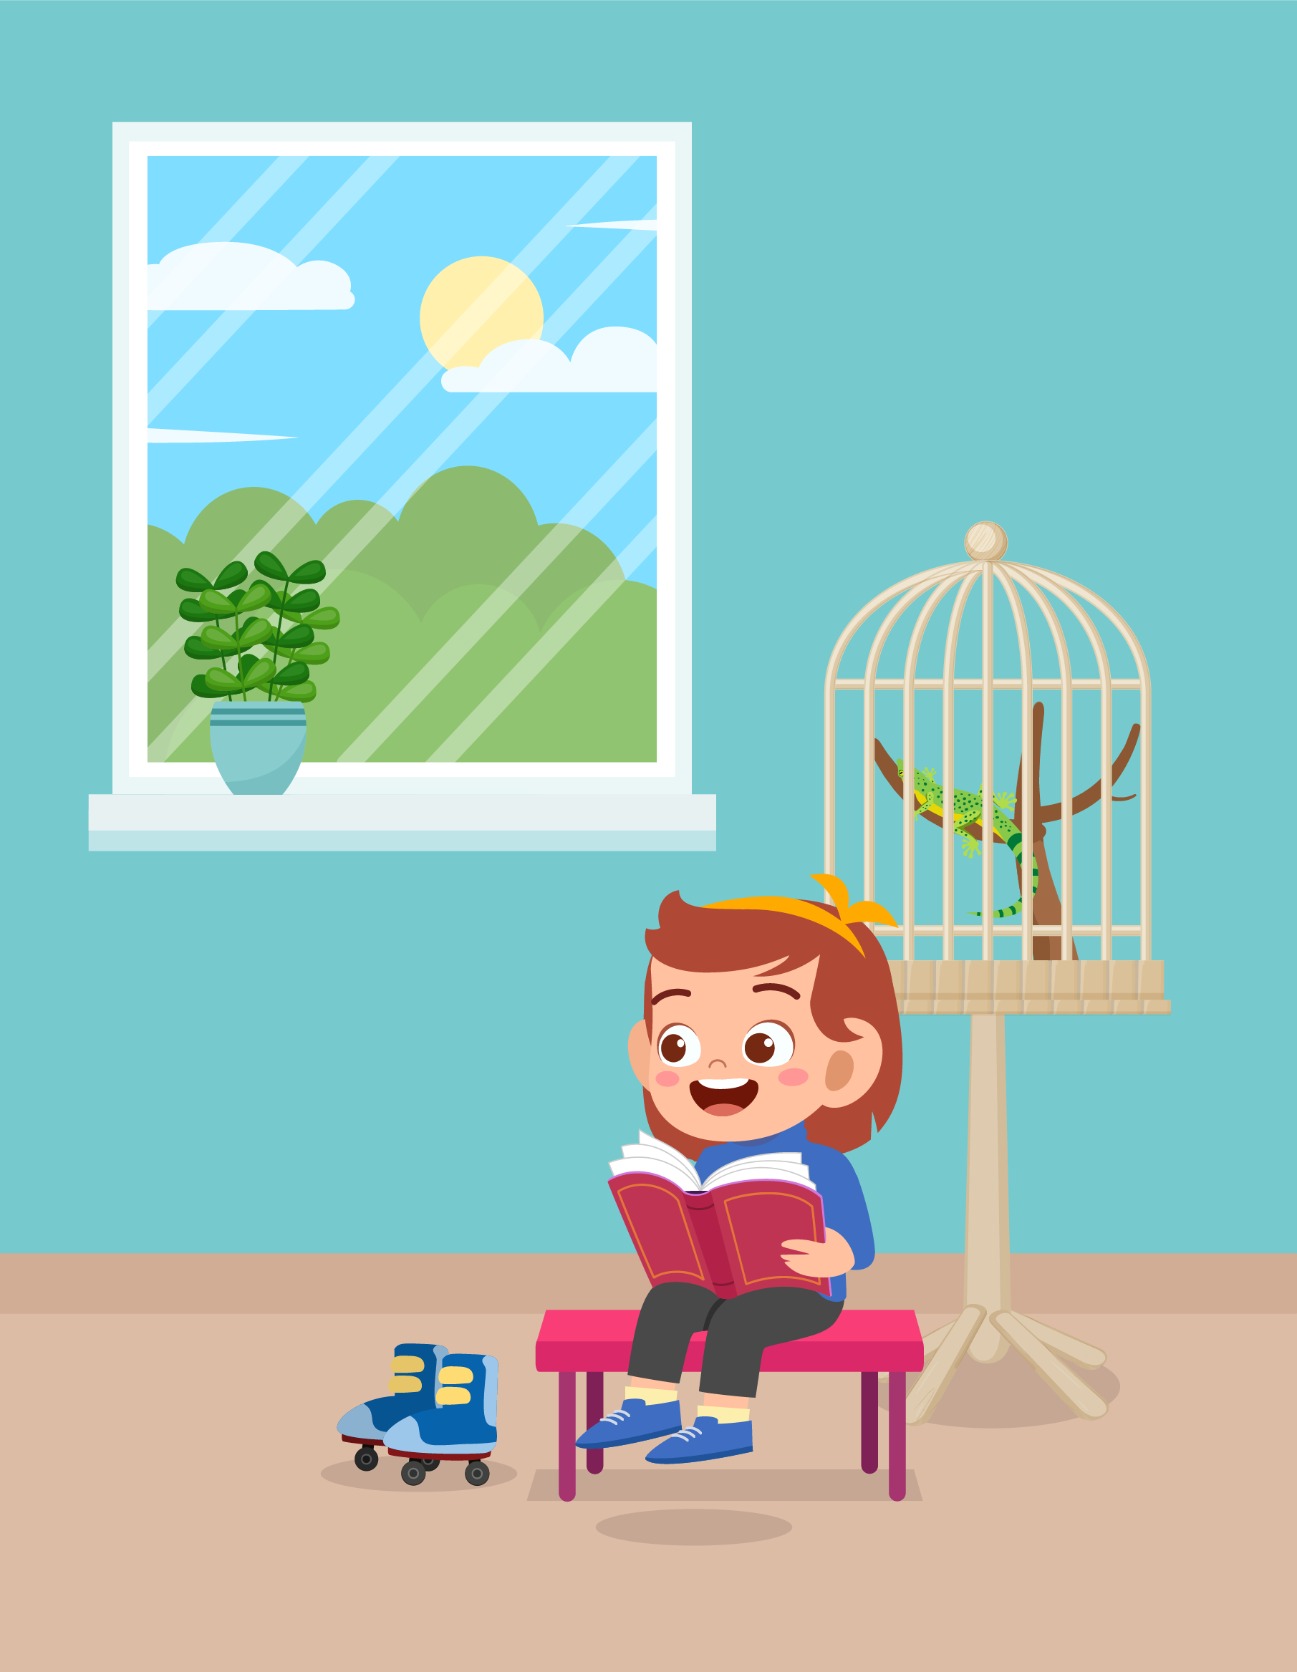 |  | 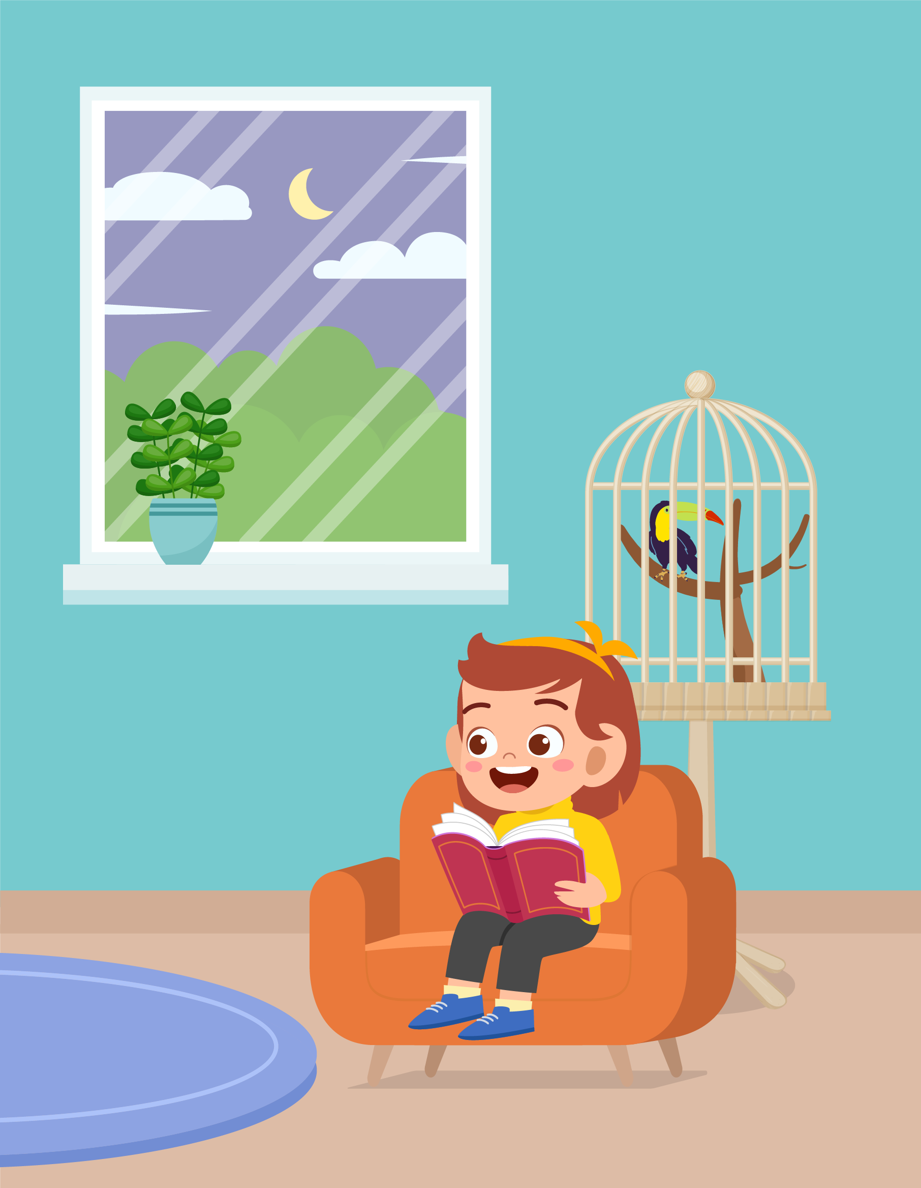

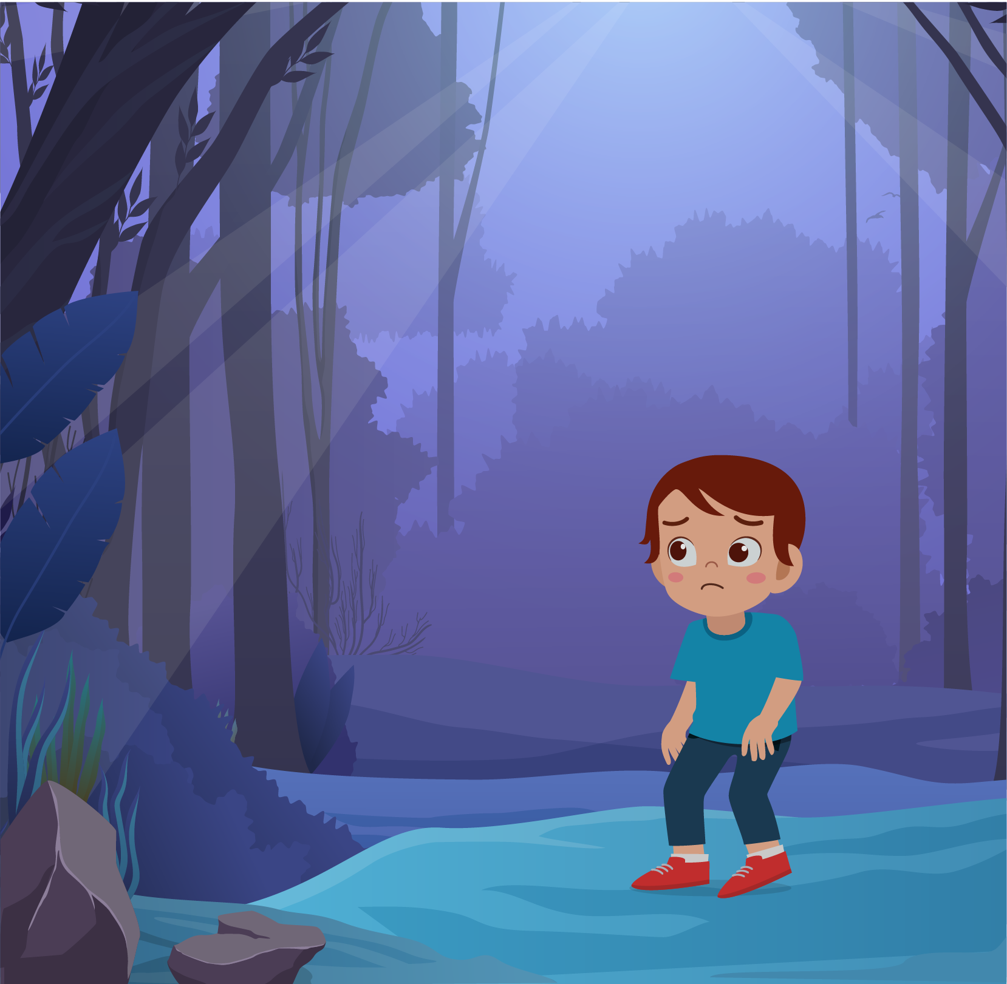
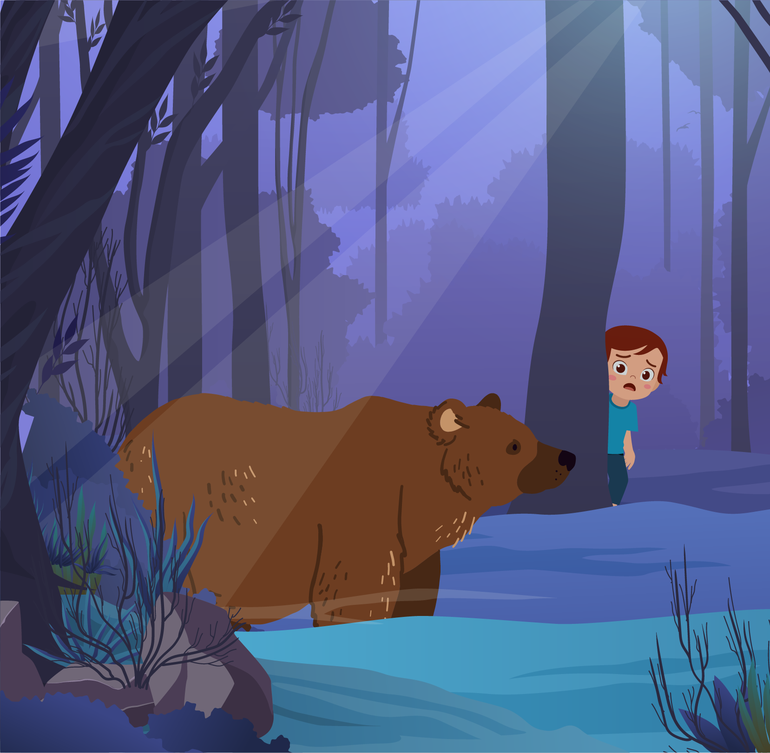 | 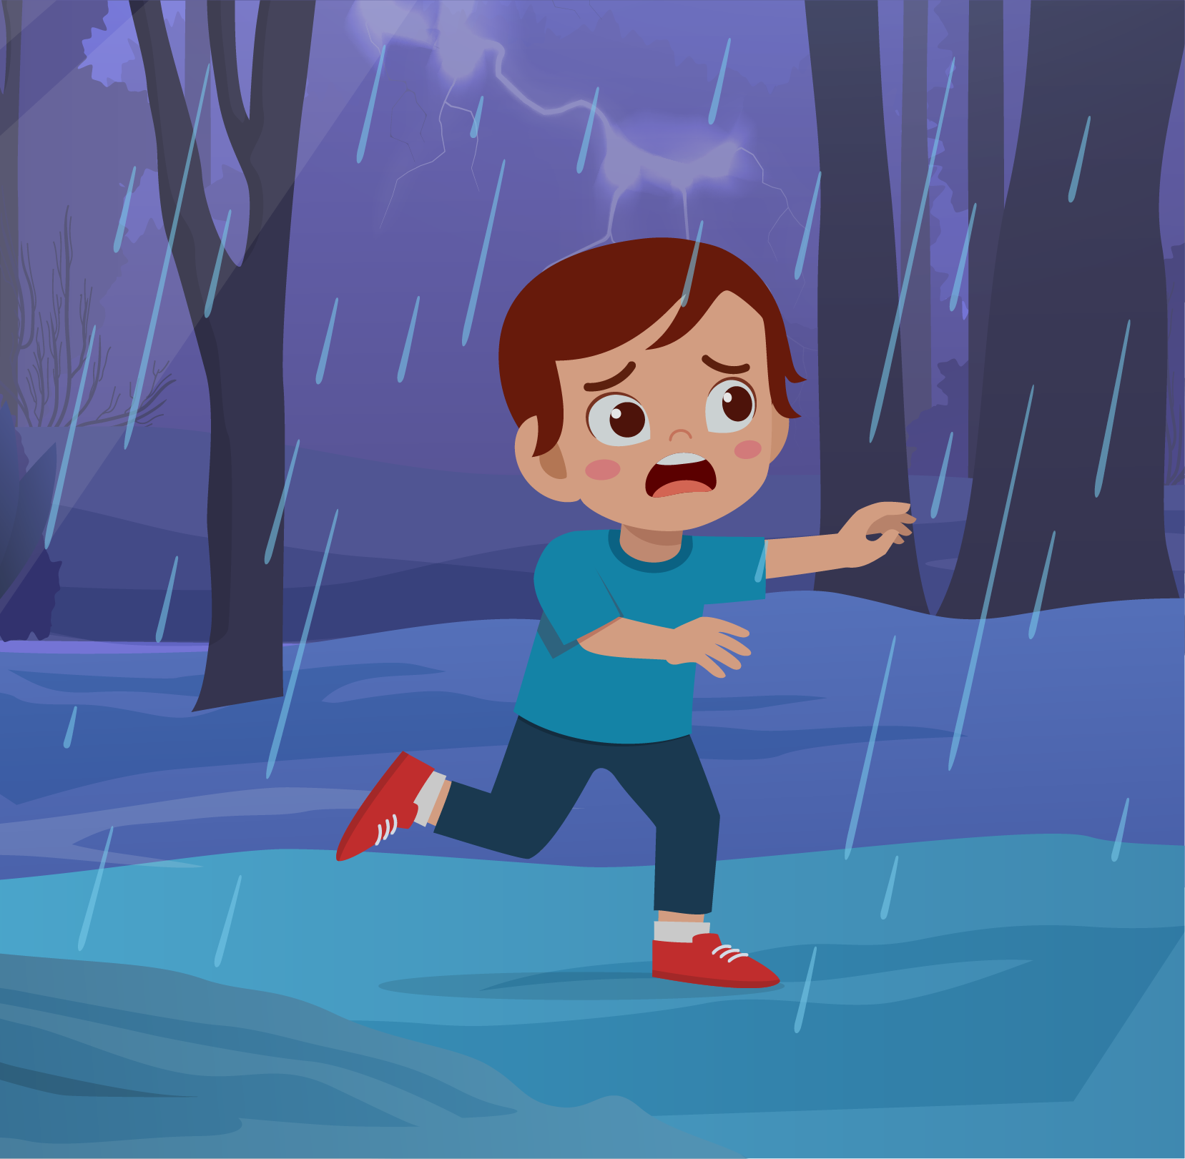 | 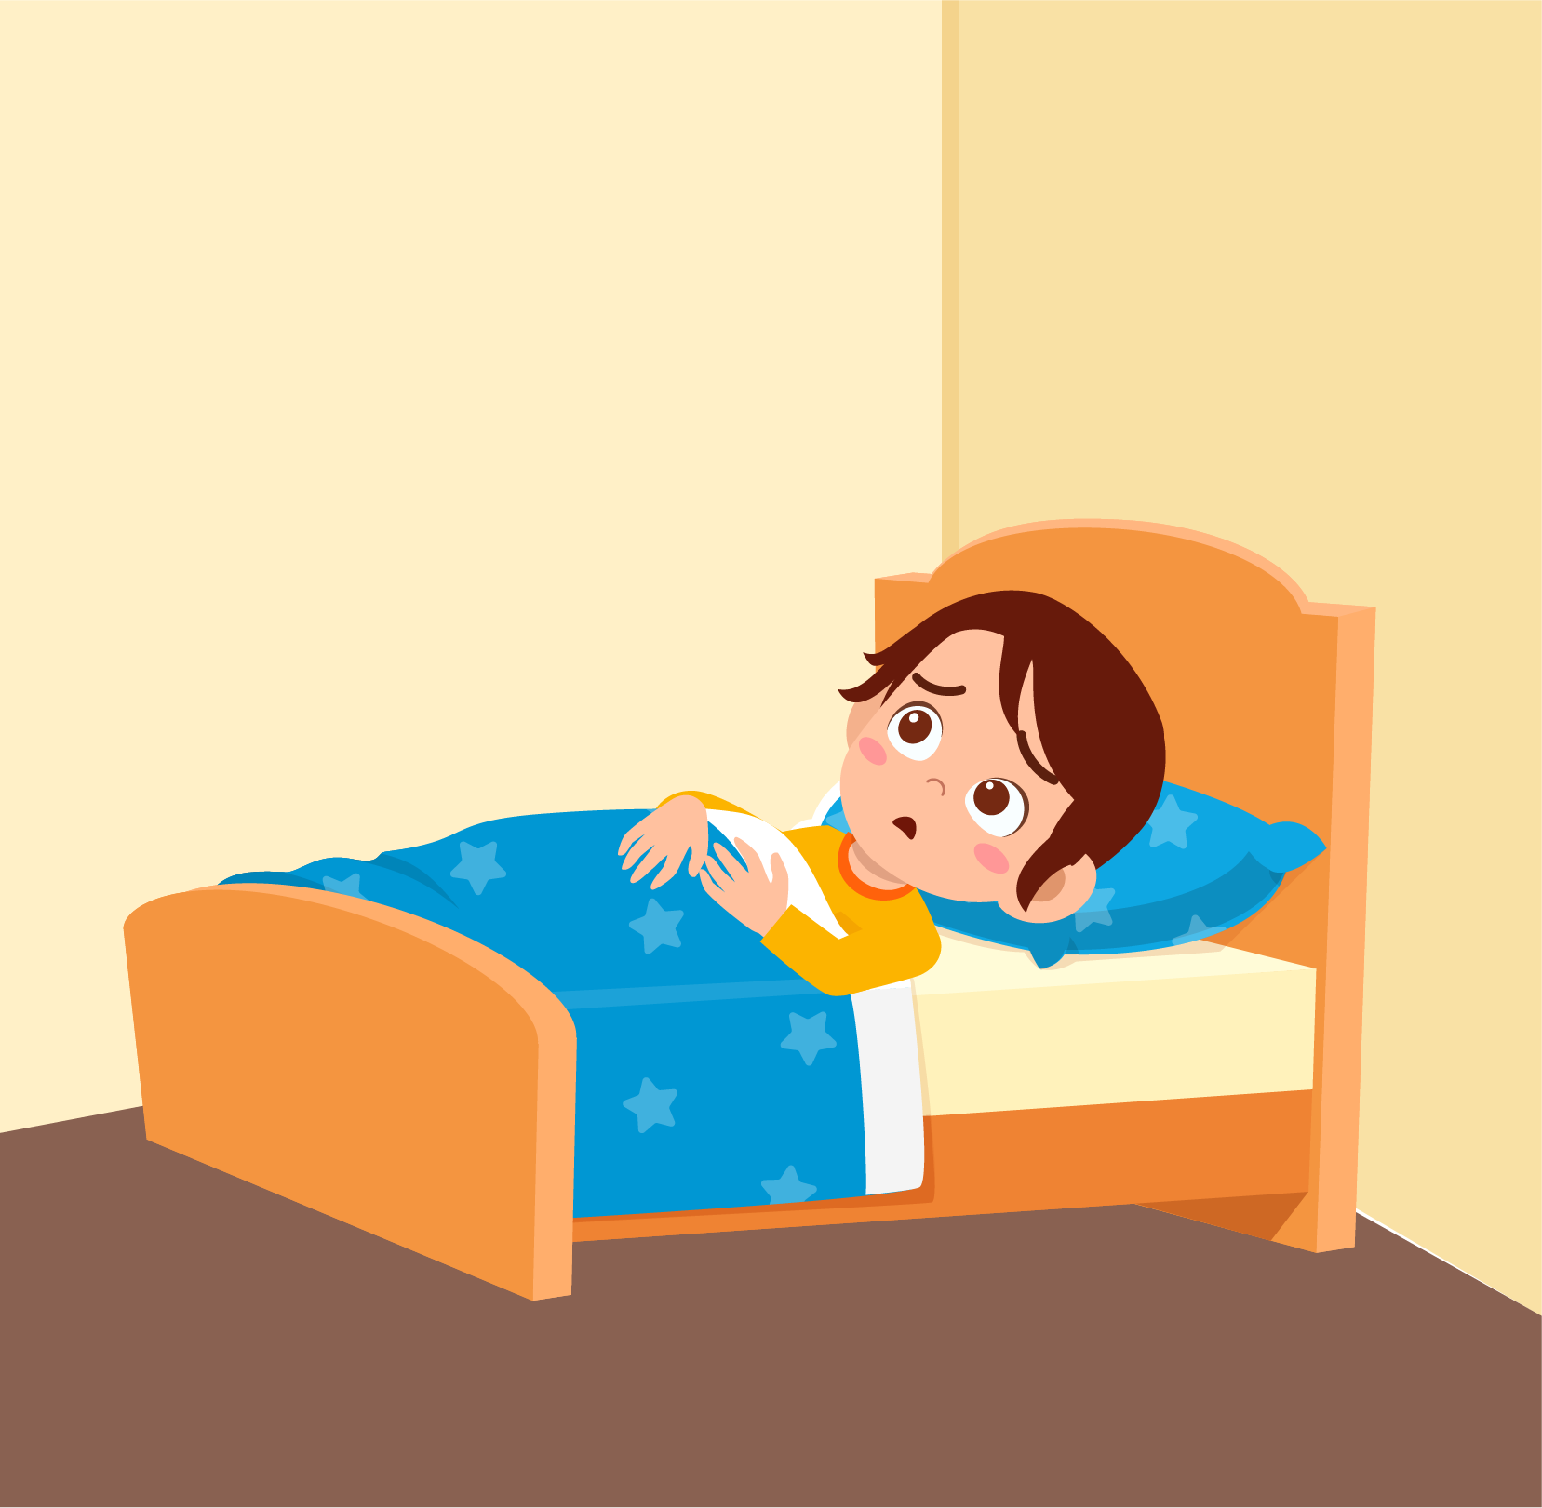

 |  | 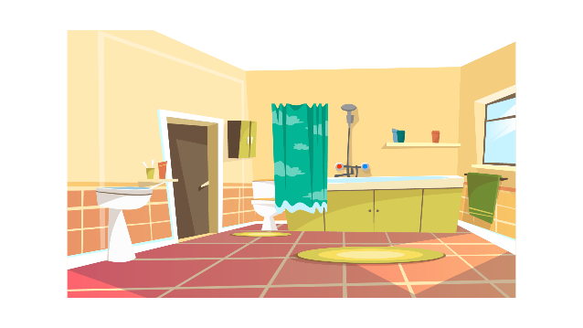 | 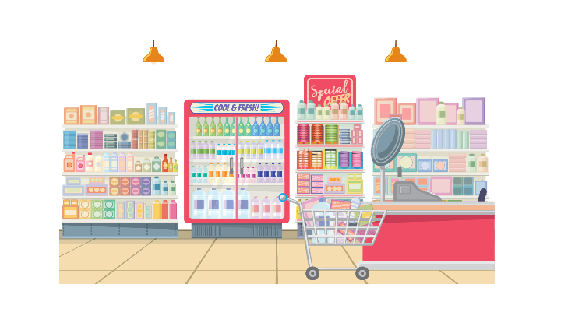
 |  |  | 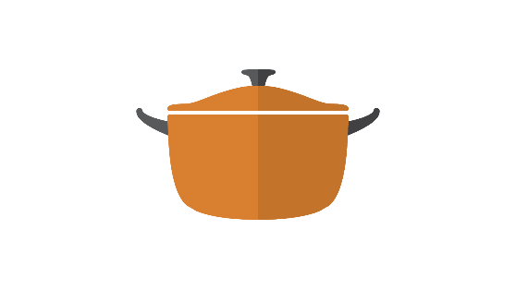

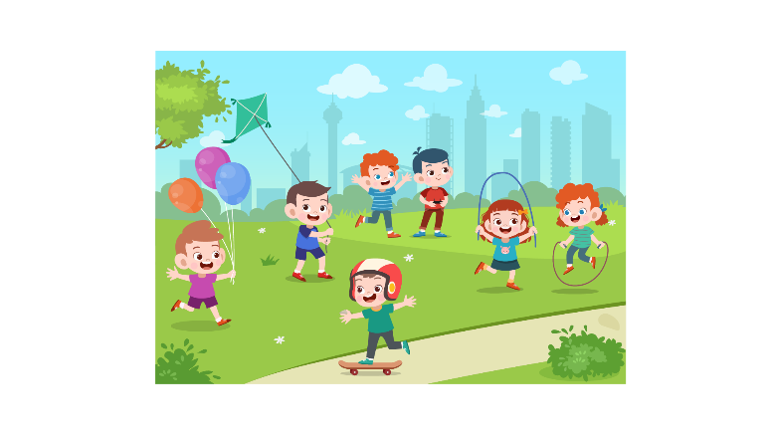 |  | 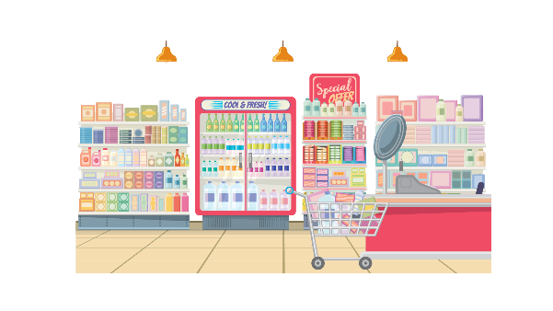 | 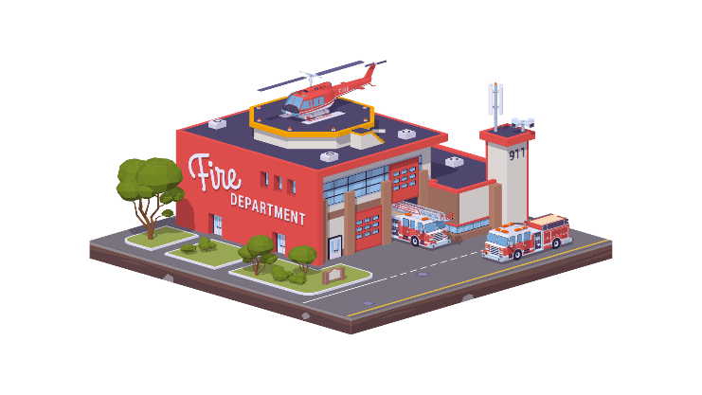
 | 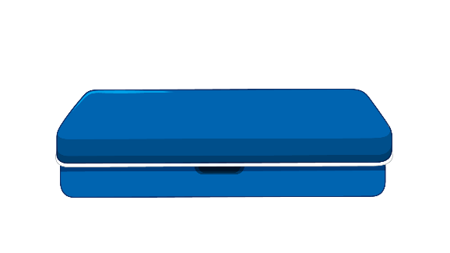 |  | 