|  |  |
| --- | --- |
|  |  |

**Họ tên thí sinh: .................................................................**

**Số báo danh: ......................................................................**

**Mã Đề: 027.**

**Câu 1.** Where does Rafa suggest meeting Mark instead of the café?

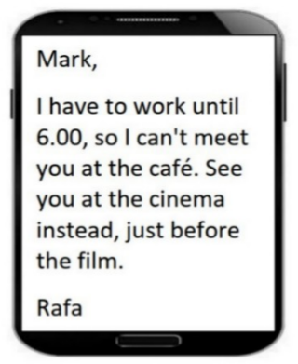

**A.** At work  **B.** At the cinema  **C.** At home  **D.** At a restaurant

**Câu 2.** What is the main reason Emma cannot attend Dorothy's birthday party?

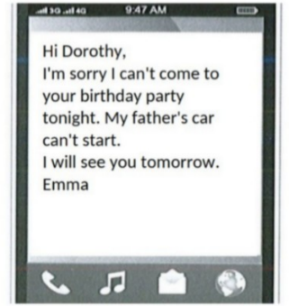

**A.** She has another commitment  **B.** She is sick

**C.** Her father's car won't start  **D.** She forgot about the party

**Câu 3.** What does the sign say?



**A.** Smoking is not permitted here.  **B.** Smoking is optional here.

**C.** Smoking is useful here.  **D.** Smoking is compulsory here.

**Câu 4.** What is the purpose of the charity event on November 10 at the Hilton Hotel?

You're invited to join us for our charity event on November 10 at 7 pm at the Hilton Hotel. We'll have a silent auction, live music, and cocktails, with all proceeds going towards supporting the homeless in our community. We hope you can make it!

**A.** To celebrate the end of the year  **B.** To support the homeless in the community

**C.** To raise money for a political campaign  **D.** To promote a new product

**Câu 5.** **Look at the signs. Choose the best answer for the question.**

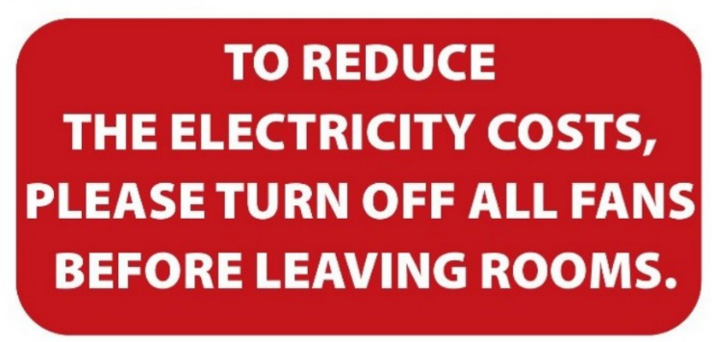

**A.** Please switch off fans when you finish using a room to save electricity.

**B.** When you leave, please reduce the number of fans in your room.

**C.** Please reduce the costs of electricity by leaving the room.

**D.** Please leave the fans in the room after you go out.

**Câu 6.** Who is Andrew planning to go to the cinema with?

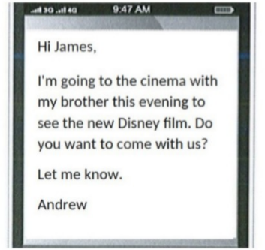

**A.** His parents  **B.** His brother  **C.** Alone  **D.** James

**Câu 7.** What alternative does Missie suggest if Tess can't lend her laptop?

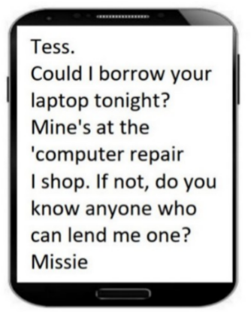

**A.** Using a desktop computer  **B.** Asking Tess to help with her work

**C.** Finding someone else who can lend a laptop  **D.** Going to an internet cafe

**Câu 8.** **Look at the signs. Choose the best answer for the question.**

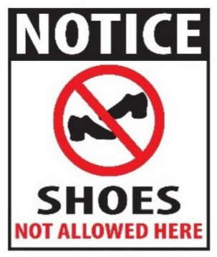

**A.** Please take off your shoes when entering this place.

**B.** You don’t have to wear shoes in this place.

**C.** You can’t buy any shoes in this place.

**D.** Please put on your shoes when entering this place.

**Câu 9.** What activity is being proposed in the message?

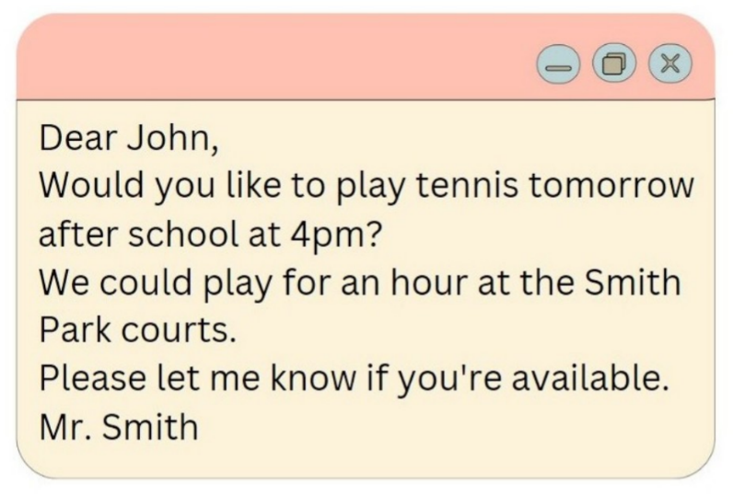

**A.** Playing basketball  **B.** Going swimming  **C.** Going for a run  **D.** Playing tennis

**Câu 10.** **Look at the signs. Choose the best answer for the question.**

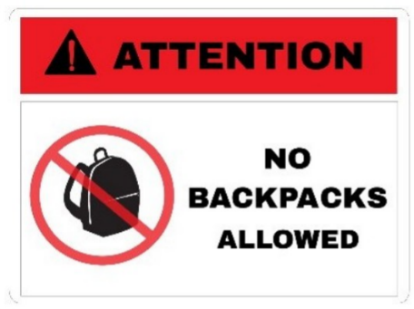

**A.** Backpacks are not allowed in this area without your attention.

**B.** You shouldn’t carry a backpack when you’re in this area.

**C.** You cannot bring your backpacks into this area.

**D.** You must pay attention when you bring a backpack.

**----HẾT---**