School: ……………………………………….. | Date: ………………………………..
Class: ……………………………..................... | Period: ………………………..........

UNIT 10: ENERGY SOURCES
Lesson 4 – Review (Pages 110, 111)

I. OBJECTIVES
By the end of the lesson, Ss will be able to:
1.1. Language knowledge and skills
- review words about energy (wind turbines, natural gas, power plant, pollution, non-renewable, solar panels, nuclear power, renewable, …) and talk about them.
- review grammar: Connectors: and, but; Comparison: more…than…, less…than…
- talk about types and sources of energy; benefits and drawbacks of energy sources.
- pronoun some vowels and consonants correctly: /e/, /æ/, /ə, /aʊ/, /əʊ/, “s” endings.
- put stress on nouns with two syllables.
1.2. Competences
- improve speaking, listening, reading and writing skills.
- improve the use of English.
1.3. Attributes
- have positive attitude in English language learning so that they actively participate in all classroom activities.
- review the old lesson and have good preparation for any assessment.

II. TEACHING AIDS AND LEARNING MATERIALS
1. Teacher’s aids: Student book and Teacher’s book, class CDs, Digital Book (DCR phần mềm tương tác SB, DHA (từ vựng/ cấu trúc) phần mềm trò chơi tương tác), projector/interactive whiteboard / TV (if any), PowerPoint slides, handouts.
2. Students’ aids: Student’s book, workbook, notebook.

III. ASSESSMENT EVIDENCE
Performance Tasks | Performance Products | Assessment Tools
- Listening: Listen to Steve talking to Alice about energy. For each question, choose the correct answer (A, B, or C). You will hear the conversation twice. | - Ss’ answers. | - T’s feedback/Peers’ feedback.
- Reading: Read the text about Midnight City. Choose the best word (A, B, or C) for each space. | - Ss’ answers. | - T’s feedback/Peers’ feedback.
- Vocabulary: Fill in the blanks with the words and phrases in the box. | - Ss’ answers. | - T’s feedback/Peers’ feedback.
- Grammar: Combine the sentences using “and” or “but”. | - Ss’ answers. | - T’s feedback/Peers’ feedback.
-Pronunciation:  + Circle the word that differs from the other three in the position of primary stress in each of the following questions.  + Circle the word that has the underlined part pronounced differently from the others. | - Ss’ answers/ presentation. | - T’s observation, T’s feedback/Peers’ feedback.

IV. PROCEDURES
A. Warm up: (5’)
a) Objective: Introduce the new lesson and set the scene for Ss to acquire new language; get students' attention at the beginning of the class by enjoyable and short activities as well as to engage them in the steps that followed.
b) Content: Review: words about energy.
c) Expected outcomes: Ss are ready for the new lesson.
d) Organization of the activity:
TEACHER’S ACTIVITIES | STUDENTS’ ACTIVITIES
- Option 1: Review: Words about energy.  - Have Ss review words about energy by looking at the pictures and give names of the things in the pictures.  - Call Ss to give answers.  - Give feedback.  - Lead to the new lesson.  *Illustration:  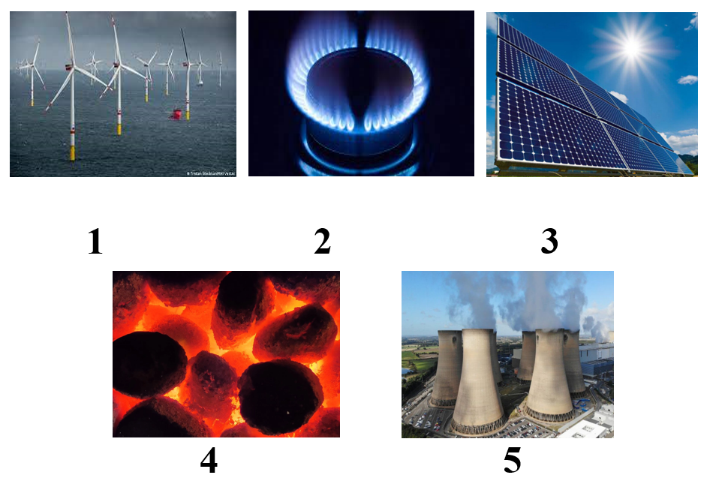  - Option 2: Odd one out  - Have Ss do a small exercise: Odd 1 out (find a word which does not belong to the group.  - Call Ss to give answers, explain for their answers.  - Give feedback.  - Lead to the new lesson.  *Illustration: Odd one out  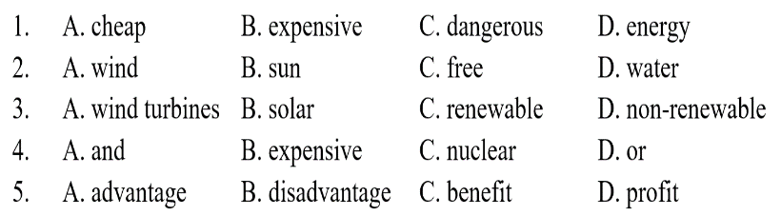 | - Look at the pictures and give answers.  - Listen.  Answer keys  1. wind turbines  2. natural gas  3. solar panels  4. coal  5. power plant / power station  - Work in pairs.  - Give answers.  - Listen.  Answer keys  1. energy (not adjective)  2. free (not noun)  3. wind turbines (not adjective)  4. expensive (not connectors)  5. disadvantage (not positive meaning)

B. New lesson (35’)
- Activity 1: Listening (7’)
a) Objective: Help Ss improve their listening skill.
b) Content:
- Listen to Steve talking to Alice about energy. For each question, choose the correct answer (A, B, or C). You will hear the conversation twice.
c) Expected outcomes: Ss listen in details and get familiar with the listening format test.
d) Organization of the activity:
TEACHER’S ACTIVITIES | STUDENTS’ ACTIVITIES
Listen to Steve talking to Alice about energy. For each question, choose the correct answer (A, B, or C). You will hear the conversation twice.  - Have Ss read through the listening part.  - Demonstrate the activity by using the example.  - Play the audio (CD 2 – Track 44). Have Ss listen and choose the correct answer.  - Have Ss check answers with pairs, then read answers.  - Check answers as a whole class using DCR. | - Read in silence.  - Listen and read answers.  Answer keys  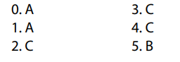
- Activity 2: Reading (7’)
a) Objective: Students can improve their reading skill.
b) Content:
- Read the text about Midnight City. Choose the best word (A, B, or C) for each space.
c) Expected outcomes: Ss read for comprehension and get familiar with the reading format test.
d) Organization of the activity:

TEACHER’S ACTIVITIES | STUDENTS’ ACTIVITIES
Read the text about Midnight City. Choose the best word (A, B, or C) for each space.  - Demonstrate the activity on DCR by using the example.  - Have Ss look and read, then choose the correct answer (A, B, or C).  - Call Ss to give answers, explain.  - Give feedback and evaluation. | - Observe and listen.  - Listen and choose the correct answer (A, B, or C).  - Give answers, explain.  Answer keys  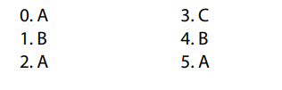

- Activity 3: Vocabulary (7’)
a) Objective: Ss can review vocabulary about tourism and cultures.
b) Content: Fill in the blanks with the words and phrases in the box.
c) Expected outcomes: Ss produce the new language successfully, and they can use these words in speaking and writing.
d) Organization of the activity:
TEACHER’S ACTIVITIES | STUDENTS’ ACTIVITIES
Fill in the blanks with the words and phrases in the box.  - Have Ss read the sentences.  - Ask Ss to work in pairs to fill in the blanks with the words and phrases in the box.  - Have Ss give answers, tell the meaning of the words /phrase again.  - Check answers as a whole class using DCR. | - Read the sentences.  - Work in pairs to fill in the blanks.  - Give answers.  Answer keys  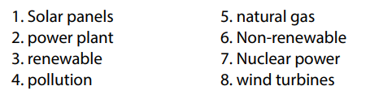
- Activity 4: Grammar (10’)
a) Objective: Ss can review the use of English: Connectors: “and” or “but”.
b) Content:
- Combine the sentences using “and” or “but”.
c) Expected outcomes: Ss produce the new language successfully, and they can use the grammar points in speaking and writing.
d) Organization of the activity:
TEACHER’S ACTIVITIES | STUDENTS’ ACTIVITIES
Combine the sentences using “and” or “but”.  - Have Ss tell the way to use the Connectors: “and” or “but”.  - Ask Ss to work individually to combine the sentences using “and” or “but”.  - Have Ss work in pairs to check each other’s work.  - Call Ss to give answers, explain for their choice.  - Check answers as a whole class using DCR. | - Retell.  - Work individually.  - Work in pairs.  - Give answers.  Answer keys  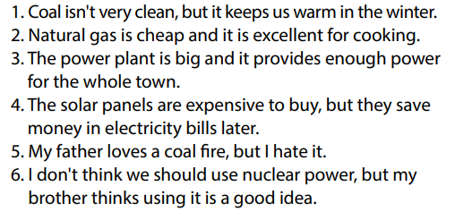
- Activity 5: Pronunciation (4’)
a) Objective: Ss can review the stress of nouns with 2 syllables, vowels and consonants: /e/, /æ/, /ə, /aʊ/, /əʊ/, “s” endings.
b) Content:
- Circle the word that differs from the other three in the position of primary stress in each of the following questions.
- Circle the word that has the underlined part pronounces differently from the others.
c) Expected outcomes: Ss produce the new language successfully.
d) Organization of the activity:
TEACHER’S ACTIVITIES | STUDENTS’ ACTIVITIES
Task a. Circle the word that differs from the other three in the position of primary stress in each of the following questions.  - Remind Ss some basic rules of putting stress on nouns with 2 syllables.  - Ask Ss to work individually.  - Have Ss work in pairs to check each other’s work.  - Call Ss to give answers, pronounce the words again.  - Give feedback, correct Ss’ pronunciation if necessary.  Task b. Circle the word that has the underlined part pronounced differently from the others.  - Have Ss distinguish vowels and consonants: /e/, /æ/, /ə, /aʊ/, /əʊ/, “s” endings.  - Ask Ss to work individually to circle the answer.  - Have Ss work in pairs to check each other’s work.  - Call Ss to give answers, pronounce the words again.  - Give feedback, correct Ss’ pronunciation if necessary. | - Listen.  - Work individually.  - Work in pairs.  - Give answers.  Answer keys  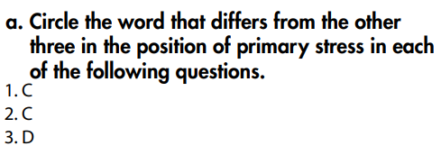  - Review.  - Work individually.  - Work in pairs.  - Give answers.  Answer keys  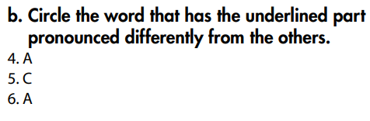

C. Consolidation and homework assignments (5’)
* Consolidation:
* Grammar of Unit 10: Connectors: and, but; Comparison: more…than…, less…than…
* Vocabulary of Unit 10: Words about energy: wind turbines, natural gas, power plant, pollution, non-renewable, solar panels, nuclear power, renewable, …

* Homework:
- Review vocabulary, grammar of unit 10.
- Do the exercises in WB: Review of Unit 10 (page 71).
- Do exercises in Tiếng Anh 7 i-Learn Smart World Notebook: Review Units 6-10 (pages 66 & 67).
- Do the Semester 2 Test in Tiếng Anh 7 i-Learn Smart World Notebook (pages 70, 71 & 72).
- Have good preparation for the second semester test.

D. Reflection
a. What I liked most about this lesson today:
…………………………………………………………………………………………
- What I learned from this lesson today:
…………………………………………………………………………………………
c. What I should improve for this lesson next time:
…………………………………………………………………………………………

