School: ……………………………………….. | Date:……………………………………..
Class: ……………………………..................... | Period: 47

Review Unit 4, page 93
1. Objectives
By the end of this lesson, students will be able to…
1.1. Language knowledge/ skills
- review the target language learnt in the unit.
- practice test taking skills.
1.2. Competences
- improve Ss’ collaboration, analytical, critical thinking skills.
1.3. Attributes
- know the dangers of natural disasters and how to keep safe.
2. Teaching aids and materials
- Teacher’s aids: Student’s book and Teacher’s book, class CDs, DCR– Phần mềm tương tác trực quan, DHA – Ứng dụng trò chơi tương tác, projector / interactive whiteboard /TV (if any), PowerPoint slides.
- Students’ aids: Student’s book, Workbook, Notebook.
3. Assessment Evidence
Performance Tasks | Performance Products | Assessment Tools
- Fill in the blanks with the words from the box.  - Circle the correct preposition of place.  - Underline the mistakes and write the correct words on the lines.  - Circle the word that has the underlined part pronounced differently from the others.  - Write an announcement about a disaster in the place where you live. Write 80 to 100 words. | - Ss’ answers.  - Ss’ answers.  - Ss’ answers.  - Ss’ answers.  - Ss’ answers. | - Observation.  - Observation.  - Observation.  - Observation.  - Checking.
4. Procedures
A. Warm up: 5’
a. Objective: review the vocabulary learnt in the unit.
b. Content: guessing game
c. Expected outcomes: Ss can say the words correctly.
Teacher’s activities | Students’ activities
Guessing game  Typhoon, earthquake, tsunami, flood, wildfire, blizzard, heat wave, drought, landslide, avalanche  - Explain the game: T divides the class into 2 teams; T picks 2 Ss from to teams to go to the board; T gives them a natural disaster and ask them to draw for their team to guess; the faster team will get point; the team with more points at the end will win.  - Get Ss to play in 2 teams.  - Decide the winner. | -Play the games in two teams.
B. New lesson (35’)
1. Vocabulary: 10’
a. Objectives: to help Ss review the vocabulary learnt in the unit.
b. Content: vocabulary task.
c. Expected outcomes: Ss can understand the meanings of the vocabulary and labe the pictures with the correct words.
d. Organization
Teacher’s activities | Students’ activities
Fill in the blanks with the words from the box.  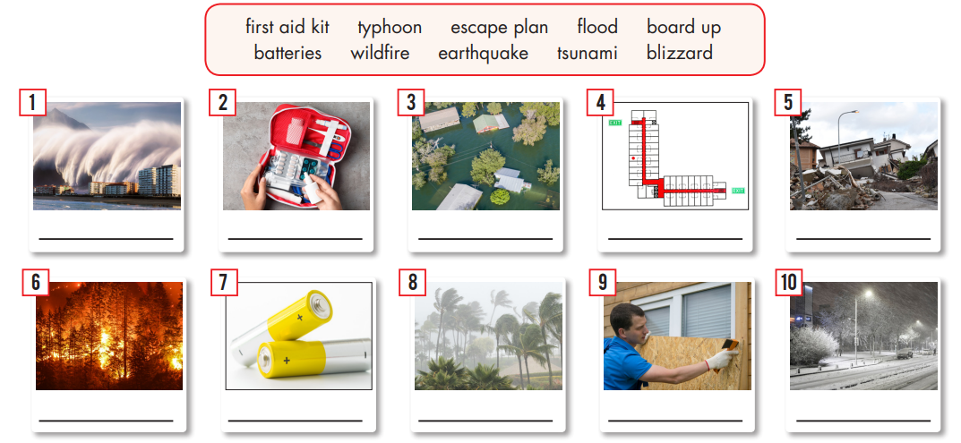  - Ask Ss to look at the pictures carefully and write the correct word under each picture.  - Give Ss time to do it.  - Let them compare their answers with their partners.  - Pick some Ss to give their answers.  - Give feedback. | .  - Look at the pictures carefully and write the correct word under each picture.  - Compare their answers with their partners.  - Give their answers.  Answer keys:  1. tsunami 2. first aid kit  3. flood 4. escape plan  5. earthquake 6. wildfire  7. batteries 8. typhoon  9. board up 10. blizzard
2. Grammar: 10’
a. Objectives: to help Ss review grammar learnt in the unit.
b. Content: grammar task
c. Expected outcomes: Ss can use prepositions of places and make Wh- questions correctly.
d. Organization:
Teacher’s activities | Students’ activities
Task a. Circle the correct preposition of place.  1. You should keep a fire extinguisher in/under your home.  2. In an earthquake, you should get into/under a table.  3. If there is a tsunami, you need to go inside/to higher ground.  4. During a flood, don't go into/outside the water because it's dangerous.  5. An escape plan can help you to get outside/inside in an emergency.  - Use IWB to show the task.  - Review the use of prepositions of place.  - Ask Ss to circle the correct preposition of place.  - Give Ss time to do the exercise.  - Let them compare their answers with their partners.  - Pick some Ss to give their answers.  - Give feedback.  Task b. Underline the mistakes and write the correct words on the lines.  1. What was the big typhoon?  2. How tall be the tsunami?  3. When wide was the typhoon?  4. How much people died in the flood?  5. How many damage did the fire cause?  - Review the meaning and structures of different Wh- questions.  - Ask Ss to underline the mistakes and write the correct words on the lines  - Give Ss time to do the exercise.  - Let them compare their answers with their partners.  - Pick some Ss to give their answers and explain.  - Give feedback. | - Circle the correct prepositions.  - Compare their answers with their partners.  - Give their answers.  Answer keys:  1. in 2. Under 3. To 4. Into 5. outside  - Underline the mistakes and write the correct words on the lines.  - Compare their answers with their partners.  - Give their answers.  Answer keys:  1. big –> biggest  2. be –> was  3. When –> How  4. much –> many  5. many –> much
3. Pronunciation: 5’
a. Objectives: to help Ss pronounce the words correctly.
b. Content: pronunciation task
c. Expected outcomes: Ss can pronounce the words correctly.
d. Organization
Teacher’s activities | Students’ activities
Circle the word that has the underlined part pronounced differently from the others.  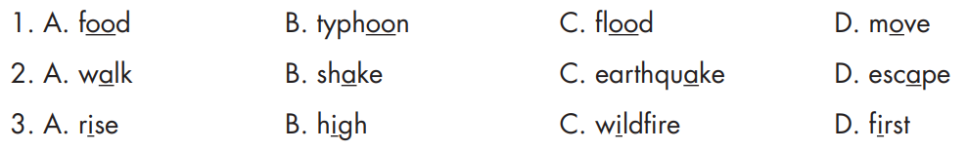  -Ask Ss to say the words.  -Get them choose the word that has the underlined part pronounced differently from the others.  -Show them the pronunciation of the words (using PPT slides) and confirm the answers. | - Say the words.  - Choose the word that has the underlined part pronounced differently from the others.  Answer keys:  1. C 2. A 3. D
4. Writing: 15’
a. Objectives: to help Ss write an announcement about a disaster.
b. Content: writing task
c. Expected outcomes: Ss can write an announcement about a disaster in the place where they live.
d. Organization
Teacher’s activities | Students’ activities
Write an announcement about a disaster in the place where you live. Write 80 to 100 words.  -Ask Ss to brainstorm for information about the disaster where you live, including what, where, when, possible damage, and some instructions to keep safe.  - Give Ss some time to write.  - Go around to help if necessary.  - Pick some Ss to show their writing.  - Give feedback. | - Brainstorm for information about the disaster where you live, including what, where, when, possible damage, and some instructions to keep safe.  - Write their passage.  - Show their writing.  Sample:  Sent: 8:00 May 15  What: Typhoon  Where: Newtown  When: From 10:00 May 15 to 6:00 May 16  Heavy rains and strong winds will cause damage to our town. The wind could knock down trees. The water could flood the streets. We expect damage to buildings, houses, and cars.  Instructions:  · Have emergency items ready to go.  · Stay in the highest part of your home.  · Move food and important things to the highest part of your home.  · Do not walk or drive into the flood water.  · Board up your lower windows.
C. Consolidation and homework assignments: 5’
- Prepare the next lesson: Unit 5, page 44.
- Do the exercises in WB (page 53).

5. Reflection

a. What I liked most about this lesson today:
…………………………………………………………………………………………
b. What I learned from this lesson today:
…………………………………………………………………………………………
c. What I should improve for this lesson next time:
…………………………………………………………………………………………

