i-Learn Smart World 6 (workbook)
Week: Date of teaching:
Period: 1
UNIT 3: FRIENDS
Lesson 1 (p. 14)
- Objectives:
By the end of this lesson, students will be able to:
- Language knowledge and skills
- Vocabulary: consolidate vocabulary items about adjectives to describe appearance.
- Structure: use the questions – “What does he/she look like?”– “He/she is + adj.”
→ Describe people’s personal appearances
- Core competencies and personal qualities
- Raise motivations and interests in learning English as a foreign language
- Develop communicative and team-working skills through learning activities
- Illustrate problem-solving and critical-thinking skills through learning activities
- Establish responsive and independent characteristics to be a long-life learner
- Teaching aids:
- Teacher’s aids: workbook and teacher’s book, class CDs, flashcards, IWB software, laptop/TV.
- Students’ aids: notebook, workbook.
- Procedures:
Time | Steps/Activities | Organization
5’ | Warm-up  Option 1: Adjectives  - Teacher shows pictures and adjectives, students choose pairs of adjectives that best describe each picture.  - Teacher checks and gives the correct answer  Option 2: Sticking  - Teacher shows pictures on the board, students choose suitable flashcards to stick on the picture.  - Some students volunteer to do the task.  - One plus mark is for every student having a correct answer. | - Teacher – whole class  - Students in groups  - Whole class
   | heavy | big | fat
  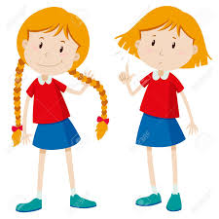 | tall | long | weak
  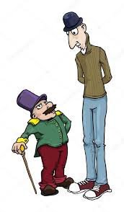 | light | thin | short
25’ | New lesson  - Teacher reviews adjectives that are used to describe appearance, adjectives with opposite meaning.  A-New words. (10’)  Activity 1. Gaps fill  - Teacher lets students work in pairs, fill in the blanks in sentences using the words in the box. (exercise a/p. 14)  - Students show their answers on the board.  - Teacher and other students check and correct.  Answer:  - glasses  - blue  - blond  - tall  - brown  - long  - short  - slim - red  Activity 2: describing  - Teacher has students review the way to describe someone’s appearance  Structure:  S + be + adj  S + have / has + adj. + N  Example:  - I am tall. I have long black hair.  - Nam is tall. He has short hair.  - Have students use words in task A to describe a student in class.  - Some students share their answers.  - Teacher checks and corrects.  B-Listening. (10’)  Activity 1: Guessing  - Have students get through the sentences, guess the answers before listening.  - Teacher gets and shows the answer on the board.  Activity 2: Listen and circle the correct answers.  - Have students listen two times and circle the correct answer for each sentence.  - Have students listen again and check the answers.  Answer:  - A  - B  - C  - C  - A | - Teacher – whole class/ individuals/ pairwork  - Teacher/ Whole class/ groupwork  - Teacher – whole class/ pairs
5’ | Wrap-up  Option 1: Speaking  - Teacher asks students to look at the pictures and the description, correct if they are wrong.  - Have students work in pairs, check and correct the false ones.  - Some pairs present in front of the class.  Option 2: Describing.  - Ask students to work individually, make a sentence to describe him, then the next student says that sentence again, adds a sentence about him / her.  - The chain stops at the fifth student.  - Students who can complete the five sentences win the game.  Sentences:  - I’m short.  - He is short. I am tall  - He is short. She is tall. I am tall, too.  - He is short. She is tall. She is tall. I have long hair.  - He is short. She is tall. She is tall, too. He has long hair. I have short hair. | - Teacher – whole class/ individuals  - Teacher –Students in groups
   | The girl is slim.  She has short black hair
   | The girl is shorter than the boy.  She has long red hair.
   | The boy is fat.  He has long brown hair.
  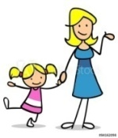 | My mom is short and slim.  She has blonde hair.
Homework
Write sentences to describe members of your family.

i-Learn Smart World 6 (workbook)
Week: Date of teaching:
Period: 2
UNIT 3: FRIENDS
Lesson 1 (p. 15)
- Objectives:
By the end of this lesson, students will be able to use simple present and present progressive to describe people’s appearance.
- Teaching aids:
- Teacher’s aids: workbook and teacher’s book, flashcards, IWB software, projector/interactive whiteboard/laptop/TV.
- Students’ aids: notebook, workbook.
- Language focus:
- Vocabulary: adjectives
- Structure: present simple, present progressive
- Procedures:
Time | Steps/Activities | Organization
5’ | Warm-up  Option 1: Speaking  - Teacher has some students describe his / her family members. (individually)  - Teacher follows and gives feedback.  Example:  My mom is ………………. She has……………………..hair  My dad is …………………….. he has………………………hair.  My brother / sister is………………and……………. He / she has……….hair.  I am …………….and ………………… I have…………………hair.  Option 2: Guessing  - Teacher invites four students to stand in front of the class.  - Another student chooses one of the four students, another student asks Yes – No questions to find out that one.  Example:  - Is he tall / short?  - Is he slim / fat?  - Does he have long hair / short hair?  - The student finding out the person wins the game. | - Teacher – whole class  - Students in groups
25’ | New lesson  A-Grammar (10’)  Activity 1. Reviewing new words.  - Teacher lets students review adjectives (length & color) that are used to describe people’s appearance before doing the task. (exercise a/p. 15)  - Students use the words above to fill the space in each sentence.  - Teacher gets answers from students.  - Teacher and other students check and correct.  Answer:  - Long brown  - Long blonde  - Short black  - Short red  Activity 2: Unscramble the sentences.  - Have students work in groups, use the words given to make complete questions, then answer the questions. (task b/p. 15).  - Groups show the answers on the board.  - Teacher checks and gives feedback.  - Teacher shows example sentences to remind students of simple present & present progressive.  Example  - He has long black hair.  - He is wearing white glasses.  Activity 3: Matching  - Have students look at the pictures below and match the pictures to the descriptions.  Answer: 1 – 3 – 4 – 2 | - Teacher – whole class/ individuals/ pairwork  - Teacher/ Whole class/ group work  - Teacher – whole class/ pairs
5’ | Wrap-up  Option 1: Speaking  - Teacher asks a student to choose another student in class to describe him / her.  - Teacher asks students to write down the description  - Students do as directed.  - Some students present in front of the class.  Option 2: Writing  - Have students read, then answer the questions in writing (individual).  - Some students give the answers to the class.  - Note:  My best friend is ………………………………. He / she is ……………….  He / she has…………………………………  - Ask students to take notes in their notebook. | - Teacher – whole class/ individuals  - Teacher –Students in groups
Homework
Write a description of your best friend.

i-Learn Smart World 6 (workbook)
Week: Date of teaching:
Period: 3
UNIT 3: FRIENDS
Lesson 2 (p. 16)
- Objectives:
By the end of this lesson, students will be able to invite someone to do an activity.
- Teaching aids:
- Teacher’s aids: workbook and teacher’s book, flashcards, IWB software, laptop/TV.
- Students’ aids: notebook, workbook.
- Language focus:
- Vocabulary: daily activities.
- Structure : present simple tense
- Procedures:
Time | Steps/Activities | Organization
5’ | Warm-up  Option 1: Speaking  - Teacher asks students to describe their best friend.  - Other students follow to know who his best friend is.  - Teacher checks and gives feedback.  Option 2: Guessing game  - Teacher sets the rules of the game.  - Some students volunteer to choose a request. Then he / she has to make an action / a gesture.  - Other students guess what he / she is doing.  - One plus mark for every student having a correct answer. | - Teacher – whole class  - Whole class
25’ | New lesson  A-New words (15’)  Activity 1. Label the pictures.  - Teacher shows pictures for students to review daily activities before labeling the pictures. (exercise a/p. 16)  - Teacher shows pictures, students speak the words.  - Teacher checks and corrects.  - Have students work in pairs, label the pictures.  Answer:  - Go shopping  - Watch a movie  - Have a barbecue  - Make a pizza  - Go swimming  - Play badminton  - Go to the beach  - Watch TV  - Go to the mall  - Have a party  - Play video games  - Make a cake  - Teacher checks and corrects  - Have students read the words again.  Activity 2: fill in the blanks with words in task A  - Have students use words in task A to fill in the blanks in task b/p. 16  - Have students work in pairs, complete the task.  - Pairs cross check the answers.  - Some students share their answers.  - Teacher checks and corrects.  Answer:  - Go shopping  - Go to the mall  - Go to the beach  - Make a pizza  - Watch a movie  - Play badminton  - Watch TV  - Play video games  - Make a cake  - Have a party  - Have a barbecue  - Go swimming  Activity 3: Review structure  - Teacher has students identify some structures:  - Like / want + to – V  - Let’s + V (making suggestion)  - Be + V.ing (for future meaning)  - Have students make sentences with the structure.  - Teacher checks and gives feedback.  Example:  - I like to go out with my friends.  - Let’s make a pizza.  - I’m having a party for my birthday. | - Teacher – whole class/ individuals/ pairwork  - Teacher/ Whole class/ groupwork  - Teacher – whole class/ pairs
5’ | Wrap-up  Option 1: Game: Lucky money  - Teacher divides class into two groups, each member from group takes turn to choose the number and complete the task given. (gaps fill, answer the question, mistake correction, …..)  - One mark is given for each correct answer.  - If they get a Lucky number, they can get a bonus mark.  - Which group has more points wins the game  Option 2: Interviewing.  - Teacher reviews some structures used to A&A about daily activities.  - Ask students to play role, one asks and one answers.  - Some students give the answers to the class.  Examples:  - What is your favorite pastime?  - Please tell me about your daily routine.  - What do you often do after school?  - How often do you go shopping?  - Do you like playing video games?  Suggested answers:  - I like playing …………………………  - Everyday I ……………………….  - I often go swimming / watch TV  - Twice a week  - Yes, I do / No, I don’t. | - Teacher – whole class/ individuals  - Teacher –Students in groups
Homework
Write sentences about your daily activities.

i-Learn Smart World 6 (workbook)
Week: Date of teaching:
Period: 4
UNIT 3: FRIENDS
Lesson 2 (p. 17)
- Objectives:
By the end of this lesson, students will be able to review school activities and the clubs they join.
- Teaching aids:
- Teacher’s aids: student’s book and teacher’s book, class CDs, flashcards, IWB software, projector/interactive whiteboard/laptop/TV.
- Students’ aids: notebook, workbook.
- Language focus:
- Vocabulary: school activities, clubs.
- Structure: simple present tense, simple future tense
- Procedures:
Time | Steps/Activities | Organization
5’ | Warm-up  Option 1: Song “The more we get together”  - Teacher plays the song.  - The whole class sings together.  - Students may sing and dance together for fun.  Option 2: Matching  - Teacher shows pictures of daily activities, students match / choose the correct word.  - Teacher checks and gives the correct answer. | - Teacher – whole class  - Students in groups  - Whole class
  1.  | 1. | - Play volleyball
  2.  | 2. | - go swimming
  3.  | 3. | - Have a party
  4.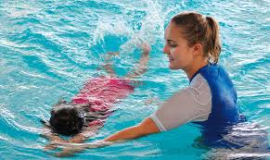 | 4. | - Go shopping
  5.  | 5. | - Make a pizza
25’ | New lesson  A-Listening. (10’)  Listen and fill in the blank (p. 17)  Before listening:  - Teacher sets the scene of the task and guides students how to do the task.  While listening:  - Have students listen (1st time), gets the answers from students.  - Listen again to check the answers.  After listening  - Teacher checks and corrects.  Answer:  - Weekend  - Party  - Pizzas  - Beach  - Barbecue  B- Grammar (10’) (p. 17)  - Teacher shows some example sentences of the Present progressive tense on the board.  - Have students review the rules of forming V.ing.  - Students give the answers to class.  Example:  - I am putting on weight.  - My friend is having a party tonight.  - The students are playing soccer on the playground.  Option 1: Writing as requested  - Have students complete the –ing form of the verbs given  Answer  - Going  - Swimming  - Playing  - Having  - Eating  - Watching  - Making  - Studying  - Doing  - Visiting  Option 2: making sentences with these verbs  - Students volunteer to make sentences with these verbs.  - Teacher checks and gives feedback.  Option 3: Read, circle the correct answers.  - Have students work in pairs, circle the correct answer for each sentence.  Answer:  - B  - B  - A  - B  - C  - A  - C  C- Writing (10’)  - Have students work in pairs, practice asking and answering the questions given.  - Some pairs present in front of class.  - Teacher checks and corrects.  Students’ answer  - I’m …………………………………  - I’m ………………………………. | - Teacher – whole class/ individuals/ pair work  - Teacher/ Whole class/ individual  - Teacher – whole class/ pairs  - Teacher – whole class/ individuals
5’ | Wrap-up  Option 1: Speaking  - Teacher asks each student to make plans for his / her activities at the weekend.  - Then practice with their partner to share it.  - One of the pair reports their talking to class.  Example:  This weekend I am having a picnic with some friends in the countryside  My partner, Mai is going to the cinema this weekend. She is watching a new film.  - Other students may ask questions if they want  - Teacher checks and gives feedback. | - Teacher – whole class/ individuals
Homework
Write the notes and sentences about your plans for this weekend

i-Learn Smart World 6 (workbook)
Week: Date of teaching:
Period: 5
UNIT 3: FRIENDS
Lesson 3 – Literature (p. 18)
- Objectives:
By the end of this lesson, students will be able to review some adjectives to talk about someone’s character.
- Teaching aids:
- Teacher’s aids: workbook and teacher’s book, class CDs, flashcards, IWB software, projector/interactive whiteboard/laptop/TV.
- Students’ aids: notebook, workbook.
- Language focus:
- Vocabulary: adjectives of character.
- Structure: Present simple to talk about caractères.
- Procedures:
Time | Steps/Activities | Organization
5’ | Warm-up  What is he doing?  - Teacher shows some pictures, students look and guess what these people are doing.  - Teacher checks, gives feedback, then leads to new lesson | - Teacher – whole class  - Students in groups  - Whole class
   | What is she doing  She Is talking with friends
   | What is he doing?  He is helping the old man.
  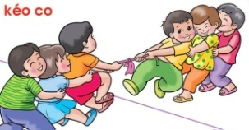 | What are they doing?  They are playing team games
25’ | New lesson  A-New words. (10’) -  Activity 1: words completing. (a/p. 18)  - Teacher shows the pictures again, adds more information about the character of the people.  - Have students list some more adjectives to describe someone’s character.  - Have students work individually; complete the words with letters given. (p. 12)  - Students give the answers.  - Teacher checks and gives feedback.  Answer:  - selfish  - helpful  - kind  - lazy  - funny  - friendly  - Have students read all the words again.  Activity 2: Fill in the blanks with words given.  - Teacher makes an example sentence with words in task A  - Have students work in pairs, fill in the blanks with words in task A.  - Some students give their answers, ask them to give more explanation for their choices.  - Teacher checks, corrects or gives feedback.  Answer:  - Selfish  - Funny  - Friendly  - kind  - helpful  - lazy  B-Listening. (10’) – listen and answer the questions.  - Have students look at the sentences in the task.  - Have students guess the answers for the questions.  - Have students listen and answer the questions.(1st time)  - Listen again to check the answers.  Answer:  - She’s funny  - She likes reading books  - They want her to study at home  - He’s kind  - She’s happy and friendly. | - Teacher – whole class/ individuals/ pairwork  - Teacher/ Whole class/ groupwork  - Teacher – whole class/ pairs  - Teacher – whole class/ individuals
5’ | Wrap-up  Option 1: Further practice  - Teacher has students review adjectives to describe people’s character.  - Teacher picks out an adjective, asks some students about people in class.  Questions:  - Who is friendly?  Trang is friendly  - Who is funny?  ……………………………….  - Who is lazy?  …………………………………….  - Teacher checks and gives feedback.  Option 2: Adjectives with opposite meaning  - Teacher shows list of adjectives on the board.  - Have students work in pairs, discuss and find the adjectives with opposite meaning.  - Teacher gives help if necessary.  Guided questions & answers  - Lazy # …………….. (hard)  - Friendly # unfriendly  - Helpful # helpless  - Selfish # ……………. (generous)  - Kind # unkind  - Some students share the answers.  - Teacher listens and gives feedback. | - Teacher – whole class/ individuals  - Teacher –Students in groups
Homework
Describe the character of your family members.

i-Learn Smart World 6 (workbook)
Week: Date of teaching:
Period: 6
UNIT 3: FRIENDS
Lesson 3 (p. 19)
- Objectives:
By the end of this lesson, students will be able to read a summary of a story and write an email about a person you may know.
- Teaching aids:
- Teacher’s aids: workbook and teacher’s book, IWB software, projector/interactive whiteboard/laptop/TV.
- Students’ aids: notebook, workbook.
- Language focus:
- Vocabulary: (n) pig, spider, fair, prize
(adj): shy, amazing
- Structure: Questions about appearance, character and pastime activity.
- Procedures:
Time | Steps/Activities | Organization
5’ | Warm-up  Option 1: Speaking  - Teacher shows a poster of Harry Potter, asks students some questions about him.  Questions:  - Do you know this boy?  - What does he look like?  - What is he like?  - Teacher gets the answers from students.  - Teacher gives feedback, gives more information if necessary.  Option 2: Speaking  - Teacher shows a poster of the story “Charlotte’s Web” and asks student some questions about him.  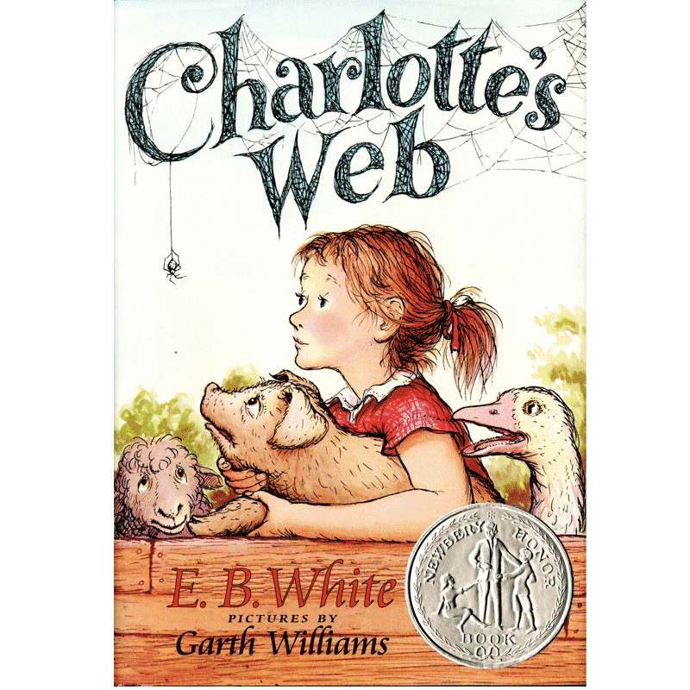  - Do you know this story? (Yes / No)  - Have you ever read it? (Yes / No)  - Who wrote this book? (E. B. White)  - What is it about? (about a story happens to Wilbur, the shy pig, at Zuckerman farm)  - Have students share the information  - Teacher adds some information, then leads to new lesson. | - Teacher – whole class  - Students in groups  - Whole class
25’ | New lesson  A-Reading. (10’) -  Activity 1: teach new words.  - Teacher introduces the characters of the story and elicits meaning of some new words.  - Have students follow and guess the meaning of new words.  New words:  - Pig (n)  - spider (n)  - prize (n)  - fair (n)  - shy (a)  - amazing (a)  - Have students read all the words again.  - Teacher checks their understanding and gives feedback.  Activity 2: read the passage, answer True – false (a/p. 19)  - Teacher asks students to get through the text, decide the statements are True - False. (pairs work)  - Teacher gets the answer, ask students to correct the false ones.  - Teacher gives feedback.  Answer:  - F  - T  - T  - T  - F  B-Writing. (10’)  Speaking  - Teacher explains the request of the task.  - Have students work in pairs, choose a person they know to write the email to.  - Students practice A&A the questions first.  - Some pairs present in front of the class.  Writing  - Have students work in groups, write an email about 40 – 50 words, use the information given.  - Two fastest groups show the answer to class  - Teacher checks and gives feedback. | - Teacher – whole class/ individuals/ pairwork  - Teacher/ Whole class/ groupwork  - Teacher – whole class/ pairs  - Teacher – whole class/ individuals
5’ | Wrap-up  Option 1: Speaking  - Teacher asks students to name some films they have seen or stories they have read recently.  - Some students share the ideas. (individually)  Example:  What is your favorite film / story?  I like ……………………………………  What is it about?  ………………………………………..  What do you think about it?  …………………………………… | - Teacher – whole class/ individuals  - Teacher –Students in class
Homework
Write an email to a friend about your favorite film / story.

i-Learn Smart World 6 (workbook)
Week: Date of teaching:
Period: 7
UNIT 3: FRIENDS
REVIEW - (p. 64)
- Objectives:
By the end of this lesson, students will be able to review all about description people’s appearance and character as well as their plan for the weekend.
- Teaching aids:
- Teacher’s aids: workbook and teacher’s book, flashcards, laptop/TV.
- Students’ aids: notebook, workbook.
- Language focus:
- Vocabulary: daily activities, people’s character.
- Structure: Simple present tense.
- Procedures:
Time | Steps/Activities | Organization
5’ | Previous lesson  Option 1: Guessing game (Kim’s game)  - Teacher gives clues, students have to guess what story teacher talks about.  Ex:  - This is about a boy kid in a comic book.  - He was born to be a detective.  - He really helpful and kindhearted.  - He ………………………………………….  Answer: Conan  - Teacher gives feedback, leads to new lesson. | - Teacher – whole class
25’ | New lesson  Part 1: Listening  Activity 1 - (5’)  - Have students look at the questions and the answers, review the places and adjectives before listening. (individual)  - Some students give their guessing.  - Teacher plays the recording twice, gets students’ answer.  - Listen again to check their answers.  Answer:  - C  - B  - B  - A  - B  - Teacher checks and corrects the answers. (ask students what they heard in the dialogue)  Activity 2:  - Have students give the answer by saying the whole sentence using present simple tense.  Part 2: Reading:  Read the text about what three students usually do on the weekends. Choose the correct answers.  Pre-reading:  - Teacher asks students to read the text and answer some questions about the three people.  - Have students complete the task, read and choose the correct answers. (pairs work)  - Teacher gets the answers from students.  Answers:  - C  - A  - A  - B  - B | - Teacher – whole class/ individuals/ pairwork  - Teacher/ Whole class/ groupwork  - Teacher – whole class/ pairs
5’ | Consolidation  Writing  - Teacher sets the scene for the task:  - Students work in groups of four, write a story about what you and your friends or your family often do on the weekend.  - Some students share the ideas.  - Teacher checks and gives feedback.  Example:  OUR WEEKEND  I’m ………………… I don’t have classes on the weekend. It’s time for outdoors activities.  I often have a picnic with my …………………. We often go to ……………..  There we often ………………………  We usually go home at about………………………….  This weekend, we are ………………………………………..  I hope we are having more fun this weekend. | - Teacher – whole class/ individuals
3’ | Homework  Review all words and grammar notes of the lesson.

