School: ……………………………………….. | Date:…………………………………..
Class: ……………………………..................... | Period: ………………………….........

UNIT 3: PROTECTING THE ENVIRONMENT
Lesson 3.1 - Reading & Writing (Pages 32 & 33)

I. OBJECTIVES
By the end of the lesson, Ss will be able to:
1.1. Language knowledge and skills
- practice reading for main ideas and specific information.
- write short guide to make their school greener.
1.2. Competences
- improve communication, collaboration, analytical and critical thinking skills.
1.3. Attributes
- be aware of the causes and effects of pollution.
II. TEACHING AIDS AND LEARNING MATERIALS
1. Teacher’s aids: Student book and Teacher’s book, class CDs, Digital Book (DCR phần mềm tương tác SB, DHA (từ vựng/ cấu trúc) phần mềm trò chơi tương tác), projector/interactive whiteboard / TV (if any), PowerPoint slides.
2. Students’ aids: Student’s book, workbook, notebook.

III. ASSESSMENT EVIDENCE
Performance Tasks | Performance Products | Assessment Tools
- Read the guide and write the correct heading for each section.  -Read and circle the correct answers.  - Speaking: Do you have the same problems where you live? What other solutions could help improve the problems?  - Read about writing guides.  - Read the guide and write headings for each section. | - Ss’ answers.  - Ss’ answers.  - Ss’ answers / presentation.  - Ss answers  - Ss answers | - T’s feedback.  - T’s feedback.  - T’s feedback/Peers’ feedback.  - T’s feedback/Peers’ feedback.  - T’s feedback/Peers’ feedback.

IV. PROCEDURES
A. Warm up: (5’)
a) Objective: Introduce the new lesson and set the scene for Ss to acquire new language; get students' attention at the beginning of the class by giving enjoyable and short activities as well as to engage them in the follow-up steps.
b) Content: words about eco-friendly city.
c) Expected outcomes: Ss have general ideas about eco-friendly city, which they are going to read and write in the new lesson.
d) Organization of the activity:
TEACHER’S ACTIVITIES | STUDENTS’ ACTIVITIES
- Option 1: Let’s Talk!  - Use the “Let’s talk!” part in the textbook– page 32 for warm-up activity.  - Ask Ss to work in pairs to discuss about the environmental problems and ways to improve the environment.  Questions: “What environmental problems can you see? What people do to improve the environment where they live?”  - Call Ss to share their answers with the whole class.  - Give feedback and evaluation.  - Lead to the new lesson.  - Option 2: Bingo game  - Review previous vocabulary: affect, cause, pollute, disease, wildlife, tourism, environment, damage, electricity, air conditioner.  - Have Ss write nine words on paper.  - Read the vocabulary randomly.  - Choose the winners ss provide that they have three-word in vertical, horizontal or diagonal. Give winners scores if necessary.  - Lead to the new lesson. | - Work in pairs to discuss.  - Present.  - Read the vocabulary  - Write on paper.  - Check.

B. New lesson (35’)
- Activity 1: Reading (20’)
a) Objective: Students can develop their reading skills.
b) Content: Read the guide, write the correct heading for each section and circle the correct answers.
c) Expected outcomes: Students can practice reading and understanding general + specific information about how to make eco-friendly city.
d) Organization of the activity:

TEACHER’S ACTIVITIES | STUDENTS’ ACTIVITIES
Task a. Read the guide and write the correct heading for each section.  - Use DCR to show the task.  - Have Ss read the questions and find the keywords.  - Have Ss choose the correct heading for each section.  - Call Ss to give answer, explain.  - Check answers as a whole class using DCR.  Task b. Now, read and circle the correct answer.  - Use DCR to show the task.  - Have Ss read again the content of the text “How to Make Our City More Eco-friendly”.  - Have Ss read and circle the correct answers.  - Have Ss check answers with their partners.  - Call Ss to give answers, explain.  - Check answers as a whole class using DCR.  Task c. Listen and read.  - Play the audio (track 37).  - Have Ss listen and read.  Task d. Discuss in pairs  - Have Ss discuss in pairs about environmental problems and solutions.  - Have some Ss present and give feedback.  Questions: Do you have the same problems where you live? What other solutions could help improve the problems?  Answer “Our town doesn’t have many green spaces. I think that we should plant more trees in our town.” | - Read.  - Work individually.  - Ss answer.  Answer keys  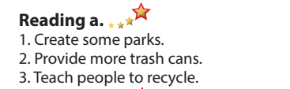  - Read.  - Read and circle the correct answers.  - Exchange answers.  - Give answers.  Answer keys  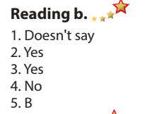  - Listen and read.  - Work in pairs.  - Present.

- Activity 2: Writing (15’)
a) Objective: Students can develop their writing skills.
b) Content: Read about writing guides and write a good, simple guide.
c) Expected outcomes: Students can read writing guides and they can create a title, headings and write an introduction and explanation.
d) Organization of the activity:
TEACHER’S ACTIVITIES | STUDENTS’ ACTIVITIES
Task a. Read about writing guides. Then read the guide from the reading again and circle the imperatives and underline the reasons for solutions.  - Use DCR to show the Writing Skill box and the guide.  - Have Ss read and make a mind map about writing guides.  - Have ss work in pairs, read the guide from the reading again and circle the imperatives and underline the reasons for solutions.  - Check answers as a whole class using DCR.  Task b. Read the guide and write headings for each section.  - Have DCR to show the task.  - Have Ss work in groups of 4, read the guide and write the headings.  - Call Ss to give answers.  - Check answers as a whole class using DCR. | - Read individually.  - Make mind map.  - Give answer.  Answer keys  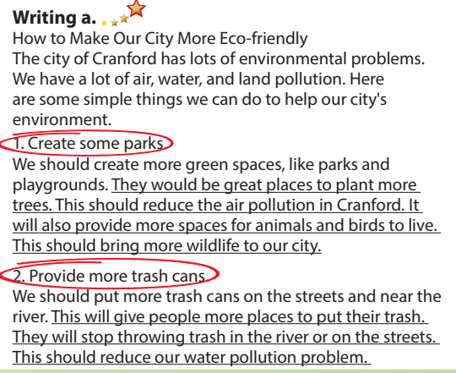  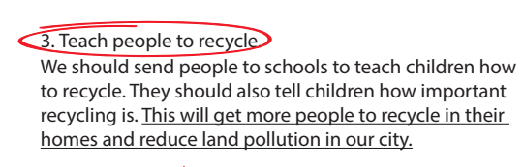  - Read and write the headings.  - Give answers.  Answer keys  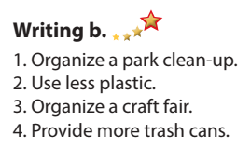

C. Consolidation and homework assignments (5’)
*Consolidation:
- Writing guides: to write a good, simple guide.
*Homework
- Practice writing skill: writing guide with imperatives.
- Do the exercises in WB: Listening and Reading (page 18).
- Play the consolidation games in Tiếng Anh 8 i-Learn Smart World DHA App on www.eduhome.com.vn
- Prepare: Lesson 3.2 – Speaking and Writing (page 33 – SB).

V. Reflection
a. What I liked most about this lesson today:
…………………………………………………………………………………………
- What I learned from this lesson today:
…………………………………………………………………………………………
c. What I should improve for this lesson next time:
…………………………………………………………………………………………

