











HỘI THẢO CÁC TRƯỜNG THPT CHUYÊN
KHU VỰC DUYÊN HẢI – ĐỒNG BẰNG BẮC BỘ

CHUYÊN ĐỀ MÔN TIẾNG ANH

USING AI APPS TO ASSIST TEACHERS IN DESIGNING LISTENING TASKS FOR GIFTED STUDENTS

TABLE OF CONTENTS

ABSTRACT 1
INTRODUCTION 2
1. Rationale 2
2. Objectives of the study 3
3. Scope of the study 3
4. Structure of the study 3
CHAPTER 1: LITERATURE REVIEW 5
1. The role of listening in language acquisition and advanced thinking 5
2. Characteristics of gifted students in language learning 5
3. Challenges in designing listening tasks for gifted students 5
4. Task-Based Language Teaching and Cognitive Demands of Listening Tasks 6
5. An overview of AI Apps and their role in language education 6
6. TPACK Framework in Task-Based Integration: Synthesizing Technology, Pedagogy, and Content 7
7. Incorporating AI into Teaching: A TPACK- Guided Approach for Listening Tasks Design 9
CHAPTER 2: APPLICATION 11
1. Applications to transcribe audio/voice/video to text 11
1.1. Turboscribe 11
1.2. Descript 12
2. Applications to convert text to audio/voice/video 13
2.1. TTSMP3 13
2.2. ElevenLabs 15
2.3. Narakeet 15
3. Applications support regularly audio edit 16
3.1. MP3 Cutter joiner 16
4. Applications support creation of customized interactive listening tasks 17
4.1. Twee 17
4.2. Quizalize 19
4.3. D-iD 21
5. Using ChatGPT to build listening comprehension questions aligned with NEC listening test 23
5.1. Analyze the exam questions 24
5.2. Create prompts based on test specification analysis 24
5.3. Refine result and generate audio 29
CHAPTER 3: CONCLUSION 30
REFERENCES 31
APPENDIX 32
1. Self-designed Grade 10 listening comprehension exercises bank by topic 32
2. Listening exercises (Three-way matching, NEC format_2024) 32
3. Prompts to have ChatGPT support task designing 32

LIST OF ABBREVIATIONS

AI: Artificial Intelligence
CEFR: Common European Framework of Reference
NLP: Natural Language Processing
TBLT: Task-Based Language Teaching
TPACK: Technological Pedagogical Content Knowledge
LLM: Large Language Learning Model

ABSTRACT

In the evolving landscape of education, artificial intelligence (AI) has emerged as a transformative force, offering teachers powerful tools to enhance instructional design and personalize learning. For gifted students learners with exceptional intellectual and cognitive abilities, developing advanced listening skills is crucial, particularly in preparation for high-stakes academic competitions and lifelong communicative competence. This study explores how AI applications can support teachers in designing listening tasks tailored to the unique needs of gifted English learners.
Drawing on classroom experience and practical experimentation, the study introduces a variety of AI-based apps such as Turboscribe, TTSMP3, Narakeet, ElevenLabs, and ChatGPT, which assist in different stages of task creation, from transcribing authentic materials and generating native-like audio to designing quizzes and customizing question formats. These tools enable educators to address common challenges in listening instruction, including time constraints, material authenticity, and cognitive complexity.
By framing the integration of AI within the TPACK (Technological Pedagogical Content Knowledge) model, the study emphasizes the importance of balancing technology use with sound pedagogical principles and content relevance. The study not only provides examples of effective AI-assisted task design, but also encourages educators to embrace technology as a means to foster learner autonomy, engagement, and high-level thinking.
Keywords: gifted students, listening tasks, AI apps, TPACK, authentic materials, personalized learning.

INTRODUCTION

Rationale
In today’s fast-changing educational landscape, technology has become more than just a supporting tool, it is a central force shaping the way we teach and learn. The integration of Artificial Intelligence (AI) into classroom practice is no longer a futuristic idea, but a current reality that brings new possibilities for both teachers and students. In particular, for language teachers working with gifted students, AI offers innovative solutions to one of the most demanding areas of instruction: task design.
Listening comprehension is a complex skill, involving not only the decoding of sounds but also inference, prediction, and critical interpretation. For gifted learners, who often process information more quickly, think more abstractly, and crave deeper engagement, traditional textbook-based listening materials frequently fall short. They may be predictable, or lack the authenticity and cognitive challenge these students require. Designing high-quality, personalized listening tasks that match the academic level and intellectual curiosity of gifted students has long been a challenge for teachers, especially under constraints of time and resources.
This is where AI apps present a timely and practical solution. Various AI apps such have evolved as Turboscribe, TTSMP3, Twee, Elevenlabs, ChatGPT etc allowing teachers to convert authentic materials like news clips, interviews, or TED talks into customized, pedagogically rich listening tasks. These applications offer features such as instant transcription, natural-sounding voice generation, question creation, and video/audio editing, which were once time-consuming or required technical expertise. Now, with user-friendly interfaces and free versions available, these tools empower teachers to become designers of high-quality listening experiences.
From the perspective of gifted education, incorporating AI in task design is not just about saving time. It is about providing stimulating, personalized, and real-world-relevant input that speaks to gifted learners’ abilities and aspirations. It is also about equipping the “digital native” Gen with 21st-century skills, including digital literacy and autonomous learning strategies, as they engage with diverse media sources through tasks that challenge their intellect.
A review of current AI integration practices in EFL classrooms shows that teachers are increasingly using AI not only to automate repetitive tasks but also to support meaningful learning experiences, especially in listening instruction (Fang & Liu, 2023).
This study arises from the practical needs of teachers who wish to harness the power of AI but may not know where to begin. It seeks to demonstrate how everyday tools when selected and applied thoughtfully can support task-based listening instruction in a way that is both technologically feasible and pedagogically meaningful. Most importantly, it aims to show how AI can help teachers unlock the potential of their most advanced students not by replacing the human element of teaching, but by enhancing it.

Objectives of the study
The primary objective of this study is to introduce and analyze the application of AI apps/tools in the process of designing listening tasks for high school gifted students in English. The study aims to demonstrate how these apps can effectively support teachers in saving time and effort, while still ensuring the quality and authenticity of listening materials. Additionally, it seeks to provide specific illustration of how AI tools can be implemented in the real classroom context, including sample activities. Last but not least, the study encourages teachers to explore, experiment, and integrate modern technology into their task - based designing and lesson planning to enhance the learning experience of their students, especially in the domain of listening, a skill that is both essential and often challenging.

Scope of the study
In the mountainous region where the researcher works, a gifted high school will be the site of the investigation. The research participants were gifted high school students, ages 15 to 18, with seven years of English language experience. These learners are mainly B2 - C1 according to the CEFR. The research is delimited to the listening skill and practical ways to integrate AI tools into listening task design, based on what author has applied in real classroom setting from the school years: 2023 - 2024 and 2024-2025.

Structure of the study
The thesis consists of four parts: Introduction, Literature Review, Application and Conclusion.
Introduction: Provides readers with general ideas about the current research study, including rationale for the study, objectives of the study, subjects of the study, scope of the study, and structure of the study.
Chapter 1 (Literature Review): Provides theoretical foundation for the study by reviewing the key concepts relevant to listening instruction, gifted education, and the integration of artificial intelligence in task designing. It discusses the challenges teachers face when creating listening tasks for this student group. The chapter also introduces the TPACK framework as a guiding model for integrating pedagogy, content, and technology in instructional design.
Chapter 2 (Application): This chapter presents the practical implementation of various AI apps in the process of creating authentic, engaging, and cognitively appropriate listening tasks for gifted students. It introduces several applications, demonstrating how each tool supports a particular stage in task design, from sourcing materials and generating voiceovers to crafting questions and delivering final activities. The author also shares real-world examples from classroom practice to illustrate how these tools enhance both teaching effectiveness and learner engagement.
Conclusion: This section summarizes the main findings and contributions of the research. It reflects on the impact of AI-supported task design in gifted education and suggests practical recommendations for English teachers seeking to adopt similar approaches in their classrooms. The author hopes that this study serves as a reference for educators aiming to personalize instruction, optimize planning time, and elevate the listening experience for their high-achieving students.

CHAPTER 1: LITERATURE REVIEW

The Role of Listening in Language Acquisition and Advanced Thinking
Listening is a complex, active, and essential component of language learning. As Vandergrift and Goh (2012) note, listening involves not only the decoding of speech sounds but also higher-order processing such as interpreting context, recognizing speaker intentions, and integrating prior knowledge. For gifted students, who often excel in pattern recognition and abstract reasoning, listening provides an avenue for engaging with real-world language while activating deep cognitive processing.
In contexts such as national English contests or advanced programs, listening tasks frequently move beyond simple comprehension toward critical analysis, synthesis of viewpoints, or inferring tone and nuance. Thus, effective listening instruction must train learners not just to understand speech but to interact intellectually with spoken input (Field, 2008). Prioritizing listening in curriculum design can therefore strengthen not only linguistic competence but also academic thinking skills.

Characteristics of Gifted Students in Language Learning
Gifted language learners tend to demonstrate early language sensitivity, creative language use, high retention, and rapid progress (VanTassel-Baska, 2005). However, they also require differentiated instruction that avoids routine drills and instead stimulates curiosity and challenge. According to Tomlinson (2014), effective instruction for gifted learners involves tasks that are complex, open-ended, and encourage self-direction.
In listening, these students thrive when provided with authentic texts that require them to evaluate speaker stance, identify implicit assumptions, or interpret layered meanings.

Challenges in Designing Listening Tasks for Gifted Students
Developing Despite their abilities, gifted students often face the paradox of being underserved by generic curriculum materials. Teachers, too, struggle to find or develop listening resources that balance challenge, authenticity, and curricular alignment. As Gagné (2015) observes, gifted education requires attention not only to acceleration but also to enrichment and complexity - features often absent from traditional listening textbooks.
Teachers may lack the time, tools, or training to build high-quality, differentiated listening tasks from scratch. Additionally, limited access to up-to-date, authentic audio materials hinders their ability to simulate real-world speech scenarios (Gilakjani & Sabouri, 2016). AI tools offer a promising response to these challenges, but their effectiveness depends on how well they are integrated into a sound pedagogical design.
- Task-Based Language Teaching and Cognitive Demands of Listening Tasks
Task-Based Language Teaching (TBLT) is grounded in the principle that language is best acquired through use in meaningful communication. According to Ellis (2003), TBLT tasks are goal-oriented, involve real-world processes, and require learners to focus on both meaning and form. For listening, this means moving beyond discrete-item exercises to tasks like summarizing arguments, comparing speaker viewpoints, or proposing solutions based on audio prompts.
These tasks engage cognitive processes such as organizing, evaluating, and predicting - skills that align well with the strengths of gifted learners (Robinson, 2001). The integration of AI-generated materials into TBLT frameworks enables teachers to provide input-rich, cognitively engaging, and learner-centered listening experiences, even with limited preparation time. In the context of Vietnamese high schools, the integration of authentic listening materials within a task-based approach has been shown to enhance student engagement and promote deeper listening comprehension (Nguyen, 2021).
- An overview of AI Apps and their role in language education
Artificial Intelligence (AI) applications, commonly referred to as AI apps, are software programs that simulate human intelligence by performing tasks such as recognizing speech, translating languages, generating content, or making decisions based on data. In educational contexts, AI apps are increasingly used to automate repetitive processes, personalize learning experiences, and enhance instructional efficiency.
In the field of language teaching and learning, AI apps serve various functions that traditionally required significant time or technical expertise. These may include transcribing spoken language into text, generating realistic voice recordings from written scripts (text-to-speech), analyzing student performance patterns, or even creating adaptive quizzes based on learner input. The growing availability of free and user-friendly AI tools has made such applications more accessible to classroom teachers, even those with limited technological training.
AI apps differ from general educational technologies in that they rely on intelligent algorithms - often powered by machine learning or natural language processing (NLP) to interpret and respond to user inputs in dynamic ways. Rather than operating on fixed rules or content, AI apps can adjust outputs based on context, data, or goals. This makes them particularly useful in designing listening tasks, where input can vary in speed, accent, tone, or complexity. Recent research highlights that AI tools enable teachers to create highly personalized language learning activities by adapting content and task types to learners’ individual needs and proficiency levels (Wang & Wang, 2022).
In the context of this study, the term "AI apps" refers to practical, web-based or downloadable tools that assist teachers in the design, generation, or delivery of listening materials and tasks for gifted English learners. These include, but are not limited to, applications such as Turboscribe (for transcription), Narakeet and TTSMP3 (for voice generation), ElevenLabs (for expressive voiceovers), Video editing platforms like D-ID or Twee and ChatGPT (for question creation and content transformation).
These tools do not replace the teacher’s role in curriculum design or pedagogical planning; rather, they function as intelligent assistants that help educators work more efficiently and creatively. When used thoughtfully, AI apps can serve to enrich the listening input students receive, diversify task types, and enable a more engaging and cognitively demanding learning experience, particularly for gifted learners who require depth, challenge, and authenticity in their studies.
In summary, Artificial Intelligence is transforming how teachers design and deliver instruction. In the field of language education, AI enables rapid content creation, real-time feedback, speech analysis, and adaptation to learner pace. Holmes, Bialik, and Fadel (2019) argue that AI, when properly used, can shift the teacher's role from content delivery to orchestrator of meaningful learning experiences.
- TPACK Framework in Task-Based Integration: Synthesizing Technology, Pedagogy, and Content
The TPACK model, or Technological Pedagogical Content Knowledge, is a widely recognized framework that guides educators in the effective integration of technology into teaching. Introduced by Mishra and Koehler (2006), it emphasizes the dynamic interplay between three core domains: Content Knowledge (CK), Pedagogical Knowledge (PK), and Technological Knowledge (TK).
Content Knowledge refers to the teacher’s mastery of subject matter such as listening comprehension, vocabulary, or grammar in English language instruction. Pedagogical Knowledge encompasses an understanding of how students learn, including classroom strategies, task design, assessment, and differentiation. Technological Knowledge involves the ability to select and apply digital tools to enhance learning outcomes. At the heart of the TPACK model is the integrated zone where these three areas converge, allowing educators not just to use technology, but to apply it purposefully and strategically in ways that support both pedagogy and content goals.
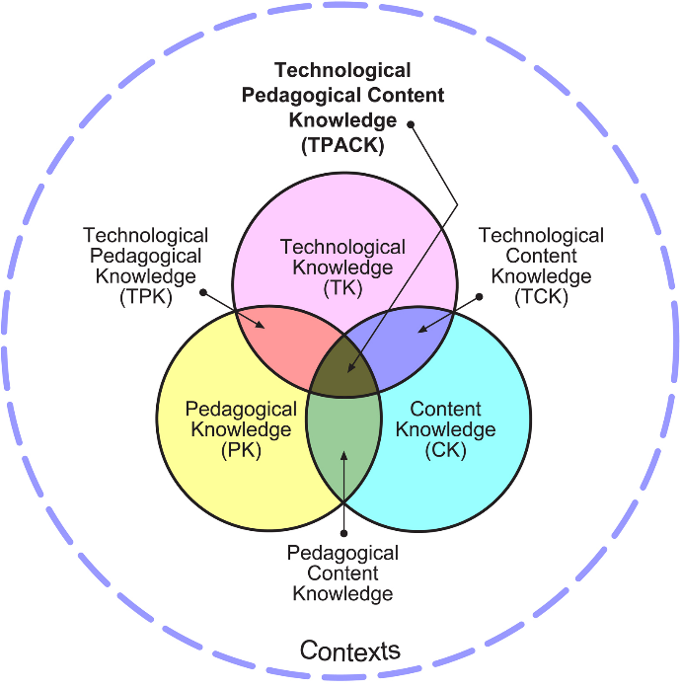

Figure 1. The TPACK Model (Mishra & Koehler, 2006)

In modern education, TPACK has gained importance for several reasons. It helps balance innovation with pedagogical intention, ensuring that technology use serves learning objectives rather than novelty. It fosters the development of 21st-century skills such as critical thinking, media literacy, and self-directed learning. It also allows teachers to tailor instruction for diverse learners by leveraging multimedia input and differentiated resources. In the context of AI-supported instruction, TPACK becomes essential as it encourages thoughtful decision-making about tool selection and implementation. Rather than adopting AI for its own sake, teachers are urged to consider how each tool contributes to authentic and effective task design.
Numerous studies have validated the relevance of the TPACK framework. For example, Tseng et al. (2020) argue that TPACK encourages educators to go beyond technical proficiency by cultivating strategic thinking in aligning tools with learning goals. Similarly, Voogt et al. (2013) highlight that the synergy between content, pedagogy, and technology is necessary to create meaningful and cognitively engaging instruction. These perspectives strongly support the use of AI in language teaching, particularly in designing listening tasks when applied within a coherent pedagogical structure such as TPACK.
From the author's perspective, using AI in the design of listening tasks for gifted students demands an intentional balance among the three TPACK domains. Teachers must begin with clear learning objectives grounded in CK, such as identifying the specific listening sub-skills to be targeted: detail recognition, inference, or gist comprehension and aligning them with the format of national competitions like NEC. Then, they must consider pedagogical strategies (PK) that cater to the needs of gifted students, such as task-based learning, scaffolded project work, or gamified listening practice. Only after these elements are clear should the technological tools (TK) be chosen, based on how well they support the instructional design.
- Incorporating AI into Teaching: A TPACK- Guided Approach for Listening Task Design
Think of TPACK as a triangle: each corner represents one kind of teacher knowledge: what to teach (Content), how to teach (Pedagogy), and what tools to use (Technology).
Here’s how each part looks in practice when designing listening tasks:
Content Knowledge (CK) means understanding different types of listening skills (like identifying details, understanding gist, or making inferences) and being familiar with formats like NEC or IELTS, CEFR framework.
Pedagogical Knowledge (PK) involves knowing how to teach different types of students. For gifted students, this might include task-based learning, project-based work, or even gamified listening tasks to challenge and motivate them.
Technological Knowledge (TK) is knowing which tools to use and how to use them. For example, AI tools like Turboscribe, Narakeet, ElevenLabs, Quizalize, or VideoZen can help turn materials into interactive, real-world listening experiences.
Principles for Integrating AI in Listening Task Design (Grounded in TPACK)
#1. Clarify learning objectives (CK + PK)
Before using any tech tool, start by asking: What do I want my students to learn? Is it identifying key details? Understanding attitude or emotion? Following a discussion? For instance, if you're preparing students for NEC, choose a short, content-rich video clip (around 3–5 minutes) from BBC Learning English or TED-Ed, and focus your questions on common competition skills.
#2. Match the tool to the teaching method (TK + PK)
Different tools do different jobs just like classroom activities. For example:
- Use Turboscribe to get transcripts from real-world videos,
- Try Narakeet or ElevenLabs to turn your own script into natural-sounding audio,
- Use Quizalize to make fun, interactive quizzes,
- Design multi-type questions (T/F, Gap fill, MC) using Twee
Teachers, however, should not stick to just one app but choose them based on their activity’s goal.
#3. Align activities with learner profiles (CK + PK)
Gifted students need challenge and variety. One task does not fit all, so teachers should consider creating multiple levels of questions (from basic comprehension to higher-order inference),
#4. Use multimodal input to enhance comprehension (CK + TK)
AI can bring listening texts to life. Instead of just audio, teachers can combine:
Voice + Image + Subtitles = deeper learning.
Tools like VideoZen or D-ID let you add visuals, text, and voiceover to make the content richer and more memorable. This is great for different learning styles as some students remember better when they see and hear the information at the same time.
#5. Teacher oversight is essential (PK + TK)
Even the best tools need a teacher’s touch. Some suggestions include:
- Check transcripts for errors,
- Review AI-generated audio for pronunciation or pacing,
- Adjust task difficulty to match your learners.
In conclusion, TPACK is more than a framework for digital teaching it is a mindset that helps teachers make informed, learner-centered decisions. By viewing AI integration through the TPACK lens, educators can design digital learning environments that are effective, inclusive, and future-ready. This model empowers teachers to become not just users of technology, but architects of meaningful, technology-enhanced instruction tailored to the needs of today’s gifted learners.

CHAPTER 2: APPLICATION
In this section, I aim to introduce and reflect on a range of AI-based applications that I have personally explored and applied in my own teaching practice. The selection of tools featured here is the result of practical experimentation, with a focus on usability, accessibility, and relevance to the learning needs of the gifted students in the context. Most of these tools are free or offer generous trial versions, making them highly feasible for regular classroom use, especially in public school contexts where resources may be limited.
Each application presented belongs to one among four main group and supports a different stage in the listening task design process.
- Applications to transcribe audio/voice/video to text
  - Turboscribe
Link: https://turboscribe.ai/
Turboscribe is an AI-powered transcription tool that allows teachers to convert audio and video files, especially from platforms like YouTube into accurate, time-stamped text transcripts. This is particularly useful when teachers want to use interviews, documentaries, or news reports as input materials for listening tasks. Turboscribe enables users to transcribe 3 videos/audios/voice files per day within a registered account for free version.
Step to use: Log in into the web at https://turboscribe.ai/ to have an account. Select videos from any online websites. Then copy and paste the video URL (or upload file from computer) and receive a full transcript with speaker turns and time codes within minutes. The transcript extracted allows teachers to check again with highlight text playing along with audio file enabling users to edit text if needed before download them and export to various format (doc. pdf. txt.) for further designing steps. The speaker recognition function is especially useful when teachers use the extracted transcript for designing the “Matching speakers with opinion” in NEC listening test part 1.
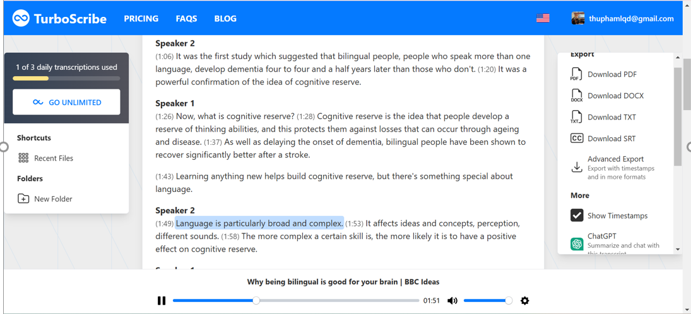
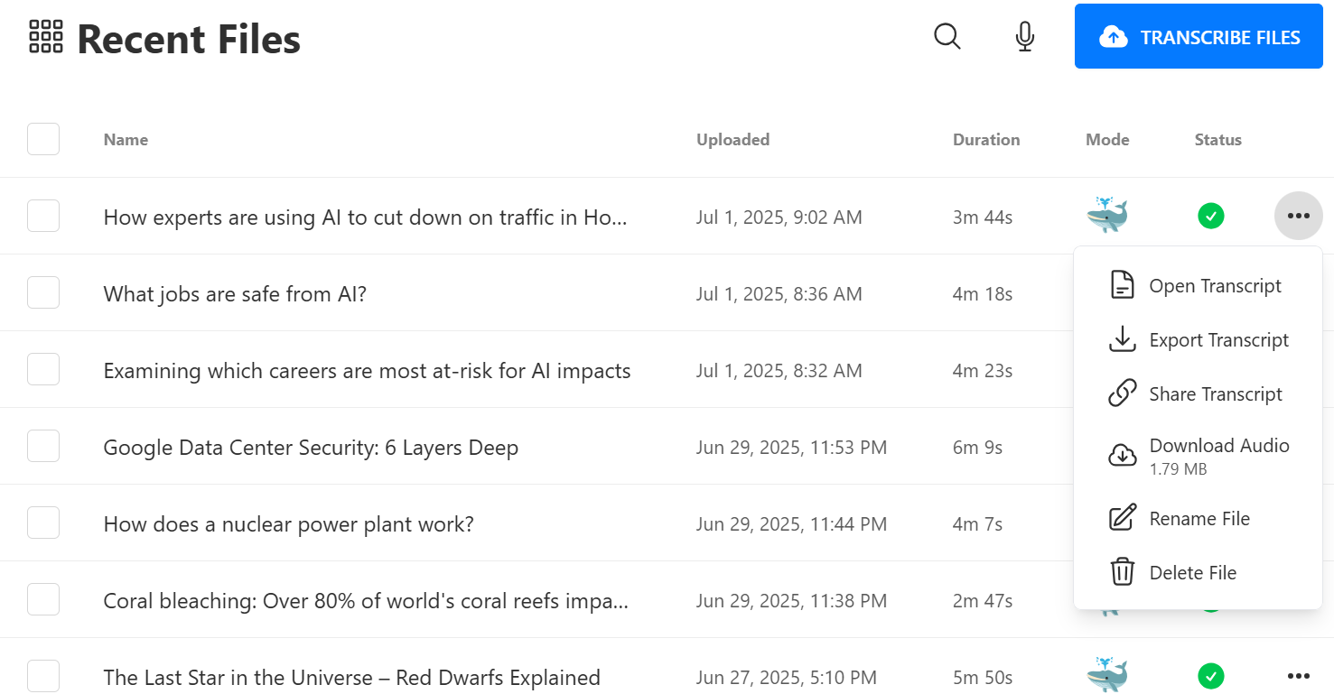
Outstanding feature: generate quickly and accurately ready for use doc. format transcript without editing
Tutorial: https://www.youtube.com/watch?v=VyS4mgmra6s
  - Descript
Link: https://www.descript.com
Descript is a powerful AI-based platform that combines audio/video editing with automatic transcription, making it an ideal tool for teachers designing listening comprehension materials. Apart from transcribing file quickly as Turboscribe, its standout feature is text-based editing, allowing users to cut, rearrange, and revise audio simply by editing the transcript - just like using a word processor.
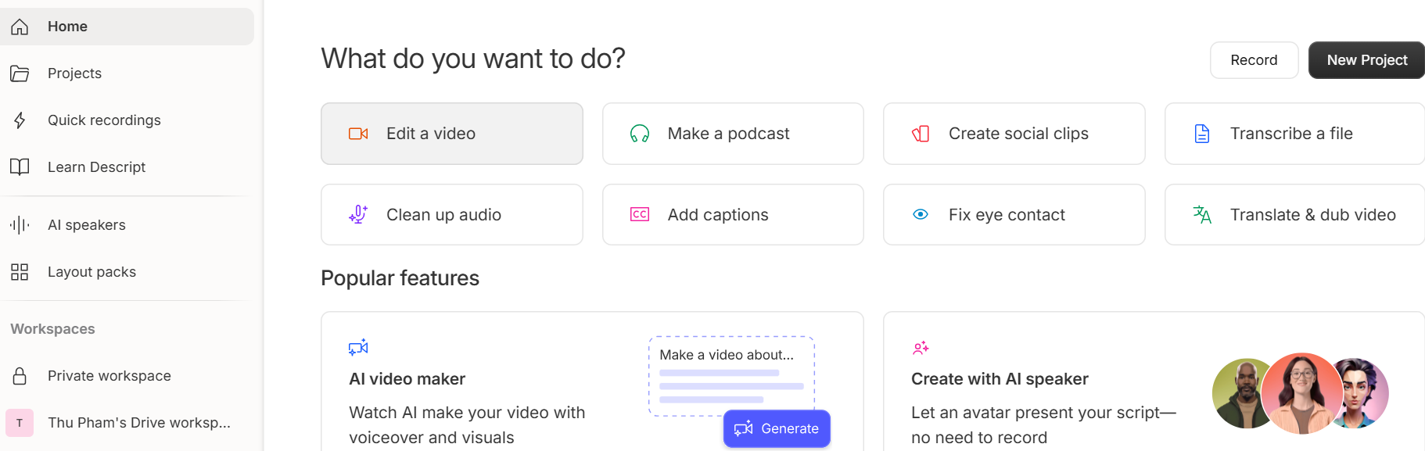
Steps to use:
Create an Account at https://www.descript.com (sign up by gmail)
Upload Media File: Drag in your MP3, MP4, or YouTube link.
Transcribe Automatically: Let Descript generate the text transcript.
Edit the Transcript: Fix errors, cut filler words, and clean up the audio by deleting text.
Add Subtitles and Voiceover: Use auto-captioning and Overdub to enhance the listening experience.
Export and Use: Download as MP4/Mp3 with subtitles or export transcript + audio for question design.
Example:
To introduce Topic: The Human and Environment, I selected a short YouTube video titled “Greenwashing: a Fiji water story” at https://www.youtube.com/watch?v=mOpa8kd6fBI
Using Descript, I performed the following steps:
- Imported the video link directly into the platform.
- Increased the playback speed slightly to simulate real-time listening challenge
- Trimmed the beginning and ending sections to reduce the video length to under 3 minutes – suitable for classroom use.
- Generated a transcript automatically, edited a few minor errors, and added captions
- Exported the cleaned video with subtitles for classroom presentation.
I used this edited version: as a Pre-Listening Task, where students were asked to:
- Predict the content based on the title and visuals.
- Listen and answer 5 multiple-choice questions designed to test key ideas and vocabulary.
- Discuss how human actions affect natural cycles, leading into the main reading/listening in the unit.
This approach provided a strong, real-world context to spark discussion and improve listening comprehension, while also building background knowledge for the main topic.
- Applications to convert text to audio/voice/video
  - TTSMP3
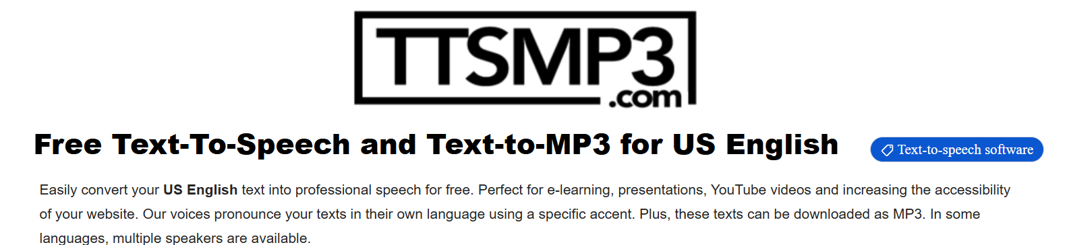
TTSMP3 (available at https://ttsmp3.com/) is a free and user-friendly online text-to-speech application that enables teachers to convert written text into natural-sounding audio files. This tool supports a wide range of voices in multiple native English accents (e.g., American, British, Australian), making it an excellent resource for creating personalized listening materials that closely resemble authentic speech.
One of the most practical advantages of TTSMP3 is its flexibility. The platform provides several adjustable features that allow teachers to fine-tune the audio according to specific instructional needs. Key customization options include:
Voice Selection: Users can choose from a variety of native-speaker voices, both male and female, across different English dialects.
Speed Control: The playback speed of the speech can be adjusted to suit different levels of learner proficiency from slower delivery for lower-level students to natural speed for advanced learners.
Pitch and Whisper Effects: These features help add expressive variation to the audio, making the listening input more realistic and engaging.
Pauses and Breaks: Teachers can insert pauses (e.g., using the tag <break time="1s"/>) at logical points in the text, mimicking natural speech rhythm.
Emphasis and Prosody: Teachers can highlight specific words or phrases for pronunciation focus or emotional tone by adjusting pitch and emphasis settings.
Hereby are some illustrated features which are highlighted as Prompt (copy then insert into the app while generating speech for specific purpose):

Add a break
Mary had a little lamb <break time="1s"/> Whose fleece was white as snow.

Emphasizing words
I already told you I <emphasis level="strong">really like </emphasis> that person.

Speed
For dramatic purposes, you might wish to <prosody rate="slow">slow down the speaking rate of your text.</prosody>
Or if you are in a hurry <prosody rate="fast">you may want to speed it up a bit.</prosody>

Pitch
Do you like sythesized speech <prosody pitch="high">with a pitch that is higher than normal?</prosody>
Or do you prefer your speech <prosody pitch="-20%">with a somewhat lower pitch?</prosody>

Whisper
<amazon:effect name="whispered">If you make any noise, </amazon:effect> she said, <amazon:effect name="whispered">they will hear us.</amazon:effect>

Conversations
It is possible to switch between speakers within the text by using the format:
[speaker:Brian] Hello Emma
[speaker:Emma] Hey Brian
[speaker:Brian] How are you doing?
[speaker:Emma] I am fine. May i invite you to a cup of tea?

  - ElevenLabs
Link: https://www.elevenlabs.io/
ElevenLabs is an advanced AI text-to-speech platform that converts written scripts into highly realistic, expressive speech. Unlike basic TTS tools, ElevenLabs analyzes not only words but also tone, emotion, and pacing. This makes it ideal for teachers who want their listening materials to sound natural, emotionally rich, and adapted to the context of the lesson. The free version enables script with 3000 characters (around 550 words in length
Step to use:
Create an account at https://www.elevenlabs.io/. After logging in, access the “Text to Speech” tab choose format (monologue, conversation) and speakers (from a library of diverse voices (e.g., cheerful, calm, professional) paste in your script/upload a document adjust reading speed, clarity, and emotional tone generate audio (the app provide 2 versions) download the voiceover in MP3 format.
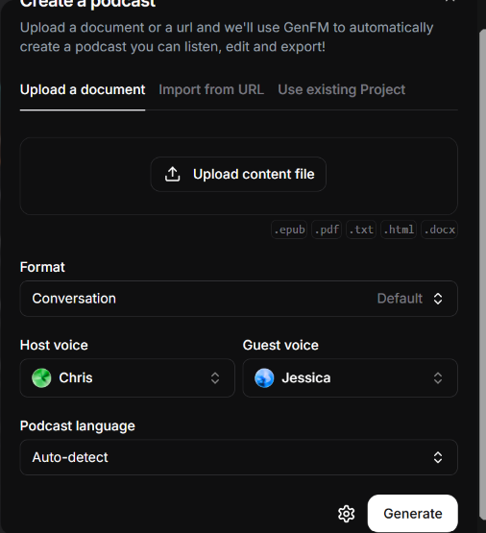
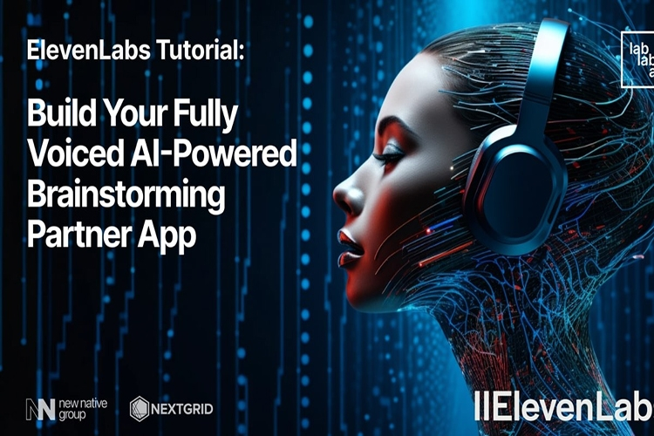
Standout feature:
Offers natural-sounding, emotionally appropriate voiceovers.
Allows custom control of tone, pace, and clarity.
Enables creation of high-quality audio content mimicking human speech.
Generate both monologue and dialogue quickly.
Free version enables 3000 characters length (suitable for even long duration audio)
Tutorial: https://www.youtube.com/watch?v=SYf7lzYRIqY
  - Narakeet
Link: https://www.narakeet.com/
Narakeet is an AI text-to-speech (TTS) tool that transforms written text into natural-sounding audio, or converts slides to engaging video using a wide range of voices, languages, and accents. It is especially helpful for teachers who want to generate listening materials based on customized scripts such as monologues, dialogue summaries, or thematic content. Free version enables users to upload scripts up to 2 minutes in length (around 200 words) and download MP3 files instantly.
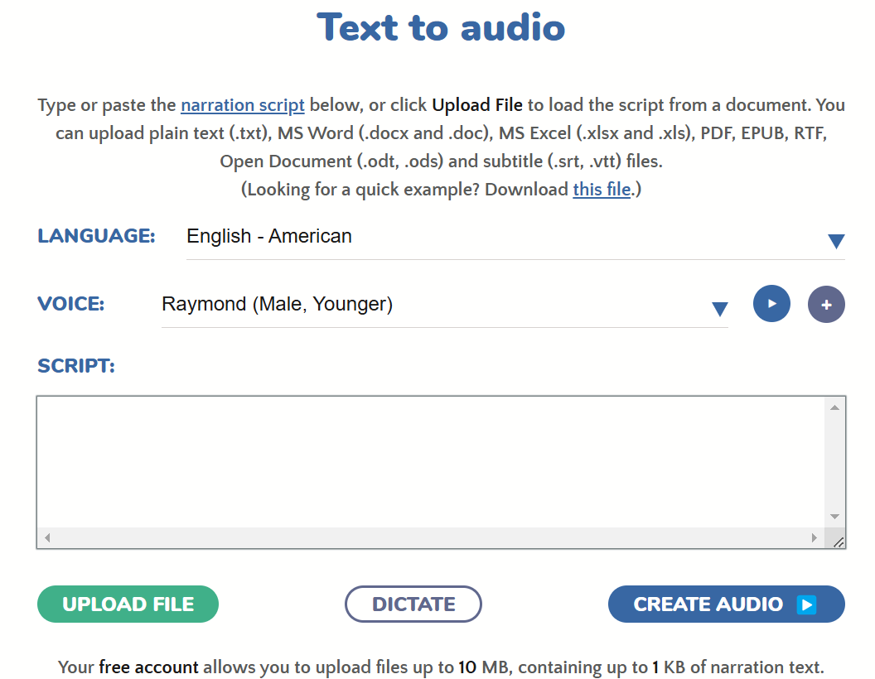
Suggestion for classroom practice:
• Custom-designed listening comprehension activities
• Assign students as mini projects or Flipped classroom
Sample script for a dialogue:
Breaking news!
Facebook acquires Ireland
The government announced this deal in a press release today. Martin Heydon, the Minister of State, this afternoon told journalists:
(voice: Brian)
“Facebook has a proven track record of supporting local businesses and communities. We are confident this transition will be a great success.”
---
It will be interesting to see how Facebook operates in Ireland without the regulatory oversight that helped put a check on some of its more extreme antics in the United States. Facebook has been rumored to be on the lookout for a new base of operations. In fact, a Facebook spokesperson told ABC News:
(voice: Rodney)
“we are especially excited to maintain our heavy Irish heritage and will maintain many core values from our native Menlo Park, including a laid-back attitude toward political corruption.”

Example: audio created by Narakeet: https://lnk.ink/r7tQT

- Applications support regularly audio edit
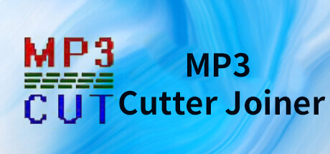
  - MP3 Cutter joiner
Link download: https://apps.microsoft.com/detail/9pckzd9x7ggw?hl=en-us&gl=VN
Free MP3 Cutter Joiner is a free and user-friendly audio editing tool. This is a lightweight application that do not take up much storage space, suitable for teachers to install on their computers for regular use. It offers essential features such as:
Cut segments from large audio files and convert them into MP3 format.
Cut and join with high precision while preserving original sound quality.
Merge multiple files or selected parts of various files into one large audio file.
Comes with a built-in mini player for easy pre-listening.
With its basic yet powerful functions, intuitive interface, and zero cost, this application is one of the easiest tools to use for quick and effective audio editing.
- Applications support creation of customized interactive listening tasks
  - Twee
Link: https://app.twee.com/
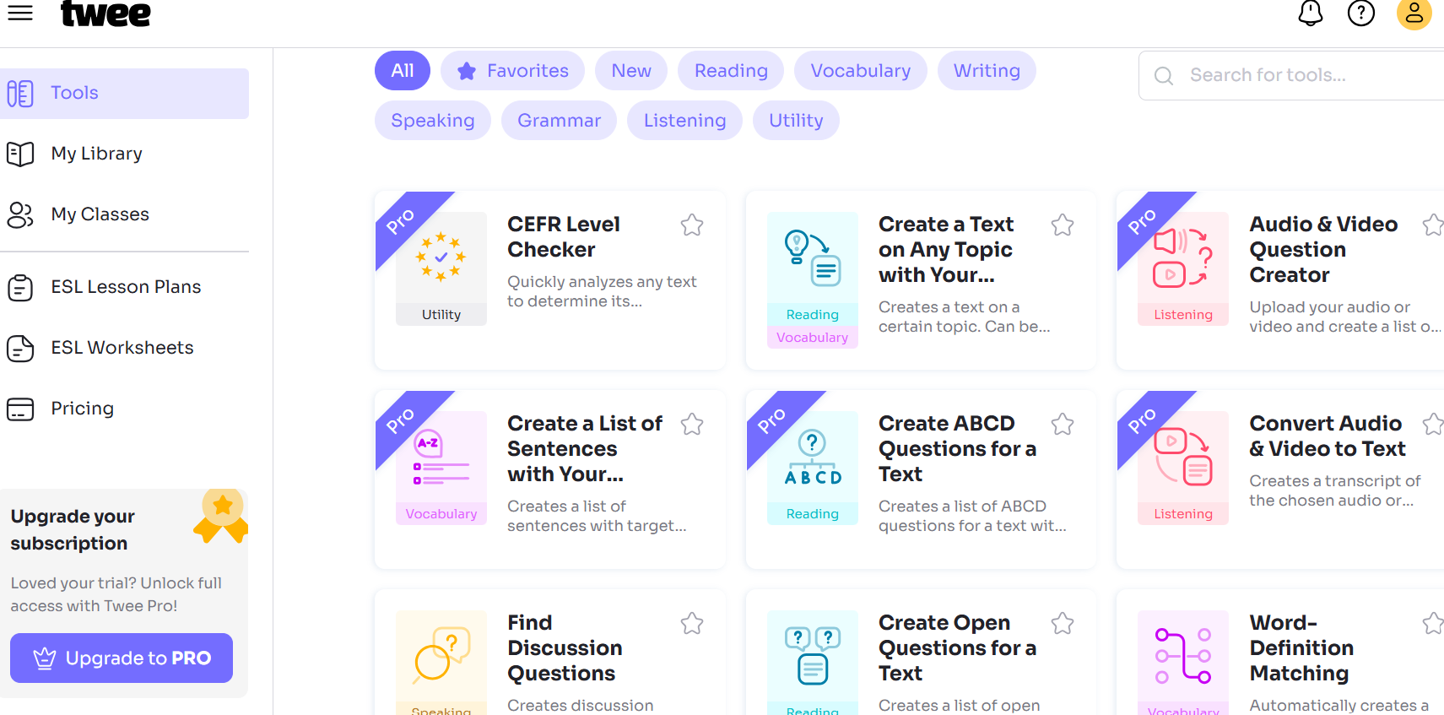
Tutorial: https://youtu.be/hNcTuQMDTOU
Twee is an “one for all” app, supporting teachers in multi-tasks design with all four skills listening, reading, writing, speaking and vocabulary. There’s a variety of tools and functions and with both free and charged version, cater to language teachers’ need in task designing especially in listening task design: audio & video question creator, audio & video summary Gap fill, choose the right summary, convert audio & video to text. The app also supports teachers to design various types of question from text on a certain topic, (with and without target words) and generate text- based CERF framework. This makes the app an ideal choice for teachers who seek to differentiate tasks and assist students’ personalized learning.
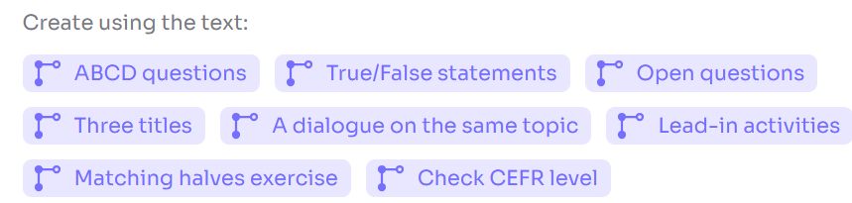
Example for listening task design
For designing a listening Gap fill task to teach in Unit 2, listening period – Human and the environment, I use “create text on any topic with your vocabulary” tool to generate a text topic “Zero waste” with 5 target - vocabulary: disposable, conscientious, raw material, unattainable, nutrient-rich soil. The steps include: choose the topic and title paste in 5 target vocab, choose CERF level: Advanced and text length (250-350 words) Do the magic. Herein are the step demo and result:
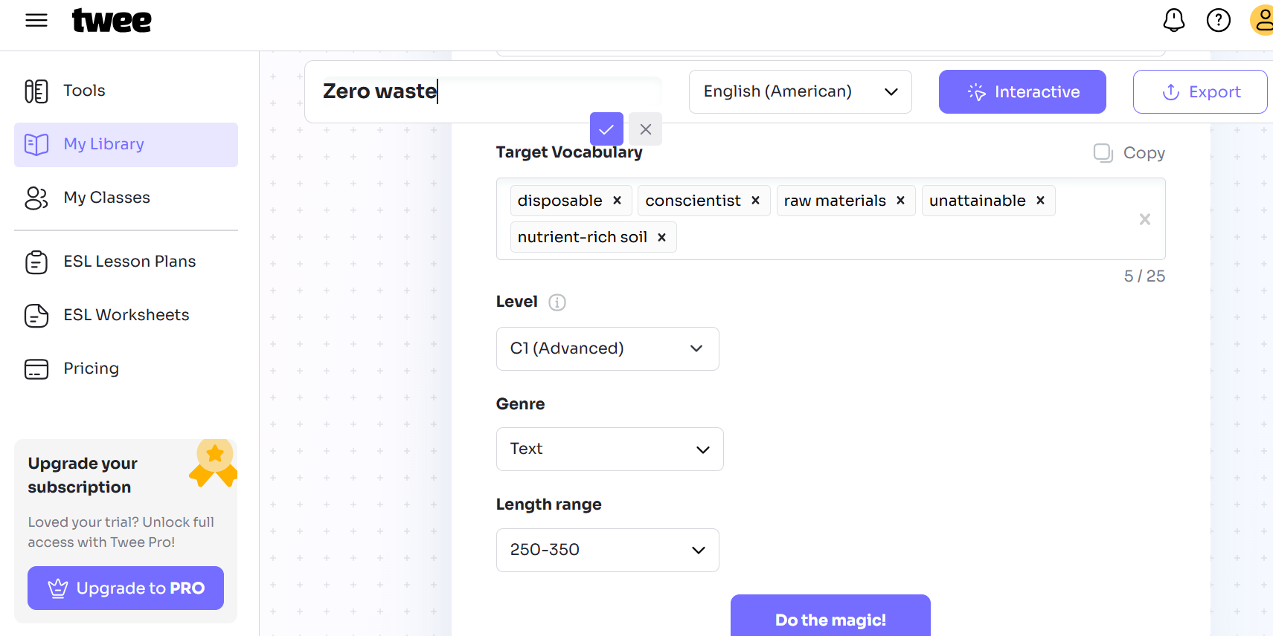
Fill in the blanks
Embracing a zero - waste lifestyle might seem _______________ (1) to many, but it stands as a beacon of hope and a sustainable way forward. The concept revolves around reducing reliance on _______________ (2) items and fostering a deeper connection with the resources around us. As individuals shift away from single-use plastics, they start to recognize the inherent value of reusing and recycling. This shift in mindset encourages the mindful use of _______________ (3), ensuring that every product is made with mindfulness towards its environmental impact.
A crucial aspect of zero waste is the transformation of organic waste into _______________ (4) through composting. This process not only reduces the volume of waste sent to landfills but also enriches the ground, promoting healthier plant growth and more resilient ecosystems. It is a cycle that emphasizes renewal over disposal, where each component plays a vital role in sustaining life.
For those starting out on their zero - waste journey, becoming a _______________ (5) consumer is key. This means being vigilant about the origins and life cycle of the products one purchases, choosing items that favor minimal packaging, and opting for durable alternatives over items that contribute to the growing mountain of refuse. By supporting companies that prioritize sustainable practices, consumers can drive positive change and encourage industries to adopt more eco-friendly methods.
KEY:
1. unattainable 2. disposable 3. raw material
4. nutrient-rich soil 5. conscientious
Then I made minor refinement to have final version and use ElevenLabs app to generate audio (charged version of Twee enable users to generate audio within the app).
Link to twee exercises: https://lnk.ink/7T6a4
  - Quizalize
Link: https://www.quizalize.com/
Quizalize is an AI-assisted quiz creation platform that allows teachers to design interactive, gamified listening comprehension questions. With real-time feedback and performance analytics, Quizalize supports individualized learning, It transforms static listening tasks into engaging, self-paced exercises.
Suggestion:
Teachers upload the audio or video file, then align questions with specific listening sections. Teachers can create a Quizalize quiz using question types such as multiple-choice, fill-in-the-blank, or true/false. Quizalize provides automatic scoring and a dashboard to track each student’s performance. In my classroom, I assigned a Quizalize quiz linked to a 3-minute video from BBC Learning English. Students completed the task at home and received instant feedback. I used the analytics to identify students who needed additional support with certain listening strategies.
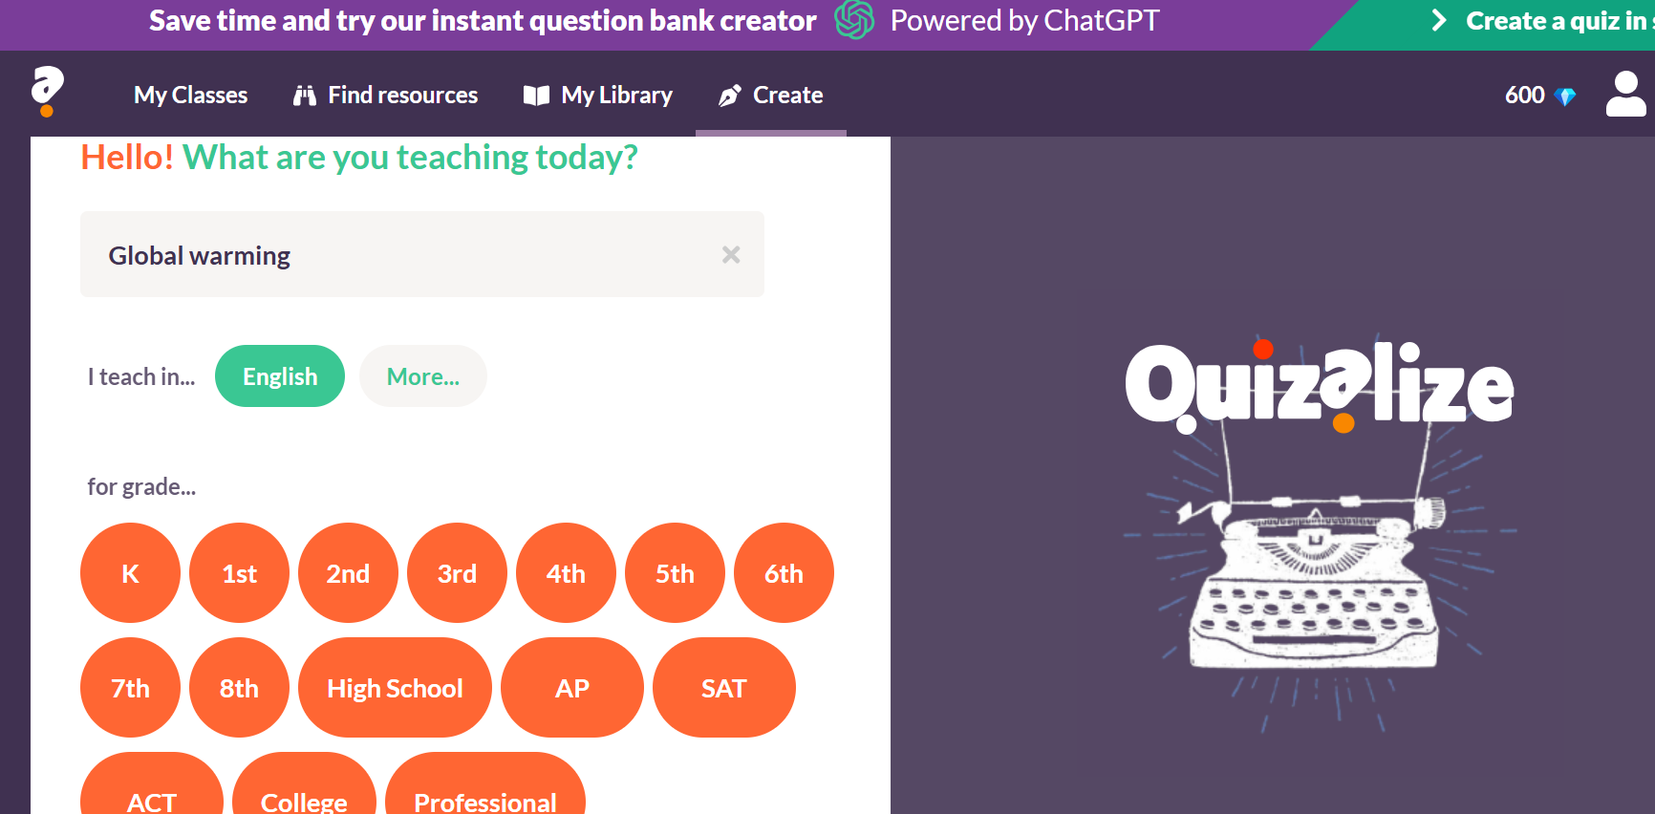
Steps to Create a Listening Quiz:
Sign Up/Login: Go to the Quizalize website and sign up or log in with your own account.
Create a Quiz: Click on "Create Quiz" to start designing your quiz.
Add Questions: Select the format for your listening comprehension questions (multiple-choice, true/false, or fill-in-the-blank).
Input Content: Write the question prompts and instructions for students.
Embed Audio: Use Quizalize's audio embedding feature to upload or link to the clip (from YouTube, Drive, etc.).
Set Answers: Choose the correct answers and provide explanations if needed.
Optional Settings: Add time limits, assign points, and enable feedback options.
Save and Assign: Share the quiz link with students. Their responses and scores can be tracked live.
Example:
After completing a reading lesson on topic “Global warming”, I selected a short video titled “What is Global Warming?” from the YouTube channel National Geographic. Using Quizalize, I created a listening quiz with 10 comprehension questions. The aim was to check their understanding of causes, consequences, and potential solutions related to global warming in a dynamic format.
generated questions by Quizaline: Topic “Global Warming”
Quizalize
10 questions
1. What is the primary cause of the recent increase in the Earth's temperature?
A. Volcanic activity
B. Ocean currents
C. Human activity
D. Natural climate cycles
2. How much has the Earth's temperature risen in the last century?
A. About 1.5 to 2 degrees Fahrenheit
B. About 2 to 3 degrees Fahrenheit
C. About 0.5 to 1 degree Fahrenheit
D. About 1.2 to 1.4 degrees Fahrenheit
3. What do we call the process where greenhouse gases trap heat in the atmosphere?
A. The greenhouse effect
B. Global warming
C. The heat retention process
D. The atmospheric cycle
4. Which gas is NOT mentioned as contributing to global warming?
A. Nitrogen
B. Methane
C. Carbon dioxide
D. Water vapor
5. What has been the trend in Arctic sea ice over the last 30 years?
A. It has remained the same
B. It has declined about 10 percent
C. It has increased by about 5 percent
D. It has declined by about 25 percent
6. What year was reported as the warmest in measured history according to scientists?
A. 1998
B. 2010
C. 2005
D. 2015
7. What is one way that consumers can help combat global warming?
A. Increasing energy consumption
B. Switching to compact fluorescent light bulbs
C. Driving more frequently
D. Using more plastic products
8. What could be a potential consequence of rising temperatures?
A. Flooded coastal areas
B. Stable weather patterns
C. Increased snow in winter
D. More polar ice caps
9. What is predicted about future temperatures by the end of the century?
A. They will decrease about 1 degree Fahrenheit
B. They will stay the same
C. They may increase about 2 to 10 degrees Fahrenheit
D. They may increase about 1 to 2 degrees Fahrenheit
10. What do some organizations advocate to help reduce global warming?
A. Ignoring climate change
B. Deforesting areas for agriculture
C. Increasing fossil fuel consumption
D. Cutting greenhouse gas emissions

Link video: https://www.youtube.com/watch?v=oJAbATJCugs
Link quizaline: https://app.quizalize.com/view/quiz/global-warming-8f15171e-e78f-42eb-b3fd-1524f235ce19

  - D-iD
Link: https://studio.d-id.com/
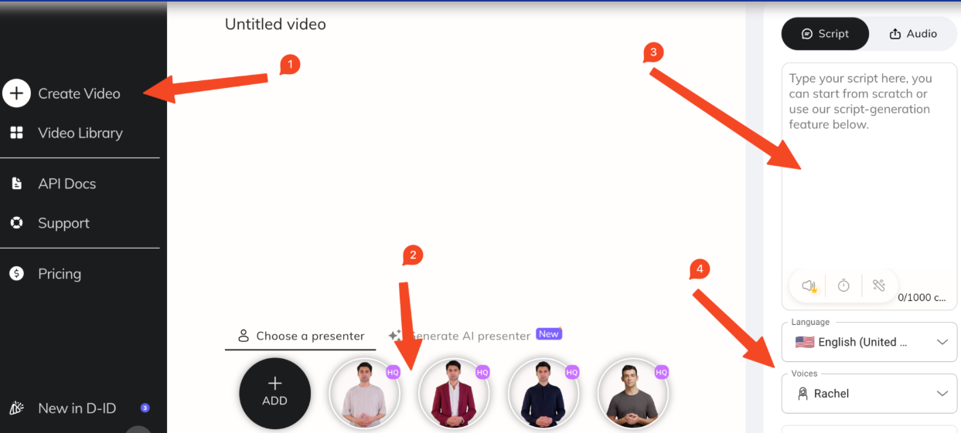
The D-iD platform leverages artificial intelligence (AI) to help create engaging audiovisual materials, specifically designed for use in education. Thanks to its user-friendly interface and advanced functionality, this tool offers teachers a practical way to develop high-quality listening comprehension resources for learners.
With its smooth integration of AI-generated speech with both images and videos, teachers can easily incorporate visuals whether generic or personal media including their own portraits or recordings to accompany the synthesized voice. This fusion creates a tailored and immersive learning environment for students, strengthens both understanding and memory of the lesson content, while also addressing diverse learning preferences.
Example:
To support the teaching of Unit 6, "Preserving Our Heritage" (Textbook Grade 11), I used AI technology to combine a historical text with my own image, creating a spoken narrative about the construction of the Egyptian pyramids. The narrative focused on the architectural brilliance and cultural significance of the Pyramids of Giza, connecting directly with the theme of the unit.
By integrating my personalized image with the AI-generated voiceover, I was able to offer students a more engaging and immersive experience. This multimodal presentation helped spark students’ curiosity about ancient civilizations while improving their listening comprehension. The blend of visual and auditory elements promoted deeper understanding and made the lesson more memorable and enjoyable.
Here is the text created by ChatGPT and the spoken narrative generated by the D-ID tool.
Listen to a short story about the Egyptian Pyramids and fill in each blank with ONE suitable word.
The Egyptian pyramids, particularly those of Giza, stand as enduring (1) ________________ of human achievement. Constructed over 4,000 years ago, these monumental structures transcended mere burial purposes and functioned as assertions of divine (2) ________________.
The Great Pyramid of Khufu exemplifies architectural prowess that continues to defy modern (3) ________________. Despite lacking contemporary engineering tools, ancient builders accomplished feats of geometric alignment with astonishing accuracy.
Contrary to outdated assumptions, recent discoveries suggest that the workforce consisted of skilled laborers motivated by cultural (4) ________________, not coercion. This reframes our understanding of ancient Egyptian societal (5) ________________.
Today, the pyramids face environmental degradation and anthropogenic pressures. Their long-term (6) ________________ depends on both national commitment and global stewardship, supported by technological tools such as 3D scanning and remote sensing.
Beyond their material form, the pyramids resonate with a universal human (7) ________________ for permanence and transcendence. They continue to stimulate academic (8) ________________ and represent a bridge between antiquity and modern civilization.
Key
1.testaments | 2.legitimacy | 3. comprehension | 4. allegiance
5. hierarchy | 6. safeguarding | 7. yearning | 8. discourse

Link to spoken narrative created by D-iD: https://lnk.ink/gOSY6
- Using ChatGPT to build listening comprehension questions aligned with NEC listening test
In recent years, the format of the high-stakes exams like The National High School Graduation Examination or National Excellent Student Exam (NEC) has undergone notable changes, increasingly shifting toward the use of authentic materials and task types that reflect real-world language use. While a wide range of listening resources is available, few are readily aligned with the “evolving structure” and cognitive demands of the NEC format. As a result, teachers face the dual challenge of sourcing appropriate content and adapting it to meet specific exam requirements, especially for new format types. Take the NEC 2024 - 2025 listening test as an example: three out of four parts are designed using authentic sources. Among them, Part 1 and Part 2 introduce relatively new question formats such as matching (speakers vs opinion, names of locations vs relevant ideas) compared to more traditional types: multiple choice (Part 3) and summary gap-fill (Part 4). In fact, teachers can find these types of questions in CPE exam old version. However, the sources may be outdated or may not align with recent changes in question design or level of challenge.
To address this issue, teachers can make use of advanced AI tools, particularly Large Language Models (LLMs), to support the design of listening comprehension questions whether based on audio transcripts or generated texts. In this way, ChatGPT can generate questions tailored to specific formats such as multiple choice, gap-fill, or short-answer types based on a given transcript or text. Teachers can either adapt transcripts from textbooks or online sources, or use AI to generate original scripts from scratch. This functionality is particularly valuable when working with authentic listening materials, such as YouTube videos, which can be converted into transcripts using widely available audio-to-text tools. Once the audio has been transcribed, teachers can edit or segment the content as needed, and then employ ChatGPT to produce question sets aligned with exam standards.
In my practice, I have found ChatGPT to be a highly accessible and flexible tool for this purpose. Specifically, the platform allows teachers to interact with it in a natural, conversational way specifying question types, difficulty levels, and target skills such as inference, detail recognition, or identifying speaker opinion. While other AI applications like Gemini or Microsoft Copilot may also support similar processes, this paper focuses on ChatGPT as the primary tool incorporated with other apps I have used in real classroom settings. With its support, I have been able to design customized, exam-aligned listening tasks that reflect both the curriculum content and the proficiency levels of my students.
In the following section, I will illustrate the steps I have taken to utilize ChatGPT in designing one part of a listening task aligned with the NEC exam format.
  - Analyze the exam questions
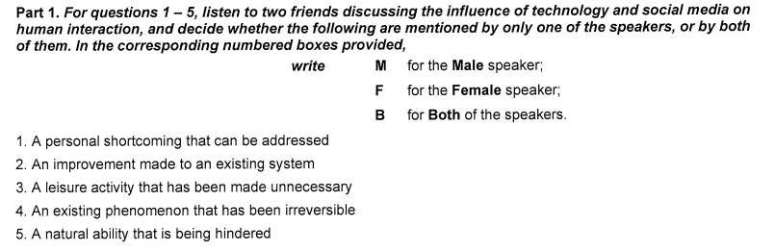
(NEC, listening test 2024 – 2025)
Prompt #1: Base on the image, analyze the following test items and provide a detailed breakdown of their specifications, including:
- Question Type – What type of question is this (e.g., grammar, vocabulary, reading comprehension)?
- Knowledge Scope – What language skill or grammar/vocabulary topic does it test?
- Question Structure – How is the question designed (e.g., gap-fill, sentence completion, matching, multiple-choice format)?
- Distractor Design – How are the incorrect options (distractors) created to make the question challenging?
- Stem Difficulty Level – How difficult is the question according to CEFR framework (A1, A2, B1, B2, C1, C2) and why?

  - Create prompts based on test specification analysis
Basing on the analysis of the sample test questions, teachers can use it as a foundation to write effective prompt commands that clearly convey the intended design of similar questions to AI. After rounds of trial and refinement, I propose the following prompts as a suggestion for asking AI to generate a listening comprehension task based on test sample.
Prompt to generate questions with available transcript
Prompt #2: You are a test developer. Base on the transcript below, create a C1–C2 level listening comprehension task in the form of a matching exercise.
Format: There are 5 statements describing ideas or opinions expressed in the dialogue.
Each statement must be matched with one of the following:
M – Male speaker only
F – Female speaker only
B – Both speakers
The ideas must be paraphrased, not copied directly from the transcript.
Each statement should reflect a viewpoint, belief, or subtle implication that challenges the listener to distinguish between speakers.
Include:
The 5 matching questions
The answer key with short justifications
Transcript:
[Paste transcript here]

Prompt to generate questions without available transcript (transcript created by AI)
Prompt #3: You are an expert test designer. Please create a C1–C2 level listening comprehension task in the format of a matching exercise.
- Use a dialogue between two speakers (e.g., a male and a female) discussing a complex or controversial topic such as [social change, technology, education, psychology, or global issues]
- The transcript should be about 300–400 words and contain 5 distinct opinions or ideas expressed individually by either one speaker or both.
- Then write 5 matching statements, each expressing one of those ideas or attitudes.
- The answer choices should be:
M for Male speaker only
F for Female speaker only
B for Both speakers
- Avoid using exact word matching. Use paraphrasing and abstract phrasing in the statements.
- Each matching statement should test the listener’s ability to identify viewpoint, infer meaning, or distinguish between subtly different opinions.
- Provide:
1. Full transcript (highlighting which speaker says what)
2. matching questions
3. Answer key with brief justifications

Note: [Suggestion for other topics:
The role of artificial intelligence in daily life
Social media and mental health
The future of work in a digital age
The effects of globalization on culture
Education reform and student well-being]

Hereby are examples of transcript and listening questions (part 1, NEC) generated by AI
Example 1
Topic: Artificial Intelligence in Education
Male(M):
I’ve been reading a lot about AI tools being used in classrooms lately, and honestly, I’m a bit concerned. I mean, yes, they can automate tasks and personalize learning, but at what cost? Students might become too reliant on them and lose the ability to think critically.
Female(F):
I see your point, but I think you’re underestimating their potential. When used correctly, AI can enhance critical thinking by freeing up teachers to focus on higher-order skills instead of grading papers all day. Plus, it can offer immediate feedback something a teacher alone can’t always manage with 30 students.
M:
Sure, but don’t you worry about data privacy? These tools are collecting vast amounts of student data. Who’s ensuring that information is secure and not being misused?
F:
Data privacy is definitely an issue, I agree with you there. But that’s a problem with digital technology in general, not just AI. The key is setting strict policies and making sure companies are held accountable.
M:
Another thing—what about the human touch? Learning isn’t just about delivering content. It's about relationships. No algorithm can replicate the empathy of a teacher.
F:
That’s true. No one’s saying we should replace teachers. But we also shouldn't ignore innovations that can make education more accessible—especially for students with special needs or those in remote areas. AI has the potential to close gaps, not widen them.

Questions
Match each statement below to the speaker(s) who express(es) the idea.
Write M for Male, F for Female, or B for Both.
No. | Statement
1. | Effective integration of AI can support students who are underserved or geographically isolated.
2. | There's a shared concern about the ethical risks linked to data protection in AI systems.
3. | AI has the potential to reduce teachers’ workload, allowing them to focus on more impactful educational practices.
4. | Dependence on AI in learning environments may weaken students' independent thinking abilities.
5. | Technology alone cannot replicate the interpersonal aspects essential to good teaching.

Key
No. | Answer | Justification
1. | F | The female speaker mentions AI helping students in remote areas or with special needs.
2. | B | Both speakers agree data privacy is an issue; the male raises it, and the female acknowledges it.
3. | F | The female speaker believes AI enables teachers to focus on higher-order thinking tasks.
4. | M | The male speaker explicitly worries that reliance on AI will diminish students’ critical thinking.
5. | M | The male speaker argues that human relationships in education are irreplaceable by algorithms.

Example 2
Topic: Greenwashing – Corporate Ethics or Consumer Manipulation?
Female(F):
I’ve been seeing more and more companies plastering their ads with words like “eco-friendly,” “sustainable,” and “green,” but I can’t help feeling skeptical. It’s like they’re using environmental concerns as a marketing gimmick rather than a genuine commitment.
Male(M):
Yeah, that’s the essence of greenwashing, right? When companies exaggerate or fabricate their environmental credentials to attract conscious consumers. I think it’s deceptive, especially when there's no real accountability or proof behind their claims.
F: Exactly. And it’s so hard for the average consumer to know what’s real. I mean, who has the time to read the fine print or research every product label? Most people just take the messaging at face value.
M: But then again, isn’t some progress better than none? Even if a company isn’t perfect, if they’re moving in a greener direction—even if just for image—it might still lead to actual improvement.
F: Hmm, I don’t know. I think the problem is that it creates a false sense of achievement. If consumers feel like they're already “doing their part” just by choosing a “green” brand that’s actually not so green, it may reduce pressure for real systemic change.
M: That’s a good point. There’s definitely a danger in creating complacency. But I still think the market rewards perception, and that can drive competition, which could push companies to become genuinely sustainable just to keep up.
F: That sounds optimistic, but we’ve seen too many examples of companies getting away with minimal changes and reaping the benefits. Honestly, I believe stricter regulations and third-party certifications are the only way to stop this.
M: I agree that regulation is essential. Otherwise, it's like letting students grade their own exams. But the government can only do so much consumers need to stay critical and informed too.
F: Which is easier said than done. That’s why I think education and awareness campaigns are just as important as policy. If people don't know they’re being misled, how can they resist it?
M: Exactly. And that’s why we need to stay vigilant because true sustainability isn’t just about greener products. It’s about changing systems and behaviors.
Matching Exercise: Choose who expresses each idea below. Match each statement to the correct speaker, write:
M = Male speaker only
F = Female speaker only
B = Both speakers

Statements:
- It’s difficult for the average person to distinguish between genuine environmental efforts and clever branding.
- Appearing environmentally conscious, even without full authenticity, can potentially lead to real improvement over time.
- Greenwashing might prevent people from demanding deeper environmental reforms.
- Regulatory oversight is crucial to prevent companies from making unverified claims.
- Consumer awareness and critical thinking are essential tools in combating greenwashing.

Key
No. | Answer | Justification
1 | F | The female speaker says, “Most people just take the messaging at face value,” showing her concern about how hard it is for consumers to discern the truth.
2 | M | The male speaker says, “Even if a company isn’t perfect... it might still lead to actual improvement,” implying that even partial efforts could trigger change.
3 | F | The female speaker argues that greenwashing creates a “false sense of achievement” and discourages real action.
4 | B | Both speakers mention regulation: F says “stricter regulations are the only way,” and M adds, “regulation is essential.”
5 | M | The male speaker concludes with, “consumers need to stay critical and informed too,” emphasizing public awareness as a solution.
Link to prompt: https://chatgpt.com/share/686fca71-a874-800d-a5a7-24bc85103ada

Prompt to have AI generate multi-level question set
Prompt #4: Base on script [paste script or attach file .doc], please generate three versions of test questions with difficulty level B2, C1, C2 following the same format as in sample test image.
Example: After extracting the script to text format from the teacher book Toward Proficiency –listening task (find script here: https://lnk.ink/k2iD8) and audio file here:, I use prompt above to generate three versions of test questions, and the app generated as following:
Version 1: B2 Level – Concrete ideas and paraphrasing
Instructions: You will hear a conversation about Feng Shui. Decide who expresses the following ideas, write:
F = Fay (Feng Shui consultant)
M = Milo (Journalist)
B = Both
Statements
- Most people who try Feng Shui say they feel better afterward.
- It doesn’t cost much to make a room feel better with Feng Shui.
- Some people believe Feng Shui works only because they expect it to.
- Feng Shui uses decoration to make places more comfortable.
- One football team used Feng Shui but didn’t see better results.
Answer Key:
1. F 2. F 3. M 4. M 5. M
Version 2: C1 Level – Inference and abstract interpretation
Instructions: You will hear a conversation about the use of Feng Shui in modern life. Decide who expresses the following ideas, write:
F = Fay
M = Milo
B = Both
Statements
- Positive reactions to Feng Shui spaces occur even in people unfamiliar with it.
- People in the West may misapply Feng Shui due to misunderstanding.
- The psychological effects of Feng Shui may explain why it feels helpful.
- Feng Shui can bring benefits even without scientific proof.
- Some Westerners adopt superficial elements of Feng Shui expecting fast solutions.
Answer Key:
1. F 2. B 3. M 4. F 5. M

Version 3: C2 Level – Nuanced critique and philosophical reflection
Instructions: You will hear an interview with a Feng Shui consultant and a skeptical journalist. For each statement, decide who expresses the idea, write:
F = Fay
M = Milo
B = Both
Statements
- The effectiveness of Feng Shui might be attributed more to belief than to tangible forces.
- Judging an ancient tradition by one failed example is unreasonable.
- The emotional response people have to a space can’t always be logically explained.
- Cultural borrowing without philosophical context risks oversimplification.
- The concept of ‘chi’ remains scientifically unverified.
Answer Key:
1. M 2. F 3. F 4. B 5. M
  - Refine result and generate audio
Once the initial questions are generated by ChatGPT, the teacher refines and modifies them to ensure test validity and alignment with learners’ needs, resulting in a finalized version ready for classroom use.
The last step is to convert the script generated by AI by utilizing the app ElevenLabs (as guided before).
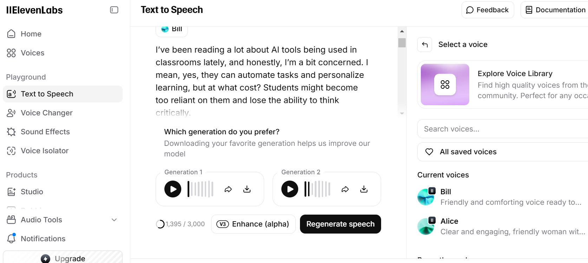
These are audio files created by ElevenLabs from script generated by ChatGPT

Topic: Artificial Intelligence in Education |  Topic: Greenwashing - Corporate Ethics or Consumer Manipulation?

In summary, there are various apps available to support teachers at different stages of designing listening tasks. Teachers are encouraged to be flexible and combine multiple tools in order to create high-quality listening activities that suit their specific teaching purposes.

CHAPTER 3: CONCLUSION

The central theme of the study on using AI applications to assist teachers in designing listening tasks for gifted students has been addressed comprehensively across all chapters, combining theoretical insights with hands-on strategies. Conducted within the context of specialized English programs at a high school for the gifted, this study primarily aimed to explore the potentials and practicalities of integrating AI tools into the listening task design process. It also sought to demonstrate how such tools can enhance instructional quality, save teacher time, and better align listening practice with the demands of national academic competitions.
Through a combination of theoretical analysis and practical examples, the study has illustrated how various AI tools can be purposefully incorporated into the TPACK framework to create engaging, cognitively demanding, and authentic listening experiences for gifted learners. In doing so, it reinforces the idea that it’s not about using the most advanced tools, but rather using the right tool for the right purpose in the right context - can bridge gaps between curriculum goals and real-world language use. By applying the TPACK model, teachers can become confident designers of digital learning environments that are effective, inclusive, and future-ready.
The study also offers several practical recommendations for teachers working with gifted students. These include using AI apps to diversify listening input, generating multi-tiered questions aligned with high-stakes exam formats. Moreover, the research emphasizes the importance of teacher role in selecting appropriate content, evaluating AI-generated materials, and scaffolding learners’ engagement with technology.
Ultimately, this study hopes to make a minor meaningful contribution to the field of technology-integrated language teaching for gifted learners. It aspires to serve as a useful reference for English teachers seeking to enhance their teaching practice by leveraging AI in pedagogically sound ways. It also aims to encourage innovation in lesson design, especially in areas where conventional resources fall short of the complex needs of high-performing students.
By spotlighting the intersection of AI, pedagogy, and gifted education, this study invites further exploration and collaboration in the field. As digital tools become increasingly relevant in modern classrooms, their thoughtful integration can empower both teachers and students.

REFERENCES
Ellis, R. (2003). Task-based language learning and teaching. Oxford University Press.
Fang, F., & Liu, Y. (2023). Integrating AI into EFL teaching: A review of current practices and perspectives. Journal of English Language Teaching and Research, 13(2), 145–160.
Field, J. (2008). Listening in the language classroom. Cambridge University Press.
Gagné, F. (2015). Differentiated instruction and gifted education: A curriculum-based approach. Routledge.
Gilakjani, A. P., & Sabouri, N. B. (2016). Learners’ listening comprehension difficulties in English language learning: A literature review. English Language Teaching, 9(6), 123–133.
Holmes, W., Bialik, M., & Fadel, C. (2019). Artificial intelligence in education: Promises and implications for teaching and learning. Center for Curriculum Redesign.
Mishra, P., & Koehler, M. J. (2006). Technological pedagogical content knowledge: A framework for teacher knowledge. Teachers College Record, 108(6), 1017–1054.
Nguyen, T. T. M. (2021). Designing listening tasks for high school students using authentic materials: A task-based approach. Vietnam Journal of Education, 7(3), 12–19.
Robinson, P. (2001). Task complexity, task difficulty, and task production: Exploring interactions in a componential framework. Applied Linguistics, 22(1), 27–57.
Tomlinson, C. A. (2014). The differentiated classroom: Responding to the needs of all learners (2nd ed.). ASCD.
Tseng, J. J., Tuan, Y. F., & Chin, C. C. (2020). Integrating TPACK into a professional development program for digital learning design. Australasian Journal of Educational Technology, 36(6), 17–31. https://doi.org/10.14742/ajet.5939
VanTassel-Baska, J. (2005). Curriculum planning and instructional design for gifted learners. Love Publishing.
Vandergrift, L., & Goh, C. C. M. (2012). Teaching and learning second language listening: Metacognition in action. Routledge.
Voogt, J., Fisser, P., Pareja Roblin, N., Tondeur, J., & van Braak, J. (2013). Technological pedagogical content knowledge – a review of the literature. Journal of Computer Assisted Learning, 29(2), 109–121.
Wang, Y., & Wang, J. (2022). Using AI tools to design personalized language learning activities: Teacher perspectives and challenges. Computer-Assisted Language Learning Electronic Journal (CALL-EJ), 23(1), 87–104.

APPENDIX

1. Self-designed Grade 10 listening comprehension exercises bank by topic
Designing listening tasks tailored to the curriculum requires careful alignment with the official textbook themes and the actual needs of gifted students. This is also time-consuming task requiring integration of technology into designing process. With this in mind, I am pleased to share a collection of topic-based listening exercises that I have personally developed using authentic video materials from reputable YouTube channels or books with the help of technology tools and apps I have mentioned in above chapters. These materials were selected based on thematic similarity to the units in the Grade 10 English curriculum (global success) and were designed with the support of AI tools to enhance task authenticity and efficiency. All tasks have been piloted and refined based on student feedback and classroom observations to ensure suitability and effectiveness. These exercises can be used flexibly either as supplementary materials to enhance listening skills or as activities within the main listening periods.
https://drive.google.com/drive/folders/1Z7GP_sy5O3J6M3kB8Qt3M2UluFEYlrE_?usp=drive_link


2. Listening exercises (sample Three-way matching, NEC format_2024)
https://drive.google.com/drive/folders/1SqtX57LkrpVYqhkQUSTi3-_EqMydz7ze?usp=sharing


3. Prompts to have ChatGPT support task designing
https://drive.google.com/drive/folders/1GkEGKbqiEbHLuUVgQd5JJTvzidqFGelX?usp=drive_link


