**LỚP HỌC THẦY (CÔ) ___________________________** **ĐỀ ÔN TẬP: READING SIGNS/ NOTICES – A2**

**Test 10**

*Thời gian làm bài: [Time]*

Họ và tên: ________________________________________________ Lớp: 9/___

**Nội dung:**

**Question 1:** What does the sign mean?

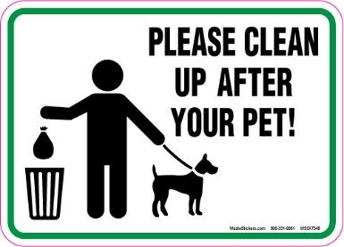

**A.** Leave pet waste as it is.

**B.** Clean up any waste your pet leaves behind**.**

**C.** Cleaning up pet waste is optional.

**D.** Only some pet waste needs to be cleaned.

**Question 2:** What does the notice tell you?

All visitors must sign in at the front desk. This helps us keep track of everyone.

**A.** No need to sign in **B.** Sign in at the front desk  
**C.** Sign out at the end **D.** Enter without signing in

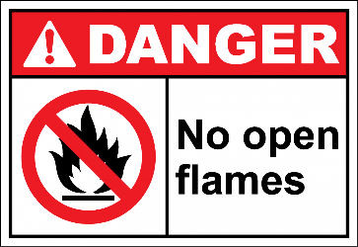**Question 3:** What does the sign indicate?

**A.** It is safe to light a fire in this area because it is not dangerous.

**B.** Do not use any open flames, such as candles, matches, or lighters, here.

**C.** Only small fires, like campfires or candles, are allowed in this are**a.**

**D.** Fire can be used in this area only when the weather is very cold outside.

**Question 4:** What is the notice about?

"Do not use the elevator during a fire. Use the stairs to get out safely."

**A.** Use the elevator during a fire **B.** Use the stairs during a fire  
**C.** Stay in the building during a fire **D.** Exit through the windows

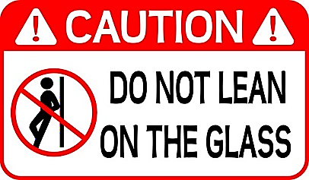**Question 5:** What does the sign suggest?

**A.** Leaning on the railing is dangerous because it is not safe.

**B.** Do not stand near the railing.

**C.** Do not touch the railing to stay safe.

**D.** Only lean on the railing when you are tired**.**

**Question 6:** What should you do according to the notice?

Please turn off your mobile phone during the meeting to avoid distractions.

**A.** Turn off your phone to keep the meeting quiet. **B.** Do not use your phone during the meeting.

**C.** Use your phone during the meeting. **D.** Put your phone in your pocket.

**Question 7:** What does the sign suggest?

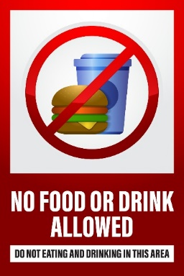**A.** You are free to eat or drink anything you like in this area whenever you want.

**B.** Eating and drinking are permitted only in this specific area and not outside of it.

**C.** Do not bring any food or drinks into this area at any time, as it is not allowed**.**

**D.** Food and drink can only be consumed in this area during certain hours of the day.

**Question 8:** What is the announcement about?

The gym will be closed for cleaning on Saturday from 8am to 10am.

**A.** The gym is open on Saturday **B.** The gym opens early on Saturday

**C.** The gym closes at 10am every day **D.** The gym is closed for cleaning on Saturday

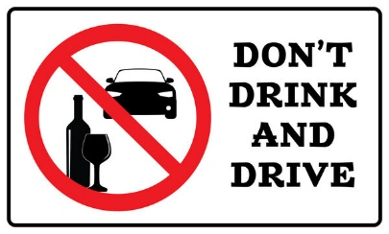**Question 9:** What does the sign suggest?

**A.** Drinking alcohol is not safe when you are driving a car or other vehicles.

**B.** You can drive a car if you drink only a little alcohol and feel okay.  
**C.** It is good to drink water while driving so you stay awake and safe.  
**D.** You should only drive if you have not had any alcohol to drink.

**Question 10:** What should you bring?

Bring a notebook and a pen to the workshop. You will need them to take notes.

**A.** Bring a book and a pencil **B.** Bring a notebook and a pen

**C.** Bring a laptop and a highlighter **D.** Bring a tablet and a notebook

**[HẾT]**