|  |  |
| --- | --- |
| **Tiếng Anh 8 Friends Plus** | **FP 8 - UNIT 4 - TEST 2**  **Test for Unit**  *Thời gian làm bài: 40 phút (Không kể thời gian giao đề)*  *-------------------------* |

**I. Pronunciation (1-4)**

**Câu 1.** Which word has the underlined part pronounced differently from that of the others?

**A.** damage  **B.** away  **C.** bank  **D.** charity

**Câu 2.** Which word has the underlined part pronounced differently from that of the others?

**A.** book  **B.** look  **C.** cook  **D.** food

**Câu 3.** Which word has a different stress pattern from that of the others?

**A.** extra  **B.** hungry  **C.** pollute  **D.** Nordic

**Câu 4.** Which word has a different stress pattern from that of the others?

**A.** people  **B.** insect  **C.** honey  **D.** combine

**II. Choose the answer (A, B, C or D) that best fits the space in each question. (5-14)**

**Câu 5.** They saw beautiful landscapes, ______?

**A.** didn't they  **B.** have they

**C.** haven't they  **D.** did they

**Câu 6.** Recycling programs help us ________ valuable resources.

**A.** recycle  **B.** pollute

**C.** throw away  **D.** provide

**Câu 7.** Governments must ________ effective solutions to the waste crisis.

**A.** destroy  **B.** provide  **C.** protect  **D.** view

**Câu 8.** If we overfish, some species may ________ completely.

**A.** develop  **B.** disappear  **C.** convince  **D.** persuade

**Câu 9.** What are the advantages of this cell phone?

**A.** I'm going to buy a new cell phone this weekend.

**B.** I enjoy watching movies on cell phones.

**C.** High-resolution display, fast processing speed, and a long-lasting battery.

**D.** I have a new cell phone.

**Câu 10.** She studied all night, ______?

**A.** didn't she  **B.** has she

**C.** hasn't she  **D.** did she

**Câu 11.** You want to go home now, ______?

**A.** didn't you  **B.** don't you

**C.** do you  **D.** have you

**Câu 12.** We lived there for ten years, _____?

**A.** do we  **B.** has we  **C.** have we  **D.** didn't we

**Câu 13.** We must ________ with climate change through policy changes.

**A.** deal  **B.** convince  **C.** produce  **D.** develop

**Câu 14.** Many consumers have changed their ________ of shopping.

**A.** view  **B.** damage

**C.** conviction  **D.** solution

**III. Look at the signs/ messages. Choose the best answer (A, B, C or D). (15-16)**

**Câu 15.**

When is the grand opening of the new department store?

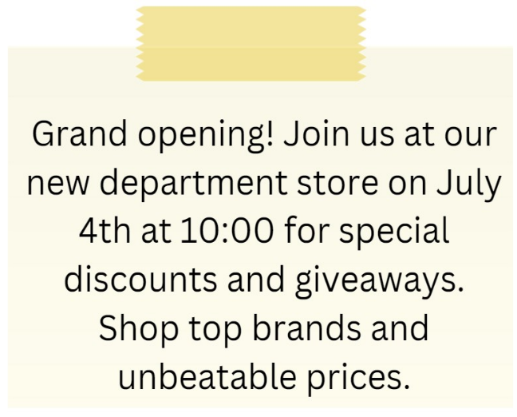

**A.** June 4th  **B.** July 3rd  **C.** July 4th  **D.** July 5th

**Câu 16.**

What can customers expect at the new store opening?



**A.** Exclusive deals and entertainment  **B.** Only fashion items

**C.** Expensive prices on everything  **D.** No entertainment, only shopping

**IV. Read the following passage and do as direct. (17-22)**

We can help protect the environment by choosing the right kind of food. Eating food that is grown in a sustainable way can reduce the negative impact on the environment. One way to do this is by choosing organic food, which is grown without the use of harmful chemicals. Another way is by choosing food that is locally grown. This means that the food doesn't have to travel long distances to reach us, and therefore reduces the carbon footprint. Eating less meat and more plant-based foods can also have a positive impact on the environment, as it takes less resources to produce plant-based foods. We can also reduce food waste by only buying what we need and using up leftovers. By making small changes in our diet, we can make a big difference in protecting the environment for future generations.

**Câu 17.** Eating organic food can reduce the negative impact on the environment.

**A.** True  **B.** False

**Câu 18.** Choosing locally grown food doesn't have any impact on the environment.

**A.** False  **B.** True

**Câu 19.** Eating more meat and less plant-based foods can have a positive impact on the environment.

**A.** False  **B.** True

**Câu 20.** Reducing food waste by only buying what we need and using up leftovers can help protect the environment.

**A.** True  **B.** False

**Câu 21.** Which of the following is a way to reduce the negative impact of food on the environment?

**A.** Eating more meat  **B.** Choosing organic food

**C.** Buying food that travels long distances  **D.** Wasting food

**Câu 22.** What is the benefit of eating plant-based foods over meat-based foods for protecting the environment?

**A.** Meat-based foods are healthier

**B.** Plant-based foods are more expensive

**C.** Meat-based foods have a smaller carbon footprint

**D.** Plant-based foods take less resources to produce

**V. Choose the word (A, B, C or D) that best fits the blank space in the following passage. (23-28)**

The trip **____23____** by ABC Travel Agency was very nice. They arranged everything - the flights, hotel, and transportation. The vacation **____24____** was beautiful, with beaches, an ocean, and warm, sunny weather.

The hotel was clean and spacious, with a swimming pool. The rooms had air **____25____** and TVs with many channels. The breakfast and dinner at the hotel restaurant were very good, with a wide variety of food to choose from. The hotel staff were **____26____** and helpful with any questions.

The beach near the hotel was not very crowded. The beach chairs and umbrellas for relaxation were free to use. The ocean water was clean and warm. My children enjoyed **____27____** and building sandcastles. We had fun playing volleyball and swimming in the hotel pool as well.

I highly recommend ABC Travel Agency and this vacation trip. The price was fair for what we received. Both the travel **____28____** and hotel staff made my family happy and provided us with a relaxing time. It was a wonderful vacation! The coordination between the travel agency and hotel went smoothly, and no problems occurred that could ruin the trip.

**Câu 23.** The trip ____ by ABC Travel Agency was very nice.

**A.** ruined  **B.** cancelled  **C.** delayed  **D.** organized

**Câu 24.** The vacation destination was ____.

**A.** beautiful  **B.** ugly  **C.** boring  **D.** dangerous

**Câu 25.** The rooms had air ____.

**A.** conditioning  **B.** pollution

**C.** guitars  **D.** balloons

**Câu 26.** The hotel staff were ____.

**A.** friendly  **B.** rude  **C.** unhelpful  **D.** absent

**Câu 27.** My children enjoyed ____.

**A.** swimming  **B.** crying

**C.** fighting  **D.** being bored

**Câu 28.** Both the travel agency and hotel staff made my family ____.

**A.** angry  **B.** sad

**C.** happy  **D.** disappointed

**VI. Supply the correct form of the word given in each sentence. (29-34)**

**Câu 29.** The city has implemented a new ________ program to reduce waste. (recycle)

**Câu 30.** The river has become heavily ________ due to industrial waste. (pollute)

**Câu 31.** The fire was so intense that it completely ________ the building. (destruction)

**Câu 32.** We should avoid ________ resources and use them wisely. (waste)

**Câu 33.** The television show has gained a large number of ________. (view)

**Câu 34.** The company is a leading ________ of internet services. (provide)

**VII. Rearrange the groups of words in a correct order to make complete sentences. (35-36)**

**Câu 35.** violence in / too much / There was / the film.

…

**Câu 36.** German, can / speak / She can’t / she?

…

**VIII. Rewrite each of the following sentences in another way so that it means almost the same as the sentence printed before it. (37-40)**

**Câu 37.** Some students love riding bicycles around the lake in their free time. (keen on)

Some students …

**Câu 38.** How much does this TV cost? (price)

What …

**Câu 39.** Should we practice every day for the show? (tag question)

We should ___________________________ , _____________?

**Câu 40.** Tom goes to the store because he needs to buy a new phone.

Tom goes to the store in order …

**IX. Listening: listen and do as direct.**

*Listen and fill in the blanks*

**Câu 41.** The black and white striped shirt cost _____________.

**Câu 42.** John thought the material of the striped shirt was ____________.

**Câu 43.** John did not like the fit of the _________ checked shirt.

**Câu 44.** Tom suggested that John try a __________ size for the blue checked shirt.

**Câu 45.** The grey shirt cost ___________ and had a better fit.

**Câu 46.** In the end, John decided to buy the __________ shirt.

**Câu 47.** The price of the blue checked shirt was _______.

**Câu 48.** Tom helped John __________ a shirt that fit better.

**Câu 49.** Tom was happy he could __________ John save some money.

**Câu 50.** Initially, John was holding a _________ checked shirt.

**----HẾT---**