**READING**

**PART 1**

**Look at the picture. Read the words. Which words go with the picture? Fill in the correct circles on your answer sheet.**

|  |
| --- |
| **1.**     1. **(A)**The boy is drawing a picture. 2. **(B)**The boy is taking a photo. 3. **(C)**The boy is talking on the phone.   **The answer is "B." Fill in "B" on your answer sheet.**  **2.**  **What does the arrow show?**  **The boy with the arrow is ahead of the other boy.**   1. **(A)**Ahead 2. **(B)**Beside 3. **(C)**Under   **The answer is "A." Fill in "A" on your answer sheet.** |

|  |  |  |
| --- | --- | --- |
| 3. |  |  |
|  | | |
| **(A)** Book | **(B)** Notebook | **(C)** School bag |
| 4. |  |  |
|  | | |
| **(A)** Truck | **(B)** Motorbike | **(C)** Train |
| 5. |  |  |
|  |  |  |
| **(A)** Hippo | **(B)** Squirrel | **(C)** Monkey |
| 6. |  |  |
|  | | |
| **(A)** Pomelo | **(B)** Watermelon | **(C)** Jackfruit |
| 7. |  |  |
|  | | |
| **(A)** Noodles | **(B)** Sausage | **(C)** Rice |
| 8. |  |  |
|  | | |
| **(A)** Straight | **(B)** Curly | **(C)** Bald |
| 9. |  |  |
|  | | |
| **(A)** Shirt | **(B)** Skirt | **(C)** Polo shirt |
| 10. |  |  |
|  | | |
| **(A)** They are playing soccer. | **(B)** They are riding bikes. | **(C)** They are walking. |
| 11. |  |  |
|  | | |
| **(A)** The boy is sleeping. | **(B)** The boy is playing. | **(C)** The boy is singing. |
| 12. |  |  |
|  | | |
| **(A)** The girls are in the Literature class. | **(B)** The girls are in the Chemistry class. | **(C)** The girls are in the Geography class. |
| 13. |  |  |
|  | | |
| **(A)** She is taking food from the fridge. | **(B)** She is taking food from the oven. | **(C)** She is taking food from the cabinet. |
| 14. |  |  |
|  | | |
| **(A)** The boy wears a raincoat. | **(B)** The boy takes a hat. | **(C)** The boy uses an umbrella. |
| 15. |  |  |
|  | | |
| **(A)** She is eating ice cream. | **(B)** She is eating salad. | **(C)** She is eating a hamburger. |
| 16. |  |  |
|  | | |
| **(A)** The dog is chasing a mouse. | **(B)** The dog is lying in front of the house. | **(C)** The dog is playing with a boy. |
| 17. |  |  |
|  | | |
| **(A)** The black car is smaller than the white car. | **(B)** The white car is bigger than the black car. | **(C)** The black car is bigger than the white car. |

**PART 2**

**Read and find the answer.  
Fill in the correct circles on your answer sheet.**

|  |
| --- |
| **Let’s do an example.**   1. **Students go to class here. Teachers work here. It has many desks. What is it?**     1. **(A)  A house**    2. **(B)  A school**    3. **(C)  A bank**   **The correct answer is a school. Fill in "B" on your answer sheet.** |

1. **It is a big place. Cooks work there. They make delicious food. Where is it?**

**Where is it?**

**(A)** A farm

**(B)** A factory

**(C)** A hospital

1. **This is a colorful school object. You use it for painting or drawing. What is it?**

**(A)** A crayon

**(B)** A pencil sharpener

**(C)** An eraser

1. **Peter can draw beautiful pictures. He wants to be ________________ in the future.**

**(A)** a singer

**(B)** an artist

**(C)** a pianist

1. **You feel a pain inside your head. You have a/an _________.**

**(A)** headache

**(B)** earache

**(C)** stomachache

1. **When a bird moves through the air, it _________.**

**(A)** walks

**(B)** runs

**(C)** flies

1. **Lan is going out. She wears warm clothes. It is ______________ outside.**

**(A)** sunny

**(B)** cold

**(C)** cool

1. **Rosie is _________________ and she needs something to drink.**

**(A)** hungry

**(B)** happy

**(C)** thirsty

**PART 3  
Read the sign. Answer questions 26 to 29.**

**Fill in the correct circles on your answer sheet.**

Jay, Alex, Ellen, Kelly and Ana go to the school campus. They read this sign at the campus.

**Guide to the School campus**

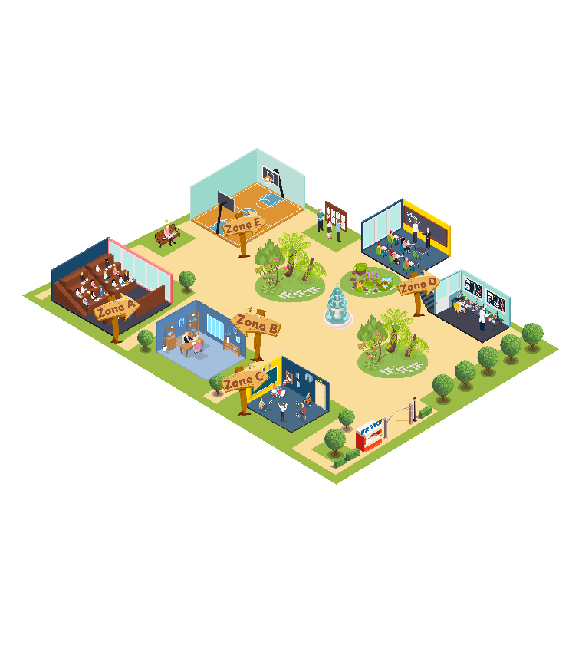

1. **Jay wants to do some chemistry experiments. He goes to the ____________.**

**(A)** ground floor

**(B)** building A

**(C)** building E

1. **Ana needs some advice on her studying program. She goes to the ____________.**

**(A)** building A

**(B)** building B

**(C)** building D

1. **Ellen wants to practice drawing. She goes to the____________.**

**(A)** building C

**(B)** building D

**(C)** building E

**29. Alex wants to go swimming. He goes to the____________.**

**(A)** ground floor

**(B)** building D

**(C)** building E

**Read about how students share classroom duty. Answer questions 30 to 33.**

|  |  |  |  |
| --- | --- | --- | --- |
|  | Tuesday | Wednesday | Thursday |
| Clean the board | Jessica | Romeo | Jessica |
| Water the flowers | Moana | Hillary | Romeo |
| Sweep the floor | Romeo | Jessica | Moana |

**30. What does Jessica do on Tuesday?**

**(A)** Water the flowers

**(B)** Clean the board

**(C)** Sweep the floor

**31. When does Romeo clean the board?**

**(A)** Tuesday

**(B)** Wednesday

**(C)** Thursday

**32. Who waters the flowers on Wednesday?**

**(A)** Hillary

**(B)** Romeo

**(C)** Jessica

**33. When does Moana sweep the floor?**

**(A)** Tuesday

**(B)** Wednesday

**(C)** Thursday

**Read the email. Answer questions 34 to 35.**

|  |
| --- |
| **From**: Anna Smith  **To**: Jane Browns **Subject**: Your meeting on 14 March  Dear Ms Jane,  I am writing to check your meeting with our boss, Mrs Emily.  It will take place at 3 p.m. on Thursday 14 March at our office in Sun Building.  When you get to the building, please go to the information desk on the 26th floor and ask for me. I will take you to Mrs Emily’s office.  We look forward to meeting you soon.  Best regards,  Anna Smith |

**34. Why does Anna write to Jane?**

(A) To show Jane how to go to the office

(B) To make the appointment certain

(C) To tell Jane who she will meet

**35. What is probably NOT true about the appointment?**

(A) It is on 14 March.

(B) Jane is having a meeting with Anna.

(C) It takes place in Sun Building.

**Read the email. Answer questions 36 to 37.**

**From**: Simona Reggia  
**To**: City Language School  
**Subject**: Courses in August

Dear Sir or Madam,

I have seen your website and I would like to know more about your English courses.

I am interested in taking a two-week course in August. Are there any places available, and what are the start dates?

Also, do you have any accommodation for those dates?

Thank you for your help.

Regards,

Simona.

**36. Why does Simona write to City Language School?**

**(A)** To get information about English courses

**(B)** To show her interest in English

**(C)** To apply for the English courses

**37. What Simona does NOT need to know?**

**(A)** the day the courses begin

**(B)** the places she will live during the courses

**(C)** the cities in which the courses are available

**Read the letter. Answer questions 38 to 39.**

Dear Jane,

Hi! You are invited to my birthday party on 25th August.

The party will be at the Sunny Park from 4:00 to 7:00 PM. As the party is about ‘Spiderman’, please wear a dress in red or black color. It will be fun as there will be a game, a ‘Spidey’ web game, and a light and music show. I am very excited as I will wear a special Spidey costume designed by my sister. Please come as it will be good to have your company. Also, bring your brother Will.

Waiting for your answer.

Jack

**38. Why does Jack write to Jane?**

(A) To invite him to one birthday party

(B) To give information about Spiderman

(C) To tell about a special game

**39. What is NOT true about Jack’s birthday party?**

(A) His sister will design his clothes.

(B) It is held in a company.

(C) People will play a web game.

*You finished the reading test.*

**LISTENING**

**PART 1**

**Listen to the words. Look at the pictures.  
Fill in the correct circles on your answer sheet.**

|  |  |  |
| --- | --- | --- |
| **1.** | | |
|  |  |  |
| **(A)** | **(B)** | **(C)** |
| **2.** |  |  |
|  |  |  |
| **(A)** | **(B)** | **(C)** |
| **3.** |  |  |
|  |  |  |
| **(A)** | **(B)** | **(C)** |
| **4.** |  |  |
|  |  |  |
| **(A)** | **(B)** | **(C)** |
| **5.** |  |  |
|  |  |  |
| **(A)** | **(B)** | **(C)** |
| **6.** |  |  |
|  |  |  |
| **(A)** | **(B)** | **(C)** |
| **7.** |  |  |
|  |  |  |
| **(A)** | **(B)** | **(C)** |
| **8.** |  |  |
|  |  |  |
| **(A)** | **(B)** | **(C)** |

**PART 2**

**Fill in the correct circles on your answer sheet.**

|  |  |  |
| --- | --- | --- |
| **9.** | | |
|  |  |  |
| **(A)** | **(B)** | **(C)** |
| **10.** |  |  |
|  |  |  |
| **(A)** | **(B)** | **(C)** |
| **11.** |  |  |
|  |  |  |
| **(A)** | **(B)** | **(C)** |
| **12.** |  |  |
|  |  |  |
| **(A)** | **(B)** | **(C)** |
| **13.** |  |  |
|  |  |  |
| **(A)** | **(B)** | **(C)** |
| **14.** |  |  |
|  |  |  |
| **(A)** | **(B)** | **(C)** |
| **15.** |  |  |
|  |  |  |
| **(A)** | **(B)** | **(C)** |
| **16.** |  |  |
|  |  |  |
| **(A)** | **(B)** | **(C)** |
| **17.** |  |  |
|  |  |  |
| **(A)** | **(B)** | **(C)** |

**PART 3**

**Fill in the correct circles on your answer sheet.**

**Look at your answer sheet. Listen to a conversation. Which conversation sounds correct?**

**Let’s do an example.**

|  |  |  |
| --- | --- | --- |
| **(Narrator): A**  **(Boy):** Hello. What’s your name?  **(Girl):** I’m fine, thanks.  **(Narrator): B**  **(Boy):** How are you today?  **(Girl):** I’m six years old.  **(Narrator): C**  **(Boy):** Nice to meet you!  **(Girl):** Nice to meet you, too! **The answer is "C." Fill in "C" on your answer sheet. Now, you do it.** | | |
| **18.** |  |  |
| (A) | (B) | **(C)** |
| **19.** |  |  |
| (A) | (B) | (C) |
| **20.** |  |  |
| (A) | (B) | (C) |
| **21.** |  |  |
| (A) | (B) | (C) |
| **22.** |  |  |
| (A) | (B) | (C) |
| **23.** |  |  |
| (A) | (B) | (C) |
| **24.** |  |  |
| (A) | (B) | (C) |
| **25.** |  |  |
| (A) | (B) | (C) |
| **26.** |  |  |
| (A) | (B) | (C) |
| **27.** |  |  |
| (A) | (B) | (C) |

**PART 4**

**Listen to a conversation and answer the question. Fill in the correct circle on your answer sheet.**

**Let’s do an example.**

|  |
| --- |
| **28. When is the girl's party?**  **(A)**Tonight  **(B)**Next week  **(C)**This weekend  **The answer is "C." Fill in "C" on your answer sheet. Now, you do it.** |

**29.** **What did the boy do last weekend?**

**(A)**Go to the cinema

(B) Play tennis

(C) Go camping

**30. What does the customer buy?**

**(A)**A small white shirt

**(B)**A big blue shirt

**(C)**A small blue shirt

**31**. **What will the boy do this summer holiday?**

**(A)**go to the beach

**(B)**go to the zoo

**(C)**go camping

**32.** **What does the teacher tell the boy to do?**

**(A)**write an essay

**(B)**make a presentation

**(C)**draw some pictures

**33.** **What does the girl need to do?**

**(A)**make a cake

**(B)**buy some apples

**(C)**prepare sweet food

**34. What do the friends want to do?**

**(A)**submit the essay

**(B)**read books

**(C)**go to the library

**PART 5**

**Listen and answer the question.  
Fill in the correct circle on your answer sheet.**

**Let’s do an example.**

|  |
| --- |
| 1. **What did Mike call about?**   (A)  Homework  (B)  A movie  (C)  A library book  **The answer is "B." Fill in "B" on your answer sheet. Now, you do it.** |

**36. Why did Mina’s mother call?**

**(A)**To remind her of having dinner at Aunt Kate’s house

**(B)**To inform about the food at Aunt Kate’s house

**(C)**To tell her not to cook dinner

**37. Why did July call?**

**(A)**To remind about the homework

**(B)**To tell her problems with the homework

**(C)**To ask for help with the homework

**38. Why did Camilla call?**

**(A)**To choose a film

**(B)**To tell about her class schedule

**(C)**To cancel the plan

**39. Why did the teacher call?**

**(A)**To invite Lucy to the concert

**(B)**To talk about music skills

**(C)**To remind about the concert

**40. Why did the shop assistant call?**

**(A)** To ask Dan to check his phone

**(B)**To confirm his order

**(C)**To instruct Dan to receive his order

**41.** **Why did Bee call?**

**(A)**To get feedbacks for an essay

**(B)**To ask for advice on one writing part

**(C)**To change the role in group work