Mã đề 9.1.3  ĐỀ CHÍNH THỨC | ĐỀ KIỂM TRA GIỮA HỌC KÌ I  NĂM HỌC 2021-2022  MÔN: TIẾNG ANH 9 – HỆ 10 NĂM  Thời gian làm bài: 45 phút  (Đề bàigồm có 05 trang)
A.LISTENING (2.0 POINTS)
Question1. You will hear five short conversations. You will hear each conversation twice. There is one question for each conversation. For questions 1-5, circle the right answer.(1.0pt)
- How many people were at the meeting?
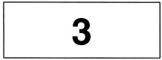  A |  | 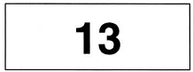  B |  | 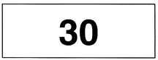  C
- What’s Steve doing now?
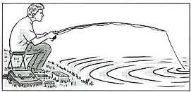  A | 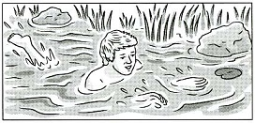  B |  | 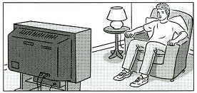  C
2. What did Peter buy today?
  A |   B |  | 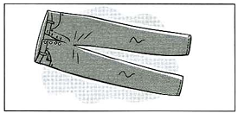  C
3. What time is it?
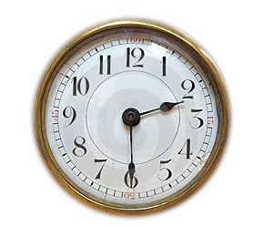  A | 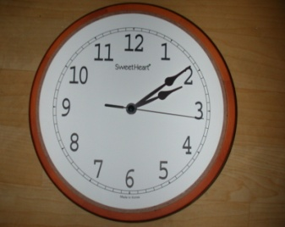  B |  | 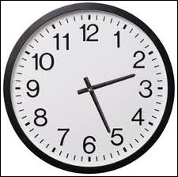  C
4. What was the weather like in Portugal?
  A |   B |  | 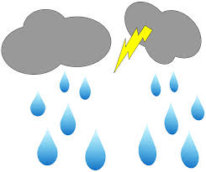  C
5. When’s Wendy’s birthday?
  A | 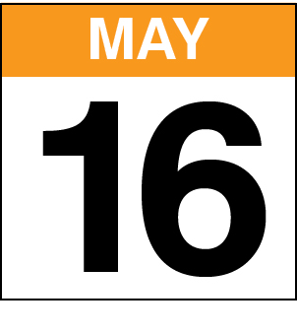  B |  |   C
Question2. You will hear a student telephoning a school. Listen and complete questions 6-10. You will hear the conversation twice. (1,0pt)

Notebook
Name of school: International Language School
Next course begin:
Day: (5) ________________
Date: (6) 3rd ______________
Classes begin at: (7) ___________________
Address: (8) _____________London Road
Near: (9) ___________________

B. GRAMMAR - VOCABULARY- LANGUAGE FUNTION ( 2.0 POINTS)
Choose the correct answer to complete these sentences.
1. He feels ________ after the exam because he did the test very well.
A. stressful B. delighted C. nervous
2. ________, I’d buy an English – Vietnamese dictionary.
A. If I have money B. If I had your shoes C. If I were in your shoes
3. City life not only offers young people with lots of opportunities, but it has lots of ________as well.
A. variety B. advantages C. drawbacks
4. What is the point of trying to stay here when you don’t have a job? You have been ______ for two years!
A. uncomfortable B. unemployed C. unhappy
5. Many teens try to work hard to meet parents’ ______.
A. hope B. expectation C. belief
6. Transportation systems in big cities are often ___________ those in the countryside.
A. more reliable B. more reliably than C. more reliable than
7. Many students do not know ________to get cognitive skills.
A. how B. what C. how much
8. Man: Congratulations! Boy: _____________
A. I’m sorry. B. Thank you. C. What a pity!
9. They have to ________the factory because of the economic problem.
A. close down B. turn down C. pass down
10. If you don’t know the meaning of this word, ________ in the dictionary!
A. look for B. look after C. look up
C. READING (3.0 POINTS)
I. Read the notices and match each of them with a suitable sentence (1.5 points).
1 You can't drive this way.  2 Children do not have to pay.  3 You can shop here six days a week.  4 Be careful when you stand up.  5 We work quickly. | 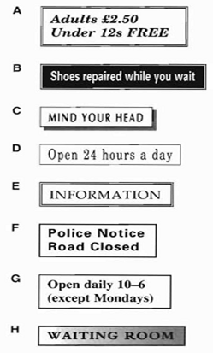
II. Read the text and do the task below (2.0 points)
If you live in a city, you will probably see many people, hear the noise of traffic, and smell the pollution from cars and factories. We are living in a new era in the history of the world. Before this, most people were farmers. They lived in small communities in the country. Now many people are leaving the farms and moving into the cities. They are looking for better jobs. As a result, the cities are growing very quickly. Most cities are becoming more crowded. People are driving more cars, burning more fuel, using more water, eating more food, making more garbage, and producing more things in factories than ever before. Life in modern cities can bring many opportunities, but also many difficulties.
The authorities are trying to plan for a better future. They are building new roads, putting up new houses, looking for more water sources, and limiting growth in certain areas. But people are still crowding into the cities faster than the cities can take them. The cities are running out of space. There are no easy answers to this problem.
1. What is the main idea of the text?
A. Drawbacks of the city life and the solutions.
B. Advantages of living in the city.
C. Disadvantages of living in the city.
2. People tend to move to big cities to _________
A. find jobs B. do farming C. entertain
3. The word “They” in paragraph 1 refers to_________
A. Cities B. People C. Many people
4. Which sentence is NOT true according to the text
A. People used to live in small communities in the country
B. A lot of people move to the city which makes the city more crowded.
C. Life in modern cities only brings many opportunities.
5. How many solutions are mentioned in the plan of authorities for a better future?
A. 3 B. 4 C. 5
D. WRITING (3.0 POINTS)
I. Rewrite the following sentences without changing the meaning (1.0 point)
1. Don’t leave the lights on when you leave the classroom.
=> Turn off______________________________________________________
2. The weather was bad, but we went to school on time.
=> Although_____________________________________________________
3. This handicraft is much more traditional than that one.
=> That handicraft is not __________________________________________
4. “This cinema attracts a lot of youngsters” Jim said.
=> Jim said __________________________________________________
5. He wondered where he should go after the incident.
=> He wondered _________________________________________________
II. Imagine that your American pen friend is coming to Viet Nam and will spend a day in your hometown. He/She has asked for your advice on the places of interest they should go to and the things they can do there. Write an email to give him/her some information (2.0 points)
You can start with:
Dear Tom,
____________________________________________________________________________________________________________________________________________________________________________________________________________________________________________________________________________Bye for now,
Nam
-- The end --

HƯỚNG DẪN CHẤM ĐỀ KIỂM TRA, ĐÁNH GIÁ
GIỮA HỌC KÌ INĂM HỌC 2021-2022
MÔN: TIẾNG ANH 9 – HỆ 10 NĂM
(Hướng dẫn chấm gồm có 01 trang)

A. LISTENING( 2.0 POINTS)
I. Listen and tick () the boxes.(1.0 point). 02x5= 1point
1: B | 2: C | 3: A | 4: B | 5: C
II. Listen and write. (1 point): 02x5= 1pt (wrong spelling: 0pt)
- Monday | - January | - 9.15 | - 57 | - station
B. GRAMMAR – VOCABULARY – LANGUAGE FUNCTIONS(2.0 POINTS)
2 point (0.2 point/ 1 correct answer)
1.B | 2.C | 3.C | 4.B | 5.B | 6.C | 7.A | 8.B | 9.A | 10.C
C. READING (3.0 POINTS)
I.1.5 point (0.3 point/ each correct answer)
1. F 2. A 3. G 4. C 5. B
II.1.0 point (0.2 point/ each correct answer)
1. A 2. A 3. C 4. C 5. B
D. WRITING
I. 1.0 point (0.2 point/ each correct answer)
1. Turn off the lights when you leave the classroom.
2. Although the weather was bad, we went to school on time.
3. That handicraft is not as traditional as this one/ handicraft.
4. Jim said that cinema attracted a lot of youngsters.
5. He wondered where to go after the incident.
II. 2.0 points
* Form: (0,2 point)
- Correct form of an email.
* Task fulfillment: (0,8 point)
- Complete the task with relevant information
- Well – organized.
* Language: (1.0 point)
- accurate grammar. (0,4 point)
- appropriate vocabulary. (0,4 point)
- Correct spelling and punctuation (0,2 point)

-- The end --

