ĐỀ THI CHỌN HỌC SINH GIỎI

Môn: TIẾNG ANH – Lớp: 8 THCS

Thời gian làm bài: 120 phút

PART A. LISTENING (4.0 POINTS)
Hướng dẫn phần thi nghe hiểu:
- Nội dung phần nghe gồm 03 phần, mỗi thí sinh được nghe 2 lần, đĩa CD tự chạy 2 lần.
- Mở đầu và kết thúc phần nghe có tín hiệu nhạc, hướng dẫn chi tiết đã có trong bài nghe.

- You will hear an interview with a singer called Nick Parker who plays in a band called Krispy with his sister Mel.
1. B
2. C
3. A
4. A
5. C
TAPESCRIPT:
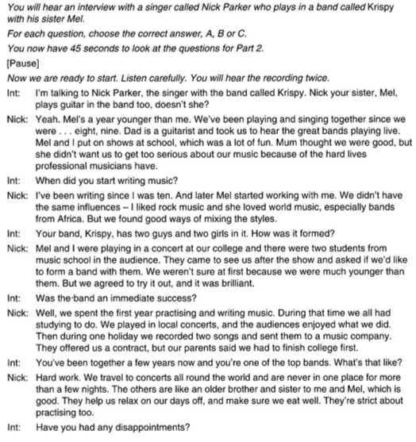
- You will hear a boy called Thomas and a girl called Ruby talking about a poster for their school sports day.

- F 2.F 3. T 4. T 5. F

TAPESCRIPT
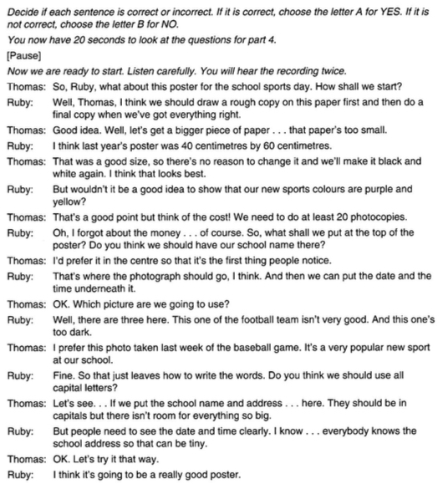

- Complete the notes below.
Write no more than TWO WORDS AND/OR A NUMBER for each answer.

Cycling Holiday In Austria

- 17th April /17 April /April 17/17th April
- 16/sixteen
- 45 km
- swimming pool / pool
- 1,013
- snacks
- helmet/cycle helmet
- Ballantyne
- Route
- theater

TAPESCRIPT:
Cycling Holiday In Austria
Man:
'Holidays for You'. Sean Speaking. Can I help you?
Woman:
Oh hi. I've been looking at your website. Um, I'm interested in a cycling holiday in Austria in April.
Man:
Ah! We have two trips in April - one lasts fourteen days and the other ten days.
Woman:
Mm ... I think the 10-day trip is better. So let's see. I've got a calendar here. What are the dates?
Man:
Well, that trip is in the middle of the month. It starts on the 17th of April and it finishes on the 27th.
Woman:
That suits me. I can't leave work before the 10th of April.
Man:
Let me see if there are any spaces. Is it just for yourself?
Woman:
Myself and my sister - so two of us.
Man:
Um, yes. We have spaces.
Woman:
Is it a big group?
Man:
At the moment there are 12 people booked on this trip and with you two that will be 14. The maximum number is 16 so it's almost fully booked. We can't go over that because it's hard to keep a larger group together.
Woman:
l need to check that ['m fit enough for this but the distances look OK. The website says we'll ride approximately 45km a day. Is that right?
Man:
That's correct and I've got the exact distances here. It really depends on which part of the trip, Some days are only 35km and some are more. But you'!! never have to cycle more than 50km in one day.
Woman:
Oh, OK. I can manage that. And we stay in hotels?
Man:
Yes. They all have restaurants and the rooms have en-suite facilities.
Woman:
And do they have pools? It's how I relax after a long day.
Man:
There is a swimming poof in a few of the hotels but none of them has a gym.
Woman:
I don't think we'll need a gym after all that cycling! I'd better find out how much the holiday costs before I get too excited.
Man:
Including flights it's £1, 177 for one person.
Woman:
Oh, we'll book our own flights on the Internet.
Man:
Ah, that's just£ 1.013 then. And we can book insurance for you if you want.
Woman:
Mm ... and which meals are included in that price?
Man:
Well, er, breakfast of course. And the hotels will provide you with a packed lunch each day.
Man:
We do stop during the afternoon in a village somewhere for a rest, so any snacks you buy then are extra. Then dinner will be in the hotel every evening and that's included in the price of the holiday.
Woman:
And you provide the bicycles of course. What else?
Man:
A lock and a bell come with the bike as well as lights, although you shouldn't need to cycle in the dark. There's a small bag, or pannier, on the front of the bike, where you can put the things you want to take with you during the day like water or fruit.
Man:
But we won't allow you to cycle unless you bring a helmet. We don't provide these locally because, like walking boots on a walking holiday, it's really important it fits properly.
Woman:
OK.
Man:
If there's any special gear you need for your holiday, we recommend a particular website and you can get a discount by quoting your booking reference.
Woman:
Great. What is it?
Man:
It's www.ballantyne.com. That's all one word, and I'll spell it for you: www dot B-A double L-A-N-T-Y-N-E dot com.
Woman:
Good. I've got that down. I've been looking at your website while we've been talking. I see we cycle along the river Danube?
Man:
Yes, it's one of Europe's most well-known areas for cycling.
Woman:
It looks fascinating - lots ·of beautiful countryside and things to see.
Man:
I should warn you that we do reserve the right to make some alterations to the route if the weather is bad. Some of the tracks sometimes get very muddy.
Woman:
OK. Well, hopefully it won't rain too much! I know we stop in towns and villages but do we get a chance to look around? Because I'm really interested in history.
Man:
Oh yes, you get opportunities to explore. Is there something in particular you want to see?
Woman:
There's a theatre in a town called Grein. A friend of mine went there last year and said it was amazing.
Man:
Let's see. Um, ah yes, there's a guide who'll take you round. the building. We don't have any other tours arranged but you can visit several castles and museums on the holiday.
Woman:
Well, thank you for all that information. I'd like to book that then.
Man:
Right. Well, I'll just ...

. PART B. GRAMMAR AND VOCABULARY (6.0 POINTS)
I. Circle the letter A, B, C or D to indicate the correct answer to each of the following sentences. (4pts)
Question 1: - Would you like tea or coffee? - I _______ drink tea than coffee.
A. would like B. would prefer C. would rather D. would wish
Question 2: My mother had to work 12 hours a day in a factory just to _______.
A. make ends meet B. call it a day C. tighten the belt D. break the ice
Question 3: Katie really _______ her mother. She has got the same character.
A. takes after B. takes up C. takes in D. takes on
Question 4: There are a lot of tickets left, so you _______ book for the tickets in advance.
A. mustn’t B. won’t C. shouldn’t D. don’t have to
Question 5: Do you know what made so many people _______ their home?
A. evacuate B. to evacuate C. evacuated D. be evacuated
Question 6: My daughter likes playing with a(n) ______ rope to get lean in the early morning.
A. old black leather skipping B. leather black old skipping
C. skipping black old leather D. leather old black skipping
Question 7: Solar energy is not widely used _______ it is friendly to the environment.
A. since B. although C. in spite of D. because of
Question 8: Could you lend me some more? I’ve spent ______ money you gave me yesterday.
A. Ø B. the C. a D. an
Question 9: Of the two lectures, the first was _______, partly because the person who delivered it had such a dynamic style.
- the better B. better C. best D. the best
Question 10: Each of the guests _______ a bunch of flowers.
A. are given B. is given C. were given D. give
Question 11: I had to get up early, _______ I would miss the train.
A. otherwise B. if not C. so that D. but
Question 12: If you _______ to my advice in the first place, you wouldn’t be in this mess now.
A. listen B. will listen C. listened D. had listened
Question 13: Turn off this machine, please. The harsh sound really _______ me crazy.
A. drives B. takes C. bothers D. worries
Question 14: As is known to all language learners, the newly learnt words will soon be forgotten
unless _______ used in everyday communication.
A. gradually B. loosely C. exactly D. frequently
Question 15: Mark the letter A, B, C or D on your answer sheet to indicate the most suitable response to complete each of the following exchanges.
Nancy and James are talking about their school days.
- Nancy: “I think school days are the best time of our lives.”
- James: “______. We had sweet memories together then.”
A. I’m afraid so B. Absolutely C. That’s nonsense D. I doubt it
Question 16: Either you or your friend _______ on charge today.
A. are B. is C. was D. were
Question 17: It is _______ knowledge in the village that Mr. and Mrs. Thome quarrel violently
several times a week.
A. common B. important C. popular D. general
Question 18: These figures show a _______ in the number of unemployed people in England
and Wales.
A. loss B. lessening C. reduction D. lowering
Question 19: I don’t think she can get her message _______ to the students. She seems too nervous.
A. across B. around C. out D. over
Question 20: Studies indicate _______ collecting art today than ever before.
A. there are that more people B. more people that are
C. that there are more people D. people there are more

II. Give the correct form of the words in the brackets. Write your answers in the blanks. (1pt)
- What tune (play) ________________ when we came in? was being played
- - Can you tell me when the bus for Ho Chi Minh City (leave) ________________ ? leaves
- At 8 every morning.
- Two miles (be) ________________ enough for her to go jogging every morning. is
- Don’t call him at 2.30 p.m. He (interview) ________________ job applicants at that time.
will be interviewing
- - Remember (phone) ________________ Sally tomorrow. to phone
- OK I won't forget.
III. Give the correct form of the words in the brackets. Write your answers in the blanks. (1pt)
- They are waiting for the ________________ of our plane. (ARRIVE) arrival
- The woman cried ________________ when she heard the news. (EXCITE) excitedly
- The boy has cut himself and his finger is ________________ quite badly. (BLOOD) bleeding
- Bell experimented with ways of transmitting ________________ over a long distance. (SPEAK) speech
- She wanted to have her skirt ________________. (LONG) lengthened

PART C. READING (5.0 POINTS)
- Read the text below and think of the word that best fits each gap. Use only ONE word in each gap. There is an example at the beginning (0). Write your answers in the blanks. (1.0 pt)
A mobile phone, also known as a cell phone, is one that we can use to (0) make telephone calls to anyone from a great (1) _________ via a radio link. Apart from telephony, modern smart mobile phones also support a number of other services (2) _________ text messaging, Internet access, gaming, photography, and many business applications.
The first cell phone weighed about 2 kilograms and (3) _________ demonstrated in 1973 by Dr. Martin Cooper and John F. Mitchell of Motorola. Ten years later, in 1983, the first model of cell phone went on (4) _________ to the public. By 2011, over six billion people, 87% of the world’s (5) _________, used mobile networks. In spite of the many (6) _________ a cell phone has, it also brings about several problems that users should be aware of. Mobile phone radiation is believed to be harmful to human health. Some recent studies have found an association (7) _________ cell phone use and certain kinds of brain disease. Another serious problem can be privacy and tracking. Once users have the phone on, they can be interrupted in many ways, and they can also (8) _________ tracked by location data.
(Adapted from https://hoidap247.com/)
(1) distance (2) including (3) was (4) sale

(5) population (6) advantages (7) between (8) be

- Read the following passage and circle the letter A, B, C or D to indicate the correct answer to each of the blanks. (2.0 pts)
BIRTH OF THE COMPUTER
Most people think of computers as very modern inventions, products of our new technological age. But actually the idea for a computer (1) _______ worked out over two centuries ago by a man (2) _______ Charles Babbage. Babbage was born (3) _______ 1791 and grew up to be a brilliant mathematician. He drew up plans for several calculating machines (4) _______ he called “engines”. Despite the fact that he (5) _______ building some of these he never finished any of them. Over the year people have argued (6) _______ his machines would ever work. Recently, however, the Science Museum in London has finished building (7) _______ engine based on one of Babbage’s designs. (8) _______ has taken six years to complete and more (9) _______ four thousand parts have been specially made. Whether it works or not, the machine will be on show at a special exhibition in the Science Museum (10) _______ remind people of Babbage’s work.
(Adapted from https://tuyensinh247.com/)
- A. has B. was C. had D. is
- A. known B. recognized C. written D. called
- A. on B. in C. by D. for
- A. whose B. who C. these D. which
- A. wanted B. made C. started D. missed
- A. until B. whether C. while D. though
- A. some B. the C. an D. that
- A. One B. He C. They D. It
- A. than B. therefore C. when D. then
- A. to B. as C. for D. so
III. Read the following passage and circle the letter A, B, C, or D to indicate the correct answer to each of the questions. (1.6 pts)
As Christmas evolved in the United States, new customs were adopted and many old ones were reworked. The legend of Santa Claus, for example, had origins in Europe and was brought by Dutch settlers to New York in the early 18th century. Traditionally, Santa Claus - from the Dutch Sinter Klaas – was depicted as a tall, dignified, religious figure riding a white horse through the air. Known as Saint Nicholas in Germany, he was usually accompanied by Black Peter, an elf who punished disobedient children. In North America he eventually developed into a fat, jolly old gentleman who had neither the religious attributes of Saint Nicholas nor the strict disciplinarian character of Black Peter.
Santa’s transformation began in 1823, when a New York newspaper published the poem A Visit from Saint Nicholas, which Clement Clark Moore had written to amuse his daughter. The poem introduced many Americans to the story of a kindly saint who flew over housetops in a reindeer-drawn sleigh. Portraits and drawings of Santa Claus by American illustrator Thomas Nast further strengthened the legend during the second half of the 19th century. Living at the North Pole and assisted by elves, the modern Santa produced and delivered toys to all good children. By the late 19th century he had become such a prominent figure of American folklore that in 1897, when Virginia O’Hanlon wrote to the New York Sun newspaper asking if Santa was real, she received a direct answer: “Yes, Virginia, there is a Santa Claus”.
(Adapted from https://tracnghiemtienganh.vn/)
Question 1. Who brought the legend of Santa Claus to the USA according to the passage?
A. Sinter Klaas B. Saint Nicholas C. A German D. Dutch settlers
Question 2. Santa Claus was traditionally described as a _______.
A. tall man who could walk through the air. B. fat, jolly, old man.
C. religious figure. D. fat man riding a Whitehorse.
Question 3. Who was Black Peter?
A. an elf accompanying Saint Nicholas. B. an elf who rode a Whitehorse.
C. one of the disobedient children. D. a popular traditional figure.
Question 4. What word is closest in meaning to “attributes”?
A. symbols of a person B. natural qualities
C. effects D. outer appearance
Question 5. Where did the legend of Santa Claus come from?
A. the North Pole B. Europe
C. North America D. the City of New York
Question 6. According to Clement Clark Moore’s poem, _______.
A. Santa Claus had nothing different in appearance from the tradition alone.
B. Santa Claus had wings and could fly.
C. Santa Claus liked poetry.
D. Santa Claus was a kindly saint who flew over housetops in a sleigh.
Question 7. Which of the following statements is TRUE?
A. Santa Claus was an imaginary old man created by artists based on traditional figures.
B. Living in the North Pole, Santa Claus visited children at Christmas.
C. Santa Claus was a real figure living in northern America.
D. Santa Claus was a story based on Saint Nicholas and Black Peter.
PART D. WRITING (5.0 points)
I. Rewrite each of the following sentences in such a way that it has the same meaning as the first sentence, using the cues at the beginning of each sentence. Write your answers in the spaces provided. (2.0 pts)
- Mary knew what the answer was after reading the book.
By the time Mary knew what the answer was, she had finished reading the book.
- You must never mention this to him.
Under no circumstances must you mention this to him.
- She took extra night classes, so as not to have to repeat the course.
She avoided having to repeating the course by taking extra night classes.
- This was one of the most powerful earthquakes ever.
No other earthquakes were more powerful than this one.
- It was a four-hour flight from Ho Chi Minh to Bangkok.
It took two hours to fly from Ha Noi to Ho Chi Minh city.
- In spite of having a good salary, he was unhappy in his job.
Although he had a good salary, he was unhappy in his job.
- I can't understand him because he speaks so quickly.
If he didn't speak so quickly, I could understand him.
- The garage is going to repair the car for us next week.
We are going to have the car repaired by the garage next week.
- The drama critic of the “daily news” regards the new play as a major breakthrough.
According to the drama critic of the “daily news”, the new play is a major breakthrough.
- That man used to work with me when I lived in New York.
That is the man who used to work with me when I lived in New York.

II. Complete the second sentence so that it has a similar meaning to the first sentence, using the word given. Do not change the word given. You must use BETWEEN THREE AND FIVE WORDS, including the word given. Write your answers in the spaces provided. (1.0 pt)
  - It was raining cats and dogs. (TORRENTS)
The rain was COMING DOWN IN TORRENTS.
  - It was wrong of you to borrow my book without asking. (HAVE)
You SHOULD HAVE ASKED ME for permission before you borrowed my book.
  - When I was younger, this record was one of my favorites. (FAVORITE)
This record used TO BE A/ ONE FAVORITE OF mine when I was younger.
  - My sister finds commuting every day annoying. (PUT)
It’s difficult for my sister PUT UP WITH commuting every day.
  - When he arrived at the airport, his family welcomed him warmly. (ARRIVAL)
On HIS ARRIVAL AT THE AIRPORT, he was given a warm welcome by his family.

III. Image that you have a friend in another country and you would like to invite him or her to visit your village.
Write a brief introduction (about 120 -150 words) to attract him/her to visit your village. (2.0pts)
---- THE END ----

