School: ……………………………………….. | Date:……………………………………..
Class: ……………………………..................... | Period: 16

UNIT 2: LILE IN THE COUNTRY
Lesson 2.2 - Grammar, pages 19 & 20
1. Objectives
By the end of this lesson, students will be able to…
1.1. Language knowledge/ skills
- learn, practice and use Verbs expressing preference + to infinitive and adverbs of frequency
1.2. Competences
- improve Ss’ communication, collaboration, analytical, critical thinking skills.
1.3. Attributes
- have knowledge about folk games.
2. Teaching aids and materials
- Teacher’s aids: Student’s book and Teacher’s book, class CDs, DCR– Phần mềm tương tác trực quan, DHA – Ứng dụng trò chơi tương tác, projector / interactive whiteboard /TV (if any), PowerPoint slides.- Students’ aids: Student’s book, Workbook, Notebook.
3. Assessment Evidence
Performance Tasks | Performance Products | Assessment Tools
- Read about verbs (to express preference) + to-infinitives and adverbs of frequency, then fill in the blanks to complete a conversation.  - Read the examples and unscramble the sentences.  - Write sentences using the prompts.  - In pairs: Ask and answer about what An likes to do. | - Ss’ answers.  - Ss’ answers.  - Ss’ answers.  - Ss’ answers. | - Observation.  - Observation.  - Observation.  - Observation.
4. Procedures
A. Warm up: 5’
a. Objective: to review vocabulary about folk games.
b. Content: vocabulary game
c. Expected outcomes: Ss can name the folk games they have learned.
d. Organization
Teacher’s activities | Students’ activities
Word race  - Divide the class into two groups.  - Pick one student at a time to mime the game given in a piece of paper; ask the two groups to guess; decide the winner with mor correct guesses. | -Play the game in two groups  Possible words:  Tug of war, hide and seek, herd buffalo, pick flowers, play soccer, spinning tops, jump rope, fly a kite.
B. New lesson (35’)
1. Presentation: 15’
a. Objective: to help Ss know the verb form after Verbs (to express preference) and how to use Adverbs of frequency correctly.
b. Content: tasks a & b.
c. Expected outcomes: Ss can use to infinitive after Verbs (to express preference) and use Adverbs of frequency correctly.
d. Organization
Teacher’s activities | Students’ activities
Verbs (to express preference) + to -infinitives - Ask Ss to read the sentences below and circle the Verbs (to express preference) and underline the verbs after them, then answer the question:  What’s the form of the verbs after verbs to express preference.  A: What do kids in your town like to do?  B: They like to play tug of war here.  - Pick some Ss to give the answers.  - Check their answers.  - Give some more examples:  I love to play folk games.  She prefers to play spinning tops.  They don't like to go to the park.  Adverbs of frequency  - Write some adverbs of Frequency on the board: never, rarely, sometimes, often, usually, always.  - Ask Ss to insert the adverbs of frequency on the time line:  - Pick some Ss to give the answers.  - Check their answers.  - Introduce the use of Adverbs of frequency: to say how often things happen.  - Review the positions of Adverbs of frequency by asking Ss to complete the rules with after or before:  We use adverbs of Frequency … verbs and … To Be.  - Pick some Ss to give the answers.  - Confirm their answers.  Task a: Read about verbs (to express preference) + to-infinitives and adverbs of frequency, then fill in the blanks.  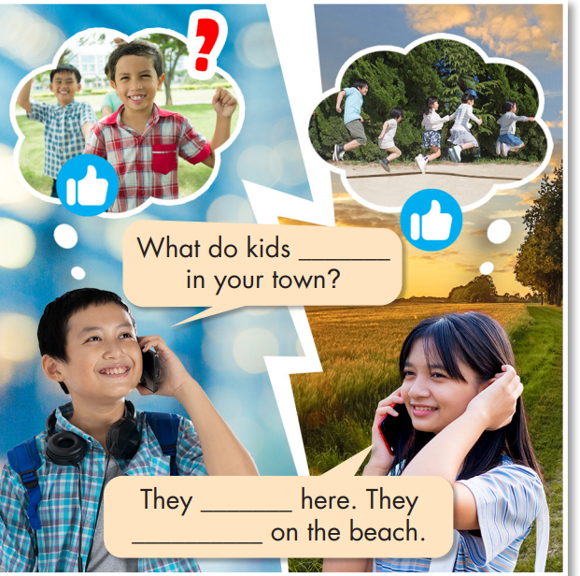  - Ask Ss to read about verbs (to express preference) + to-infinitives and adverbs of frequency, then fill in the blanks with appropriate words.  - Get Ss to check with their partners.  - Pick some Ss to give their answers.  Task b. Listen and check your answers. Listen again and repeat.  - Ask Ss to listen and check.  - Pick some Ss to share their ideas.  - Check their answers.  - Ask Ss to listen again and repeat chorally.  - Pick some pairs to read the conversation again and check their pronunciation if necessary. | - Read the sentences below and circle the Verbs (to express preference) and underline the verbs after them, then answer the question  Answer keys:  To infinitive  -Listen and take notes.  -Insert the adverbs of frequency on the time line.  -Give their answers.  Answer keys:  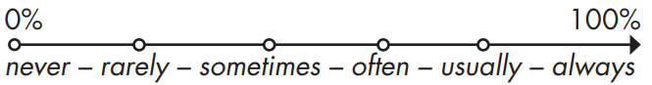  Answer keys:  We use adverbs of Frequency before verbs and after To Be.  - Read about verbs (to express preference) + to-infinitives and adverbs of frequency, then fill in the blanks.  - Check with their partners.  - Give their answers.  -Listen and check.  - Give their answers.  Answer keys:  What do kids like to do in your town?  They like to jump rope here. They usually jump rope on the beach.  -Listen and repeat.
2. Practice: 15’
a. Objective: to help Ss practice using Verbs (to express preference) + to -infinitives and Adverb of Frequency correctly.
b. Content: tasks a, b, and c.
c. Expected outcomes: Ss can talk about the activities they like doing and how often they do them using Verbs (to express preference) + to -infinitives and Adverb of Frequency.
d. Organization:
Teacher’s activities | Students’ activities
Task a: Read the examples and notes above, then unscramble the sentences.  - Introduce the task.  - Ask Ss to unscramble the sentences.  - Let Ss check with their partner.  - Pick some students to write their sentences on the board.  - Check their sentences.  1. visit/to/love/We/the/country.  2. to/games./He/folk/prefers/play  3. play?/she/like/Where/does/to  4. play/to/don't/shuttlecock./like/I  5. they/hometown?/to/their/Do/like/visit  6. spinning/with/never/play/tops/my/sister./I  7. herd/buffalo/you/always/on/weekends?/Do  8. play/games/folk/in/cities./rarely/People | - Unscramble the sentences  - Check with their partner.  - Write their answers.  Answer Keys:  1. We love to visit the country.  2. He prefers to play folk games.  3. Where does she like to play?  4. I don't like to play shuttlecock.  5. Do they like to visit their hometown?  6. I never play spinning tops with my sister.  7. Do you always herd buffalo on the weekends?  8. People rarely play folk games in cities.
Task b: Write sentences using the prompts.  - Ask Ss to write sentences using the prompts.  - Let Ss check with their partner.  - Pick some Ss to write their answers on the board.  - Check their answers.  1. I/like/visit/country.  2. she/prefer/jump rope?  3. what/kids/like/play/here?  4. he/like/play/tug of war.  5. we/not/like/pick/flowers.  6. we/not/often/play spinning tops/after school.  7. who/she/usually/jump rope/with?  8. people/my hometown/sometimes/play/folk games.  Task c: In pairs: Ask and answer about what An likes to do.  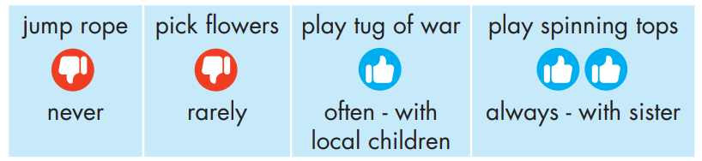  - Ask Ss to work in pairs to ask and answer about what An likes to do.  - Pick some pairs to speak.  - Give feedback. | - Write sentences using the prompts.  - Check with their partner.  - Write their answers on the board.  Answer keys:  1. I like to visit the country.  2. Does she prefer to jump rope?  3. What do kids like to play here?  4. He likes to play tug of war.  5. We don't like to pick flowers.  6. We don't often play spinning tops after school.  7. Who does she usually jump rope with?  8. People in my hometown sometimes play folk games.  -Work in pairs to ask and answer about what An likes to do.  Sample:  A: Does An like to jump rope?  B: No, she doesn't. She never jumps rope.
3. Production: 5’
a. Objective: to help Ss use the language in real situation.
b. Content: Speaking activity.
c. Expected outcomes: Ss can talk about their schedule using Present Simple Tense and prepositions of time appropriately.
d. Organization:
Teacher’s activities | Students’ activities
- Ask Ss to work in pairs to ask and answer about what they like doing for fun and how often they do those activities.  - Pick some pairs to speak.  - Give feedback. | - Work in pairs to ask and answer about what they like doing for fun and how often they do those activities.  Sample:  A: What do you like to do for fun?  B: I prefer to play sports. I often play badminton with my friends after school.
C. Consolidation and homework assignments: 5’
- Grammar: Verbs (to express preference) + to -infinitives and Adverbs of Frequency.
- Do exercises in workbook on page 11.
- Prepare the next lesson: Lesson 2.3 – Pronunciation & Speaking, pages 21 & 22
- Do the exercises in Tiếng Anh 8 i-Learn Smart World notebook (page 16).
5. Reflection

a. What I liked most about this lesson today:
…………………………………………………………………………………………
b. What I learned from this lesson today:
…………………………………………………………………………………………
c. What I should improve for this lesson next time:
…………………………………………………………………………………………

