|  |  |
| --- | --- |
|  | *Thời gian làm bài: 40 phút (Không kể thời gian giao đề)*  *-------------------------* |

**Họ tên thí sinh: .................................................................**

**Số báo danh: ......................................................................**

**Mã Đề: 012.**

**Câu 1.** **Look at the signs. Choose the best answer for the question.**

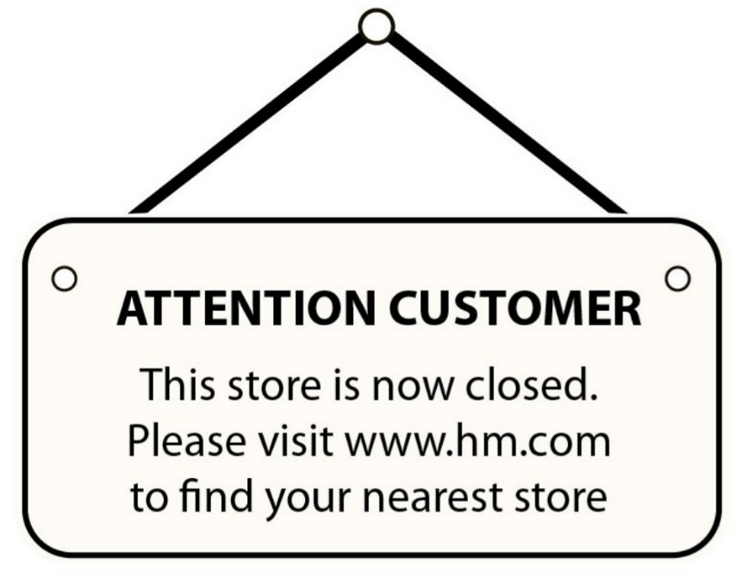

**A.** You can visit the website to find the nearest location that is open.

**B.** This store will be moved to the nearest location.

**C.** You should pay attention when you find the nearest store.

**D.** Please visit the website and shop online.

**Câu 2.** What is the condition of the bicycle's tyres according to the advertisement?

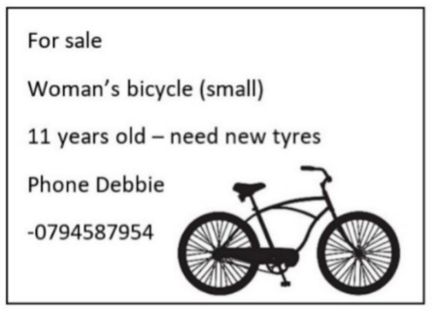

**A.** They are brand new  **B.** The advertisement doesn't mention the tyres

**C.** They need to be replaced  **D.** They are in good condition

**Câu 3.** What subject does John need help with?

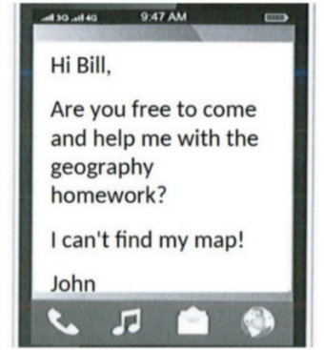

**A.** Geography  **B.** Math  **C.** English  **D.** History

**Câu 4.** What should visitors do if the gate is closed?

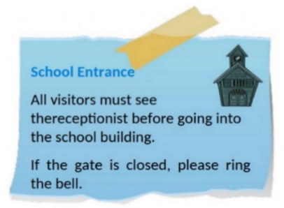

**A.** Call the school office  **B.** Ring the bell

**C.** Come back later  **D.** Wait for someone to open it

**Câu 5.** "What activity is the person inviting their friend to do?"

Hey friend! I hope you're having a good day. I wanted to see if you're up for watching a film this weekend. I heard that a new blockbuster just came out and it's supposed to be really good. Let me know if you're free and we can catch it together.

**A.** Attend a play  **B.** Read a book  **C.** Watch a film  **D.** Go to a museum

**Câu 6.** **Look at the signs. Choose the best answer for the question.**

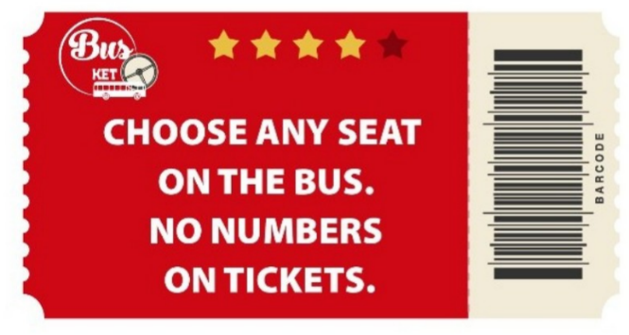

**A.** There aren’t any numbers on the seats.

**B.** You have to choose your seat when you buy tickets.

**C.** The tickets don’t show bus numbers.

**D.** You may sit where you like.

**Câu 7.** What is Peter asking Helen to bring to the barbecue?

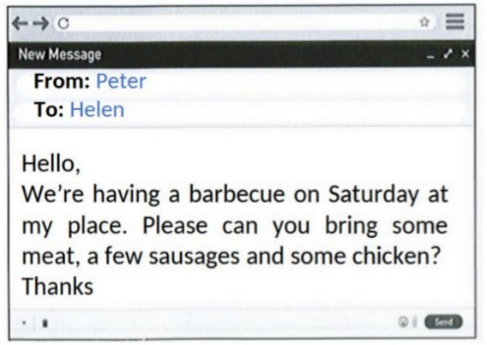

**A.** Meat, sausages, and chicken  **B.** Bread and condiments

**C.** Dessert and side dishes  **D.** Drinks and salad

**Câu 8.** What does this sign mean?

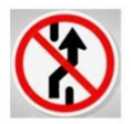

**A.** No parking here.  **B.** Roundabout ahead

**C.** Prohibit Changing Lane  **D.** Slippery road.

**Câu 9.** How long does the reading competition last?

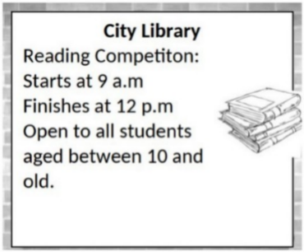

**A.** 4 hours  **B.** 2 hours  **C.** 3 hours  **D.** 5 hours

**Câu 10.** **Look at the signs. Choose the best answer for the question.**

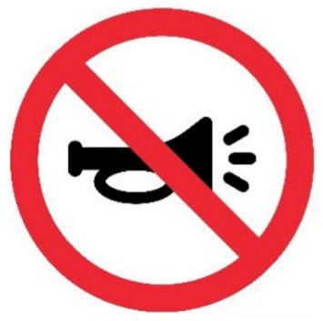

**A.** You don’t have to use the horn in this area.  **B.** There aren’t any horns in this area.

**C.** You mustn’t use the horn in this area.  **D.** You should use the horn only in an emergency.

**----HẾT---**