PHÒNG GIÁO DỤC VÀ ĐÀO TẠO NINH GIANG | ĐỀ KHẢO SÁT HỌC SINH GIỎI  Môn: Tiếng Anh 7  Năm 2024-2025
A. LISTENING (20 pts)
Part I. Listen to five short recordings and for each recording you have to choose the best of three pictures (A, B or C). (5 pts)
1. How will they book their flights?
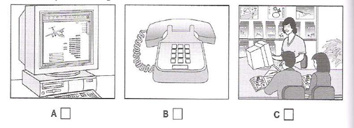
2. What has the daughter forgotten to bring on holiday?
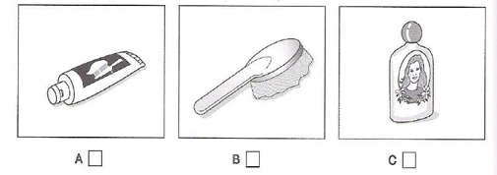
3. What will the man and woman do on Sunday?
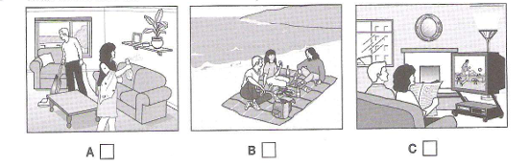
4. Which blouse does the girl decide to buy?
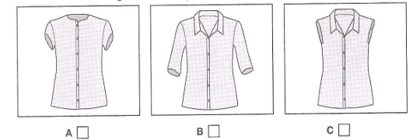
5. When is the girl having a party?
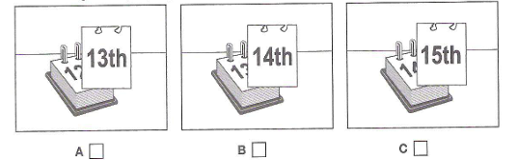
Part II. Listen and write the answers. (5 pts)
You will hear a radio presenter talking about a museum where you can see a new film.
Listen and fill in the missing information in the numbered space.
FILM AT THE SCIENCE MUSEUM
The Film
Day it is on : Sunday
Time last performance starts : (1)……………….
Other things to do at the museum:
- Use the (2)…………….. in the basement
- See a model (3)……………… on the first floor
- Try the café on the (4)……….. floor
How to get free tickets for the film
- Send an email before 12 o’clock on (5)………………
Part III. Listen to the recording twice. Do some tasks as directed. Questions 1-5. Choose the correct letter, A, B or C (5 points)
Example
0. How long has Sally been waiting?
A. five minutes B. twenty minutes C. thirty minutes
1. What does Peter want to drink?
A. tea B. coffee C. a cold drink
2. What caused Peter problems at the bank?
A. The exchange rate was down. B. He was late. C. The computers weren’t working.
3. Who did Peter talk to at the bank?
A. an old friend B. an American man C. a German man
4. Henry gave Peter a map of
A. the city. B. the bus routes. C. the train system.
5. What do Peter and Sally decide to order?
A. food and drinks B. just food C. just drinks
PART IV. Listen to a conversation between a boy, Tom, and his sister, Clare, about school and decide whether each of the following statements is True (T) or False (F). (5 pts)
1. Clare thinks their father will be pleased by Tom’s news. T/F
2. Tom believes he can manage both swimming and school work T/F
3. Tom’s teacher thinks Tom is clever T/F
4. Tom dislikes doing maths. T/F
5. Clare thinks it is a bad idea to take a friend’s advice. T/F

B. LEXICO - GRAMMAR (25 pts)
I. Choose the best answer to complete the sentence. (9 pts)
1. The Imperial Academy was constructed ………….. Emperor Ly Nhan Tong
A. within B. under C. behind D. above
2. This is a(n)______________on real life during wars in Vietnam in 1945.
A. horror film B. sci-fi C. comedy D. documentary
3. This is ………smart vehicle; ……………..is over there.
A. her- our B. her-ours C. hers – ours D. hers-our
4. I think you should take up swimming________ it is suitable for your health condition.
A. so B. because C. although D. but
5. Let’s collect and__________________ warm clothes to homeless children in our city
A. put on B. give back C. take off D. give away
6. Life in Ho Chi Minh City is ________ than we thought at first.
A. far the busier B. the more busier C. much more busy D. much busier
7. South-East Asia has many tourist ________.
A. landmarks B. places C. spots D. attractions
8. A: “Would you mind lending me your bike?”
B:………………….
A. Yes, let’s B. Yes. Here it is C. Great D. Not at all
9. “How about an evening river boat tour? ” “……………..”
A. No, it’s good to do so.
B. Actually I’ve never gone on an evening river boat tour.
C. No, I’ve never gone an evening river boat tour
D. Actually I’ve gone twice this week.
Read the following advertisement and announcement. Mark the letter A,B,C or D to indicate the correct option that best fits each of numbered blanks ( 6pts)
Part 1:
ADVERTISEMENT
WORK FOR SCHOOL COFFEE
School Coffee is a gathering (1) for secondary school students. Do you have excellent communication skills? Can you work in a (2) ? Are you willing to learn? A lot of teenagers and adults come and work with us, so start your weekend job with us:
- Choose the hours you work
- (3) work experience
- Meet talented peers and mentors.
Join us as a team member, assistant manager or content writer. Contact: Ms.Thu An. 789 Dinh Tien Hoang Street, Binh Thanh District, Ho Chi Minh City.
- A. mark B. point C. rooftop D. balcony
- A. canteen B. food court C. team D. food center
- A. Gain B. Share C. Adopt D. Offer
Part 2:
ANNOUNCEMENT
Have you always wanted to know the secrets of professional quality black-and-white nature photography? In our first class, held (1) Thursday evening, we will discuss exposure, composition, lighting, and equipment. Saturday (2) an all-day outdoor shooting session. Sunday, participants practice simple darkroom techniques and develop the photos shot on Saturday.
The workshop ends Monday evening with a review and critique of photographs taken. Bring camera, four (3) of black-and-white film, and enthusiasm.
Location: Middleton Recreation
Center Dates: Oct. 12, 14, 15, and 16
Fees: City residents: Advance registration $75 On-site registration $80
Non-city residents: Advance registration $95 On-site registration $100
- A. In B. on C. at D. from
- A. celebrate B. plays C. involves D. jogs
- A. papers B. rolls C. tins D. bars
III. There are 5 mistakes in this passage. Find and correct them (5pts)
We are students and we are sure that you are interested to sports. Many of you certainly play such games as volleyball or football, basketball or tennis. People whose play a game are players. Players form teams and plays matches against each other teams – their opponents. Two people play with each other are partners. Each team can lose or win. In a football match, players try to score as much goals as they can.
There are so many kinds of sports such as cycling, boxing, swimming, gymnastics, rowing and many more. You could take an active part in all of them or you can just be a devoted fan. Eveybody may choose the sport he is fond of or interested in.
1………………. 2………………. 3…………………….
4…………………. 5………………….
IV. Give the correct form of the words in CAPITAL to complete the sentences. (5pts)
1. We shouldn’t eat too much ___________ food and sugar. (FAT)
2. My brother is a good football ___________. (PLAY)
3. We are all ________ about going on an excursion to Cuc Phuong forest next weekend. (EXCITE)
4. Mai is ________ at Math than me. (GOOD)
5. There are thirty-six ____________ in our school (CLASS)
C. READING (25 pts)
I. In the following text, five sentences or parts of sentences have been removed. Above the extract you will find the six removed sentences PLUS one sentence which doesn't fit. Choose from the sentences (A-F) the one which fits each gap (1-5). Remember, there is one extra sentence you do not need to use. Write the correct letter in the box. (5pts)
A I was much more confident than before.
B None of them spoke any French.
C It's often difficult for us to get the teacher’s attention.
D Usually all my lessons are the same.
E But at the college there was huge electronic board.
F This allowed each student to get more individual attention.
My experience at Summer school
by Francoise Armand, aged 13
Last summer I went to a summer school in Oxford to study English. We studied at a college where adults normally study. The classrooms were very modern. In my classroom at school, the teacher writes on a blackboard (1)……………. The teacher could display photos or video clips on it. It was really cool.
The summer school was different from my normal school in France. The classes were a lot smaller. We only had sixteen pupils in the class in Oxford, but at my school in France there are over thirty five (2)………… It was also easier for the teacher to control the class, which meant that we wasted less time.
The lessons were a lot different to the kind of lessons I’m used to. In my normal school, we have a course book and we spend our lessons doing exercises from it(3)…………….At summer school, though, we did lots of different activities, such as games, songs and role plays. Because of the variety, I rarely got bored.
Overnight, we all stayed with different families in the city. I stayed with a couple and their teenage daughter(4)……………… I was forced to speak English! I had to learn the words for things, or to go without them! At the time, I didn’t think I learned very much in England. But when I returned to my normal school, I noticed the improvement (5)………….. I had got better by having fun and communicating with English people. All in all, summer school was a useful experience and I recommend it to all teenagers!
II. Read the passage and choose the best option. Cirle A, B, C or D (10 pts)
Drawing has always been a very popular hobby. Young children draw with a pencil as (1).................as they can hold one. Drawing is often seen as a special skill, and it is (2) ..........that some people seem to draw perfect pictures without any effort. Yet drawing, like writing, can be (3) …………;you can draw accurately if you work really hard at it. Drawing is first (4) ……………..all about looking carefully. It sounds easy to say that all you (5)…………….to do is look at things, but it really is that simple. The best way to draw a familiar (6)………….. is to imagine that you are looking at it for the first (7)………………
Nowaday, there are (8) ……………… courses and materials available than ever before (9)……………..means that you can experiment to improve your skills. The only (10)……………….. is your imagination.
1. A. fast B. immediately C.soon D. shortly
2. A. true B. actual C. exact D. real
3. A. discovered B.made C. learnt D. reached
4. A. of B. in C. from D. for
5. A. should B. need C. must D. could
6. A. topic B. subject C. area D. person
7. A. period B. term C. moment D. time
8. A. more B. many C. plenty D. much
9. A. who B. what C. where D. which
10.A. final B. end C. limit D. finish

III. Read the passage and choose the correct answer to each of the questions.

(10 pts)
BOOKS IN YOUR LIFE
It is often said that books are always a good friend and reading is an active mental process. Unlike TV, books make you use your brain. By reading, you think more and become smarter. Reading improves concentration and focus. Reading books takes brain power. It requires you to focus on what you are reading for long periods. Unlike magazines, Internet posts or e-emails might contain small pieces of information. Books tell the whole story. Since you must concentrate in order to read, you will get better at concentration. Many studies show if you do not use your memory; you lose it. Reading helps you stretch your memory muscles. Reading requires remembering details, facts and figures and in literature, plot lines, themes and characters.
Reading is a good way to improve your vocabulary. Do you remember that when you were at elementary school you learned how to infer the meaning of one word by reading the context of the other words in the sentence? While reading books, especially challenging ones, you will find yourself exposed to many new words.
Reading is a fundamental skill builder. Every good course has a matching book to go with it. Why? Because books help clarify difficult subjects. Books provide information that goes deeper than just classroom discussions By reading more books you become better informed and more of an expert on the topics you read about. This expertise translates into higher self-esteem. Since you are so well-read, people look to you for answers. Your feelings about yourself can only get better.
Books give you knowledge of other cultures and places. The more information you have got, the richer your knowledge is. Books can expand your horizons by letting you see what other cities and countries have to offer before you visit them.
1. What do you use when you read books?
A. eyes B. ears C. hands D. brain
2. What media helps you be smarter in the text?
A Books B. Internet C. Television D. Radio
3. It is said that if you don't use your memory you will ____________
A. hide it in your mind. B. lose it. C. enrich it. D. waste it.
4. Why is reading most good for you?
A. You can relax. B. You must use most of senses and skil
C. You can only use eyes to read. D. You can have lot of fun.
5. By reading you can____________
A. enrich your vocabulary. B. know a few words.
C. get tired. D. do the same as you were in elementary school.
6. Why does every course have a matching book to go with it?
A. For students to read. B. To clarify difficult subjects.
C. For teachers to teach easily. D. To support vocabulary.
7. What activity in class gives more information?
A. Discussions B. Listening C. Writing D. Reading
8. What feeling does reading books help you?
A. more confident. B. more comfortable C. more relaxing D. more active.
9. According to the writer, the main benefit of reading is____________
A. supporting vocabulary. B. building a fundamental skill.
C. supporting information about the cities and countries. D. A, B and C
10. According to the text, reading books is ____________
A. the most useful way for practise the brain. B. not as good as surfing the internet.
C. the same as watching television . D. not suitable today anymore.
D. WRITING (25 pts)
I. Finish each of the following sentences in such a way that it is as similar as possible in meaning to the original sentence. (5 pts)
1. Although he is old, he still runs 5 kms in the morning.
=> In spite of his ……………………………………………………………...............
2. The new building is as the old one.
=> The new building is the same ……………………………………………………….
3. It takes my teacher of Literature about fifteen minutes to walk to school to every day.
=> My teacher of Literature spends …………………………………………………
4. Learning Chinese is very difficult for me.
=> It………………………………………………………..…………………………
5. Our summer vacation lasts two months.
=>We have a…………………………………………………………………………
II. (10 pts) This is part of a letter you receive from a pen friend.
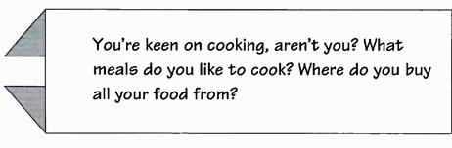
Now write a letter answering your penfriend’s questions (about 60-80 words).

Dear Jenny,
.........................................................................................................................................................................................................................................................................................................................................................................................................................................................................................................................................................................................................................................................................................................................................................................................................................................................................................................................................................................................................................................
Love,
Josh.
III. Write a composition of at least 100 words to talk about the volunteer activity you took part in. You may use the following questions to help you. (15 points)
* What volunteer activity did you take part in?
* How did you do it?
* What are the benefits of it?
..............................................................................................................................................................................................................................................................................................................................................................................................................................................................................................................................................................................................................................................................................................................................................................................................................................................................................................................................................................................................................................................................................................................................................................................................................................................................................................................................................................................................................................................................................................................................................................................................................................................................................................................................................................................................................................................................................................................................................................................................................................................................................................................................................................................................................................................................................................................................................................................................................................................................................................................................................................................................................................................................................

PHÒNG GIÁO DỤC VÀ ĐÀO TẠO NINH GIANG | ĐÁP ÁN, BIỂU ĐIỂM, HƯỚNG DẪN CHẤM ĐỀ KHẢO SÁT HỌC SINH GIỎI MÔN TIẾNG ANH 7

Câu |  | Đáp án + Biểu điểm + Hướng dẫn chấm | Điểm
A. LISTENING
I. |  | Tổng 5 điểm. Mỗi câu trả lời đúng cho 1 điểm  1. C 2. C 3. B 4. B 5. A | 5 điểm  1x5
II. |  | Tổng 5 điểm. Mỗi câu trả lời đúng cho 1 điểm  1. 5 p.m/ five o’clock 2. Computer(s) 3. Space(-)ship 4. top  5. Friday | 5 điểm  1x5
III |  | Tổng 5 điểm. Mỗi câu trả lời đúng cho 1 điểm  1. C 2. C 3. B 4. B 5. A | 5 điểm  1x5
III. |  | Tổng 5 điểm. Mỗi câu trả lời đúng cho 1 điểm  1. F 2. T 3. T 4. F 5. T | 5 điểm  1x5
B. LEXICO - GRAMMAR
I |  | Tổng 9 điểm. Mỗi câu trả lời đúng cho 1 điểm  1. B 2. D 3. B 4. B 5. D 6. D 7. D 8. D 9. D | 9 điểm  1x9
II |  | Tổng 6 điểm. Mỗi câu đúng cho 1 điểm  Part 1: 1. B 2.C 3.A  Part 2: 1.B 2. C 3.B | 6 điểm  1x6
III |  | Tổng 5 điểm. Mỗi câu đúng cho 1 điểm  1. to → in 2.whose → who 3. Plays → play  4. much → many 5. Could → can | 5 điểm  1x5
IV |  | Tổng 5 điểm. Mỗi câu đúng cho 1 điểm  1.fatty 2. player 3. excited 4. better 5. classes | 5 điểm  1x5
C. READING
I |  | Tổng 5 điểm. Mỗi câu đúng cho 1 điểm  1.E 2.F 3.D 4.B 5.A | 5 điểm  1x5
II |  | Tổng 10 điểm. Mỗi câu đúng cho 1 điểm  1. C 2. A 3. C 4. A 5. B 6.B 7.D 8.A 9.D 10.C | 10điểm  1x10
III |  | Tổng 10 điểm. Mỗi câu đúng cho 1 điểm  1.D 2.A 3.B 4.B 5.A 6.B 7.D 8.A 9.D 10.A | 10 điểm  1x10
D. WRITING
I | Tổng 5 điểm. Mỗi câu đúng cho 1 điểm  - In spite of his age, he still runs 5kms in the morning  - The new building is the same height as the old one.  - My teacher of Literature spends about fifteen minutes walking to school every day.  - It is very difficult for me to learn Chinese.  - We have a two-month vacation. |  | 5 điểm  1x5
II | + Language: 5 điểm  + for correct grammar (prepositions, articles, tenses...) 2 điểm  + for vocabulary (wide range of vocabulary, spelling), use of suitable connectives... 2 điểm  + for a good format of a passage. 1 điểm  Nếu sai 1 lỗi ngữ pháp hoặc 2 lỗi chính tả giảm 1 điểm |  | 10 điểm
III |  |  | 15 điểm
  + Language: | 10điểm
  + for correct grammar (prepositions, articles, tenses...) | 2 điểm
  + for vocabulary (wide range of vocabulary, spelling), use of suitable connectives... | 2 điểm
  + for a good format of a passage. | 1 điểm
  Nếu sai 1 lỗi ngữ pháp hoặc 2 lỗi chính tả giảm 1 điểm
 | Tổng toàn bài |  | 100 điểm

