Mã đề 7.1.1 | ĐỀ KIỂM TRA GIỮA KỲ I  Năm học: 2022 - 2023  Môn : TIẾNG ANH 7  Thời gian làm bài: 60 phút  (Đề thi gồm : trang)
A. LISTENING. (2.0 pts)
I. Listen and tick the box. (1.0 pt)
1. What has Richard hurt ?  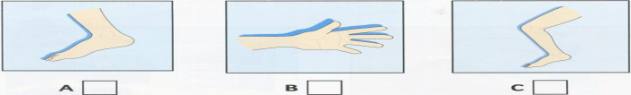  2. Where are Richard’s football shorts ?  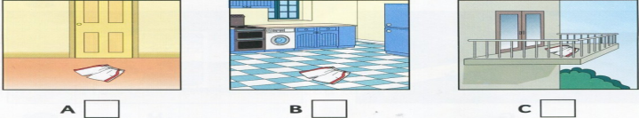  3. What does Richard need for football ?  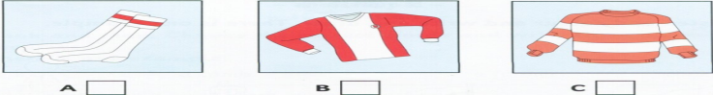 | 4. What is Richard going to do on Friday evening ?  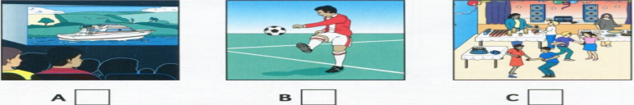  5. What’s Richard going to do first ?  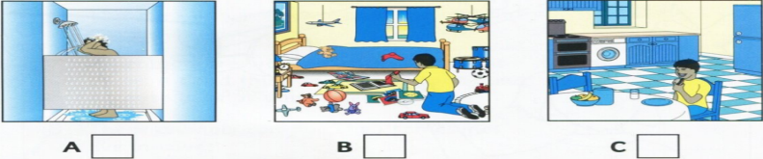
II. Listen and write. There is one example. (1.0 pt)
My aunt’s job
Kind of job: cook
1. Where she works: in a.…………………………………………….
2. How she gets there: by……………………………………………….
3. Time she starts work: ……………………………………………..a.m
4. What she makes: …………………………………………………
5. What she wears at work: …………………………………………………
B. LANGUAGE. (3.0 pts)
Choose the word whose underlined part pronounced differently from that of the others by circling A, B, C
1. A. how B. low C. slow
2. A. stopped B. played C. listened
Choose the best option (A, B, C or D) to complete these sentences.
3………………. have you had your hobby? ~ For three years.
A. How much B. How long C. How often
4. Hoa looks red. She was outdoors yesterday. Perhaps she has ...................
A. flu B. sunburn C. spots
5. You need to be ……………….to follow eggshell carving because it may take two weeks to complete one shell.
A. paitent B. interested C. fast
6. She wants to lose weight, ………………. he began jogging last Sunday.
A. because B. and C. so
7. Eat...............junk food and do..............exercies to keep fit and stay healthy.
A. less/more B. more/ more C. more/ less
8. If you love flowers and plants, your hobby is……………….
A. collecting B. doing gardening C. dancing
9. My brother doesn’t like ice-skating because he thinks it is……………….
A. funny B. interesting C. dangerous
10. Ngoc loves ………………… outdoors with trees and flowers.
A. plays B. play C. playing
11. Tim: “I feel itchy and my nose is running”. Doctor: “……………….”.
A. Wash your hair more. B. I think you have the flu. C. Drink more water. Eat less meat
12. Shall we go camping this weekend?
A. That's a good idea. B. You’re welcome. C. Yes, you’re right.
13. My school is ……………….it was when I last visited it 2 years ago.
A. same as B. the same C. different from
Circle the letter A, B, C or D under the word/ phrase that needs correcting.
14. I felt excting when I visited my old village with my friends last week.
A B C D
15. you should does homework carefully before going to school.
A B C D
C. READING. ( 2.5 pts)
I. Choose the best answer to fill in the blank. (1.0 pt)
Model making means making very small replicas of real life objects. You can (1) ………… models of many things world. But the most (2)………… models are models of people, aircraft,and war manchines like tanks or ships. Another very popular type of model making is architectural. It means that people make models (3)……...........buildings and even groups of buildings.The first thing to do is to indentify the item you like the most. (4) ……...........should be practical and affordable. The planes will be in kit form and you will have the joy of assenbling the full model plane. If you (5)……….. new to this hobby, you should something simple to start with.
1. A. making B. to make C. make
2. A. good B. popular C. bad
3. A. Of B. in C. at
4. A. They B. It C. them
5. A. are B. was C. is
II. Read the passage and, for Questions 1 - 5, choose the best option. ( 1.5 pts)
Many people continue to forget breakfast despite its being the most important meal of the day. Busy people often go out the door in the mornings without giving their bodies the energy they need to handle a long day at work. They end up feeling tired by the afternoon and resort to the office snack machine or biscuit tin.
Loysa Hourigan, from Nutrition Australia, said that catching up on food at lunchtime did not provide the body with enough sustenance to keep it going for the rest of the day. “Even if you have had lunch, you won’t have as much food as you need. Your brain gets depleted of glucose and you feel tired.” Ms. Hourigan said.
According to Ms. Hourigan, wholegrain bread and cereals provide endurance. Milk, eggs, and baked beans provide protein, which helps people to be alert. Rolled oats are also an excellent endurance food.
1. According to the passage, people should………… .......
A. have breakfast B. forget lunch C. not have breakfast
2. The word “energy” in the passage means……………..
A. food B. meal C. calories
3. Ms. Hourigan said that if we did not have breakfast, we would feel tired because……………
A. our brain ran out of glucose
B. our brain was full of glucose
C. there was no oxygen in our
4. According to Ms. Hourigan, which of the following is NOT mentioned as endurance foods?
A. roll oats B. bananas C. whole grain bread
5. Loysa Hourigan might work as a …………………
A. teacher B. nutritionist C. businesswoman
D. WRITING.
I. Rewrite the following sentences, using the given words and beginnings. (1.0 pt)
1. This is the last time I go to this restaurant.
-> I certainly will......................................................................................
2.My younger brother likes collecting coins
.=> My younger brother is………………………………………………
3. Many people think that using computer is time- consuming .
=> Many people find…………………………………………………....
4. Lan is a better swimmer than my brother.
→ My brother can’t……………………………..…..............................
5. His book is not the same as hers.
=>His book is………………..................................................................

II. Write a paragraph about eating habits in your family (about 80-100 words). (1.5 pts)
These questions may help you:
- How many meals does your family have a day?
- What food does your family like eating for breakfast/ lunch/ dinner?
- What time does your family often have breakfast/ lunch/ dinner?
- What do you think about food in your family?
- What do you think about eating habits in your family?
-------The end--------

Mã đề 7.1.1 |  | ĐÁP ÁN KIỂM TRA GIỮA KỲ I  Năm học: 2022 - 2023  Môn : TIẾNG ANH 7  Thời gian làm bài: 60 phút  (Đề thi gồm : trang)
Questions | Keys |  | Points
I. LISTENING (2.0 pts) | 1.  1. B 2. A 3. C 4. C 5. A  2.  1. factory  2. bus  3. 7 a.m  4. cakes  5 . uniform(s) |  | 0.2 pt for each  0.2 pt for each
II. LANGUAGE  (3.0 pts) | 1. A 2. A 3.B 4. B 5. A  6.C 7. A 8.B 9. C 10. C  11.B 12. A 13. C 14. A 15. A |  | 0.3 pt for each
III. READING  (2.5 pts) | 1.  1. C 2. B 3. A 4. B 5. A  2.  1. A 2. C 3. A 4. B 5.B |  | 0.2 pt for each  0.3 pt for each
IV. WRITING  (2.5 pts) | 1.  1. I certainly will never go to this restaurant.  2. My younger brother is interested in collecting coins.  3. Many people find using computer time- consuming .  4. My brother can’t swim better than my mother.  5. His book is different from hers.  2.  Form: 0.2 pt  - Correct form of a paragraph  Task fulfillment: 0.5 pt  - Tasks completed with relevant information: 0.2 pt  - Well-organized: 0.1 pt  Language: 0.8 pt  - Accurate grammar: 0.2 pt  - Appropriate vocabulary: 0.2 pt  - Correct spelling and punctuation: 0.1 pt |  | 0.2 pt for each
--- The end ---

