School: ……………………………………….. | Date: …………………………………..
Class: ……………………………..................... | Period: ………………………….........

UNIT 8: FESTIVALS AROUND THE WORLD
Lesson 2.3 – Pronunciation and Speaking (page 65)

I. OBJECTIVES
By the end of the lesson, Ss will be able to:
1.1. Language knowledge and skills
- distinguish and pronounce the /ɪ/ sound correctly.
- compare traditions in different countries.
- compare how different Vietnamese traditions are to the traditions in South Korea and Mongolia.
1.2. Competences
- improve listening and speaking skills.
1.3. Attributes
- respect family traditions.
- respect cultures and tradition of home-country and other countries in the world.

II. TEACHING AIDS AND LEARNING MATERIALS
1. Teacher’s aids: Student book and Teacher’s book, class CDs, Digital Book (DCR phần mềm tương tác SB, DHA (từ vựng/ cấu trúc) phần mềm trò chơi tương tác), projector/interactive whiteboard / TV (if any), PowerPoint slides, handouts.
2. Students’ aids: Student’s book, workbook, notebook, pens, pencils, crayons.

III. ASSESSMENT EVIDENCE
Performance Tasks | Performance Products | Assessment Tools
- Listen to the words and focus on the underlined letters. | - Ss’ performance and answers. | - T’s observation.
- Listen to the /ɪ/ sound. Cross out the word that doesn’t follow the note in “a”. | - Ss’ answers. | - T’s feedback/Peers’ feedback.
- Read the words with the sound noted in “a” to a partner. | - Ss’ performance. | - T’s feedback/Peers’ feedback.
- Take turns comparing the traditions in different countries. | - Ss’ performance. | - T’s feedback/Peers’ feedback.
- Take turns comparing how different your traditions are to the traditions in South Korea and Mongolia. | - Ss’ performance /  Presentation. | - T’s observation, T’s feedback/Peers’ feedback.
- What are some other traditions to celebrate Lunar New Year and Mid-Autumn Festival in your family? | - Ss’ performance /  Presentation. | - T’s observation, T’s feedback/Peers’ feedback.

IV. PROCEDURES
A. Warm up: (5’)
a) Objective: Introduce the new lesson and set the scene for Ss to acquire new language; get students' attention at the beginning of the class by enjoyable and short activities as well as to engage them in the follow-up steps.
b) Content: Introduce the /ɪ/ sound.
c) Expected outcomes: Ss get to know what they are going to study in the new lesson and use them in other speaking activities.
d) Organization of the activity:
TEACHER’S ACTIVITIES | STUDENTS’ ACTIVITIES
- Option 1: Introduce the /ɪ/ sound.  - Play a video clip to introduce the /ɪ/ sound.  - Have Ss watch the video clip and repeat after the teacher.  - Lead to the new lesson: how to pronounce the /ɪ/ sound.  *Illustration:  Link: https://www.youtube.com/watch?v=6_PmNN4VgGo    - Option 2: Reading a poem  - Have Ss read a poem: Room with a View, By Stephen Swinburne.  - Encourage Ss to read the poem slowly and then quickly. Ss can read the poem with different tones to make the poem sound more lovely.  - Ask Ss to pay attention to the bold words.  - Have Ss make comments on the sound of the bold words.  - Give feedback.  - Lead to the new lesson.  *The poem: Room with a View  By Stephen Swinburne  I live in a room by the sea,  where the view is great and the food is free.  Some of the tenants come and go.  Some I eat, if they’re too slow.  One end of me is firmly locked.  The other end just gently rocks.  I live in a room by the sea.  It’s perfect for an anemone. | - Watch and repeat.  - Read the poem slowly and then quickly (individually first, then whole class).  - Give answer.  Suggested answer: All the bold words contain the /ɪ/ sound

B. New lesson (35’)
- Activity 1: Pre-Speaking: Pronunciation (7’)
a) Objective: Introduce the /ɪ/ sound.
b) Content:
- recognize: the /ɪ/ sound.
- listen to the /ɪ/ sound. Cross out the word that doesn’t follow the note in “a”.
- practice.
c) Expected outcomes: Ss distinguish and pronounce the /ɪ/ sound correctly in their speaking.
d) Organization of the activity:
TEACHER’S ACTIVITIES | STUDENTS’ ACTIVITIES
Task a + b. Listen to the words and focus on the underlined letters.  - Play the recording (CD2, track 9).  - Ask Ss to listen and focus on the underlined letters.  - Play the recording again, have Ss listen and repeat with a focus on the sound feature.  - Explain more about how to pronounce the /ɪ/ sound:  The lips are relaxed and the central/front area of the tongue is in the central/high area of the mouth for this sound. The overall neutrality and relaxed tongue and lip position is why it is one of the pronunciations used in an unstressed vowel position.  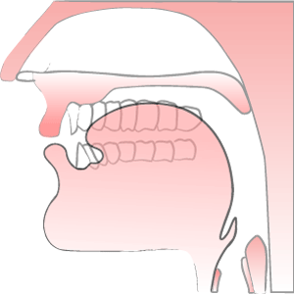  Task c + d. Listen to the /ɪ/ sound. Cross out the word that doesn’t follow the note in “a”.  - Play the recording (CD 2 – Track 10), have Ss listen to the /ɪ/ sound, then cross out the word that doesn’t follow the note in “a”.  - Call Ss to give answers.  - Play the recording again and check answer as a whole class using DCR.  - Give feedback and evaluation. | - Listen.  - Listen again and repeat.  - Listen.  - Listen and give answers.  Answers keys  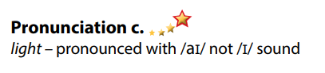
- Activity 2: While-speaking (23’)
a) Objective: Students can compare traditions in different countries.
b) Content:
- Take turns comparing the traditions in different countries.
- Take turns comparing how different your traditions are to the traditions in South Korea and Mongolia.
c) Expected outcomes: Ss produce the new language successfully.
d) Organization of the activity:

TEACHER’S ACTIVITIES | STUDENTS’ ACTIVITIES
PRACTICE  Take turns comparing the traditions in different countries.  - Demonstrate the activity on DCR using the examples.  - Divide the class into pairs.  - Have pairs take turns comparing the traditions in different countries.  - Have some pairs demonstrate the activity in front of the class.  - Give feedback and evaluation.  SPEAKING: Same Holiday, Different Tradition.  * Task a. Take turns comparing how different your traditions are to the traditions in South Korea and Mongolia.  - Demonstrate the activity by practicing the activity with a student.  - Divide the class into pairs.  - Have students take turns comparing how different the traditions in Vietnam are to the traditions in South Korea and Mongolia.  - Observe, give help if necessary.  - Have some students demonstrate the activity in front of the class.  - Give feedback and evaluation. | - Observe, listen.  - Work in pairs.  - Present.  Suggested ideas  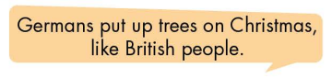  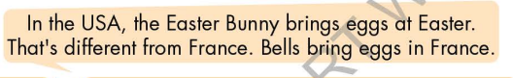  - Observe, listen.  - Work in pairs.  - Present.  Suggested ideas  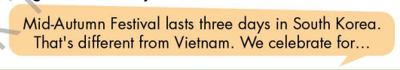

- Activity 3: Production (5’)
a) Objective: Students can compare traditions to celebrate Lunar New Year and Mid – Autumn Festival in their family.
b) Content: What are some other traditions to celebrate Lunar New Year and Mid-Autumn Festival in your family?
c) Expected outcomes: Ss produce the new language successfully in everyday speaking and writing.
d) Organization of the activity:
TEACHER’S ACTIVITIES | STUDENTS’ ACTIVITIES
SPEAKING:  Task b. What are some other traditions to celebrate Lunar New Year and Mid-Autumn Festival in your family?  - Have students discuss other traditions to celebrate Lunar New Year and Mid-Autumn Festival in their family.  - Have some students share their ideas with the class.  - Give feedback and evaluation. | - Discuss in pairs / groups.  - Present.

C. Consolidation and homework assignments (5’)
* Consolidation: Some words with the /ɪ/ sound: midnight, Christmas, festival, tradition, gift, light …

* Homework:
- Practice: reading words with the /ɪ/ sound.
- Find more words containing the /ɪ/ sound.
- Prepare: Unit 8 - Lesson 3 –Listening and Reading (page 66 – SB).
- Review the vocabulary and grammar notes in Tiếng Anh 7 i-Learn Smart World Notebook
(pages 50 & 51).
- Play consolation games in Tiếng Anh 7 i-Learn Smart World DHA App on www.eduhome.com.vn

D. Reflection
a. What I liked most about this lesson today:
…………………………………………………………………………………………
- What I learned from this lesson today:
…………………………………………………………………………………………
c. What I should improve for this lesson next time:
…………………………………………………………………………………………

