|  |  |
| --- | --- |
| **Tiếng Anh 8 Friends Plus** | **FP 8 - REVIEW 4 - TEST 1**  **Test for Unit**  *Thời gian làm bài: 40 phút (Không kể thời gian giao đề)*  *-------------------------* |

**I. Pronunciation (1-4)**

**Câu 1.** Which word has the underlined part pronounced differently from that of the others?

**A.** reject  **B.** pandemic  **C.** benefit  **D.** access

**Đáp án đúng**: C

**Câu 2.** Which word has the underlined part pronounced differently from that of the others?

**A.** undo  **B.** unhappiness

**C.** uncle  **D.** support

**Đáp án đúng**: D

**Câu 3.** Which word has a different stress pattern from that of the others?

**A.** donate  **B.** campaign  **C.** access  **D.** propose

**Đáp án đúng**: C

**Câu 4.** Which word has a different stress pattern from that of the others?

**A.** award  **B.** gossip  **C.** comedy  **D.** classic

**Đáp án đúng**: A

**II. Choose the answer (A, B, C or D) that best fits the space in each question. (5-14)**

**Câu 5.** The ___________ of the artist was required on the contract before the album could be released.

**A.** petition  **B.** record  **C.** character  **D.** access

**Đáp án đúng**: B

**Câu 6.** What is your favourite movie and why do you like it?

**A.** My favourite movie is "The Shawshank Redemption" because it has a compelling story and powerful performances.

**B.** Let’s go to the cinema. There are some great films showing.

**C.** My favourite colour is blue.

**D.** I love my cat because of its beautiful fur.

**Đáp án đúng**: A

**Câu 7.** Mary said, "I don't like pizza."

**A.** Mary said she doesn't like pizza.  **B.** Mary said she not like pizza.

**C.** Mary said she didn't like pizza.  **D.** Mary said she don't like pizza.

**Đáp án đúng**: C

**Câu 8.** The cake _______ by my mother this morning.

**A.** are made  **B.** were made  **C.** is made  **D.** was made

**Đáp án đúng**: D

**Câu 9.** The new ___________ by Taylor Swift is topping the charts.

**A.** musical  **B.** pandemic

**C.** release  **D.** extraordinary

**Đáp án đúng**: C

**Câu 10.** The company decided to ___________ the proposal to raise salary, which made the employees disappointed.

**A.** sign  **B.** volunteer  **C.** reject  **D.** allow

**Đáp án đúng**: C

**Câu 11.** If I _______ a million dollars, I would buy a big house.

**A.** had  **B.** has  **C.** having  **D.** have

**Đáp án đúng**: A

**Câu 12.** Many celebrities are showing ___________ towards the victims of the disasters.

**A.** campaign  **B.** genre  **C.** support  **D.** gossip

**Đáp án đúng**: C

**Câu 13.** The film was classified as a ___________ and had the audience on the edge of their seats.

**A.** aim  **B.** award  **C.** thriller  **D.** propose

**Đáp án đúng**: C

**Câu 14.** John said, "I am going to the store."

**A.** John said he went to the store.  **B.** John said he is going to the store.

**C.** John said he was going to the store.  **D.** John said he go to the store.

**Đáp án đúng**: C

**III. Look at the signs. Choose the best answer (A, B, C or D). (15-16)**

**Câu 15.**

When is the concert featuring local talent taking place?

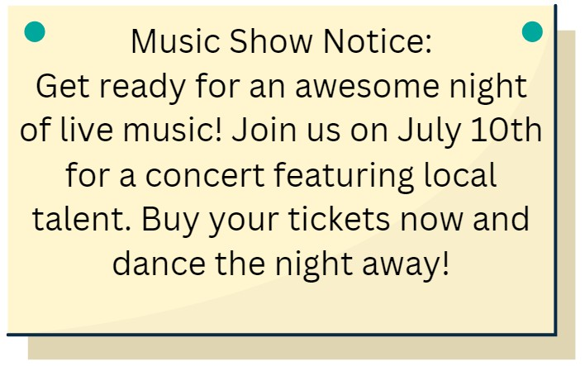

**A.** September 10th  **B.** July 10th

**C.** August 10th  **D.** June 25th

**Đáp án đúng**: B

**Câu 16.**

What is the name of the new movie that will be released on June 25th?

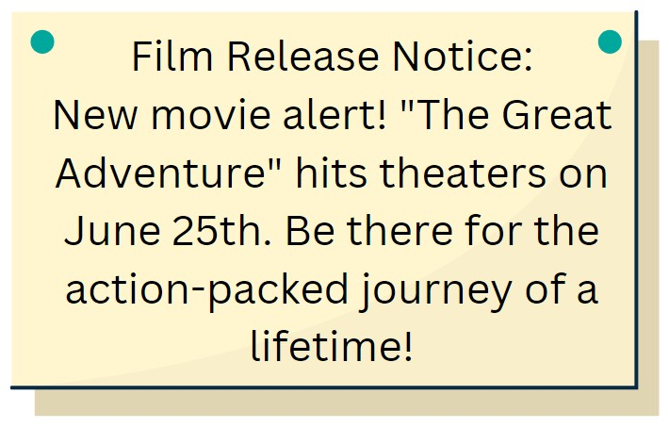

**A.** The Great Adventure  **B.** The Lifetime Adventure

**C.** The Action-Packed Journey  **D.** The Great Journey

**Đáp án đúng**: A

**IV. Read the following passage and do as direct. (17-22)**

My London school is going to start giving regular lessons about how to eat well. But is it okay for schools to tell kids what they should eat? One reason for the new learning is that some young people in the UK eat too much sugary food and don't eat enough vegetables. For instance, they sometimes drink too many sugary drinks, which can make their teeth hurt. Some young people also don't get enough exercise, which can also cause them to gain weight. On the other hand, some people say that students should only learn academic topics in school. They think that school isn't the right place to teach kids how to live. I think a few lessons about healthy eating are a good idea, but not every week. I think students should learn about this as a part of biology, not as a separate course.

**Câu 17.** The London school is going to start giving regular lessons about how to sleep well.

**A.** False  **B.** True

**Đáp án đúng**: A

**Câu 18.** Some young people in the UK eat too much sugary food and don't eat enough vegetables.

**A.** True  **B.** False

**Đáp án đúng**: A

**Câu 19.** Some people say that students should only learn academic topics in school.

**A.** False  **B.** True

**Đáp án đúng**: B

**Câu 20.** The author thinks that students shouldn’t learn about healthy eating as a part of biology, not as a separate course.

**A.** True  **B.** False

**Đáp án đúng**: B

**Câu 21.** What is one reason for the new learning about how to eat well?

**A.** Some young people in the UK don't drink enough water.

**B.** Some young people in the UK get too much exercise.

**C.** Some young people in the UK eat too much sugary food and don't eat enough vegetables.

**D.** Some young people in the UK don't get enough sleep.

**Đáp án đúng**: C

**Câu 22.** What does the author think about the new learning?

**A.** The author thinks that students should learn about healthy eating as a separate course.

**B.** The author thinks that a few lessons about healthy eating are a good idea, but not every week.

**C.** The author thinks that school isn't the right place to teach kids how to live.

**D.** The author thinks that students should only learn academic topics in school.

**Đáp án đúng**: B

**V. Choose the word (A, B, C or D) that best fits the blank space in the following passage. (23-28)**

Last night's music show **____23___** simply amazing! The venue was packed **___24____** fans, all eagerly anticipating the performance of the night. The music was fantastic, with the band playing a **___25____** of songs that kept the crowd energized and engaged throughout the entire show. The lead singer had an incredible **____26___**, hitting every note with precision and power. The musicians **___27____** also very skilled, playing their instruments with passion and finesse. The lighting and sound were spot on, enhancing the overall experience. The only downside was that the show had to end! I highly recommend this band to anyone who loves great music and a fun atmosphere. Don't **____28___** their next show!

**Câu 23.** Last night's music show ____ simply amazing!

**A.** is  **B.** are  **C.** were  **D.** was

**Đáp án đúng**: D

**Câu 24.** The venue was packed ___ fans.

**A.** by  **B.** in  **C.** of  **D.** with

**Đáp án đúng**: D

**Câu 25.** The music was fantastic, with the band playing a ___ of songs.

**A.** mix  **B.** mixture  **C.** variety  **D.** range

**Đáp án đúng**: C

**Câu 26.** The lead singer had an incredible ____, hitting every note with precision and power.

**A.** pitch  **B.** voice  **C.** sound  **D.** tone

**Đáp án đúng**: B

**Câu 27.** The musicians ___ also very skilled.

**A.** had  **B.** were  **C.** was  **D.** is

**Đáp án đúng**: B

**Câu 28.** Don't ___ their next show!

**A.** miss  **B.** skip  **C.** forget  **D.** lose

**Đáp án đúng**: A

**VI. Supply the correct form of the word given in each sentence. (29-34)**

**Câu 29.** The library has a ramp to make it more ___________ for people with disabilities. (access)

**Đáp án đúng**: accessible

**Câu 30.** His ___________ of her offer made her feel sad. (reject)

**Đáp án đúng**: rejection

**Câu 31.** The ___________ gave a large sum of money to the charity. (donate)

**Đáp án đúng**: donator

**Câu 32.** Eating vegetables is ___________ for your health. (benefit)

**Đáp án đúng**: beneficial

**Câu 33.** Please ___________ here if you agree to the terms and conditions. (signature)

**Đáp án đúng**: sign

**Câu 34.** She made a ___________ to her boss about working from home. (propose)

**Đáp án đúng**: proposal

**VII. Rearrange the groups of words in a correct order to make complete sentences. (35-36)**

**Câu 35.** you / were online? / would / share if / you / What files

…

**Đáp án đúng**: What files would you share if you were online?

**Câu 36.** The team / to food / said that people / need still had / access / in / and resources.

…

**Đáp án đúng**: The team said that people in need still had access to food and resources.

**VIII. Rewrite each of the following sentences in another way so that it means almost the same as the sentence printed before it. (37-40)**

**Câu 37.** We celebrated a surprise party for Jim last night.

A surprise …

**Đáp án đúng**: A surprise party was celebrated for Jim last night.

**Câu 38.** That boat model was made by Susan last week.

Susan …

**Đáp án đúng**: Susan made that boat model last week.

**Câu 39.** My father said, ‘You have to do morning exercises to keep fit.’

My father told …

**Đáp án đúng**: My father told me that I had to do morning exercises to keep fit.

**Câu 40.** I want to buy that book, but I don’t have enough money. (Second conditional)

If I …

**Đáp án đúng**: If I had enough money, I would buy that book.

**IX. Listening: listen and do as direct. (41-50)**

*Listen to a dialogue between two friends Andy and Mia discussing a music show next week:*

**Câu 41.** Andy heard about the music show on the radio.

**A.** False  **B.** True

**Đáp án đúng**: B

**Câu 42.** The concert is going to be held at a stadium.

**A.** False  **B.** True

**Đáp án đúng**: A

**Câu 43.** Mia is excited to see the reggae band.

**A.** True  **B.** False

**Đáp án đúng**: B

**Câu 44.** The concert will feature a few local bands.

**A.** False  **B.** True

**Đáp án đúng**: B

**Câu 45.** The tickets cost $100 each.

**A.** False  **B.** True

**Đáp án đúng**: A

**Câu 46.** Mia suggests having a picnic before the concert.

**A.** False  **B.** True

**Đáp án đúng**: A

**Câu 47.** There will be an indie rock band playing at the concert.

**A.** True  **B.** False

**Đáp án đúng**: A

**Câu 48.** Mia knows who is playing in the jazz band.

**A.** True  **B.** False

**Đáp án đúng**: B

**Câu 49.** The concert is next Saturday at 6 pm.

**A.** True  **B.** False

**Đáp án đúng**: A

**Câu 50.** Tickets can only be bought online.

**A.** True  **B.** False

**Đáp án đúng**: B

**----HẾT---**