|  |  |  |
| --- | --- | --- |
| PHÒNG GIÁO DỤC VÀ ĐÀO TẠO ĐỀ CHÍNH THỨC | ĐỀ KIỂM TRA __________ Năm học: 20__ - 20__ Tiếng Anh - Lớp 7 Thời gian làm bài: 60 phút | |
| Trường: ________________________ Họ tên: _______________________ Lớp: _____________ | Điểm | Nhận xét của giáo viên |

|  |  |  |
| --- | --- | --- |
|  | **Tiếng Anh 7 i-Learn Smart World - Unit 7.1 Time allotted: 60** | Mã đề: A |

|  |  |
| --- | --- |
| **PART 1** | **Pronunciation (4 questions)** |

**Choose the word whose underlined part is pronounced differently.**

1. A. subway B. luggage C. public D. support

2. A. backpacks B. tickets C. customs D. passports

**Choose the word that has a different stressed syllable from the rest.**

3. A. around B. boarding C. baggage D. local

4. A. environment B. transportation C. reliable D. convenient

|  |  |
| --- | --- |
| **PART 2** | **Vocabulary and Grammar (12 questions)** |

**Choose the best option (A, B, C or D) to complete each of the following questions.**

5. Make sure you don’t take the wrong bag at the ______________.

A. custom B. security C. boarding D. baggage claim

6. Bicycles are ______________ for the environment than cars.

A. better B. more C. as good D. the best

7. For commuting in our city, ______________ form of transportation is the bus because it’s ______________ than going by car or taxi.

A. the most popular / the cheapest B. the most popular / cheaper

C. more popular / cheaper D. more popular / the cheapest

8. There are ______________ buses from Tân Sơn Nhất airport to the city center. Buses depart every 15 minutes.

A. friendly B. public C. easy D. frequent

9. Korea has excellent ______________. The buses are regular and the trains are on time.

A. vehicle B. transport system C. public transportation D. moving system

10. Person A: Is this Andy’s backpack?  
Person B: No, it isn’t. He has a ______________ backpack.

A. new big dark blue B. big new dark blue C. dark blue big new D. new dark blue big

11. Person A: Whose suitcase is this?   
Person B: It has Jodie and Jack’s names on it, so it must be ______________.

A. their B. they C. them D. theirs

12. Officers will check your luggage when you go through ______________.

A. airport B. baggage claim C. customs D. check-in

13. It’s very important to keep your ______________ in a safe place. You need this document to enter or leave a foreign country.

A. passport B. boarding pass C. ticket D. luggage

14. Person A: Excuse me, does this bag belong to you?  
Person B: ______________. Thank you a lot.

A. Yes, it’s my. B. Yes, it’s mine bag. C. Yes, my bag is this. D. Yes, it’s mine.

**Choose the best option (A, B, C or D) to complete each of the following questions.**

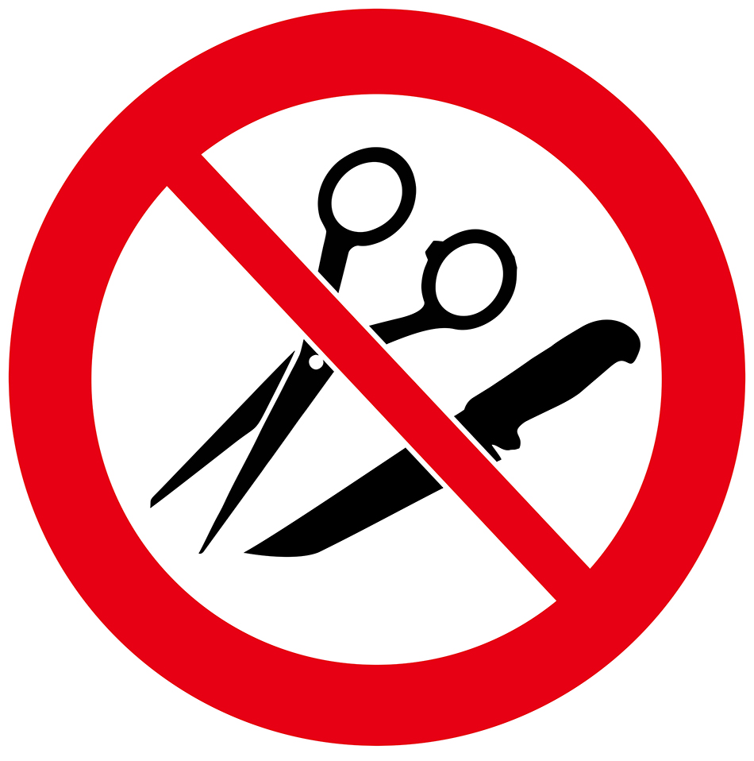

15. What does this sign on the plane mean?

A. You can’t use scissors and knives at the same time on the plane.

B. You can’t buy any scissors or knives on the plane.

C. You can’t bring any sharp objects on the plane.

D. You can’t use scissors or knives because they are sharp.

**Choose the best option (A, B, C or D) to complete each of the following questions.**

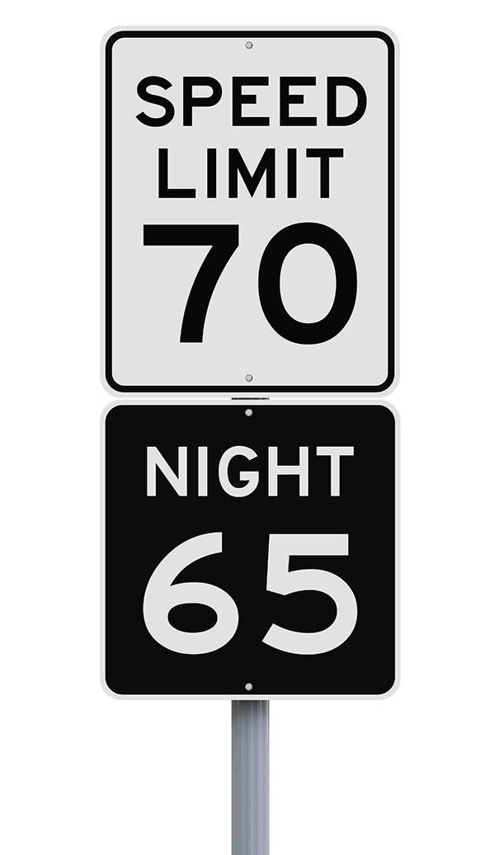

16. What does this sign mean?

A. You have to drive slower at night than during the day. B. You can’t drive faster than 70 miles per hour at night. C. You have to go at 65 kilometers per hour at night. D. The fastest speed you can drive is 65 miles per hour.

|  |  |
| --- | --- |
| **PART 3** | **Word Formation (6 questions)** |

**Write the correct form and compound of the words in brackets.**

17. I think electric cars are more ___________ than petrol cars because they don’t produce air pollution. ***(FRIEND)***

18. Buses in this country aren’t ___________. They’re often late. ***(RELY)***

19. Traveling by train is the best option for long-distance travel. They are clean, ___________ and punctual. ***(COMFORT)***

20. MTR (Mass Transit Railway), with ten lines and more than 70 stations, is the most ___________ way of traveling in Hong Kong. ***(CONVENIENCE)***

21. I like traveling by motorbike because it’s a great way to get around Hồ Chí Minh City ___________. ***(QUICK)***

22. In the UK, there are several ___________ kinds of public transportation. ***(DIFFER)***

|  |  |
| --- | --- |
| **PART 4** | **Reading (10 questions)** |

**Read the following passage. For each question, complete the notes with NO MORE THAN TWO WORDS. (5 questions)**

Transportation has changed in many ways over the years. The oldest known form of transportation is the boat. Around 60,000 years ago, boats were made by hollowing out a tree trunk, also known as a canoe. Riders had to use paddles to control the canoe across the water. However, today boats are more convenient because they have an engine that powers them.   
Next came horses. Surprisingly it took 55,000 years after the invention of the boat to discover horses as a means of transportation. At first, horses were ridden without a saddle, also called riding bareback. But over time, riders used saddles to make traveling more comfortable and easier to control the horse. After that, it didn’t take long for us to figure out we could use a wagon and a horse to help carry equipment and people.   
   
This article is about how much (23)___________ has changed over the years. Nearly 60,000 years ago, riders had to use a paddle to control the (24)___________ across dangerous waters. Today, boats are more (25)___________ because they have engines.   
Riding a (26)___________ without a saddle is called riding bareback. People started using saddles to make it more (27)___________ and easier to control the horse.

**Read the following passage. For each question, choose the correct option. (5 questions)**

Last summer, I was planning on taking an airplane for the first time, but there were many things I didn’t know. For example, how many suitcases should I take or what can I bring in my backpack? So, I asked my mom for help, and she told me that the more luggage you bring, the more expensive the ticket is. So, she suggested bringing only the things I needed. She also told me not to take dangerous items like large batteries or sharp objects because I’ll have to go through customs. My mom also said not to lose my boarding pass or passport because I’d need them to get on the plane. Finally, she told me I needed to find the baggage claim after the airplane landed to pick up my suitcases. I’m happy my mom was able to help me know more about air traveling because it made the experience better.

**Questions:**

28. The more luggage you bring,…

A. the more expensive the ticket is. B. the more it weighs.

C. the more trouble you can get in. D. the less you carry.

29. Why do you need a boarding pass and passport?

A. to leave the airport B. to get on the airplane C. to bring your luggage D. to purchase food

30. Where do you pick up your suitcases after the airplane lands?

A. the ticket counter B. the lounge C. the security office D. the baggage claim

31. Why is it important to know how to travel on an airplane?

A. The ticket is expensive. B. It makes the experience better.

C. Taking an airplane is faster. D. Bringing extra luggage costs more.

32. What is true about the story?

A. It’s important to use the seatbelt. B. There are many places to eat at the airport.

C. There are many things to know about flying on an airplane. D. You can get lost at the airport.

|  |  |
| --- | --- |
| **PART 5** | **Writing (8 questions)** |

**Rewrite the following sentences without changing their meaning. Use the given word(s) if any.**

33. During the rush hours in New York, cycling to work and going by bus take the same amount of time. (FAST)

→ During the rush hours in New York, cycling to work is___________

34. An underground train across London costs £6 while a taxi costs £15. (CHEAPER)

→ An underground train___________

35. Heathrow Airport is currently busier than any other airports in the UK.

→ Heathrow Airport is currently the___________

36. No one else in my family drives better than my father.

→ My father is___________

**Use the given words or phrases to make complete sentences.**

37. I / think / travel / bus / be / relaxing / than / car.

→ ___________

38. This / be / not / my mother / handbag / because / hers / be / brown.

→ ___________

39. Subway / be / popular / means of transportation / New York.

→ ___________

40. I / prefer / ride my bike / school / because / it / healthy / take the bus.

→ ___________

|  |  |
| --- | --- |
| **PART 6** | **Listening (10 questions)** |

**You will listen to a conversation about two types of transportation. Complete the table with ONE WORD for each blank. (5 questions)**

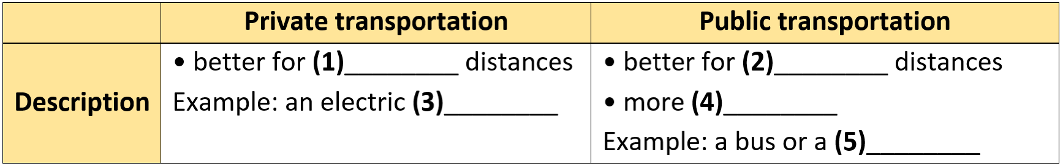

(41)___________________  
(42)___________________  
(43)___________________  
(44)___________________  
(45)___________________

**Listen to the following conversation. For each question, write T if the statement is TRUE, F if it is FALSE, and NI if there is NO INFORMATION. (5 questions)**

**Answers** **True** **False** **Not given**

46. The main topic of the conversation is about two guys traveling around the city. **◯** **◯** **◯**

47. Steve had a wonderful time using public transportation to get around. **◯** **◯** **◯**

48. Locals like to take the train because it’s cheap. **◯** **◯** **◯**

49. Trains are usually not near the cities. **◯** **◯** **◯**

50. The food on a train is better than on a bus. **◯** **◯** **◯**

**---THE END---**