School: ……………………………………….. | Date:……………………………………..
Class: ……………………………..................... | Period: 40

UNIT 4: NATURAL DISASTERS
Lesson 1.3 – Pronunciation & Speaking, pages 36 & 37
1. Objectives
By the end of this lesson, students will be able to…
1.1. Language knowledge/ skills
- practice sound changes
- practice talking about disasters
1.2. Competencies
- improve Ss’ communication, collaboration, analytical, critical thinking skills.
1.3. Attributes
- know more about natural disasters around the world.
2. Teaching aids and materials
- Teacher’s aids: Student’s book and Teacher’s book, class CDs, DCR– Phần mềm tương tác trực quan, DHA – Ứng dụng trò chơi tương tác, projector / interactive whiteboard /TV (if any), PowerPoint slides.
- Students’ aids: Student’s book, Workbook, Notebook.
3. Assessment Evidence
Performance Tasks | Performance Products | Assessment Tools
- Listen and cross out the sentence that doesn't have sound changes.  - Read the sentences with the sound changes to a partner.  - Ask and answer about each of the world's biggest disasters.  - Play the Disasters Quiz Show.  - Pair work: Which disasters are common/rare in your country? Which disaster is the scariest for you? Why? | - Ss’ answers.  - Ss’ answers.  - Ss’ answers.  - Ss’ answers.  - Ss’ answers. | - Observation.  - Observation.  - Observation.  - Observation.  - Observation.
4. Procedures
A. Warm up: 5’
a. Objective: to review vocabulary about disaster.
b. Content: speaking activity.
c. Expected outcomes: Ss can unscramble the words about natural disasters.
d. Organization
Teacher’s activities  Unscramble the groups of letters to make words.  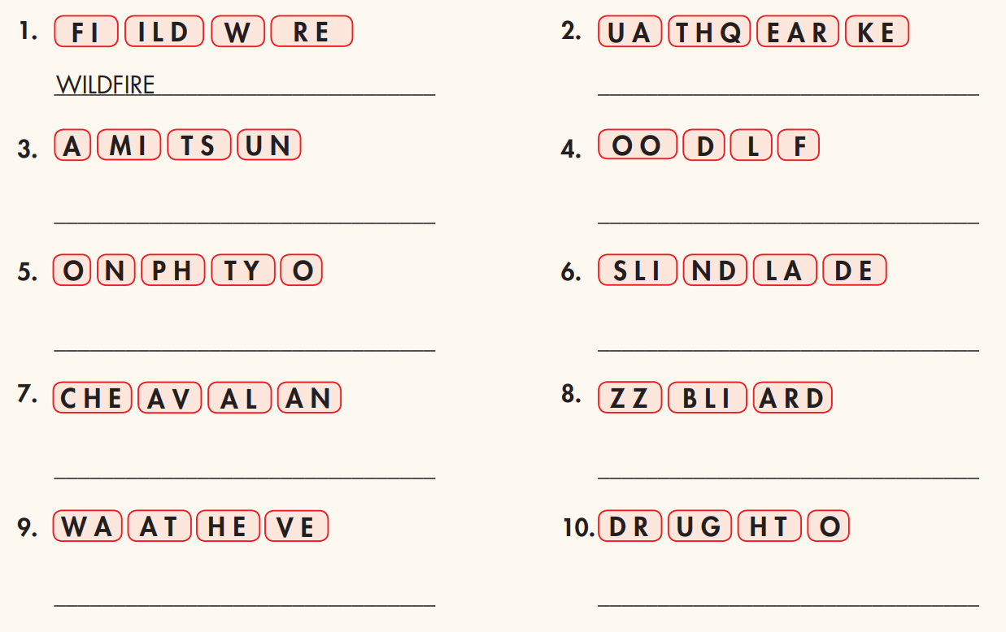 | Students’ activities  -Play in two teams.

B. New lesson (35’)
1. Pronunciation: 15’
a. Objective: to help Ss know when to change the sound of was in a sentence.
b. Content: tasks a, b, c & d.
c. Expected outcomes: Ss can pronounce was correctly.
d. Organization
Teacher’s activities | Students’ activities
Presentation:  Task a:  - Tell Ss that "…was…" often sounds like /wəz/ in a sentence.  - Give some examples:  What was the biggest wildfire?  When was the flood? – It was in 1920.  Task b:  - Ask Ss to listen to the words and focus on  the underlined letters (using the DCR/PPT slides).  What was the biggest wildfire?  When was the flood? – It was in 1920.  Practice  Task c: Listen and cross out the sentence that doesn't follow the note in "a."  Where was the flood?  It was in Japan.  It was in 1810.  - Ask Ss to listen and cross out the sentence that doesn't follow the note in "a."  - Pick some Ss to give the answers.  - Check their answers.  - Get Ss to listen again and repeat.  Task d: Read the sentences with the sound changes noted in "a." to a partner.  - Ask Ss to work in pairs, reading the sentences to their partners with the correct pronunciation.  - Pick some students to say the sentences and correct their pronunciation if necessary. | - Listen and take notes.  -Listen and take notes.  - Listen and cross out the sentence that doesn't follow the note in "a."  - Give their answer  Answer Keys:  It was in 1810. – Wrong.  (Was is fully pronounced.)  -Listen again and repeat.  -Work in pairs, reading the sentences to their partners with the correct pronunciation.
2. Practice: 10’
a. Objectives: to help Ss practice talking about natural disasters.
b. Content: practice task
c. Expected outcomes: Ss can ask and answer about natural disasters around the world.
d. Organization:
Teacher’s activities | Students’ activities
Take turns asking and answering about each of the world's biggest disasters.  - Introduce the task, using DCR.  - Give Ss some time to practice asking and answering about each of the world's biggest disasters with their partners.  - Go around and help if necessary.  - Pick some Ss to perform their conversations.  - Give feedback. | -Practice asking and answering about each of the world's biggest disasters.  -Perform their conversations.  Answer keys:  A: What was the biggest earthquake?  B: It was the Great Chilean Earthquake.  A: Where was it?  B: It was in Valdivia, Chile.  A: When was it?  B: It was in May 1960.  A: How much damage did it cause? B: It caused $675 million in total damage.  A: What were the biggest floods?  B: They were the 1931 Yangtze – Huai River Floods.  A: Where were they?  B: They were in Eastern and Central China.  A: When were they?  B: They were from June to August 1931.  A: How much damage did they cause? B: Over 400 thousand people died.  A: What was the biggest typhoon?  B: It was the Typhoon Tip.  A: Where was it?  B: It was in the Philippines, Japan, China, and North and South Korea.  A: When was it?  B: It was in October 1979.  A: How wide was it?  B: It was over two thousand kilometers wide.  A: What were the biggest wildfires?  B: They were the 2021 Russia Wildfires.  A: Where were they?  B: They were in Siberia, Russia.  A: When were they?  B: They were in June 2021.  A: How much damage did they cause? B: They burned 200 thousand km2.  A: What was the biggest tsunami?  B: It was the Lituya Bay Tsunami.  A: Where was it?  B: It was in Alaska, USA.  A: When was it?  B: It was in July 1958.  A: How tall was it?  B: It was over 500 meter tall.
3. Speaking: 10’
a. Objectives: to help Ss practice talking about natural disasters.
b. Content: task a, task b
c. Expected outcomes: Ss can ask and answer about natural disasters around the world and in their country.
d. Organization:
Task a. In pairs: Write six questions using the information on page 36 and the table in Practice. Join another pair. Take turns asking and answering the questions.  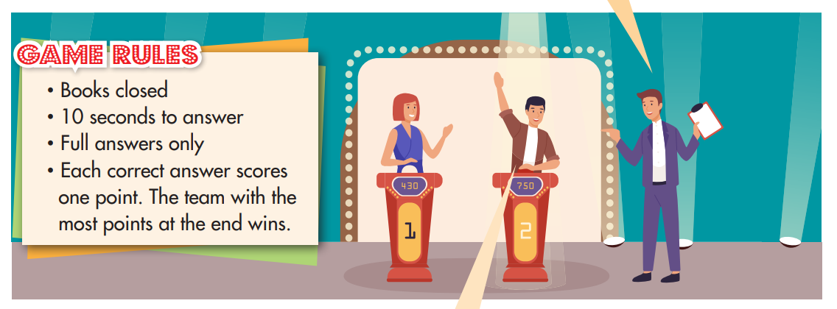  - Introduce the task, using DCR.  - Give Ss some time to practice asking and answering about each of the world's biggest disasters with their partners.  - Go around and help if necessary.  - Let Ss play the game in 2 teams.  - Decide the winner with more points.  Task b: Which disasters are common/rare in your country? Which disaster is the scariest for you? Why?  -Ask Ss to work in pairs to ask and answer about natural disasters in their country.  - Pick some Ss to share their ideas.  - Give feedback. | -Practice asking and answering about each of the world's biggest disasters with their partners.  Sample answer:  A: Where was the biggest earthquake?  B: It was in Valdivia, Chile.  -Work in pairs to ask and answer about natural disasters in their country.  -Share their ideas.  Sample answers:  I think that floods are common.  I think floods are the scariest because I can’t swim.
C. Consolidation and homework assignments: 5’
- Pronunciation: sound changes
- Prepare the next lesson: Lesson 2.1 – Vocab & Listening, pages 38 & 39
5. Reflection

a. What I liked most about this lesson today:
…………………………………………………………………………………………
b. What I learned from this lesson today:
…………………………………………………………………………………………
c. What I should improve for this lesson next time:
…………………………………………………………………………………………

