ĐỀ THAM KHẢO TS 10 25-26 ( DTC)
I. Choose the word / phrase / sentence (A, B, C or D) that best fits the space or best answers the question given in each sentence. (3.5 pts).
A. Choose the word which is pronounced differently from the others. (0.5 pt)
1. A. remotely B. solar C. organ D. obese
2. A. disturb B. plumber C. breadwinner D. border
B. Choose the word whose main stress pattern is placed differently from the others. (0.5 pt)
3. A. assistant B. pedestrian C. convenience D. monument
4. A. cafeteria B. innovation C. neighborhood D. opportunity

5. Remember ____________ any words you don’t know. Then look them up later.
A. go on B. put off C. get on D. note down
6. I couldn’t sleep last night ______the next-door neighbors played music so loudly.
A. though B. since C. so D. because of
7. Studying in an English-speaking country will give you a/an _____________to practice English.
A. opportunity B. career C. offer D. foreigner
8. There are so many more cars on the streets now that there are ________ every day.
A congested B. pedestrians C. traffic jams D. crosswalks
9. What _________ you ___________at that time?
A. did / do B. will / doing C. were / doing D. are / going to do
10. She turned __________ the new job in New York because she didn’t want to move.
A. on B. down C. off D. around
11. He is expecting______ a trip to Ha Long Bay.
A. make B. to make C. making D. made
12. My favorite foods are vegetables. They’re always so healthy and _____________.
A. nourishing B. addicted C. harmful D. fatty
13. The air quality in urban areas is not as ________ as it was in the past.
A. a lot cleaner B. a bit cleaner C. cleaner D. clean
14. Peter : Nice to meet you. -Mary : "__________"
A. Nice to see you B. Pleased to see you again C. Sorry, I can’t D. Nice to meet you, too

Answers: 1. ______ 2. ______ 3. ______ 4. ______ 5. ______ 6. ______ 7. ______
8. ______ 9. ______ 10. ______ 11. ______ 12. ______ 13. ______ 14. ______

II. Look at the sign or the notice. Choose the best answer (A, B, C or D) for questions 15 and 16. (0.5 pt)
15. This sign means:   | A. You mustn’t enter the room.  B. You must go out.  C. You mustn’t go straight ahead.  D. You must knock the door before coming into the room
16. What does the sign mean?   | A. Visitors can use this entrance, but they have to sign in first.  B. Only staff members can enter the building here.  C. Customers are allowed to enter the building here.  D. Employees can only use the front entrance to enter the building.  FB: Thầy Đình (Dạy Tiếng Anh)
Answers: 15. __________ 16. __________
III. Choose the word (A, B, C or D) that best fits each space in the following passage. (1.5 pts)
Learning foreign languages is not only about learning a new way to communicate; it is useful for students (17) ________ many ways. (18) ________, learning foreign languages is great for students’ education overall. Studies show that it can boost first language skills. It also (19) ________ the brain work better and improves memory, so students can perform better at schools. Students can also widen their knowledge because of reading books and looking up information online in foreign languages. Secondly, foreign languages are helpful for students’ future careers as well. People who can speak more than one language can have better job opportunities (20) ________employers often prefer hiring people with foreign language skills. Since schools prepare students for the world of work, they should include foreign language lessons. Thirdly, knowing foreign languages can help students build relationships. If students learn a foreign language, they (21) ________ opportunities to make new friends who do not speak the same first language (22) ________ they do. In fact, with social media, they can make friends from all over the world. Finally, learning foreign languages can create a positive attitude in language learners. It gives them a wider understanding of different cultures, as well as the ability to see their own culture in a different way.
17. A. for B. in C. with D. to
18. A. However B. In addition C. Therefore D. Firstly
19. A. causes B. makes C. encourages D. forces
20. A. because B. due to C. that D. which
21. A. have B. will have C. won’t have D. had
22. A. which B. when C. as D. that
Answers: 17. __________ 18. __________ 19. __________
20. __________ 21. __________ 22. __________
IV. Read the following text carefully. Decide whether the statements from 23 to 26 are True or False and choose the correct answer (A, B, C or D) to complete the statements in the questions 27 and 28. (1.5 pts)
How can we improve the cities where we live in? Let’s find out.
- One of the best ways to improve cities is to add green spaces. Urban farming is popular in Paris, France, which is home to the world’s largest rooftop garden. People use it to grow fresh food for local restaurants and homes.
- Reducing the use of cars is also important. Cities like Auckland, New Zealand create safe paths which make walking a better choice than driving. Amsterdam in the Netherlands has over 500 kilometres of cycling paths.
- Constructing green buildings can also improve living environment. These buildings improve air quality both inside and outside. People get sick less often and can work better - they even sleep better at night because green buildings use natural light all day. Adelaide in Australia has got many green buildings.
- Clean transport is essential in a green city. Electric vehicles are becoming more popular around the world. In the USA, in 2022; people bought 800,000 new ones. The best American city for owners of electric cars in San Jose, California, which offers many electric charging stations.
Adelaide has got the most green buildings in Australia. NG

23. The biggest rooftop garden in the world is in Paris.
24. There are nearly 500 kilometres of cycling paths in Amsterdam.
25. At night green buildings use natural light, so people can sleep well.
26. There are lots of electric charging stations in San Jose.
27. Which isn’t mentioned in the text?
A. Urban farming is popular in Paris, France .
B. Green buildings help people get sick less often and work better
C. There are many green buildings in Adelaide, Australia.
D. In 2022, 800,000 new electric vehicles were produced in the USA.
28. The text gives us _________________.
A. some tourist information.
B. ways to make a city green
C. information about the most liveable cities in the world
D. special information about some famous places in the world
Answers: 23. __________ 24. __________ 25. __________
26. __________ 27. __________ 28. __________
V. Use the correct form of the word given in each sentence: (1.5 pts)
29. After a long week of work, nothing is more _________________ than spending a couple of hours at the spa and enjoying a massage. (relax)
30. His mother works in a school for children with learning________________ (difficult)
31. Last weekend, my parents celebrated 25 years of happy ________________ with a big party.(marry)
32. He is still _____________on his parents because he can’t find a job after graduation. (depend)
33. Her house is the most beautiful in our neighborhood. It is ________________decorated.(attract)
34. The children were ____________ against the major childhood diseases. (vaccination)
FB: Thầy Đình (Dạy Tiếng Anh)

Answers: 29. ________________ 30. ________________ 31. ________________
32. ________________ 33. ________________ 34. ________________
VI. Look at the entry of the word ‘limited’ in a dictionary. Use what you can get from the entry to complete the sentences with two or three words. (0.5 pt)
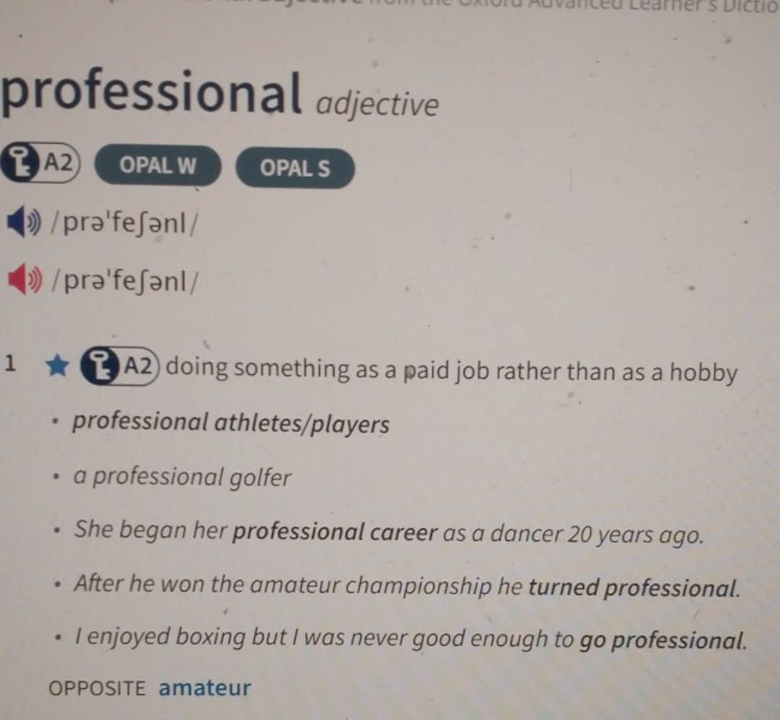 | 35. He was a keen amateur photographer for many years before he_______________ .  36. After retiring from sport, he began his_________________ as a journalist.  Answers: 35. ______________________  36. ______________________
VII. Rewrite the following sentences using the given words. (1.0 pt)
37. What a pity! I don’t have her phone number.
I wish __________________________________________________________________
38. Mr. Quang is the director of that famous film. He is my next-door neighbor.
→ Mr. Quang,_________________________________________________________________
39. The test was easy enough for us to get good marks.
It was such______________________________________________________________
40.Why not use water economically to reduce the water bill?
I suggest water __________________________________________________________

THE END OF THE TEST

