**ĐỀ MINH HỌA SỐ 08**  
**KỲ THI TỐT NGHIỆP TRUNG HỌC PHỔ THÔNG NĂM 2025**  
(Đề thi có 08 trang)  
**Môn thi: TIẾNG ANH**  
**Thời gian làm bài: 50 phút, không kể thời gian phát đề**

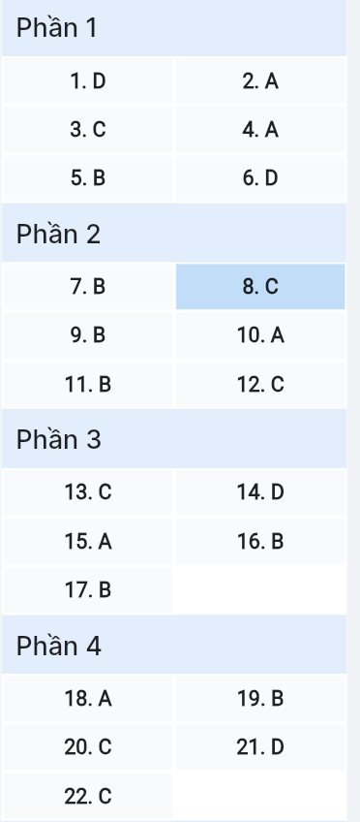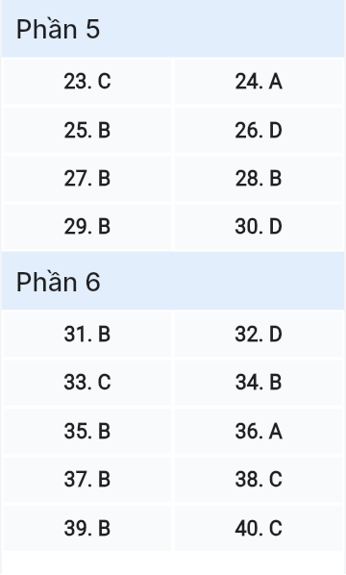

***Read the following advertisement and mark the letter A, B, C or D on your answer sheet to indicate the option that best fits each of the numbered blanks from 1 to 6.***

**DISCOVER THE WORLD IN HUE WITH GLOBEWANDER**

Have you ever dreamed of exploring the most colorful places on Earth? GlobeWander, an (1) _____, is here to help you fulfill your travel desires. Whether you want (2) _________ crowded, bustling cities or tranquil countryside, we’ve got it all! Our platform connects you to unique experiences, from discovering hidden gems to enjoying (3) _____ festivals. All you need to do is sign up, and we’ll match you with a perfect travel itinerary tailored (4) _____ to your preferences.

So, why wait? Pack your bags and embark (5) _____ an unforgettable journey with us! If you wish to explore famous landmarks, GlobeWander will (6) _____ it easy with just a click.



**Question 1 [6957056]:** A. ideal exploration guide world B. exploration ideal world guide  
 C. world ideal guide exploration D. ideal world exploration guide

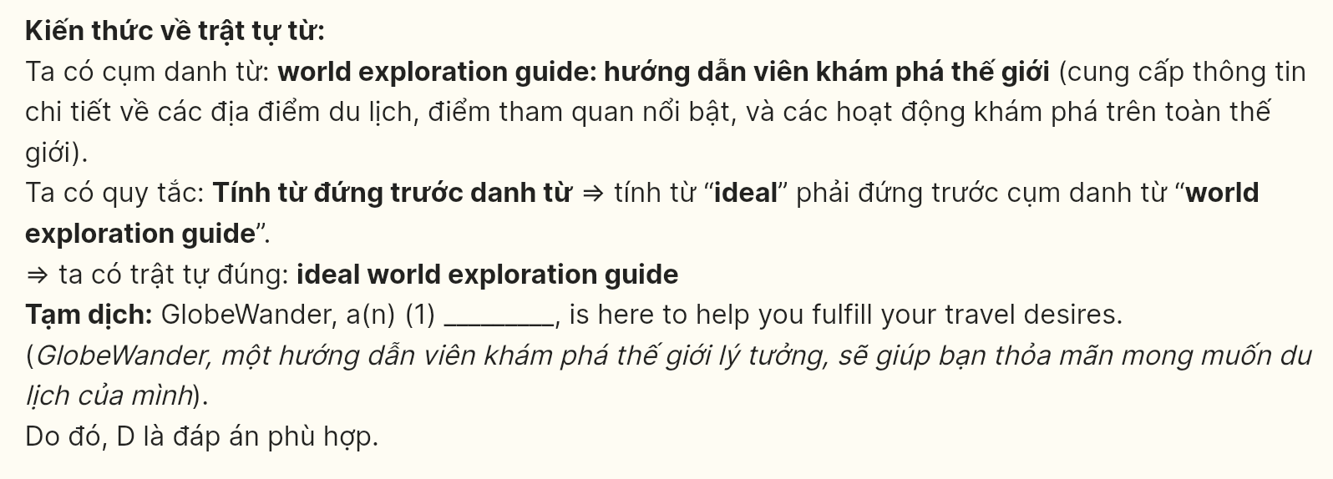

**Question 2 [6957057]:** A. to visit B. visiting C. to visiting D. visit



**Question 3 [6957058]:** A. vibrate B. vibration C. vibrant D. vibrantly

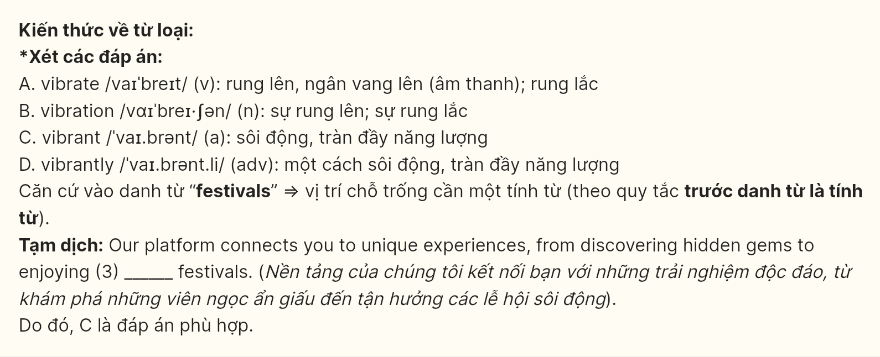

**Question 4 [6957059]:** A. tailored B. tailor C. tailoring D. which tailor



**Question 5 [6957101]:** A. in B. on C. for D. at

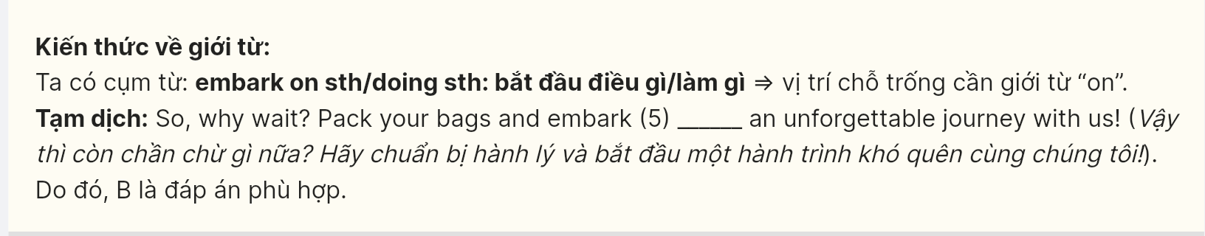

**Question 6 [6957154]:** A. take B. last C. lead D. make

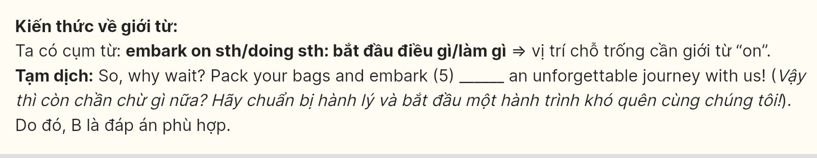

***Read the following leaflet and mark the letter A, B, C, or D on your answer sheet to indicate the option that best fits each of the numbered blanks from 7 to 12.***

**Explore Your Career Opportunities!**

Are you looking for a job that offers both growth and satisfaction? At ACE Corporation, we provide numerous opportunities for you to advance your career. With a competitive (7) _____ and benefits, you can build a fulfilling professional life.

**Why Choose Us?**

* **Career Development:** We believe in investing in our employees. With a (8) _____ of training programs available, you can (9) _____ your skills and climb the career ladder.
* **Work-Life Balance:** We understand the importance of balance. (10) _____, we offer flexible hours and (11) _____ benefits that cater to your needs.
* **Supportive Environment:** Our team is dedicated to your success. Many employees in the company have found their passion and excelled, thanks to our collaborative culture.

**Join Us Today!**

If you are ready to (12) ______ new challenges and make a difference, apply now! To learn more about our openings or to submit your application, visit our website or contact us.

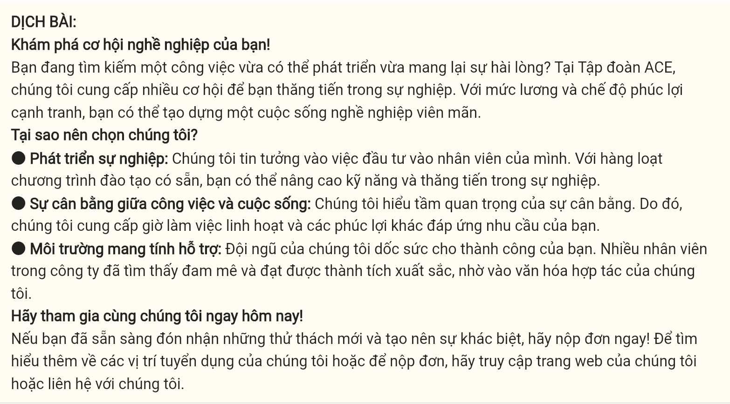

**Question 7 [695712]:** A. fee B. salary C. money D. fare

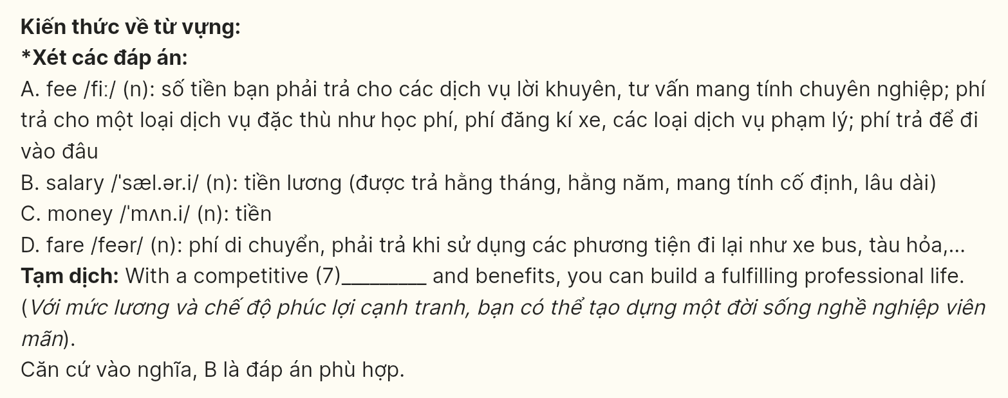

**Question 8 [695713]:** A. large amount B. little C. range D. bit

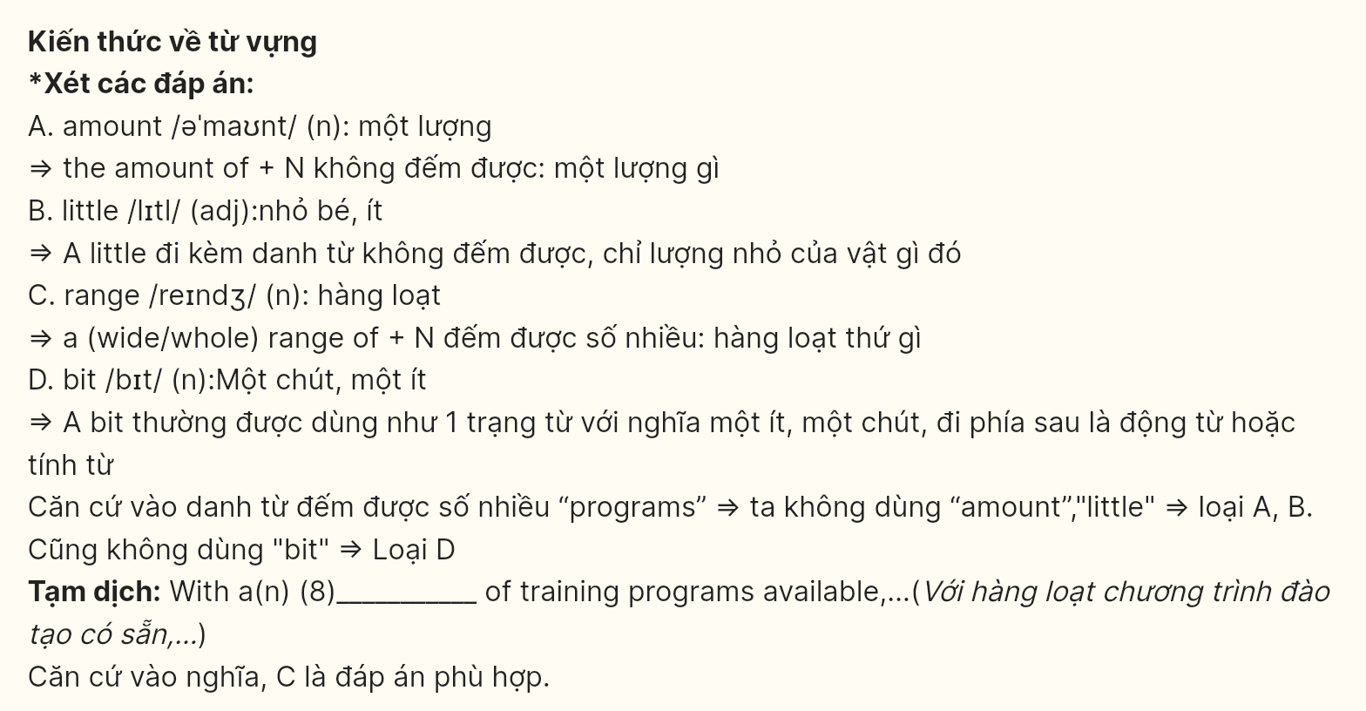

**Question 9 [695714]:** A. ensure B. enhance C. devote D. separate

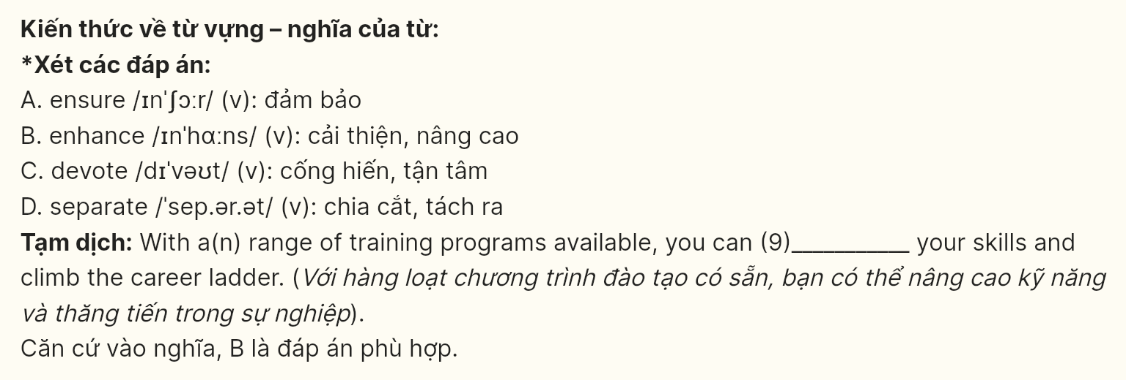

**Question 10 [695715]:** A. Therefore B. In addition C. By contrast D. However

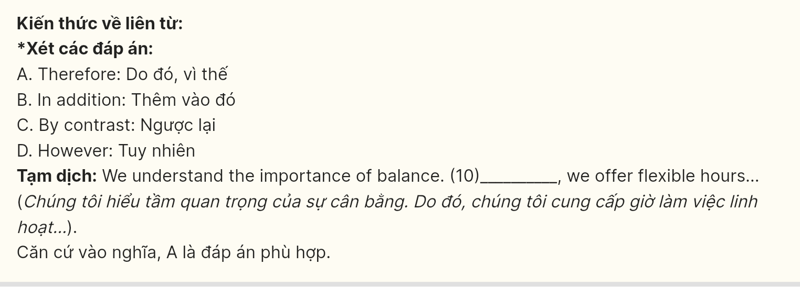

**Question 11 [695716]:** A. the other B. other C. another D. others



**Question 12 [695717]:** A. catch on B. back up C. take on D. bring up

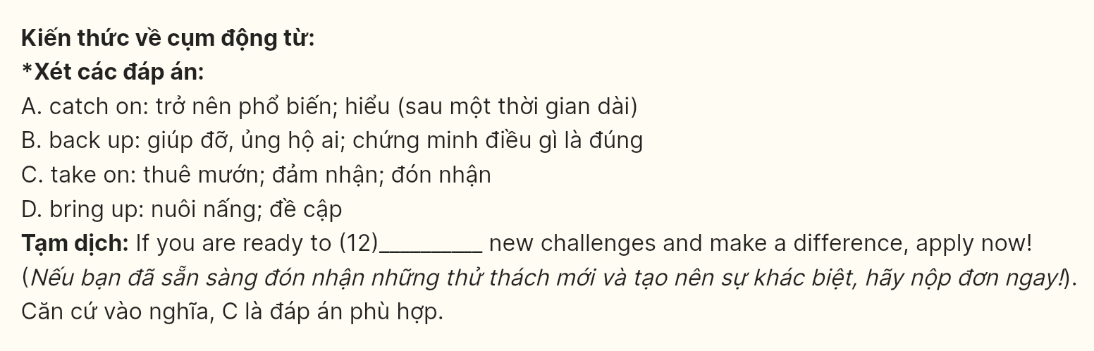

***Mark the letter A, B, C, or D on your answer sheet to indicate the best arrangement of utterances or sentences to make a meaningful exchange or text in each of the following questions from 13 to 17.***

**Question 13 [695718]:**  
a. Ann: Hi, Mi. Long time no see. How’re you doing?  
b. Ann: Oh, that’s why I haven’t seen you in the Reading Club very often.  
c. Mi: I’m fine, thanks. By the way, we moved to a new house in a suburb last month.

*(Adapted from Global Success 9)*

A. a-b-c B. c-a-b C. a-c-b D. b-a-c



**Question 14 [695719]:**  
a. Man: Yeah. I’ve got no problem with that. It sounds good, actually. The last place I worked for was quite demanding too. We had to make sure we gave a really high level of service.  
b. Man: That’s fine. I’m very used to working in that kind of environment.  
c. Woman: That’s good to hear because that will be equally important at Milo’s. I know they want people who have an eye for detail.  
d. Woman: OK. Now, they do have some quite specific requirements for the kind of person they’re looking for. Milo’s a young, dynamic company and they’re really keen on creating a strong team. It’s really important you fit in and get on well with everyone.  
e. Woman: Perfect. So the only other thing that’s required is good communication skills, so you’ll need to have a certificate in English.

*(Adapted from Cambridge IELTS 18)*

A. e-a-c-b-d B. a-e-d-b-c C. c-a-b-e-d D. d-a-c-b-e

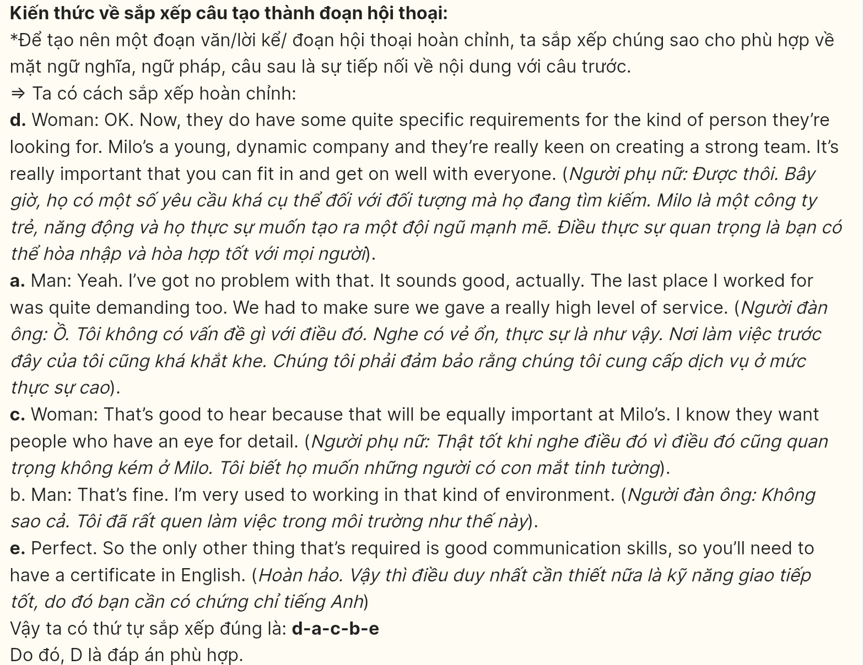

**Question 15 [695720]:**  
Hi Susan,  
a. The streets are bigger now, and two new highways were built last year.  
b. I’m happy to hear you’re having fun at university. And you’re right, my town is different now. Do you remember what it looked like when you visited five years ago?  
c. A new movie theater has just been opened too, so I’m going there with my friends tomorrow. What else? Well, two skyscrapers were built two years ago. Because the town center is more crowded now, many people have moved to the outskirts recently.  
d. My aunt’s family moved last month, and they like it there.  
e. It’s so much easier to get around now. Last month, two new bookstores were opened near my house. Overall, I like all the changes. How about your town? Has it changed much?  
Love,  
Molly.

*(Adapted from iLearn Smart World)*

A. b-a-e-c-d B. a-e-d-b-c C. c-a-b-e-d D. d-e-c-b-a

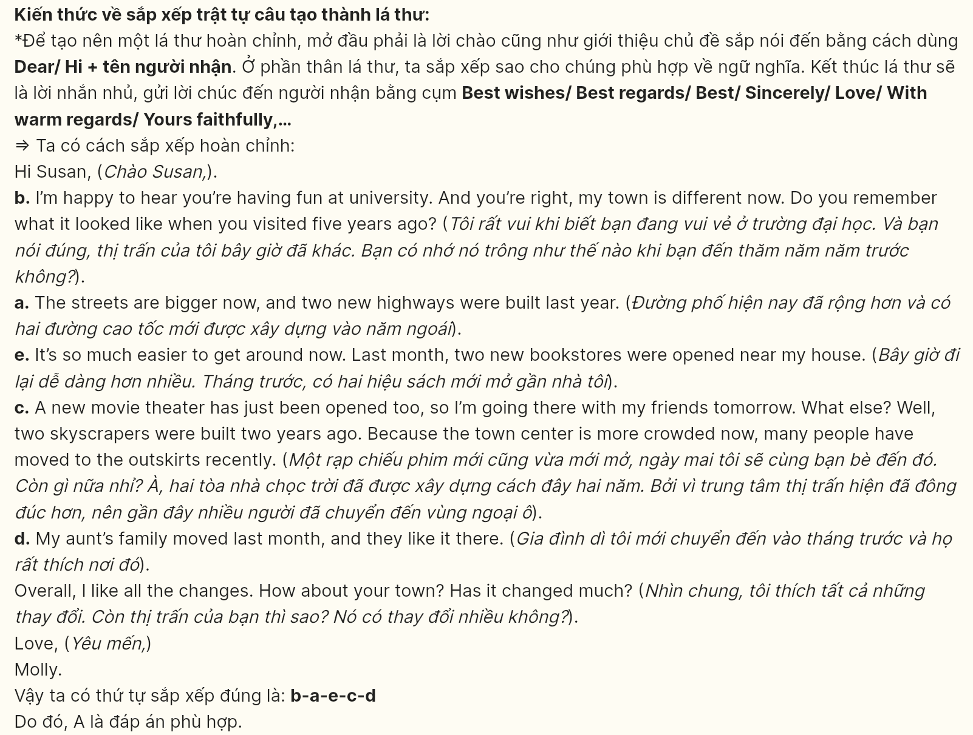

**Question 16 [695721]:**  
a. It’s taken decades for scientists to develop tasty food that astronauts can easily consume in space.  
b. When astronauts get hungry, they simply rehydrate the food with water from a special dispenser and wait for 20 to 30 minutes until it’s ready.  
c. Much of this is freeze-dried; a process by which the food is cooked, frozen, and then it has all its water sucked out.  
d. The food containers can then be attached to trays with fasteners to secure them.  
e. Freeze-dried food lasts for a long time and doesn’t need to be refrigerated, making it ideal for space travel.

*(Adapted from Exam Essentials Practice Tests FCE)*

A. c-a-e-b-d B. a-c-e-b-d C. a-d-b-e-c D. b-e-c-d-a



**Question 17 [695722]:**  
a. The sport saw some success among boomers in more recent years.  
b. Experts also attribute the sport’s rapid popularity to a few other factors, including its ease of play, low cost of entry, and sociability.  
c. Pickleball can be learned in just a few lessons, and players can find tournaments at varying competitive levels.  
d. Pickleball, a combination of tennis, badminton, and ping-pong, was first created in 1965 in Bainbridge Island, Washington.  
e. The Villages in Florida now feature more than 220 pickleball courts.

*(Adapted from CNBC Sport)*

A. c-b-e-a-d B. d-a-e-b-c C. e-d-b-a-c D. a-e-b-d-c



***Read the following passage about AI in healthcare and mark the letter A, B, C, or D on your answer sheet to indicate the option that best fits each of the numbered blanks from 18 to 22.***

Artificial intelligence (AI) in healthcare, a rapidly evolving field, (18) _____. These technologies leverage machine learning and data analytics to improve diagnostics, treatment plans, and patient outcomes. This innovation not only enhances efficiency in healthcare delivery but also supports personalized medicine tailored to individual patient needs.

One notable feature (19) _____ and medical professionals is their ability to analyze vast amounts of data quickly. AI systems can identify patterns in medical records and imaging, assisting doctors in making more informed decisions.

Despite these advantages, concerns persist about the ethical implications and accuracy of AI-driven solutions. Misdiagnoses or data privacy breaches can lead to significant consequences for patients. (20) _____

AI in healthcare presents the potential for groundbreaking advancements. Offering significant transformative advantages for both patients and providers, (21) _____. However, substantial regulatory, ethical, and technical challenges remain. (22) _____



**Question 18 [695723]:**  
A. is increasingly becoming integral to modern medical practices  
B. of which has increasingly become integral to modern medical practices  
C. having increasingly become integral to modern medical practices  
D. that is increasingly becoming integral to modern medical practices



**Question 19 [695724]:**  
A. makes AI tools particularly attractive to healthcare providers  
B. that renders AI tools especially attractive to healthcare providers  
C. converts AI tools into something appealing to healthcare providers  
D. in which AI tools are especially attractive to healthcare providers

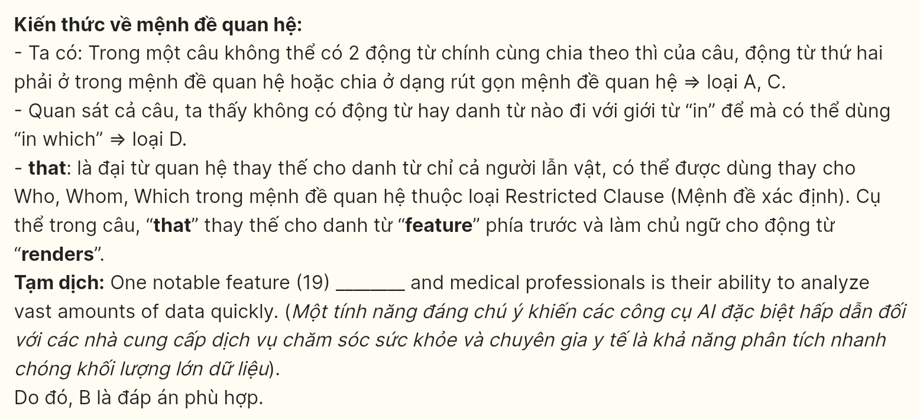

**Question 20 [695725]:**  
A. Aiming to address biases in AI, many organizations are implementing rigorous testing protocols  
B. They raise concerns about the accuracy of AI due to the absence of potential biases in training data  
C. The risk of technology malfunctioning during critical medical situations is also a worry  
D. AI technologies have been developed to enhance decision-making in healthcare



**Question 21 [695726]:**  
A. We expect it to have a revolutionary impact on healthcare delivery  
B. A revolutionary role in healthcare will be taken by these technologies  
C. People expect it to revolutionize the way healthcare is delivered  
D. It is expected to revolutionize the way healthcare is delivered

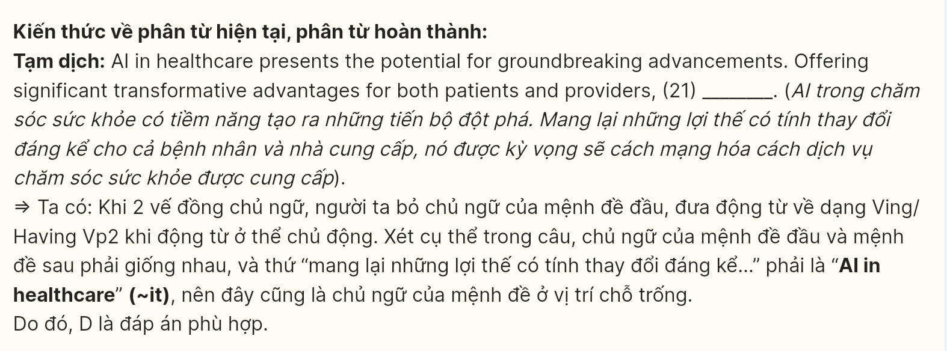

**Question 22 [695727]:**  
A. If these issues are resolved, effective implementation might remain unattainable  
B. Without tackling these issues, these machines can realize their full operational potential  
C. To achieve effective implementation, it is crucial that these obstacles are dealt with  
D. In order for effective implementation to be achieved, these obstacles must be tackled with

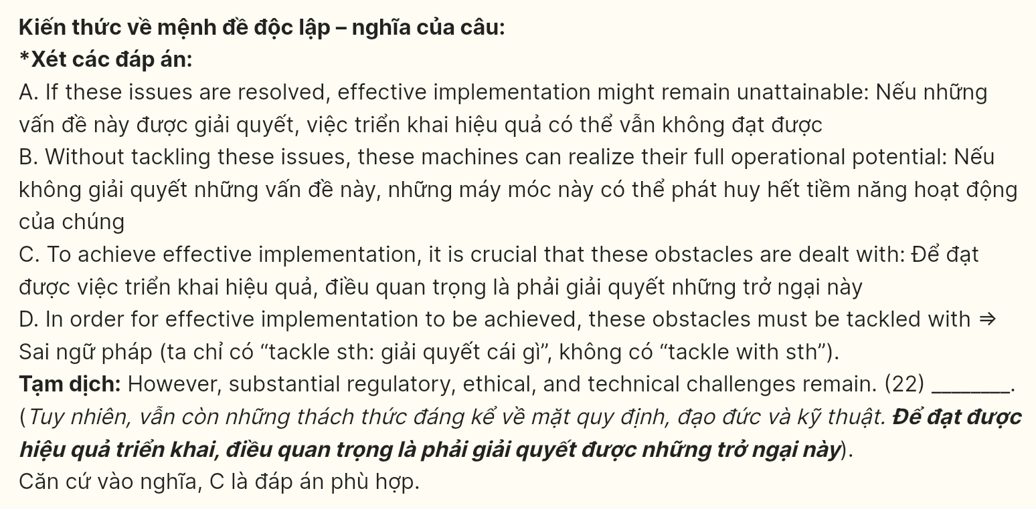

**Read the following passage about the magazine’s power and mark the letter A, B, C, or D on your answer sheet to indicate the option that best fits each of the numbered blanks from 23 to 30.**

Who says print is dead? Walk into Joseph’s Magazine Stand in downtown Chicago, where glossy covers still catch eyes and spark conversations. “People come here seeking stories, not just information,” muses Joseph Chen, who has run stands since 1985. Between towering racks of publications, readers forge their unexpected connections.

Print magazines shape cultural narratives in ways digital platforms struggle to replicate. Market research from Columbia Journalism Review unveils that readers retain 65% more information from print articles than digital ones. Readers’ emotional engagement amplifies through **their** physical interaction with pages. Magazine subscribers demonstrate remarkable loyalty, with specialty publications maintaining subscription rates even as digital alternatives proliferate. Independent magazines flourish in particular niches, where devoted readers savor curated content and tangible experiences.

Print publications cultivate distinct reading rituals. Morning commuters fold newspaper corners on trains, while coffee shop regulars annotate magazine margins. The tactile nature of print media engenders **contemplative** reading practices. Scientific studies reveal that paper-based reading stimulates neural pathways associated with deeper comprehension. Paper activates spatial memory, allowing readers to map information physically across pages.

Magazines build bridges between creators and audiences through innovative formats. Art directors experiment with paper types and printing techniques to enhance storytelling. Photography gains depth through carefully chosen paper finishes. **Editorial teams orchestrate visual narratives across spreads, guiding readers through carefully paced journeys.** Reader letters transform into community forums, where subscribers debate ideas across monthly issues. This collaborative spirit **permeates** throughout production, fostering meaningful dialogue between writers, designers, and devoted readers who anticipate each carefully crafted edition.

*(Adapted from The New Yorker)*

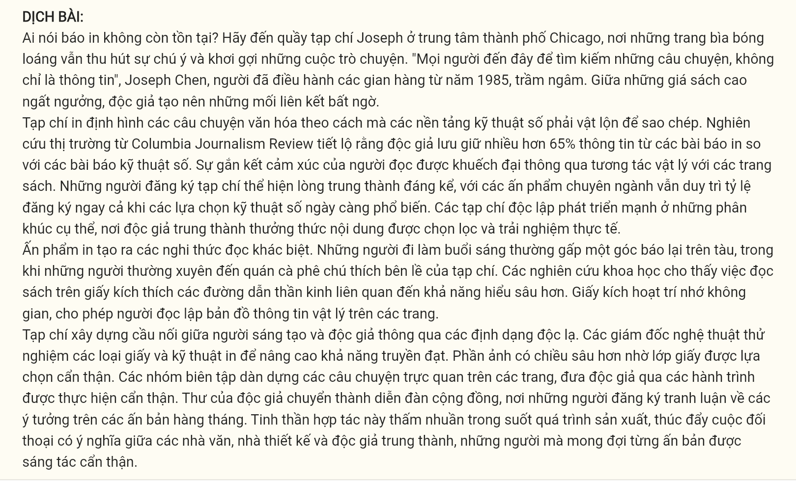

**Question 23 [695728]:** Which of the following is **NOT** mentioned as an advantage of print magazines?  
A. enhanced memory retention rates B. specialized content curation  
C. advertising effectiveness rates D. tactile reading experience

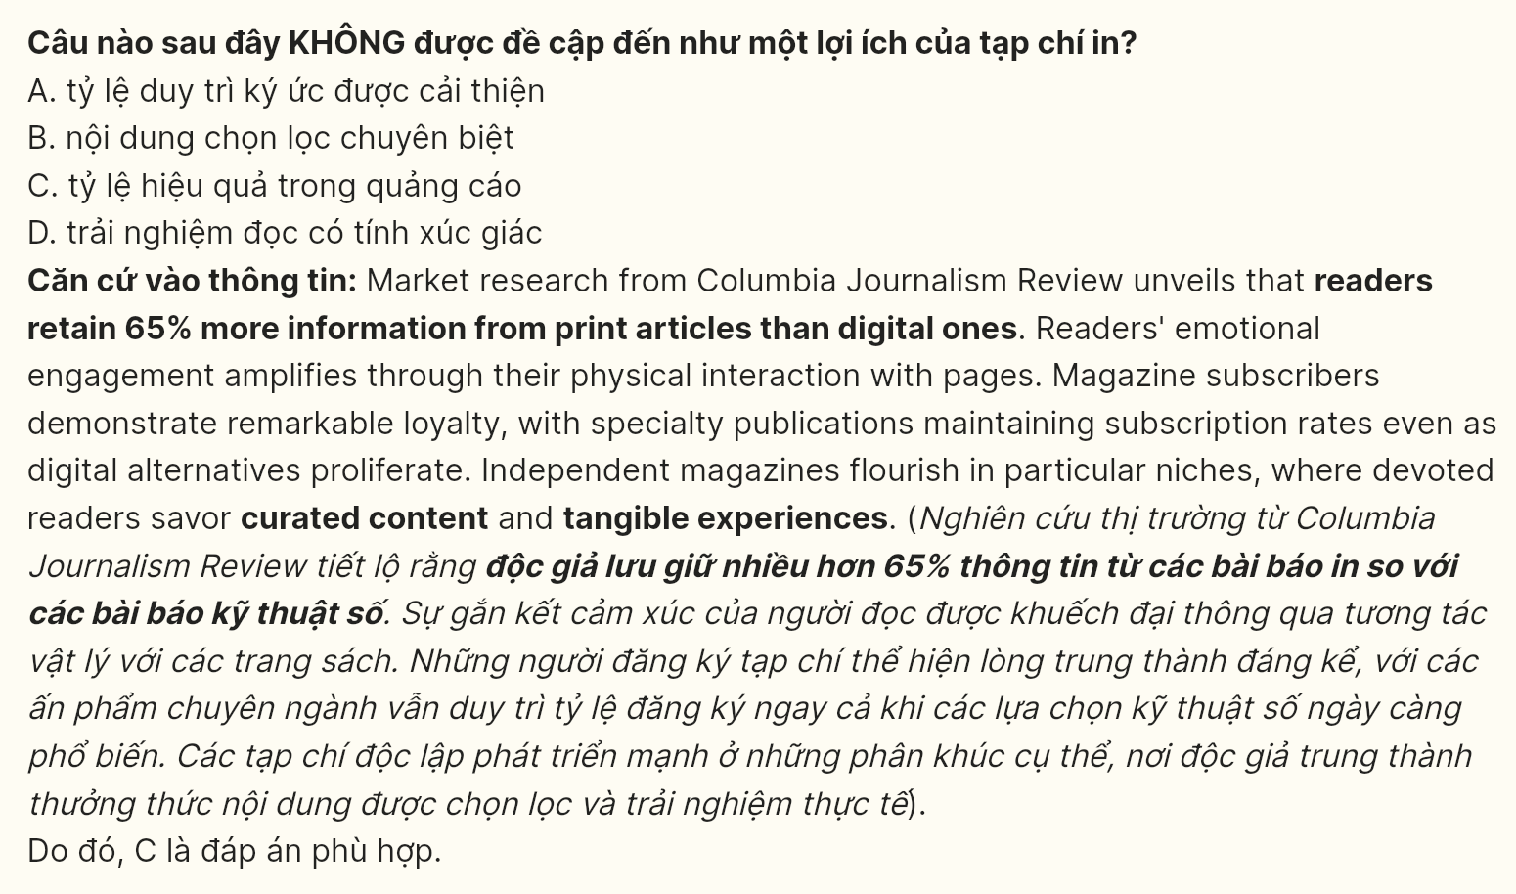

**Question 24 [695729]:** The word “**permeates**” in the final paragraph is **OPPOSITE** in meaning to ______  
A. dissipates B. saturates C. infiltrates D. penetrates

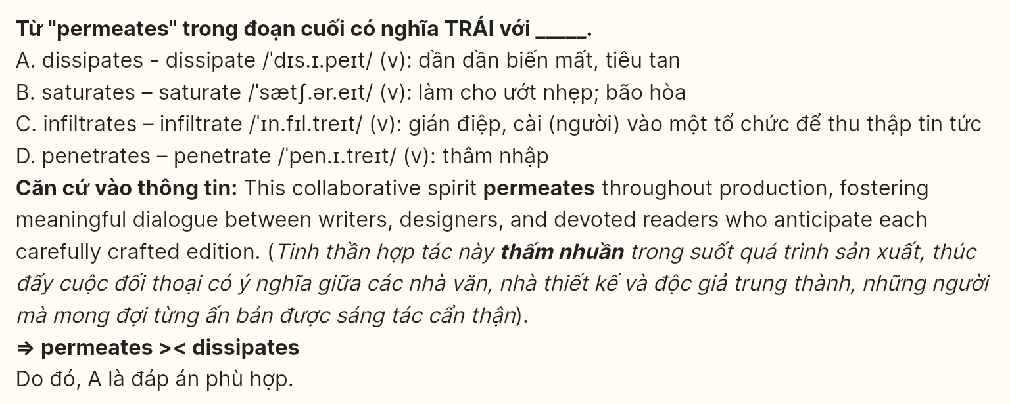

**Question 25 [695730]:** The word “**their**” in paragraph 2 refers to ______  
A. platforms B. readers C. magazines D. narratives

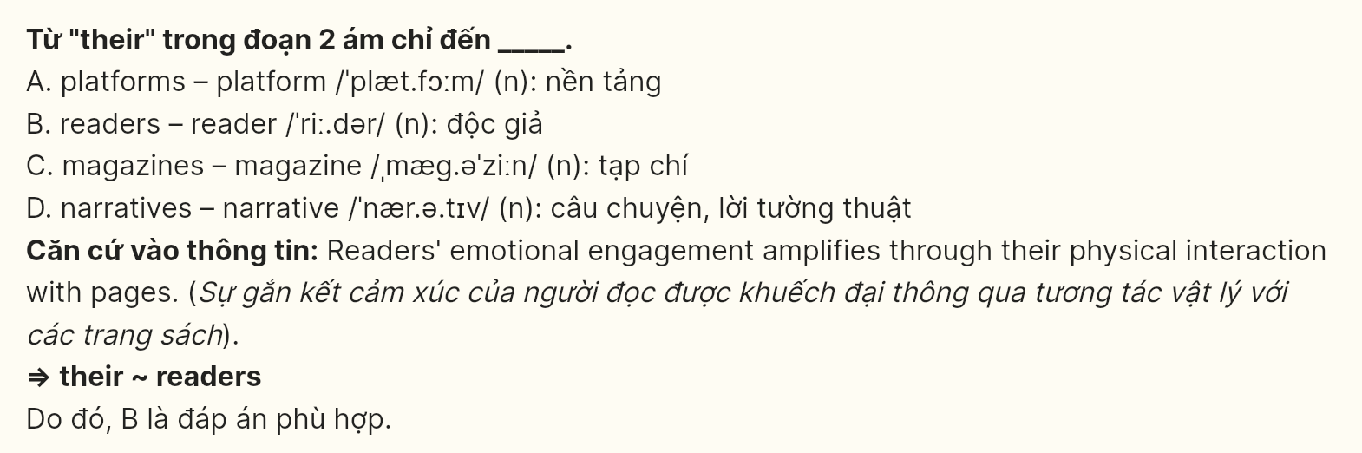

**Question 26 [695731]:** The word “**contemplative**” in paragraph three could be best replaced by ______  
A. perceptive B. cognitive C. attentive D. ruminative

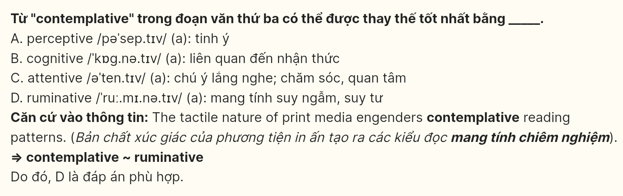

**Question 27 [695732]:** Which of the following best paraphrases the underlined sentence?  
A. Design specialists strategically position visual elements throughout publications to shape reader engagement patterns  
B. Editorial departments carefully construct sequential visual stories that lead audiences through magazine experiences  
C. Magazine teams develop interconnected layouts across multiple pages to direct information consumption rates  
D. Publication staff members coordinate the arrangement of imagery to control audience reading progression

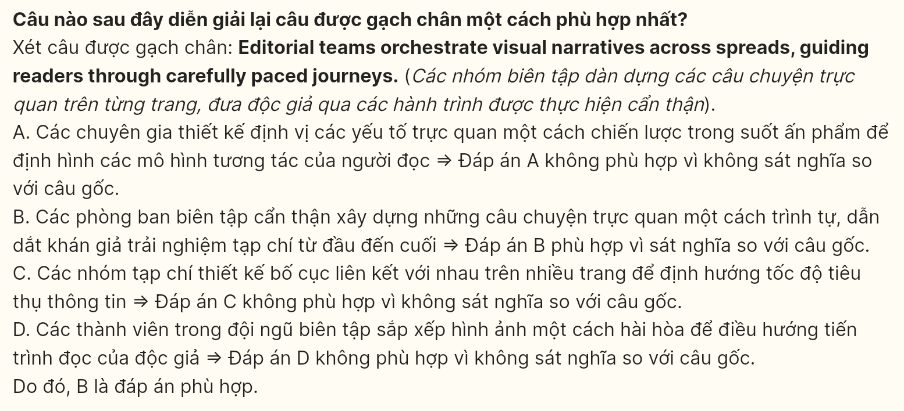

**Question 28 [695733]:** Which of the following is **TRUE** according to the passage?  
A. Print media provides readers with more useful information than digital ones  
B. Some print magazines maintain subscription numbers despite digital reading options  
C. Paper-based reading activates some specific pathways in neural comprehension  
D. Magazine stands to create spaces where readers discover their unexpected insights

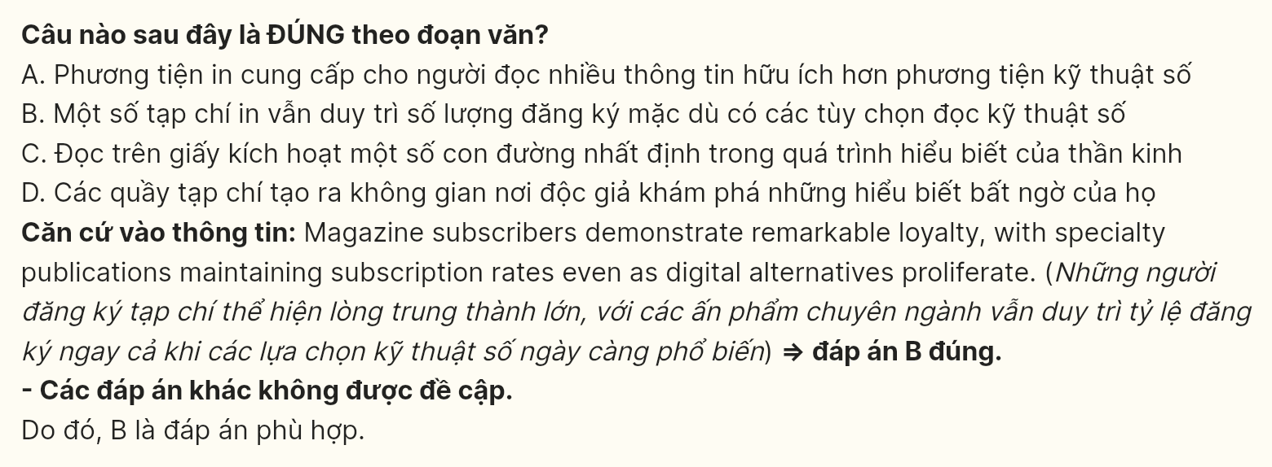

**Question 29 [695734]:** In which paragraph does the writer examine the reading-memory relationship?  
A. Paragraph 1 B. Paragraph 2 C. Paragraph 3 D. Paragraph 4

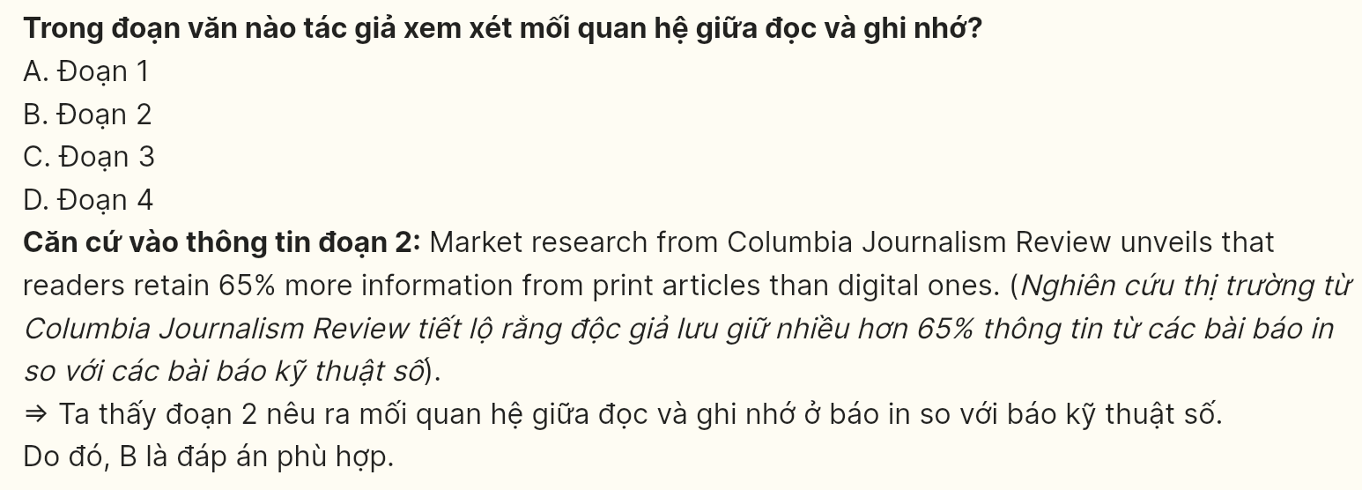

**Question 30 [695735]:** In which paragraph does the writer explore creative production elements?  
A. Paragraph 1 B. Paragraph 2 C. Paragraph 3 D. Paragraph 4

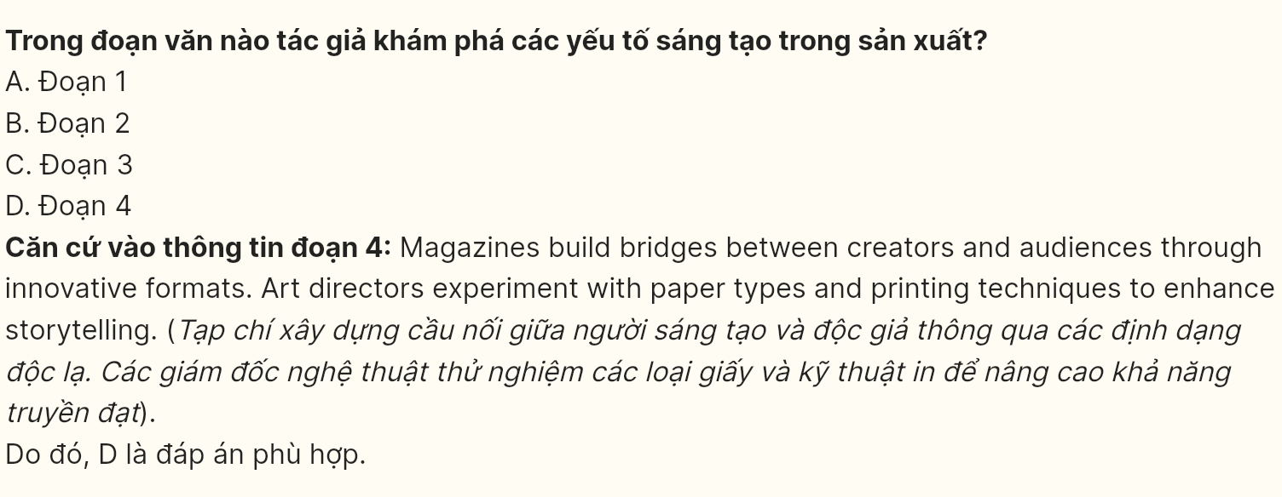

**Read the following passage and mark the letter A, B, C, or D on your answer sheet to indicate the option that best fits each of the numbered blanks from 31 to 40.**

“Just finished editing a short film for my photography class,” types Maya Chen in a group chat, while simultaneously helping coordinate her basketball team’s practice schedule and managing three different art accounts. [I] It’s 9 PM on a typical Tuesday, and like many of her peers, Maya’s digital engagement runs far deeper than casual scrolling or gaming.

[II] In local gaming cafes, the scene tells an unexpected story. Teenagers huddle around screens, but **they’re** not just playing games – they’re running small businesses, organizing community events, and even learning foreign languages through international gaming partners. “Yesterday I practiced Japanese with my raid team,” says Alex Rodriguez, who picked up the language through his gaming community. “Today I’m helping design merchandise for our team’s streaming channel.”

**What adults often miss in these digital interactions is their layered complexity.** [III] During a typical school session, James Park seamlessly weaves between editing YouTube tutorials, managing social media for local businesses, and collaborating on class projects. His YouTube channel, which started as a hobby sharing gaming clips, now serves as a portfolio for potential clients. "Each video teaches me something new about editing, marketing, or audience engagement," James explains while adjusting color grades on his latest project.

School clubs have taken notice of this digital sophistication. [**IV**] The debate team now runs a podcast analyzing current events, while the art club showcases student work through carefully **curated** Instagram galleries. "We’re not just posting pictures," explains Sarah Thompson, head of the media club. "We’re building portfolios, learning brand management, and developing professional networks."

Local creative studios report an interesting trend: teenagers arriving with increasingly sophisticated digital skills. "They understand audience engagement instinctively," notes studio owner David Chen. "Many have been managing online communities since middle school." This early exposure to content creation often translates into unexpected career paths. Emma Watson, who started by making simple gaming videos, now freelances as a video editor for environmental organizations. She’s really **hit the ground running**, combining her technical skills with her passion for sustainability.

*(Adapted from C1 CEFR Reading Practices)*

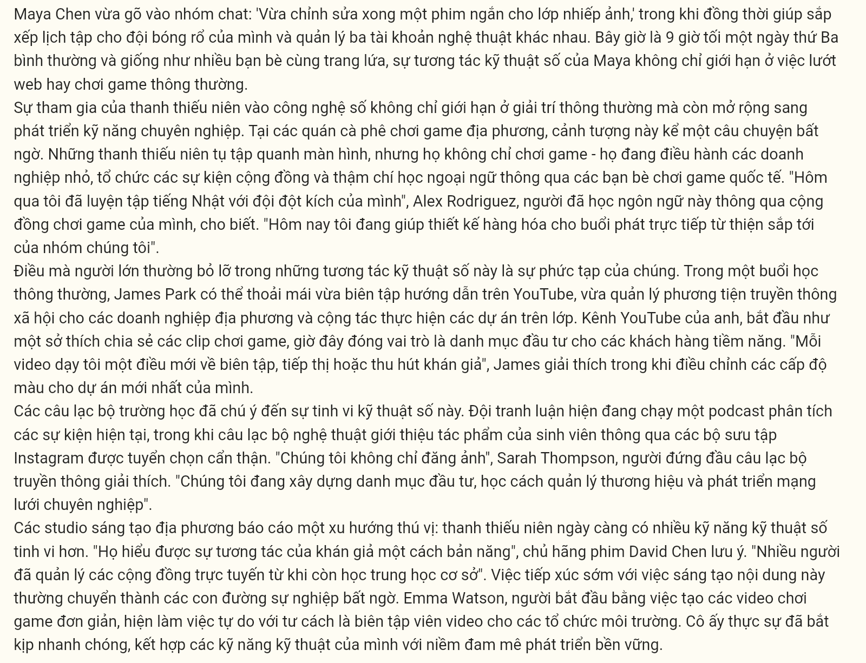

**Question 31 [695736]:** Where in the passage does the following sentence best fit?  
**Digital engagement among teenagers extends far beyond casual entertainment into professional skill development.**  
A. [I] B. [II] C. [III] D. [IV]

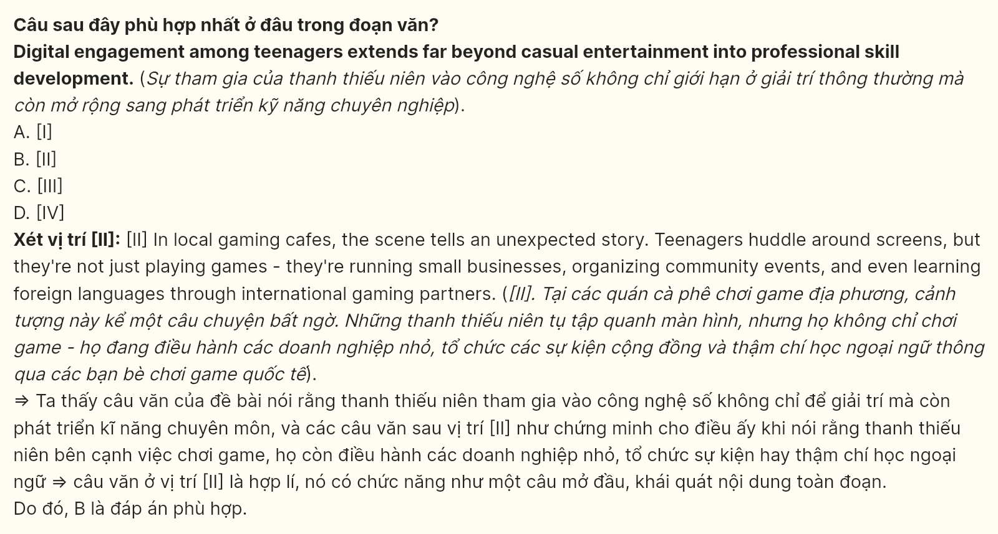

**Question 32 [695737]:** The word "**they**" in paragraph 2 refers to ______.  
A. students B. screens C. cafes D. teenagers

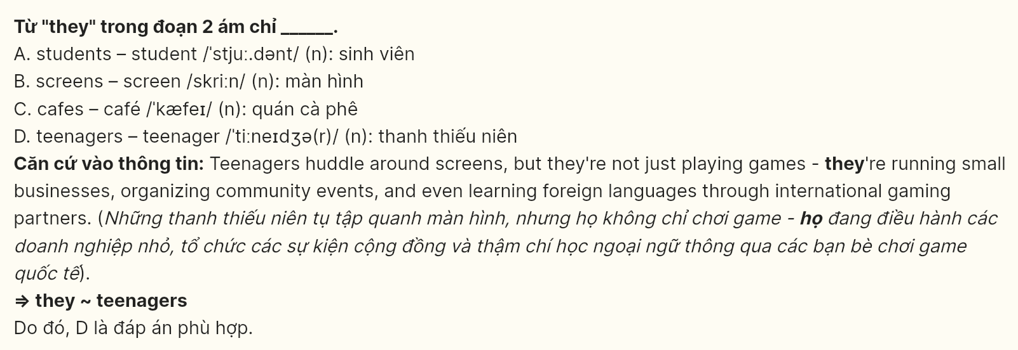

**Question 33 [695738]:** According to the passage, which of the following activities is **NOT** described as taking place in gaming cafes?  
A. Running small businesses B. Learning foreign languages  
C. Editing YouTube content D. Organizing community events

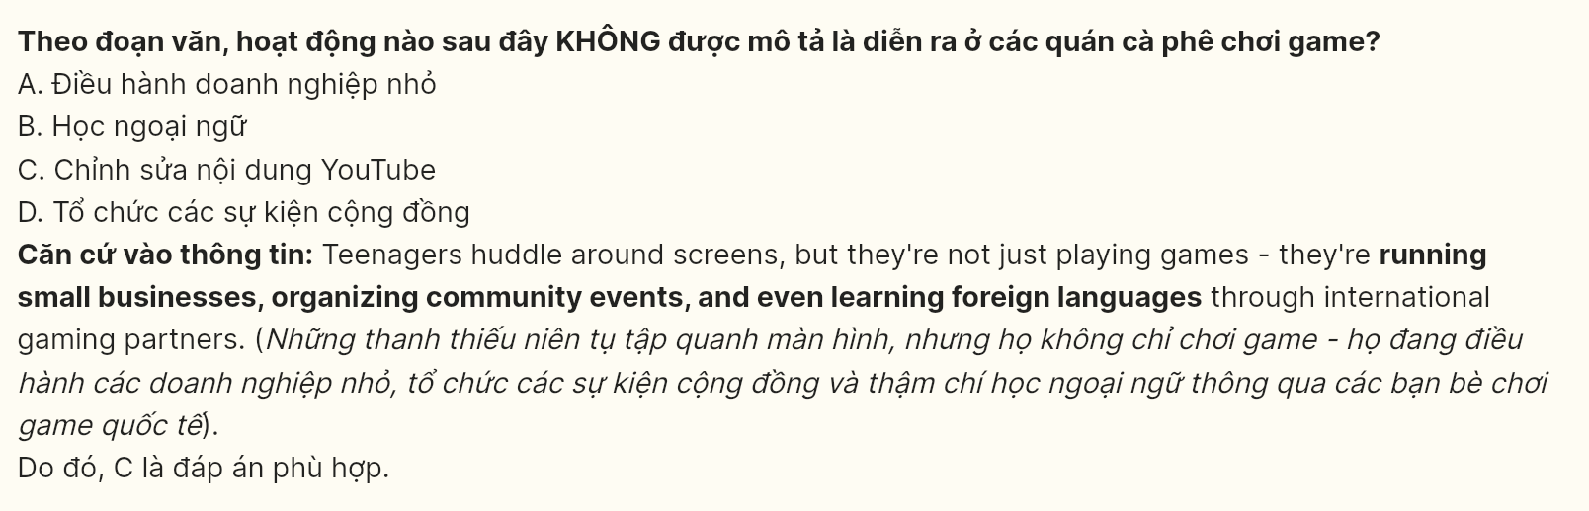

**Question 34 [695739]:** Which of the following best paraphrases the underlined sentence in paragraph 3?  
A. Adults frequently fail to perceive that these digital interactions involve multiple, intricate layers.  
B. The intricate and multifaceted nature of digital interactions is often overlooked by adults.  
C. These digital interactions are complex on many levels, a detail that often escapes adult awareness.  
D. Adults are commonly unaware that digital interactions possess an intricately layered structure.

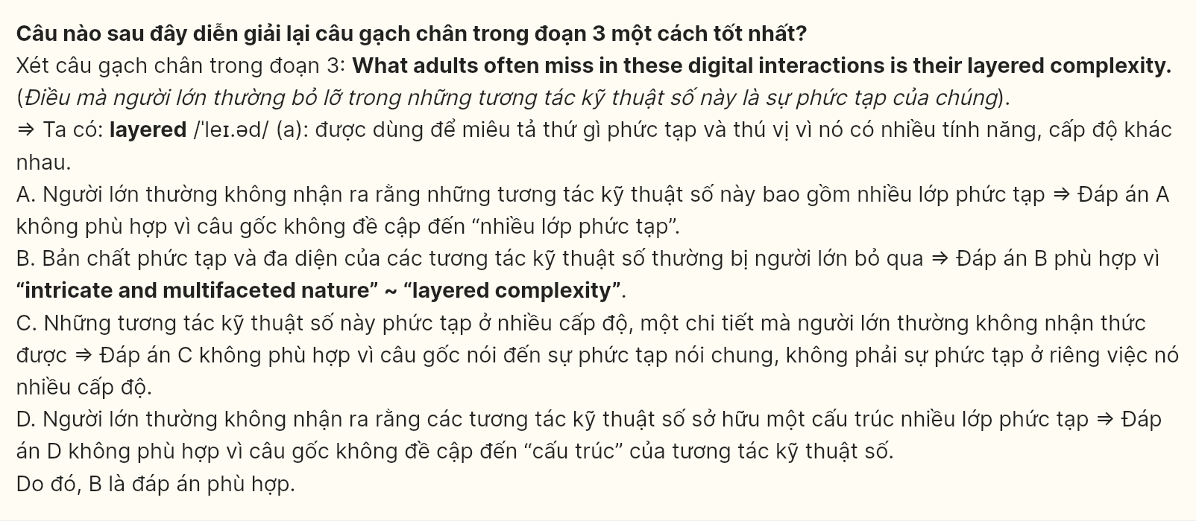

**Question 35 [695740]:** The word "**curated**" in paragraph 4 is closest in meaning to ______.  
A. collected B. organized C. displayed D. managed

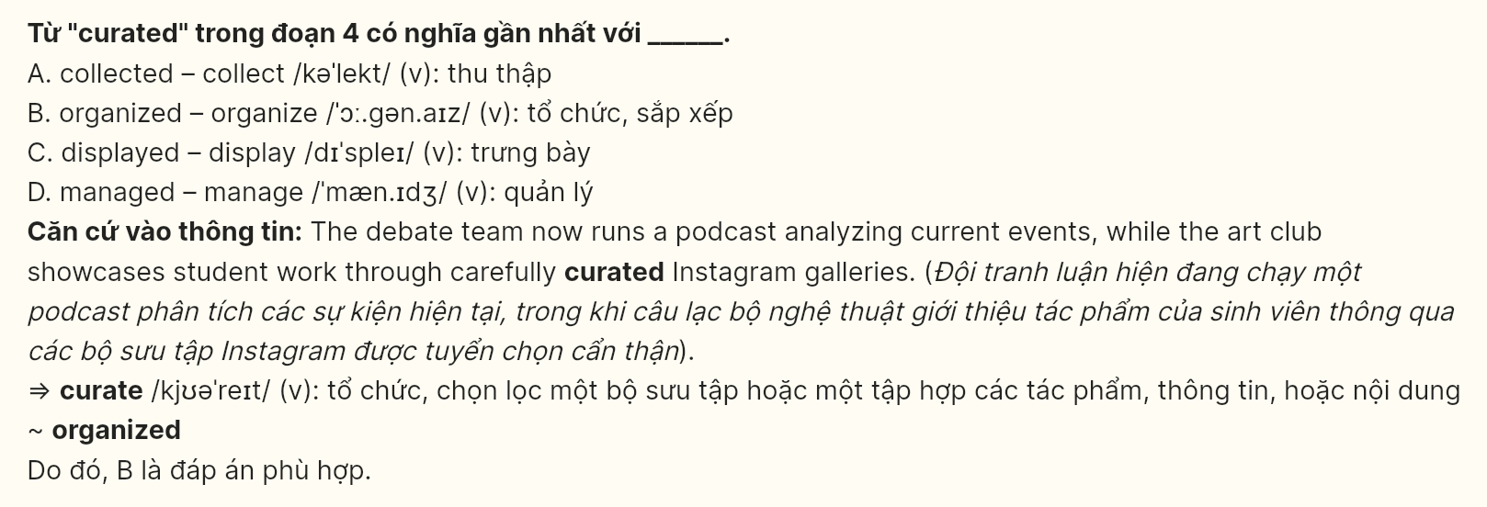

**Question 36 [695741]:** Which of the following best summarizes paragraph 4?  
A. School clubs have enhanced their activities by using digital tools.  
B. Students are learning to build professional networks through clubs.  
C. Clubs are innovating with digital media to showcase their work.  
D. Digital sophistication is helping clubs enhance traditional activities.

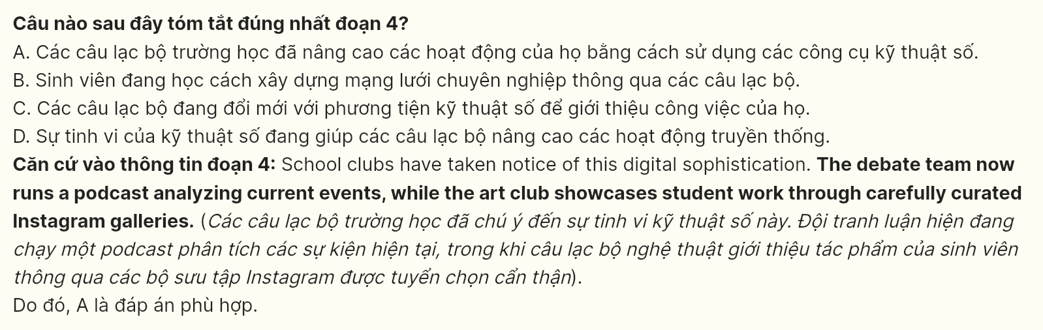

**Question 37 [695742]:** Which of the following is TRUE according to the passage?  
A. The art club curates student work through dedicated Instagram gallery platforms.  
B. Local gaming cafes can function as spaces for teenagers’ entrepreneurial activities.  
C. James’s recreational video content developed into various professional work samples.  
D. Digital studios hire teenagers because of their advanced content creation skills.

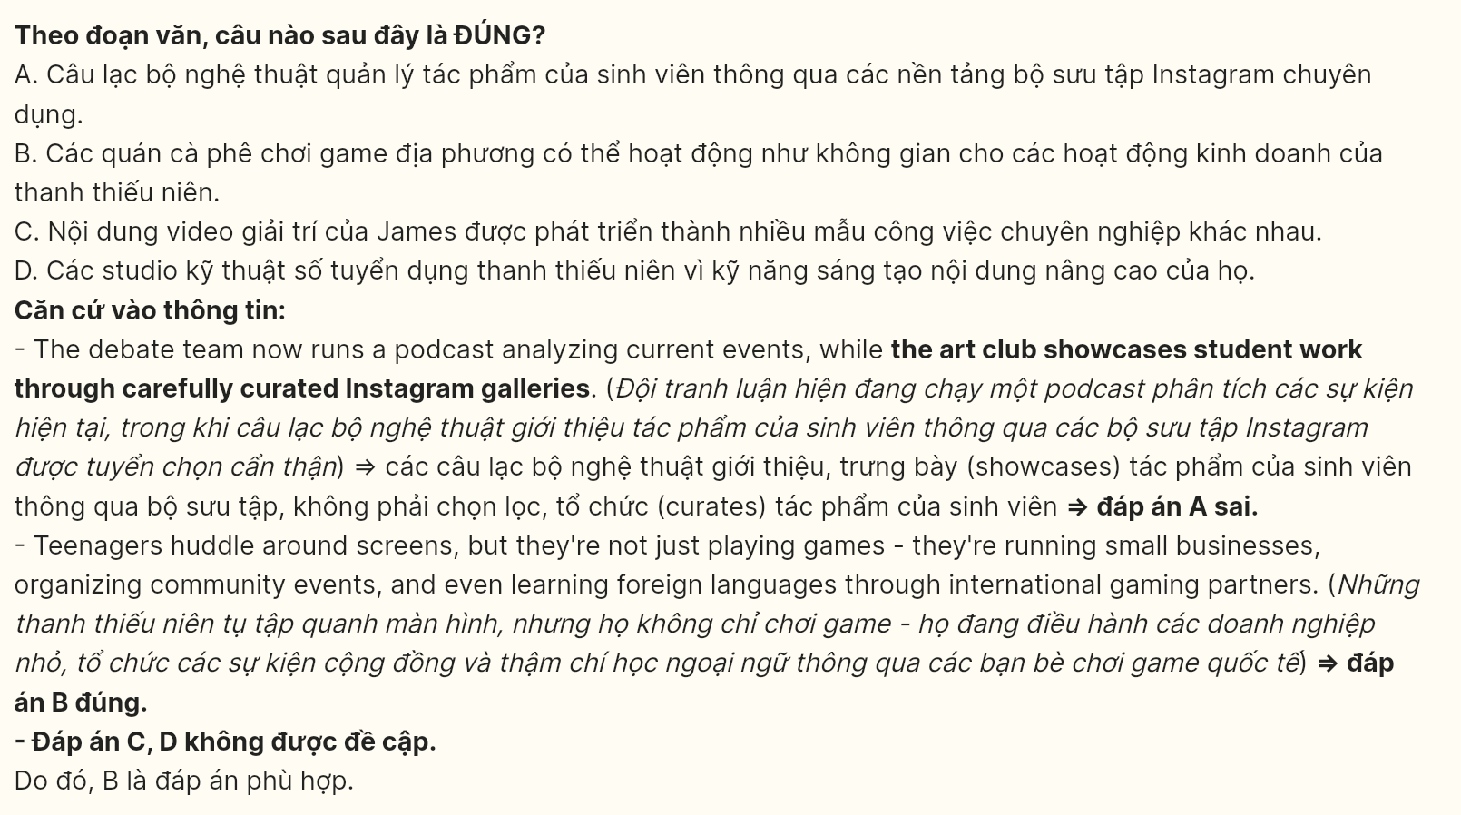

**Question 38 [695743]:** The phrase **"hit the ground running"** in the final paragraph could best be replaced by ______.  
A. finished effectively B. moved quickly C. adapted well D. learned fast

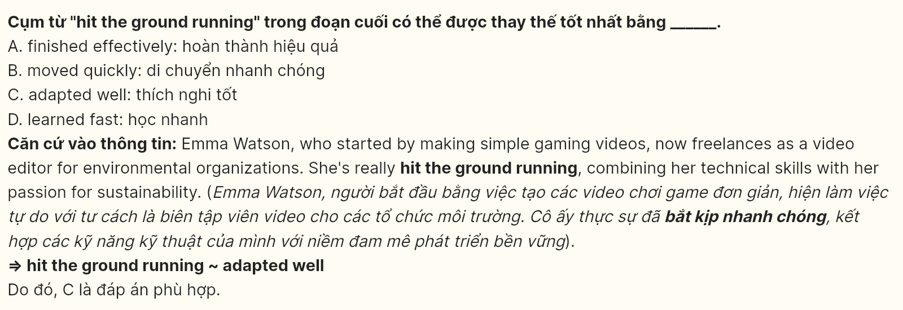

**Question 39 [695744]:** What can be inferred from the passage?  
A. Teenagers begin developing their media management experience well before entering high school.  
B. Students managing online communities often possess superior content engagement understanding.  
C. Early exposure to digital content creation naturally leads to environmental advocacy careers.  
D. Youth-driven gaming channels frequently transform into professional development opportunities.

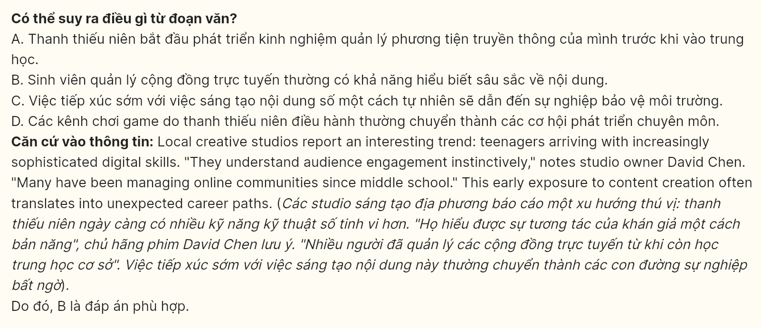

**Question 40 [695745]:** Which of the following best summarizes the passage?  
A. Teenagers merge online gaming with professional development, while simultaneously building portfolios and managing digital communities through diverse platforms.  
B. Modern youth leverage gaming environments and social media to develop marketable skills, creating unexpected pathways toward professional careers.  
C. Digital spaces enable teenagers to blend academic work, creative projects, and professional growth while managing multiple online responsibilities.  
D. Students transform recreational gaming activities into learning opportunities, leading creative studios to recognize their sophisticated digital capabilities.

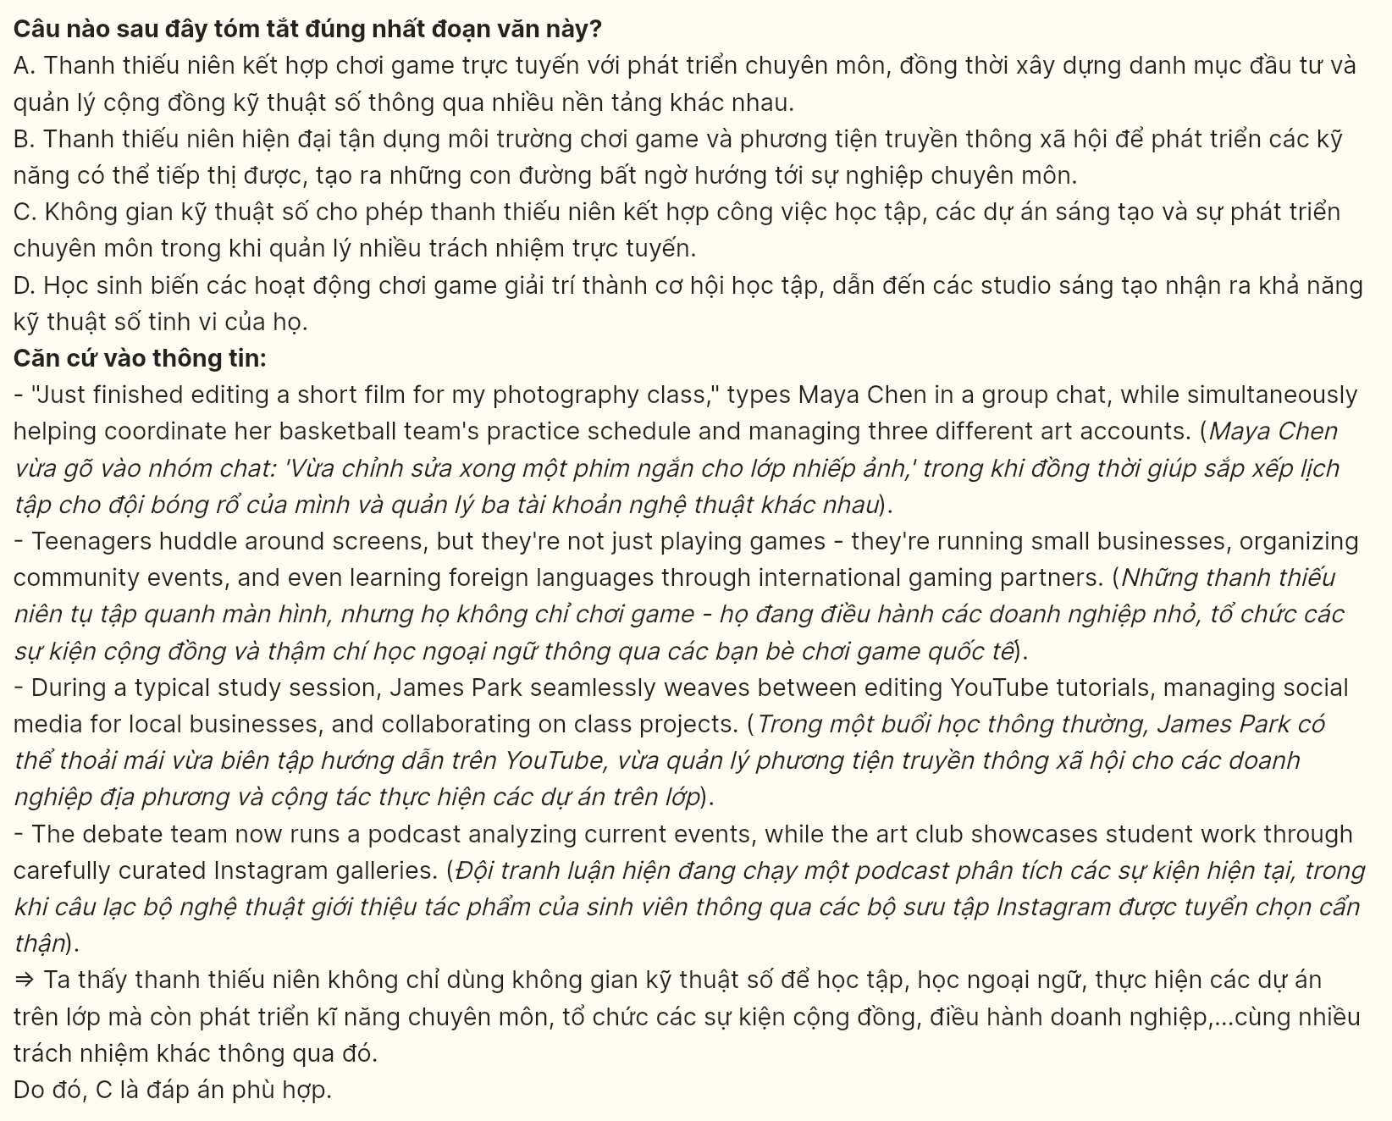

**--- THE END ---**