

Tiết thứ ......
UNIT 10: ENERGY SOURCES
Lesson 2: A closer look 1

Class | Date of teaching | Attendence
7... | ...../........./202....
7… | ..../......../202...
7…. | ..../......../202....
I. OBJECTIVES: By the end of this unit, students will be able to gain the following things:
1. Knowledge:
+ use the lexical items related to the topic sources of energy;
+ pronunciation: Stress in three-syllable words .
+ Vocabulary: - Use the vocabulary to talk about sources of energy:
+ Grammar:
2. Competence:
a) General competencies:
Students will be able to know more words and phrases about sources of energy; Develop communication skills and creativity; Actively join in class activities.
b) Specific competencies:
- Develop communication skills and cultural awareness.
- Be cooperative and supportive in pair work and teamwork.
- Actively join in class activities.
3. Qualities:
Develop awareness of energy sources and energy saving
- Develop self-study skills.
II. PREPARATIONS
- Teacher: Grade 7 text book, laptop, projector / TV/ pictures and cards.....
- Students : Text books, studying equipment….
III. PROCEDURE:
Notes: In each activity, each step will be represented as following:
* Deliver the task.
* Implement the task.
* Discuss.
* Give comments or feedback.
Activity 1. WARM UP (5’-IW, GW)
* Aim:
- To activate students’ knowledge on the topic of the unit
- To enhance students’ skills of cooperating with team mates
* Content:
To have some warm-up activities to create a friendly and relaxed atmosphere to inspire Ss to warm up to the subject and new lesson.
* Product: Having a chance to speak English and focus on the topic of the lesson..
* Implementation:Teacher’s instructions…
Teacher’s & Student’s activities | Content
+ Greeting  + CROSSWORDS  * Teacher gives instructions  ** Ss are divided into 2 groups  - Teacher show the crosswords onto the screen with hints/clues and students choose each line and take turn to answer.  - take turns to write until finish all the words or find out the key word.  ntroduce what they are going to study….   Teacher checks and corrects if Ss pronounce the words incorrectly. | + Greeting  + CROSSWORDS  Suggested answers:  Answers:  1- Sun  2- coal  3- oiL  4- renewable  5- natural gas
Activity 2. KNOWLEDGE FORMATION (15'- PW, IW)
* Aim:
- To help students use key language more appropriately
- To get students interested in the topic
- To set the context
- To help Ss understand the main idea of the text
* Content: Teach some new words. Read the conversation and find out new words.
* Product: Knowing more new words. Understanding the conversation; topic of the lesson, grammar points…
* Implementation: Teacher’s instructions…
Teacher’s & Student’s activities | Content
- VOCABULARY  *Pre- teach vocabulary:  * Teacher introduces the vocabulary by:  + providing the synonyms or antonyms of the words;  + providing the pictures of the words.  - Teacher has students read the phrases aloud and corrects their pronunciation if needed.  - Teacher asks students for the Vietnamese meanings of these phrases.  ** Students say the words.  *** Other students correct if the previous answers are incorrect.   Teacher shows and says the words aloud and asks students to repeat them.  Task 1. Match the types of energy in A * Teacher asks Ss to look at the table and match the energy with its source.  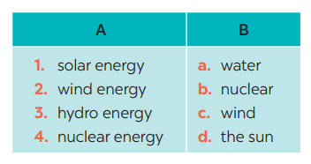  ** Ss work out and answer questions in pairs.  *** Ss share their answers as a whole class.   T asks them to to check their answers.  * Teacher asks students to make full sentences to tell about the sources of different energy. Then tell share them to share their sentences with a partner and correct for them. | * Vocabulary:  1. solar energy (n.phr.) /ˈsōlər ˈenədʒi/: năng lượng mặt trời    2. hydro energy (n.phr.) /ˈhīdrō ˈenədʒi/: năng lượng nước    3. nuclear (n) /njuː.klɪər/: hạt nhân  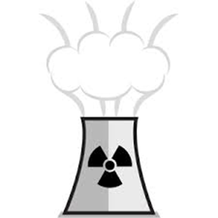  Task 1. Match the types of energy in A with the energy sources in B  Answer key:  Answers:  1- D 2 – C 3 – A 4 – B
Activity 3. PRACTICE (15’-IW, PW, GW)
* Aim:
- To practise identifying the meanings of road signs.
- To develop Ss' knowledge of vocabulary
- To help Ss deeply understand how to read the road signs
- To practise the targeted language in life context
* Product: Ss can learn how to use the words and phrases to do the exercises.
* Implementation: Teacher’s instructions…
Teacher’s Student’s activities | Content
Task 2: Write the phrases to label the pictures:  * Teacher asks Ss to look at the pictures and use the knowledge from Task 1 to guess the pictures.  Then work and share their answers with their partners who sit next to them. (peer check)  ** Ss do exercise 3 in pairs.  *** Ss share and discuss with their partners to write all words/ phrases down on the notebooks.   Teacher corrects their answers as a class.  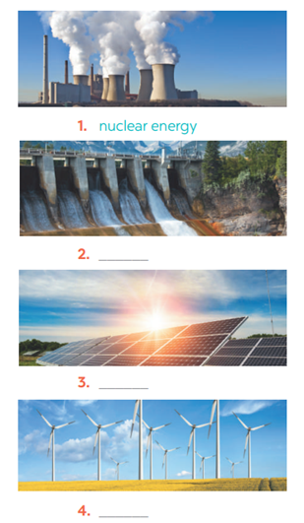 | Task 2: Write the phrases to label the pictures:  Answers  1. Nuclear energy  2. Hydro energy  3. Solar energy  4. Wind energy
Task 3: Complete the sentences with the words and phrases from 1 or 2.  * Teacher gives students time to do the exercise individually, then share their sentences.  *** Teacher nominates Ss to say the sentences aloud.   Teacher checks and gives the corrections if they have mistakes.  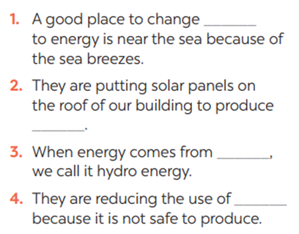 | Task 3: Complete the sentences with the words and phrases from 1 or 2.  Answers  1. wind  2. solar energy  3. water  4. nuclear
Activity 4. APPLICATION (7’-IW, PW, GW)
* Aim: - To help Ss identify the and classify the sounds
- To give students authentic practice in using pronouncing sounds in common words
- To help Ss memorise the target language and skills that they have learned
- To consolidate what students have learnt in the lesson.
* Content: Play a game: Simon says
* Product: Ss can remember the words. Revise and learn more new words.
* Implementation: Teacher’s instructions
PRONUNCIATION  Task 4: Listen and repeat. Pay attention to the stressed syllables in the words.  Teacher gives Ss time to listen and practice pronouncing the words with correct primary stress.  Task 5: Listen and repeat, paying attention to the stressed syllables in the underlined words.  ** Ss do as instructed   Teacher gives Ss feedback.  - choose some common mispronounced words and suggest students practise using them.  - choose some typical errors and correct as a whole class  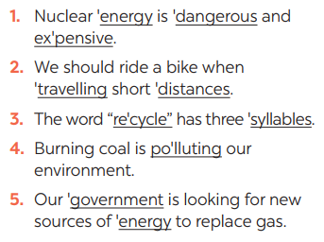  Consolidation  - Vocabulary about sources of energy.  - Pronunciation: Stress in three-syllable words  Homework:  Ss memorise the target language and skills that they have learned | 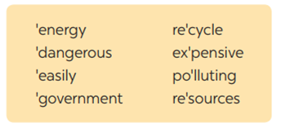  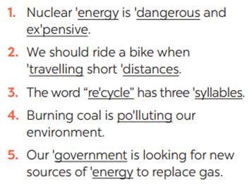  * Home assignment  - Exercises in the workbook
V. FEEDBACK:
With 7 ……………………………………………………………………………..…
With 7 …………………………...……………………………………..……………
With 7 ………………………………………………………………………….……

