|  |  |
| --- | --- |
| **Mã đề 9.1.39** | **ĐỀ KIỂM TRA CUỐI HỌC KÌ I**  **NĂM HỌC 2022 - 2023**  **MÔN: TIẾNG ANH 9**  **Thời gian làm bài: 60 phút**  (Không kể thời gian giao đề)  Đề gồm: 03 trang |

**A. LISTENING (2.0 POINTS)**

**I. Listen to the five short conversations and choose the correct picture for each question (1.0 point)**

1. What is Nick listening to? (**NHẬN BIẾT)**

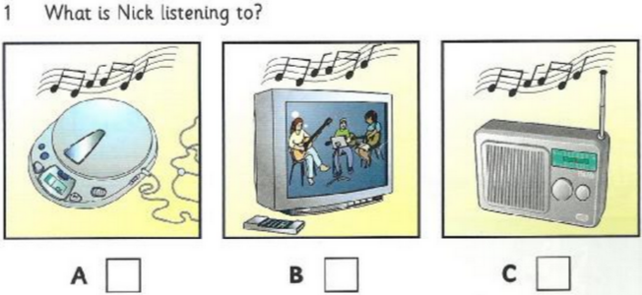

2. Which man is Sue’s teacher?(**NHẬN BIẾT)**

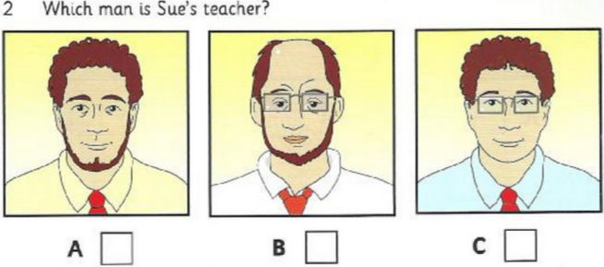

3. What does Pat want to do today?**(THÔNG HIỂU)**

4. Why has Ben got a stomachache?**(THÔNG HIỂU)**

5. What does Bill want to see first at the zoo?**(NHẬN BIẾT)**

**II. Listen and write. (1.0 point)**

|  |
| --- |
| **Sports day**  1. Day : ________________________(**NHẬN BIẾT)**  2. How many sports?: _____________________(**NHẬN BIẾT)**  3. Favorite sport? : ____________________**(NHẬN BIẾT )**  4. Where picnic? : ______________ Park **(THÔNG HIỂU)**  5. Food? : ___________________**(NHẬN BIẾT )** |

**B: LANGUAGE (2 POINTS)**

**I. Choose the best option (A, B, C or D) to complete these sentences. (2 points)**

1. I wish I _____________ more time to relax. **NP NHẬN BIẾT**  
A. having B. had C. have D. will have  
 2. Your brother passed the final exam, _____________ ? **NP NHẬN BIẾT**  
A. did he B. does he C. doesn’t he D. didn’t he  
3. I’d like to visit Viet Nam ___________ Vietnamese people are very friendly. ______________________________________________________**NP(THÔNG HIỂU)**  
A. so B. But C. Because D. though  
4. If I _______an opportunity to study in New Zealand, I would be very happy. ______________________________________________________**NP(THÔNG HIỂU )**  
A. had B. have C. to have D. having  
 5 . ________ I was really tired , I couldn’t sleep. **NP(THÔNG HIỂU)**

A. Therefore B. So C. Even though D. Because of  
6. “It’s expensive to go there by taxi. I suggest _____ a bus ”, Nam said.**NP NHẬN BIẾT**  
A. to take B. taking C. to taking D. for taking  
**7. Tourist:"**May I sit here?" **- Nam:" _______"CNNN (THÔNG HIỂU)**

A. I am sorry the chair is taken. B. No, I haven't been waiting for long.

C. Yes, I have just arrived. D. I am lonely.

8. I’d like to watch the news. Please ____________ the television. **TV(THÔNG HIỂU )**  
A. put on B. turn down C. turn on D. turn off

9. - Why don't we eat out in a restaurant tonight? - .................................

**CNNN NHẬN BIẾT**

A. That's a good idea B. I hope so C. What a pity

10. It is _____ that Thang Long Bridge was built in the 20th century. **NP NHẬN BIẾT**

A. believes B. believe C.. believed

**C. READING (2 POINTS)**

**I. Read the passage and then choose the correct answer to each question. (1 point)**

I come from Switzerland. I came to London six months (1) _____ to learn English. I haven’t met many English people yet, only my teachers. I started learning English at school in Switzerland (2) _____ I was eleven, so I have learned it for nearly ten years. At first in London, I couldn’t understand anything, but now my English (3) ____ improved. I have just taken an exam. If I pass (4) I _____ into the next class. I’m excited today because my parents will come tomorrow to stay with me for a few days and I (5) _____ them for a long time. They have never been to England and they can’t speak English.

1. A. tomorrow B. before C. last D.ago (**NHẬN BIẾT)**

2. A. because B. that C. when D. it**(THÔNG HIỂU)**  
3. A. were B. is C. are D. is **(THÔNG HIỂU)**  
4. A. will move B. moved C. would move D. move(**NHẬN BIẾT)**

5. A. haven’t seen B. didn’t see C. hasn’t seen D. saw**(NHẬN BIẾT )**  
II.  **Read the passage and choose the correct answer for each question (1 point)**

If you live in a city, you will probably see many people, hear the noise of traffic, and smell the pollution from cars and factories. We are living in a new era in the history of the world. Before this, most people were farmers. They lived in small communities in the country. Now many people are leaving the farms and moving into the cities. ***They*** are looking for better jobs. As a result, the cities are growing very quickly. Most cities are becoming more crowded. People are driving more cars, burning more fuel, using more water, eating more food, making more garbage, and producing more things in factories than ever before. Life in modern cities can bring many opportunities, but also many difficulties.

The authorities are trying to plan for a better future. They are building new roads, putting up new houses, looking for more water sources, and limiting growth in certain areas. But people are still crowding into the cities faster than the cities can take them. The cities are running out of space. There are no easy answers to this problem.

*1. What is the main idea of the text?***(THÔNG HIỂU)**  
A. Drawbacks of the city life and the solutions.

B. Advantages of living in the city.

C. Disadvantages of living in the city.

D. No Advantages of living in the city.

*2. People tend to move to big cities to* ____**(THÔNG HIỂU)**  
A. find jobs B. do farming C. entertain D. find house

*3. The word “****They****” in paragraph 1 refers to* ***(*VẬN DỤNG)**

A. Cities B. People C. Many people D. vilage

*4. Which sentence is NOT true according to the text* **(THÔNG HIỂU)**  
A. People used to live in small communities in the country

B. A lot of people move to the city which makes the city more crowded.

C. Life in modern cities only brings many opportunities

D. Life in the country only brings many opportunities

*5. How many solutions are mentioned in the plan of authorities for a better future?* ______________________________________________________ **(THÔNG HIỂU)**  
A. 3 B. 4 C. 5 D.6

**D. WRITING (2.0 POINTS):**

**I.**  **Complete the second sentence so that it has similar meaning to the first sentence (1.0 point)**

1. We arranged to meet each other, but she never arrived. (**turned**)***(*VẬN DỤNG)**

->________________________________________________________________

2. “When can I take this English test?”.Phuc asked ***(*VẬN DỤNG)**

->Phuc wanted to know ______________________________________________

3. People think that he traveled to England last year.***(*VẬN DỤNG)**

-> It _____________________________________________________________

4. “Let’s do something to protect valuable things in the pagoda.” ***(*VẬN DỤNG)**

-> He suggested____________________________________________________

5. It’s a shame. I don’t have a key.***(*VẬN DỤNG)**

->I wish __________________________________________________________

**II. Write a passage describing a wonder of Viet Nam.(1.0 points) *(*VẬN DỤNG CAO)**

- Name, location, reason..., views, what..see/do, comments, feelings......

**-----------The end --------------**

|  |
| --- |
| **HƯỚNG DẪN CHẤM ĐỀ KIỂM TRA**  **CUỐI HỌC KÌ I NĂM HỌC 2022-2023**  **MÔN: TIẾNG ANH 9 –HỆ 10 NĂM**  *(Hướng dẫn chấm gồm có 01 trang)* |

**A. LISTENING (2.0 PONTS)**

**I. 1.0 point(0.2 point/ each correct answer)**

1. A 2. C 3.C 4.A 5.B

**II. 1.0 point (0.2 point/ each correct answer)**

1. Wednesday 2. 10 3.table tennis 4. city 5. ice – creams

**B. LANGUAGE (2 POINTS)**

**I.2.0 point (0.2 point/ each correct answer)**

1.B 2. D 3.C 4. A 5. C 6.B 7.A 8.C 9A 10 C

**C. READING (2 POINTS)**

**1.0 point (0.2 point/ each correct answer)**

1. D 2. C 3. B 4. A 5.A

**1.0 point (0.2 point/ each correct answer)**

1. A 2. A 3. C 4. C 5. D

**D. WRITING (2.0 POINTS)**

**I. 1.0 point (0.2point/ 1 correct answer)**

1. We arranged to meet each other, but she never turned up

2. Phuc wanted to know when he could take in that English test

Phuc wanted to know when to take in that English test

3. It is thought that he traveled to England last year

4. He suggested doing something to protect valuable things in the pagoda.

5. I wish I had a key

**II. Write a passage describing a wonder of Viet Nam (1.0 point)**

**\* Task fulfillment: (1.0 point)**

- complete the passage with all relevant information

- well-organized.

**\*Language: (1.0 point)**

- accurate grammar

- appropriate vocabulary

**Note:** Sai chính tả/mạo từ/giới từ…: trừ 0.1 đ/2 lỗi. Sai động từ: trừ 0.1 đ/1lỗi