|  |  |
| --- | --- |
| **Tiếng Anh 8 Friends Plus** | **FP 8 – REVIEW 3 - TEST 2**  **Test for Unit**  *Thời gian làm bài: 40 phút (Không kể thời gian giao đề)*  *-------------------------* |

**I. Pronunciation (1-4)**

**Câu 1.** Which word has the underlined part pronounced differently from that of the others?

**A.** attend  **B.** enrol  **C.** benefit  **D.** upset

**Đáp án đúng**: B

**Câu 2.** Which word has the underlined part pronounced differently from that of the others?

**A.** college  **B.** university

**C.** because  **D.** believe

**Đáp án đúng**: B

**Câu 3.** Which word has a different stress pattern from that of the others?

**A.** involve  **B.** construction

**C.** panic  **D.** position

**Đáp án đúng**: C

**Câu 4.** Which word has a different stress pattern from that of the others?

**A.** driving  **B.** settle  **C.** pension  **D.** prefer

**Đáp án đúng**: D

**II. Choose the answer (A, B, C or D) that best fits the space in each question. (5-14)**

**Câu 5.** The school offers a ___________ program for students who want to study journalism.

**A.** historic  **B.** journalism

**C.** apprenticeship  **D.** graduate

**Đáp án đúng**: C

**Câu 6.** The university requires students to ___________ in a variety of courses to fulfill graduation requirements.

**A.** manipulate  **B.** process

**C.** enrol  **D.** adapt

**Đáp án đúng**: C

**Câu 7.** If he _____ on time, we will start the meeting.

**A.** arrived  **B.** had arrived

**C.** will arrive  **D.** arrives

**Đáp án đúng**: D

**Câu 8.** Mike: "I'm thinking of going on a road trip this weekend. " - Emily: "______"

**A.** I have a lot of work to do.

**B.** I went on a road trip last month.

**C.** I don't like driving.

**D.** That sounds like fun, where are you planning to go?

**Đáp án đúng**: D

**Câu 9.** Unless you hurry, you _____ the train.

**A.** have missed  **B.** miss

**C.** will miss  **D.** missed

**Đáp án đúng**: C

**Câu 10.** The factory ___________ raw materials to produce finished products.

**A.** manipulate  **B.** process

**C.** destroy  **D.** adapt

**Đáp án đúng**: B

**Câu 11.** The student was caught trying to ___________ on the exam.

**A.** attend  **B.** alternative

**C.** cheat  **D.** enrol

**Đáp án đúng**: C

**Câu 12.** In an hour, he _____ his homework.

**A.** will do  **B.** did

**C.** will be doing  **D.** does

**Đáp án đúng**: C

**Câu 13.** Next week at this time, we _____ for our exams.

**A.** will be studying  **B.** studied

**C.** study  **D.** will study

**Đáp án đúng**: A

**Câu 14.** The historical site is a ___________ landmark that attracts tourists from all over the world.

**A.** graffiti art  **B.** concerned

**C.** journalism  **D.** historic

**Đáp án đúng**: D

**III. Look at the signs. Choose the best answer (A, B, C or D). (15-16)**

**Câu 15.**

Which of the following statements is true?

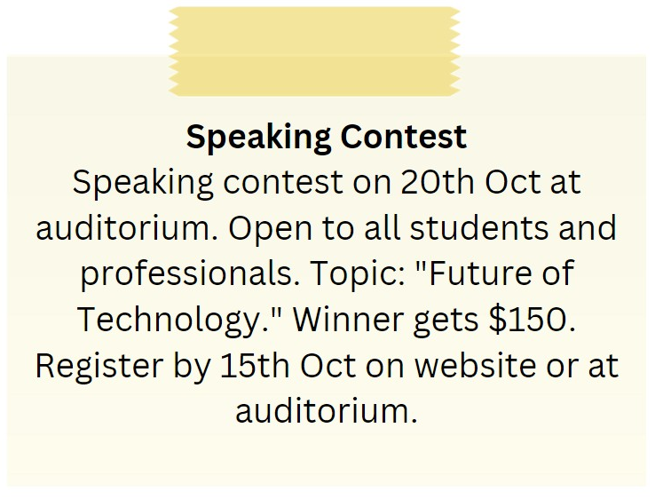

**A.** The speaking contest is on 15th October.

**B.** The speaking contest is only open to students.

**C.** The winner of the speaking contest gets $100.

**D.** The topic of the speaking contest is "Future of Technology."

**Đáp án đúng**: D

**Câu 16.**

Which of the following statements is true?



**A.** The IT course is for advanced learners.

**B.** The IT course covers hardware, software, networking, and security.

**C.** The IT course starts on 1st October.

**D.** The IT course does not provide a certificate.

**Đáp án đúng**: B

**IV. Read the following passage and do as direct. (17-22)**

My friend, Alex, has shared his exciting plans for the summer vacation with me. He wants to explore Europe and visit some of the most famous tourist destinations. He plans to start his journey in France, where he will visit the Eiffel Tower and the Louvre Museum. From there, he will travel to Italy to see the Colosseum and the Leaning Tower of Pisa. He is also looking forward to trying authentic Italian food. After Italy, he plans to visit Spain to experience the vibrant culture and beautiful beaches. He has already booked his flights and made reservations at some of the top hotels. Alex is thrilled about this adventure and cannot wait to make unforgettable memories. I am excited for him and cannot wait to hear all about his exciting travels when he returns.

**Câu 17.** Alex wants to explore Europe during his summer vacation.

**A.** False  **B.** True

**Đáp án đúng**: B

**Câu 18.** Alex plans to start his journey in Italy.

**A.** False  **B.** True

**Đáp án đúng**: A

**Câu 19.** Alex is looking forward to trying authentic Italian food.

**A.** False  **B.** True

**Đáp án đúng**: B

**Câu 20.** Alex has not made any reservations for his trip.

**A.** False  **B.** True

**Đáp án đúng**: A

**Câu 21.** What is the first country Alex plans to visit on his trip?

**A.** Germany  **B.** Italy  **C.** France  **D.** Spain

**Đáp án đúng**: C

**Câu 22.** What is Alex most excited about during his trip to Spain?

**A.** Experiencing the vibrant culture and beautiful beaches

**B.** Trying authentic Italian food

**C.** Seeing the Colosseum

**D.** Visiting the Eiffel Tower

**Đáp án đúng**: A

**V. Choose the word (A, B, C or D) that best fits the blank space in the following passage. (23-28)**

The debate over whether books **____23____** ebooks are better has been ongoing for years. Some people prefer the feeling of a **____24____** book in their hands, while others prefer the convenience and portability of ebooks. In my opinion, I believe that books are superior to ebooks.

Firstly, books **____25____** a unique sensory experience that ebooks cannot replicate. The smell of the pages, the weight of the book in your hands, and the sound of turning the pages all add to the overall reading experience.

**____26____**, books do not require any batteries or charging, making them more reliable than ebooks. Additionally, books do not emit blue light, which is known to negatively impact sleep patterns and eye health.

Lastly, books have a longer lifespan than most electronic **____27____**, making them a more sustainable and environmentally friendly option.

In conclusion, while ebooks have their **___28_____**, I believe that books are the superior choice for a more enjoyable, reliable, and sustainable reading experience.

**Câu 23.** The debate over whether books ____ ebooks are better has been ongoing for years.

**A.** so  **B.** or  **C.** but  **D.** and

**Đáp án đúng**: B

**Câu 24.** Some people prefer the feeling of a ____ book in their hands.

**A.** electronic  **B.** virtual

**C.** physical  **D.** digital

**Đáp án đúng**: C

**Câu 25.** Firstly, books ____ a unique sensory experience that ebooks cannot replicate.

**A.** offer  **B.** offered  **C.** offering  **D.** offers

**Đáp án đúng**: A

**Câu 26.** ____, books do not require any batteries or charging, making them more reliable than ebooks.

**A.** Lastly  **B.** Secondly  **C.** Fourthly  **D.** Thirdly

**Đáp án đúng**: B

**Câu 27.** Lastly, books have a longer lifespan than most electronic ____.

**A.** covers  **B.** devices  **C.** pages  **D.** papers

**Đáp án đúng**: B

**Câu 28.** In conclusion, while ebooks have their _____, I believe that books are the superior choice for a more enjoyable, reliable, and sustainable reading experience.

**A.** differences  **B.** disadvantages

**C.** similarities  **D.** advantages

**Đáp án đúng**: D

**VI. Supply the correct form of the word given in each sentence. (29-34)**

**Câu 29.** A smile and a kind word can go a long way in showing ___________ to others. (friend)

**Đáp án đúng**: friendliness

**Câu 30.** Yoga can help improve your ___________ and balance. (flexible)

**Đáp án đúng**: flexibility

**Câu 31.** The graceful ___________ twirled across the stage. (dance)

**Đáp án đúng**: dancer

**Câu 32.** Eating too much junk food can be ___________ for your body. (health)

**Đáp án đúng**: unhealthy

**Câu 33.** Don't forget to set a ___________ to take your medicine. (remind)

**Đáp án đúng**: reminder

**Câu 34.** Recycling is one way to be more ___________ friendly. (environment)

**Đáp án đúng**: environmentally

**VII. Rearrange the groups of words in a correct order to make complete sentences. (35-36)**

**Câu 35.** school. / misses the / bus, she’ll / If she / be late for

…

**Đáp án đúng**: If she misses the bus, she’ll be late for school.

**Câu 36.** the house / already clean. / because it is / We don’t / have to clean

…

**Đáp án đúng**: We don’t have to clean the house because it is already clean.

**VIII. Rewrite each of the following sentences in another way so that it means almost the same as the sentence printed before it. (37-40)**

**Câu 37.** It took John two hours to finish the project.

John spent ____________________________________________________________

**Đáp án đúng**: John spent two hours finishing the project.

**Câu 38.** She enjoys practicing yoga in her free time. (interesting)

She finds ____________________________________________________________

**Đáp án đúng**: She finds practicing yoga in her free time interesting.

**Câu 39.** Developing good study habits is crucial for academic success.

It is ____________________________________________________________

**Đáp án đúng**: It is crucial for academic success to develop good study habits.

**Câu 40.** You must complete all of the exercises before the end of class.

If I were ____________________________________________________________

**Đáp án đúng**: If I were you, I would complete all of the exercises before the end of class.

**IX. Listening: listen and do as direct. (41-50)**

*Listen to a dialogue and fill in the blanks.*

**Câu 41.** John is a bit ______ about school.

**Đáp án đúng**: John is a bit worried about school.

**Câu 42.** Mary feels ______ too.

**Đáp án đúng**: Mary feels stressed too.

**Câu 43.** John is having trouble with ______ and English.

**Đáp án đúng**: John is having trouble with Math and English.

**Câu 44.** Mary is not so good at ______ and science.

**Đáp án đúng**: Mary is not so good at history and science.

**Câu 45.** Mary suggests they can help each ______.

**Đáp án đúng**: Mary suggests they can help each other.

**Câu 46.** They plan to meet at the ______ after school.

**Đáp án đúng**: They plan to meet at the library after school.

**Câu 47.** John is free on ______ and Thursdays.

**Đáp án đúng**: John is free on Tuesdays and Thursdays.

**Câu 48.** Mary is free on Tuesdays and ______.

**Đáp án đúng**: Mary is free on Tuesdays and Thursdays.

**Câu 49.** They plan to start studying together next ______.

**Đáp án đúng**: They plan to start studying together next week.

**Câu 50.** John and Mary believe they will do better in their exams if they study ______.

**Đáp án đúng**: John and Mary believe they will do better in their exams if they study together.

**----HẾT---**