Date of preparing: ………………………………….
Date of teaching: ………………………………….

Period……
UNIT 2: SCHOOL
Lesson 1 - Part 1 (Page 14) - Vocabulary and Listening

I. OBJECTIVES
By the end of the lesson, Ss will be able to
1. Knowledge
- talk about school subjects they like or don’t like.
- use some sentences / phrases to pass turn to someone after finishing speaking.
- listen for gist and details about school subjects.
2. Ability
- improve Listening and Speaking skills.
3. Quality
- have positive attitude in English language learning so that they actively participate in all classroom activities, especially with the topic “School” conducted by the teacher.
- love their school, identify their favorite subject(s) and even orient themselves to what they want to do in the future, using the knowledge from the subject(s) they like.
II. TEACHING AIDS AND LEARNING MATERIALS
Lesson plan, PPT slides, student’s book, workbook, notebook, personal computer (if any), projector/TV, speakers, DCR & DHA on EDUHOME, handouts…
III. PROCEDURES
A. Warm up: (5’)
a) Objectives: to introduce the new lesson and set the scene for Ss to acquire new language; to get students' attention at the beginning of the class by means of enjoyable and short activities as well as to engage them in the steps that follow.
b) Content: introduction of new words about subjects at school.
c) Product: Ss can review the names of some subjects they used to learn and getting to know some new ones.
d) Competence: collaboration, communication, critical thinking.
e) Organization of the activity:
Teacher’s Activities | Students’ Activities
- Give greetings  - Check attendance  - Option 1: Game “CROSSWORD PUZZLE”  - Explain the rules of the game  - Design the game “crossword Puzzle” with words and pictures about what Ss study at school  - Let Ss play the game, encourage Ss to guess the key word  - If any S can give the correct key word, T hasn’t confirmed yet, the game will be continued until the keyword is opened (to check whether his/her answer is correct or not and to let other Ss take part in the game eagerly)  - Give a small gift to the Ss who is the fastest to give the correct key word  - Give feedback and lead to the new lesson  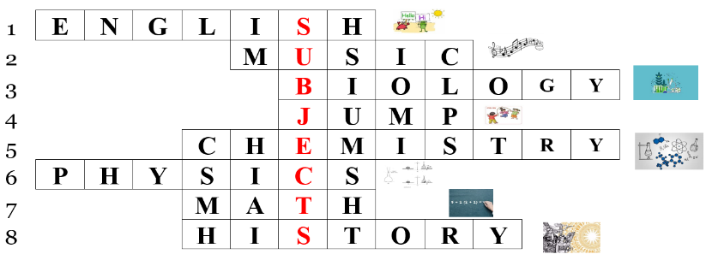  - Option 2: Game “DRAWING”  - Ask Ss to work in groups of 4 or 5  - Ask each group to choose a subject they like best, then draw a simple picture to illustrate their subject, using a piece of paper (or extra board) given by the teacher  - Set limited time for drawing (about 2 minutes)  - Call Ss to hang their pictures on the board and ask Ss from different groups to look at the pictures and guess the name of the subjects  - Give feedback and lead to the new lesson | - Greet T  - Listen  - Take part in the game by answer the questions in horizontal line (not in order) and try to guess keyword in the vertical column  - Form groups  - Draw a picture to illustrate a subject  - Look and give answers

B. New lesson (35’)
- Activities 1: Vocabulary (15’)
a) Objective: Ss know more about school subjects and talk about what subjects they like or don’t like.
b) Content:
- Vocabulary study
- Speaking
c) Products: Ss can know how to pronounce the new words correctly and use them in appropriate situations.
d) Competence: Communication, collaboration, presentation, analytical skill
e) Organization of the activity:
Teacher’s Activities | Students’ Activities
a. Number the pictures. Listen and repeat  - Option 1: Matching  - Divide class into 2 sides  - Give 8 pictures (A-H) to the first side and 8 vocabularies with the number (printed in 8 pieces of paper) to the other one  - Ask Ss to go round and try to match the vocabularies with the pictures  - Have Ss hang pairs of pictures and vocabularies on the board  - Play the audio for Ss to check their answers  - Make comments, correct Ss’ answers if needed  - Guide Ss to pronounce the vocabularies correctly, then ask them to read aloud  - Option 2:  - Ask Ss to work in pairs to number the pictures  - Play the audio for Ss to check their answers, let Ss repeat after listening to each word  - Call some Ss to read the words aloud, check pronunciation if necessary  b. Note 3 more subjects. Discuss if you like them  - Option 1:  - Have Ss note 3 more subjects they know (Ss can use words from the warmup activity – more than 3 answers: acceptable)  - Let Ss practice in pairs, asking and answering:  Do you like…. (name of subject)?  Yes, I do / No, I don’t  - Encourage Ss to be creative, add more information to make their dialogue more interesting  - Call some pairs to act out the dialogue in front of the class  - Make comments on Ss’ presentation, give evaluation (marks) if necessary  - Option 2: Survey  - Ask Ss to list more subjects they know  - Have Ss work in groups to ask, answer about the subjects they like or dislike and fill in the survey paper:  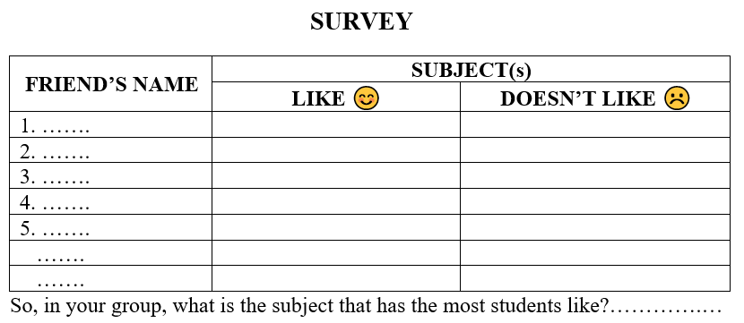  - Call some Ss to share their survey results with the class | - Receive the material  - Go and match  - Hang pictures and vocabularies  - Listen and check  Answer keys  A-8 B -4 C-1 D-5  E-6 F-7 G-3 H-2  - Listen and take notes  - Pronoun the words  - Work in pairs  - Listen and check  - Pronoun the words  - Work in pairs  - Practice  Suggested dialogue  A: Do you like Music?  B: Yes, I do  A: Why do you like it?  B: Because it’s interesting  A: Do you like Math?  B: No, I don’t / Not really  A: Why?  B: Because it’s difficult.  A: So, what is your favorite subject?  B: It’s English.  - Add more subjects  - Work in groups  Expected answers/Sample answers  In my group, Lan likes Math and Music, but she doesn’t like Physics because it’s difficult.  Minh likes P.E because he’s very active.  Phong likes Math  ….  →In my group, the subject that has the most students like is Math.
- Activity 2: Listening (20’)
a) Objective: Ss can make questions or answer the questions to develop a conversation, and they can aslo finish the listening task in the textbook.
b) Content: Listening to 2 students talking about school subjects, listening for gist and detail
c) Products: Ss can produce the new language successfully and apply the useful language to the listening task in everyday communication.
d) Competence: Collaboration, communication, critical thinking skills (guessing/ reasoning), presentation.
e) Organization of the activity:

Teacher’s Activities | Students’ Activities
- Option 1: Follow the order of activity: a, b, c  a. Listen to Adrian and Sarah talking about school subjects. Who likes more school subjects?  - Have Ss look at the questions and underline key words  - Play the audio once. Have Ss listen and answer the question  - Check answers as a whole class  b. Now, listen and fill in the blanks  - Have Ss look at the uncompleted sentences in this task  - Play the audio once. Have Ss listen and fill in the blanks  - Check answers as a whole class  c. Conversation skill  - Have Ss listen to the audio again and pay attention to the sentences / phrases that the speakers use to pass their turn  - Call Ss to give answers  - Give feedback, and provide more ways to pass turn  How about you?  What about you?  And you?  What do you think?  …  - Ask Ss to use these sentences / phrases to make up simple dialogues about school and subjects  - Have Ss present  - Option 2: Follow a different order of activities: c, a, b | - Look at the questions, underline key words  - Listen and answer the question  - Check answers  Answer key: Sarah  - Look and read  - Listen and fill in the blanks.  - Check answers  Answer keys  1. art 2. P.E  3. geography 4. P.E  - Listen to the dialogue again and find how the speakers pass their turn.  - Give answers  - Listen and take notes  - Work in pairs  - Act out the dialogue

C. Consolidation (3’)
* School subjects: P.E, I.T, music, geography, physics, literature, biology, math, English, history, chemistry…
* Asking and answering about school subjects you like / don’t like:
Do you like…. (Name of subject)?
Yes, I do / No, I don’t
* Ways to pass your turn in speaking:
How about you?
What about you?
And you?
What do you think?

D. Homework (2’)
- Learn by heart the vocabulary about subjects
- Practice asking and answering about school subjects, using some phrases / sentences to pass your turn
- Do exercises in Workbook: Lesson 1 - New words (page 8) and Listening (page 9)
- Prepare: Lesson 1 – Grammar (page 15 – SB)

