|  |  |
| --- | --- |
| **PHÒNG GD&ĐT XYZ**  **TRƯỜNG THCS ABC** | **ĐỀ KIỂM TRA CUỐI KỲ 2 - NĂM HỌC: 2024- 2025**  **MÔN: TIẾNG ANH - LỚP 9**  *Thời gian: 60 phút (Không kể thời gian giao đề)*  *(Đề thi có 0X trang)* |

**Họ và tên: Nguyễn Thị Hồng Thơ Tên Zalo: Nguyễn Hồng Thơ**

**SĐT Zalo: 0966304366 Email: hongtho84.nt@gmail.com**

**I. LISTENING:**

**Listen to the conversation and choose the letter A, B, C, or D to indicate the corect answer to each of the following questions. (You will hear the recording TWICE.) (1.0 point)**

**Question 1. How will they travel to the pop concert?**

A. by bus B. by taxi C. by car

**Question2. What was the weather like on Beth’s holiday?**

A. rainy B. cloudy C. sunny

**Question 3. Where has the teacher put the dictionaries?**

A. on the shelf in the classroom B. in the library C. in the cafe

**Question 4.Where did Paul go running yesterday?**

A. through the farmer’s fields B. in the path through the wood C. by the river

**II. You will hear the manager of cycling club giving some information about a bike race. Listen and decide whether the following statements are True or False. (You will hear the recording TWICE.) (1.0 point)**

|  |  |  |
| --- | --- | --- |
| **STATEMENTS** | **T** | **F** |
| **Question 5.** The colour of the team is blue. |  |  |
| **Question 6.** There are four people in each team. |  |  |
| **Question 7.** The race starts at eight-thirty. |  |  |
| **Question 8.** The first price this year is a cycling shirt |  |  |

**II. PRONUNCIATION**

**Choose the letter A, B, C, or D to indicate the word whose underlined part differs from the other three in pronunciation in each of the following questions**. **(0.5 point)**

**Question** 9. A. statement B. quality C. education D. operation

**Question** 10. A. counter B. mountain C. country D. outside

**Choose the letter A, B, C, or D to indicate the word that differs from the other three in the position of the primary stress in each of the following questions. (0.5 point)**

**Question 11.** A. density B. historic C. religious D. domestic

**Question 12.** A. variety B. establishment C. operation D. ability

**III. GRAMMAR AND VOCABULARY**

**Choose the letter A, B, C, or D to indicate the correct answer to each of the following questions. (1.75 points)**

**Question. 13** _____________ is happening and it affects almost everybody on Earth.

A. Solar system B. Weather forecast C. Nature reserve D. Climate change

**Question.14** She suggested ____________ prices of the same laptop in different stores.

A. compare B. to compare C. being compared D. comparing

**Question 15.** George asked ______________ me to go to England for a study tour.

A. whether I want B. did I want C. whether I wanted D. if I do want

**Question 16.** The medical robot can perform precise tasks that lead to fewer ______ problems.  
**A.** social media **B.** health **C.** customer **D.** entertainment

**Question.17** He asked ______________ the school planned to organise a career orientation seminar.

A. about B. unless C. who D. whether

**Question.18** My father works as a _________ whose job is to make men’s clothes for individual customers.

A. designer B. painter C. tailor D. planner

**Question 19.** The Harbin festival, ______________ first took place in 1963, is the largest ice and snow festival in the world.

A. which B. who C. when D. what

**Read the following advertisement / school announcement and choose the letter A, B, C, or D to indicate the correct option that best fits each of the numbered blanks from 20 to 22**. **(0.75 point)**

|  |
| --- |
| **Career Choice Workshop: Find Your Path**  Are you unsure about your future job? Join our workshop to explore (20) ________ job options and find the best fit for you!  ● Discover various job paths and job choices. ● Meet people from different (21) ________ jobs who will share their advice and stories. ● Join fun talks to help you understand what you like best.  Don’t miss this chance to make good choices (22) ________ your job!  Date: March 15 Time: 10:00 AM - 2:00 PM Location: Career Center, 123 Main Street |

**Question 20**. **A.** different **B.** difference **C.** differently **D.** differ

**Question 21**. **A.** the **B.** an **C.** a **D.** x (no article)

**Question 22**. **A.** about **B.** in **C.** on **D.** for

**IV. READING:**

**Read the following passage and choose the letter A, B, C, or D to indicate the correct option that best fits each of the numbered blanks from 23 to 27. (1.25 points)**

Planet Earth is our home, a beautiful and diverse place. It is the third planet from the Sun and the only planet known to (**23**) _____________ life. Earth is covered mostly in water, with vast oceans that is full of marine life. It also has majestic mountains, lush forests, and expansive deserts.

The Earth has a (**24**) _____________ of climates and ecosystems, from the freezing cold of the polar regions to the scorching heat of the equator. It is (**25**) _____________ to millions of species, including plants, animals, and humans.

We rely on Earth for everything we need: air to breathe, water to drink, and land to grow our food. It is important to take care of our planet (**26**) _____________ reducing waste, recycling, and conserving energy.

However, Earth faces many challenges, such as pollution, deforestation, and climate change. It is crucial for us to work (**27**) _____________ to protect our planet for future generations. Let's appreciate the beauty of Earth and strive to be responsible stewards of this precious home we all share.

**Question 23.** A. offer B. support C. provide D. create

**Question24**. A. variety B. various C. vary D. variant

**Question 25.** A. area B. house C. place D. home

**Question 26.** A. for B. with C. by D. in

**Question27.** A. others B. one another C. together D. each other

**Read the following passage and choose the letter A, B, C, or D to indicate the correct answer to each of the questions from 28 to 32. (1.25 points)**

Today, smartphones are everywhere and can be found in many places like homes, offices, shops, and schools. People depend on smartphones so much that they get upset and have trouble when their phones are not working. Smartphones are now used for many things, from checking emails to navigating places.

Modern smartphones are much faster, cheaper, and smaller than older ones. Many smartphones are so small that they can fit in your pocket. With smartwatches and portable devices, users can stay connected and access information from almost anywhere easily.

In the future, smartphones will be even smaller and faster. **They** might have advanced features like voice recognition or facial recognition and could be as tiny as a coin. This will make it easier for people to use their phones for managing data from calls, messages, and online activities. New technologies such as smart glasses and foldable phones are already being developed today.

**Question** 28. Why do people get upset when their smartphones stop working?

**A.** Because people depend on smartphones. **B.** Because they dislike smartphones.

**C.** Because smartphones are too cheap. **D.** Because they find smartphones too easy to use.

**Question** 29. What is the advantage of using smartwatches and portable devices?

**A.** They are cheaper than other devices.

**B.** They are much faster and more powerful than other devices.

**C.** They are more portable and can be used in various places.

**D.** They have better battery life.

**Question** 30. The word "They" in paragraph 3 refers to _________.

**A.** future phones **B.** advanced features **C.** new technologies **D.** smartwatches

**Question** 31. What are some examples of new technologies for smartphones?

**A.** Smart glasses and foldable phones. **B.** Smart TVs and foldable tablets.

**C.** Smart speakers and foldable computers. **D.** Smart refrigerators and foldable laptops.

**Question** 32. What is the purpose of the passage?

**A.** To encourage people to buy new smartphones.

**B.** To inform readers about the future of smartphones and new technologies.

**C.** To explain how smartphones work.

**D.** To describe how people use smartphones today.

**V. WRTING**

**Choose the letter A, B, C, or D to indicate the sentence that best combines each pair of sentences in the following questions. (0.5 point)**

**Question 33.** A man got on the bus. He was carrying a big cat in the box.

A. A man, which was carrying a big cat in the box, got on the bus.

B. A man, whom was carrying a big cat in the box, got on the bus.

C. A man, who was carrying a big cat in the box, got on the bus.

D. A man got on the bus, whom was carrying a big cat in the box.

**Question 34.** “Do you meet requirements for being a bartender?”

A. Sue wanted to know do I meet requirements for being a bartender.

B. Sue asked if I meet requirements for being a bartender.

C. Sue asked if I met requirements for being a bartender.

D. Sue wants to know where I meet requirements for being a bartender.

***Finish each of the following sentences in such a way that it means the same as the sentence***

***printed before it.***

**Question 35.** “I am trying my best to prepare for the upcoming examination next month,” my sister said.

🡪 My sister said ………………………………………...……………………………………

**Question 36.** Guglielmo Marconi invented the radio. He received a Nobel prize for Physics in 1909.

🡪 Guglielmo Marconi, ………………………………………...…………………………….

***Read the following sign or notice and mark the letter A, B, C or D on your answer sheet to indicate the correct answer to each of the following questions.***

**Question 37.** What does the sign say?

|  |  |
| --- | --- |
|  | 1. Everyone can enter the area freely without needing a pass. 2. You can only enter this area if you have a pass or permission. 3. You do not need a pass to enter this area; it is open to all 4. Having a pass is not necessary; entry is allowed without one. |

**Question 38.** What does the notice say?

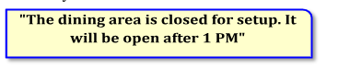

1. The dining area only opens after 1 PM
2. The dining area will be closed for preparation. Please eat within 1 hour
3. You can eat within 1 hour while we finish preparing
4. The dining area is closed for setup and will open after 1 PM

***Mark the letter A, B, C or D on your answer sheet to indicate the correct answer to each of the following questions 39.***

1. In the afternoon, we are going to try cooking in bamboo tubes
2. Dear Jimmy, We are going to have the annual Spring Fair this Sunday. Can you join us?
3. All the students are going to enjoy an enormous concert in the morning.
4. Late at night, making Banh Chung must be the key activitiy for a foreigner like you.
5. b-c-a-d B. b-a-d-c C. b-d-a-c D. b-a-d-c

***Question 40. Choose the sentence that most appropriately ends the text (in question 39)***

1. The weather is quite good now
2. We have arranged everything, so you don’t have to bring anything.
3. Good bye
4. Cooking rice in bamboo tubes is so exciting and you shouldn’t miss it.

**=== THE END ===**

|  |  |  |  |  |  |
| --- | --- | --- | --- | --- | --- |
| **TRƯỜNG THCS ..........**  **ĐỀ CHÍNH THỨC** | | | | **HƯỚNG DẪN CHẤM**  **ĐỀ KIỂM TRA CUỐI KÌ 2**  **NĂM HỌC 2024-2025**  **Môn: Tiếng Anh – Lớp 9** | |
| **Câu** | **Ý** | **Đáp án** | | **Điểm** |
| **I.1**  **(1.0pts)** | 1 | A | | 0,25 |
| 2 | B | | 0,25 |
| 3 | B | | 0,25 |
| 4 | C | | 0,25 |
| **I.2**  **(1.0pts)** | 5 | T | | 0,25 |
| 6 | F | | 0,25 |
| 7 | T | | 0,25 |
| 8 | F | | 0,25 |
| **II**  **(1.0pts)** | 9 | B | | 0,25 |
| 10 | C | | 0,25 |
| 11 | A | | 0,25 |
| 12 | C | | 0,25 |
| **III**  **(2.0pts)** | 13 | D | | 0,25 |
| 14 | D | | 0,25 |
| 15 | C | | 0,25 |
| 16 | B | | 0,25 |
| 17 | D | | 0,25 |
| 18 | C | | 0,25 |
| 19 | A | | 0,25 |
| 20 | A | | 0,25 |
| 21 | D | | 0,25 |
| 22 | A | | 0,25 |
| **IV.1**  **(1.25pts)** | 23 | B | | 0,25 |
| 24 | A | | 0,25 |
| 25 | D | | 0,25 |
| 26 | C | | 0,25 |
|  | 27 | C | | 0,25 |
| **IV.2**  **(1.25pts)** | 28 | A | | 0,25 |
| 29 | C | | 0,25 |
| 30 | A | | 0,25 |
| 31 | A | | 0,25 |
|  | 32 | B | | 0,25 |
| **V.1**  **(0.5pts)** | 33 | C | | 0,25 |
| 34 | C | | 0,25 |
| **V.2**  **(1.5pts )** |  | *Task fulfillment: 5pts*  Complete the task appropriately with all main ideas and important details.  *+ Language: 10pts*  - Accurate grammar: appropriate vocabulary  - Variety of sentence types: appropriate linking words  - Good organization | | 1.5 |

**Question 2.** “I am trying my best to prepare for the upcoming examination next month,” my sister said.

🡪 **My sister said she was trying her best to prepare for the upcoming examination the next month/ the following month.**

**Question 5.** Guglielmo Marconi invented the radio. He received a Nobel prize for Physics in 1909.

🡪 **Guglielmo Marconi, who received a Nobel prize for Physics in 1909, invented the radio.**

***Read the following sign or notice and mark the letter A, B, C or D on your answer sheet to indicate the correct answer to each of the following questions.***

**Question 37.** What does the sign say?

|  |  |
| --- | --- |
|  | 1. Everyone can enter the area freely without needing a pass.  1. You can only enter this area if you have a pass or permission. 2. You do not need a pass to enter this area; it is open to all 3. Having a pass is not necessary; entry is allowed without one. |

**Question 38.** What does the notice say?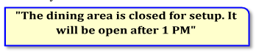

1. The dining area only opens after 1 PM
2. The dining area will be closed for preparation. Please eat within 1 hour
3. You can eat within 1 hour while we finish preparing
4. The dining area is closed for setup and will open after 1 PM

***Mark the letter A, B, C or D on your answer sheet to indicate the correct answer to each of the following questions 39.***

1. In the afternoon, we are going to try cooking in bamboo tubes
2. Dear Jimmy, We are going to have the annual Spring Fair this Sunday. Can you join us?
3. All the students are going to enjoy an enormous concert in the morning.
4. Late at night, making Banh Chung must be the key activitiy for a foreigner like you.

A. b-c-a-d B. b-a-d-c C. b-d-a-c D. b-a-d-c

***Question 40. Choose the sentence that most appropriately ends the text (in question 17)***

* 1. The weather is quite good now
  2. We have arranged everything, so you don’t have to bring anything.
  3. Good bye
  4. Cooking rice in bamboo tubes is so exciting and you shouldn’t miss it.

**TAPESCRIPTS**

PART 1

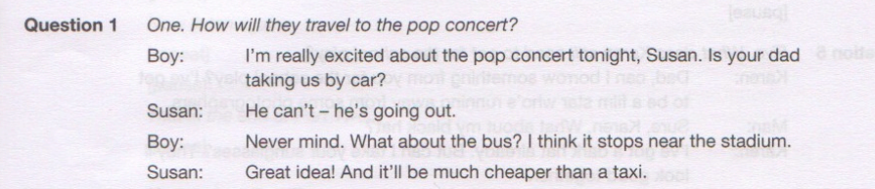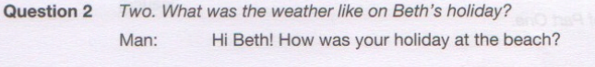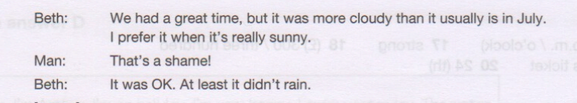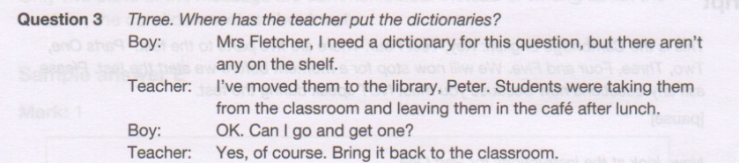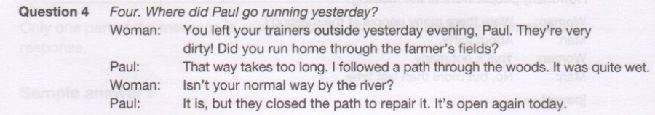

PART 2

