|  |  |
| --- | --- |
| *Họ và tên: ....................................................*  *Lớp: .............................................................* | PHIẾU GHI BÀI HÓA HỌC 11 CÁNH DIỀU  **Bài 7: SULFURIC ACID VÀ MUỐI SULFATE** |

**MỞ ĐẦU**

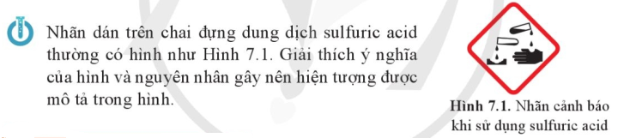

..........................................................................................................................................................................

..........................................................................................................................................................................

**I. SULFURIC ACID**

**1) Cấu tạo phân tử và tính chất vật lí**

|  |  |
| --- | --- |
| Công thức phân tử: ..............................  Mô hình phân tử:     | ***Tính chất vật lí***  Trạng thái: .................................................................  Màu sắc: ....................................................................  Tính tan trong nước:  ....................................................................................  ....................................................................................  ....................................................................................  Cách hòa tan H2SO4 đặc vào nước:  ....................................................................................  ....................................................................................  .................................................................................... |

**2) Tính chất hóa học**

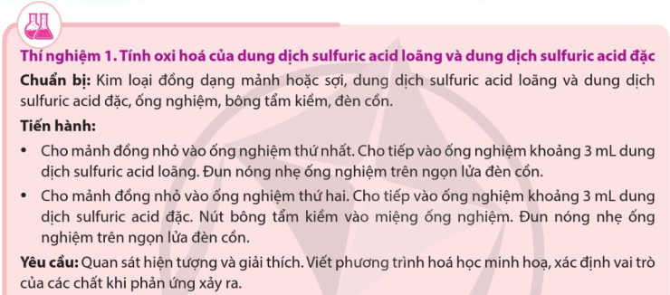

..........................................................................................................................................................................

..........................................................................................................................................................................

..........................................................................................................................................................................

..........................................................................................................................................................................

..........................................................................................................................................................................

..........................................................................................................................................................................

..........................................................................................................................................................................

..........................................................................................................................................................................

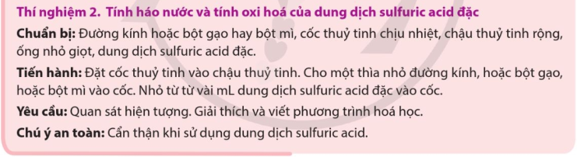

..........................................................................................................................................................................

..........................................................................................................................................................................

..........................................................................................................................................................................

..........................................................................................................................................................................

..........................................................................................................................................................................

..........................................................................................................................................................................

..........................................................................................................................................................................

..........................................................................................................................................................................

***a) Tính chất hóa học của dung dịch H2SO4 loãng***

..........................................................................................................................................................................

..........................................................................................................................................................................

..........................................................................................................................................................................

..........................................................................................................................................................................

..........................................................................................................................................................................

..........................................................................................................................................................................

|  |  |
| --- | --- |
|  | ..................................................................................................................  ..................................................................................................................  ..................................................................................................................  ..................................................................................................................  .................................................................................................................. |

***b) Tính chất hóa học của dung dịch sulfuric acid đặc***

■ *Tính oxi hóa mạnh:*

Vì sao, H2SO4 có tính oxi hóa? ........................................................................................................................

..........................................................................................................................................................................

..........................................................................................................................................................................

Tính oxi hóa mạnh của H2SO4 được thể hiện khi tác dụng với những chất nào?

..........................................................................................................................................................................

..........................................................................................................................................................................

..........................................................................................................................................................................

..........................................................................................................................................................................

..........................................................................................................................................................................

..........................................................................................................................................................................

..........................................................................................................................................................................

..........................................................................................................................................................................

..........................................................................................................................................................................

|  |  |
| --- | --- |
|  | ................................................................................................................  ................................................................................................................  ................................................................................................................  ................................................................................................................ |

■ *Tính háo nước*:

..........................................................................................................................................................................

..........................................................................................................................................................................

..........................................................................................................................................................................

..........................................................................................................................................................................

..........................................................................................................................................................................

..........................................................................................................................................................................

|  |  |
| --- | --- |
|  | ..................................................................................................................  ..................................................................................................................  ..................................................................................................................  ..................................................................................................................  ..................................................................................................................  ..................................................................................................................  .................................................................................................................. |

**3) Bảo quản và xử lí bỏng sulfuric acid**

..........................................................................................................................................................................

..........................................................................................................................................................................

..........................................................................................................................................................................

..........................................................................................................................................................................

..........................................................................................................................................................................

|  |  |  |
| --- | --- | --- |
|  |  | ..............................................................  ..............................................................  ..............................................................  ..............................................................  ..............................................................  ..............................................................  .............................................................. |

**4) Ứng dụng và sản xuất sulfuric acid**

***a) Ứng dụng***

..........................................................................................................................................................................

..........................................................................................................................................................................

..........................................................................................................................................................................

..........................................................................................................................................................................

..........................................................................................................................................................................

***b) Sản xuất sulfuric acid bằng phương pháp tiếp xúc***

Nguyên liệu: ....................................................................................................................................................

Các giai đoạn:

..........................................................................................................................................................................

..........................................................................................................................................................................

..........................................................................................................................................................................

..........................................................................................................................................................................

..........................................................................................................................................................................

..........................................................................................................................................................................

..........................................................................................................................................................................

..........................................................................................................................................................................

..........................................................................................................................................................................

..........................................................................................................................................................................

|  |  |
| --- | --- |
|  | ..................................................................................................................  ..................................................................................................................  ..................................................................................................................  .................................................................................................................. |
|  | ..................................................................................................................  ..................................................................................................................  ..................................................................................................................  ..................................................................................................................  ..................................................................................................................  .................................................................................................................. |

**II. MUỐI SULFATE**

**1) Một số muối sulfate**

Khái niệm: ............................................................................................ Công thức chung: ..............................

Tính tan trong nước: ........................................................................................................................................

Một số muối sulfate:

..........................................................................................................................................................................

..........................................................................................................................................................................

..........................................................................................................................................................................

..........................................................................................................................................................................

..........................................................................................................................................................................

..........................................................................................................................................................................

..........................................................................................................................................................................

..........................................................................................................................................................................

..........................................................................................................................................................................

..........................................................................................................................................................................

..........................................................................................................................................................................

..........................................................................................................................................................................

..........................................................................................................................................................................

..........................................................................................................................................................................

..........................................................................................................................................................................

|  |  |
| --- | --- |
|  | ..................................................................................................................  ..................................................................................................................  ..................................................................................................................  ..................................................................................................................  .................................................................................................................. |

**2) Nhận biết ion SO42- trong dung dịch**

Thuốc thử: .......................................................................................................................................................

Hiện tượng: ......................................................................................................................................................

Phương trình hóa học: .....................................................................................................................................

|  |  |
| --- | --- |
|  | ..................................................................................................................  ..................................................................................................................  ..................................................................................................................  ..................................................................................................................  .................................................................................................................. |