**READING**

**PART 1**

**Look at the picture. Read the words. Which words go with the picture? Fill in the correct circles on your answer sheet.**

|  |  |  |
| --- | --- | --- |
| **1.**  **CDR_T_Test 1_A1_T25_LIS_P1_1_0** | | |
| **(A)**The boy is drawing a picture. | **(B)**The boy is taking a photo. | **(C)**The boy is talking on the phone |
| **The answer is “B”. Fill in “B” on your answer sheet.** | | |
| **2.**  **CDR_T_Test 1_A1_T25_LIS_P1_2_0**  **What does**   **the arrow show?**  **The boy with the arrow is ahead of the other boy.** | | |
| **(A)**Ahead | **(B)**Beside | **(C)**Under |
| **The answer is “A”. Fill in “A” on your answer sheet.** | | |

|  |  |  |
| --- | --- | --- |
| 3. |  |  |
| Set of chair and couch | | |
| **(A)** Couch | **(B)** Sofa | **(C)** Armchair |
| 4. |  |  |
|  | | |
| **(A)** Car | **(B)** Bus | **(C)** Train |
| 5. |  |  |
|  | | |
| **(A)** Elephant | **(B)** Tiger | **(C)** Dolphin |
| 6. |  |  |
|  | | |
| **(A)** Classroom | **(B)** Cinema | **(C)** Living room |
| 7. |  |  |
|  | | |
| **(A)** Sad | **(B)** Happy | **(C)** Angry |
| 8. |  |  |
|  | | |
| **(A)** Slim | **(B)** Thin | **(C)** Fat |
| 9. |  |  |
|  | | |
| **(A)** Evening | **(B)** Morning | **(C)** Afternoon |
| 10. | | |
| **(A)** They are singing a song. | **(B)** They are playing the drums. | **(C)** They are running on the bridge. |
| 11. |  |  |
|  | | |
| **(A)** The teacher is reading a book. | **(B)** The teacher is writing on the board. | **(C)** The teacher is talking to the students. |
| 12. |  |  |
|  | | |
| **(A)** Loud | **(B)** Noisy | **(C)** Quiet |
| 13. |  |  |
|  | | |
| **(A)** The dog is between the horses. | **(B)** The dog is behind the horses. | **(C)** The dog is in front of the horses. |
| 14. | C:\Users\Huong Yeri\AppData\Local\Microsoft\Windows\INetCache\Content.Word\L2_T02_LIS_Q1_9_0.png |  |
| **(A)** The girl is in the pharmacy. | **(B)** The girl is in the bakery. | **(C)** The girl is in the library. |
| 15. |  |  |
|  | | |
| **(A)** They are painting the walls. | **(B)** They are taking photos. | **(C)** They are drawing pictures. |
| 16. |  |  |
|  | | |
| **(A)** The family went shopping. | **(B)** The family went campting. | **(C)** The family went fishing. |
| 17. |  |  |
|  | | |
| **(A)** The ship is smaller than the boat. | **(B)** The ship is bigger than the boat. | **(C)** The boat is taller than the ship. |

**PART 2**

**Read and find the answer.  
Fill in the correct circles on your answer sheet.**

|  |
| --- |
| **Let’s do an example.**   1. **Students go to class here. Teachers work here. It has many desks. What is it?**     1. **(A)  A house**    2. **(B)  A school**    3. **(C)  A bank**   **The correct answer is a school. Fill in "B" on your answer sheet.** |

1. **It is a big place. There are many plants and animals.**

**Where is it?**

**(A)** A farm

**(B)** An office

**(C)** A hospital

1. **This is an item. People usually wear it to see clearly under the sun.**

**What is it?**

**(A)** A raincoat

**(B)** Jeans

**(C)** Sunglasses

1. **This takes you from one place to another. It is underground, and it can travel fast.**

(A) A subway

(B) A bus

**(C)** A plane

1. **Before going to bed, you should \_\_\_\_\_\_\_ your teeth.**

**(A)** pick

**(B)** wash

**(C)** brush

1. **You do this to win in a football game. You will lose the ball if you don’t do this.**

**You \_\_\_\_\_\_\_\_\_ it.**

**(A)** kick

**(B)** hold

**(C)** throw

1. **In the movie theatre, people are screaming because the movie is \_\_\_\_\_\_\_\_\_\_.**

**(A)** funny

**(B)** scary

**(C)** sad

1. **You went to the supermarket and paid $45 to buy food. Then you went to the bookstore and bought some school things for $10.  
   The school things were less \_\_\_\_\_\_\_\_\_\_\_\_\_.**

**(A)** cheap

**(B)** expensive

**(C)** colorful

**PART 3  
Read the sign. Answer questions 26 to 29.**

**Fill in the correct circles on your answer sheet.**

Monica, Joey, Ross, and Chandler go to the shopping mall. They read this sign at the shopping mall.

**Guide to the shopping mall**

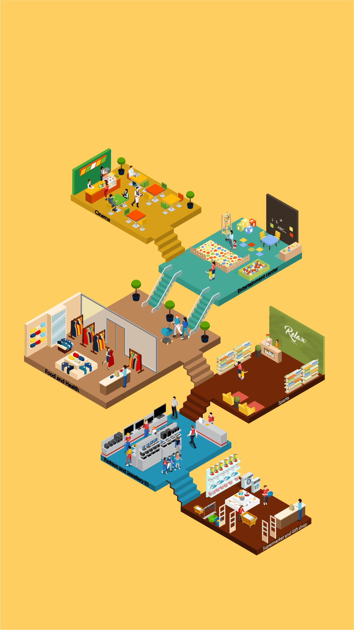

1. **Monica wants to buy clothes for her husband. She goes to the \_\_\_\_\_\_\_\_\_\_\_\_.**

**(A)** ground floor

**(B)** 1st floor

**(C)** 3rd floor

1. **Ross likes to play different types of games. He goes to the \_\_\_\_\_\_\_\_\_\_\_\_.**

**(A)** 2nd floor

**(B)** 3rd floor

**(C)** 4th floor

1. **Joey wants to watch a movie. He goes to the\_\_\_\_\_\_\_\_\_\_\_\_.**

**(A)** 2nd floor

**(B)** 4th floor

**(C)** 5th floor

**29. Chandler wants to buy a ball for his football match. He goes to the\_\_\_\_\_\_\_\_\_\_\_\_.**

**(A)** 2nd floor

**(B)** 4th floor

**(C)** 5th floor

**Read about Rachel’s timetable. Answer questions 30 to 33.**

|  |  |  |  |
| --- | --- | --- | --- |
|  | **Monday** | **Thursday** | **Friday** |
| **Morning** | Have a violin class | Study Japanese | Go fishing |
| **Afternoon** | Have a cooking class | Have a ballet class | Study Math |
| **Evening** | Play piano | Do homework | Watch movies |

**30. What does Rachel do on Thursday?**

**(A)** Play violin

**(B)** Study Japanese

**(C)** Watch movie

**31. When does Rachel go fishing?**

**(A)** Friday

**(B)** Thursday

**(C)** Monday

**32. When does Rachel have a ballet class on Thursday?**

**(A)** Morning

**(B)** Afternoon

**(C)** Evening

**33. What does Rachel do on Monday evening?**

**(A)** Study Math

**(B)** Play piano

**(C)** Do homework

**Read the letter. Answer questions 34 to 35.**

|  |
| --- |
| Dear Aunt May,  This is Peter. I am writing this letter to thank you for taking me to the central park yesterday. I enjoyed spending time with you a lot. It was very kind of you to buy me a lot of delicious food. I really like the tuna sandwich.  I have just returned to my home from school. I made some new friends at my Art class. They are Richard, Phoebe, and Julie. We drew pictures together. We drew the circus with clowns, elephants, and lions. It was just like the place you took me to yesterday. I invited them to my house to watch some movies and play games tonight. My mom told me to finish my homework first, and I have a lot of homework today. I should start doing them now. Hope you are well and see you this weekend!  Your nephew,  Peter |

**34. Why does Peter write to Aunt May?**

**(A)** To ask her to come and watch movies together

**(B)** To get some help with his homework

**(C)** To thank her for spending time with him

**35. What does Peter say about his day at school?**

**(A)** He made some new friends.

**(B)** He didn’t like studying.

**(C)** He joined a circus.

**Read the email. Answer questions 36 to 37.**

To: Huy

From: Jane

Subject: Invitation

Hi Huy,

Sorry I didn’t write to you sooner. My exams are coming next week and I have to study for two or three hours every evening.

Did I tell you that next Friday is my birthday? I want to invite you to my birthday party. The party is at 5 p.m. at my house in New York. There are a lot of fun activities. I can ask my mom to pick you up if you like. Do you remember Alicia and Roberto? They are going too, so it will be fun. Please send me a reply if you could come.

That’s all for now.

See you soon.

Jane

**36. Why does Jane write to Huy?**

**(A)** To ask him if he remembers her friends.

**(B)** To invite him to her birthday party.

**(C)** To tell him about a new friend.

**37. What is probably true about Juan?**

**(A)** She is busy revising for her exam.

**(B)** She is living with Alicia and Roberto.

**(C)** She is not living in New York.

**Read the letter. Answer questions 38 to 39.**

|  |
| --- |
| Dear Evan,  Thanks for your letter. I moved to this school 2 weeks ago. I needed some time to prepare for my new classes, so I could not write to you earlier. And about our new school, there are two four-story buildings with a large yard. There are different plants and flowers there. There are many students from USA, England, and even Vietnam. My class is a lovely room on the 2nd floor of the first building. I like it so much because I can see the yard and the garden. If you want, I will take pictures for you. I have so many things to tell you. How have you been? Please write to me soon.  Best,  Margaret |

**38. Why does Margaret write to Evan?**

**(A)** To ask Evan where he comes from.

**(B)** To ask Evan to go to her school.

**(C)** To tell him about her new school.

**39. What does Margaret say about her new class?**

**(A)** It has a beautiful view to the garden.

**(B)** It is on the first floor.

**(C)** It is a small classroom.

*You finished the reading test.*

**LISTENING**

**PART 1**

**Listen to the words. Look at the pictures.  
Fill in the correct circles on your answer sheet.**

|  |  |  |
| --- | --- | --- |
| **1.** | | |
|  |  |  |
| **(A)** | **(B)** | **(C)** |
| **2.** |  |  |
|  |  |  |
|  |  |  |
| **(A)** | **(B)** | **(C)** |
| **3.** |  |  |
|  |  |  |
| **(A)** | **(B)** | **(C)** |
| **4.** |  |  |
|  |  |  |
| **(A)** | **(B)** | **(C)** |
| **5.** |  |  |
|  |  |  |
| **(A)** | **(B)** | **(C)** |
| **6.** |  |  |
|  |  |  |
| **(A)** | **(B)** | **(C)** |
| **7.** |  |  |
|  |  |  |
| **(A)** | **(B)** | **(C)** |
| **8.** |  |  |
|  |  |  |
| **(A)** | **(B)** | **(C)** |

**PART 2**

**Fill in the correct circles on your answer sheet.**

|  |  |  |
| --- | --- | --- |
| **9.** | | |
|  |  |  |
| **(A)** | **(B)** | **(C)** |
| **10.** |  |  |
|  |  |  |
| **(A)** | **(B)** | **(C)** |
| **11.** |  |  |
|  |  |  |
| **(A)** | **(B)** | **(C)** |
| **12.** |  |  |
|  |  |  |
| **(A)** | **(B)** | **(C)** |
| **13.** |  |  |
|  |  |  |
| **(A)** | **(B)** | **(C)** |
| **14.** |  |  |
|  |  |  |
| **(A)** | **(B)** | **(C)** |
| **15.** |  |  |
|  |  |  |
| **(A)** | **(B)** | **(C)** |
| **16.** |  |  |
|  |  | **C:\Users\Huong Yeri\AppData\Local\Microsoft\Windows\INetCache\Content.Word\Artboard 174.png** |
| **(A)** | **(B)** | **(C)** |
| **17.** |  |  |
|  |  |  |
| **(A)** | **(B)** | **(C)** |

**PART 3**

**Fill in the correct circles on your answer sheet.**

**Look at your answer sheet. Listen to a conversation. Which conversation sounds correct?**

**Let’s do an example.**

|  |  |  |
| --- | --- | --- |
| **(Narrator): A**  **(Boy):** Hello. What’s your name?  **(Girl):** I’m fine, thanks.  **(Narrator): B**  **(Boy):** How are you today?  **(Girl):** I’m six years old.  **(Narrator): C**  **(Boy):** Nice to meet you!  **(Girl):** Nice to meet you, too! **The answer is "C." Fill in "C" on your answer sheet. Now, you do it.** | | |
| **18.** |  |  |
| (A) | (B) | **(C)** |
| **19.** |  |  |
| (A) | (B) | (C) |
| **20.** |  |  |
| (A) | (B) | (C) |
| **21.** |  |  |
| (A) | (B) | (C) |
| **22.** |  |  |
| (A) | (B) | (C) |
| **23.** |  |  |
| (A) | (B) | (C) |
| **24.** |  |  |
| (A) | (B) | (C) |
| **25.** |  |  |
| (A) | (B) | (C) |
| **26.** |  |  |
| (A) | (B) | (C) |
| **27.** |  |  |
| (A) | (B) | (C) |

**PART 4**

**Listen to a conversation and answer the question. Fill in the correct circle on your answer sheet.**

**Let’s do an example.**

|  |
| --- |
| **28. When is the girl's party?**  **(A)**Tonight  **(B)**Next week  **(C)**This weekend  **The answer is "C." Fill in "C" on your answer sheet. Now, you do it.** |

**29.** **What is the girl going to do?**

**(A)**Go to Nha Trang

**(B)**Go to her grandparents’ house

**(C)**Go to the countryside

**30. What did the girl do when she was a kid?**

**(A)**Play badminton

**(B)**Play tennis

**(C)**Play chess

**31**. **What does the boy want to do?**

**(A)**go home

**(B)**watch a movie

**(C)**go to the cinema

**32.** **How is the boy feeling?**

**(A)**He’s angry

**(B)**He’s happy

**(C)**He’s sad

**33.** **Which hat is the girl going to wear?**

**(A)**the white one

**(B)**the red one

**(C)**the blue one

**34. Where does the boy want to go?**

**(A)**the Central Lake

**(B)**the bus station

**(C)**the book shop

**PART 5**

**Listen and answer the question.  
Fill in the correct circle on your answer sheet.**

**Let’s do an example.**

|  |
| --- |
| 1. **What did Mike call about?**   (A)  Homework  (B)  A movie  (C)  A library book  **The answer is "B." Fill in "B" on your answer sheet. Now, you do it.** |

**36. Why did the woman call?**

**(A)**To tell Pete to talk to his mom

**(B)**To talk to Pete’s mom

**(C)**To ask Pete for his help

**37. Why did Ms. Blake call?**

**(A)**To ask Stacey to send her message to the class

**(B)**To tell Stacey that she’s going to see a doctor

**(C)**To help Stacey with her homework

**38. Why did Kate’s father call?**

**(A)**To ask what to do with his daughter

**(B)**To tell that he’s coming to the doctor’s office

**(C)**To make an appointment with doctor Burke

**39. Why did the teacher call?**

**(A)**To invite Jess to join the school band

**(B)**To tell Jess a good news

**(C)**To ask Jess to come to the band practice

**40. Why did Megan call Mike?**

**(A)**To tell him that she was sick

**(B)**To ask him about the homework

**(C)**To tell him that she won’t be at school tomorrow

**41.** **Why did Katie call?**

**(A)**To invite Lauren to a party

**(B)**To ask Lauren about Ted and Robin

**(C)**To tell Lauren about the BBQ party