ĐỀ SỐ 18
Đề kiểm tra chất lượng HSG lớp 8 – huyện Yên Thành, tỉnh Nghệ An
Thời gian làm bài: 120 phút

SECTION A: LISTENING
Part 1. For each question, choose the correct picture.
1. What time will the taxi arrive at the woman’s house?
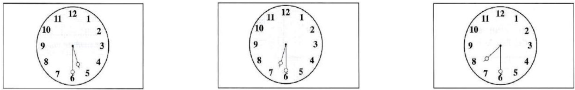
A | B | C
2. What will they give George?
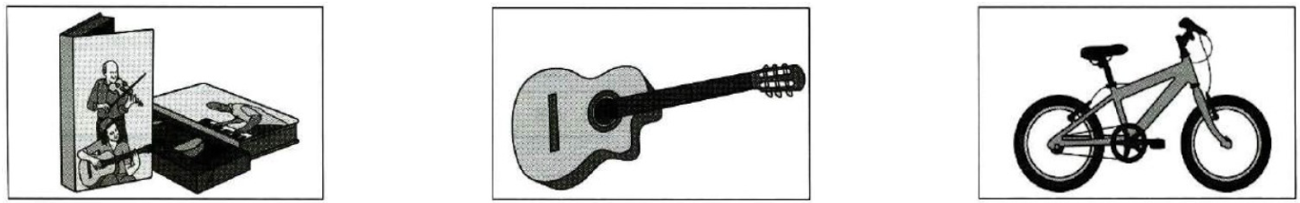
A | B | C
3. Where will they sit?
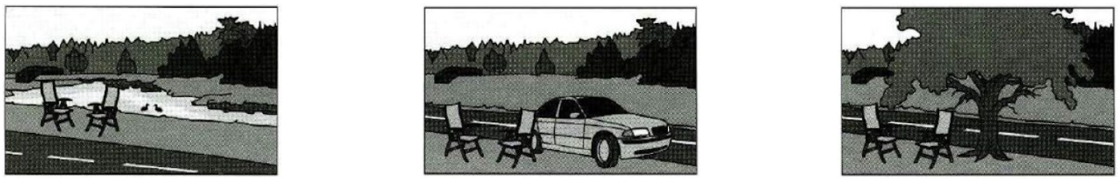
A | B | C
4. What size does the woman buy?
A | B | C
5. Which ice cream will they have?
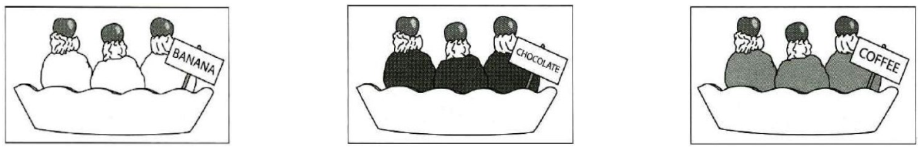
A | B | C
Part 2. Listen to Sam talking to her friend Paul about a play. What will each person help with? Write a letter A-H next to each person.
People | Help with
6. Marco  | A. clothes
7. Mary | B. actors
8. Robert | C. lights
9. Ivanna | D. dancers
10. Diego | E. instruments
 | F. photographs
 | G. tickets
 | H. singers
Part 3. You will hear a manager, Victoria, talking to her assistant, Daniel, about the company building. Choose the correct answer.
11. How will staff find out about the new building?
A. in an email
B. at a meeting
C. at a company meal
12. Why is the company moving to a new building?
A. to save money
B. to be in the town center
C. to have larger offices
13. When will staff start working in the new building?
A. the end of May
B. the beginning of July
C. the middle of August
14. What does Daniel think the staff will enjoy most about the new area?
A. the restaurant
B. the shops
C. the gym
15. What does Daniel need to order next?
A. keys
B. signs
C. furniture
Part 4. Complete the note below. Write one word and/or a number for each answer.
CLASS TRIP
When: Tomorrow
Where: the (16) ____________________ Museum
Time we leave: (17) ____________________ a.m.
Meet at the: (18) ____________________
Bring: (19) ____________________
Cost: (20) £ ____________________

SECTION B: VOCABULARY AND GRAMMAR
Part 1. Choose the word or phrase (A, B, C, or D) that best completes each of the following exchanges.
1. I don't know that because I _________ today's newspaper yet.
A. don't read B. am not reading C. haven't read D. didn't read
2. _________ his exhaustion, he won the marathon by nearly three minutes.
A. In spite B. Despite C. Although D. However
3. We took _________ of the fine weather and spent the day on the beach.
A. chance B. advantage C. occasion D. effect
4. Sorry, but that book is_________. We'll get some copies from the publisher next Monday.
A. out of print B. out of order C. off shelf D. out of stock
5. While my father was watching TV, the light _________ out.
A. was going B. went C. go D. to go
6. I suggest that we _________ some money for poor children.
A. to raise B. raising C. raised D. should raise
7. Her mother has just bought a _________ car for her.
A. Italian beautiful black B. beautiful black Italian
C. black Italian beautiful D. black beautiful Italian
8. Thomas and Peter are meeting after a long time.
Thomas: “How have you been recently?” Peter: “_________.”
A. I am going on holiday next week. B. By car, usually
C. I am working here D. Pretty busy, I think
Mark the letter A, B, C, or D to indicate the word(s) CLOSEST in meaning to the underlined word(s) in the following question.
9. I'm sorry I can't come out this weekend - I'm up to my ears in work.
A. very busy B. very bored C. very scared D. very idle
Mark the letter A, B, C, or D to indicate the word(s) OPPOSITE in meaning to the underlined word(s) in the following question.
10. A new study suggests that artificial sweeteners are linked to weight gain - not weight loss - as well as obesity, diabetes, and heart disease.
A. traditional B. unhealthy C. innovative D. natural
Part 2. There are 10 mistakes in the following passage. Identify the mistakes and write the corrections in the corresponding numbered boxes.
When Vicky Harmiston was a child, her parents gave her and her brother Jamie the free to decide what they did in their spare time. Vicky chose to do lots of difference sports. She was a good swimmer, and the coach at the swimming club she went to thought she might be good enough to become a championship. But the club was a long way from her home, so it was difficult for her fitting the training around her schoolwork. When they were teenager, Jamie, who loved cycling, bought himself a special track-racing bike and started taking part on competitions. Vicky thought it looked very excited and decided to try it for herself. She says that was the better decision she ever made. Soon she was cycling every day and doing really well. The track was near her school, which meant it was no problem for her to attend training sessions after school every day. Vicky went on to have successful career in track cycling and won several competition. Then, when she was 28, she retired from competitive cycling. Vicky told me: “For years I'd loved winning competitions but I began to get a bit tired of the whole thing - and when the excitement stops, there's no point. Lucky, I went on to have a new career.”
1. ______________ | 2. ______________ | 3. ______________ | 4. ______________ | 5. ______________
6. ______________ | 7. ______________ | 8. ______________ | 9. ______________ | 10. _____________

SECTION C: READING COMPREHENSION
Part 1. Read the following passage and decide which option A, B, C, or D best fits each space.
People today are probably more concerned about food than ever before. We worry about eating foods that (1) ________ too much fat or carbohydrates, and so we cut (2) ________ on things like meat, bread, potatoes, and dairy (3) ________. The problem with making dramatic changes to our eating (4) ________ like these is that we may also be cutting out good (5) ________ of iron or other vitamins and minerals. Suddenly we start feeling tired and irritable. The secret of a (6) ________ diet is to reduce foods that are (7) ________ in cholesterol while, at the same time, eating those that are (8) ________ in calcium and iron like soy protein, sesame seeds, spinach, and broccoli. Eating well does not mean that you should cut out all your (9) ________ foods; it just means eating sensibly and trying to avoid too much (10) ________ food!
1. A. hold | B. contain | C. enclose | D. carry
2. A. out | B. off | C. down | D. up
3. A. products | B. specimens | C. examples | D. samples
4. A. customs | B. rules | C. norms | D. habits
5. A. bases | B. origins | C. sources | D. causes
6. A. balanced | B. neutral | C. steady | D. solid
7. A. large | B. tall | C. high | D. big
8. A. strong | B. rich | C. full | D. wealthy
9. A. preferred | B. lovely | C. favourite | D. admired
10. A. rubbish | B. junk | C. trash | D. garbage
Part 2. Fill each blank with ONE suitable word. Write your answers in the numbered blanks provided below the passage.
The idea of World Music day or Fete de la Musique began in France (1) ________ the 1980s but has quickly spread across the globe and is now celebrated (2) ________ 21st June in over 120 countries. (3) ________ American musician, Joe Cohen, who was working for a French radio station, first came up (4) ________ the idea for a music festival that everyone could enjoy and take (5) ________ in. He suggested an all-night music festival (6) ________ celebrate the summer solstice (the longest day). The French minister for culture liked the idea and it first became reality in June 1982. The main idea behind the festival is that music is a great way to bring people together regardless (7) ________ their nationality, ethnic and cultural background or age. It was extremely popular, particularly because all the events were free.
Today the event is celebrated in cities (8) ________ far apart as Potsdam and Osaka, New York and Sydney. The day does not (9) ________ involve individual musicians but also orchestra, cultural organizations, and schools. The best thing about the festival is that musicians are encouraged to perform outside the usual music venues and concert halls. Whole towns (10) ________ turned into huge outdoor concerts. And every kind of music is on offer. You can hear classical music, jazz bands, rock groups, pop bands, folk music and singersongwriters all in the same place, and all for free.
Part 3. Read the passage below and choose the best answer to each question.
In 1826, a Frenchman named Niépce needed pictures for his business. He was not a good artist, so he invented a very simple camera. He put it in a window of his house and took a picture of his yard. That was the first photograph. The next important date in the history of photography was 1837. That year, Daguerre, another Frenchman, took a picture of his studio. He used a new kind of camera and a different process. In his pictures, you could see everything clearly, even the smallest details. This kind of photograph was called a daguerreotype.
Soon, other people began to use Daguerre’s process. Travelers brought back daguerreotypes from all around the world. People photographed famous buildings, cities, and mountains.
In about 1840, the process was improved. Then photographers could take pictures of people and moving things. The process was not simple, and photographers had to carry lots of film and processing equipment. However, this did not stop photographers, especially in the United States. After 1840, daguerreotype artists were popular in most cities.
Matthew Brady was one well-known American photographer. He took many portraits of famous people. The portraits were unusual because they were lifelike and full of personality. Brady was also the first person to take pictures of a war. His 1862 Civil War pictures showed dead soldiers and ruined cities. They made the war seem more real and more terrible.
In the 1880s, new inventions began to change photography. Photographers could buy film ready-made in rolls, instead of having to make the film themselves. Also, they did not have to process the film immediately. They could bring it back to their studios and develop it later. They did not have to carry lots of equipment. And finally, the invention of the small handheld camera made photography less expensive.
With a small camera, anyone could be a photographer. People began to use cameras just for fun. They took pictures of their families, friends, and favorite places. They called these pictures “snapshots”.
Documentary photographs became popular in newspapers in the 1890s. Soon magazines and books also used them. These pictures showed true events and people. They were much more real than drawings. Some people began to think of photography as a form of art. They thought that photography could do more than show the real world. It could also show ideas and feelings, like other art forms.
1. The first photograph was taken with _______.
A. a small handheld camera B. a very simple camera
C. a daguerreotype D. new types of film
2. Daguerre took a picture of his studio with _______.
A. a new kind of camera B. a very simple camera
C. special equipment D. an electronic camera
3. The word “this” in the passage refers to the _______.
A. carrying of lots of film and processing equipment
B. stopping of photographers from taking photos
C. fact that daguerreotype artists were popular in most cities
D. taking of pictures of people and moving things
4. The word “ruined” in the passage is closest in meaning to _______.
A. poorly painted B. heavily polluted C. terribly spoiled D. badly damaged
5. The word “lifelike” in the passage is closest in meaning to _______.
A. moving B. realistic C. touching D. manlike
6. The latest invention mentioned in the passage is the invention of _______.
A. handheld cameras B. processing equipment
C. daguerreotypes D. rolls of film
7. The word “handheld” in the passage is closest in meaning to _______.
A. handling manually B. held by hand
C. controlling hands D. operated by hand
8. Matthew Brady was well-known for _______.
A. inventing daguerreotypes B. the small handheld camera
C. taking pictures of French cities D. portraits and war photographs
9. As mentioned in the passage, photography can _______.
A. print old pictures B. convey ideas and feelings
C. show the underworld D. replace drawings
10. Which of the following could best serve as the title of the passage?
A. Different Steps in Film Processing B. Story of Photography
C. Photography and Painting D. Story of Famous Photographers
Part 4. The people below all want to find a castle to visit. Decide which castle would be the most suitable for the people below.
1. Alan is keen on history and wants to visit a castle that was the site of well-known historical events. He'd like the castle to be near the coast, with tours led by a guide.
2. Yoshiko wants to see a castle that people are still living in. She loves visiting beautiful gardens and would like to explore interesting places in the castle.
3. Paulo and Maria collect antiques, so want to visit a castle that still has some of its original furniture on display, and hear about the building’s history. They also want something that's particularly suitable for young children.
4. Kerim wants somewhere with a great historical atmosphere, with typical food from the past to try, and people dressed in costume. He’d also like to see art that’s been in the castle for centuries.
5. Jake and his brother have always wanted to visit the ruins of a castle surrounded by water, with great views. Jake also wants to learn about any wildlife living in and around the castle.
These are descriptions of eight castles for people wanting to join:
Castles to visit
A. Durston Castle
Durston Castle has a valuable art collection, secret tunnels - one leading to the beach - and visitors mustn't miss the unusual rooms deep beneath the castle walls. Because the building is the Durston family's home, some parts cannot be visited - but you can sit on the grass under the trees and admire the flower beds and fountains. There's a play area for children too.
B. Castle Woodward
At Castle Woodward, you can experience what life was like at the time it was built. Staff wear clothes typical of the time and offer everyone tasty snacks made using recipes from different periods of history. Inside, the walls are covered with original paintings of the generations of people who've lived in the castle.
C. Castle Hemsworth
Castle Hemsworth's guides, dressed in historical costumes, give visitors information about the traditional castle building, towers and gardens. Wild horses live nearby. Inside, the castle looks unchanged, with old furniture and portraits of people who've lived here.
D. Castle of Marlin
Only a few parts of the ancient castle of Marlin are left, but you can still visit some underground rooms and see beautiful countryside from the high tower. The castle is in the middle of a lake and has lovely gardens. There are talks about the castle, and the bats, birds and butterflies chat have made Marlin their home.
E. Chartsmouth Castle
Chartsmouth Castle was once owned and lived in by kings. Visitors love exploring the rooms, some of which have hidden tunnels. You can see the sea from the top of the walls, and younger visitors will love the outdoor games.
F. Carston Castle
Experts at the ruins of Carston Castle will show you around and give you information, and offer you 17th-century snacks! Hear how the building was once the scene of famous battles and is now home to a variety of wildlife. And from the south side, there are fantastic sea views.
G. Rushford Castle
This is an old castle on the coast which is a popular local attraction. The Rushford Castle café in the walls serves food typical of the castle's history. Inside, there are beautiful rooms with antique tables and clocks. Outside, visitors can see a wide variety of wildlife.
H. Sawbridge Castle
This castle was built in 1712 on an island in a lake. Inside, you can still see beautifully designed beds, tables and other objects once used by families living there. Put on headphones and listen to information about the history of Sawbridge Castle. Visitors of all ages will love the toy museum in the gardens.
1. _________ | 2. _________ | 3. _________ | 4. _________ | 5. _________

SECTION D: WRITING
Part 1 (5 points). Complete the second sentence so that it has a similar meaning to the first sentence using the word given. DO NOT change the word given. You must use between three and five words, including the words given.
1. He studied history because he wanted to be a teacher. (VIEW)
He studied history __________________________________________________________________ a teacher.
2. You can borrow my book, but you must promise to return it by Monday. (LONG)
You can borrow my book _____________________________________________ to return it by Monday.
3. She has a good relationship with her assistant. (WELL)
She _________________________________________________________________________ with her assistant.
4. They are too young to stay out late. (ENOUGH)
They __________________________________________________________________________ to stay out late.
5. She got the part even though she didn't have much acting experience. (OF)
In __________________________________________________ much acting experience, she got the part.
Part 2. This is part of a letter you receive from an English friend, Jane.
My favourite subject at school is history. I don't like science. What subjects do you study? What's your favourite? And what subjects don't you like?

Now write a letter to Jane, answering her questions.
Write your letter in about 100 - 120 words on your answer sheet.
Use Linh as your name.
________________________________________________________________________________________________
________________________________________________________________________________________________
________________________________________________________________________________________________
________________________________________________________________________________________________
________________________________________________________________________________________________
________________________________________________________________________________________________
________________________________________________________________________________________________
________________________________________________________________________________________________
________________________________________________________________________________________________
________________________________________________________________________________________________
________________________________________________________________________________________________
________________________________________________________________________________________________
________________________________________________________________________________________________
________________________________________________________________________________________________
________________________________________________________________________________________________
________________________________________________________________________________________________
________________________________________________________________________________________________
________________________________________________________________________________________________
________________________________________________________________________________________________
________________________________________________________________________________________________
________________________________________________________________________________________________
________________________________________________________________________________________________
________________________________________________________________________________________________
________________________________________________________________________________________________
________________________________________________________________________________________________
________________________________________________________________________________________________
________________________________________________________________________________________________
________________________________________________________________________________________________
________________________________________________________________________________________________
________________________________________________________________________________________________
________________________________________________________________________________________________
________________________________________________________________________________________________
________________________________________________________________________________________________
________________________________________________________________________________________________
________________________________________________________________________________________________
________________________________________________________________________________________________
________________________________________________________________________________________________
________________________________________________________________________________________________
________________________________________________________________________________________________
________________________________________________________________________________________________
________________________________________________________________________________________________
________________________________________________________________________________________________
________________________________________________________________________________________________
________________________________________________________________________________________________
________________________________________________________________________________________________
________________________________________________________________________________________________
________________________________________________________________________________________________
________________________________________________________________________________________________
Part 3. Choose ONE of the following options:
Option 1: Your English teacher has asked you to write a story (150-180 words) for your school story writing competition. Your story MUST begin with the following sentence:
When Sharon arrived, everyone was really surprised to see her.

Option 2: Write an essay (200-250 words) about the advantages and disadvantages of online learning.
________________________________________________________________________________________________
________________________________________________________________________________________________
________________________________________________________________________________________________
________________________________________________________________________________________________
________________________________________________________________________________________________
________________________________________________________________________________________________
________________________________________________________________________________________________
________________________________________________________________________________________________
________________________________________________________________________________________________
________________________________________________________________________________________________
________________________________________________________________________________________________
________________________________________________________________________________________________
________________________________________________________________________________________________
________________________________________________________________________________________________
________________________________________________________________________________________________
________________________________________________________________________________________________
________________________________________________________________________________________________
________________________________________________________________________________________________
________________________________________________________________________________________________
________________________________________________________________________________________________
________________________________________________________________________________________________
________________________________________________________________________________________________
________________________________________________________________________________________________
________________________________________________________________________________________________
________________________________________________________________________________________________
________________________________________________________________________________________________
________________________________________________________________________________________________
________________________________________________________________________________________________
________________________________________________________________________________________________
________________________________________________________________________________________________
________________________________________________________________________________________________
________________________________________________________________________________________________
________________________________________________________________________________________________
________________________________________________________________________________________________
________________________________________________________________________________________________
________________________________________________________________________________________________
________________________________________________________________________________________________
________________________________________________________________________________________________
________________________________________________________________________________________________
________________________________________________________________________________________________
________________________________________________________________________________________________
________________________________________________________________________________________________
________________________________________________________________________________________________
________________________________________________________________________________________________
________________________________________________________________________________________________
________________________________________________________________________________________________
________________________________________________________________________________________________
________________________________________________________________________________________________
________________________________________________________________________________________________

