II. Interview :SPEAKING ENGLISH 7-UNIT 9 : FESTIVALS
a
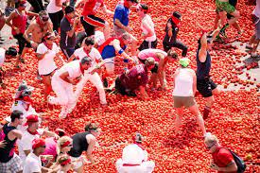
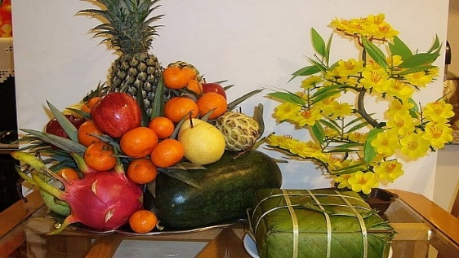
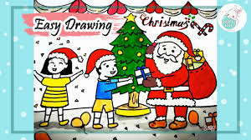
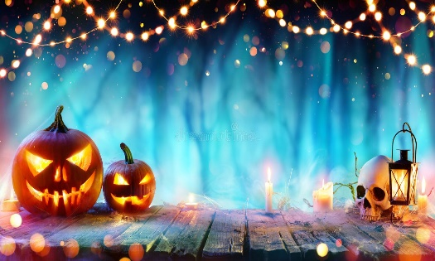
e
h
f
l
k
j
i
g
d
c
- What festival is this?
- What do they prepare for this festival?
- Which events do you think happen at this festival?
- It is the symbol of the winner’s prize.
- You can watch this traditional dance on Mid-Autumn Festival….
- It is a noun that mean “Two children born to the same other at the same time”.

3
2
1
1

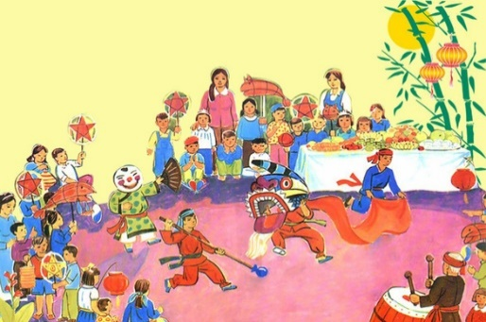
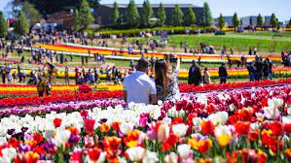

5
1

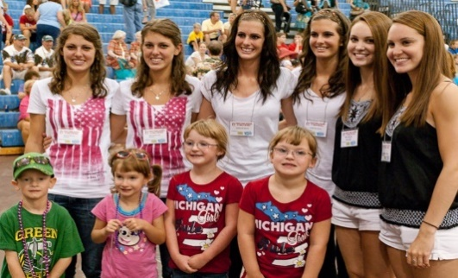
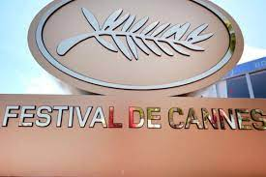

4
6

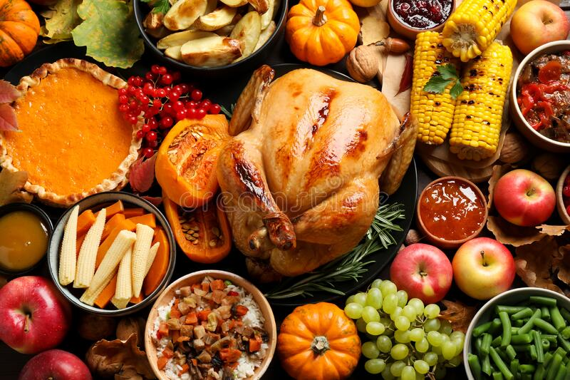
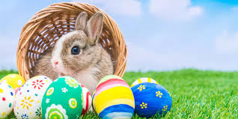
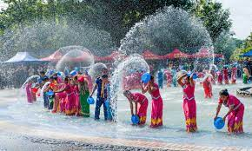
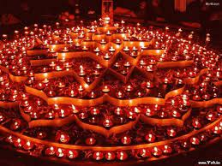

3
3
3
3

