School: ……………………………………….. | Date:……………………………………..
Class: ……………………………..................... | Period: …………………………….........

UNIT 8: TRADITIONS OF ETHNIC GROUPS IN VIETNAM
Lesson 3.1 – Speaking & Writing (Page 83)
I. OBJECTIVES
By the end of the lesson, Ss will be able to:
1.1. Language knowledge and skills
- study how to give supporting information.
- talk about fun things to do at ethnic villages in Vietnam.
- write a passage about a trip to an ethnic village in Vietnam.
1.2. Competences
- improve communication, collaboration, writing and critical thinking skills.
1.3. Attributes
- choose healthy food for themselves.
- lead a healthy life.
- make a polite request for better things in everyday life.
II. TEACHING AIDS AND LEARNING MATERIALS
1. Teacher’s aids: Student book and Teacher’s book, class CDs, Digital Book (DCR phần mềm tương tác SB, DHA (từ vựng/ cấu trúc) phần mềm trò chơi tương tác), projector/interactive whiteboard / TV (if any), PowerPoint slides.
2. Students’ aids: Student’s book, workbook, notebook.
III. ASSESSMENT EVIDENCE
Performance Tasks | Performance Products | Assessment Tools
- Read a passage again and underline the facts, examples, and opinions.  - Read the topic sentence and the supporting information. Write "F" for facts, "E" for examples, and "O" for opinions.  - Speak in pairs about a fun trip to ethnic villages in Vietnam.  - Share personal ideas about the trips.  - Write a passage about one of the trips to the ethnic villages discussed in speaking part. | - Ss’ answers.  - Ss’ answers.  - Ss’ answers.  - Ss’ answers.  - Ss’ answers/ presentation. | - T’s feedback.  - T’s observation/ DCR.  - T’s feedback/Peers’ feedback.  - T’s feedback/Peers’ feedback.  - T’s observation and feedback.

IV. PROCEDURES
A. Warm up: (5’)
a) Objective: Introduce the new lesson and set the scene for Ss to acquire new language; get students' attention at the beginning of the class by enjoyable and short activities as well as to engage them in the follow-up steps.
b) Content: review the learned vocabulary words from the previous lesson through exciting activities.
c) Expected outcomes: Ss remember some words about the ethnic village activities that will support them in their writing piece.
d) Organization of the activity:
TEACHER’S ACTIVITIES | STUDENTS’ ACTIVITIES
Option 1: Jumble words  - Introduce the jumble letters.  - Demonstrate the activity by telling Ss to unscramble the letters to make a correct word.  - Call two Ss to come to the board and complete te words.  - Check and correct as a class.  - Lead to the new lesson.  Jumble words:  + ngog gong  + lgievla village  + etysahom homestay  + ttsli uohse stilt house  + tlnadoritia traditional  + onecferpram performance  Option 2: Discuss the questions from the previous lesson.  - Remind the Ss the questions in task d from previous lesson.  + “What do you think about the activities Lan did on her trip?”  + “Would you like to try any of them?”  - Have Ss open the textbook on page 82 to read the passage again.  - Ss do the activity individually.  - Call some Ss to stand up and answer the questions. | - Look and listen to T’s instruction.  - Look and try to unscramble the letters.  - Raise hand to give the answers.  - Correcth the mispelled words.  -  - Open the textbook page 82 and read the passage again.  - Read and take note.  - Raise hand to share opnions.

B. New lesson (35’)
- Activity 1: Pre-Writing (Speaking) (10’)
a) Objective: Ss prepare for what they are going to write about.
b) Content:
- Reading: Read Lan’s passage again and underline facts, examples, and opinions.
- Complete the table to understand more about the learning point of the lesson.
c) Expected outcomes: Ss know more about the the types of giving supporting information.
d) Organization of the activity:
TEACHER’S ACTIVITIES | STUDENTS’ ACTIVITIES
Task a. Read about giving supporting information. Then, read Lan’s passage again and underline the facts, examples, and opinons.  - Use DCR to show the task.  - Have Ss read through the theory box in the textbook.  - Go over each point in the writing skill box and make sure Ss comprehend fully about the facts, examples, and opnions.  - Check Ss’ undertanding by have them read Lan’s passage one more time and underline the facts, examples, and opinions.  - Have Ss work individually.  - Set the time in 5 minutes for the task.  - Call some Ss to give the answer.  - Give the correct answer and have them read the sentences again.  Answer keys.  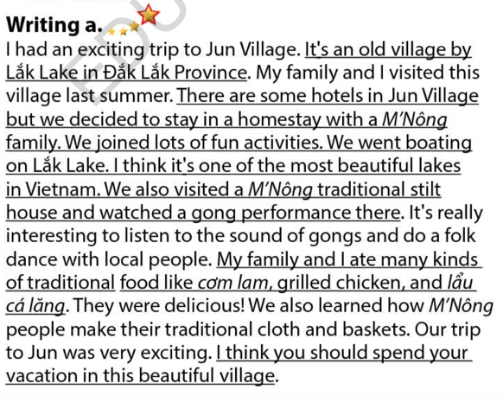  Task b. Read the topic sentence and the supporting information. Then, write "F" for facts, "E" for examples, and "O" for opinions.  - Use DCR to show the task.  - Tell Ss to look at the picture and ask them to describe the picture.    - Have Ss work in pairs and complete the task.  - Ask Ss if there are any new words they don’t understand from the exercise.  - Set the time in 5 minutes.  - Call some pairs to give answers and tell them to read the sentences aloud.  - Give correction and check Ss’s understanding about giving supporting information again.  Answer keys  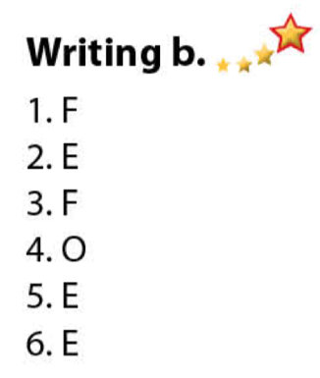 | - Read the thery box.  - Look and ask questions if any.  - Read the passage an do the task.  - Work individually.  - Give answers.  - Read the sentences aloud with correct pronunication.  - Look and try to describe the picture.  - Work in pairs and do the task.  - Give answers and read the sentences aloud.  - Look and correct the mistakes.

- Activity 2: While - Writing (20’)
a) Objective:
- Students can develop their speaking skills through the knowledge from the pre-writing.
- Students can write a passage following the writing theory about types of supporting information.
b) Content:
- Speak about the trip to ethnic villages in Vietnam.
- Share your thoughts about the trips.
- Write a passage about the trip to ethnic village.
c) Expected outcomes: Ss can use the ideas and knowledge to write a passage about their trip to ethnic village.
d) Organization of the activity:
TEACHER’S ACTIVITIES | STUDENTS’ ACTIVITIES
Task a. You had a fun trip to an ethnic village. ☞Student A, 116 File 6 . Student B, ask and take notes on what Student A said. Swap roles and repeat. Student B, answer using the notes and your own ideas.  - Have Ss work in pairs.  - Have student A go to page 116.  - Have student A ask and student B asnwer and vice versa.  - Have both students read the questions in the cards and add in more personal ideas while speaking.  - Set the time in 10 minutes for discussion.  - Have some pairs present in front of the class.  - Give feedback and evaluation.  Task b. In pairs: What do you think about the trips to Kon K’Tu and Phia Thấp? Would you like to go there?  - Have Ss work individually.  - Have Ss share their thoughts on the questions.  - Elicit asnwers from some students.  - Call some Ss to verablly share their thoughts with the whole class.  *Let’s Write: Write a passage about one of the trips to the ethnic villages you discussed in Speaking. Use the Writing Skill box and your speaking notes to help you. Write 80 to 100 words.  - Draw Ss’ attention to the feedback form (using DCR).  - Have Ss use their notes to write a passage about one of the trips to an ethnic village they discuss in Speaking.  - Have Ss begin to write their passage.  - Have some Ss read their writing piece in front of the class.  Suggested writing  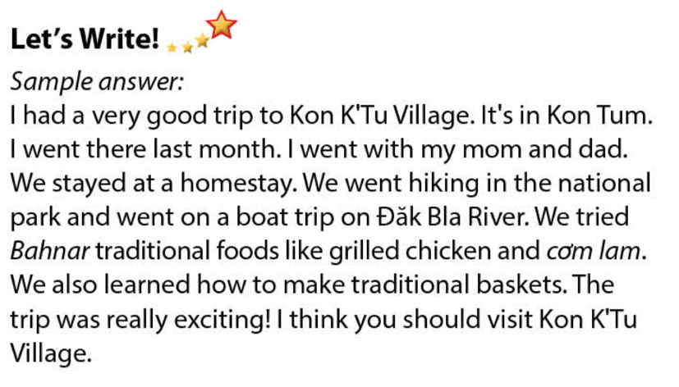 | - Work in pairs.  - Student A goes to page 116.  - Work together as a pairs.  - Read the questions and add in more personal ideas.  - Present in front of the class.  - Listen to T’s feedback.  - Work individually.  - Read the questions and ready to share the ideas.  - Present in front of the class.  - Look at the speaking and collect information.  - Start to write.  - Read the passage in front of the class.

- Activity 3: Post - Writing (5’)
a) Objective: Help Ss realize their mistakes in writing and correct them.
b) Content: Correcting Ss’ writings.
c) Expected outcomes: Students know whether their letters follow the model and use the correct structures and language, whether their writings are interesting and understandable or not.
d) Organization of the activity:
TEACHER’S ACTIVITIES | STUDENTS’ ACTIVITIES
- Give feedback, correct Ss’ mistakes.  - Use the feedback form to give evaluation. Focus on:  + the format, the structures.  + the understandability.  + the coherence and cohesion. | - Look, listen and correct mistakes.

C. Consolidation and homework assignments (5’)
* Consolidation:
- Common types of supporting information.

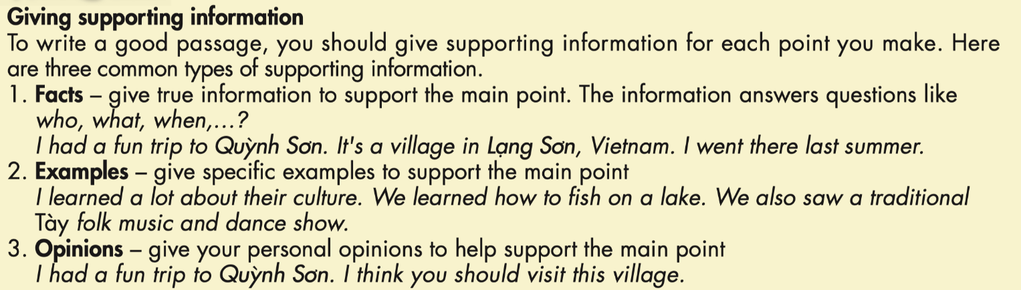
* Homework
- Know how to write a passage with common types of supporting information.
- Finish the writing part.
- Do the exercises in WB: Writing (page 49).
- Complete the writing exercise in Tiếng Anh 8 i-Learn Smart World Notebook (page 69).
- Play the consolidation games in Tiếng Anh 7 i-Learn Smart World DHA App on www.eduhome.com.vn
- Prepare: Unit 8 – Review 1.

D. Reflection
a. What I liked most about this lesson today:
…………………………………………………………………………………………
- What I learned from this lesson today:
…………………………………………………………………………………………
c. What I should improve for this lesson next time:
…………………………………………………………………………………………

