AI-Assisted Reading Task Design:
A ChatGPT-Based Approach

TABLE OF CONTENTS
PART A. INTRODUCTION
I. Rationale of the study ………………………………………. page 2
II. Aims of the study ………………………………………. page 2
PART B: CONTENTS
I. Literature review ………………………………………. page 3
II. Overview of reading tasks in the 2024 National English Contest …… page 4
III. The Role of ChatGPT in designing reading tasks ………………… page 5

1. Automated generation of reading passages …………………… page 5

2. Designing diverse reading tasks …………………………… page 5

3. Building vocabulary support and pre-reading scaffolds …………… page 7

4. Differentiation and level adaptation ………………….…… page 7

5. Creating higher-order thinking activities …………………………… page 7

6. Providing Instant Feedback and Explanation ………………………… page 8

7. Time-saving for teachers……………………………………… page 8
IV. Applications and implementation ………………………… page 8
1. Steps to use ChatGPT for designing reading tasks ………………… page 8
2. Sample reading tasks generated with ChatGPT ……………………… page 9
V. Academic and study outcomes ………………………………………. page 28
PART C: CONCLUSION

I. The importance of the study ………………………………………. page 29

II. Suggestions and implications ………………………………………. page 29
REFERENCES ………………………………………………………. page 30
APPENDIX ………………………………………………………….. page 31

PART A. INTRODUCTION
I. Rationale of the study
“AI will not replace teachers. But teachers who use AI will probably replace those who do not”. In an era marked by rapid technological advancement, Artificial Intelligence (AI) is a transformative force that is reshaping the way we live, work, and learn. Among these technologies, ChatGPT stands out for its accessibility, versatility, and capacity to generate high-quality language materials in real time.
Gifted learners frequently outpace their peers in terms of reading proficiency, critical thinking, and language acquisition. However, in many educational contexts, especially those with large class sizes and limited resources, it is difficult for teachers to consistently provide differentiated reading materials that meet these students’ advanced needs. Traditional textbooks may fall short in terms of text complexity, vocabulary richness, and task variety. Moreover, manually creating reading tasks that align with both students' interests and their high language proficiency is time-consuming and unsustainable for many educators.
By integrating ChatGPT into the process, teachers can generate authentic, level-appropriate, and thematically diverse reading texts along with custom comprehension questions. This AI-supported approach not only saves time but also enhances the quality and personalization of reading instruction. Therefore, the study aims to investigate how ChatGPT can be effectively used to design reading tasks that foster critical reading skills, promote engagement, and support the academic development of gifted English language learners.
This is the reason why the study "AI-Assisted Reading Task Design: A ChatGPT-Based Approach" was conducted. It addresses not only a current educational trend but also a practical and urgent need in the teaching of English to talented learners at the upper-secondary level.
II. Aims of the study
This study aims to examine the advantages and challenges of using ChatGPT in designing reading comprehension tasks for gifted students. By exploring practical ways to apply ChatGPT in the creation process, the study demonstrates how AI can support teachers in generating high-quality, engaging tasks. In addition, it presents sample reading tasks tailored for gifted learners and evaluates their academic impact and learning outcomes.
PART B: CONTENTS
I. Literature review
The integration of Artificial Intelligence (AI) into education has transformed traditional instructional design, particularly in reading pedagogy. Recent advances in Natural Language Processing (NLP) have enabled AI models to generate human-like text, allowing educators to automate and personalize aspects of teaching that were once highly time-consuming. Among such tools, ChatGPT—a large language model developed by OpenAI—has shown promising potential in designing and facilitating reading tasks tailored to specific learner needs.
Several scholars have explored the use of AI in language education. Kukulska-Hulme et al. (2020) emphasized the potential of AI to support personalized learning through adaptive content generation. Similarly, Holmes et al. (2019) argued that AI technologies could offer scalable solutions for differentiated instruction in language learning, including reading comprehension. These studies highlight the shifting role of teachers from sole content creators to facilitators and curators of AI-generated materials.
The design of reading tasks, especially for advanced and gifted learners, demands cognitive rigor, lexical variety, and text authenticity. According to Nation and Newton (2009), effective reading tasks should promote both language input and strategic comprehension skills. However, traditional methods of creating such tasks are labor-intensive and often lack linguistic variability or thematic freshness. In this context, AI tools like ChatGPT can be employed to assist educators in generating reading passages, vocabulary exercises, and comprehension questions aligned with higher-order thinking skills.
Emerging research has begun to examine ChatGPT specifically in educational settings. Zhai (2022) explored the use of ChatGPT to scaffold reading and writing tasks and found it beneficial for generating sample texts, prompts, and feedback. In another study, Lo (2023) investigated the effectiveness of ChatGPT in generating IELTS-style reading passages and noted its ability to replicate both the tone and complexity of authentic texts. However, concerns remain regarding factual accuracy, bias, and the need for teacher moderation.
While much of the literature recognizes the potential of AI, particularly ChatGPT, in supporting reading task design, there is limited empirical work focused specifically on gifted students or national examination formats. This gap presents an opportunity to explore how ChatGPT can be effectively leveraged to design high-quality, exam-aligned reading tasks that meet the cognitive demands of advanced learners.
Using ChatGPT to help design reading tasks offers several advantages for teachers of gifted students. It saves time by generating texts and questions quickly, and allows for high customization based on topic, difficulty, or question type. ChatGPT also provides a rich variety of themes, including up-to-date and academic topics that appeal to advanced learners. Its fluent and coherent outputs expose students to complex vocabulary and structures, supporting language development. Moreover, teachers can easily revise, adapt, or regenerate materials to match specific learning goals.
However, challenges remain. AI-generated content may lack depth, authenticity, or relevance to students’ real context. Without careful review, teachers risk relying on texts that are too general or inaccurately pitched. ChatGPT does not fully replace pedagogical judgment, especially when aligning materials with national exam formats or critical thinking skills. Ethical concerns also arise, such as students overusing AI or misusing it to avoid genuine effort. Therefore, while ChatGPT is a powerful tool, it must be used thoughtfully and selectively.

II. Overview of reading tasks in the 2024 National English Contest

According to the official format of the 2024 National English Contest (NEC), the Reading section accounts for 8 out of 20 points, making it a significant component of the test. This section is divided into two main parts: Language in Use and Reading Comprehension.
The Language in Use part integrates grammar and vocabulary tasks into short reading passages, requiring students not only to recognize correct forms but also to understand context and usage. Meanwhile, the Reading Comprehension part includes a variety of academic texts accompanied by multiple task types such as gap-filling, reference and inference questions, missing paragraph identification, information location, and tasks that require students to determine the writer’s attitude, tone, or main idea
These tasks are highly demanding, as they call for both a strong command of language knowledge and sharp analytical thinking. Students must demonstrate their ability to process dense information, decode complex sentence structures, and respond to nuanced questions—all under time pressure. This reflects the contest’s goal of identifying truly gifted learners with advanced English proficiency and intellectual agility.
READING (8.0 points) | LANGUAGE IN USE (3.0 points)  Part 1. Cloze test (10 items)  Part 2. Word formation (6 items)  Part 3. Error correction (5 items)  READING COMPREHENSION (5.0 points)  Part 1. Open cloze (10 items)  Part 2. IELTS reading (True/False/Not Given Summary Completion) (13 items)  Part 3. Paragraph insertion (6 items)  Part 4. Multiple choice (10 items)  Part 5. Information location (10 items)

III. The Role of ChatGPT in Designing Reading Tasks

1. Automated generation of reading passages
One of ChatGPT’s most powerful features is its ability to generate reading texts according to precise teacher specifications. Educators can input specific criteria—such as topic, word count, CEFR level, genre, tone, and target age group—and receive a coherent, relevant, and level-appropriate reading passage within seconds.
Example: “Generate a 400-word informational text on ‘The impact of urbanization on mental health’ suitable for C1 students, using academic tone and varied sentence structures.”
ChatGPT will not only produce a passage aligned with this prompt but also ensure internal coherence, lexical variety, and thematic consistency. This reduces planning time for teachers while allowing greater creativity in topic selection.
Furthermore, the generated content can be used as-is or further edited by the teacher, making it ideal for both standard and differentiated instruction.

2. Designing diverse reading tasks
Reading instruction is most effective when it targets a wide spectrum of subskills: skimming, scanning, inferring, summarizing, identifying paraphrased ideas, and understanding vocabulary in context. ChatGPT enables teachers to build customized reading tasks that test these specific skills.
Some examples include:
- Multiple Choice Questions (MCQs) for:
- Main idea recognition
- Inference
- Vocabulary meaning in context
- Paraphrase identification
- True/False/Not Given items for:
- Factual recall
- Distinguishing between stated and implied information
- Matching Exercises:
- Headings to paragraphs (coherence and cohesion)
- Statements to specific lines or sections of the passage
- Sentence and Summary Completion: Requiring students to reconstruct missing information based on comprehension
- Gap-fill Tasks: With or without a word bank, targeting context clues, collocations, or grammar
- Paragraph Insertion: A higher-level task assessing text cohesion and logical sequencing
ChatGPT can generate these task types on demand. For example: “Create 10 multiple-choice questions based on this passage that test detail, inference, and vocabulary.”
This capability helps ensure that reading tasks are varied, balanced, and aligned with Bloom’s taxonomy and CEFR descriptors.

3. Building vocabulary support and pre-reading scaffolds
Effective reading lessons often begin with pre-reading activities to activate schema and introduce key vocabulary. ChatGPT can assist in creating:
- Glossaries of unfamiliar words from a given text, with definitions and example sentences
- Word banks grouped by theme or word family
- Pre-reading discussion prompts or prediction questions
- Concept maps or semantic webs to visually represent vocabulary networks
This is especially helpful for CLIL (Content and Language Integrated Learning) environments or when working with students at mixed proficiency levels.
Prompt example: “List 20 potentially unfamiliar academic words from this passage, define them in simple English, and use each in a new sentence.”

4. Differentiation and level adaptation
One major challenge in designing reading tasks is catering to students with different levels of language proficiency. ChatGPT can simplify or elevate texts as needed without changing the core content, supporting inclusive and scaffolded instruction.
For example:
- A teacher may input a C1-level text and ask: “Simplify this passage for a B1 learner while keeping the main ideas and replacing complex vocabulary with more common equivalents.”
- Conversely, a teacher could ask: “Rewrite this B1-level story in a more formal academic tone suitable for C1 students, using passive voice and nominalisation.”
This functionality supports tiered instruction, remedial practice, and enrichment tasks for gifted students.

5. Creating higher-order thinking activities
Beyond basic comprehension, ChatGPT supports the development of higher-order reading tasks that encourage critical thinking and active engagement with the text. These include:
- Paraphrasing Tasks: Students are asked to rewrite ideas in different words or change the sentence structure. ChatGPT can generate sample paraphrases or identify equivalent meanings.
- Inference-Based Questions: These challenge learners to read between the lines and draw logical conclusions from implicit information.
- Text Summarization Exercises: Students summarize a text in 2–3 sentences, which tests their ability to extract and prioritize key ideas.
- Debate and Argumentation Prompts: After reading, students respond to a controversial statement or opposing viewpoint, either in writing or speaking.
These activities push students to go beyond surface understanding, developing skills that align with upper CEFR bands (B2–C2) and standardized test rubrics such as IELTS or TOEFL.

6. Providing instant feedback and explanation
Teachers can also use ChatGPT to explain why a particular answer is correct or incorrect, point out distractors and test-taking strategies and clarify misunderstood ideas or vocabulary
This can be especially useful in test preparation settings, where students need immediate and focused feedback to improve their performance.
Prompt: “Explain why option B is the correct answer to question 4, and why A, C, and D are incorrect based on the text.”

7. Time-saving for teachers
ChatGPT serves as a time-saving assistant that enables teachers to focus more on personalizing instruction, monitoring student progress, designing effective feedback, and enriching learning experiences. Teachers remain in control of content selection, task relevance, scaffolding, and alignment with learning objectives.
IV. Applications and implementation
1. Steps to use ChatGPT for designing reading tasks

To make the most of ChatGPT in a reliable and purposeful way, these steps should be followed when designing reading tasks for gifted students.

Step 1: Select a reliable source text or use ChatGPT for automated generation

Begin by choosing an informative and well-structured article or paragraph from reliable sources such as National Geographic, The Guardian, Scientific American, Smithsonian Magazine, or official course books/workbooks. Alternatively, if time is limited or you need a customized passage, you can ask ChatGPT to generate one based on specific instructional needs.

Step 2: Input the text into ChatGPT with clear instructions
Go to https://chat.openai.com and log into your account. You can use the free version or subscribe to ChatGPT Plus for access to advanced features and better performance. Copy and paste the selected text into ChatGPT and give specific instructions—for example:
“Paraphrase this into a more academic style suitable for advanced students.”
You can ask ChatGPT to shorten, lengthen, or rephrase certain sections to match your learning objectives.
Step 3: Design reading tasks
Ask ChatGPT to generate different types of questions based on the modified text, such as: multiple-choice comprehension questions, gap-filling exercises (cloze tests), matching headings with paragraphs, inserting a missing sentence into the appropriate paragraph.
Besides, you can also use a clear and specific prompt like: "Create a 300-word academic reading passage on the topic of greenwashing. Then generate 10 MCQ with four options (with answers and explanations). Level: C1–C2."
Step 4: Review and adjust the output
Carefully review all generated questions and answers to ensure they are accurate, level-appropriate, and aligned with your teaching goals. You may edit or refine wording, distractors, or options as needed.
Step 5: Export or adapt for class Use
Copy the content to a Word document, Google Docs, or PDF.
You can also convert it into worksheets, Google Forms, or use platforms like Azota, Twee, Liveworksheets, or Quizziz.
2. Sample reading tasks generated with ChatGPT
Here are some reading exercises generated from ChatGPT, designed to challenge and engage gifted learners through a variety of task types and academic topics.

Exercise 1: Fill in the blanks with the correct form of the word in parentheses.
Five Essential Attributes for a Successful Architectural Career
Pursuing architecture as a profession requires more than just technical proficiency; it demands a high level of intellectual (1) _______ (know) and a broad set of interpersonal and creative abilities.
Artistic Vision and Aesthetic Sensibility
Architects must be able to produce innovative and visually compelling (2) ________ (design), often through both hand-drawing and advanced digital software.
Collaborative Competence and Leadership
Since architectural projects are carried out through constant collaboration with engineers, clients, and (3) _________ (construct) professionals, the ability to lead discussions and ensure smooth (4) _________ (communicate) is indispensable.
Regulatory Awareness
A thorough understanding of zoning laws and legal (5) _________ (regulate) is crucial, as failing to comply may result in rejected proposals or halted construction.
Strategic Thinking and Flexibility
Due to the (6) _________ (predict) nature of construction processes, architects often face unexpected challenges. Rapid, yet thoughtful, (7) _________ (respond) rooted in logic and creativity is essential.
Market-Oriented Design Sensibility
Ultimately, architectural concepts must resonate with clients and communities. This requires ongoing (8) _______ (real) of market trends and continuous (9) _______ (research) into emerging materials, technologies, and (10) _______ (aesthetics) preferences.
(Adapted from iLearn Smart World)
ANSWER KEY
1. knowledge | 2. designs | 3. construction | 4. communication | 5. regulations
6. unpredictability | 7. responses | 8. realization | 9. research | 10. aesthetic
Exercise 2: Read the passage and choose the best answer for the following questions below.

The Role of CRISPR in Genetic Engineering
In recent years, the revolutionary gene-editing tool known as CRISPR-Cas9 has dramatically transformed the field of genetic engineering. Originally discovered as part of the immune defense system in bacteria, CRISPR allows scientists to alter DNA with unprecedented precision, efficiency, and ease. Its arrival has opened doors to potentially curing genetic diseases, improving crop resilience, and even eradicating certain inherited disorders.
CRISPR works by utilizing a guide RNA to direct the Cas9 enzyme to a specific DNA sequence. Once there, Cas9 makes a precise cut, allowing genes to be deleted, replaced, or altered. This targeted approach surpasses earlier methods, which were often clumsy and imprecise. For example, CRISPR has been used to develop disease-resistant rice varieties and to treat conditions like sickle cell anemia in experimental trials.
However, the technology has sparked fierce ethical debates. Editing the genes of somatic (non-reproductive) cells to treat disease is largely supported. But germline editing—modifying the DNA of embryos in ways that affect future generations—raises significant concerns. Many scientists argue that while the science is progressing rapidly, the moral and social implications have yet to be thoroughly addressed. Questions about consent, access, inequality, and unintended consequences remain unresolved.
Moreover, despite its accuracy, CRISPR is not flawless. Off-target effects—unintended edits in the genome—can pose serious risks. There is a growing consensus that further refinement and oversight are needed before its widespread application. Regulatory frameworks also vary widely between countries, adding to the complexity of international collaboration and governance.
In essence, CRISPR holds immense promise, but its power must be matched with caution. As with any powerful tool, its future will depend not only on scientific progress but also on society’s collective wisdom to wield it responsibly.
1. What is the primary function of CRISPR-Cas9 in genetic engineering?
A. To eliminate bacterial infections B. To allow targeted editing of genetic material
C. To enhance protein synthesis in DNA D. To replace traditional forms of cloning
2. According to the passage, which application of CRISPR has already shown potential in practice?
A. Eradicating cancer in all patients B. Developing new vaccines
C. Creating synthetic organs for humans D. Treating sickle cell anemia in trials
3. The phrase "fierce ethical debates" in paragraph 3 refers to:
A. Arguments between nations over CRISPR patents
B. Discussions about the cost of gene-editing tools
C. Controversy over how and when to use gene editing
D. Scientific disagreements about RNA and DNA
4. Why is germline editing more controversial than somatic cell editing?
A. Because it affects all future generations
B. Because it alters the DNA of only certain body parts
C. Because it is less effective and less accurate
D. Because it is banned in most scientific labs
5. The word “refinement” in paragraph 4 is closest in meaning to:
A. Regulation B. Improvement C. Clarification D. Observation
6. Which of the following is NOT mentioned as a concern regarding CRISPR use?
A. Unequal access to gene-editing therapies B. The cost of gene-editing research
C. The possibility of unintended edits D. The lack of uniform global regulation
7. What can be inferred about international regulation of CRISPR?
A. It is coordinated by a single global agency.
B. It is consistent among developed countries.
C. It varies and complicates collaboration.
D. It is stricter in countries with advanced healthcare.
8. The author's tone in the passage is best described as:
A. Alarmist and emotional B. Cautiously optimistic
C. Skeptical and dismissive D. Indifferent and neutral
9. What is the main purpose of the passage?
A. To criticize the current use of genetic engineering
B. To inform readers about CRISPR and its implications
C. To persuade governments to ban germline editing
D. To explain how to use CRISPR in scientific research
10. Which title best summarizes the article?
A. CRISPR: The End of Genetic Disorders
B. CRISPR-Cas9: Promise, Progress, and Precautions
C. How CRISPR is Reshaping the Future of Agriculture
D. Ethical Disasters in Modern Biology
ANSWER KEY
1. B | 2. D | 3. C | 4. A | 5. B
6. B | 7. C | 8. B | 9. B | 10. B

Exercise 3: Read the passage and do the tasks that follow.
The Rise and Risks of Greenwashing
As sustainability has gained prominence in public discourse, corporations have rushed to align their branding with environmentally friendly values. Terms such as eco-conscious, carbon-neutral, and biodegradable now appear on everything from shampoo bottles to airline ads. But beneath this green veneer lies a growing concern: greenwashing—the act of misleading consumers regarding the environmental practices or benefits of a product, service, or company.
Greenwashing is not a new phenomenon. It first emerged in the 1980s, when hotel chains encouraged guests to reuse towels "to save the planet"—a move criticized as a cost-cutting tactic disguised as eco-awareness. Today, the practice is more sophisticated. Companies employ vague labels, irrelevant certifications, or cherry-picked data to appear more sustainable than they truly are. A common strategy involves emphasizing one green aspect of a product while ignoring its broader ecological footprint. For instance, a plastic bottle made with "25% recycled materials" may still contribute heavily to pollution, but the label implies it is environmentally sound.
The danger of greenwashing lies not just in false advertising, but in its broader implications. It can undermine genuine sustainability efforts by confusing consumers and eroding trust. When people feel deceived, they may become cynical about environmental claims altogether, potentially disengaging from green behaviors. Moreover, greenwashing can create an uneven playing field, where truly sustainable businesses struggle to compete with companies that only appear to be eco-friendly.
Regulators and watchdog groups have begun responding. The European Union and several other jurisdictions now require firms to substantiate environmental claims with scientific evidence. Some NGOs also maintain "greenwashing scorecards" to hold brands accountable. However, enforcement remains patchy, and in many markets, green marketing still operates in a regulatory grey area.
Ultimately, combating greenwashing will require a combination of informed consumers, stricter regulations, and corporate transparency. Until then, critical thinking—not colorful labels—may be the consumer’s best defense against being misled.

TASK 1: True / False / Not Given
Do the following statements agree with the information in the reading passage?
Write TRUE, FALSE, or NOT GIVEN.
- Greenwashing was first identified in the early 21st century.
- The towel reuse campaign in hotels was an example of early greenwashing.
- Companies often highlight minor eco-features to distract from larger environmental issues.
- Most consumers can easily distinguish between greenwashing and authentic eco-labeling.
- The EU has introduced regulations to address misleading environmental claims.

TASK 2: Matching Information
Match each statement (Questions 6–9) with the correct paragraph (A–D).
Write the letter A, B, C or D next to each statement.
Paragraph A: Introduction of greenwashing as a modern marketing problem
Paragraph B: Historical origins and current deceptive techniques
Paragraph C: Consequences of greenwashing on trust and fairness
Paragraph D: Legal and public responses to greenwashing
- Greenwashing can have a negative impact on consumer motivation.
- Businesses may emphasize certain environmental features while ignoring the rest.
- There is growing institutional effort to hold greenwashing accountable.
- Misleading sustainability claims can harm companies that are genuinely eco-friendly.

TASK 3: Multiple Choice (One correct answer)
- According to the passage, why is greenwashing considered dangerous?
A. It leads to increased environmental pollution
B. It encourages overconsumption of green products
C. It damages trust and distorts the sustainability market
D. It reduces the cost of eco-labeling for companies
- What does the author suggest is the best immediate defense against greenwashing?
A. Using only certified eco-products
B. Government subsidies for green businesses
C. Consumer skepticism and critical thinking
D. Switching to local products
- What can be inferred about green marketing regulations?
A. They are consistently enforced worldwide
B. They are still lacking in many areas
C. They have eliminated greenwashing in Europe
D. They mostly apply to the food industry

ANSWER KEY
1. F | 2. T | 3. T | 4. NG | 5. T | 6. C
7.B | 8. D | 9. C | 10. C | 11. C | 12. B

Exercise 4: Read the passage and do the tasks that follow.

The Ripple Effects of Modern Conflict
In today’s interconnected world, war and political instability rarely remain confined to national borders. Whether sparked by territorial disputes, ideological clashes, or failed states, modern conflicts generate ripple effects that impact economies, migration patterns, and global governance far beyond their immediate regions.
One major consequence is economic disruption. Wars devastate local infrastructure and industries, but their effects also reach trading partners. Energy markets are especially sensitive. The war in Ukraine, for instance, sent shockwaves through global oil and gas prices, driving up inflation worldwide. Investors become risk-averse, supply chains are interrupted, and countries heavily dependent on imports or exports suffer the most.
Another by-product of conflict is the mass displacement of people. Refugees fleeing violence place immense pressure on neighboring countries’ resources, education, and healthcare systems. The Syrian civil war displaced over 13 million people, overwhelming camps in Jordan, Lebanon, and Turkey. Host countries must balance humanitarian obligations with domestic political tensions, often leading to rising nationalism and anti-immigrant sentiment.
The erosion of international cooperation is another concern. During major conflicts, global organizations like the United Nations often face deadlock due to geopolitical rivalry. Countries tend to prioritize national interest over collective action, leading to delayed responses or ineffective resolutions. Trust in international institutions wanes, and unilateral actions become more common, risking further instability.
However, some argue that global crises can also serve as catalysts for innovation and reform. Post-war reconstruction has, in some cases, led to more robust governance and investment in sustainable systems. The Marshall Plan after World War II, for example, not only revived European economies but also strengthened transatlantic alliances. In this sense, conflict may expose systemic flaws and compel international actors to address them.
Ultimately, modern warfare extends beyond the battlefield. Its reach infiltrates energy markets, refugee policy, and the architecture of global diplomacy. While the devastation it causes is undeniable, the response to such crises may shape the future world order—for better or for worse.

Questions 1–4: Matching Headings
Choose the correct heading for each paragraph (1–4) from the list below.
Write the correct letter A–F.
Headings:
A. War’s economic chain reaction
B. The collapse of public trust in leadership
C. Political fragmentation of global institutions
D. Hope after devastation
E. The power of ideological conflict
F. Human movement as a consequence of war
Paragraph 1 →
Paragraph 2 →
Paragraph 3 →
Paragraph 4 →

Questions 5–9: True / False / Not Given
Do the following statements agree with the information in the passage?
Write TRUE, FALSE, or NOT GIVEN.
- Armed conflicts today often remain confined within one country.
- Rising inflation can be traced back to conflicts in energy-producing regions.
- Refugees from Syria were well accommodated in Europe.
- The UN’s effectiveness tends to decrease during global political rivalries.
- The Marshall Plan was designed to prevent future wars in Asia.

Questions 10–11: Multiple Choice
Choose the correct letter A, B, C, or D.
- What does the author imply about the role of war in economic systems?
A. War only affects local economies and infrastructure
B. Conflicts rarely impact supply chains unless they involve oil
C. Investors are more likely to support warring economies
D. Global markets react strongly to conflicts, causing widespread instability
- According to the passage, what is one positive effect of post-conflict situations?
A. A reduction in nationalist sentiment
B. The dissolution of old political alliances
C. Stronger systems may emerge during reconstruction
D. Immediate peace across the region

Questions 12–13: Sentence Completion
Complete the sentences using NO MORE THAN THREE WORDS from the passage.
- Host countries often experience ________ due to the pressure of hosting large refugee populations.
- Conflicts can reveal ________ in global systems, leading to necessary reforms.

ANSWER KEY
1. A | 2. F | 3. C | 4. D | 5. FALSE | 6. TRUE
7. FALSE | 8. TRUE | 9. FALSE | 10. D | 11. C | 12. domestic political tensions  13. systemic flaws
Exercise 5. Choose the best answer to fill in the blank
The word media refers to the various means through which people transmit and exchange information. By this definition, it is widely believed that human beings first created a form of media approximately 64,000 years ago, when they began painting rudimentary (1) ______ on cave walls. These early visual records served not only as artistic expression but also as a medium of communication.
According to historical records, written language was introduced around 3,400 BC, marking a major milestone in the evolution of communication. However, for many (2) ______, messages had to be recorded manually—a process that was both time-consuming and inaccessible to the majority. That changed in the mid-15th century when Johannes Gutenberg introduced the printing press, a groundbreaking (3) ______ that enabled large-scale production of books and other printed materials. This revolutionised the dissemination of information, allowing ideas to be (4) ______ with a wider audience than ever before.
In the 19th century, new technologies such as photography and radio emerged, ushering in the era of broadcast media. The invention of television soon followed, offering visual (5) ______ that could reach millions of viewers simultaneously. Over time, media content expanded to include not only entertainment but also educational (6) ______ and news reporting.
The arrival of the Internet in the late 20th century once again transformed the media landscape. Digital platforms enabled instantaneous communication and interactive content. Today, media continues to evolve, often blurring the lines between producers and consumers. This shift has raised important questions about digital literacy, information (7) ______, and the ethical responsibilities of media users.
As we navigate this complex environment, it is essential to think critically about the sources of information we consume and to remain aware of potential (8) ______ such as misinformation and algorithmic bias. Understanding how media shapes perception and influences society is no longer optional—it is a (9) ______ skill in the digital age.
Indeed, from prehistoric drawings to social media feeds, the story of media is also the story of human (10) ______—our persistent drive to connect, inform, and innovate.
(Adapted from Bright)
- A. letters B. symbols C. cartoons D. characters
- A. generations B. decades C. eras D. centuries
- A. innovative B. innovation C. innovator D. innovate
- A. distributed B. shared C. divided D. relocated
- A. exhibitions B. screenings C. broadcasts D. representations
- A. documentaries B. modules C. features D. programs
- A. overload B. access C. bias D. literacy
- A. benefits B. threats C. solutions D. gaps
- A. fundamental B. optional C. isolated D. mechanical
- A. progression B. limitation C. creativity D. evolution

ANSWER KEY
1. B | 2. D | 3. B | 4. A | 5. C
6. A | 7. D | 8. B | 9. A | 10. D

Exercise 6: Choose the correct six words/phrases from the box to complete the passage. Four options are not used.
concerned about | sea levels | Annual temperatures | deforestation | focused on
global warming | annual rainfall | polar ice caps | dengue fever | drought-prone regions

Some experts argue that one of the most pressing environmental threats today is (1) __________, a phenomenon largely driven by human activity. As the consequences of climate change become more visible, scientists and policymakers are increasingly (2) __________ the rate at which our planet is warming. One of the clearest indicators of this trend is the steady rise in (3) __________, which has led to the accelerated melting of (4) __________ and severe disruptions in weather patterns.
In many coastal and low-lying areas, rising (5) __________ pose a significant risk to infrastructure and livelihoods. At the same time, health experts warn about a surge in vector-borne diseases such as (6) __________, as higher temperatures and changing precipitation patterns create favorable conditions for mosquito populations to thrive.

(Adapted from Discovery)
ANSWER KEY
1. global warming 2. concerned about 3. annual temperatures
4. polar ice caps 5. sea levels 6. dengue fever
Exercise 7: There are 7 mistakes in the passage above. Underline and correct them.
While installing gas pipelines in Lima, workers was found an ancient mummy of a child aged 10–15, wrapped in a shroud with dark hair still visible. Experts believe the mummy belonged to Chancay culture, which existed from 1000 to 1500, before the Inca Empire.
Grave items like pots and plates suggest the child lived in a fisher community. The body was buried about four feet underground, beneath a tree’s trunk, likely used as a tomb marker.
Due to Peru’s dry climate, many mummies remain well preserved. Some were naturally mummified, others were sitting with their hands covers their faces.
Lima has hundred of archaeological sites, but urban development continues. By law, construction companies must hire archaeologists to monitor digs. Over 2,000 items has been discovered during such projects.
(Adapted from https://www.smithsonianmag.com/smart-news/)

ANSWER KEY
While installing gas pipelines in Lima, workers was found an ancient mummy of a child aged 10–15, wrapped in a shroud with dark hair still visible. Experts believe the mummy belonged to Chancay culture, which existed from 1000 to 1500, before the Inca Empire.
Grave items like pots and plates suggest the child lived in a fisher community. The body was buried about four feet underground, beneath a tree’s trunk, likely used as a tomb marker.
Due to Peru’s dry climate, many mummies remain well preserved. Some were naturally mummified, others were sitting with their hands covers their faces.
Lima has hundred of archaeological sites, but urban development continues. By law, construction companies must hire archaeologists to monitor digs. Over 2,000 items has been discovered during such projects.
1. was found → found | 2. to Chancay culture → to the Chancay culture | 3. fisher → fishing | 4. tree’s trunk → tree trunk | 5. covers → covering
6. hundred → hundreds | 7. has → have
Exercise 8: There are five mistakes in the passage above. Underline and correct them.
Given the complexity of modern social dynamics, policy makers are often challenged by the need to make swift decisions, many of them lack sufficient empirical evidence. While public opinion can be valuable for guiding democratic choices, it is also prone with manipulation, especially in digital spaces where algorithms amplify emotional content.
If governments have invested earlier in media literacy programs, a more resilient public might have emerged. Moreover, the role of information has shifted from passive receive to active engagement, requiring not only access but the ability to critically evaluating content across diverse platforms.

ANSWER KEY
Given the complexity of modern social dynamics, policy makers are often challenged by the need to make swift decisions, many of them lack sufficient empirical evidence. While public opinion can be valuable for guiding democratic choices, it is also prone with manipulation, especially in digital spaces where algorithms amplify emotional content.
If governments have invested earlier in media literacy programs, a more resilient public might have emerged. Moreover, the role of information has shifted from passive receive to active engagement, requiring not only access but the ability to critically evaluating content across diverse platforms.
1. them → which | 2. with → to | 3. have → had | 4. receive → reception | 5. evaluating → evaluate
Exercise 9: Fill in ONE suitable word in each blank.
The National Museum of Roman Art aims to keep moving forward and renewing itself, both as an institution and as a collection. As an institution, its primary goal is to reclaim its role, (1) ________ within the Spanish scientific landscape. This would involve, in its case, a change of name and with a National Research Centre, similar to recent developments in other state-owned museums. Additionally, this partnership would focus on Romanity and late antiquity, (2) ________ line with its new objectives.
From the point of view of its collections, two architectural projects are urgently needed first and (3) ________. On one side, the Rafael Moneo building will undergo an extension and refurbishment, including the addition of a temporary exhibition hall and a larger assembly hall. The building will also be (4) ________ with essential improvements such as lighting and air conditioning, which require immediate attention.
The other architectural project (5) ________ to the creation of a new headquarters for the Visigoth and medieval collections of the Museum, currently still housed in the old Santa Clara building. This new headquarters will also serve to (6) ________ the institution with state-of-the-art catering services, as well as decent storage facilities.
Our Museum, as an archaeological museum, wants to build closer (7) ________ with the organization responsible for the archaeological management of Mérida. This organization is the Consortium of the Monumental City. This partnership will focus on updating (8) ________ contents and collections while working together to serve (9) ________ the public and the scientific community.
By doing so, the Museum hopes to better define its (10) ________ in national research and cultural heritage conservation.
(Adapted from https://www.cultura.gob.es/mnromano)

ANSWER KEY
1. particularly | 2. in | 3. foremost | 4. updated | 5. responds
6. equip | 7. ties | 8. its | 9. both | 10. position

Exercise 10: Match each gap (1–6) with the most suitable paragraph. There is one extra paragraph you do not need to use.

The Rise of AI-Generated Influencers on Social Media
In an era where digital content dominates daily life, a new trend is gaining momentum: AI-generated influencers. These virtual personalities, created using sophisticated algorithms and 3D modeling, are amassing millions of followers—and brand deals.
[1]
Unlike human influencers, virtual ones never age, never make public scandals, and are always “on-brand.” This consistency makes them highly appealing to corporations looking for controlled, cost-effective partnerships.
[2]
This phenomenon raises difficult questions about authenticity. Audiences are increasingly aware that what they’re seeing is scripted or generated, yet many still engage emotionally with these digital personas. What does that say about how we define “realness” online?
[3]
AI influencers also blur legal and ethical lines. Who is responsible if an AI avatar promotes a dangerous product or spreads misinformation? Current advertising laws struggle to address non-human entities with human-like influence.
[4]
From a psychological standpoint, some experts warn that exposure to digitally perfect faces may reinforce unrealistic beauty standards. While human influencers have started showing imperfections, AI-generated ones are literally flawless by design.
[5]
Still, not all reception is negative. Many users find AI influencers entertaining or artistically fascinating. Some even prefer them, citing their professionalism and lack of drama.
[6]
As the line between human and digital becomes increasingly blurred, it is clear that AI influencers are more than a passing fad—they may redefine the future of online identity and influence altogether.

Paragraph Options (A–G)
A. Behind each of these virtual figures is a creative team of designers, coders, and marketers who control every post, outfit, and facial expression. Nothing is spontaneous, yet their “personalities” are carefully crafted to seem relatable.
B. Brands are now investing more in traditional celebrity endorsements again, fearing public backlash against artificial influencers.
C. Some platforms have begun to introduce disclosure labels when a post is made by or includes an AI-generated character, though these measures remain inconsistent across regions.
D. The market is responding quickly. Agencies specializing in virtual influencer creation are popping up globally, offering customizable avatars for hire.
E. Governments are beginning to explore policies that might regulate the use of virtual personas in advertising and media.
F. These avatars can “interact” with fans through comments, livestreams, and even direct messages—simulating human connection while being entirely artificial.
G. The use of AI influencers is not only reshaping marketing but also transforming how individuals perceive relationships, trust, and credibility in online environments.

ANSWER KEY
Gap | Answer | Explanation
1 | D | Introduces how the market is responding to the AI influencer trend.
2 | A | Explains how AI influencers are designed behind the scenes.
3 | F | Adds detail to the authenticity issue—artificial but interactive.
4 | E | Follows ethical concerns with mention of legal response.
5 | C | Connects to audience perception and regulation on disclosures.
6 | G | Concludes with a broad, forward-looking perspective on identity.

Exercise 11: Match each of the following statements (1–10) with the correct paragraph (A–G). Each paragraph may be used more than once or not at all.
The Ethical Dilemma of Deepfake Technology
Paragraph A
Deepfake technology uses artificial intelligence to manipulate videos or images, making it appear that someone said or did something they never did. While it began as an experimental tool within AI research, its application has quickly expanded to social media, entertainment, and even politics.
Paragraph B
The line between fiction and reality has never been so blurred. Deepfakes can be used to create harmless parodies, but the same technology has also been weaponized for blackmail, fake news, and identity theft. The consequences are not limited to public figures—ordinary people can be victims too.
Paragraph C
One of the most alarming aspects of deepfakes is their potential to erode public trust. In an age already saturated with misinformation, the existence of hyper-realistic fake content makes it difficult for individuals to discern truth from deception.
Paragraph D
Attempts to regulate deepfake content are still in early stages. Some governments have proposed or passed legislation targeting malicious use, particularly in political or explicit content. However, enforcement remains a challenge due to the global and decentralized nature of the internet.
Paragraph E
On the other hand, some argue that deepfake technology is not inherently bad. Artists, educators, and filmmakers have used it to recreate historical events or bring characters to life in innovative ways. In such contexts, it becomes a tool for creativity rather than deception.
Paragraph F
Technology platforms are also playing a role in addressing deepfakes. Some use detection algorithms to identify manipulated media, while others label potentially altered content. However, these measures are not always consistent or effective.
Paragraph G
Looking forward, experts suggest a multi-pronged solution: improved detection tools, clearer legislation, better digital literacy education, and international cooperation. The deepfake dilemma cannot be solved by technology alone; it requires ethical awareness and collective responsibility.

Questions 1–10: Which paragraph contains the following information?
Write the letter A–G next to each question.
- A future-oriented approach involving both law and education
- Reference to the use of deepfakes in positive or creative contexts
- Deepfake-related laws that are hard to implement effectively
- The role of online platforms in detecting fake content
- Description of how deepfakes function on a technical level
- A discussion about declining public confidence in truth
- An example of how deepfakes can harm non-celebrities
- The idea that deepfakes are a reflection of broader online disinformation
- Mention of parody or humorous content created with deepfakes
- An argument that solving the problem requires more than technical fixes

ANSWER KEY
No. | Answer | Explanation
1 | G | Mentions “digital literacy,” “legislation,” “international cooperation”
2 | E | Refers to artists, educators using deepfakes for storytelling
3 | D | Talks about laws proposed and their enforcement challenges
4 | F | Platforms using detection tools and labeling
5 | A | Defines what deepfakes are and how they work
6 | C | Discusses erosion of public trust
7 | B | States ordinary people can be targeted by deepfakes
8 | C | Links deepfakes to wider issues with misinformation
9 | B | Mentions harmless parody as one use of deepfakes
10 | G | Emphasizes ethical awareness, not just tech fixes

Exercise 12: Read the passage and choose the best answer for the following questions below.
Hydration: The Overlooked Pillar of Health
Despite being the most prevalent component in the human body, water is often underestimated in its significance. According to a 2023 CivicScience survey, nearly half of U.S. adults fail to meet the recommended daily intake. This neglect poses serious consequences since hydration underpins numerous physiological functions—from temperature regulation and nutrient transport to cognitive performance and cardiovascular health.
Integrative medicine expert Dr. Dana Cohen emphasizes that even mild dehydration—often imperceptible—can result in fatigue, headaches, joint discomfort, and diminished mental clarity. Alarmingly, many people unknowingly operate in a state of chronic underhydration.
One enduring myth is that eight cups of water per day suffice. In reality, hydration requirements are individualized, influenced by factors such as body size, activity level, and climate. The Institute of Medicine recommends 11½ cups for women and 15½ cups for men daily. In hot or humid conditions, needs escalate due to fluid loss through respiration and perspiration—even when sweat is not visible.
Relying solely on thirst as an indicator is another common misconception. Experts liken thirst to a late-stage alert system: by the time it's triggered, dehydration has already begun. A more reliable cue is urination frequency and urine color—light yellow being ideal.
Moreover, hydration isn’t just about drinking water. Approximately 20% of daily fluid comes from moisture-rich foods like fruits, vegetables, and soups. Misguided beliefs also persist around caffeine and carbonated water. Contrary to popular opinion, beverages like coffee and tea do contribute to hydration.
Chugging large volumes at once is counterproductive and may result in hyponatremia—a dangerous drop in sodium levels. Instead, consistent intake throughout the day optimizes fluid absorption. During exercise, water suffices for short-duration activities, but prolonged exertion may require electrolyte supplementation.
In essence, sustaining hydration is not a one-size-fits-all protocol. Rather, it demands personalized attention, consistent habits, and the dispelling of pseudoscientific myths.
(Adapted from https://www.nationalgeographic.com/health)
1. What is the primary reason hydration is often undervalued, according to the passage?
A. It is difficult to measure hydration accurately.
B. Water's omnipresence leads people to overlook its significance.
C. People mistake hunger for thirst.
D. Health organizations fail to educate the public.
2. Which physiological functions are NOT explicitly linked to hydration in the article?
A. Cognitive performance B. Energy production
C. Vision sharpness D. Cardiovascular support
3. According to Dr. Cohen, chronic underhydration is problematic because it is often...
A. Caused by caffeine and carbonated drinks.
B. Mild and short-lived.
C. Misdiagnosed as viral fatigue.
D. Undetected by the individuals experiencing it.
4. What does the passage suggest about the 'eight-cups-a-day' guideline?
A. It is accurate for people living in temperate regions.
B. It originates from flawed scientific research.
C. It fails to account for individual and environmental variables.
D. It overestimates average hydration needs.
5. Which of the following best describes the body's thirst mechanism?
A. It is a proactive system for maintaining hydration.
B. It activates well before dehydration occurs.
C. It becomes increasingly accurate with age.
D. It signals dehydration after it has already begun.
6. Which method is cited as more effective than relying on thirst to monitor hydration?
A. Tracking fluid intake using apps.
B. Monitoring urination frequency and color.
C. Consuming vitamin-rich beverages.
D. Following a calorie-based hydration formula.
7. Why is chugging water in large volumes discouraged?
A. It can interfere with digestion and liver function.
B. It leads to inadequate absorption of nutrients.
C. It may cause a dangerous dilution of sodium in the body.
D. It accelerates water loss through perspiration.
8. Which statement about food-based hydration is true according to the article?
A. Only raw fruits contribute meaningfully to hydration.
B. Soups and smoothies are insufficient due to their low water content.
C. Foods contribute a minor yet essential portion of fluid intake.
D. Solid foods negate the need for additional water intake.
9. The comparison of thirst to the 'E signal on your gas gauge' implies that...
A. Thirst is an advanced biological mechanism.
B. Dehydration warnings often come too late.
C. Hydration levels can be easily monitored.
D. Gas gauges are a poor analogy for human biology.
10. Which is not a myth addressed in the article?
A. Sports drinks always outperform water.
B. Coffee and tea dehydrate the body.
C. Carbonated water causes bone demineralization.
D. Thirst is a reliable indicator of hydration needs.

ANSWER KEY
1. B | 2. C | 3. D | 4. C | 5. D
6. B | 7. C | 8. C | 9. B | 10. A

V. Academic and study outcomes
With the support of ChatGPT in designing reading tasks, teachers have been able to help students achieve significantly better outcomes. It allows for the creation of more personalized, engaging, and cognitively demanding materials that align closely with students’ language proficiency. As a result, learners have shown noticeable improvements in reading comprehension, vocabulary acquisition, and reading strategies.
Moreover, ChatGPT reduces the time teachers spend on manual task creation, allowing them to focus more on student-centered instruction and feedback.
The detailed outcomes of excellent student competitions in the past academic year are as follows:
* Hung Vuong Summer Camp 2024: 2 Gold Medals, 3 Silver Medals
* Regional Excellent Student Contest (Coastal and Northern Delta) 2024: 1 Gold Medal, 1 bronze medal, 3 Consolation Prizes
* Regional Excellent Student Contest (Coastal and Northern Delta) 2025: 4 Silver Medals, 1 bronze medal
* The 2024 Excellent Student Competition: 1 First Prize, 2 Second Prizes, 1 Third Prize ( 03 students advanced to Round 2 of the National Excellent Student Team Selection Exam).
* The 2025 Excellent Student Competition: 2 Second Prizes, 2 Third Prize, 1 Consolation Prize ( 02 students advanced to Round 2 of the National Excellent Student Team Selection Exam).

PART C. CONCLUSION

I. The importance of the study
This study highlights the growing potential of ChatGPT as an AI-powered assistant in the design of reading tasks for English language learners, particularly gifted students. In the context of increasing demands for personalization, authenticity, and cognitive challenge in reading comprehension tasks, ChatGPT offers a practical solution by generating diverse texts and questions quickly and efficiently. More importantly, it allows teachers to focus on pedagogical decisions rather than repetitive content creation.
By investigating how ChatGPT can be applied in reading task design, this study contributes to the emerging body of research on AI in language education, offering insights into its capabilities, benefits, and limitations when used for academic purposes.

II. Suggestions and implications
While ChatGPT presents numerous opportunities for educational innovation, its use should be guided by professional judgment. Teachers are encouraged to treat ChatGPT as a collaborative tool rather than a substitute for pedagogical expertise. They should critically review and adapt AI-generated reading materials to ensure their appropriateness, accuracy, and alignment with curriculum standards. Integrating AI use into teacher training is also essential, helping educators become more confident and skilled in leveraging ChatGPT effectively. Furthermore, teachers should design tasks that foster critical thinking and language awareness, ensuring that students remain active and engaged learners rather than passive recipients of machine-generated texts.

REFERENCES
- https://curriculumredesign.org
- https://doi.org/10.1007/978-3-030-38778-5_4
- Nation, I. S. P., & Newton, J. (2009).
Teaching ESL/EFL Listening and Speaking.
Routledge.
- Zhai, X. (2022).
ChatGPT for assisting EFL writing and reading: A new tool for learners and teachers.
International Journal of TESOL Studies, 4(4), 73–78.
https://doi.org/10.46451/ijts.2022.12.08
- Lo, K. (2023).
Generating IELTS-style reading passages using ChatGPT: Potentials and limitations.
Journal of Language and AI Education, 2(1), 45–55.
- https://openai.com/research/gpt-4

APPENDIX

*Sample commands for utilizing ChatGPT
Sample 1:
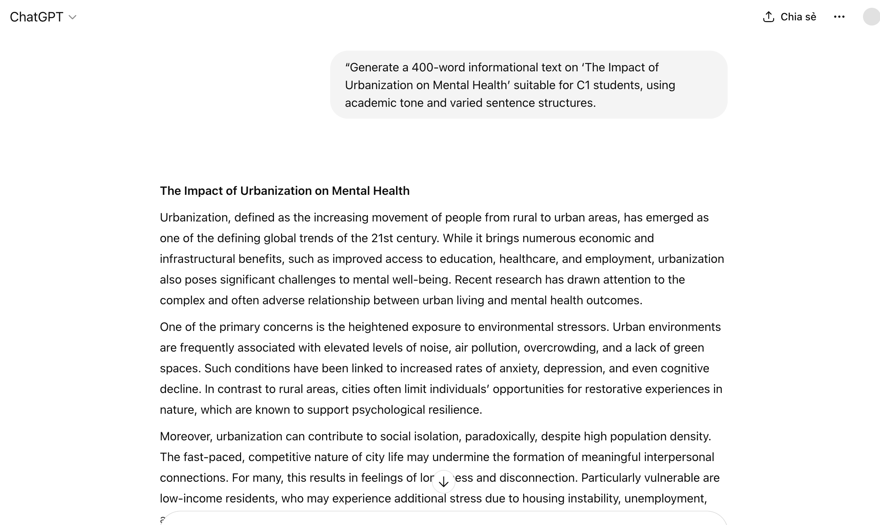
Sample 2:

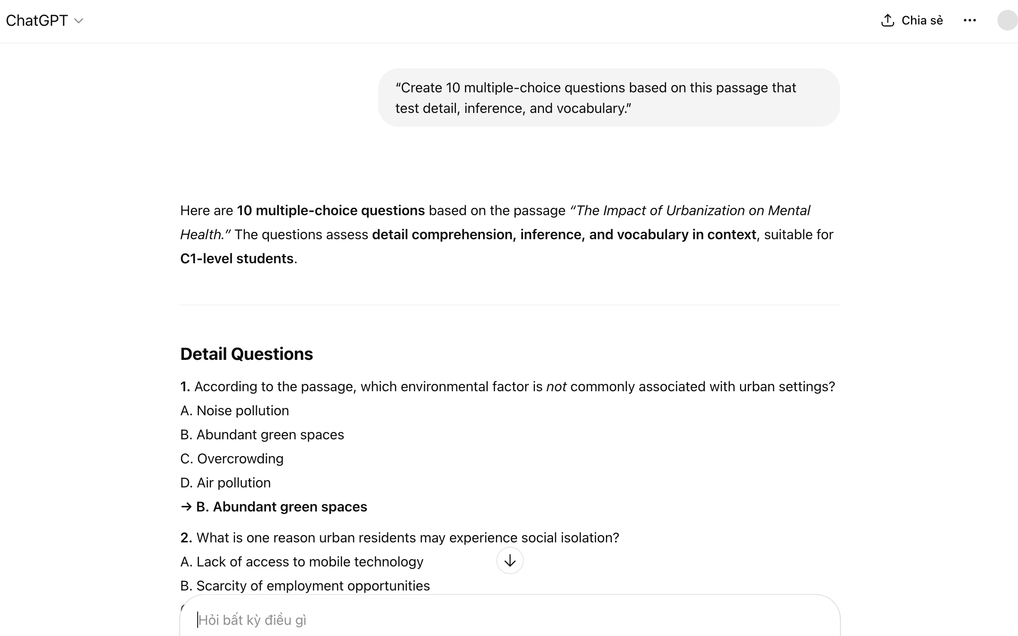
Sample 3: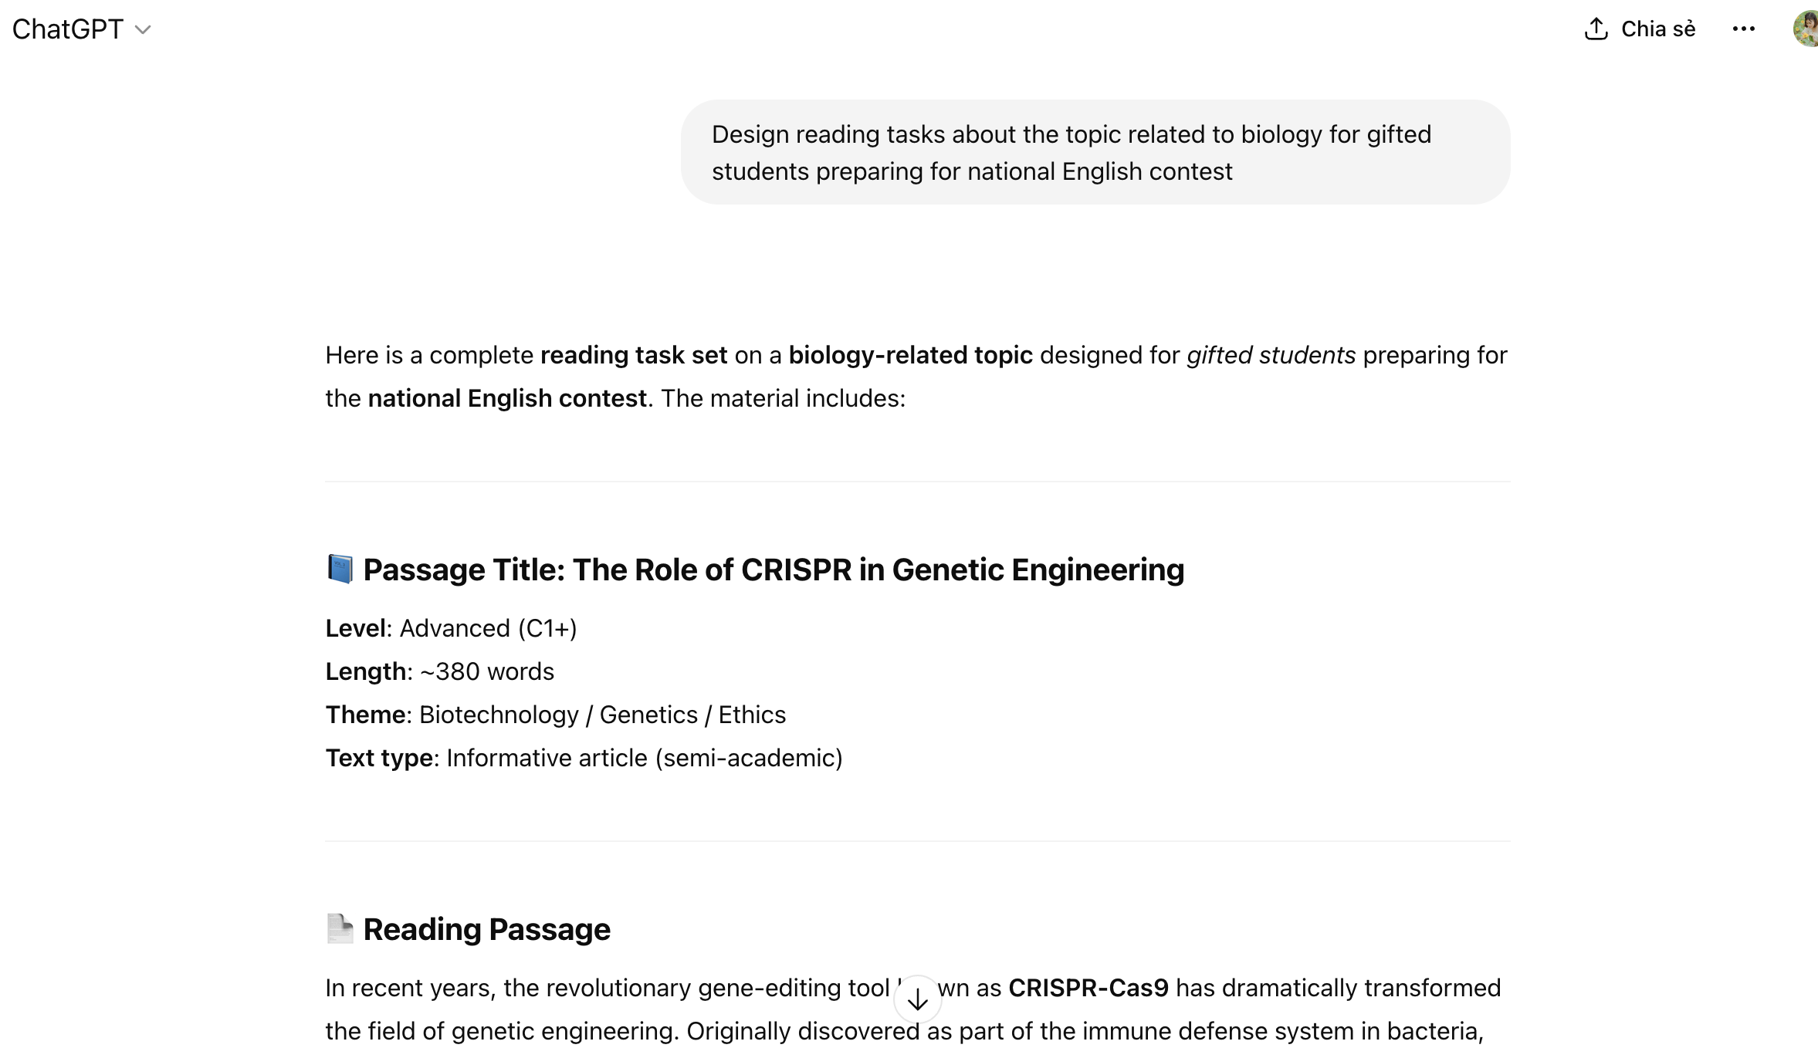

Sample 4:
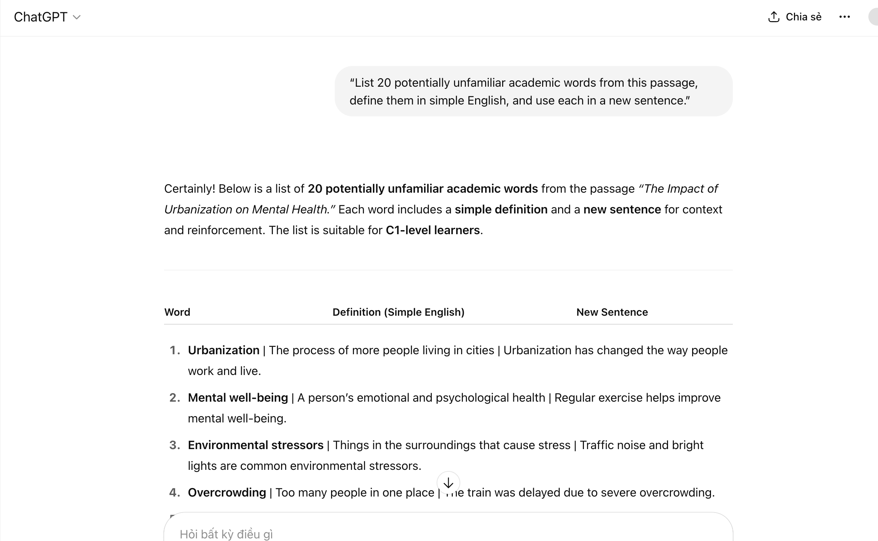

Sample 5:
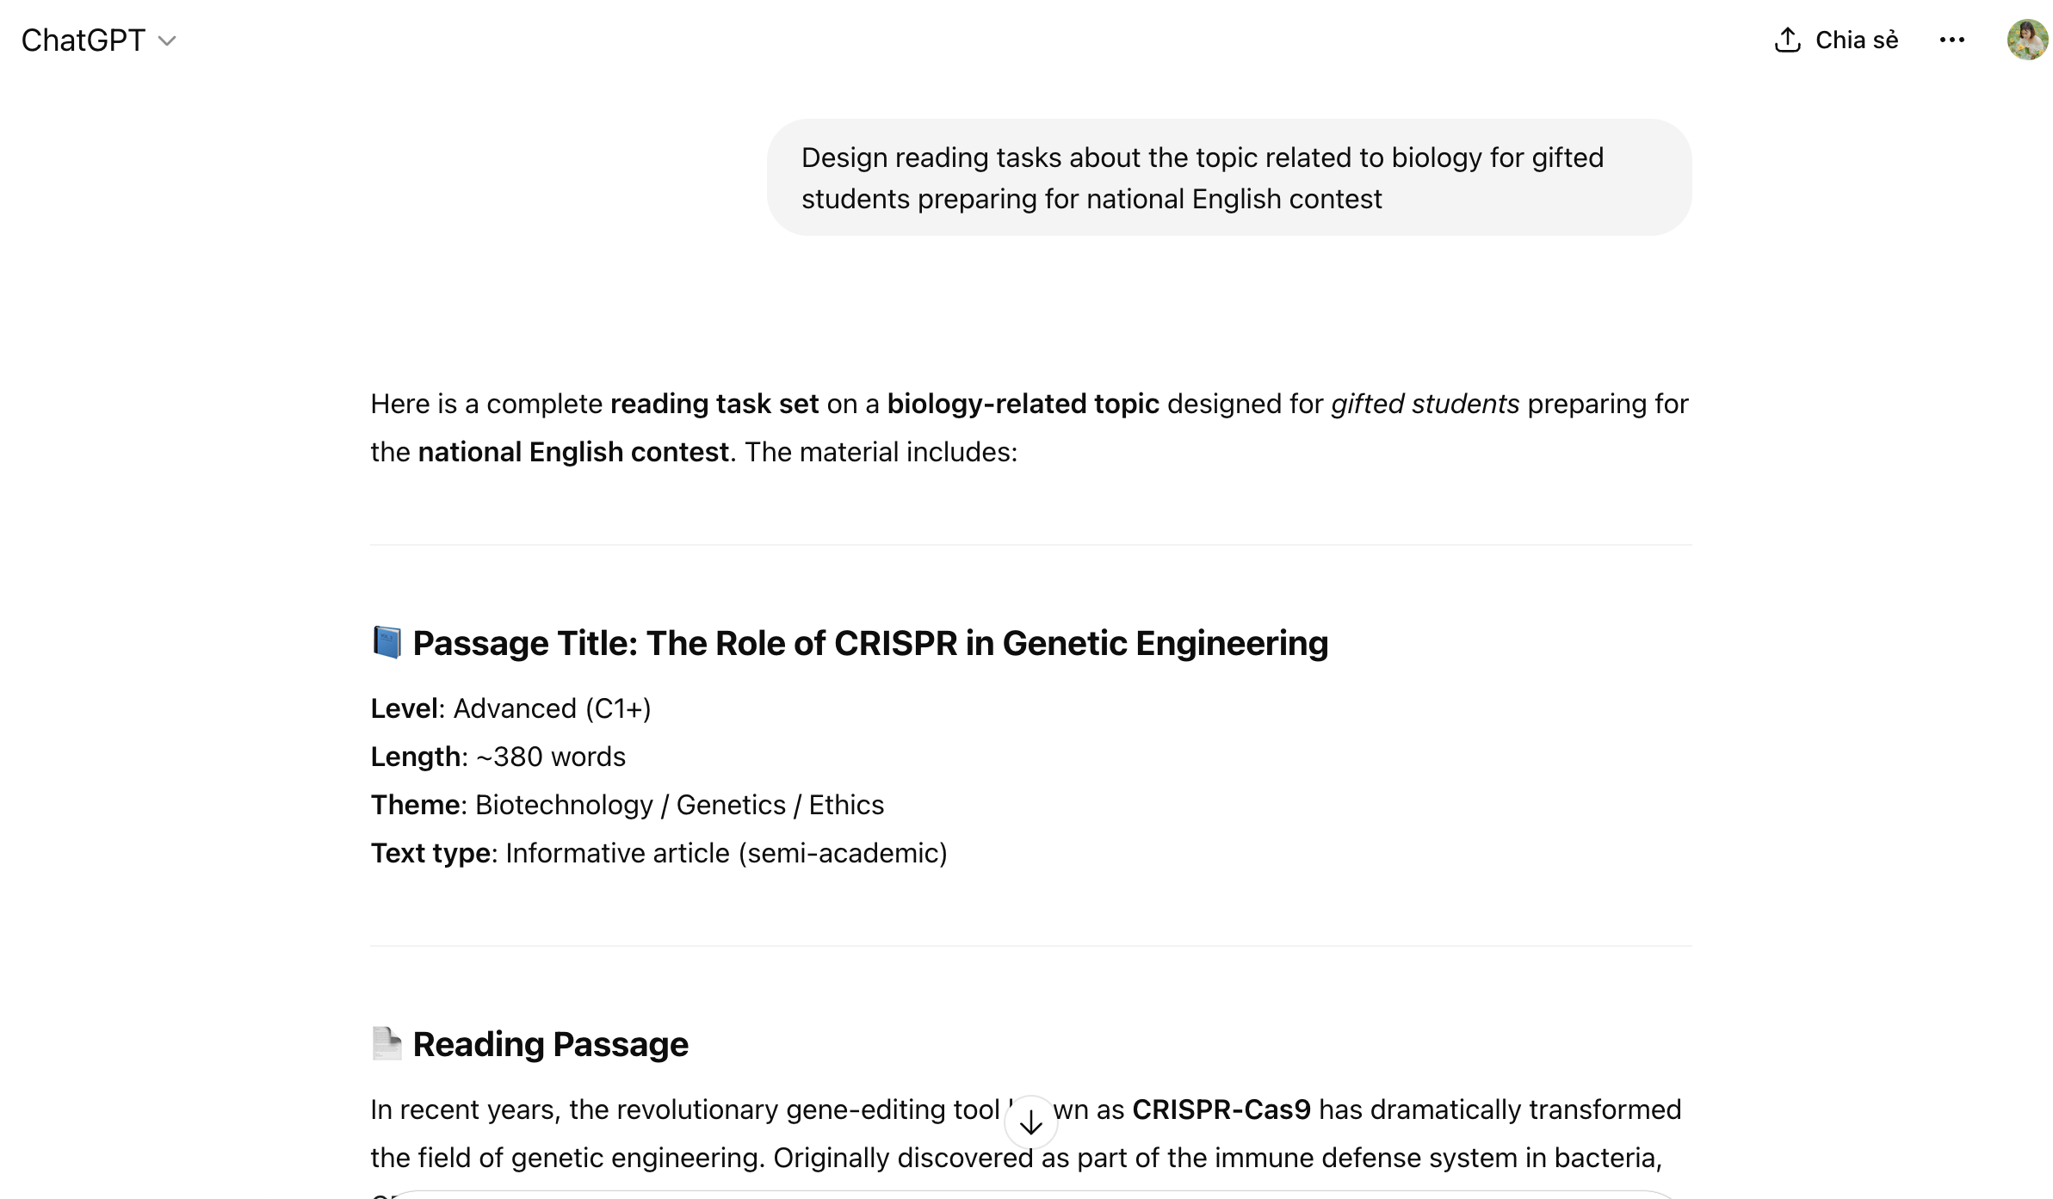
Picture 6:

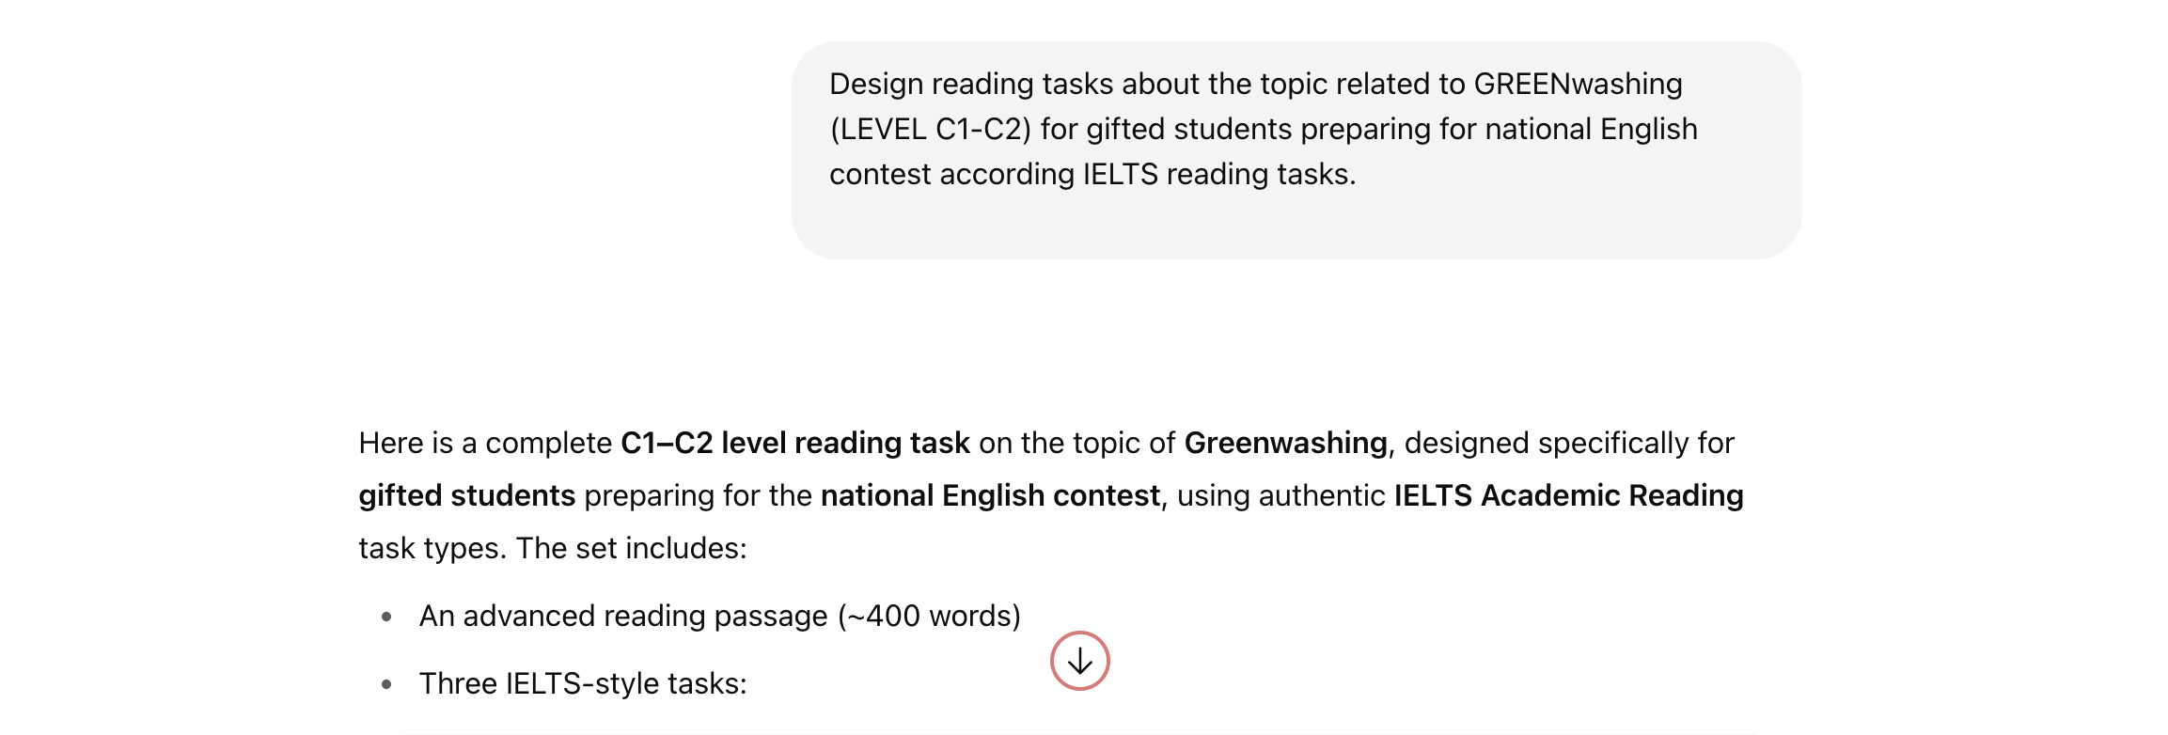Picture 7
